|  |  |  |
| --- | --- | --- |
| **Requirement #:** F_ | **Requirement Type:** Functional | **Use Case #:** |
| **Description:** The system should allow the user to login | | |
| **Rationale:** Users can access needed information faster and change | | |
| **Source:** Member, Agent, Staff, Manager, Administrator | | |
| **Fit Criterion:** The user successfully logs in | | |
| **Dependencies:** None | | |
| **Rank of Importance:** Critical | | |
| **Supporting Materials:** None | | |
| **History:** Created by Sandon Joubert 1/4/2015 | | |

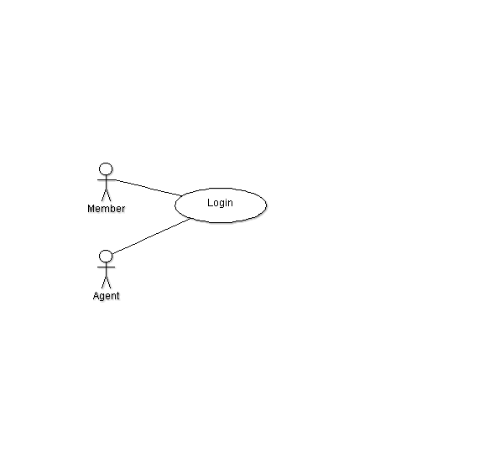

|  |  |  |
| --- | --- | --- |
| **Requirement #:** F_ | **Requirement Type:** Functional | **Use Case #:** |
| **Description:** A non-member should allow the user to become a new member | | |
| **Rationale:** Helps them keep track | | |
| **Source:** Non-member | | |
| **Fit Criterion:** The user successfully becomes a non-member | | |
| **Dependencies:** None | | |
| **Rank of Importance:** Critical | | |
| **Supporting Materials:** None | | |
| **History:** Created by Sandon Joubert 1/4/2015 | | |

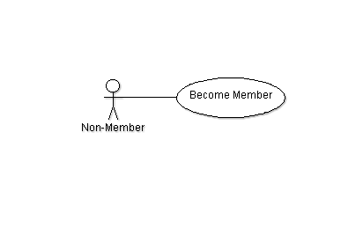

|  |  |  |
| --- | --- | --- |
| **Requirement #:** F_ | **Requirement Type:** Optional | **Use Case #:** |
| **Description:** The system should allow the user to change their password and other account information | | |
| **Rationale:** Sometimes users need to change information about themselves to better reflect changes in their life | | |
| **Source:** Member, Agent | | |
| **Fit Criterion:** The user successfully changes account information | | |
| **Dependencies:** Login F_ | | |
| **Rank of Importance:** Medium | | |
| **Supporting Materials:** None | | |
| **History:** Created by Sandon Joubert 1/4/2015 | | |

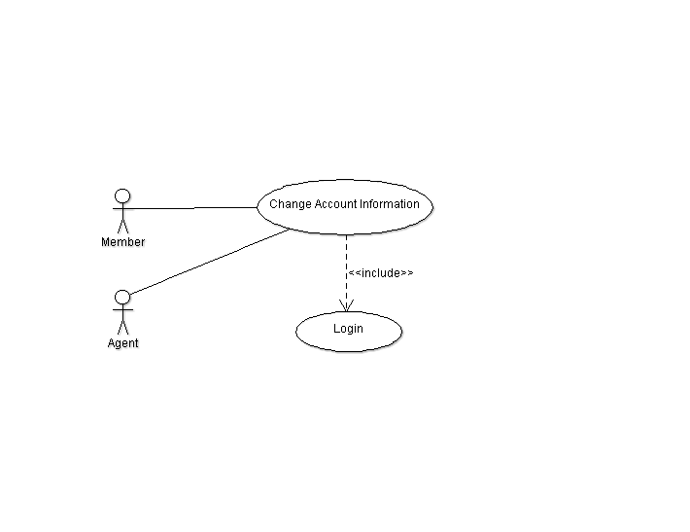

|  |  |  |
| --- | --- | --- |
| **Requirement #:** F_ | **Requirement Type:** Functional | **Use Case #:** |
| **Description:** Any customer should be able to search for a flight | | |
| **Rationale:** A customer must be able to have the liberty of finding the best flight for them | | |
| **Source:** Non-member, Member, Agent | | |
| **Fit Criterion:** The user successfully selects a flight | | |
| **Dependencies:** None | | |
| **Rank of Importance:** Critical | | |
| **Supporting Materials:** None | | |
| **History:** Created by Sandon Joubert 1/4/2015 | | |

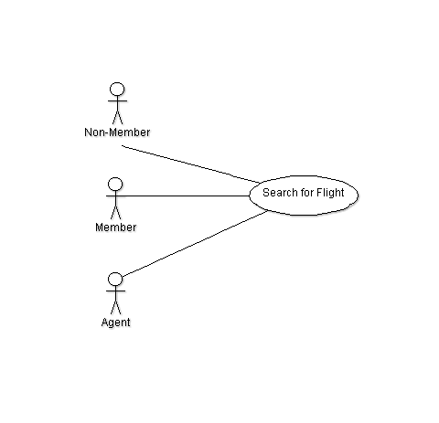

|  |  |  |
| --- | --- | --- |
| **Requirement #:** F_ | **Requirement Type:** Functional | **Use Case #:** |
| **Description:** Any customer should be able to book a flight | | |
| **Rationale:** It’s not a very good airline booking system if you can’t book a flight | | |
| **Source:** Non-member, Member, Agent | | |
| **Fit Criterion:** The user successfully books a flight | | |
| **Dependencies:** Login F_ | | |
| **Rank of Importance:** Critical | | |
| **Supporting Materials:** None | | |
| **History:** Created by Sandon Joubert 1/4/2015 | | |

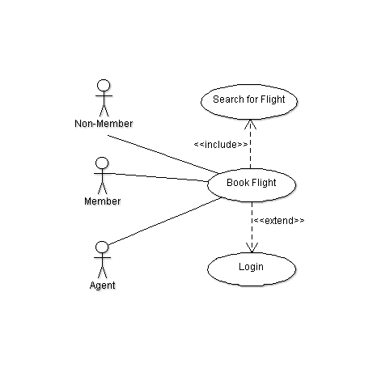

|  |  |  |
| --- | --- | --- |
| **Requirement #:** F_ | **Requirement Type:** Functional | **Use Case #:** |
| **Description:** Any customer should be able to change or add in-flight services | | |
| **Rationale:** A customer may of made a mistake or change of mind and wishes to change/add in-flight services after booking | | |
| **Source:** Non-member, Member, Agent | | |
| **Fit Criterion:** The user successfully changes / adds in-flight services | | |
| **Dependencies:** Login F_ | | |
| **Rank of Importance:** Critical | | |
| **Supporting Materials:** None | | |
| **History:** Created by Sandon Joubert 1/4/2015 | | |

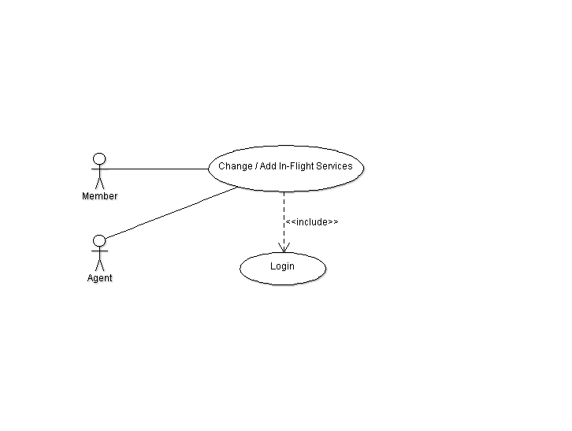

|  |  |  |
| --- | --- | --- |
| **Requirement #:** F_ | **Requirement Type:** Functional | **Use Case #:** |
| **Description:** Any customer should be able to change or cancel a booked flight | | |
| **Rationale:** A customer may of made a mistake or change of mind and wishes to change/cancel a flight after booking | | |
| **Source:** Non-member, Member, Agent | | |
| **Fit Criterion:** The user successfully changes / adds in-flight services | | |
| **Dependencies:** Login F_ | | |
| **Rank of Importance:** Critical | | |
| **Supporting Materials:** None | | |
| **History:** Created by Sandon Joubert 1/4/2015 | | |

