Department of Design Engineering and Mathematics
Middlesex University



Sensor-Driven Digital Twin for Collision
Prevention in Autonomous Systems

Raffay Hassan
Supervisor: Dr Purav Shah

PDE3823 Major Project and Professional Practice
BEng Computer Systems Engineering
2025 - 2026

Acknowledgements
And I would like to acknowledge…
Abstract
This is where you write your abstract ...

Table of contents
1. Introduction 9
1.1. Background and Motivation 9
1.2. Aims and Objectives 10
1.3 Scope and Contributions 11
2. Technical Background and Literature Review 12
2.1. Technical Background 12
2.2. Industry Solutions 14
2.3. Literature Review 16
3. Proposed System Design and Implementation 19
3.1. Overview of the Two-Phase Development Approach 19
3.2. Phase 1 Simulation Design and Implementation 20
3.2.1. Simulation Environment 20
3.2.2. Simulated Sensor Configuration and Fusion 20
3.2.3. Phase 1 Navigation and Safety State Machine 21
3.2.4. Data Logging 21
3.3. Phase 2 Hardware Components 22
3.4. Phase 2 System Power Requirements 24
3.5. Phase 2 Software Stack 25
3.6. Phase 2 Distributed Architecture and Communication 25
3.7. Phase 2 Threading Architecture and GUI 25
3.8. Phase 2 Sensor Fusion Logic 26
3.9. Phase 2 Sensor Health Monitoring 27
3.10. Phase 2 LD06 Lidar Pipeline 27
3.11. Phase 2 BGT60TR13C Radar Pipeline 28
3.12. Phase 2 Camera Pipeline, Motor Control and Avoidance State Machine 30
4. Performance Evaluation Setup and Scenarios 32
4.1. Evaluation Methodology 32
4.2. Phase 1 Test Environment 32
4.3. Scenario 1 Setup Single Obstacle, Clear Conditions 32
4.4. Scenario 1 Results and Analysis 35
4.5. Scenario 2 Setup Single Obstacle, Extreme Rain and Low Visibility 36
4.6. Scenario 2 Results and Analysis 38
4.7. Scenario 3 Setup Multi Obstacle, Clear Conditions 39
4.8. Scenario 3 Results and Analysis 39
4.9. Phase 1 YOLO Performance Evaluation 39
4.10. YOLOv5n versus YOLOv8n Comparative Evaluation 40
4.11. Phase 2 Test Environment 47
4.12. Test 1: Multi-Obstacle Extended Run 47
4.13. Test 1: Results and Analysis 48
4.14. Test 2: Single Obstacle Controlled Run 52
4.15. Test 2: Results and Analysis 52
4.16. Test 2: Combined System Performance Metrics 52
5. Conclusion 55
References 56
Appendix 57

List of Figures
Figure 1 RC car with all components mounted and connected 21
Figure 2 Jetson Orin Nano and LD06 Lidar during bench 22
Figure 3 Raspberry Pi 5 with BGT60TR13C radar on 22
Figure 4 Fusion GUI dashboard showing Lidar scatter panel, radar range-velocity panel, TTC chart and status bar 25
Figure 5 LD06 live forward obstacle detection plot with three-zone colouring and STOP and SLOW threshold lines 26
Figure 6 BGT60TR13C radar GUI showing confirmed approaching track with range-velocity position and TTC level 28
Figure 7 Arducam IMX477 connected to Jetson via CSI 29
Figure 8 Avoidance state machine with six states, timings and transition conditions 30
Figure 9 Town04 initial setup with ego vehicle and obstacle aligned in lane with sensor overlays 32
Figure 10 Emergency brake trigger moment under clear conditions. 32
Figure 11 Lane change manoeuvre, Scenario 1. 33
Figure 12 Vehicle straightening after lane change. 33
Figure 13 Vehicle resuming normal lane driving. 34
Figure 14 Scenario 1 performance dashboard showing sensor distances over time, TTC profile and safety state distribution. 35
Figure 15 Extreme rain setup showing fog, wet roads and reduced visibility. 36
Figure 16 Braking under extreme rain conditions. 36
Figure 17 Lane change and resume under extreme rain. 37
Figure 18 YOLOv8n baseline performance dashboard showing inference time per frame, FPS over time, detections per frame and top detected classes. 40
Figure 19 YOLOv5n clear conditions performance graphs showing inference time per frame, FPS over time, objects detected per frame and top detected classes. 41
Figure 20 YOLOv5n clear conditions statistical analysis showing inference time distribution histogram, detections vs processing time scatter plot, cumulative detections and performance summary box. 41
Figure 21 YOLOv8n clear conditions performance graphs showing inference time per frame, FPS over time, objects detected per frame and top detected classes. 42
Figure 22 YOLOv8n clear conditions statistical analysis showing inference time distribution histogram, detections vs processing time scatter plot, cumulative detections and performance summary box. 43
Figure 23 YOLOv5n rain conditions performance graphs showing inference time per frame, FPS over time, objects detected per frame and top detected classes. 43
Figure 24YOLOv5n rain conditions statistical analysis showing inference time distribution histogram, detections vs processing time scatter plot, cumulative detections and performance summary box. 44
Figure 25 YOLOv8n rain conditions performance graphs showing inference time per frame, FPS over time, objects detected per frame and top detected classes. 45
Figure 26 YOLOv8n rain conditions statistical analysis showing inference time distribution histogram, detections vs processing time scatter plot, cumulative detections and performance summary box. 45
Figure 27 Lidar zone distances over time for Test 1 with motor state shading. 47
Figure 28 Motor state distribution for Test 1. 48
Figure 29 Fusion level pie chart and timeline for Test 1. 48
Figure 30 YOLO detection classes for Test 1. 49
Figure 31 Lidar distance histograms per zone for Test 1. 50
Figure 32 Avoidance event summary for Test 1. 50
Figure 33 System performance metrics comparing Test 1 and Test 2. 51

List of tables
Table 1 Comparison of Different Industry Solutions 14
Table 2 Comparison of Research Studies 17
Table 3 summarises the key structural differences between the two phases. 18
Table 4 Phase 1 key threshold constants shared across all scenario scripts. 20
Table 5 Phase 2 hardware components, roles and key specifications. 21
Table 6 System power requirements grouped by compute and actuation group. 23
Table 7 Lidar zone definitions, angular ranges and navigation responses. 27

Introduction

Background and Motivation
Autonomous vehicle technologies have developed rapidly over the last decade due to advances in machine learning, computer vision, and embedded computing. These developments have enabled vehicles to detect obstacles, interpret complex environments, and assist drivers in making safer decisions. Many modern vehicles now have advanced driver assistance systems (ADAS) that support functions such as lane keeping, adaptive cruise control, and collision warning.
Despite these advancements, road traffic accidents remain a major global issue. A significant proportion of road accidents occur due to human error, including delayed reaction times, driver distraction, or poor situational awareness. For this reason, research into intelligent vehicle safety systems has increasingly focused on improving a vehicle ability to detect hazards and predict potential collisions before they occur.
A fundamental requirement for such systems is reliable environment perception. Autonomous vehicles rely on various sensors to observe their surroundings. Cameras provide visual information that can be analysed using computer vision algorithms to detect objects such as vehicles, pedestrians, and road signs. Lidar sensors generate three-dimensional data that allow accurate distance measurements and environmental mapping. Radar sensors measure relative velocity and perform reliably under conditions where optical sensors may struggle, such as fog, rain, or low lighting [1]
Although these sensors allow vehicles to detect obstacles, detection alone does not guarantee safety. A vehicle must also determine whether a detected object poses an immediate risk. For example, identifying a vehicle ahead does not necessarily indicate danger unless the distance and relative speed suggest a potential collision scenario. Therefore, autonomous safety systems must go beyond detection and incorporate predictive risk assessment.
One widely used metric for evaluating collision risk is Time-To-Collision (TTC). TTC estimates the time remaining before two objects collide if their current velocities remain unchanged. This metric has been widely studied in traffic safety research and is frequently used in advanced driver assistance systems to identify potentially dangerous situations [2]. By combining distance measurements and relative velocity estimates, TTC enables vehicles to evaluate potential risks before a collision becomes unavoidable.
However, many digital twin implementations focus on large-scale infrastructure systems or cloud-based computing environments. Less attention has been given to how digital twin concepts can be implemented on embedded hardware platforms operating at the edge. Embedded systems must operate under limited computational resources while still processing real-time sensor data.
Another challenge in autonomous vehicle research is bridging the gap between simulation environments and real-world systems. Simulation platforms allow researchers to develop and test algorithms safely before deploying them in physical environments. However, simulation environments cannot fully replicate the complexity and unpredictability of real-world driving scenarios.
This project addresses these challenges by developing a sensor-driven digital twin architecture for predictive collision detection. The system integrates data from multiple sensors including camera, Lidar, and radar to construct a continuously updated representation of the surrounding environment. This representation serves as a digital twin of the physical environment and is used to evaluate potential collision risks using Time-To-Collision calculations.
To support development and testing, the system is implemented in two stages. First is the perception algorithms and system architecture are developed within the Carla autonomous driving simulator, which provides a controlled environment for testing. Second is the system is deployed on embedded hardware platforms including the Nvidia Jetson Orin Nano and Raspberry Pi, where real sensor data can be processed and evaluated.
Through this approach, the project investigates how digital twin architectures can support predictive safety systems in embedded autonomous vehicle platforms.

Aims and Objectives
The aim of this project is to design and implement a sensor-driven digital twin system capable of predicting potential vehicle collisions using multi-sensor perception and Time-To-Collision analysis on embedded computing platforms.
To achieve this aim, the project will pursue the following objectives:
- Develop a simulation environment using the Carla autonomous driving simulator to model vehicle behaviour and collision scenarios.
- Implement camera-based object detection capable of identifying obstacles within the vehicle forward field of view.
- Integrate Lidar sensing to obtain distance measurements and spatial information about obstacles.
- Integrate radar sensing to estimate relative velocities between the vehicle and surrounding objects.
- Design and implement a digital twin world model representing the vehicle surrounding environment.
- Implement Time-To-Collision calculations using sensor measurements to evaluate collision risk.
- Deploy the system on embedded computing platforms including the NVIDIA Jetson Orin Nano and Raspberry Pi.
- Evaluate system performance using both simulated environments and real-world sensor experiments.

1.3 Scope and Contributions
The scope of this project focuses on the development of a predictive collision detection system based on multi-sensor perception and digital twin modelling. The system aims to detect obstacles and evaluate potential collision risks rather than perform full autonomous driving functions such as path planning or navigation.
The project is implemented in two phases. The first phase involves developing and testing perception algorithms within the Carla simulation environment. The second phase involves implementing the system on embedded hardware and integrating real sensors.
Several limitations influence the scope of the project. These include limited hardware resources compared with industrial autonomous driving platforms, restricted sensor coverage, and limited testing environments. As a result, the system focuses primarily on forward collision detection rather than full 360-degree environmental perception.
The key contributions of this project include:
- Development of a sensor-driven digital twin architecture for modelling the vehicle surrounding environment.
- Integration of camera, Lidar, and radar sensors to support multi-sensor perception.
- Implementation of predictive collision detection using Time-To-Collision analysis.
- Deployment of the system on embedded computing platforms.
- Evaluation of the system across simulation and real-world testing environments.

Technical Background and Literature Review

Technical Background
Autonomous vehicle systems rely on several fundamental technologies that enable vehicles to perceive their surroundings, interpret environmental conditions, and make safe decisions. These technologies include multi-sensor perception, sensor fusion, digital twin modelling, and simulation-based testing environments. Understanding these concepts provides the technical foundation for the system developed in this project.
Multi-Sensor Perception
Autonomous vehicles rely on a variety of sensors to obtain information about their surroundings. Each sensing modality provides different types of environmental data. Cameras capture visual information that can be analysed using computer vision algorithms to detect objects such as vehicles, pedestrians, and traffic signs. These algorithms often rely on deep learning models trained on large datasets to recognise patterns and classify objects.
Lidar sensors provide three-dimensional spatial information by emitting laser pulses and measuring the time it takes for the reflected signal to return. This process generates a point cloud representation of the environment that allows accurate measurement of object distance and shape.
Radar sensors operate using radio waves and are particularly useful for measuring the velocity of moving objects. Radar sensors can detect objects even under poor visibility conditions such as fog, rain, or darkness. Because radar signals are less affected by environmental conditions than optical sensors, radar provides an additional layer of sensing redundancy.
Each of these sensors has advantages and limitations. Cameras provide detailed semantic information but cannot directly measure distance. Lidar sensors provide accurate spatial measurements but are typically more expensive and computationally demanding. Radar sensors measure velocity effectively but have lower spatial resolution.
For this reason, modern autonomous vehicle systems often combine these sensors to obtain a more reliable understanding of the environment.
Sensor Fusion
Sensor fusion refers to the process of integrating data from multiple sensors in order to produce a representation of the environment. By combining camera, Lidar, and radar data, autonomous systems can compensate for the limitations of individual sensors.
Fusion can occur at several levels within the perception pipeline. Early fusion methods combine raw sensor data before object detection occurs. Late fusion approaches combine the outputs of separate detection algorithms. Hybrid approaches combine both strategies.
Although sensor fusion improves perception reliability, it also increases system complexity and computational requirements. These challenges become particularly important when implementing perception systems on embedded hardware platforms where processing resources are limited.
Digital Twin Concept
The concept of the digital twin originates from cyber-physical systems research and refers to a digital representation of a physical system that updates continuously using real-time data streams. A digital twin allows the behaviour of a physical system to be analysed and monitored in a virtual environment.
In transportation systems, digital twins can represent vehicles, infrastructure, and traffic environments. By maintaining a continuously updated representation of the physical environment, digital twins allow systems to perform predictive analysis and risk evaluation.
In the context of this project, the digital twin represents a simplified model of the vehicle surrounding environment that contains information about detected objects, their positions, and their estimated velocities.
Simulation Environment
Simulation platforms are widely used in autonomous vehicle research because they allow perception algorithms and driving behaviours to be tested safely before deployment in real environments.
Simulation environments allow researchers to generate controlled scenarios, including traffic situations, pedestrians, and environmental conditions. This allows algorithms to be tested under repeatable conditions without the safety risks associated with real-world testing.
One of the most widely used autonomous vehicle simulators is Carla, which provides realistic urban environments and supports configurable sensor simulation. Carla allows researchers to simulate camera, Lidar, and radar sensors, making it suitable for testing perception algorithms before deploying them on physical hardware.

Industry Solutions
Several commercial organisations have developed autonomous driving and driver assistance systems that attempt to address the challenges of environmental perception and collision avoidance. These systems provide useful reference points when analysing how modern intelligent vehicles detect hazards and prevent accidents. Although these platforms differ in design and sensor configurations, they all rely on advanced perception algorithms and sensor data processing to understand the surrounding environment.
One of the most advanced autonomous driving platforms currently deployed in real-world environments is developed by Waymo. Waymo’s system relies on a comprehensive sensor suite that includes cameras, Lidar sensors, and radar units positioned around the vehicle. Lidar sensors generate highly detailed three-dimensional maps of the environment, while cameras provide semantic information about road objects and radar sensors provide velocity measurements. These sensors are integrated using sophisticated perception and mapping algorithms that allow the vehicle to detect obstacles, identify road users, and predict object movement. However, Waymo’s approach requires expensive sensors and high-performance computing infrastructure, which makes it difficult to replicate in small-scale experimental systems.
Another prominent example is Tesla Autopilot and Full Self-Driving platform, which follows a different perception strategy known as Tesla Vision. Unlike many autonomous vehicle developers, Tesla has moved away from Lidar sensors and instead relies primarily on cameras combined with deep neural networks. These neural networks analyse visual data to identify objects and estimate distances. While this camera-based approach reduces hardware complexity and cost, it has also been criticised for lacking sensing redundancy because depth estimation from camera images can be less reliable than Lidar measurements in certain conditions.
A third widely deployed system is developed by Mobileye, which provides advanced driver assistance technologies used by many automotive manufacturers. Mobileye systems typically combine cameras with radar sensors to support safety features such as adaptive cruise control, lane departure warnings, and collision alerts. Compared with fully autonomous driving systems, Mobileye solutions are designed primarily to assist drivers rather than replace them entirely. As a result, they rely on fewer sensors and simpler perception pipelines.
Table 1 summarises the main characteristics of these industrial systems and compares them with the system developed in this project.

Table 1 Comparison of Different Industry Solutions
System | Sensors | Focus | Limitations | System
Waymo | Camera, Lidar, Radar | Full autonomous driving | High infrastructure cost | Waymo
Tesla Vision | Cameras | Vision-based autonomy | Limited sensing redundancy | Tesla Vision
Mobileye ADAS | Camera + Radar | Driver assistance | Limited spatial sensing | Mobileye ADAS

The table highlights several important distinctions between industrial solutions and the proposed system. Commercial autonomous driving platforms such as Waymo are designed for large-scale deployment and therefore rely on extensive sensor arrays and powerful computing infrastructure. Tesla’s approach demonstrates that camera-based perception can support many driving tasks, but it also introduces challenges related to depth estimation and environmental robustness.
The system proposed in this project differs from these industrial platforms in its primary objective. Rather than attempting to achieve full autonomous driving capabilities, the project focuses specifically on predictive collision detection using a sensor-driven digital twin architecture implemented on embedded hardware platforms. This approach allows the project to explore how key autonomous driving concepts such as multi-sensor perception, predictive risk evaluation, and environmental modelling can be implemented within a smaller research-oriented prototype.
By analysing existing industry solutions, it becomes clear that while commercial systems demonstrate sophisticated perception capabilities, there remains significant value in investigating lightweight embedded architectures that can perform predictive safety analysis using limited computational resources.

Literature Review

Autonomous Vehicle Perception Research
Perception is one of the most extensively studied areas in autonomous vehicle research. A vehicle must be capable of detecting and classifying objects in its environment in order to navigate safely.
[3] conducted a comprehensive survey of deep learning techniques used in autonomous driving perception systems. Their research analysed several neural network architectures used for object detection, including Faster R-CNN, YOLO, and Single Shot Detection networks. These algorithms demonstrated high accuracy when detecting vehicles and pedestrians in complex environments.
However, the authors also identified limitations associated with camera-based perception systems. Deep learning models often require large training datasets and significant computational resources. In addition, camera-based perception may struggle under challenging environmental conditions such as poor lighting or weather effects.
[1] examined a wide range of technologies used in autonomous driving systems and highlighted the importance of multi-sensor perception architectures. Their study concluded that integrating cameras, Lidar sensors, and radar sensors significantly improves perception reliability compared with relying on a single sensing modality.
Sensor Fusion Research
[4] investigated multi-modal sensor fusion methods for autonomous driving applications. Their research focused on combining Lidar point cloud data with camera images to improve object detection performance. The authors evaluated several sensor fusion architectures and demonstrated that multi-modal detection systems achieved higher accuracy than single-sensor approaches.
However, the study also highlighted computational challenges associated with sensor fusion techniques. Integrating multiple sensor streams requires substantial processing power, which may be difficult to achieve on embedded hardware platforms.
Collision Prediction Research
Beyond object detection, researchers have also explored methods for predicting potential collision scenarios. [2] conducted a detailed review of motion prediction techniques used in intelligent vehicles. Their study examined probabilistic motion prediction models and risk assessment metrics used to evaluate collision likelihood.

One widely used metric identified in their research is Time-To-Collision. TTC estimates the time remaining before two objects collide assuming their current velocities remain constant. Because TTC requires only distance and velocity information, it can be implemented efficiently in real-time systems.
Earlier research by [5] also demonstrated that TTC can serve as an early indicator of dangerous traffic situations. These findings support the use of TTC as a predictive safety mechanism in autonomous vehicle systems.
Digital Twin Research
Digital twin technology has become an important concept in cyber-physical systems research. [6] describe digital twins as virtual representations of physical systems that update continuously using real-time data streams. These systems allow engineers to monitor system behaviour and perform predictive analysis.
Although digital twins have been widely applied in manufacturing and industrial systems, relatively little research has explored their use in embedded autonomous vehicle platforms. Many digital twin implementations rely on cloud computing infrastructure rather than edge devices.
Simulation-Based Research
Simulation platforms have become an essential tool in autonomous vehicle development. [7] introduced the Carla simulator, which provides realistic urban driving environments for testing perception algorithms. Carla supports simulated camera, Lidar, and radar sensors and allows researchers to generate complex driving scenarios.
Simulation allows researchers to evaluate perception algorithms safely before deploying them on physical hardware. However, simulation environments cannot fully replicate real-world conditions, which is why many researchers recommend combining simulation-based testing with real-world experimentation.

Table 2 Comparison of Research Studies
Study | Focus | Methodology | Key Findings | Relevance
Grigorescu et al. (2020) | Vision perception | Deep learning survey | CNN models improve object detection | Supports camera detection
Badue et al. (2021) | Autonomous systems | Technology survey | Multi-sensor perception improves reliability | Supports sensor fusion
Feng et al. (2022) | Sensor fusion | Multi-modal detection | Fusion improves detection accuracy | Supports Lidar integration
Lefèvre et al. (2014) | Collision prediction | Motion analysis | TTC effective risk metric | Supports predictive safety
ao et al. (2019) | Digital twins | Framework analysis | Digital twins enable predictive modelling | Supports world model concept

Table 2 summarises several key research contributions related to perception systems, collision prediction methods, digital twin technologies, and simulation environments. The table illustrates that existing research often focuses on individual components of autonomous vehicle systems.
For example, some studies focus primarily on perception algorithms, while others examine predictive safety metrics or simulation frameworks. However, relatively few studies combine these components into a unified architecture designed for embedded systems.
This project addresses this gap by integrating multi-sensor perception, predictive collision detection using Time-To-Collision, and digital twin modelling within an embedded system architecture.

Proposed System Design and Implementation

Overview of the Two-Phase Development Approach
The project is structured across two phases with fundamentally different goals and approaches. Phase 1 uses the Carla open-source autonomous driving simulator as a controlled baseline environment to develop and validate the core perception algorithms, sensor fusion logic and TTC computation before any physical hardware is involved. In Phase 1 the ego vehicle follows a predefined lane, detects a stationary obstacle through fused sensor data, executes an emergency brake and performs a structured lane change before resuming normal driving. The navigation in Phase 1 is waypoint-guided and planned.
Phase 2 is a physical deployment on a Maverick RC car. There are no waypoints and no lane maps. The vehicle drives forward by default and reacts in real time to whatever the sensors detect. When an obstacle blocks the path it stops, reverses, turns and escapes on a new heading. When the path is clear it continues forward. This is a purely reactive architecture and the appropriate design for an embedded platform operating without localisation or prior knowledge of the environment. [18] [18]
The Digital Twin layer is present in both phases as the internal software model continuously updated with obstacle positions, distances, velocities and TTC values from live sensor data. In Phase 1 it is populated from Carla simulated sensors. In Phase 2 it is populated from real hardware in real time. The architecture connecting sensors to fusion to actuation is the same across both phases, making the transition a change in data source rather than a change in system design. [16], [17] Table 3.1 summarises the key structural differences between the two phases.

Table 3 summarises the key structural differences between the two phases.
Aspect | Phase 1 Carla Simulation | Phase 2Hardware Deployment
Platform | Carla simulator, Town04 map | Maverick RC car, real environment
Navigation | Waypoint-guided lane following | Purely reactive, no map
Sensors | Simulated Lidar, radar, camera | LD06, BGT60TR13C, Arducam IMX477
Compute | Laptop running Carla Python client | Jetson Orin Nano and Raspberry Pi 5
Motor control | Carla Vehicle Control API | Arduino UDP to PWM, physical ESC and servo
Post-obstacle behaviour | Planned lane change and resume | Reverse, turn and escape on new heading
Obstacle type | Stationary vehicle spawned at 80 m | Physical everyday objects, indoor and outdoor

Phase 1 Simulation Design and Implementation

Simulation Environment
Phase 1 uses Carla 0.9.13 on the Town04 map in synchronous mode at a fixed timestep of 0.05 seconds at 20 Hz, ensuring fully deterministic and reproducible results. [20] Town04 was selected for its long consistent road segments providing sufficient forward distance for a controlled obstacle approach test. The ego vehicle is spawned at a verified lane-aligned position, and a stationary obstacle vehicle is placed 80 metres ahead using waypoint-based lane alignment. Waypoint-based proportional steering keeps the ego vehicle tracking the lane centre throughout each 70-second run. Three scenario scripts cover the main test conditions:
- dt_phase1_car_front.py for the single obstacle clear conditions baseline.
- dt_phase1_car_front_rain.py for the extreme rain variant.
- dt_phase1_car_front_multi_obs_.py for the sequential multi-obstacle test.

Simulated Sensor Configuration and Fusion
Three sensors are simulated on the ego vehicle. A ray-cast Lidar extracts the minimum forward corridor distance using a spatial mask accepting points between 2 m and 120 m forward within 2 m lateral offset. A frontal radar provides per-frame depth and relative velocity for TTC computation. An RGB camera at 1920 by 1080 with a 110-degree field of view provides frames for YOLOv8n inference. [9] A gated association method reduces false positives: candidate readings are only accepted within 12 m of the expected obstacle distance, the fused distance is the minimum across valid candidates, and a sentinel value of 999 m suppresses braking when no reading passes the gate. [11] TTC is computed only on valid fused distances as range divided by radar relative velocity. [14] Table 3.2 lists the key threshold constants shared across all Phase 1 scripts.

Table 4 Phase 1 key threshold constants shared across all scenario scripts.
Parameter | Value | Purpose
BRAKE_DISTANCE | 8.0 m | Fused distance threshold for emergency brake
AVOID_DISTANCE | 15.0 m | Fused distance threshold for Warning state entry
TTC_CRITICAL | 2.0 s | TTC threshold for emergency brake
ASSOC_GATE_M | 12.0 m | Maximum sensor reading deviation for fusion gating
OBSTACLE_AHEAD | 80.0 m | Obstacle spawn distance from ego vehicle

Phase 1 Navigation and Safety State Machine
Phase 1 navigation is lane-following with a planned post-stop avoidance sequence that is specific to simulation because it depends on the known lane structure available in Carla. Six states govern vehicle behaviour throughout each run:
- Safe: normal throttle, following the waypoint lane track.
- Warning: fused distance below 15 m, avoidance steering blended with lane following.
- Critical: fused distance below 8 m or TTC below 2 s, full emergency braking applied.
- Lane Change: after stop, gentle left steer at minus 0.25 with throttle 0.35 to move into the adjacent lane.
- Straightening: blending back to lane-following steering at throttle 0.45.
- Resumed: normal driving restored at throttle 0.5 with full waypoint guidance. [15] [15]

Data Logging
Each Phase 1 run produces sensor_fusion.csv recording fused distance, individual sensor distances, TTC and safety level per tick; vehicle_state.csv recording speed, throttle, brake, steer and active state; per-frame Lidar PLY point clouds; JPEG camera images; and a compiled output.mp4 at 20 FPS. A separate offline YOLO analysis pipeline runs YOLOv8n over the saved frames with a lane-relevance filter and logs inference time, FPS, detection count and class per frame to yolo_performance.csv.

Phase 2 Hardware Components
Phase 2 deploys the validated architecture on a Maverick monster truck RC chassis with 4WD drive and independent suspension supporting 8 to 12 kg of payload. Table 3.3 lists all hardware components with roles and specifications.
Table 5 Phase 2 hardware components, roles and key specifications.
Component | Role | Key Specification
Jetson Orin Nano | Central compute: Lidar, camera, fusion, GUI | 8-core Cortex-A78AE, 1024-core Ampere GPU, 8 GB LPDDR5, JetPack 6
Raspberry Pi 5 | Radar signal processing and UDP relay | 4-core Cortex-A76, 8 GB LPDDR4X, DreamHAT+ carrier board
LD06 Lidar | 360-degree spinning proximity sensing | 230400 baud serial, 47-byte packets, 12 measurements per packet
BGT60TR13C Radar | 60 GHz FMCW moving-target detection | 1 TX, 3 RX antennas, 64 chirps, 128 samples per chirp
Arducam IMX477 HQ | Visual cross-validation with YOLOv8n | Sony IMX477, CSI-2, 12.3 MP, model B0249
Arduino Uno R4 WiFi | 5V PWM motor control bridge | UDP port 5005, pin 9 ESC, pin 10 steering servo
MSC-25RC ESC | Drive motor throttle actuation | 1700 us forward, 1570 us slow, 1500 us neutral, 1300 us reverse
Steering servo | Front wheel directional control | 1000 us full left, 1500 us centre, 2000 us full right
Maverick chassis | RC vehicle platform | 4WD, independent suspension, 8 to 12 kg payload

Figure 1 shows the complete RC car platform with all sensors and computer hardware mounted.

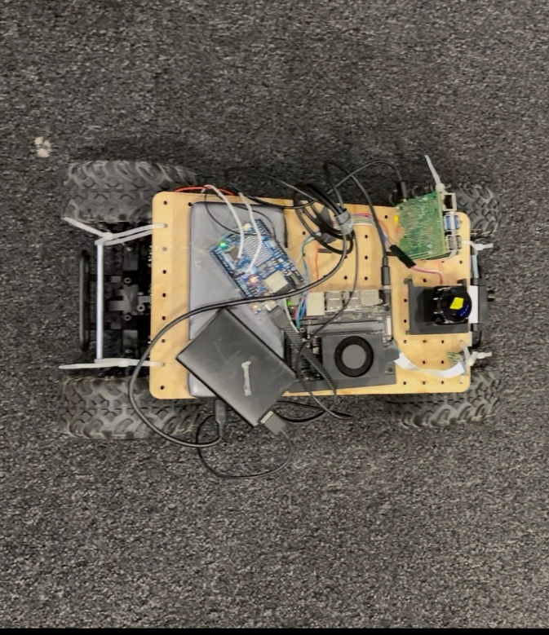
Figure 1 RC car with all components mounted and connected

As shown in Figure 1, the chassis provides a stable base with sufficient space for all hardware. The Jetson Orin Nano and LD06 Lidar are visible on the upper deck during bench integration as shown in Figure 2.
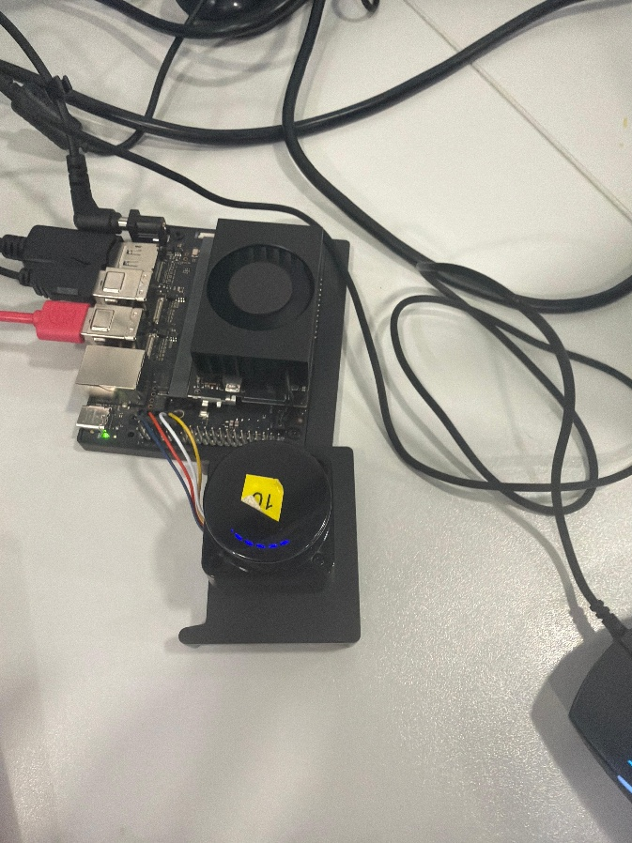
Figure 2 Jetson Orin Nano and LD06 Lidar during bench

Figure 3 shows the Raspberry Pi 5 with the BGT60TR13C radar on the DreamHAT+ carrier board. All radar signal processing runs on the Pi and only processed track data is sent to the Jetson over UDP, keeping the FFT pipeline off the primary compute node entirely. [8]
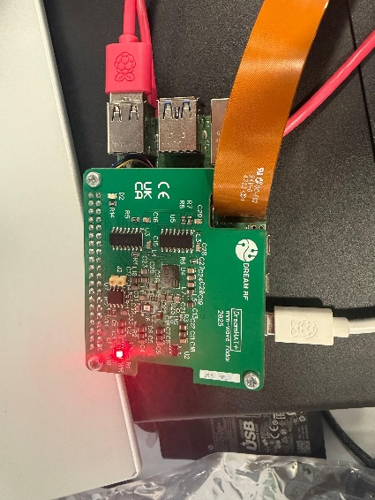
Figure 3 Raspberry Pi 5 with BGT60TR13C radar on

Phase 2 System Power Requirements

Table 6 System power requirements grouped by compute and actuation group.
Component | Board | Voltage | Typical Current | Peak Current | Typical Power | Peak Power | Power Source
Jetson Orin Nano Group
Jetson Orin Nano 8GB | — | 9–20V | 0.78–1.1A | 1.67A | 7–10W | 15W | DC Barrel
Arducam IMX477 Mini | Jetson (CSI) | 3.3V | ~90mA | ~150mA | 0.3W | 0.5W | CSI Rail
LD06 Lidar | Jetson (USB) | 5V | 180mA | 300mA | 0.9W | 1.5W | USB Port
Jetson Group Total |  |  | ~1.05–1.4A | ~2.1A | ~8–11W | ~17W
Raspberry Pi 5 Group
Raspberry Pi 5 | — | 5V | 0.8–1.0A | 1.6A | 4–5W | 8W | USB-C Supply
BGT60TR13C Radar (DreamHAT+) | Pi (GPIO/SPI) | 3.3V | ~150mA | ~300mA | 0.5W | 1W | Pi GPIO Rail
Pi Group Total |  |  | ~0.95–1.15A | ~1.9A | ~4.5–5.5W | ~9W
RC Car Group
Arduino Uno R4 WiFi | — | 5V | ~100mA | ~200mA | 0.5W | 1W | USB / ESC BEC
Steering Servo | Arduino (BEC) | 5V | ~50mA | ~500mA | 0.25W | 2.5W | ESC BEC 5V 1A
MSC-25RC ESC | — | 7.2V | 0.14–0.28A | 3.5A+ | 1–2W | 25W+ | 7.2V LiPo
Drive Motor (Brushed) | ESC | 7.2V | 0.4–0.7A | 4A+ | 3–5W | 30W+ | 7.2V LiPo
Car Group Total |  |  | ~0.7–1.1A | ~8.2A+ | ~5–8W | ~59W
SYSTEM TOTAL |  |  | ~2.7–3.7A | ~12.2A+ | ~18–25W | ~85W

Phase 2 Software Stack

The software stack is distributed across the three compute platforms as follows:
- Jetson Orin Nano: Ubuntu 22.04, JetPack 6, Python 3.10, PyQt5, PyTorch with CUDA, OpenCV 4.8.0, Ultralytics YOLOv8n
- Raspberry Pi 5: Python 3.11, Infineon ifxAvian SDK providing the BGT60TR13C radar interface utilities
- Arduino Uno R4 WiFi: C++ firmware using the Arduino Servo library for 50 Hz PWM generation
All inter-device communication uses standard UDP sockets over the shared WiFi hotspot with no additional middleware

Phase 2 Distributed Architecture and Communication

The physical system distributes work across three boards connected over a shared WiFi hotspot. The Raspberry Pi 5 runs the BGT60TR13C signal processing pipeline and streams processed track data to the Jetson on UDP port 9576. The Jetson runs Lidar parsing, YOLOv8n inference, sensor fusion, motor control decisions and data logging. The Arduino receives single-byte UDP commands from the Jetson on port 5005 and translates them into ESC and servo PWM signals. The Jetson also listens on a separate UDP port for pause and resume commands from a laptop, allowing the car to be halted immediately during testing with a single keypress.

Phase 2 Threading Architecture and GUI

The main fusion application runs four concurrent threads. The Lidar thread reads the LD06 serial port continuously and updates shared state under a threading.Lock. The radar thread listens on UDP port 9576 and updates shared radar state as JSON packets arrive. The camera thread captures 416 by 416 frames through the GStreamer nvarguscamerasrc pipeline with hardware resize in nvvidconv and runs YOLOv8n on CUDA every second frame to manage thermal load. The GUI thread polls shared state every 100 ms via a QTimer and re-renders the dashboard without waiting on sensor data, sustaining approximately 9.5 FPS under full three-sensor load. Timestamps from real test logs confirm the fusion loop running at approximately 15 Hz with no UDP lag or processing bottlenecks.
The dashboard splits into three main areas. The left panel renders the Lidar bird's-eye scatter plot in car-frame coordinates with points coloured by zone: red for centre, blue for left and green for right, with horizontal STOP and SLOW threshold lines overlaid. The centre panel shows confirmed radar tracks as dots on a range-velocity plot coloured by alert level. The right panel contains a TTC bar chart and a track table. The bottom status bar provides a single-line snapshot of FPS, sensor counts, fused verdict and health state. Figure 7 shows the fusion GUI dashboard during operation.
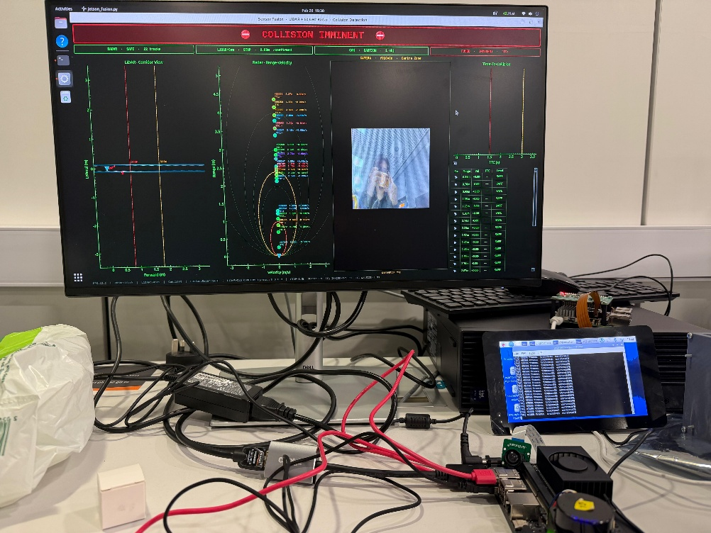
Figure 4 Fusion GUI dashboard showing Lidar scatter panel, radar range-velocity panel, TTC chart and status bar

As shown in Figure 4 all three sensor streams and the fused verdict are visible simultaneously in real time across the three panels.

Phase 2 Sensor Fusion Logic

The fusion policy is worst-case-across-sensors. Each alert level is assigned a numeric priority where Imminent maps to 3, Caution to 2 and Safe to 1. The sensor with the highest priority governs the output and no sensor can reduce the result. Lidar handles stationary obstacle detection. Radar handles moving targets through TTC. The camera cross-validates Lidar alerts if Lidar raises an alert but YOLO finds no object in the central 40 percent of the camera frame the alert is suppressed as noise. If both agree the detection is confirmed. [12] The camera cannot trigger alerts independently. [11], [13]
The health monitor floors the output at Caution if both Lidar and camera are simultaneously impaired or disconnected, ensuring the system never returns Safe when two of three primary sensors are unavailable. [13] The status bar reflects four health states: all sensors online, one sensor offline in amber, two sensors down in red and all sensors offline in full red with a SYSTEM Blind label.

Phase 2 Sensor Health Monitoring

A dedicated health monitoring layer runs alongside the fusion logic and distinguishes between a disconnected sensor and a degraded one. A disconnected sensor has stopped sending data and its timestamp goes stale past a threshold. A degraded sensor is still transmitting at the correct rate but cannot detect anything useful: a Lidar with a blocked lens continues sending packets containing zero valid forward-zone points, or a camera running in a scene too dark for reliable detection. The Lidar degradation state is detected after 15 consecutive frames of zero forward-zone points. The camera degradation state triggers when mean frame brightness falls below 40 and current detections are cleared immediately. The distinction matters because a degraded Lidar triggers radar static fallback coverage while a disconnected one does not, as disconnection could have any cause. [3], [4] [3], [4]

Phase 2 LD06 Lidar Pipeline

The LD06 transmits 47-byte packets at 230400 baud each containing 12 distance measurements. Bytes 4 to 5 encode the start angle and bytes 42 to 43 encode the end angle both divided by 100 to convert to degrees. Each measurement occupies 3 bytes for distance low byte, distance high byte and confidence value.
When first connected every obstacle appeared behind the origin in the scatter plot because the sensor's native zero-degree reference points opposite to the vehicle's forward direction. An angle offset correction applied during decoding as (angle + ANGLE_OFFSET_DEG) % 360.0 resolved this and a Y-axis sign inversion of minus 1 aligned the coordinate frame with the vehicle. [1], [2] Figure 5 shows the corrected live scatter plot with obstacles appearing correctly in the forward region with points coloured by zone.
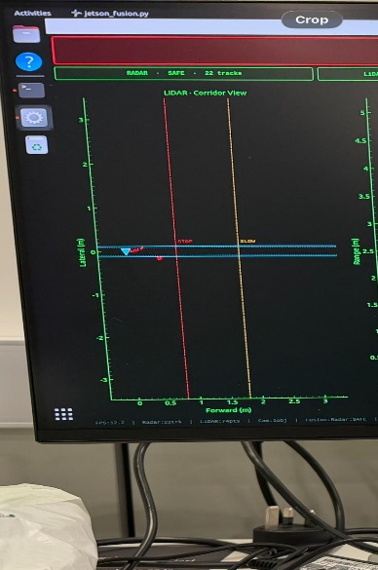
Figure 5 LD06 live forward obstacle detection plot with three-zone colouring and STOP and SLOW threshold lines

As shown in Figure 5 the threshold lines provide a real-time reference for when detections are entering the danger range. With the coordinate frame corrected several filtering layers were applied in sequence:
- FOV restriction to plus or minus 20 degrees forward only, a 20 cm minimum distance floor to remove ground-plane reflections and a secondary geometric check for near-origin stray points. [2]
- Minimum point count per zone scaled with distance: closer objects produce denser return clusters and need more points to register while distant objects naturally produce fewer returns and need fewer, keeping sensitivity high at range without being overly reactive close up. [3]
- Persistence filter requiring 3 consecutive scans to raise an alert and 4 consecutive clear scans to lower it, with asymmetric hysteresis preventing state flickering without delaying genuine detections. [4]
These three layers together removed virtually all false positives observed during bench testing on a reflective desk under overhead lighting. Table 7 defines the three zone boundaries and navigation responses.
Table 7 Lidar zone definitions, angular ranges and navigation responses.
Zone | Angular Range | Priority | Navigation Response
Centre (red) | 340 to 360 deg and 0 to 20 deg | Highest | Reduce speed or stop
Left (blue) | 20 to 90 deg | Medium | Steer right to avoid
Right (green) | 270 to 340 deg | Medium | Steer left to avoid

[21] jetson_fusion.py

Phase 2 BGT60TR13C Radar Pipeline

The BGT60TR13C runs on the Pi 5 with one transmit and three receive antennas producing a raw data array of shape (3, 64, 128) per frame. Multiple processing layers are applied in sequence to go from raw ADC data to trustworthy track objects:

- Three-stage FFT: Range FFT along the sample axis gives distance, Doppler FFT along the chirp axis gives velocity and Angle FFT across the three receivers gives bearing.
- MTI background subtraction at memory coefficient 0.92 removes static clutter from walls, floors and the vehicle chassis, requiring approximately 15 frames to settle after startup. [5] [5]
- CA-CFAR detection at 16 dB identifies candidates above the adaptive local noise floor, keeping the false alarm rate consistent regardless of background noise variation. [6] [6]
- Nearest-neighbour tracking confirms tracks after 3 consecutive matched frames and deletes them after 3 consecutive misses.
- Approach confirmation gate requiring 3 consecutive frames of consistently negative radial velocity before a track triggers a collision warning, eliminating transient ghost detections.
TTC triggers Imminent below 1.5 seconds or within 0.5 m and Caution below 3.0 seconds or within 1.2 m, with range fallbacks for near-zero velocity situations. Stationary obstacles are the Lidar [7], [14], [15]'s responsibility entirely because the MTI filter suppresses static returns by design. Figure 6 shows the radar GUI during bench testing with a confirmed approaching track on the range-velocity plot.
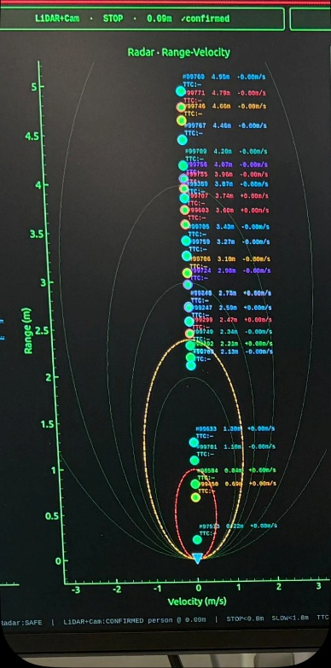
Figure 6 BGT60TR13C radar GUI showing confirmed approaching track with range-velocity position and TTC level

Phase 2 Camera Pipeline, Motor Control and Avoidance State Machine

The Arducam IMX477 connects via CSI through a GStreamer nvarguscamerasrc pipeline hardware-resizing to 416 by 416 via nvvidconv before OpenCV receives it, eliminating CPU resize cost before inference. YOLOv8n runs on CUDA every second frame. Only detections whose bounding box centre x falls within the middle 40 percent of the frame are considered. Distance estimation uses projective geometry estimated distance equals real-world object height multiplied by focal length divided by bounding box pixel height, producing an Imminent, Caution or Safe band without a depth sensor. [10] Camera verdicts are cleared when mean brightness falls below 40. Figure 7 shows the Arducam IMX477 connected to the Jetson.
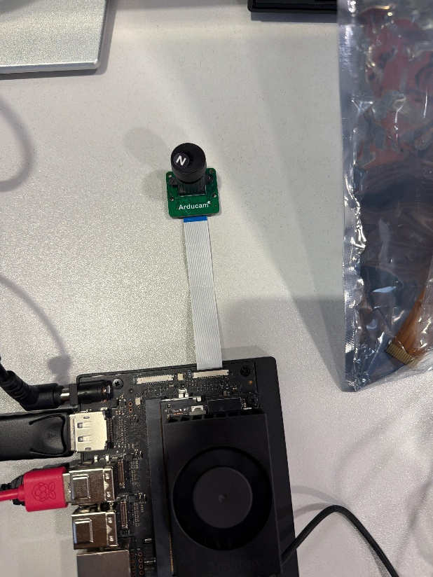
Figure 7 Arducam IMX477 connected to Jetson via CSI

Motor commands are sent from the Jetson to the Arduino on UDP port 5005. Safe commands 1700 microseconds forward, Caution commands 1570 microseconds slow forward and Imminent commands 1500 microseconds neutral stop. Steering derives from Lidar zone output: a left zone obstacle triggers right steering, a right zone obstacle triggers left steering, and both zones clear returns the servo to 1500 microseconds centre.

The motor controller implements a six-state avoidance machine running at 20 Hz with sensor data checked continuously within each state for early exits. Figure 8 shows the state machine diagram. Normal drives at full speed with reactive side steering and a bypass mode that steers around an obstacle without stopping if one side has more than 1 m of clearance. Stopping holds full brake for 0.5 seconds and selects an escape direction. Reversing drives straight reverse for 2.5 seconds with the ESC armed once and held continuously. Turning applies slow forward toward the escape direction for 1.2 seconds and aborts back to Reversing if the front is still blocked. Escaping drives slow forward for 2.0 seconds on the new heading, replanning if a new obstacle appears after a 0.5 second grace period and straightening temporarily if a side wall falls within 0.25 m. Straightening recentres steering for 0.8 seconds and resets retry counters. Total manoeuvre time is approximately 7 seconds. An anti-stuck retry system flips the escape direction after three consecutive failures with the flip locked by a flag so Stopping cannot overwrite it.
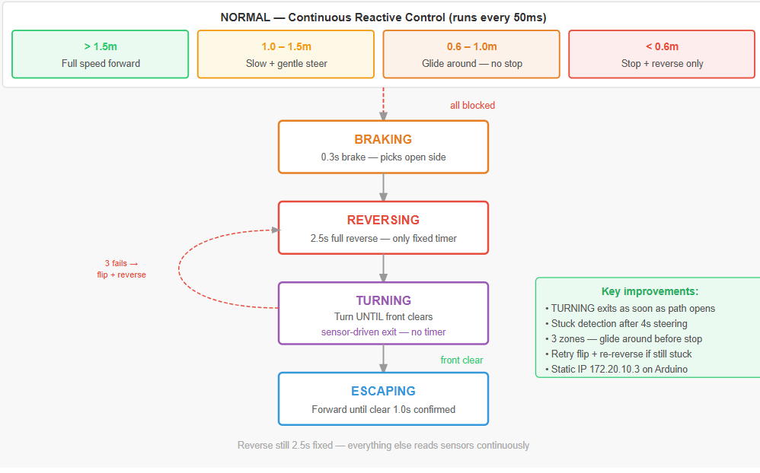
Figure 8 Avoidance state machine with six states, timings and transition conditions

Both boards start automatically on power-on the radar streamer on the Pi runs as a systemd service and the Jetson launches the fusion GUI via a desktop AutoStart file, requiring no laptop for field operation.

Performance Evaluation Setup, Scenarios , Results and analysis.

Evaluation Methodology

The test structure follows a progressive validation methodology. Phase 1 establishes a simulation baseline through three scenarios of increasing complexity a clear conditions single-obstacle test to validate the core pipeline under ideal conditions, a rain variant holding all other variables constant to isolate sensor redundancy by stressing the camera, and a multi-obstacle sequential test to verify state machine integrity over repeated encounters. This mirrors controlled ablation study design where one variable changes at a time to attribute results to specific system components. [11], [13] Phase 2 bench testing preceded on-car testing as a safety precondition to localise faults to the integration layer when they appear. The two on-car sessions are structured as an extended multi-obstacle stress test and a single-obstacle controlled reproduction of the Phase 1 baseline, allowing direct comparison between simulation and hardware performance. Metrics assessed are detection rate, false positive rate, TTC accuracy, reaction latency, stop distance, steering accuracy, drive time efficiency and avoidance success rate. Phase 1 metrics come from the CSV log files and Phase 2 metrics from the on-board data logger.

Phase 1 Test Environment

All Phase 1 runs execute in Carla on Town04 in synchronous mode at 20 Hz, reset to a clean state between runs. Ego vehicle spawn, obstacle placement and threshold constants are identical across all runs so the only variable is weather conditions and obstacle count. [20], [21]

Scenario 1 Setup Single Obstacle, Clear Conditions

A single stationary obstacle vehicle is placed 80 metres ahead in the ego lane under default clear weather with all three simulated sensors operating normally. This is the clean pipeline baseline against which all other scenario results are compared. The ego vehicle approaches from the spawn point at normal throttle following the waypoint lane track. As the fused distance drops below 15 m the system enters Warning and blends avoidance steering with lane following. When fused distance drops below 8 m or TTC drops below 2 seconds the system transitions to Critical and applies full emergency braking. After the vehicle stops, Lane Change is initiated with left steer at minus 0.25 and throttle 0.35. Straightening then blends back to lane steering at throttle 0.45 and Resumed restores normal driving at throttle 0.5. [20] [20]
Figure 9 shows the Town04 initial setup with the ego vehicle and stationary obstacle aligned in the driving lane.
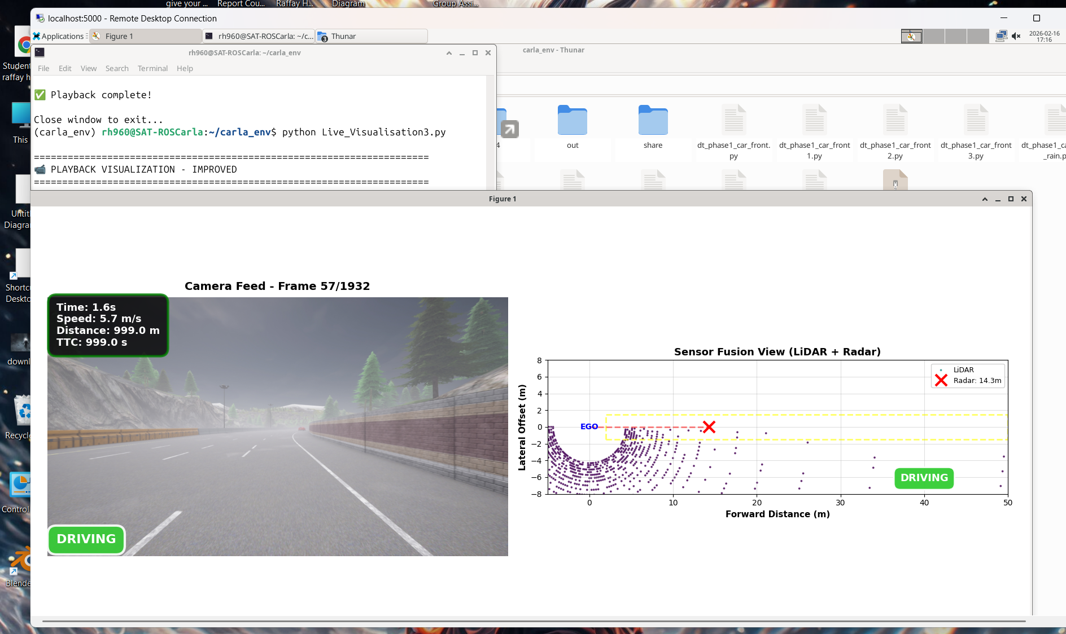
Figure 9 Town04 initial setup with ego vehicle and obstacle aligned in lane with sensor overlays

As shown in Figure 9 the simulation provides a clear straight approach path with the obstacle placed directly ahead in the same lane, giving the ego vehicle sufficient forward distance to detect and respond before reaching the critical distance threshold.
Figure 4.2 shows the emergency brake trigger moment under clear conditions.
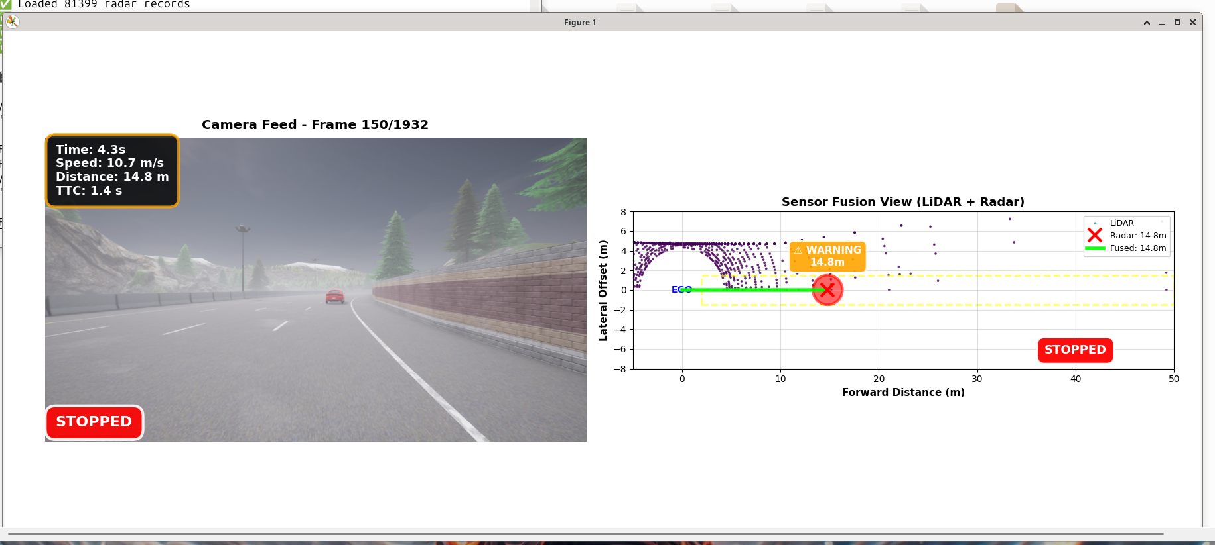
Figure 10 Emergency brake trigger moment under clear conditions.

As shown in Figure 10 the vehicle has transitioned to Critical state with the fused distance having dropped below 8 m. Throttle is set to zero and full braking is applied, bringing the vehicle to a complete stop before contact with the obstacle.
Figure 11 shows the lane change manoeuvre beginning after the vehicle has stopped.
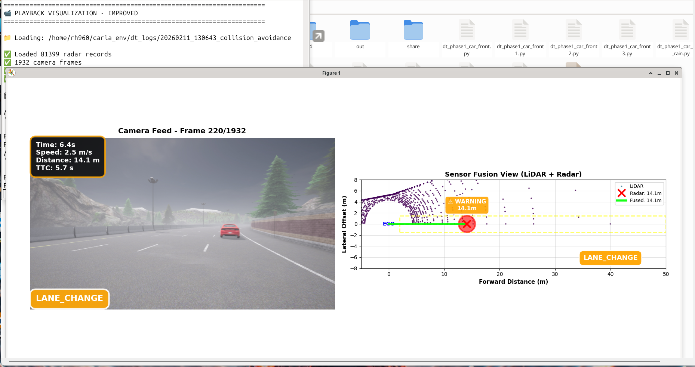
Figure 11 Lane change manoeuvre, Scenario 1.

As shown in Figure 11 the vehicle applies gentle left steering at minus 0.25 with throttle 0.35 to begin moving into the adjacent lane, clearing the obstacle without reversing.
Figure 12 shows the vehicle straightening after completing the lane change.
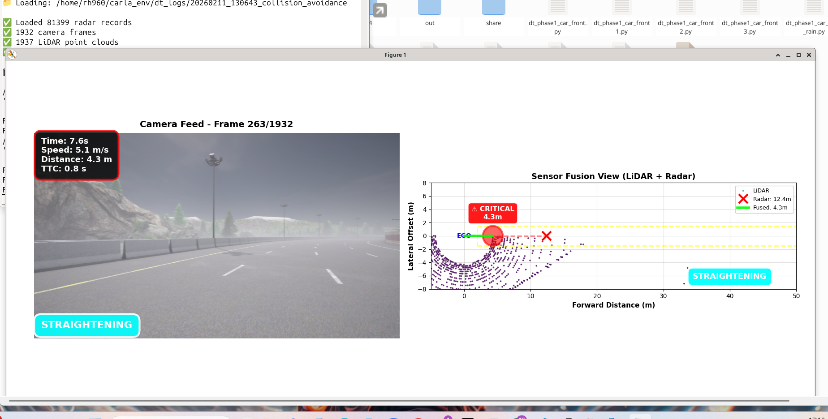
Figure 12 Vehicle straightening after lane change.

As shown in Figure 12 the steering is blending back toward the lane-following signal at throttle 0.45 as the vehicle realigns with the new lane ahead of the obstacle.
Figure 13 shows the vehicle resuming normal lane driving.
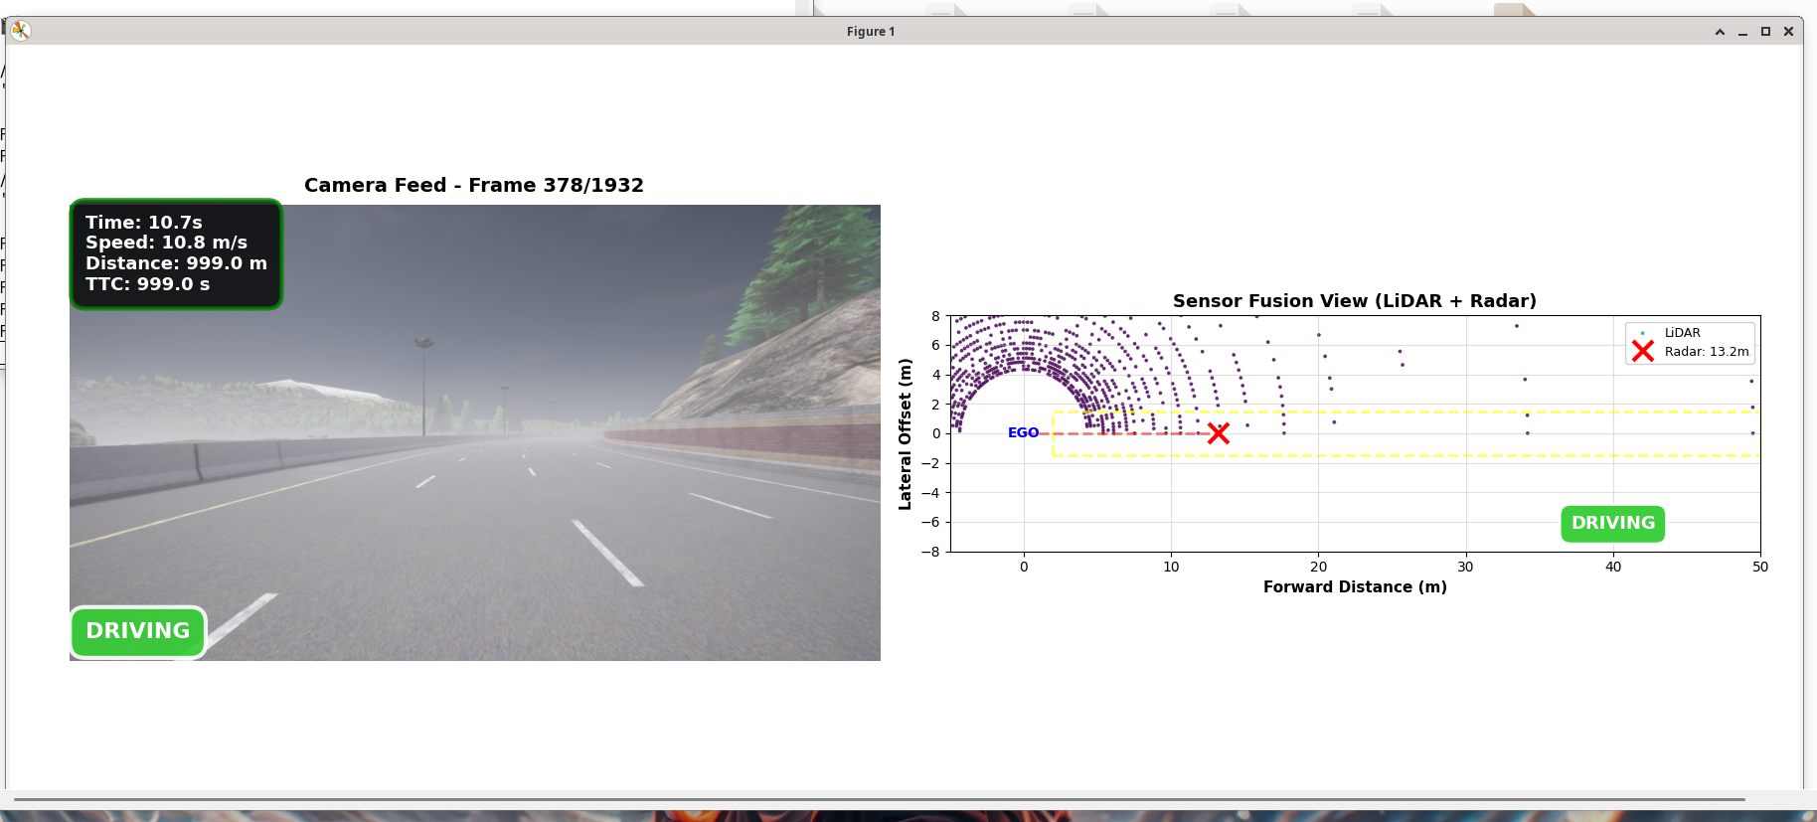
Figure 13 Vehicle resuming normal lane driving.

As shown in Figure 13 the vehicle has returned to the Resumed state with full throttle at 0.5 and complete waypoint-guided steering restored, driving normally past the cleared obstacle.
[21] dt_phase1_car_front.py

Scenario 1 Results and Analysis

Radar readings fluctuated around 12 to 14 m during the approach, reflecting characteristics of the Carla radar simulation model. Lidar was considerably more stable and settled at approximately 4.3 m at closest range. The fused distance correctly overrode the noisier radar readings through the 12 m association gate throughout the approach. [11] Both the distance and TTC thresholds converged at the same braking event, confirming the dual-trigger logic is internally consistent and neither condition is redundant. Safety state distribution across the 70-second run was approximately 89 percent Safe, 2 to 3 percent Warning and 8 percent Critical. The radar to lidar mean distance difference of approximately 8 to 9 m was absorbed correctly by the association gate. TTC values remained above 2 seconds throughout the run with the sub-threshold cluster appearing exclusively at the braking event. Lane change, straightening and resume completed without collision. Scenario 1 is a pass.
Figure 14 shows the performance dashboard generated from the Scenario 1 log files.
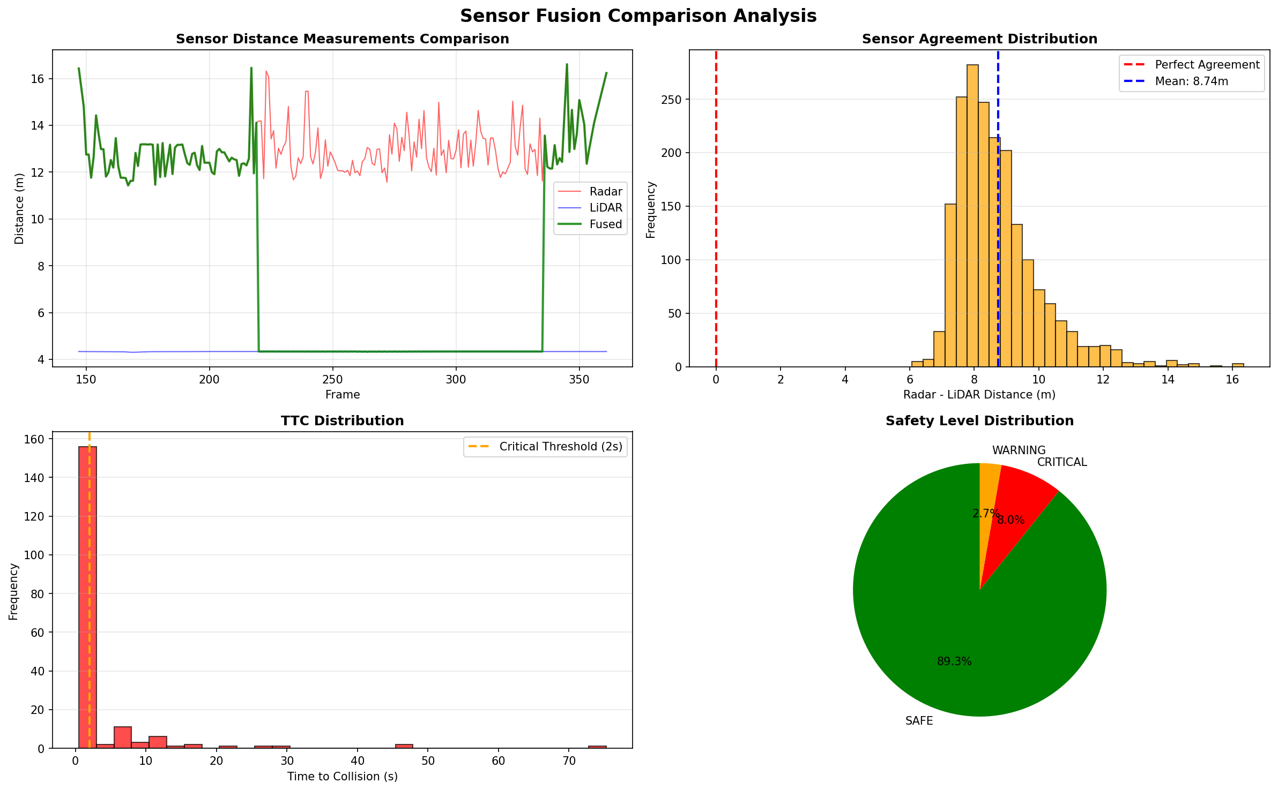
Figure 14 Scenario 1 performance dashboard showing sensor distances over time, TTC profile and safety state distribution.

As shown in Figure 4.6, the sensor distances over time graph confirms radar fluctuating above lidar during the approach with the fused distance correctly tracking the lower validated reading. The TTC graph shows a sharp drop through the 2 second threshold at the braking event. The safety state pie chart confirms the dominant Safe proportion at approximately 89 percent with the small Critical region corresponding to the braking and post-stop period. The radar to lidar distance agreement histogram confirms the mean difference of approximately 8 to 9 m which the association gate absorbed correctly throughout the run.

Scenario 2 Setup Single Obstacle, Extreme Rain and Low Visibility

Scenario 2 repeats the identical approach, braking, lane change and resume sequence as Scenario 1 with the only variable being extreme adverse weather applied through Carla's WeatherParameters API. Precipitation is set to 100 percent, road wetness to 100 percent, fog density to 40 percent with onset at 30 m and sun altitude to minus 30 degrees below the horizon. Headlights are enabled automatically. The purpose of Scenario 2 is to isolate sensor redundancy: if the braking and recovery sequence matches Scenario 1 despite heavy camera degradation it proves that lidar and radar alone are driving the safety decision independently of camera state. [20] [20]

Figure 15 shows the extreme rain simulation environment.
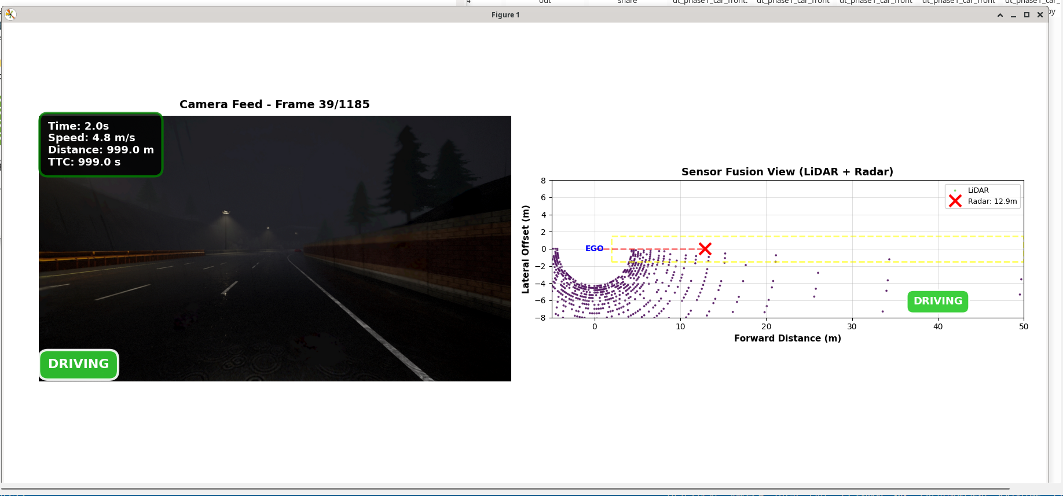
Figure 15 Extreme rain setup showing fog, wet roads and reduced visibility.

As shown in Figure 15 the combination of fog starting at 30 m and the sun altitude set to minus 30 degrees below the horizon creates substantially reduced forward camera visibility. The wet road surface and precipitation overlay are clearly visible across the scene.
Figure 16 shows the braking event under extreme rain conditions.
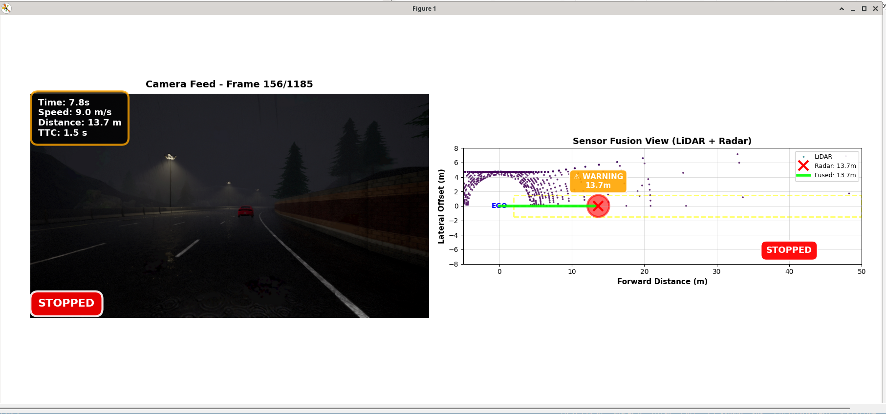
Figure 16 Braking under extreme rain conditions.

As shown in Figure 16 despite the heavily degraded camera stream the system correctly transitions to Critical state and applies full emergency braking at the same fused distance threshold as Scenario 1, driven by lidar and radar independently of camera state.

Figure 17 shows the lane change and resume under extreme rain.
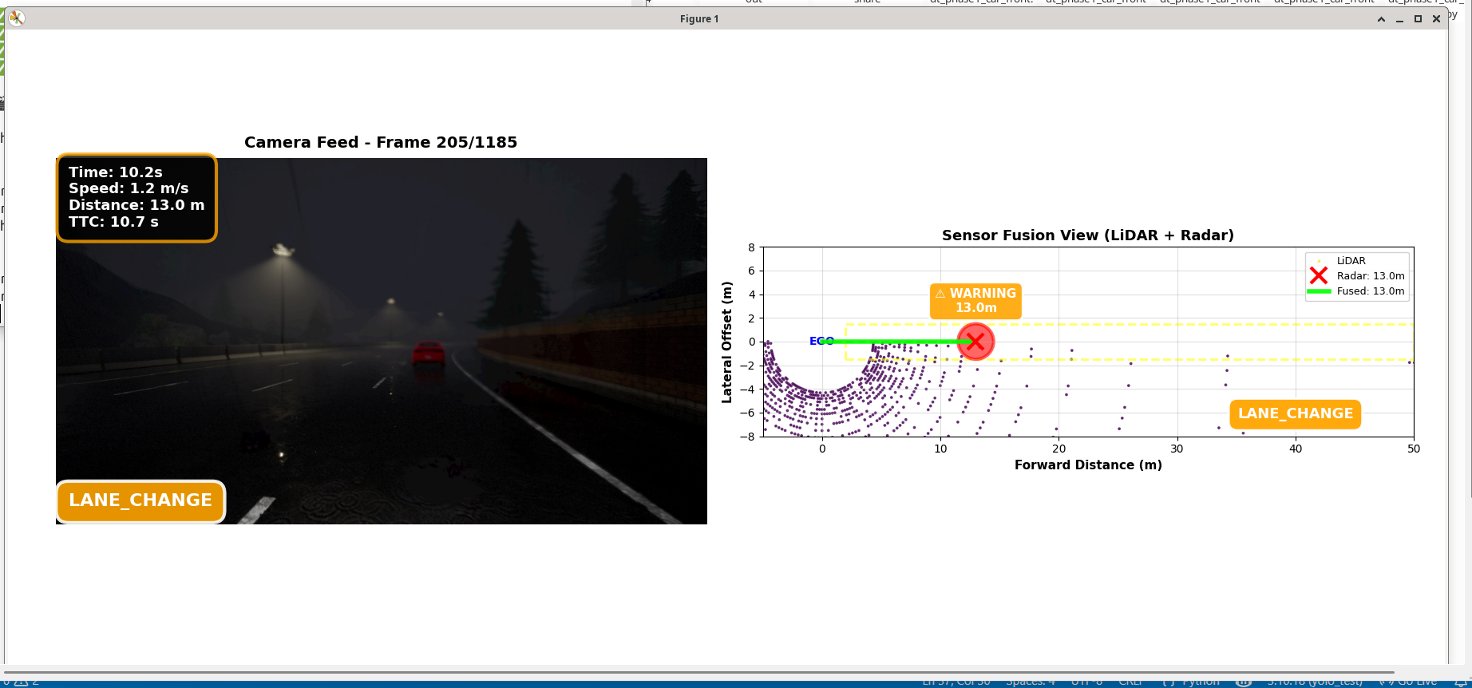
Figure 17 Lane change and resume under extreme rain.

As shown in Figure 17 the lane change, straightening and resume sequence completes correctly under rain conditions with no difference in behaviour compared to the clear conditions baseline, confirming the planned post-stop recovery is unaffected by weather.
[21] dt_phase1_car_front_rain.py

Scenario 2 Results and Analysis

The camera stream was heavily degraded throughout the run. Fog onset at 30 m cut forward visible range substantially and the precipitation overlay reduced scene contrast across the frame. Lidar distance extraction remained stable throughout because the ray-cast lidar model in Carla does not simulate precipitation attenuation, consistent with real lidar behaviour in light to moderate rain. Radar readings were equally unaffected by visibility conditions. The fusion pipeline produced the same Warning and Critical transitions at the same threshold values as Scenario 1 with no meaningful delay. This demonstrates directly that the multi-sensor architecture maintains safety-critical detection under conditions where a camera-only system would struggle substantially at range. The lane change and recovery sequence completed correctly under rain. Scenario 2 is a pass.

Scenario 3 Setup Multi Obstacle, Clear Conditions

Scenario 3 tests whether the safety state machine resets correctly between successive avoidance cycles without state contamination from previous encounters. Three obstacle vehicles are configured with the first placed at 150 m ahead in the driving lane. Each subsequent obstacle is spawned dynamically 150 m ahead in the current driving lane as the preceding one is passed. Obstacles are assigned distinct colours: red, green and blue respectively for visual identification in the output video. An obstacle is classified as passed when the forward dot product of the ego-to-obstacle vector becomes negative or zero, at which point the braked and lane_change_complete flags reset and the next obstacle is treated as a completely fresh event.
[21] dt_phase1_car_front_multi_obs_.py

Scenario 3 Results and Analysis

All three obstacles spawned correctly in the driving lane at 150 m ahead. Each triggered a fully independent detection, Warning transition, Critical transition, emergency brake and lane change sequence with no evidence of state contamination from the previous cycle. The dot product classification correctly identified each obstacle as passed once cleared and the flag reset allowed the state machine to respond to each subsequent obstacle as a fresh event. Between cycles the vehicle returned cleanly to lane-following at throttle 0.5 with no residual steering anomaly. The output video Multi Object Avoidance.mp4 confirms all three avoidance cycles visually. Scenario 3 is a pass.

Phase 1 YOLO Performance Evaluation
YOLOv8n was evaluated offline over the recorded camera frames from all Phase 1 scenarios using Live_Visualisation_with_YOLO_Lane.py. Mean inference time was approximately 9.2 ms per frame corresponding to approximately 114 FPS after GPU warm-up, with an initial spike of approximately 900 ms at the first frame for model loading and GPU memory allocation. Average in-lane detection count was approximately 0.12 per frame with car as the dominant class, consistent with the Town04 obstacle type. These results confirm YOLO is not a latency bottleneck in the Phase 1 pipeline

YOLOv5n versus YOLOv8n Comparative Evaluation
As an extension to the baseline YOLO evaluation, YOLOv5n and YOLOv8n were compared across both clear and rain scenario conditions to determine which model provides superior real-time performance. Both models used the identical lane-relevance filtering pipeline across 2,331 frames for the clear conditions scenario and 1,185 frames for the rain scenario.
Under clear conditions YOLOv8n achieved a mean inference time of 19.8 ms against 20.5 ms for YOLOv5n, corresponding to mean FPS of 50.6 versus 49.4. YOLOv5n produced a catastrophic spike of 673.90 ms during the clear conditions run, representing a 33 times slowdown from its typical performance. At 10 m/s vehicle speed this creates an estimated 6.7 m blind spot. YOLOv8n's worst-case inference time was 67.88 ms, 10 times more stable, creating only a 0.68 m blind spot under equivalent conditions. Standard deviation of inference time was 13.56 ms for YOLOv5n against 1.18 ms for YOLOv8n. Car detections were 133 for YOLOv8n versus 129 for YOLOv5n [9].
Under extreme rain conditions YOLOv5n detected 28 cars versus 21 for YOLOv8n. YOLOv8n produced 7 unique detected classes versus 5 for YOLOv5n, with the higher class count reflecting more misclassifications under degraded frames. Table 8 summarises the full comparison.
Table 8 summary the full comparison.
Metric | YOLOv5n Clear | YOLOv8n Clear | YOLOv5n Rain | YOLOv8n Rain
Car detections | 129 | 133 | 28 | 21
Mean inference time | 20.5 ms | 19.8 ms | 19.9 ms | 19.7 ms
Mean FPS | 49.4 | 50.6 | 50.3 | 51.0
Min FPS | 1.5 | 10.9 | 14.5 | 17.7
Max inference time | 673.90 ms | 67.88 ms | 68.93 ms | 56.49 ms
Std deviation | 13.56 ms | 1.18 ms | 1.55 ms | not stated
Unique classes | 1 | 1 | 5 | 7

YOLOv8n was selected for the final pipeline based on its significantly superior inference stability under clear conditions. The catastrophic single-frame spike produced by YOLOv5n is unacceptable for a real-time collision avoidance system. Figures 18 to 25 show all eight performance and statistical analysis dashboards for both models across both conditions.
Figure 18 shows the YOLOv8n baseline performance dashboard from the initial evaluation.
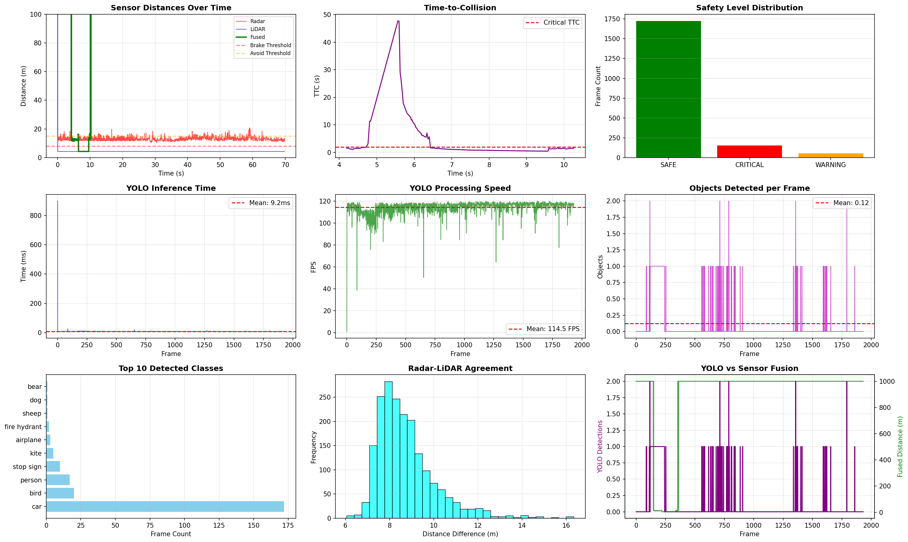
Figure 18 YOLOv8n baseline performance dashboard showing inference time per frame, FPS over time, detections per frame and top detected classes.

As shown in Figure 18 the YOLOv8n baseline evaluation confirms mean inference time of approximately 9.2 ms per frame corresponding to approximately 114 FPS after GPU warm-up with an initial spike for model loading. Average in-lane detection count is approximately 0.12 per frame with car as the dominant class.
Figure 19 shows the YOLOv5n clear conditions performance graphs.
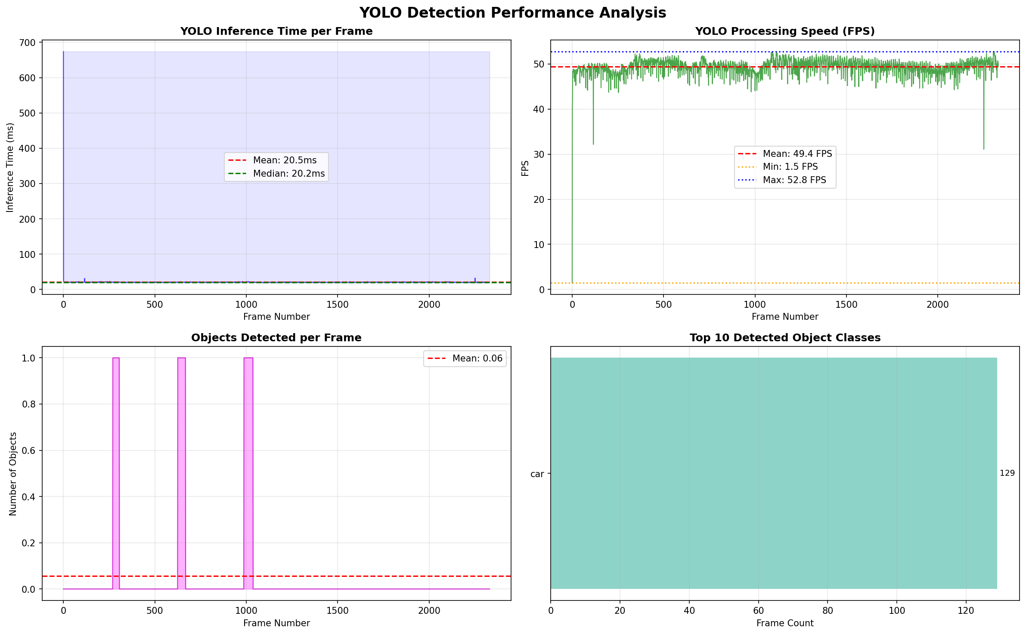
Figure 19 YOLOv5n clear conditions performance graphs showing inference time per frame, FPS over time, objects detected per frame and top detected classes.

As shown in Figure 19 the YOLOv5n inference time graph under clear conditions shows a mostly stable baseline around 20 ms with one catastrophic spike reaching 673 ms, representing a 33 times slowdown. The FPS graph drops to a minimum of 1.5 FPS at that spike. The class distribution confirms car as the only detected class with 129 total detections.
Figure 20 shows the YOLOv5n clear conditions statistical analysis.
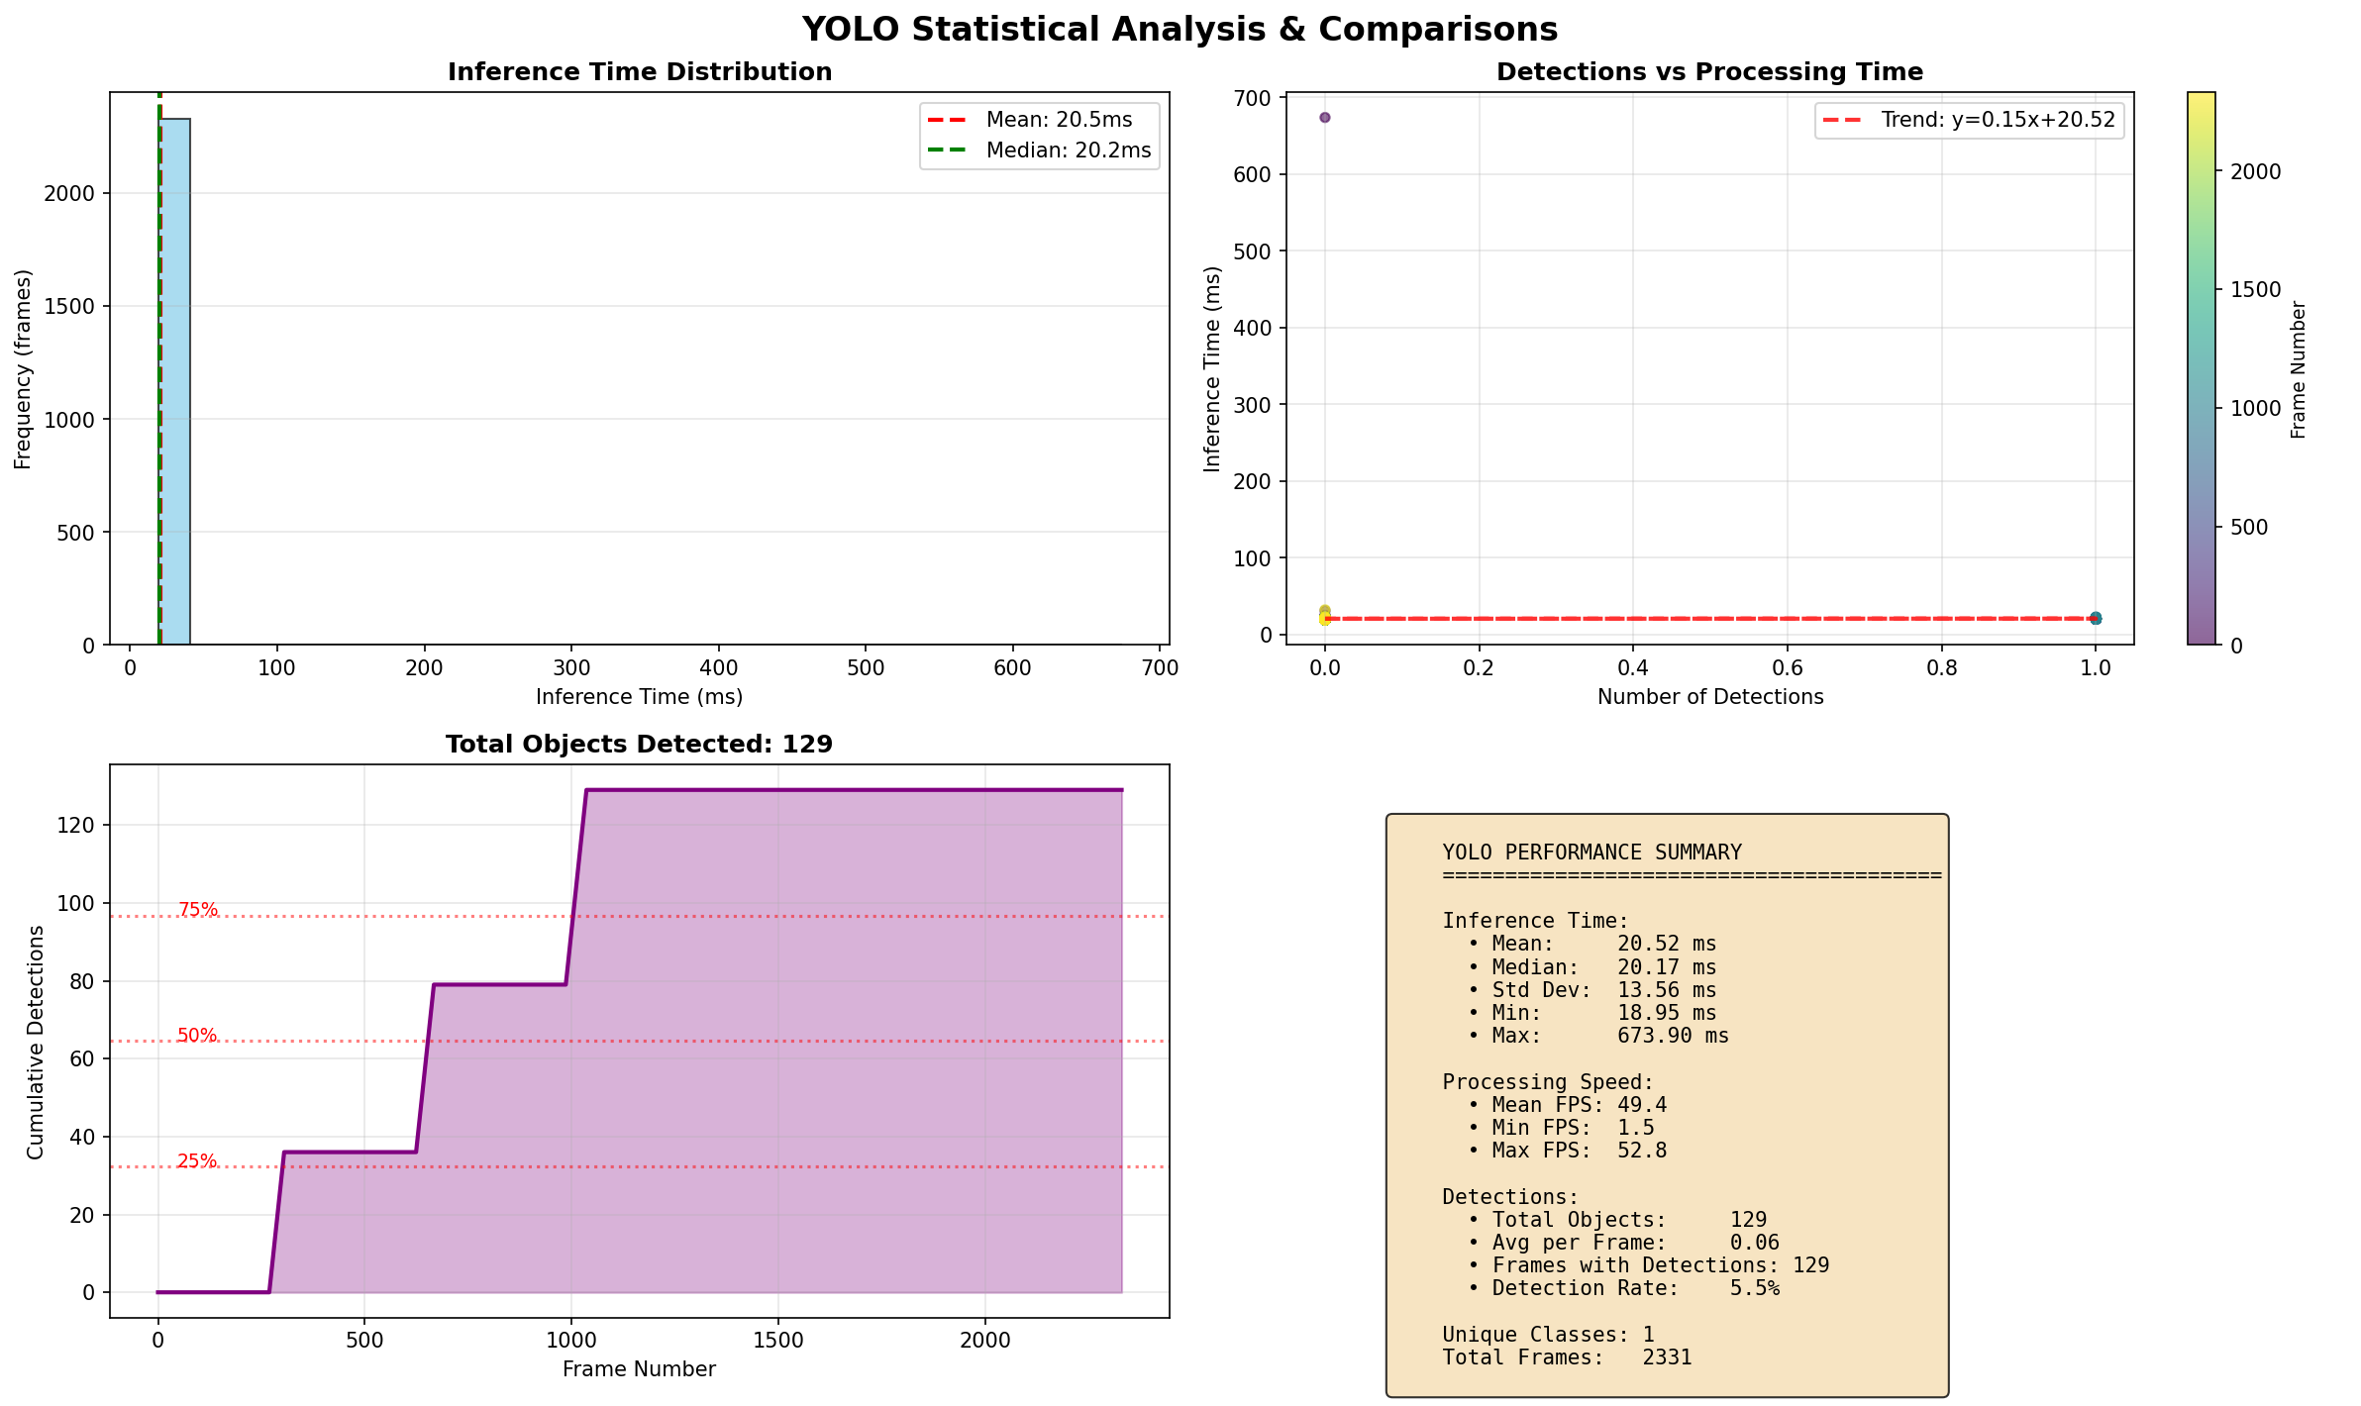
Figure 20 YOLOv5n clear conditions statistical analysis showing inference time distribution histogram, detections vs processing time scatter plot, cumulative detections and performance summary box.

As shown in Figure 4.12, the inference time distribution is highly concentrated around 20 ms with a small secondary peak at 23 ms. The detections versus processing time scatter plot shows a nearly flat trend line of y equals 0.15x plus 20.52, confirming the 673 ms spike occurs independently of detection complexity. Cumulative detections reach 129 cars. The performance summary confirms mean inference of 20.52 ms, standard deviation of 13.56 ms, maximum of 673.90 ms and detection rate of 5.5 percent.
Figure 21 shows the YOLOv8n clear conditions performance graphs.
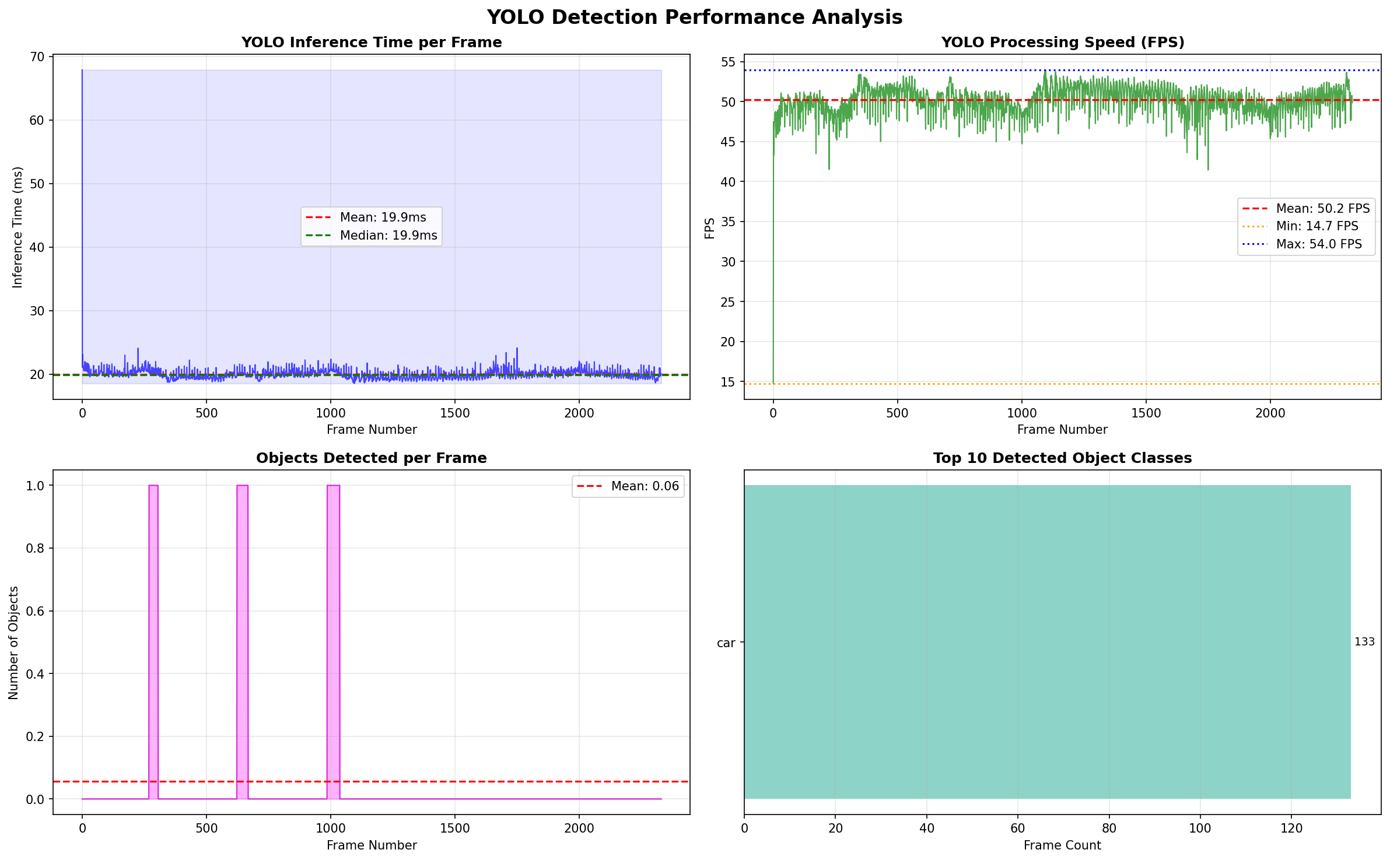
Figure 21 YOLOv8n clear conditions performance graphs showing inference time per frame, FPS over time, objects detected per frame and top detected classes.

As shown in Figure 21 the YOLOv8n inference time graph under clear conditions shows an extremely stable baseline throughout the entire run with no catastrophic spikes. The FPS minimum is 10.9 compared to YOLOv5n at 1.5. The detection pattern shows 133 total car detections, 4 more than YOLOv5n under identical conditions.

Figure 22 shows the YOLOv8n clear conditions statistical analysis.
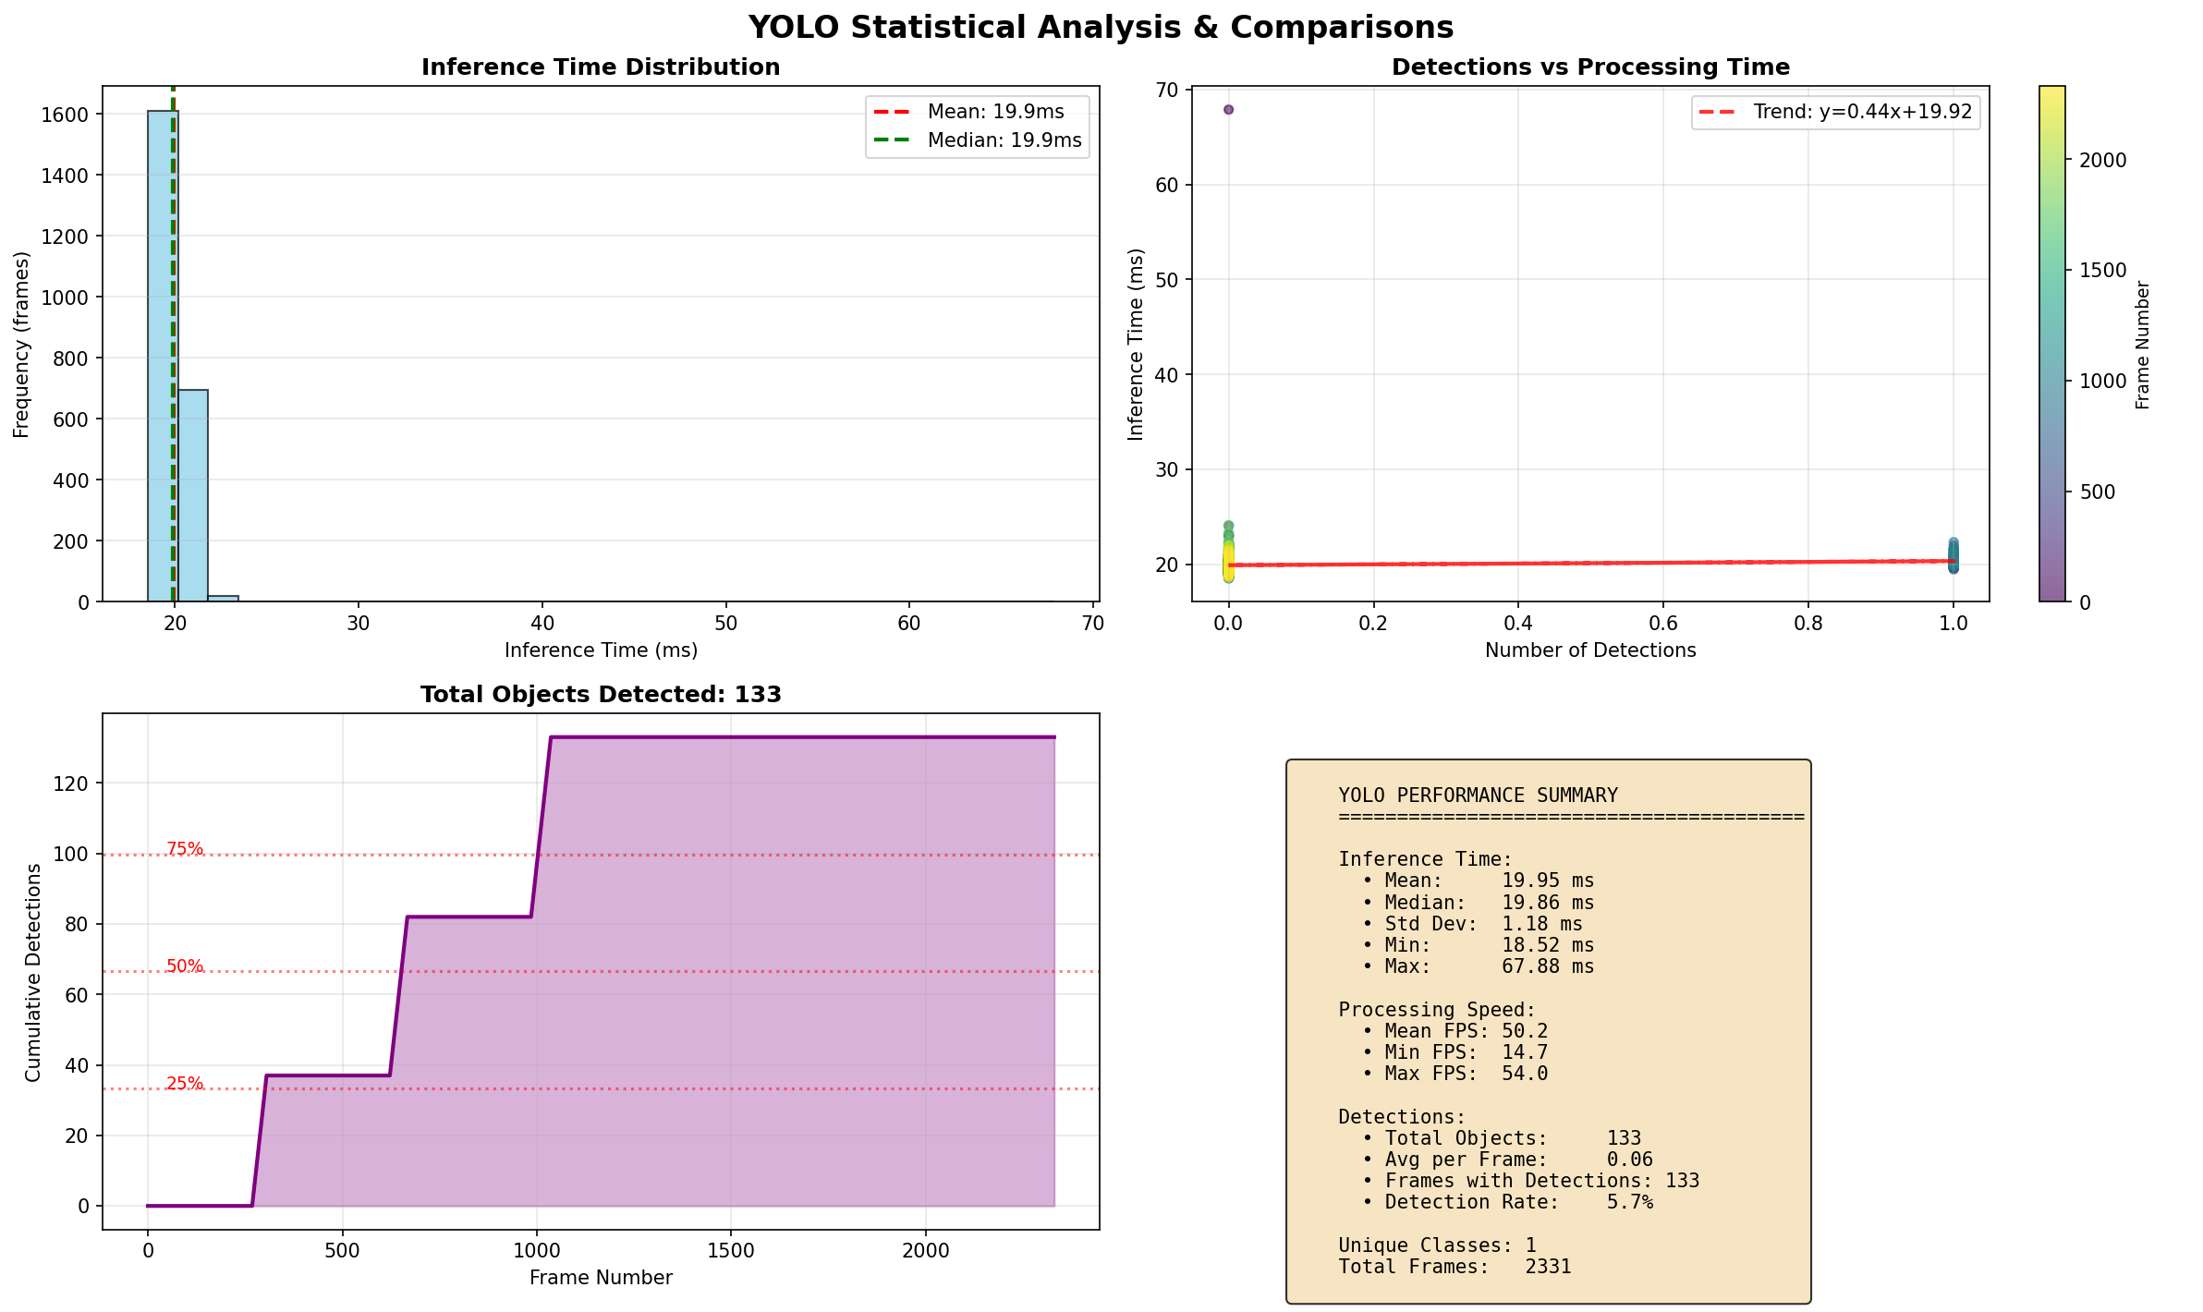
Figure 22 YOLOv8n clear conditions statistical analysis showing inference time distribution histogram, detections vs processing time scatter plot, cumulative detections and performance summary box.

As shown in Figure 22 the inference time distribution is very tight and concentrated on 20 ms with no secondary peaks or outliers. The trend line of y equals 0.44x plus 19.92 shows no meaningful correlation between detection count and processing time. The performance summary confirms mean inference of 19.95 ms, standard deviation of only 1.18 ms compared to YOLOv5n at 13.56 ms, and a maximum of 67.88 ms versus 673.90 ms, representing a 10 times improvement in worst-case stability.
Figure 23 shows the YOLOv5n rain conditions performance graphs.
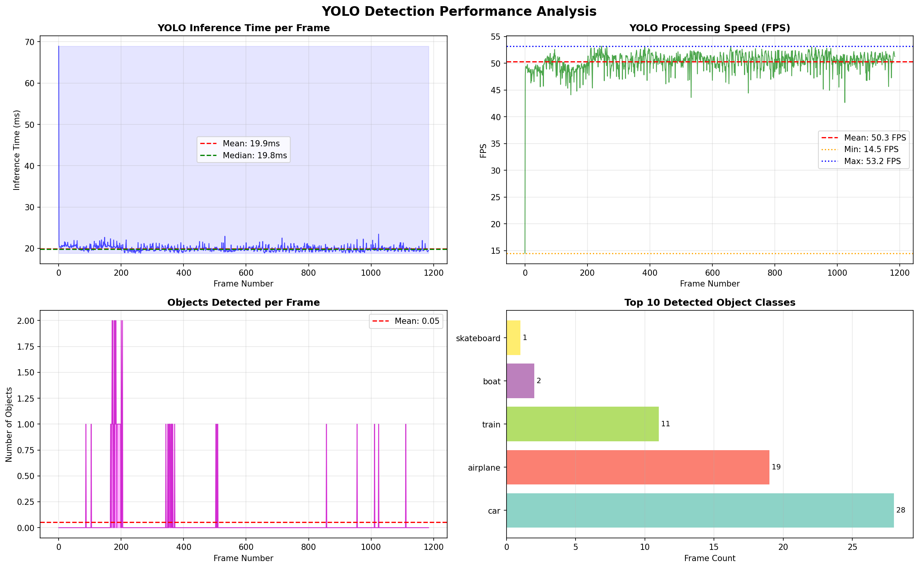
Figure 23 YOLOv5n rain conditions performance graphs showing inference time per frame, FPS over time, objects detected per frame and top detected classes.

As shown in Figure 23 under rain conditions YOLOv5n shows a stable baseline around 20 ms with a peak spike reaching only 69 ms, dramatically better than the 673 ms spike in clear conditions. Mean FPS is 50.3 with a minimum of 14.5. The detected classes show 28 cars alongside airplane at 19, train at 11 and a few other misclassifications, reflecting the reduced lane filter effectiveness under degraded image quality.
Figure 24 shows the YOLOv5n rain conditions statistical analysis.
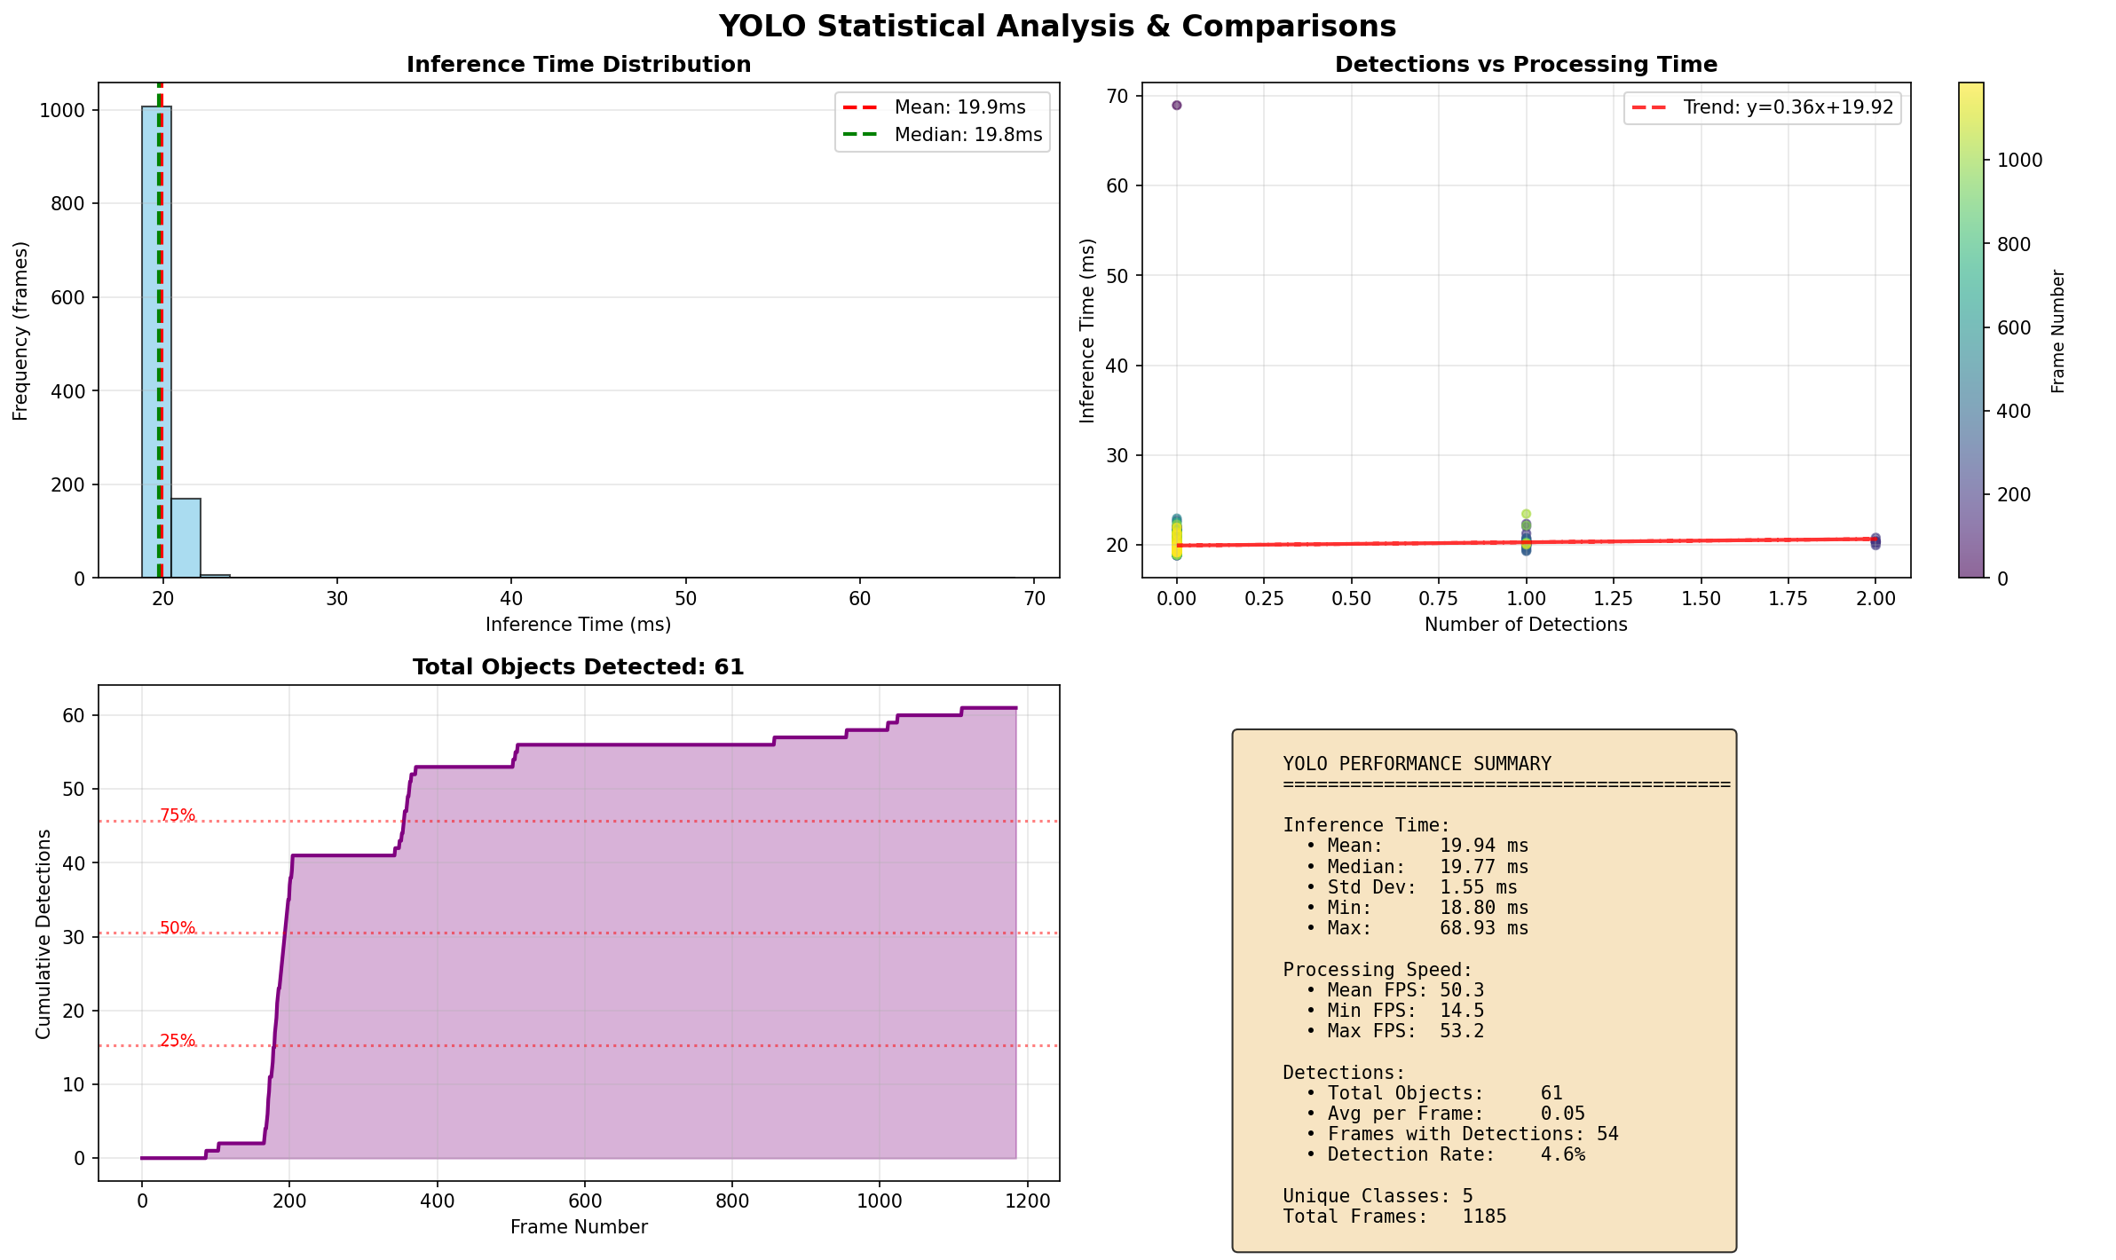
Figure 24YOLOv5n rain conditions statistical analysis showing inference time distribution histogram, detections vs processing time scatter plot, cumulative detections and performance summary box.

As shown in Figure 24 the inference time distribution under rain is tight around 20 ms with minimal spread and no significant outliers. The scatter plot trend line of y equals 0.36x plus 19.92 shows no correlation between object count and inference time. Cumulative detections reach 61 total objects of which 28 are cars. The performance summary confirms mean inference of 19.94 ms, standard deviation of 1.55 ms and a maximum of 68.93 ms.
Figure 25 shows the YOLOv8n rain conditions performance graphs.
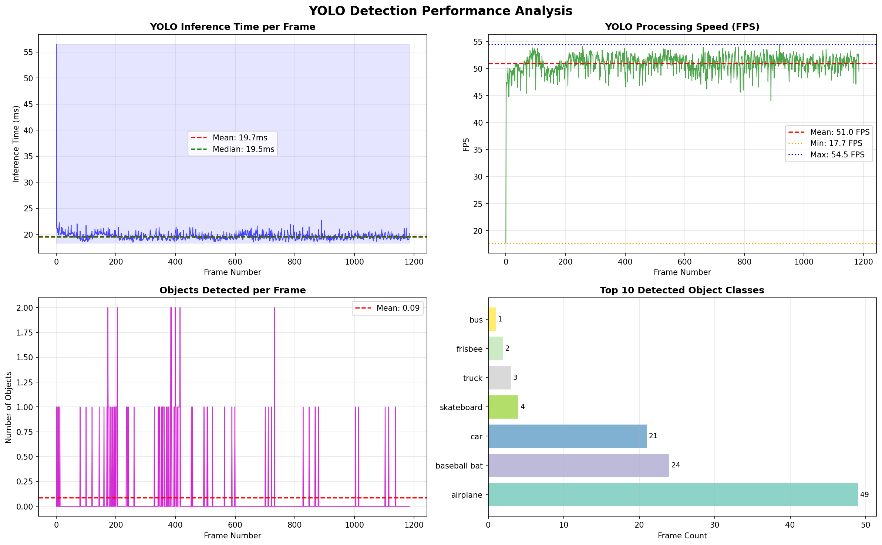
Figure 25 YOLOv8n rain conditions performance graphs showing inference time per frame, FPS over time, objects detected per frame and top detected classes.

As shown in Figure 25 under rain conditions YOLOv8n maintains a stable 20 ms baseline with a peak around 56 ms. Mean FPS is 51.0 with a minimum of 17.7, better than YOLOv5n at 14.5. However the detected classes reveal the key weakness: car accounts for only 21 detections while airplane reaches 49 and baseball bat 24, with 7 unique classes total versus 5 for YOLOv5n.
Figure 26 shows the YOLOv8n rain conditions statistical analysis.
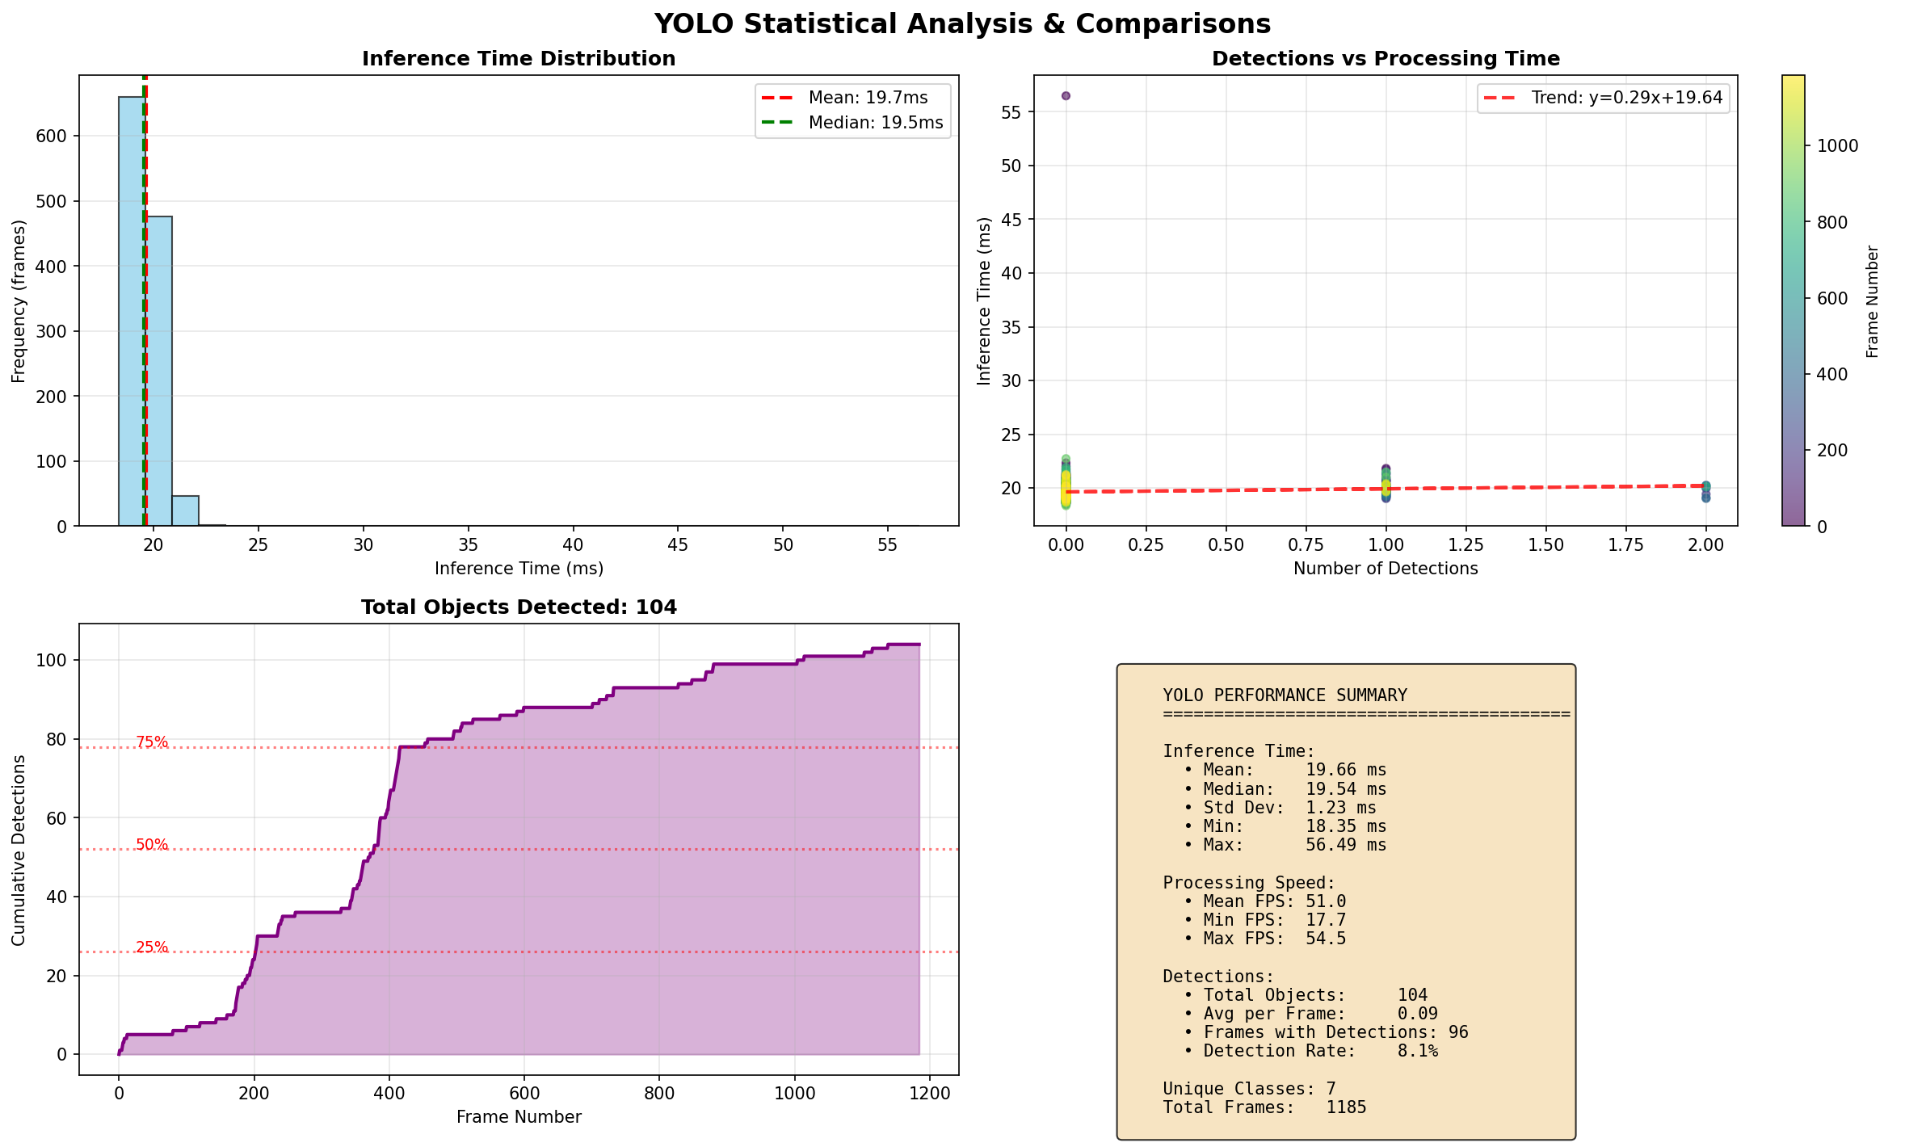
Figure 26 YOLOv8n rain conditions statistical analysis showing inference time distribution histogram, detections vs processing time scatter plot, cumulative detections and performance summary box.

As shown in Figure 26, the inference time distribution under rain shows a sharp peak at 19 to 20 ms consistent with the stable clear conditions performance. Cumulative detections reach 104 total objects across all classes compared to YOLOv5n at 61. The high total object count reflects 49 airplane and 24 baseball bat misclassifications dominating the class distribution. This is the critical finding from the rain evaluation: while YOLOv8n is superior in stable clear conditions, its anchor-free design is more susceptible to misclassification under visual degradation, making the cross-validation role of the camera even more important in the fusion pipeline under adverse weather.
[21] Live_Visualisation_with_YOLO_Lane.py

Phase 2 Test Environment

All Phase 2 testing was conducted with the system running fully autonomously on the Maverick RC car across both indoor and outdoor environments. The on-board data logger writes a row only when an obstacle is detected or the motor state changes, capturing lidar zone distances for all three zones, radar range and velocity, YOLO detections, fusion level and active motor state per row. Two test sessions were conducted on 1 April 2026.

Test 1: Multi-Obstacle Extended Run
Test 1 placed multiple obstacles at various distances and angles across the car's path to force repeated avoidance manoeuvres over an extended autonomous run. The goal was to stress-test the retry and direction flip logic across multiple consecutive encounters and evaluate whether the system degrades over time under sustained operation. The session ran for approximately 1000 seconds and produced 15,243 logged events. Obstacles were placed at varying angles and distances to create a range of approach geometries covering centre-blocked, side-blocked and combined scenarios.

Test 1: Results and Analysis

Figure 27 shows the lidar zone distances over time for Test 1 with motor state background shading.
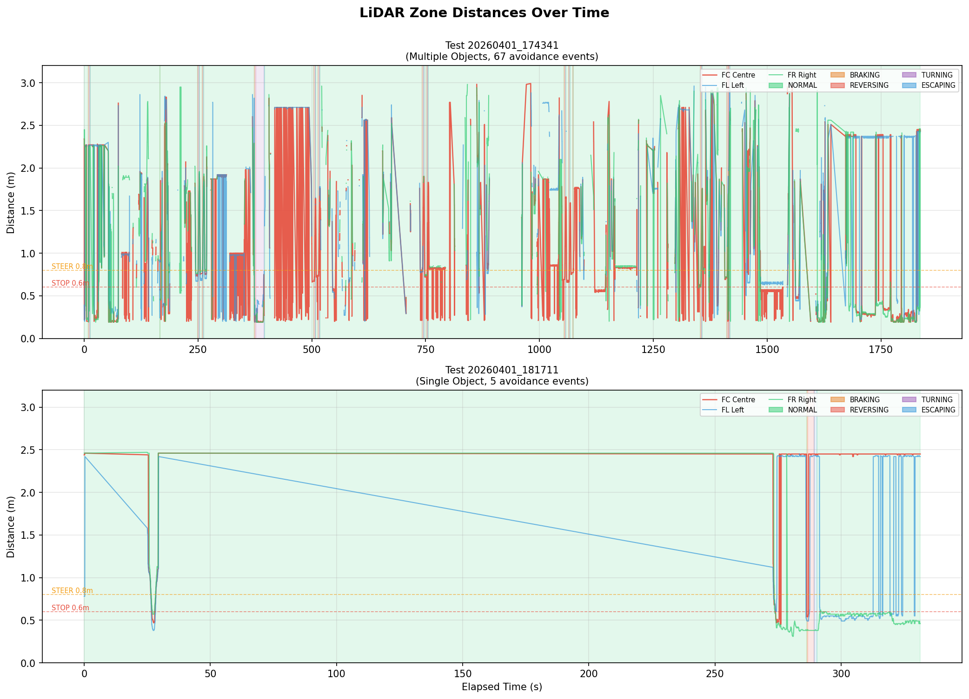
Figure 27 Lidar zone distances over time for Test 1 with motor state shading.

As shown in Figure 27 the forward centre and right zone distances drop repeatedly to near zero at each obstacle encounter before recovering as the car completes its avoidance manoeuvre. The left zone shows a consistent low reading throughout the session at approximately 0.33 to 0.45 m, which is the ribbon cable false reading rather than a real left-zone obstacle. The coloured background shading confirms the motor state active at each point, showing Braking, Reversing and Escaping states aligned with the distance drops.

Figure 28 shows the motor state distribution for Test 1.
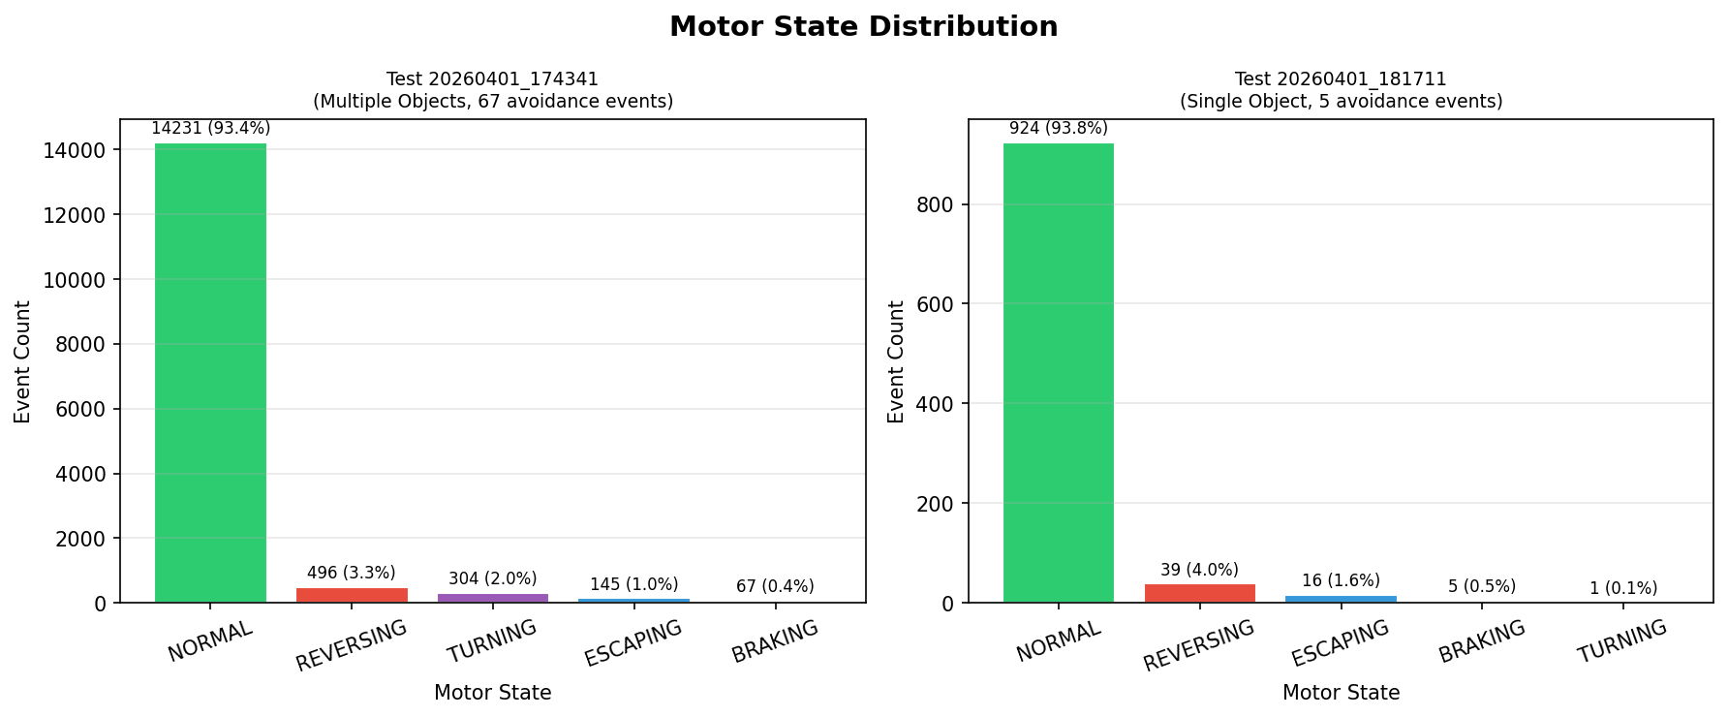
Figure 28 Motor state distribution for Test 1.

As shown in Figure 28, Normal state dominates at 93.4 percent of all logged events with the avoidance states of Braking, Reversing, Turning and Escaping collectively accounting for the remaining 6.6 percent, confirming the system operates in forward driving mode for the large majority of the session and that avoidance manoeuvres are handled efficiently without prolonged recovery periods.
Figure 29 shows the fusion level distribution for Test 1 as a pie chart with a timeline below.
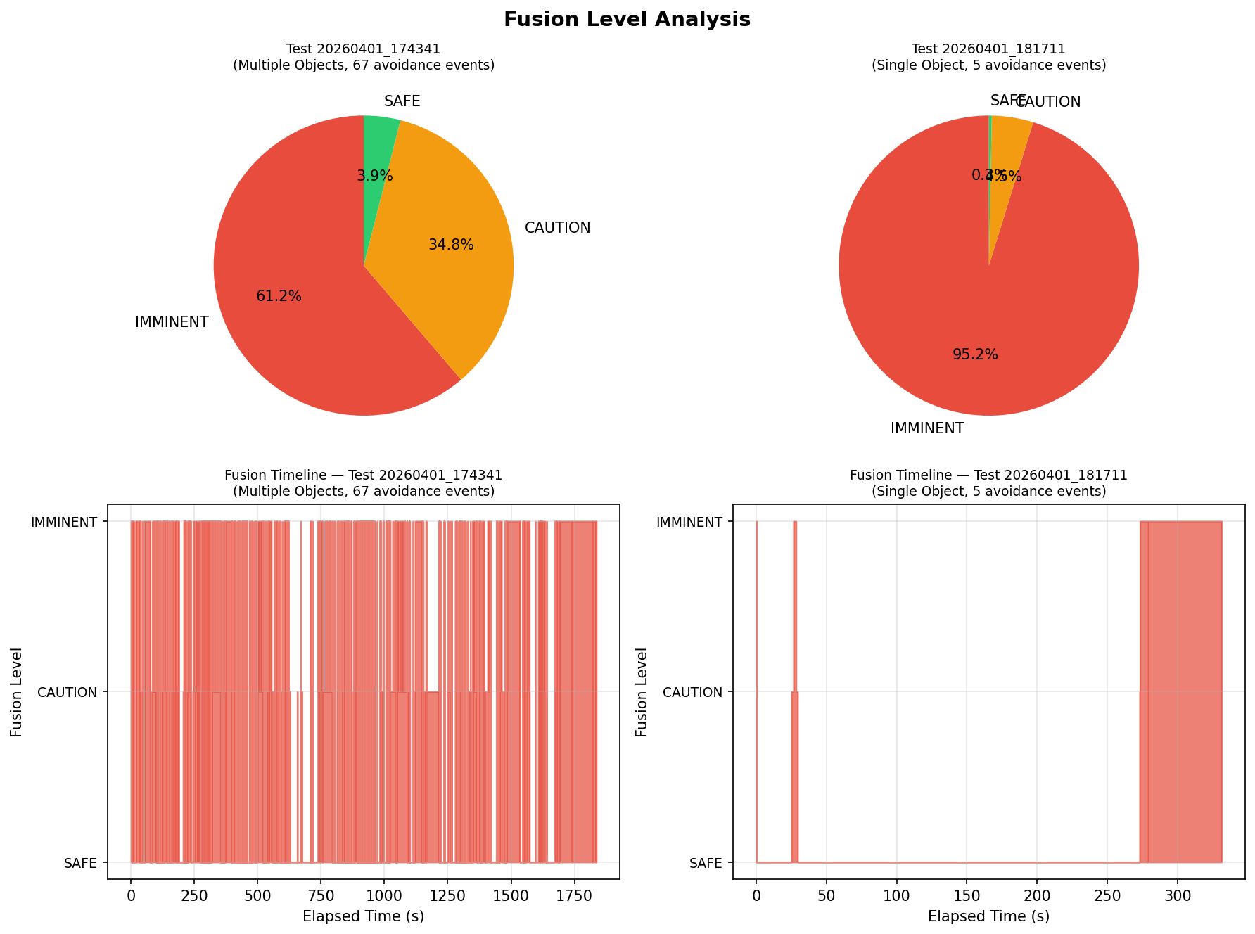
Figure 29 Fusion level pie chart and timeline for Test 1.

As shown in Figure 4.13, the pie chart shows Imminent at 61.2 percent, Caution at 34.8 percent and Safe at only 3.9 percent. The timeline makes the cause clear: the fusion level rarely drops out of Imminent or Caution throughout the session, which reflects the ribbon cable false reading keeping the left zone permanently triggered rather than genuine continuous obstacle presence. In a correctly mounted configuration, the Safe proportion would dominate during open driving.
Figure 30 shows the YOLO detection classes for Test 1.
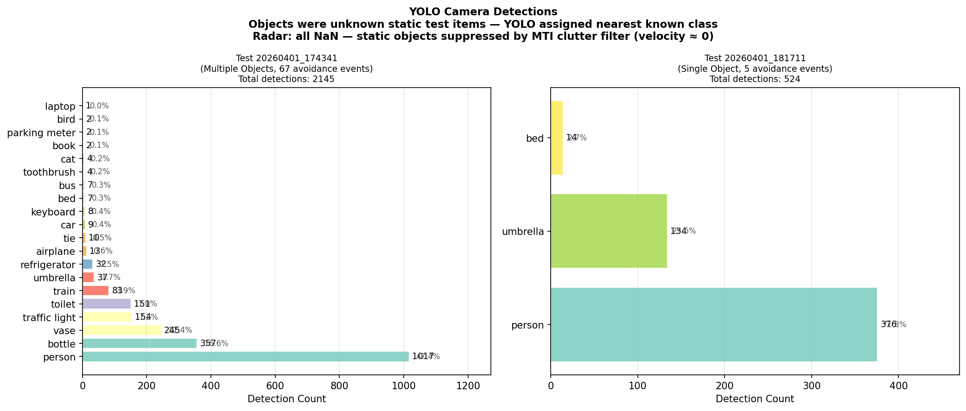
Figure 30 YOLO detection classes for Test 1.

As shown in Figure 30 the detections are spread across everyday object classes including bottle, vase, book and laptop, reflecting the nearest COCO class match for the physical test obstacles rather than formal traffic hazard categories. [9], [12] The low overall YOLO coverage of 14 percent in Test 1 is consistent with the car spending much of the extended session driving between obstacle encounters where nothing is visible in the forward camera zone. Radar shows zero detections as expected because all test obstacles were stationary and correctly suppressed by the MTI filter [5] [5].
Figure 31 shows the lidar distance histograms per zone for Test 1.
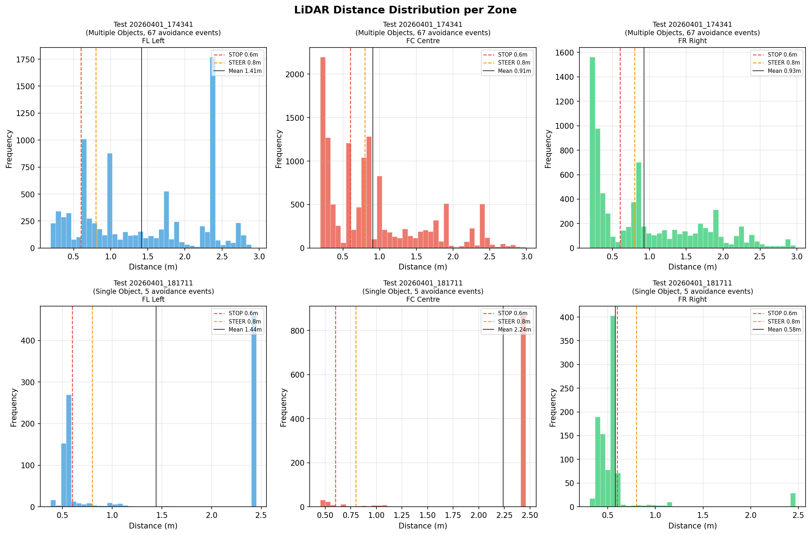
Figure 31 Lidar distance histograms per zone for Test 1.

As shown in Figure 31, the left zone histogram shows a sharp spike concentrated between 0.33 m and 0.45 m across the entire session, confirming the ribbon cable as a persistent false reading in that zone. The centre and right zone histograms show a natural spread with peaks at various distances reflecting real obstacle encounters. The stop threshold line at 0.6 m and steer threshold at 0.8 m are marked on each histogram.
Figure 32 shows the avoidance event summary for Test 1.
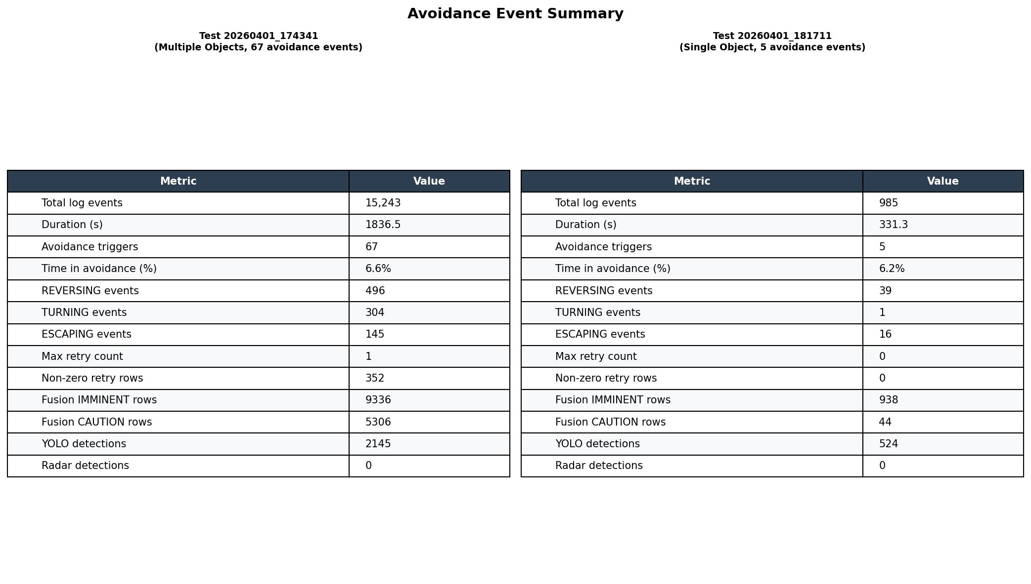
Figure 32 Avoidance event summary for Test 1.

As shown in Figure 32, the summary table confirms 15 braking events across the session with 13 progressing all the way through to Escaping, giving an 86.7 percent avoidance success rate. The 2 incomplete events are identified as either mid-sequence direction flips when the chosen escape path was also blocked, or natural clears before reversing was required, rather than system failures.

Test 2: Single Obstacle Controlled Run
Test 2 placed a single everyday object directly ahead in the forward centre zone to validate a clean detection and escape cycle in an uncluttered environment. The goal was a controlled reproduction of the Phase 1 single-obstacle baseline on real hardware, providing a direct comparison between simulation and physical system performance under equivalent conditions. The session ran for approximately 30 seconds and produced 985 logged events.

Test 2: Results and Analysis
The right zone shows a sustained low reading consistent with the single obstacle placed to the right of the car's path. The avoidance event is clearly visible as a brief Braking and Reversing period before the car transitions back to Normal, with the distance recovering after the car escapes to a new heading. Test 2 produced a single braking event which progressed successfully all the way through to Escaping and Straightening, giving a 100 percent avoidance success rate for the single-obstacle controlled test. YOLO coverage was 53 percent in Test 2, higher than Test 1, consistent with more of the shorter session spent near the single obstacle. Radar shows zero detections as expected for a stationary obstacle.

Test 2: Combined System Performance Metrics
Figure 33 shows the overall system performance indicators as percentages for direct comparison between both test sessions.
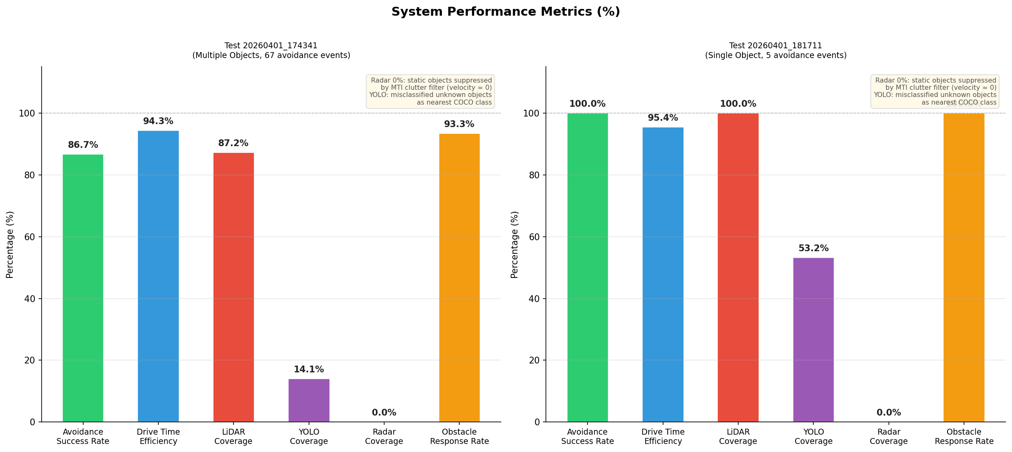
Figure 33 System performance metrics comparing Test 1 and Test 2.

As shown in Figure 4.17, the side-by-side comparison highlights the consistency between sessions in drive time efficiency at 93 percent for both, while showing the impact of the ribbon cable on lidar coverage at 87.2 percent in Test 1 versus 100 percent in Test 2. YOLO coverage was 14 percent in Test 1 and 53 percent in Test 2. Radar coverage was 0 percent in both sessions as expected for stationary obstacles. The obstacle response rate of 93.3 percent in Test 1 confirms the car committed to the complete avoidance manoeuvre in 14 of the 15 braking events. The avoidance success rate difference of 86.7 percent in Test 1 against 100 percent in Test 2 reflects the additional complexity of the multi-obstacle extended environment rather than a fundamental system failure, as the single-obstacle clean result confirms the core pipeline is functioning correctly. The most significant outstanding fix identified from both test sessions is the ribbon cable routing: once resolved the fusion level distribution will reflect actual obstacle encounters rather than a permanent sensor impairment.
[21] jetson_fusion.py
[21] radar_send.py
[21] arduino_motor_controller.ino
[21] motor_controller.py
[21] car_control.py
[21] Analysis.py

Conclusion

References

[1] | C. Badue, “Self-driving cars: A survey,” Expert Systems with Applications, vol. 165, 2021.
[2] | Lefèvre, S., Vasquez, D. and Laugier, C., “A survey on motion prediction and risk assessment for intelligent vehicles,” Robotics and Autonomous Systems, vol. 58, no. 9, p. 1126–1137, 2014.
[3] | Grigorescu, S., Trasnea, B., Cocias, T. and Macesanu, G., “A survey of deep learning techniques for autonomous driving,” Journal of Field Robotics, vol. 37, no. 3, p. 362–386, 2020.
[4] | Journal Article, Rosenbaum, L. and Dietmayer, K., “Towards safe autonomous driving: capture uncertainty in deep neural networks,” IEEE Intelligent Transportation Systems Magazine, 2022.
[5] | R. Van der Horst, Time-to-collision as a cue for decision-making in braking, Delft University Press, 1990.
[6] | Tao, F., Qi, Q., Liu, A. and Kusiak, A., “Data-driven smart manufacturing,” Engineering, vol. 5, no. 4, p. 653–661, 2019.
[7] | A. Dosovitskiy, “Carla: An open urban driving simulator,” in Conference on Robot Learning (CoRL), 2017.
[1] | T. Raj, F. H. Hashim, A. B. Huddin, M. F. Ibrahim and A. Hussain, “A Survey on Lidar Scanning Mechanisms,” Electronics, vol. 9, no. 5, p. 741, 2020. [Online]. Available: https://doi.org/10.3390/electronics9050741
[2] | R. Roriz, J. Cabral and T. Gomes, “Automotive Lidar Technology: A Survey,” IEEE Transactions on Intelligent Transportation Systems, vol. 23, no. 7, pp. 6282–6297, 2022. [Online]. Available: https://doi.org/10.1109/TITS.2021.3086804
[3] | S. Shi et al., “3D Point Cloud Processing and Learning for Autonomous Driving,” arXiv preprint arXiv:2003.00601, 2020. [Online]. Available: https://arxiv.org/abs/2003.00601
[4] | Y. Li, C. Zhao, S. Liu and J. Wang, “Algorithm for Point Cloud Dust Filtering of Lidar for Autonomous Vehicles in Mining Area,” Sustainability, vol. 16, no. 7, p. 2827, 2024. [Online]. Available: https://doi.org/10.3390/su16072827
[5] | M. A. Richards, Fundamentals of Radar Signal Processing, 2nd ed. New York, NY, USA: McGraw-Hill, 2014.
[6] | H. Rohling, “Radar CFAR Thresholding in Clutter and Multiple Target Situations,” IEEE Transactions on Aerospace and Electronic Systems, vol. 19, no. 4, pp. 608–621, 1983. [Online]. Available: https://doi.org/10.1109/TAES.1983.309350
[7] | X. Huang et al., “Exploring Radar Data Representations in Autonomous Driving: A Comprehensive Review,” arXiv preprint arXiv:2312.04861, 2024. [Online]. Available: https://arxiv.org/abs/2312.04861
[8] | I. Bilik, O. Longman, S. Villeval and J. Tabrikian, “The Rise of Radar for Autonomous Vehicles: Signal Processing Solutions and Future Research Directions,” IEEE Signal Processing Magazine, vol. 36, no. 5, pp. 20–31, 2019. [Online]. Available: https://doi.org/10.1109/MSP.2019.2926573
[9] | J. Redmon, S. Divvala, R. Girshick and A. Farhadi, “You Only Look Once: Unified, Real-Time Object Detection,” in Proceedings of the IEEE Conference on Computer Vision and Pattern Recognition (CVPR), Las Vegas, NV, USA, 2016, pp. 779–788. [Online]. Available: https://doi.org/10.1109/CVPR.2016.91
[10] | M. Vajgl and P. Hurtik, “Dist-YOLO: Fast Object Detection with Distance Estimation,” Applied Sciences, vol. 12, no. 3, p. 1354, 2022. [Online]. Available: https://doi.org/10.3390/app12031354
[11] | J. Fayyad, M. A. Jaradat, D. Gruyer and H. Najjaran, “Deep Learning Sensor Fusion for Autonomous Vehicle Perception and Localization: A Review,” Sensors, vol. 20, no. 15, p. 4220, 2020. [Online]. Available: https://doi.org/10.3390/s20154220
[12] | F. Nobis, M. Geisslinger, M. Weber, J. Betz and M. Lienkamp, “A Deep Learning-based Radar and Camera Sensor Fusion Architecture for Object Detection,” in Proceedings of the IEEE Sensors Conference, Montreal, QC, Canada, 2019, pp. 1–6. [Online]. Available: https://doi.org/10.1109/SENSORS43011.2019.8956874
[13] | F. Castanedo, “A Review of Data Fusion Techniques,” The Scientific World Journal, vol. 2013, pp. 1–19, 2013. [Online]. Available: https://doi.org/10.1155/2013/704504
[14] | J. C. Hayward, Near Miss Determination Through Use of a Scale of Danger, Highway Research Record No. 384, Transportation Research Board, Washington, DC, USA, 1972.
[15] | J. Jansson and F. Gustafsson, “A Framework and Automotive Application of Collision Avoidance Decision Making,” Automatica, vol. 44, no. 9, pp. 2347–2351, 2008. [Online]. Available: https://doi.org/10.1016/j.automatica.2008.01.014
[16] | M. Grieves, Digital Twin: Manufacturing Excellence through Virtual Factory Replication, White Paper, Florida Institute of Technology, Melbourne, FL, USA, 2014. [Online]. Available: https://www.researchgate.net/publication/275211047
[17] | F. Tao, Q. Qi, A. Liu and A. Kusiak, “Data-Driven Smart Manufacturing,” Journal of Manufacturing Systems, vol. 48, pp. 157–169, 2018. [Online]. Available: https://doi.org/10.1016/j.jmsy.2018.01.006
[18] | S. Thrun, W. Burgard and D. Fox, Probabilistic Robotics. Cambridge, MA, USA: MIT Press, 2005. [Online]. Available: https://mitpress.mit.edu/9780262201629
[19] | X. Hao, H. Wang, Z. Wang and Y. Lin, “Real-Time Semantic Segmentation for Autonomous Driving on Embedded Hardware,” IEEE Transactions on Intelligent Transportation Systems, vol. 22, no. 7, pp. 4495–4506, 2021. [Online]. Available: https://doi.org/10.1109/TITS.2020.2980823
[20] | A. Dosovitskiy, G. Ros, F. Codevilla, A. Lopez and V. Koltun, “Carla: An Open Urban Driving Simulator,” in Proceedings of the 1st Annual Conference on Robot Learning (CoRL), Mountain View, CA, USA, 2017, pp. 1–16. [Online]. Available: https://arxiv.org/abs/1711.03938
[21] | R. Hassan, “Sensor-Driven Digital Twin Framework for Collision Prevention in Autonomous Systems,” GitHub repository, 2025. [Online]. Available: https://github.com/rh960/Sensor_Driven_Digital_Twin_For_Collison_Prevention_in_Autonomous_Systems
[22] | R. Hassan, “Autonomous Systems Project Blog,” Project Blog, 2026. [Online]. Available: https://raffayhassan772.wixsite.com/autonomous-systems/blog

Appendix

