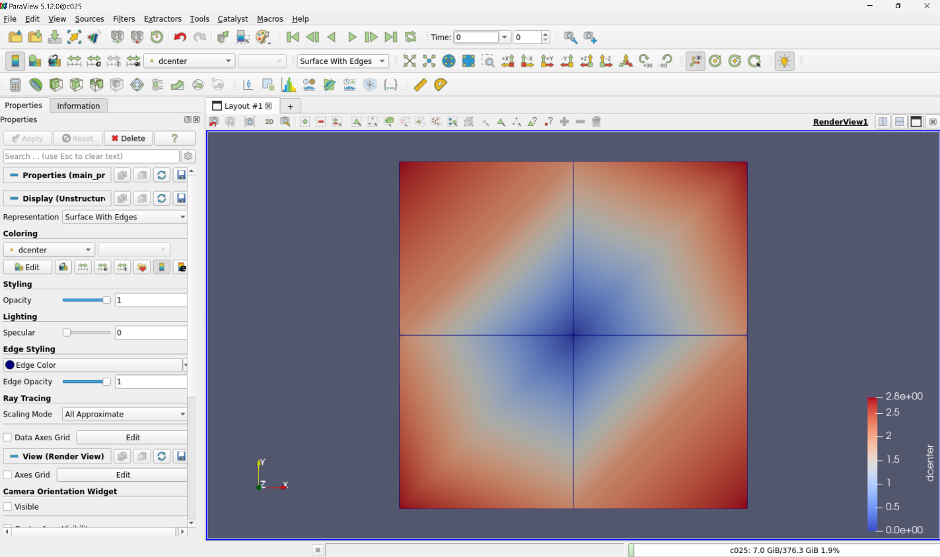

Figure: Set the view to surface with edges, and to display the scalar field (dcenter).

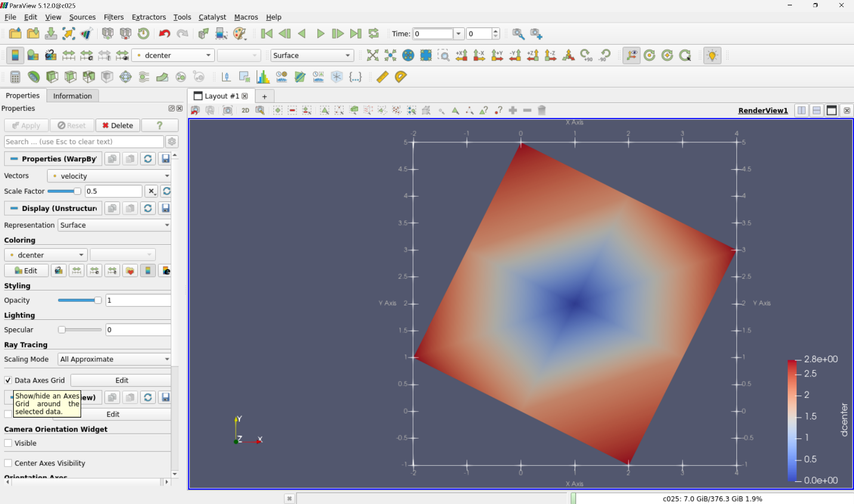

Figure: visualize the vector field (velocity). (warp by vector, Scale factor of 0.5)