**SUPPLEMENTARY MATERIAL**

**Identifying a Causal link between Prolactin Signaling Pathways and COVID-19 Vaccine-induced Menstrual Irregularities**

Rima Hajjo1,2,3*, Ensaf Momani4, Dima A. Sabbah1, Nancy Baker2, Alexander Tropsha2

1Department of Pharmacy, Faculty of Pharmacy, Al-Zaytoonah University of Jordan, P.O. Box 130 Amman 11733 Jordan.

2Laboratory for Molecular Modeling, Division of Chemical Biology and Medicinal Chemistry, Eshelman School of Pharmacy, The University of North Carolina at Chapel Hill

3Jordan CDC, Amman, Jordan.

4Al Balqa’ Applied University, Faculty of Medicine, Al-Salt, Jordan

**\*Correspondence**

Rima Hajjo, Assistant Professor in Pharmacoinformatics and Pharmacogenetics, Al-Zaytoonah University of Jordan, Amman, Jordan; Adjunct Associate Professor, UNC-Chapel Hill, North Carolina, USA.

Email: [r.hajjo@zuj.edu.jo](mailto:r.hajjo@zuj.edu.jo) ; [hajjo@unc.edu](mailto:hajjo@unc.edu)

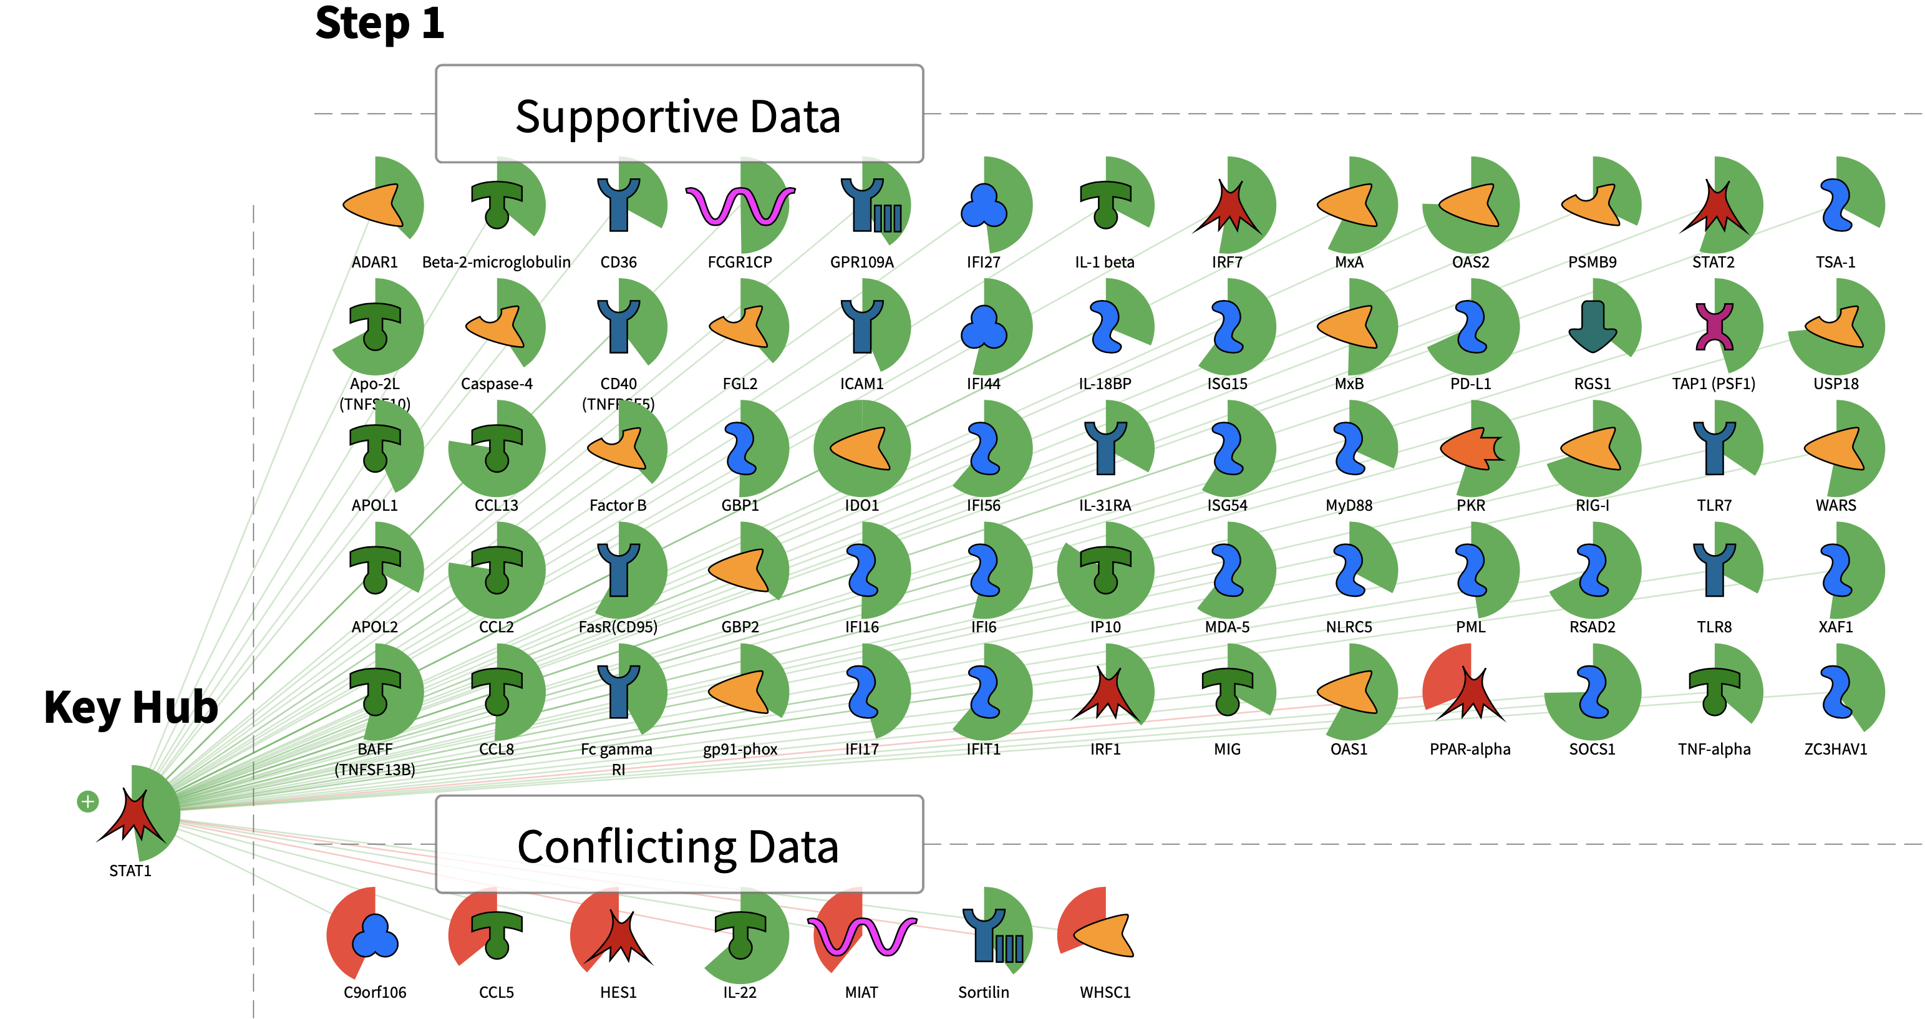

**Supplementary Figure S1.** Causal reasoning network of high confidence transcription factor STAT1 using DEGs in GS2. Gene expression changes are shown in green and red sectors around each molecule. Increased expression value corresponds to the green sector which size increases clockwise around the molecule icon. Decreased expression value corresponds to the red sector which size increases counterclockwise. Supportive data panel contains over and under-expressed genes from the experimental data set which support a hypothesis that STAT1 is in a predicted predominant “active” state. Conflicting data panel contains over and under-expressed genes from the experimental data set which are discordant with the hypothesis that STAT1 is in predicted predominant “active” state.

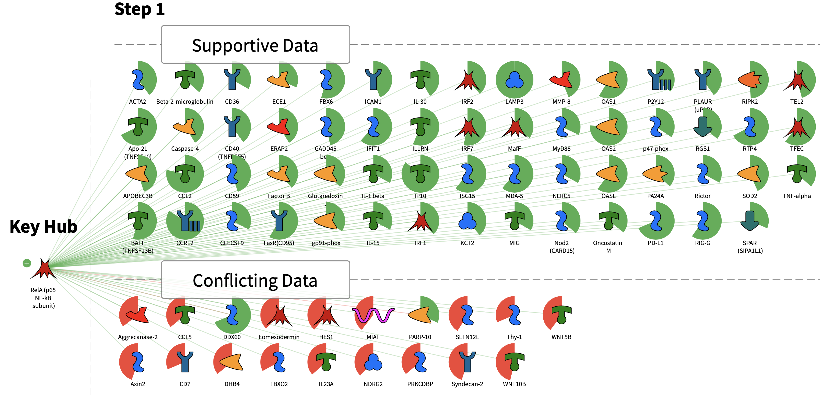

**Supplementary Figure S2.** Causal reasoning network of high confidence transcription factor RelA using DEGs in GS2. Gene expression changes are shown in green and red sectors around each molecule. Increased expression value corresponds to the green sector which size increases clockwise around the molecule icon. Decreased expression value corresponds to the red sector which size increases counterclockwise. Supportive data panel contains over and under-expressed genes from the experimental data set which support a hypothesis that RelA is in a predicted predominant “active” state. Conflicting data panel contains over and under-expressed genes from the experimental data set which are discordant with the hypothesis that RelA is in predicted predominant “active” state.

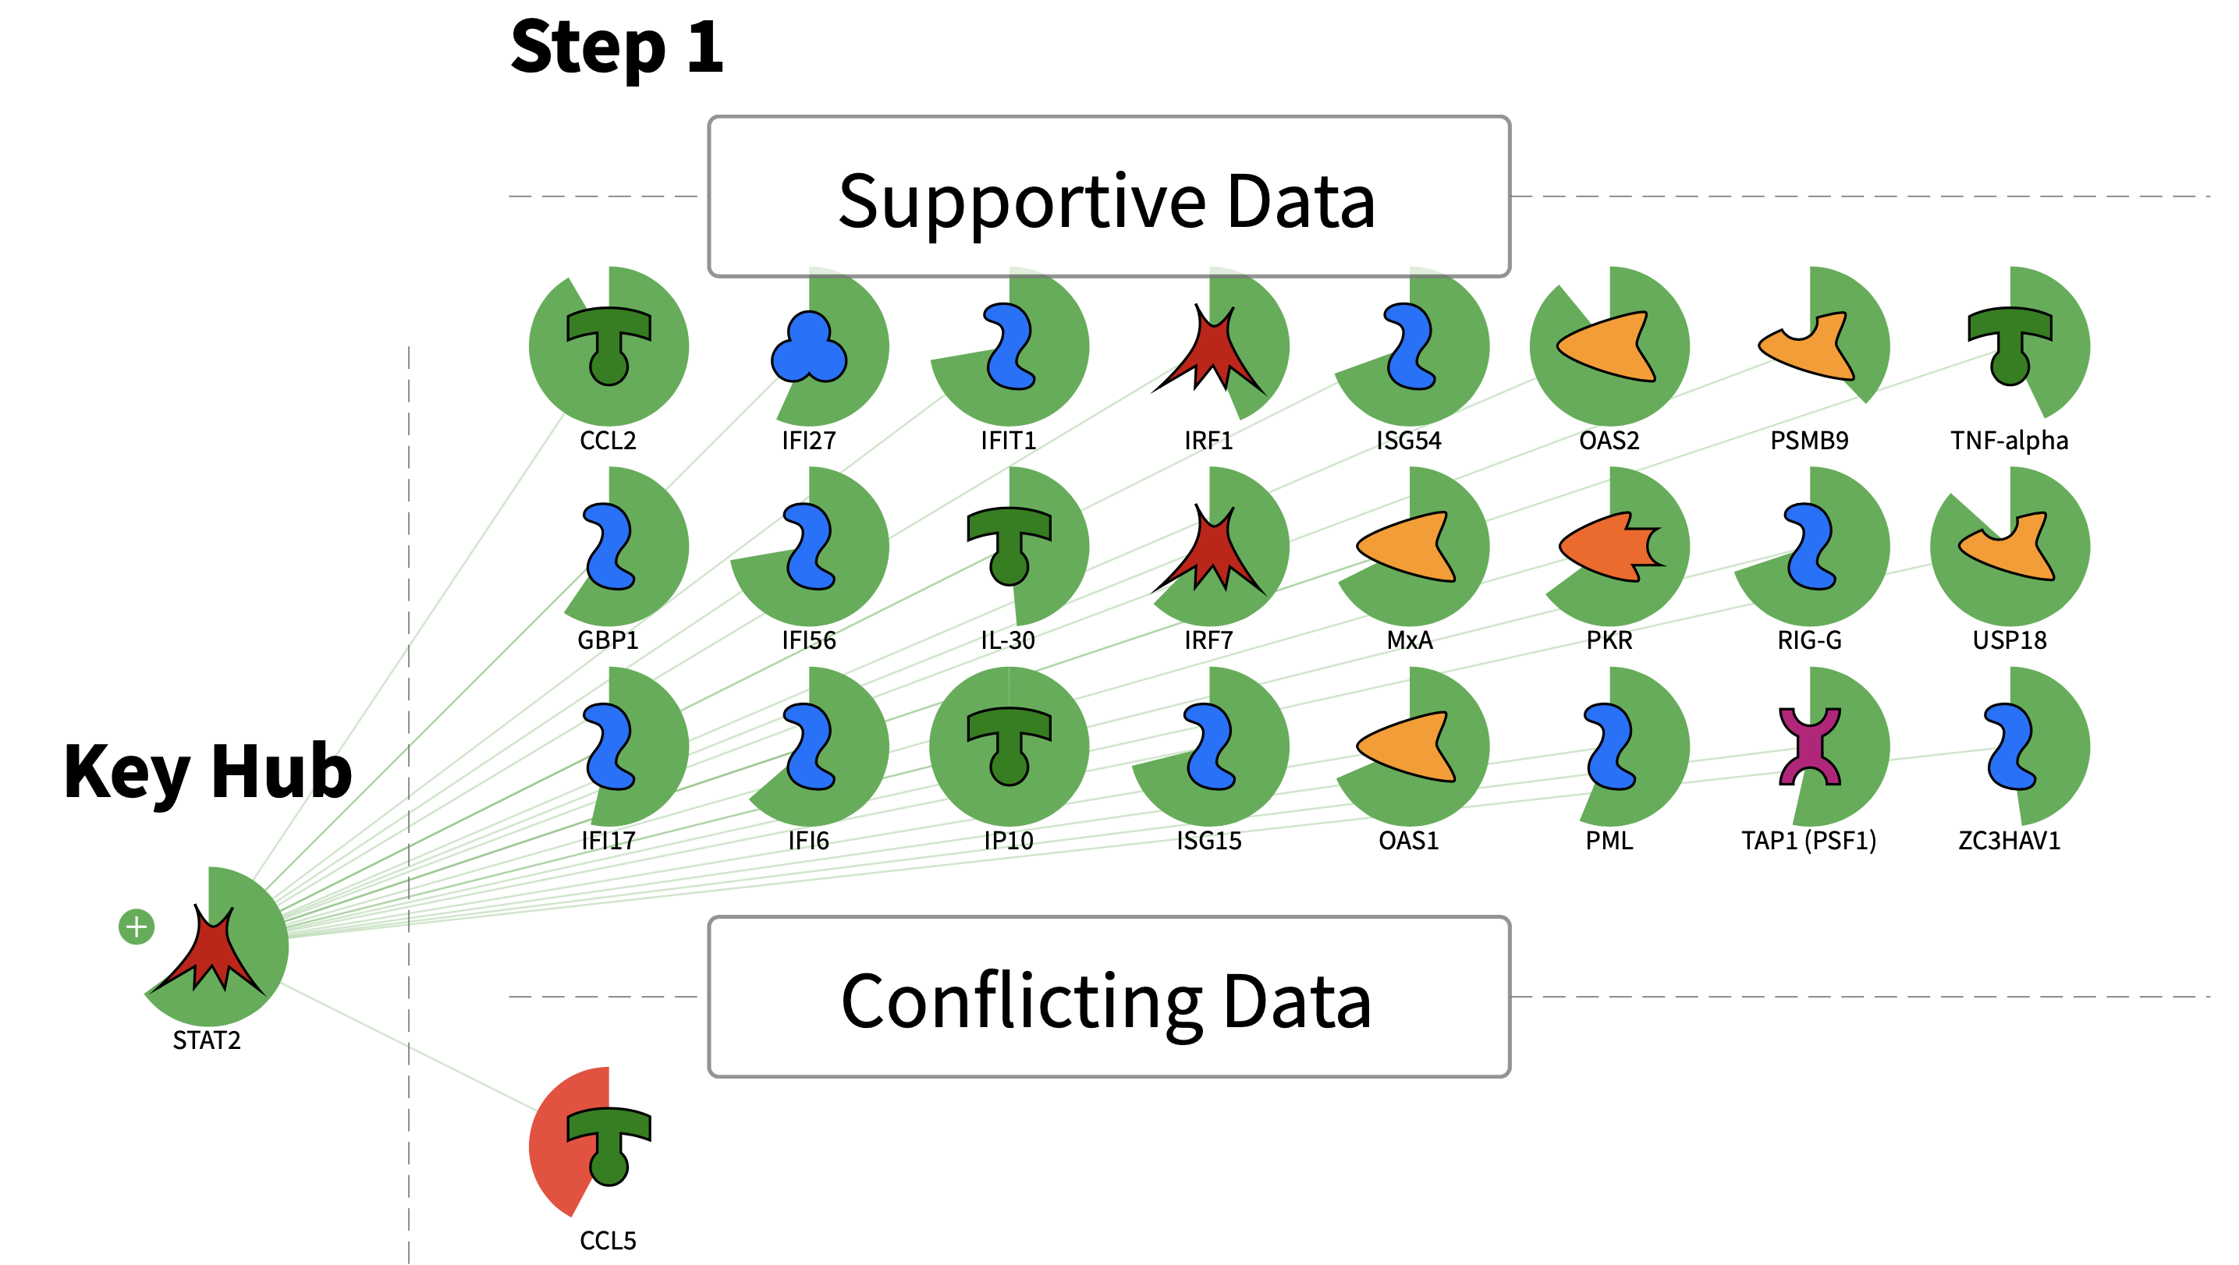

**Supplementary Figure S3.** Causal reasoning network of high confidence transcription factor STAT2 using DEGs in GS2. Gene expression changes are shown in green and red sectors around each molecule. Increased expression value corresponds to the green sector which size increases clockwise around the molecule icon. Decreased expression value corresponds to the red sector which size increases counterclockwise. Supportive data panel contains over and under-expressed genes from the experimental data set which support a hypothesis that STAT2 is in a predicted predominant “active” state. Conflicting data panel contains over and under-expressed genes from the experimental data set which are discordant with the hypothesis that STAT2 is in predicted predominant “active” state.

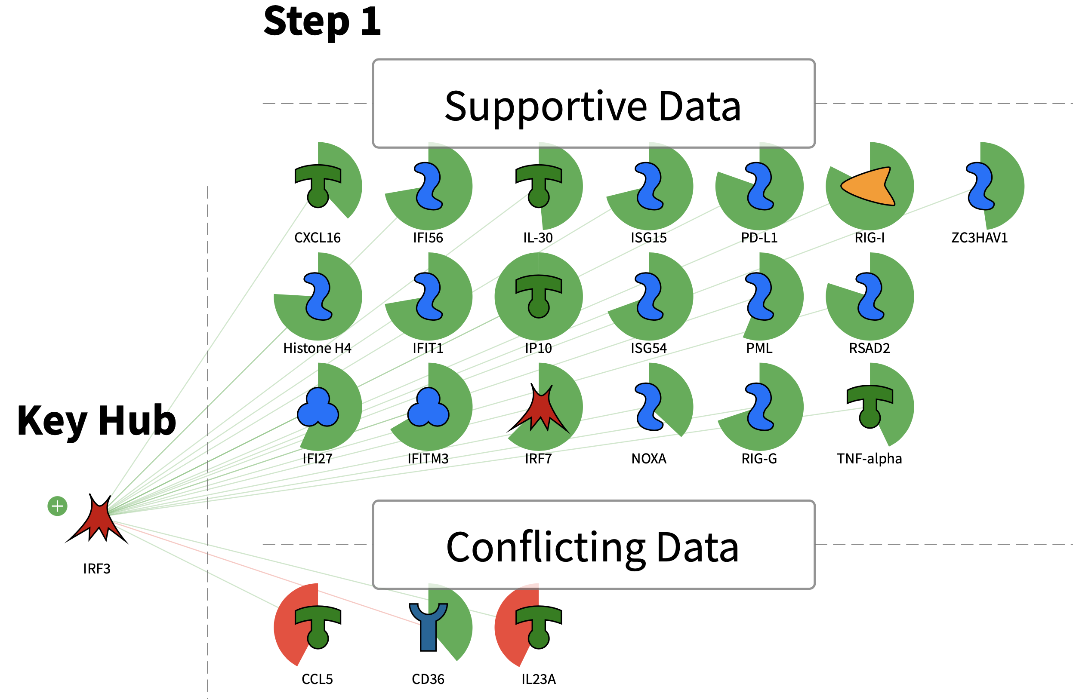

**Supplementary Figure S4.** Causal reasoning network of high confidence transcription factor IRF3 using DEGs in GS2. Gene expression changes are shown in green and red sectors around each molecule. Increased expression value corresponds to the green sector which size increases clockwise around the molecule icon. Decreased expression value corresponds to the red sector which size increases counterclockwise. Supportive data panel contains over and under-expressed genes from the experimental data set which support a hypothesis that IRF3 is in a predicted predominant “active” state. Conflicting data panel contains over and under-expressed genes from the experimental data set which are discordant with the hypothesis that IRF3 is in predicted predominant “active” state.