# Gaia Watcher v1 - Fleet Tracking System

New Tracking System for fleet management.

# Components

### app_api

### app_web

### app_socket

### app_database

# Requirements

* Physical Server
  + At least I3 3.0 ghz quad core
  + At least 8gb RAM
  + At least 1 terabytes hdd
* Windows server 2012
* IIS 8
* Dot Net Framework 4.5.2
* MySQL Community Edition

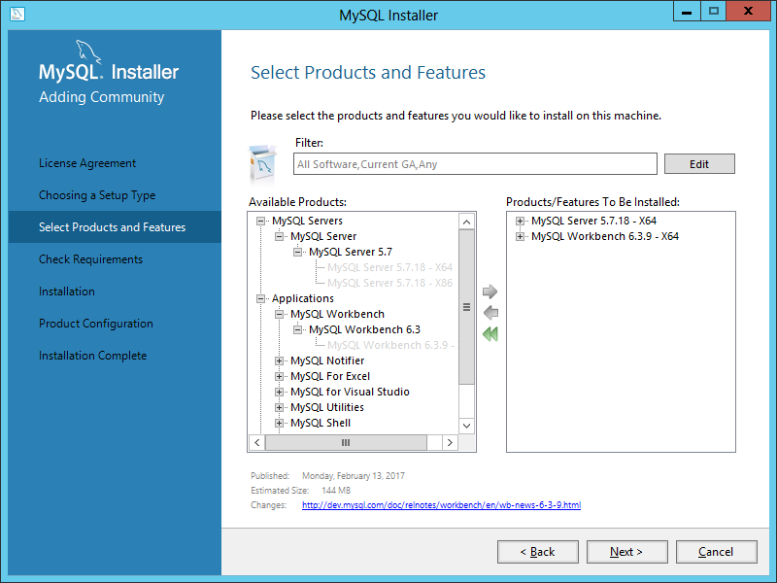

* Dot Net Framework 2.0
* Php Manager
* Php 5.6
* Google Chrome

# app_database(mysql - backend)

## Installation

* Open app_database model project file.

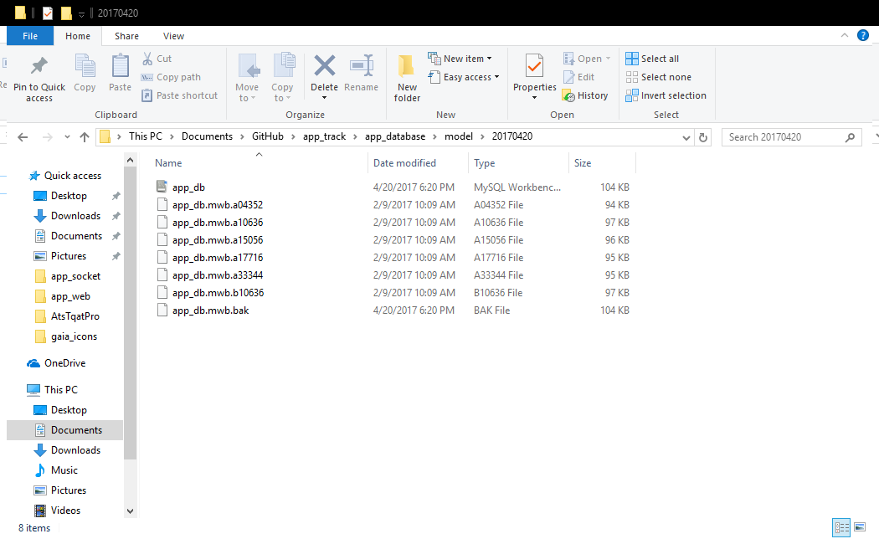

* Check databases.

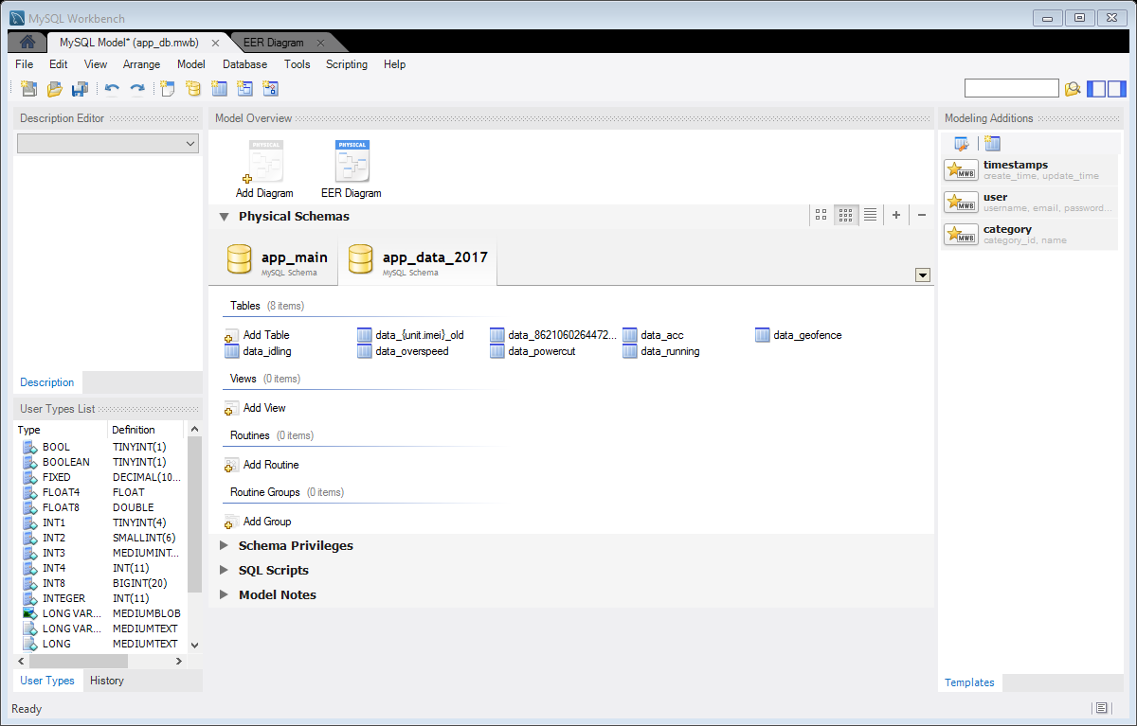

* Check diagram.

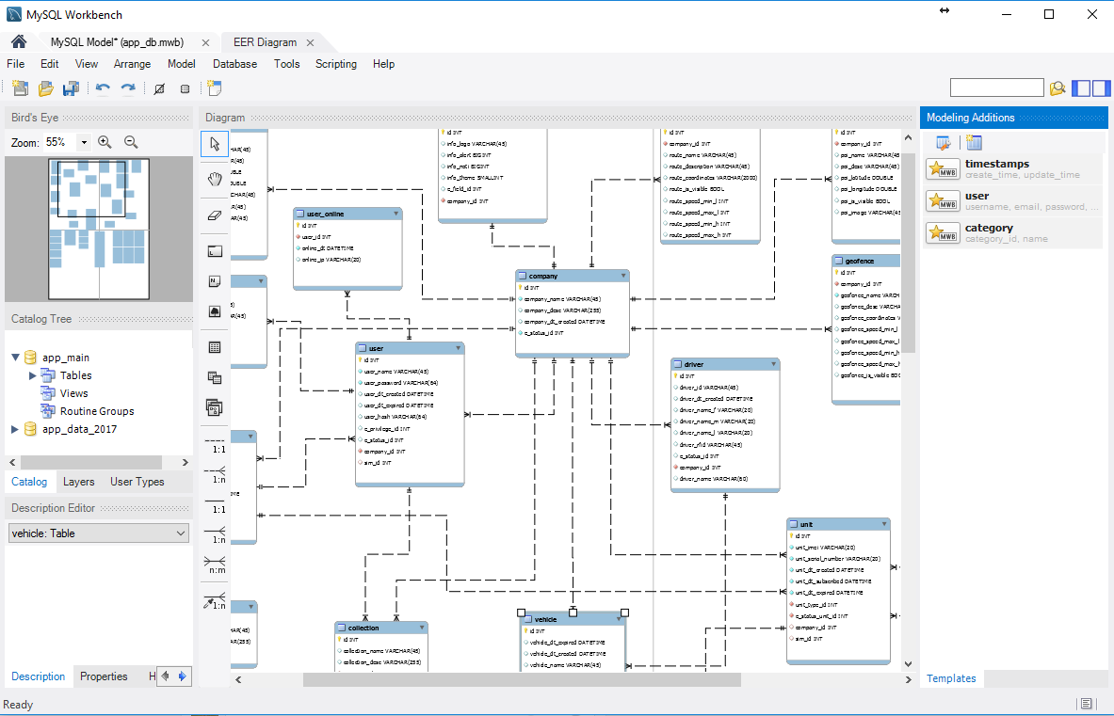

* Upload database using forward engineer function or press ctrl+g.

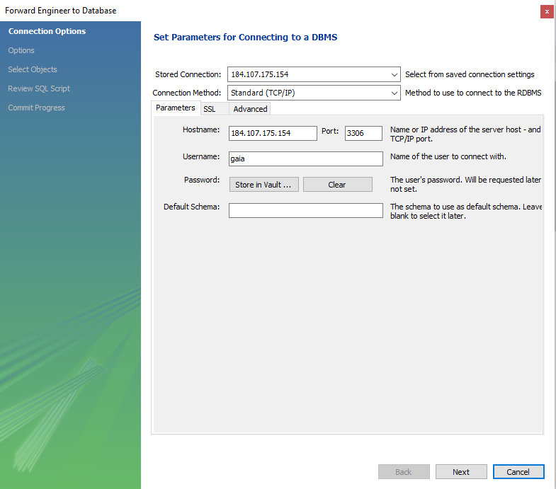

* Set your credentials such as ip, port, username and userpassword.

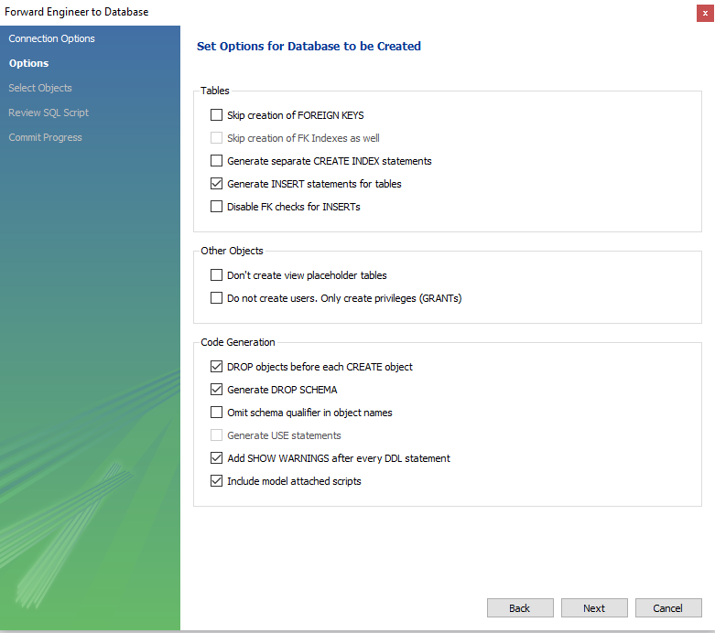

* Select checked items as indicated in picture.

# app_api (flightPhp restapi - middleware)

## Features

* Uses FlightPhp framework.
* Supports standard crud request.
* Provides a clear status response.
* Supported all platforms, browsers and devices.
* Designed in object oriented approach for each
* Updating, patching and managing source code.

## Installation

* Copy this api to a server of your wish and put inside a folder, rename the folder to "app_api".

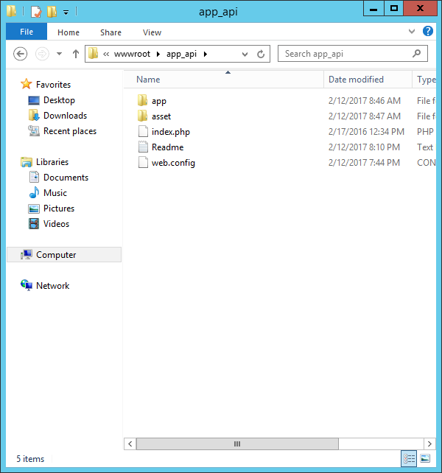

* Open iis8 and create new website.
* Direct the path into the api's folder "../../app_api".
* Set the ip and port you want "184.107.175.154".
* Go to app_api folder. Find setting.php
* Update setting database credentials.

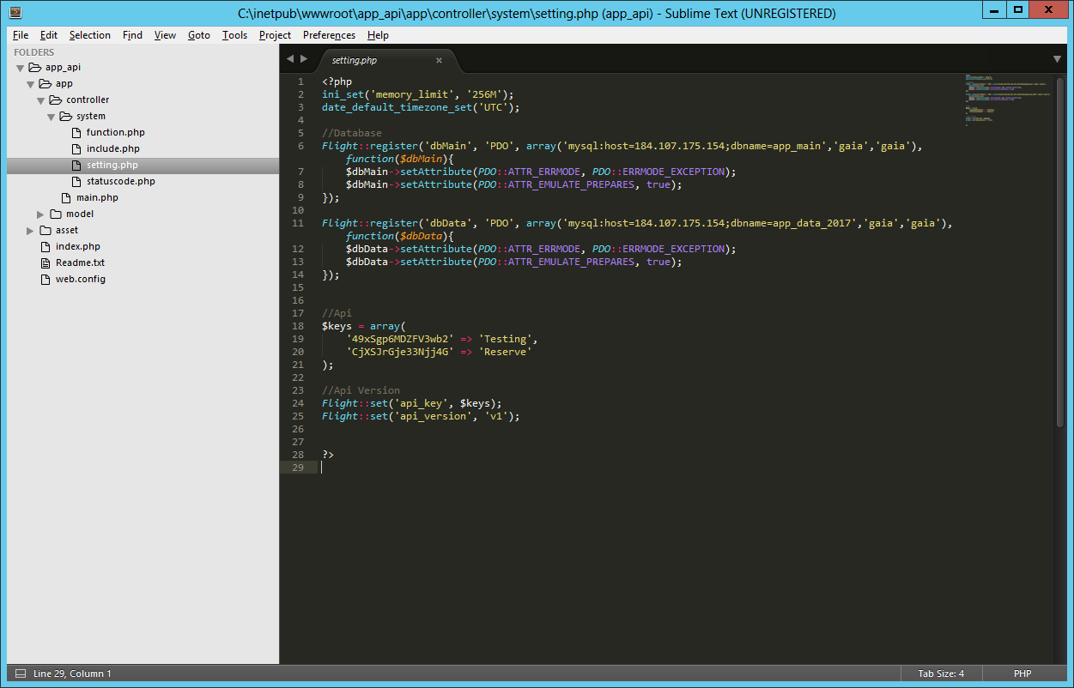

* Enable IURS and IIS_USRS if outside inetpub

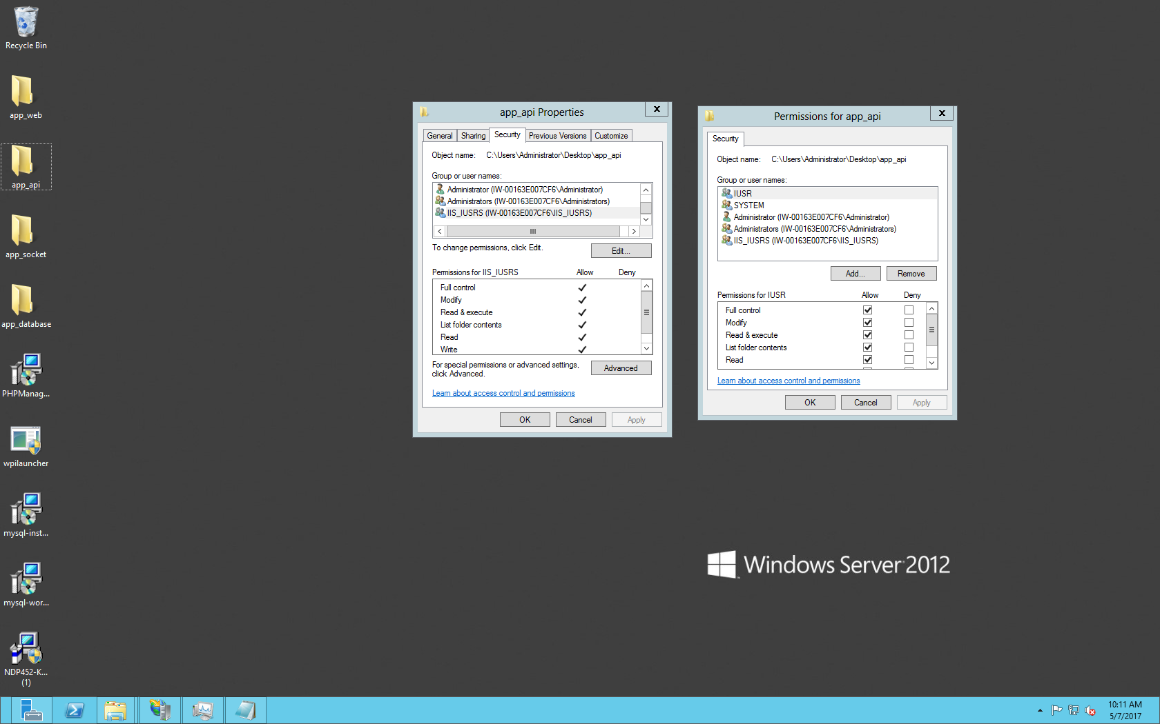

* To enable http verbs:
  + Goto C:\Windows\System32\inetsrv\config\applicationHost.config and add inside configuration tag
  + Add verbs

<location path="app_api">

<system.webServer>

<handlers accessPolicy="Read, Execute, Script">

<clear />

<add name="PHP_via_FastCGI" path="*.php" verb="GET,POST,PUT,DELETE,OPTIONS" modules="FastCgiModule" scriptProcessor="C:\Program Files (x86)\iis express\PHP\v5.6\php-cgi.exe" resourceType="Either" />

</handlers>

</system.webServer>

</location>

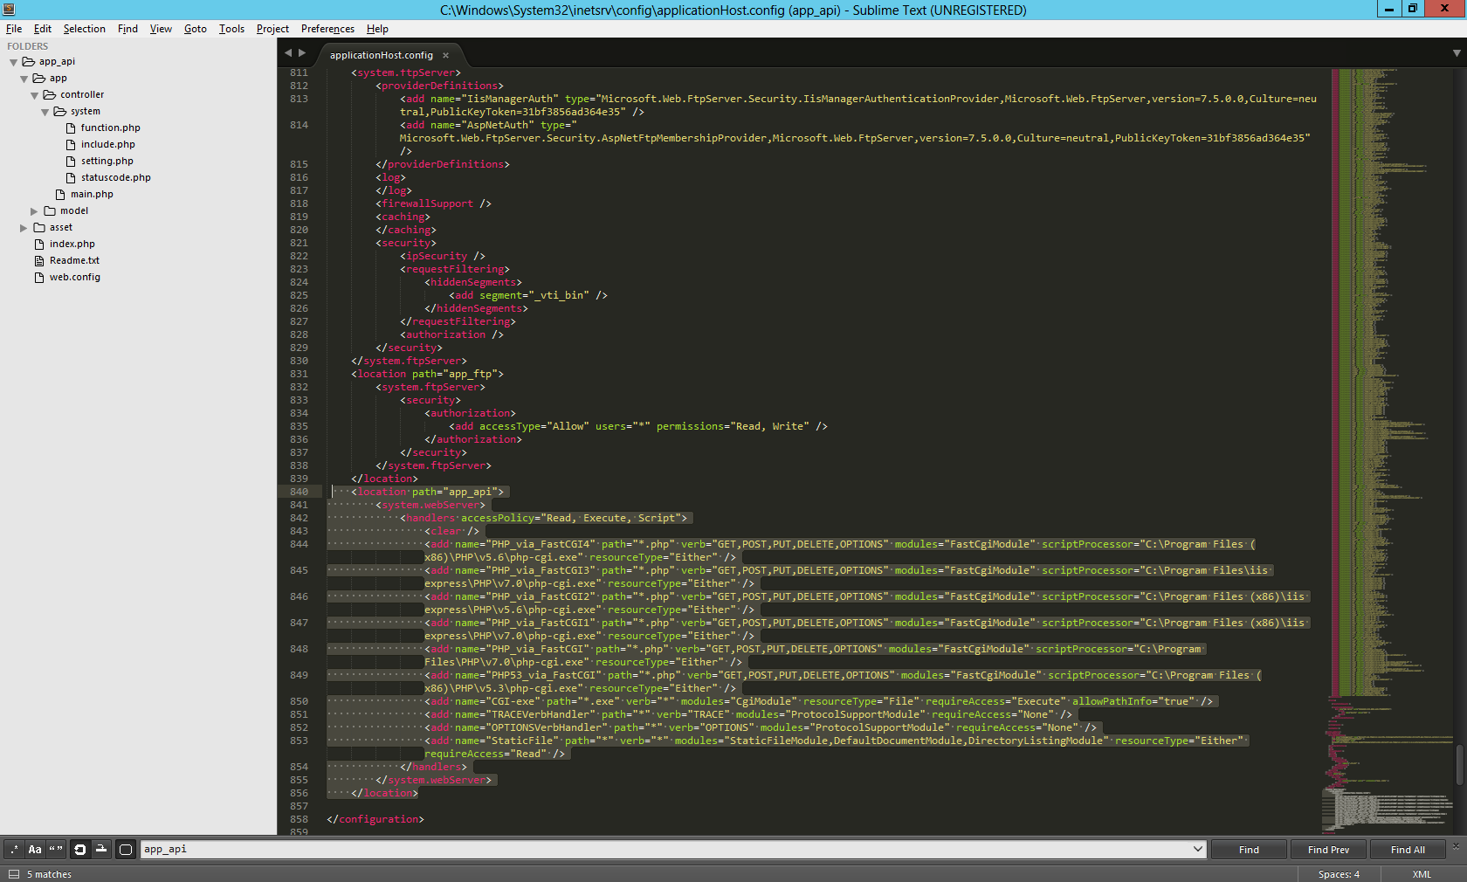

* Restart iis then test the GET command "http://184.107.175.155/v1/main/privilege/".

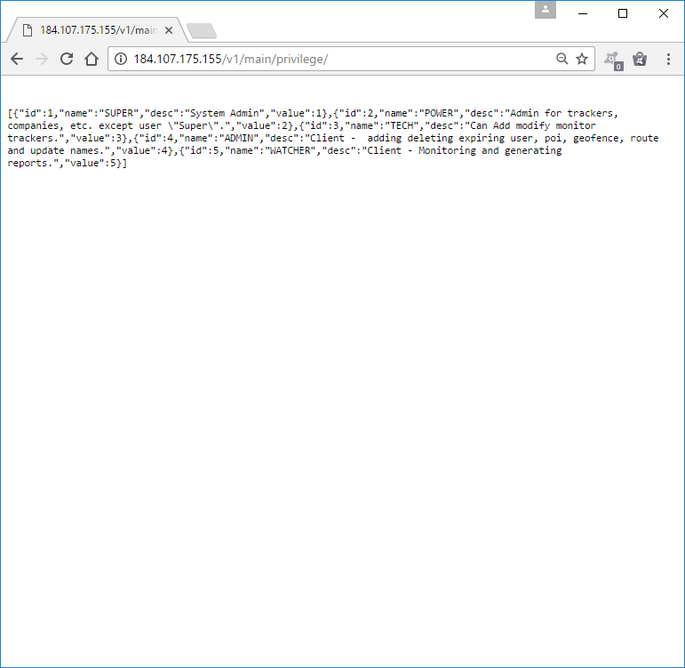

## Request Mapping

*Parts

<http://184.107.175.155/v1/main/privilege/1>

1. Port

-http = Port 80

-https = Port 443

2. Ip Address

-184.107.175.155

-Can be a domain

3. Api Version

-v1, v2

4. Class

-privilege

-user

-company

-etc...

5. Database or Source

-main

-data

-report

7. Id (Optional)

-1, 2...

-If empty then selects all

*GET

- <http://184.107.175.155/v1/main/privilege>

# app_socket(wpf c# - socket server)

## Installation

* Copy folder to the server.

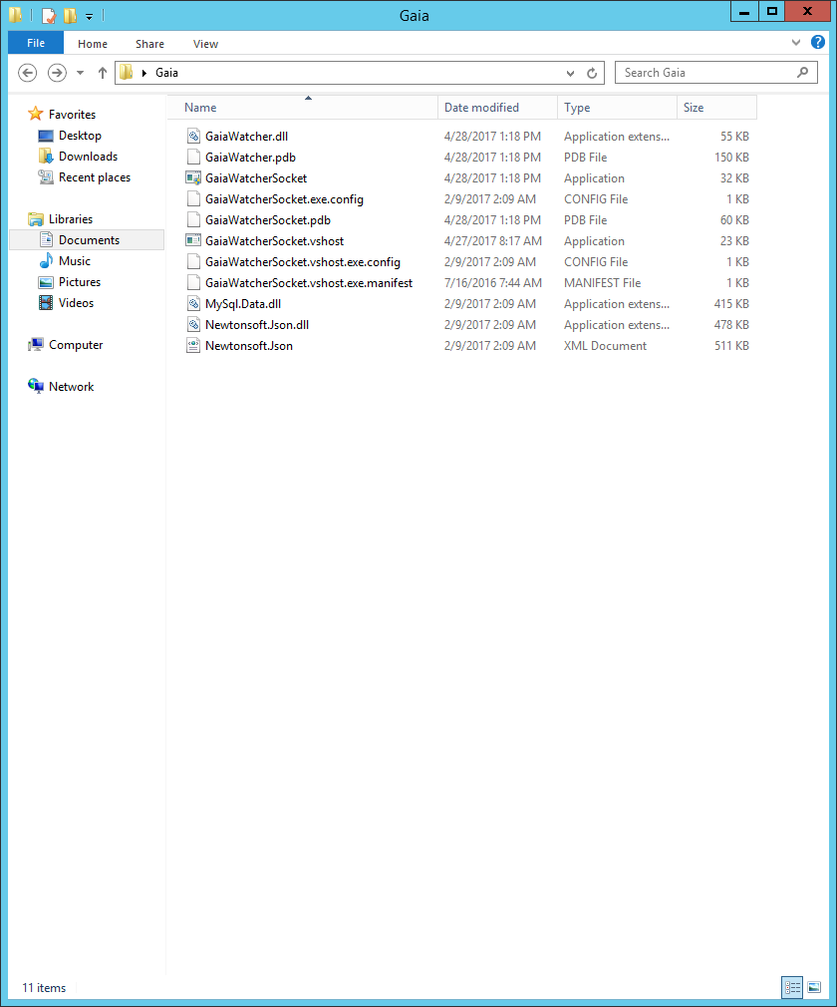

* Allow app_socket from the firewall

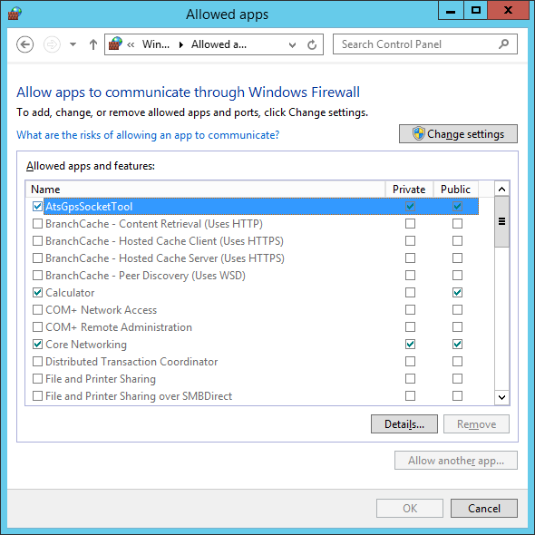

* Create a server profile.

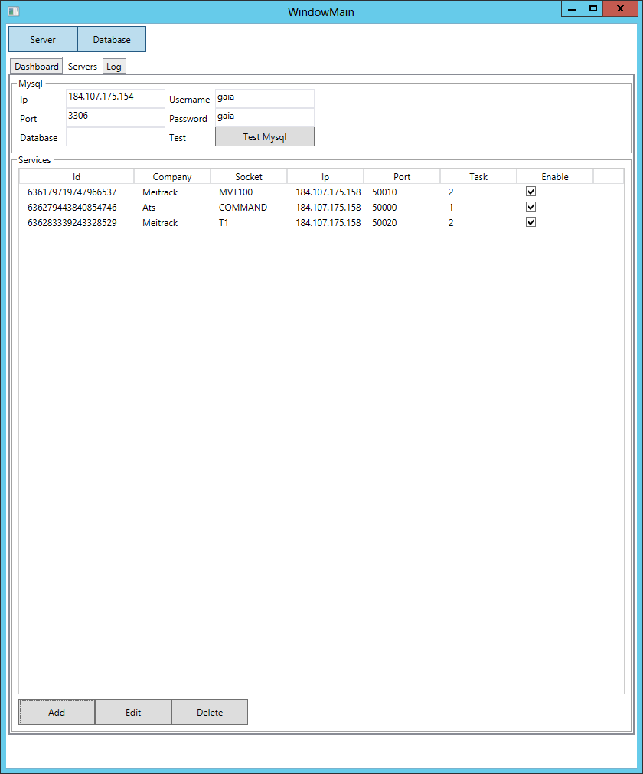

* Create ats command for receiving commands and save.

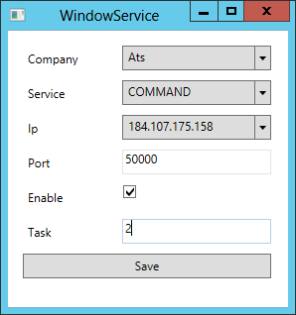

* Create meitrack mvt100 service and save.

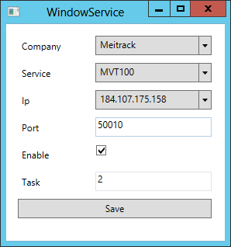

* Create meitrack t1 service and save.

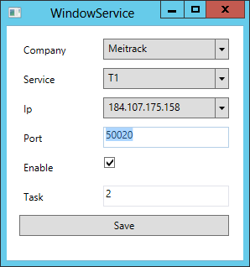

* Set Mysql credential and test.

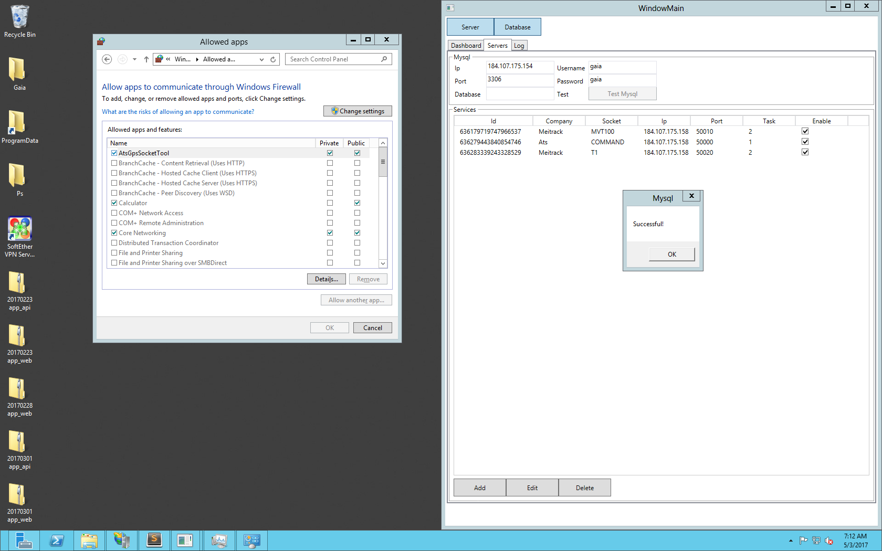

* Run server by click server and run uploading by clicking database.

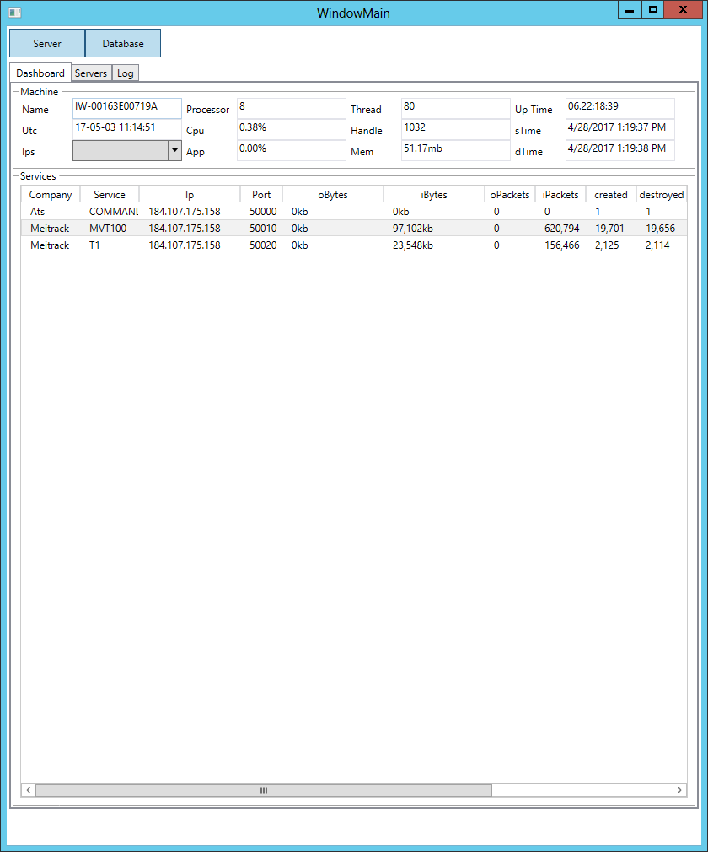

# app_web(angularjs - frontend)

## Installation

* Copy app_web/angular to server.

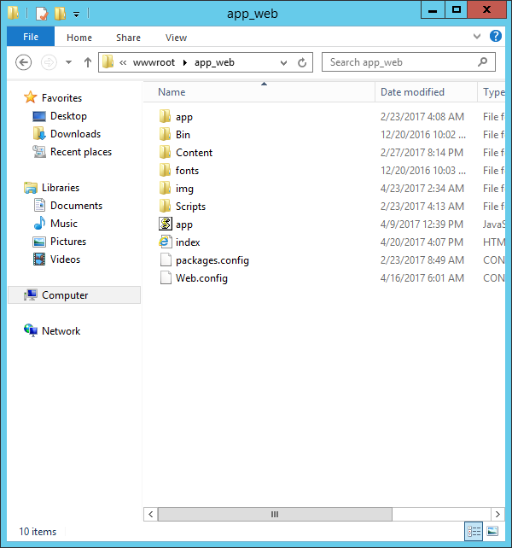

* Create a website from iis8 and direct the path to app_web location.
* Open the resourceFactory.js and edit ip.
  + var ip = 'http://184.107.179.182/';
* Open google chrome and browse the ip.

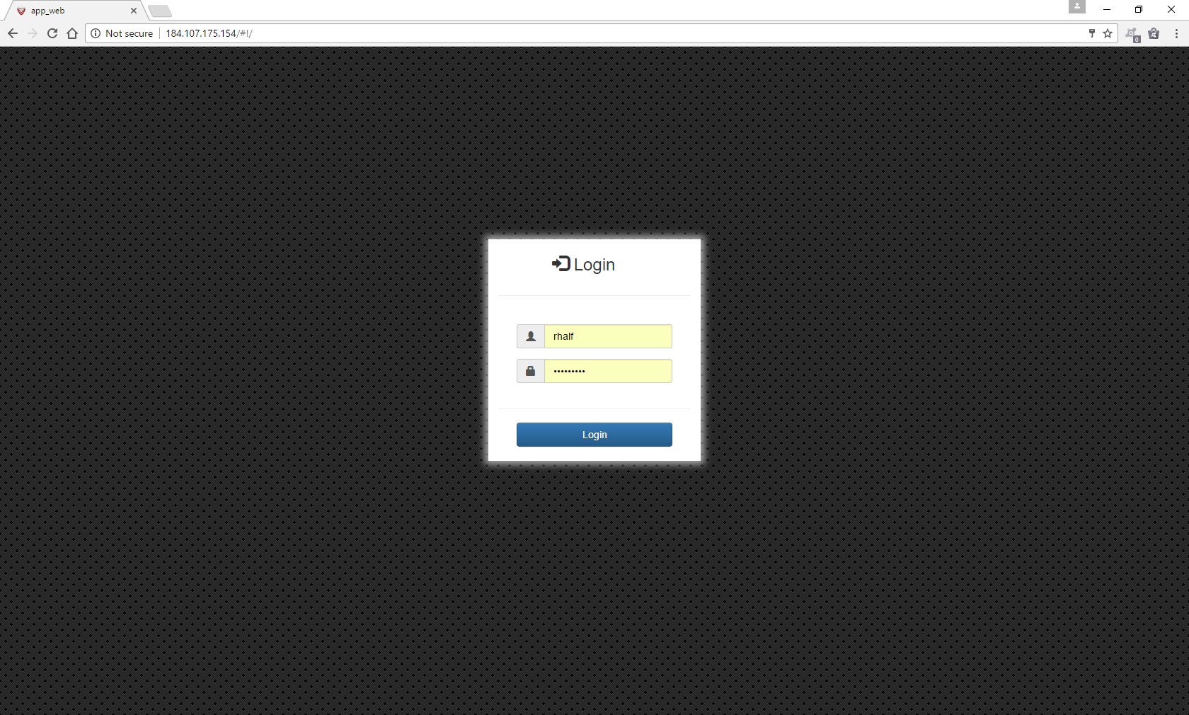

* Default username is “rhalf” and default userpassword is “321321321”

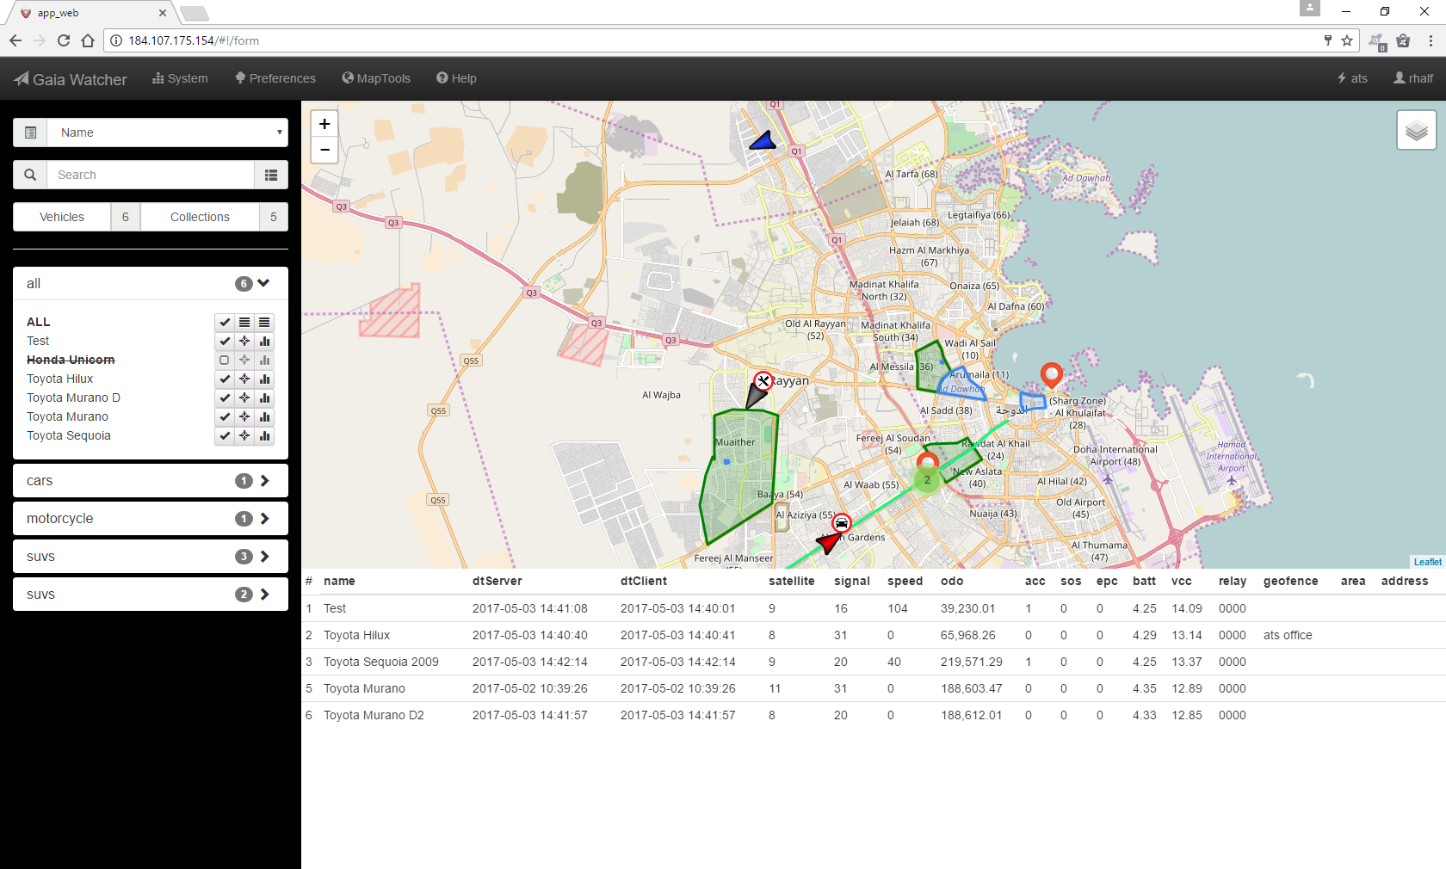

# Maintenance

UnitData will be our main problem here since we are going to store data up to 6 months.

Here is the way on how to delete that.

Set the date and time of 6 months. E.g. '2017-05-23 11:41:53' then get the index. With this query

set @index1 = (SELECT id from app_data_2017.data_012896008485887 where h_client < '2017-05-23 11:41:53' order by h_client desc limit 1);

select @index1;

Depending on result delete id lower than the result. Note that deletion should be 50k per query.

SET SQL_SAFE_UPDATES = 0;

DELETE FROM app_data_2017.data_012896008485887

WHERE id < 200000;

SET SQL_SAFE_UPDATES = 1;