Tqat Pro Socket

New socket for tqat system. [rhalfcaacbay@gmail.com](mailto:rhalfcaacbay@gmail.com)

## Installation

1. Copy Application to Server.

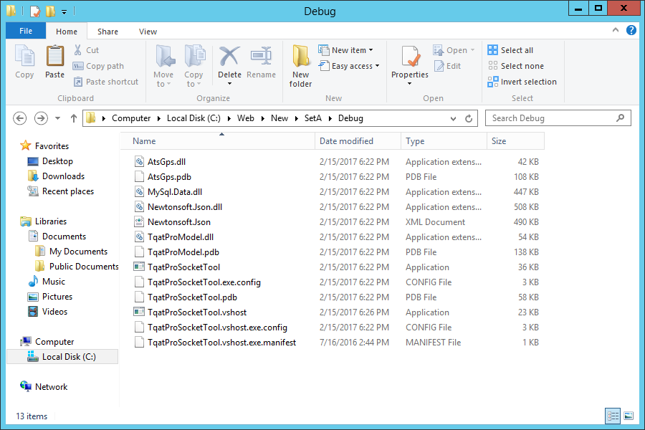

1. Allow application from firewall.

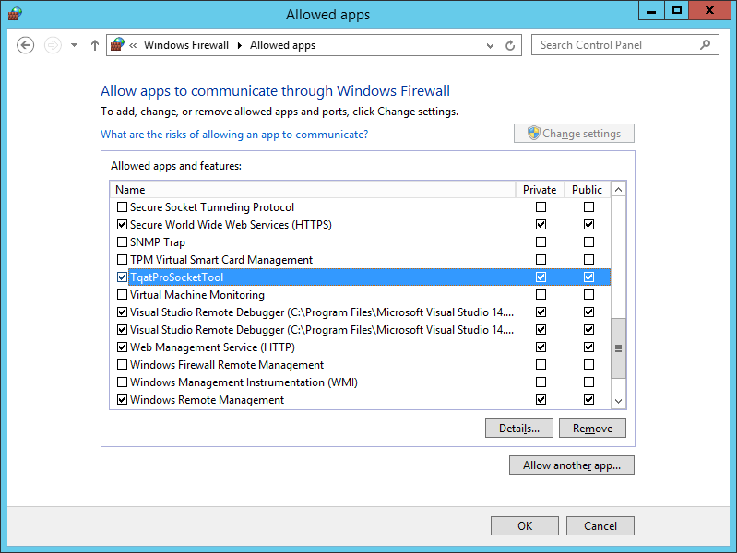

1. Run application and set parameters.
2. Set Mysql parameters and test

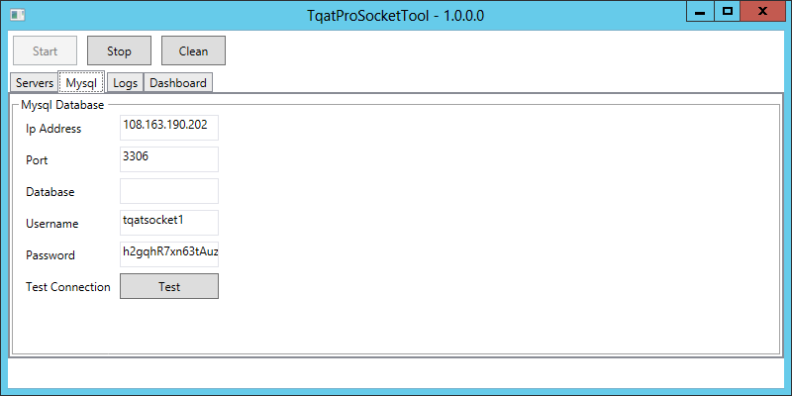.

1. Create serviceProfile for ats command.

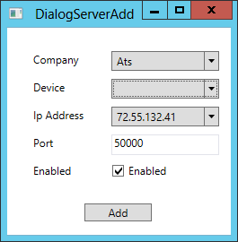

1. Create serviceProfile for meitract mvt100.

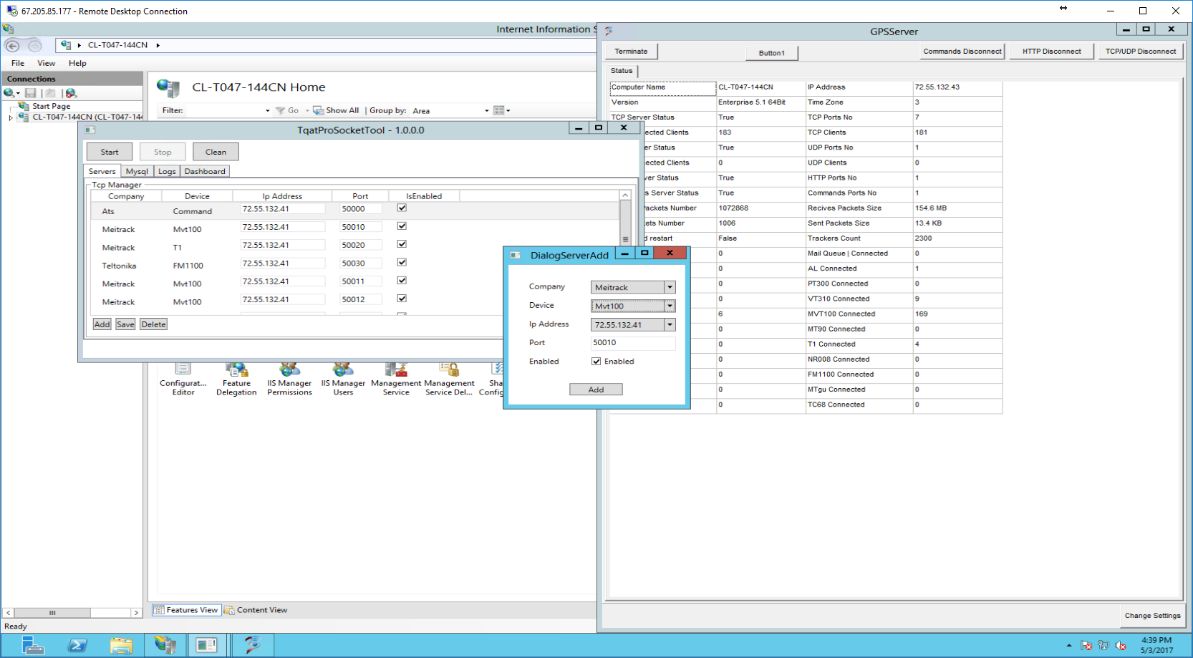

1. Create serviceProfile for meitract t1.

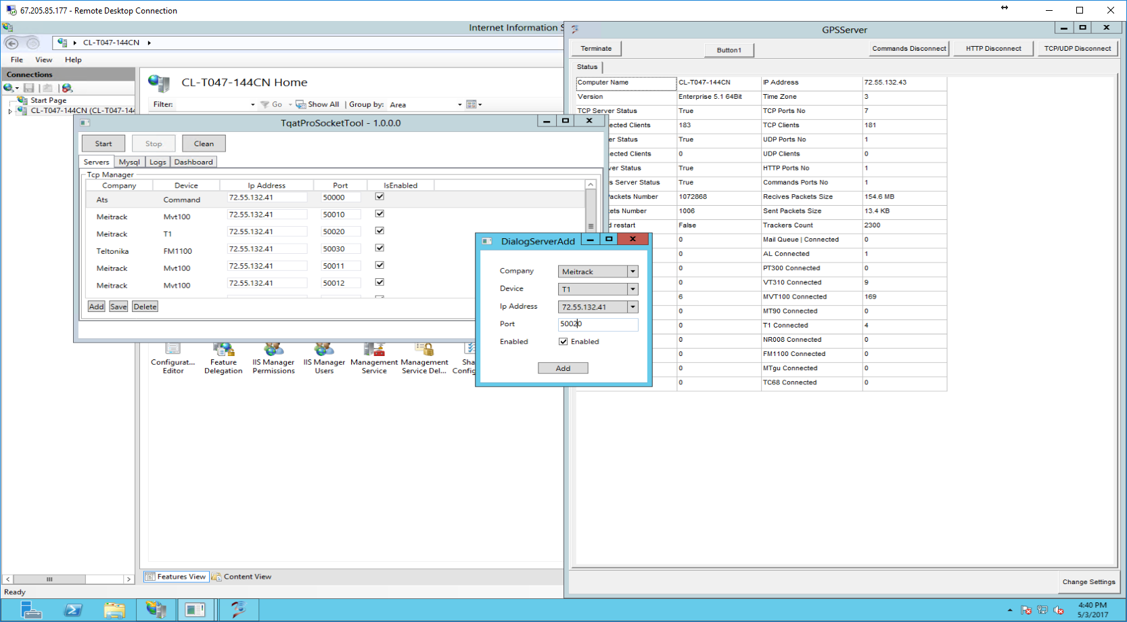

1. Start Server.

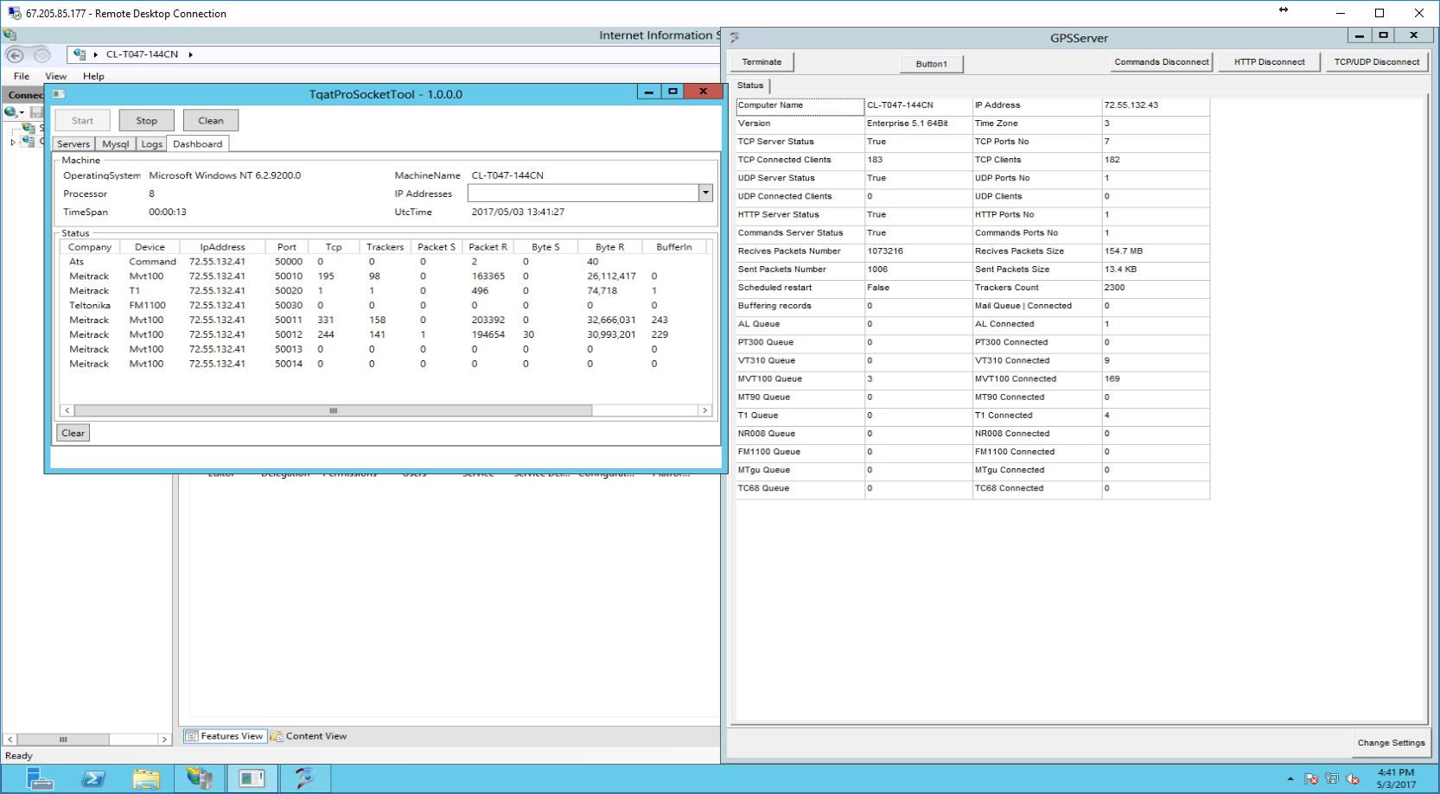

1. Just reboot if server hangs, crushed or used too much process.

Go to C:\Web\New\SetA\Debug

TqatProSocketTool.exe

Note…

If website hang just reboot iis8.

1. Server maintenance. Each trackers produce so much data. So one by one deletion of data is need to maintained performance and effectiveness. We have 6 months limit on data retention so we must get the date 6 months ago.

The timestamp 6 months ago is 1477958400;

First get the id of that timestamp from specific unit data.

SET @index = (SELECT gm_id FROM trk_bf563d3073db57c099431b1f7a652a13.gps_bf563d3073db57c099431b1f7a652a13 WHERE gm_time < 1477958400 ORDER BY gm_time desc LIMIT 1);

SELECT @index;

This command returns the index. Now we can conclude that lower that this id is older.

Note we must delete 50k items until you reach the index.

SET SQL_SAFE_UPDATES = 0;

DELETE FROM trk_bf563d3073db57c099431b1f7a652a13.gps_bf563d3073db57c099431b1f7a652a13

WHERE gm_id < 200000;

SET SQL_SAFE_UPDATES = 1;