Tuolumne Stream Data Post-Processing
Joe Ammatelli | Joseph.Ammatelli@dri.edu | March 2024

Purpose
This document seeks to provide context, guidance, and insights for collecting and processing stream data from the Upper Tuolumne Watershed in Yosemite National Park and additionally serves as the primary documentation for a Python toolkit and workflow designed for processing such data. It is my hope that it is comprehensive enough that future students can relatively efficiently and painlessly complete or interpret the post-processing steps.

The document is broken into two sections:
- The Overview section outlines the “big picture” of the work at hand, providing necessary context and background information.
- The Analyst Guide section describes in greater detail the workflow recommended for processing the stream data.

Table of Contents

Purpose 1
Table of Contents 1
Overview 3
Background 3
Tuolumne Hydroclimate Network 3
Motivation 6
Maintain long-term discharge time series for the Upper Tuolumne Watershed 6
Generate a reproducible workflow for post-processing the Tuolumne stream data 7
Workflow Overview 7
Resources 8
Citation 8
Analyst Guide 10
Foundations 10
Prerequisites 10
Bookkeeping 10
Progress spreadsheet 10
Standardized data schema and directory structure 11
Post-processing logs and notes 11
Post-Processing Toolkit 13
Repository 13
Design and features 13
Code organization 14
Conventions 15
Sites of Interest In Tuolumne/Yosemite Network 17
Description of Noteworthy Steps 18
Trimming datasets 18
Ice dams, rain events, and melt (with examples) 20
Splitting datasets 24
Offsetting and stitching datasets 25
Stuck? Try these things 26
Step by Step Guidance 27
1. Getting Set Up 27
1a. Create progress spreadsheet 27
1b. Create project directory 27
1c. Configure Python environment 27
1d. Clone code repository 27
1e. Initialize directories 28
1f. Prepare datasets 29
Unvented level and baro time series 29
Vented level datasets 30
Stage and Stage-Q Pair Spreadsheets 30
1g. Standardize raw data 32
2. Process Vented Stage (Level) Time Series 33
3. Process Unvented Stage (Level) Time Series 33
3a. Choose year of data to process 33
3b. Choose barometric pressure data 33
3c. Process time series for each site 34
3d. Update progress spreadsheet 34
3e. Repeat 3a-3c for all years of unprocessed data 34
4. Inspect Rating Curves and Stage-Q Pairs 34
5. Stitch and Offset Time Series, Convert Stage to Q 35
6. Append Time Series to the Previously Published Dataset 35
7. Generate Metadata 35
8. Save and Publish Data 36
Site Notes 36

Overview
This section outlines the “big picture” of the work at hand, providing necessary context and background information.

Background

Tuolumne Hydroclimate Network
Jessica is the mastermind of a network of hydrometeorological monitoring stations in her beloved Tuolumne Meadows in Yosemite National Park, CA.

In summer 2001, a group of researchers from Scripps Institution of Oceanography decided to be “high-altitude oceanographers” and began installing pressure transducers in the area's streams and temperature sensors in the area's trees. The goal was threefold—to better understand fine-scale variation in hydroclimatic variables at high elevations [Lundquist et al., 2003], to understand how diurnal cycles in streamflow varied through a watershed system [Lundquist, 2004; Lundquist et al., 2005], and to explore the extent to which deployment of numerous, new, and inexpensive monitoring instruments—in tandem with a few traditional high-quality measurement stations—might support greater overall hydrometeorological data coverage in a complex terrain [Bales et al., 2006]. (Lundquist et al. 2016)

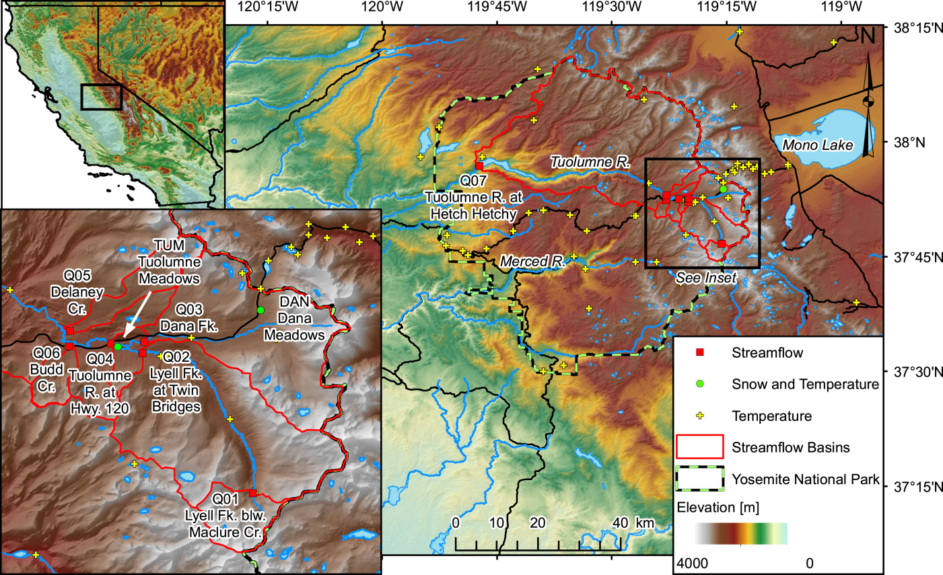
Figure 1 Map of stream gauging sites (red square), snow/met stations (green circle), and temperature sensors (yellow cross) in the Tuolumne Watershed and Yosemite National Park; reproduced from Lundquist el al. 2016.
The network includes stream gauging stations, snow/meteorological stations, and temperature sensors spread across the front/backcountry of Tuolumne. The network is significant because (a) the Tuolumne Watershed provides water for Hetch Hetchy/central California and (b) it provides a unique glimpse into hydrologic processes in an alpine basin. This document focuses on the post-processing of data collected from 6 stream gauging stations in the watershed.

Gauging stations in Tuolumne have a variety of configurations, in large part due to the Wilderness Act of 1964 and the National Environmental Policy Act (NEPA) of 1970:

These laws require that installations [in the park] have the minimum possible impact to the environment, including minimal visibility to wilderness visitors. For this reason, weirs, which are typical in other research catchments, were not used. Instead, installations were designed to be nearly invisible to park visitors desiring a wilderness experience, while still meeting research and operational needs for high data quality. (Lundquist et al. 2016)

Time series of the stream stage, used to create time series of discharge, are collected using pressure transducers. All sites are equipped with a “wilderness-style stilling tube” (basically two nested pvc pipes anchored into the bank or stream bed) that houses an unvented Solinst Levelogger, a pressure transducer that measures the pressure due to the water column and the atmosphere. Some sites also have a separate stilling tube with a vented pressure transducer. These transducers compensate for atmospheric pressure, interface with an external data logger, and log continuously. Solinst Barologgers, which are installed above ground and log the ambient atmospheric pressure, are installed at various locations throughout the watershed (e.g., in dry wells, at the Bug Lab, or at gauging stations) and are used to compensate for atmospheric pressure in the unvented Solinst Levelogger time series.

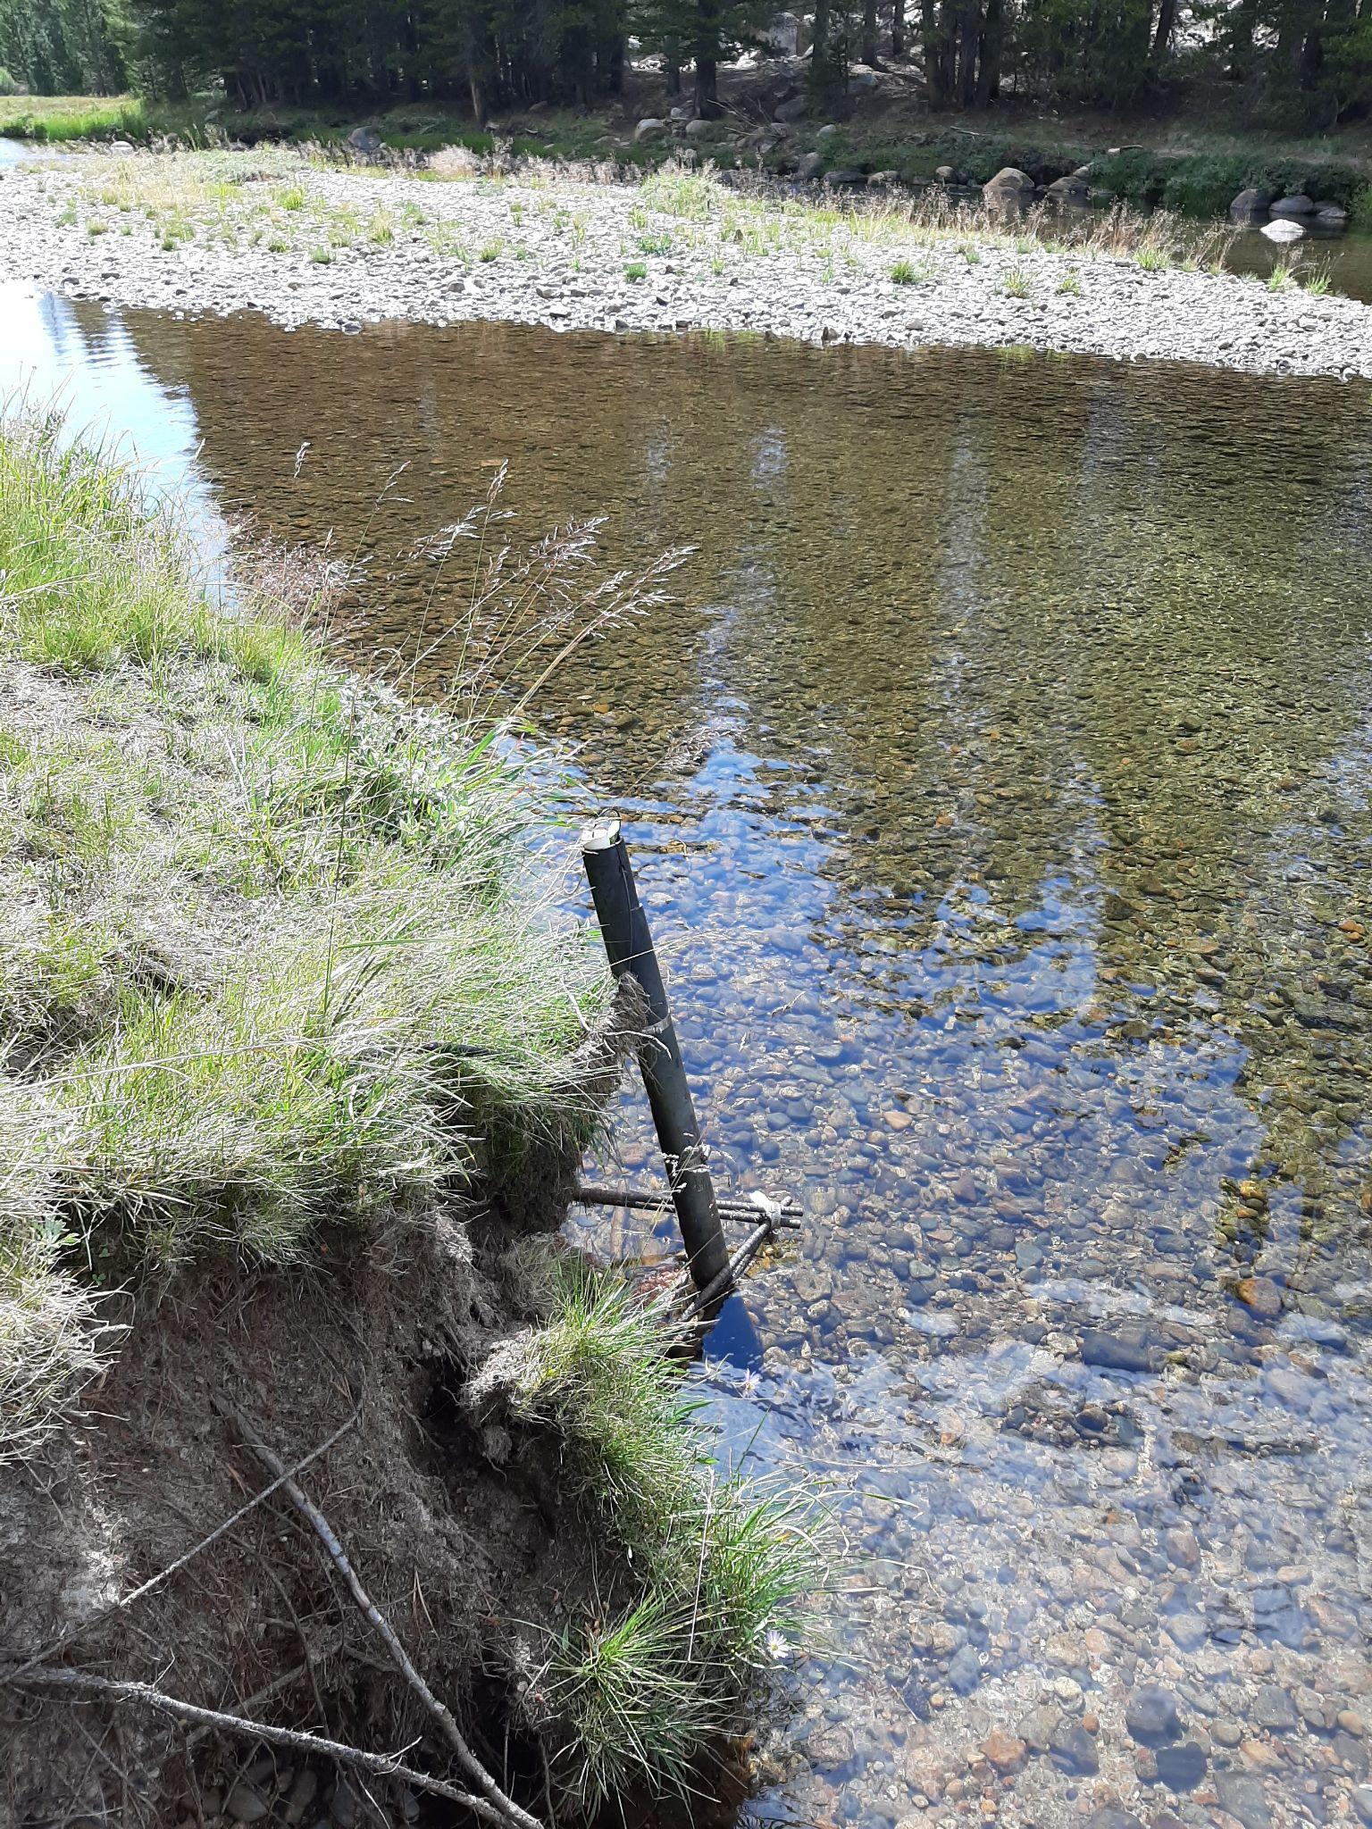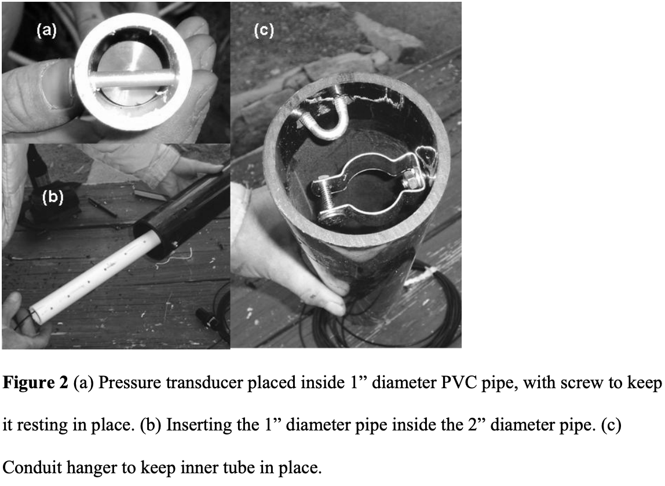
Figure 2 “Wilderness-style” stilling tubes. (Left) example of stilling tube fastened to bank (Right) Figure adapted from Lundquist et al. 2008 displaying the stilling tube internals.
Stream stage, which is used to develop the rating curve of each site and offset the stage time series, is manually measured using several approaches, depending on the site. At some sites, the water level is read directly from a staff plate. At other sites, to comply with the wilderness constraints, the height of the water is measured with respect to a more subtle reference point or datum (e.g., a bolt drilled into a boulder on the bank). The so-called tape down—or distance between the reference point (of arbitrary assigned elevation) and the water surface—is used to represent the stream stage. Typically, when a tape down measurement is collected for sites in Tuolumne, the distance from the datum to the water surface is subtracted from 10 (an arbitrary reference elevation), and the resulting value is used as the stage.

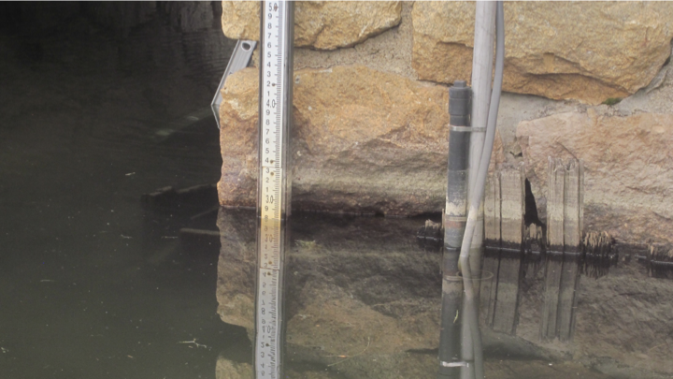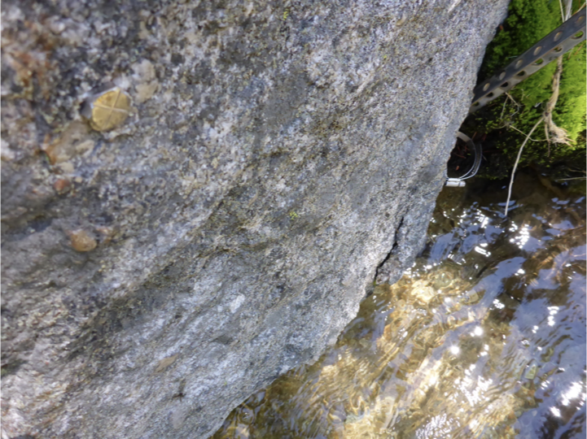
Figure 3 Methods for measuring stage. (Left) Staff plate and stilling tube at Tuolumne River at Highway 120 station (Right) Example of a tape down datum, in this case a bolt drilled into a boulder at the Budd Creek site. Photos from National Park Service.

Stream discharge, used to develop the rating curve of each site, is measured using three main methods: ADCP, ADV, and salt-dilution. When the channel is sufficiently wide and deep and/or when there are high flows for which wading across the channel would be dangerous, an ADCP boat is pulled along a fixed line to measure discharge. For shallow channels and low flows, a technician wades across the channel and uses a wading rod equipped with an ADV to measure channel depth and flow velocity at multiple points in the channel. The discharge is then approximated using these values. Finally, for backcountry field work where supplies are limited and weight is a concern, the salt dilution method is used to measure discharge.

The National Park Service (NPS), in collaboration with Jessica, currently oversees the operation and maintenance of the network. Each year, technicians in the park manually measure stage and discharge at each site (forming stage-discharge pairs), swap Barologgers and unvented Leveloggers, download data from vented loggers, survey site datums, and repair stations as necessary. The park maintains an internal database for the collected data.

Each year, Jessica sends a student to Tuolumne (and, whenever possible, makes an appearance herself) to procure the hydroclimate data and uphold the collaboration. Once the raw data has been obtained and before updated stream data can be published, several post-processing steps must be applied. Such steps are discussed in this document.

Motivation

Maintain long-term discharge time series for the Upper Tuolumne Watershed

For each site and year of available unprocessed data, convert raw stream stage time series to discharge time series for important tributaries, river stretches, and confluences in the Upper Tuolumne Watershed. Maintain a long-term record of stream discharge in the Upper Tuolumne Watershed by appending the post-processed data to previously published datasets.

This is achieved by translating stream stage time series to stream discharge time series using a rating curve.

However, the raw data used for this translation is often “messy” and must be organized, standardized, adjusted, and quality controlled.

In particular:
- Possible changes to stream morphology necessitate verifying the rating curve of each site is still accurate (and generating new rating curves as needed)
- High flows, ice dams (Figure 4), sensor malfunctions, and other disturbances can lead to spurious segments of data
- Many of the Leveloggers (pressure transducers) used in the park are “unvented”, so the level/stage time series must be “barocorrected” (must compensate for atmospheric pressure)
- Occasionally, variable names and units are inconsistent and must be standardized

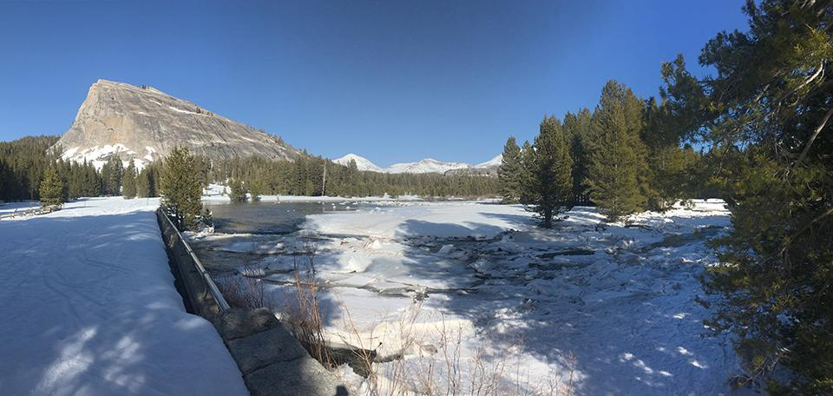
Figure 4 Ice dams, which form when water pools behind a wall of ice fragments, are common in the Tuolumne watershed and cause spurious spurious “spikes” in stream stage time series.

Generate a reproducible workflow for post-processing the Tuolumne stream data
Increasingly there is a mandate for open science, publicly available data and code, and scientific transparency. This workflow is designed so that all steps involved in post-processing the data are clearly documented and the post-processed data can be readily reproduced from the raw data.

Workflow Overview
- “Clean” the water level (stage) time series for each site

Input:
- Stream stage time series
  - Vented Solinst Levelogger time series (stream level, water temperature)
or
  - Unvented Solinst Levelogger time series (stream level, water temperature) & Solinst Barologer time series
- Barometric pressure time series
  - Using Solinst Barologger data
or
  - Using reanalysis barometric pressure data
- Site rating curve and stream discharge-stage pairs
- Supplemental data
  - Field Notes
  - Time Lapse Imagery
  - Met Station Data

Major steps
- Inspect the raw data
- Confirm that the data is in UTC
- Trim data to the times when it was actively deployed in the water
- Standardize the time series such that all samples fall on the hour or half-hour
- Barocorrection (compensation for atmospheric pressure in unvented Solinst Levelogger data)
- Flag Ice Jams
- Identify sensor shifts or malfunctions (and splitting of datasets as necessary)

Output: a .csv file with the following quantities will be generated for each contiguous
segment (period in the time series where there are no obvious sensor shifts):
- Date and time (UTC)
- raw pressure, cm (of water)
- barocorrected pressure, cm (of water)
- water temperature, degrees C
- discharge flag

- Once all sites and years have been processed, stitch consecutive years together and apply rating curve

First, verify rating curves are still accurate
- Plot rating curve and stage-q pairs from collection interval
- If considerable disagreement, generate new rating curve

Then, stitch (combine) stage time series together for all years of data

Finally, apply the rating curve to stitched time series

Output: a single .csv file with the following quantities will be generated (and will span the
entire period from which data was collected).
- date and time (UTC)
- vented pressure, cm (of water)
- raw pressure, cm (of water)
- barocorrected pressure, cm (of water)
- adjusted stage, cm (of water)
- estimated discharge, cms
- water temperature, degrees C
- discharge flag

Append to existing time series

Resources
- Tuolumne Hydroclimate Network
  - Jessica’s original paper introducing the dataset and hydroclimate network here
  - Jessica’s supplemental discussion of the network and overview of post-processing steps here
  - Previously published data and metadata available here
- Post-processing notebooks from 2019-2021 here
- Previous students or Yosemite employees who worked in Tuolumne

Citation
Lundquist, Jessica & Huggett, Brian & Roop, Heidi. Electronic Supplement to: Strategic use of stream stage recorders as proxy rain gauges in complex terrain For Water Resources Research Measurement Methods Issue 2008.

Lundquist, J. D., et al. (2016), Yosemite Hydroclimate Network: Distributed stream and atmospheric data for the Tuolumne River watershed and surroundings, Water Resour. Res., 52, 7478–7489, doi:10.1002/2016WR019261.

Analyst Guide
This section describes in greater detail the workflow recommended for processing stream data.

Foundations

Prerequisites
- Basic understanding of stage/discharge measurements and rating curves
- Basic knowledge of the command line/terminal
- Basic knowledge of Python and the conda package manager
- Basic knowledge of git and Github

Bookkeeping
Post-processing the Tuolumne stream data typically involves working with multiple years of data, multiple types of data, and data from multiple sites. Moreover, given the complexity of the post-processing workflow, inevitable roadblocks for given sites/years, and the demands of being a student-researcher, it is expected (as well as recommended) that the data is processed in chunks. Thus, bookkeeping—managing the complexity of the datasets and keeping track of progress—is perhaps the most important aspect of the work.

While analysts are free to devise their own methods/tools for bookkeeping, I implemented several strategies for staying organized.

Progress spreadsheet
Before post-processing the Tuolumne stream data, it is recommended the analyst builds upon the existing ‘Tuolumne Post-processing Status’ spreadsheet or create their own. Figure 5 depicts the spreadsheet used for post-processing data from years 2019-2021. The spreadsheet is useful for visualizing completed steps (red, yellow, green), missing or invalid data (black, X, and F), and/or steps that still need to be completed (O, D, J). Future analysts are encouraged to add columns for each year of data they process and modify the color/letter keys as needed. Note that the year in the table corresponds to the year the data was collected.

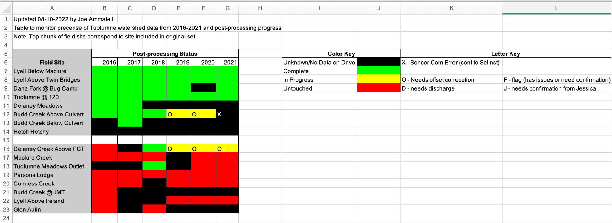
Figure 5 Progress spreadsheet used to visualize the post-processing status of data for each site/year.

Standardized data schema and directory structure
Raw data shared by the Yosemite Hydrology team is usually (a) preformatted with Solinst headers and metadata (b) compiled into a spreadsheet according to Yosemite conventions or (c) embedded in hand-written field notes. Moreover, file names and locations often vary from year to year or conform to Yosemite conventions. This complicates finding, loading, and manipulating the data—especially in an automated fashion.

I established conventions that standardize naming, units, headers, file formats, and directory structure for the entire workflow. Notebooks and code used through the workflow expect the data, files, and directories to be formatted according to such conventions.

The good news: I also implemented tools for reformatting the files and correctly initializing the directories. In particular, there is (1) a notebook that ingests all Solinst data (Level and Baro) and formats and names it correctly and (2) a notebook that auto-creates the correct directories and subdirectories.

The bad news: there are still some files and directories that need to be manually created/formatted from spreadsheets and field notes provided by the Yosemite crew.

Details regarding reformatting data and directory initialization are discussed more in the step by step guide below.

Post-processing logs and notes
For your own sanity and to simplify creating metadata down the line, it is important to document important/unique details for each dataset (e.g., obviously incorrect data, justification of whether or not a peak is due to an ice dam or not, wrong timezone, etc.).

Within key processing notebooks, I created cells where you can record notes, observations, and justifications for certain processing steps. Such comments are printed within the notebook and serve as a useful guide for current and future analysts.

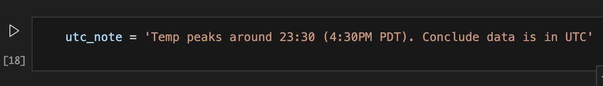
Figure 6 Example of note recorded in code cell so it can be printed within the notebook and automatically added to the log file for this site/year. Cell obtained from the notebook for the 2019 Solinst Levelogger data collected from the Tuolumne River at Highway 120.

Furthermore, I implemented a log system that, for each individual Solinst data set, auto-populates a .txt file with any important notes or variables from the post-processing. These .txt log files serve as a useful starting point for writing the metadata and provide a readable processing summary (see Figure 7 for an example). Independent personal notes may also be a good idea.

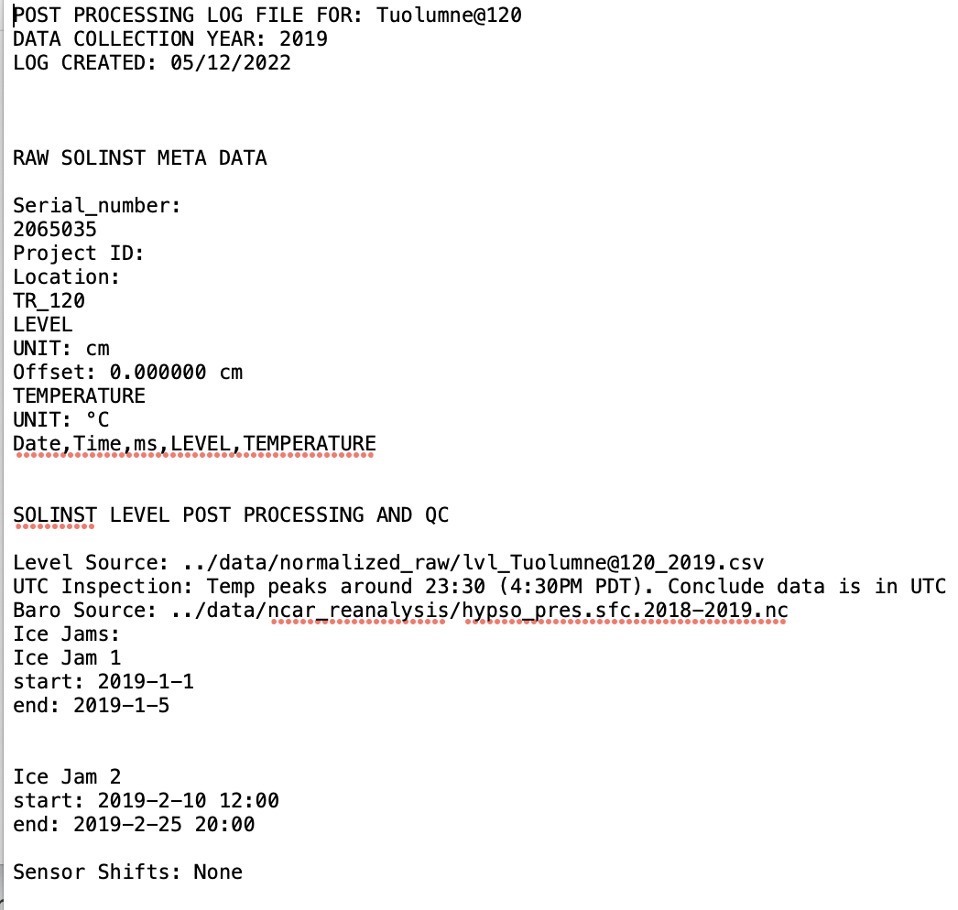
Figure 7 Example of a log file automatically created for the 2019 Solinst Levelogger data collected from the Tuolumne River at Highway 120. Notice that the note shown in Figure 6 is included in the log.

Post-Processing Toolkit
The Post-Processing Toolkit contains all of the Python code and notebooks used to implement the post-processing steps for the Tuolumne stream data. The toolkit includes a Jupyter notebook for each major step in the post-processing workflow: (1) reformatting the raw data (2) initializing directories for the workflow (3) inspecting barometric pressure data (4) inspecting Levelogger data (5) inspecting rating curves and stage-Q data and (6) stitching and offsetting Levelogger time series to generate discharge time series. The toolkit may take some time to get used to, but it is my hope the implemented features ultimately make life easier.

Repository
https://github.com/j-amma/tum_hydro_qc

https://github.com/Mountain-Hydrology-Research-Group/tum_hydro_postprocessing_2022

Design and features
Semi-automated → minimal coding required
The provided workflow is semi-automated in the sense that some analyst judgment, inspection, and input is required (e.g., for identifying ice dams) but all algorithms and functions are already implemented. That is, besides editing some parameter values and inspecting some plots, the analyst will not have to write any code and can simply “run” cells to get the desired output. When analyst input or edits are required, the variable, cell, or line of code is clearly labeled.

Templates
The toolkit includes a generalized “template” notebook for each major step in the post-processing workflow. For each site and year, the analyst simply makes a copy of the desired template notebook and customize it with the site/year specifics. This preserves consistency between notebooks for different sites/years without any tedious editing or copy-pasting.

Modular
All code used for loading, plotting, manipulating, and saving data is abstracted away into functions that are stored in util (utility) python files. This way, the analyst does not have to interact with implementation details and cannot accidentally change the function behavior. Moreover, when a function is modified, the change is reflected across all instantiations of the functions (i.e. across all notebooks).

Seamless data loading/saving
Once the raw data has been reformatted and conforms to the internal conventions, loading and saving time series data is accomplished with a simple function call and requires minimal interaction with data files themselves.

Seamless plotting and formatting
For most steps, there are a variety of pre-configured plots that facilitate inspection of the data. Information that describes a given dataset (site, name, year, etc.) is bundled into a data structure and used to effortlessly format plots and output files.

Built-in log functionality
The notebooks incorporate a log system that, for each individual Solinst data set, auto-populates a .txt file with important notes and variables from the post-processing. These .txt log files serve as a useful starting point for writing the metadata and provide a readable processing summary.

Reproducible
Once a notebook has been completed, any generated output can be readily reproduced (and old data will be overwritten) by re-running all cells in the notebook. Moreover, the workflow saves all data from intermediate steps. The net result is that there is redundancy in the workflow (less chance of losing data) and adjustments can be made to data without starting from the beginning of the procedure. However, if you make changes to a notebook, it is very important to re-run all cells in the notebook where the change was made and all subsequent notebooks!

Code organization
Python source code and Jupiter notebooks are organized into the following directory structure (key: directories, filenames, [description]):

/tum_hydro_qc [code repository]
/init [notebooks for initializing output directories and raw data]
dir_setup.ipynb [for initializing output directories]
normalize_level_baro.ipynb [for reformatting raw data]
/src [all Python source code (functions, constants, etc.) used within notebooks]
config.py [python file with formatting constants, rating curve definitions, etc.]
level_baro_utils.py [python file with functions for Level/Barologger data]
log_utils.py [python file with functions used for creating logs]
/templates [template notebooks that facilitate post-processing steps]
baro_prep_template.ipynb [for choosing/inspecting barometric pressure dataset]
combine_datasets_template.ipynb [for merging new and published datasets]
rating_curve_assessement.ipynb [for inspecting stage-q pairs and rating curve]
solinst_levelogger_postprocessing_template.ipynb [for cleaning level time series]
timeseries_stitching_template.ipynb [for combing and offsetting level time series]
vented_postprocessing_template.ipynb [for cleaning vented level time series]

The /init directory contains notebooks for initializing the output directories and raw data. Analysts will use both notebooks in this directory.

The /src directory contains all Python source code (i.e., functions, constants, etc.) used within notebooks. In general, analysts will not need to touch these files. However, if a bug arises within a notebook or an analyst wishes to modify the internal conventions, formatting variables, or the rating curve definitions of each site, the analyst may need to inspect and/or edit functions in the level_baro_utils.py file and config.py files, respectively.

The /templates directory contains all the notebooks that facilitate the post-processing steps. Analysts will use all of the notebooks in this directory. For each site and/or year of data, the analyst will make a copy of the appropriate template notebook, place it in the appropriate notebook output directory, and complete all of the steps in the notebook.

Conventions
I implemented several conventions to (a) simplify working with the raw data (b) make files and plots more readable and (c) enable customization of template notebooks. Such conventions are discussed below and implemented in the config.py file.

Year description
Because data collection usually falls in the middle of a water year, I tend to describe Tuolumne data by the year it was collected. For example, a file called ‘lvl_BuddCreek_2019.csv’ contains Levelogger data for Budd Creek collected in summer 2019 (and thus including data from both 2018 and 2019). In some cases, e.g. for a plot, I define a variable called ‘span’ which describes the range of years the data covers. In the example above, span=’18/19’.

File names
- Reformatted (normalized) raw data:
{sensor_type}_{sitename}_{year}.csv
  - sensor_type: lvl (Levelogger) or baro (Barologger)
  - sitename: abbreviated site name
  - year: collection year
- Baro-corrected (trimmed, flagged) Levelogger data: {site}_{year}_barocorrected_{segment}.csv
  - site: abbreviated site name
  - year: collection year
  - segment: integer number, needed when a time series is split into multiple segments due to a sensor malfunction or shift
- Vented (trimmed, flagged) Levelogger data:
{site}_{span}_vented_{segment}.csv
  - site: abbreviated site name
  - span: years the time series covers
  - segment: integer number, needed when a time series is split into multiple segments due to a sensor malfunction or shift
- Final Output:
- {site}_timeseries_stage_Q_T_{start}_{end}.csv
  - site: abbreviated site name
  - start: first year for which there is data
  - end: last year for which there is data
- Final Output Metadata:
{site}_timeseries_stage_Q_T_{start}_{end}_metadata.txt
  - site: abbreviated site name
  - start: first year for which there is data
  - end: last year for which there is data

Data file headers
- Reformatted Raw Levelogger Data: [lvl_cm, temp_C]
- Reformatted Raw Barologger Data: [baro_cm, temp_C]
- NCAR Reanalysis Barometric Pressure: [baro_cm]
- Baro-corrected (trimmed, flagged) Levelogger data: [date_time(UTC:PDT+7), raw_pressure(cm), barocorrected_pressure(cm), water_temperature(deg_C), discharge_flag]
- Vented (trimmed, flagged) Levelogger data: [date_time(UTC:PDT+7), vented_pressure(cm), water_temperature(deg_C), discharge_flag]
- Final Output = [date_time(UTC:PDT+7), raw_pressure(cm), barocorrected_pressure(cm), adjusted_stage(cm), estimated_discharge(cms), water_temperature(deg_C), discharge_flag]

Data units
UW Mountain Hydro tends to use metric units while the Yosemite Hydrology team tends to use standard units.

- Stage
  - Yosemite records stage in feet (ft)
  - Mountain Hydro rating curves expect stage in meters (m)
- Discharge
  - Yosemite records in cubic feet per second (cfs)
  - Mountain Hydro rating curves output discharge in cubic meters per second (cms)
- Solinst Levelogger: records stage (pressure) in cm H₂O (abbreviated as cm in headers)
- Solinst Barologger: records atmospheric pressure in either cm H₂O or kPa
- Temperature: both teams use degrees celsius
- Timezone: raw data varies, final data in UTC

Discharge flags
Unusual or spurious data is marked with a numeric discharge flag. So far flags have been defined for unknown anomalies (flag=1), ice dams (flag=2), and apparent sensor malfunctions (flag=3).

Sitenames and sitecodes
Site names—whether recorded in field notes, file names, metadata, or documents—can take a variety of forms for the same site. To minimize confusion and promote automation loading/saving of datafiles, I have tried to standardize how sites are described. For each site I defined both a “long” and “short” sitename. The “long” name is the complete name (intended for documentation and plots). The short name is an abbreviated name (intended for file names).

I have additionally assigned a sitecode (integer number) to each site, which is an unambiguous way of describing and identifying a site. Site codes were assigned from upstream to downstream.

Table 1: Site Descriptors
Sitecode | Long Name | Short Name
0 | Lyell Below Maclure | LyellBlwMaclure
1 | Lyell Above Twin Bridges | LyellAbvTB
2 | Dana Fork at Bug Camp | DanaFk@BugCamp
3 | Tuolumne River at 120 | Tuolumne@120
4 | Budd Creek | BuddCreek
5 | Delaney Above PCT | DelaneyAbvPCT

Note: The Yosemite crew does not manage the Hetch Hetchy data, so there is no post-processing to worry about here.

Sites of Interest In Tuolumne/Yosemite Network
Jessica is interested in maintaining long term records for a subset of the stream gauging sites in the greater Yosemite network. Often when data is copied from the Yosemite data repository to the UW repository, data for all sites is included. Thus, analysts should only be concerned with data from the sites Jessica cares about and can essentially disregard the other data.

Sites/datasets Jessica cares about maintaining
- Lyell Below Maclure
- Lyell Above Twin Bridges
- Dana Fork @ Bug Camp
- Tuolumne @ 120
- Delaney Creek
  - Note: the gauging station moved in 2017
    - Delaney Creek Above PCT: 2018 and beyond
    - Delaney Meadows: pre 2018
- Budd Creek
  - Note: the gauging station moved in 2017
    - Budd Creek Above Culvert: 2018 and beyond
    - Budd Creek Below Culvert: pre 2018
- Hetch Hetchy

Note: In some cases, (i.e. for Lyell Above Twin Bridges and Budd Creek), stream data was collected at both an “upstream” and “downstream” location near the gauging station. Over time, either the “upstream” or “downstream” location was observed to have more robust data and was adopted as the definitive data source. Moreover, some gauging stations (e.g., Delaney Meadows) yielded poor results due to environmental factors (e.g., bank erosion) and were relocated. Thus, you will notice subtle differences in the names/metadata between the original sites and current sites for Lyell Above Twin Bridges, Budd Creek, and Delaney Creek.

Note: The Yosemite crew does not manage the Hetch Hetchy data, so there is no post-processing to worry about here.

Other sites/datasets from in/around Tuolumne that are often bundled with the above sites that can be disregarded
- Maclure Creek
- Tuolumne Meadows Outlet
- Parsons Lodge
- Conness Creek
- Budd Creek @ JMT
- Lyell Above Ireland
- Glen Aulin

Description of Noteworthy Steps
Below I will discuss and illustrate some of the steps that require analyst judgment.

Trimming datasets
Each summer, deployed unvented Leveloggers are swapped with fresh Leveloggers so that (1) data can be downloaded from the deployed instruments and (2) an instrument with a new battery and no-known issues can be deployed for the coming year. Typically the fresh logger is launched (and begins logging) at the Bug Lab prior to being transported and deployed at the field site. Similarly, when a logger is withdrawn from a site, it continues logging until the data is downloaded back at Bug Lab. Thus, there are segments of the time series that measure ambient pressure and therefore must be removed.

The trimming step involves removing the data before/after an instrument enters/exits the water. Yosemite field technicians usually make note of the time when an instrument is deployed/removed, so the field notes are a good starting point. However, sometimes the recorded time is not exact or has an unspecified time zone. Therefore, the analyst must visually inspect the time series to find the periods when the instrument is out of the water.

Fortunately, the time series typically shows an abrupt change in both pressure and temperature when the instrument enters/exits the water. Thus, the analyst simply has to inspect the first/last couple of data points to find the segments to trim.

For example, consider the raw time series from Delaney Above the PCT collected in summer 2019.

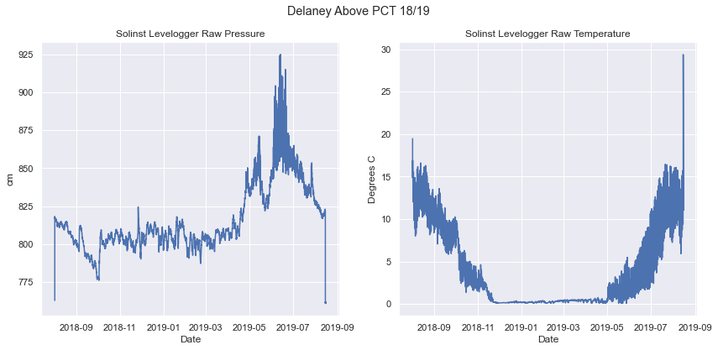
Figure 8 Raw time series from Delaney Above the PCT (18/19).

Notice how the pressure and temperature time series have distinct tails at both ends. When we zoom in, we can use the pressure and temperature time series together (usually one is more obvious) to find the exact shift.

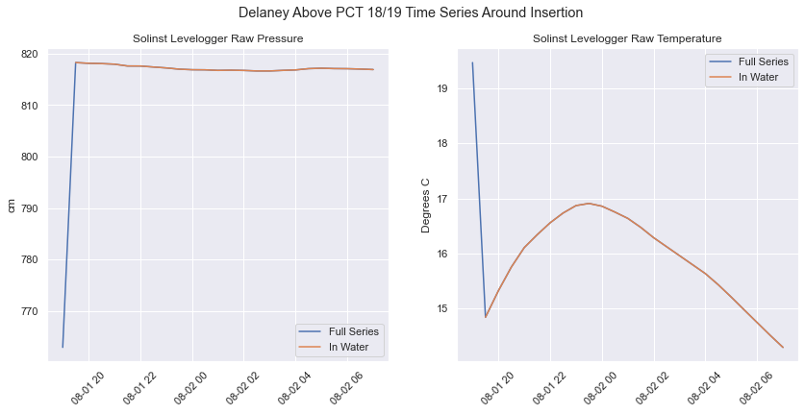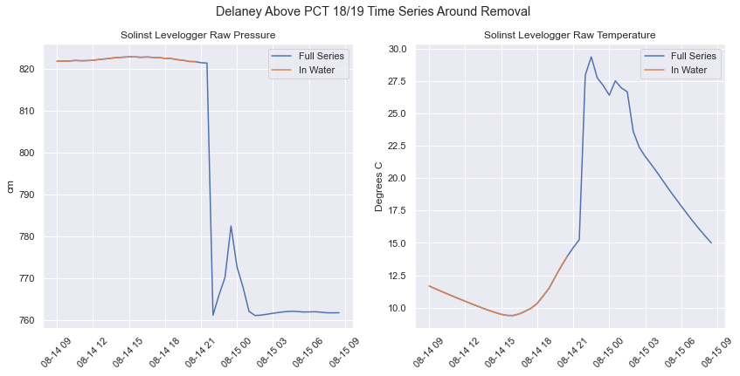
Figure 9 (Left) Beginning of time series and (Right) end of time series. The change of the line color from blue to orange shows when the sensor was placed in the water (and vice versa when it was removed).

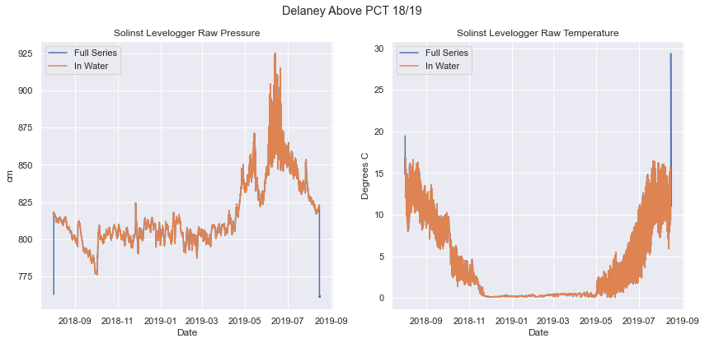
Figure 10 Delaney Above the PCT (18/19) time series after tails deployment/removal have been identified but before it has been trimmed.

Ice dams, rain events, and melt (with examples)
When inspecting the Levelogger time series, it is not uncommon to observe large spikes in pressure (relative to adjacent segments of data or the series as a whole). Sometimes these spikes reflect actual increase in discharge due to melt or precipitation and therefore should be treated as valid spikes. Other times, the spikes arise due to sensor malfunctions or pooling of water behind ice dams (see Figure 4), which do not correspond to increases in stream discharge, and therefore need to be flagged. In what is perhaps the most challenging step of the post-processing workflow, the analyst must manually inspect unusually large spikes and flag them when necessary. Note: we do not actually remove the spikes; rather, we add a numeric flag to the dataset that indicates when a segment is suspect.

Differentiating spikes due to ice dams, rain events, and melt can be very challenging, especially because two or more processes may be happening at once. Table 2 lists characteristics of each type of spike. Other useful resources include: Jessica (she really likes judging these plots and is super good at it), time lapse imagery (to look for ice dams or other disturbances), temperature and precipitation data from nearby meteorological stations (to consider melt and precip.), and time series from upstream and downstream sites (to look for similar spikes).

Table 2: Characteristics of Various Spikes in Pressure
 | Ice Dam | Rain Event | Melt Event | Sensor Malfunction
Timing | Usually during the winter moths, but can occur in fall and spring | Any time | Largest melt observed in the spring, but smaller melt events can occur any time | Any time
Magnitude | Usually very large (often as big as or bigger than the peak spring runoff) | Obviously larger than adjacent segments, but small compared to seasonal trends and spring runoff | Peak spring runoff should be the largest spike in the time series, smaller melt events may be only subtly larger than nearby diurnal swings | Usually abrupt large change in magnitude
Duration | Hours to days, usually longer than a spike due to a rain event | Hours to days | Hours to days to weeks (seasonal) | Usually shows obviously incorrect data for the rest of the series
Profile | Often has sustained large magnitude, jagged | Should see an exponential decay in the spike | Varies | Often very noisy or has a jump discontinuity

Examples

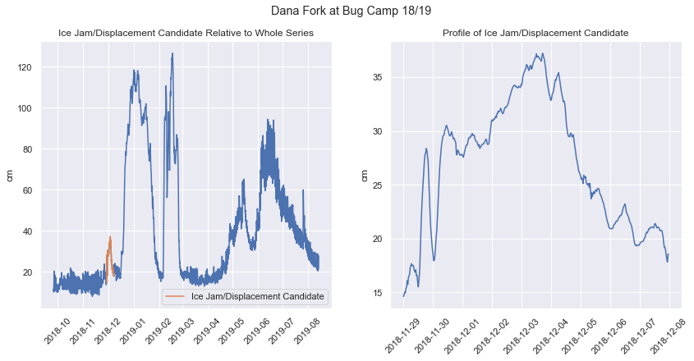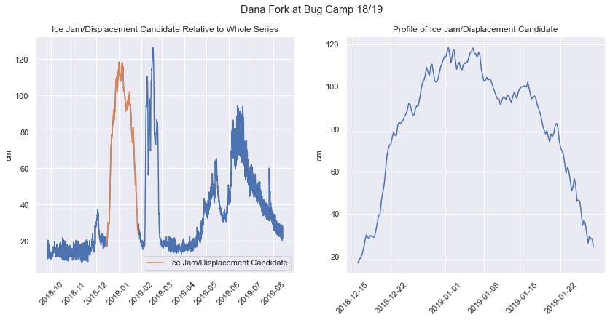
Figure 11 Selected example spikes from Dana Fork at Bug Camp (18/19). The first example (left) was deemed to be a rain event due to the exponential decay and relatively small magnitude. The second example (right) was deemed to be an ice jam due to the large duration and magnitude.

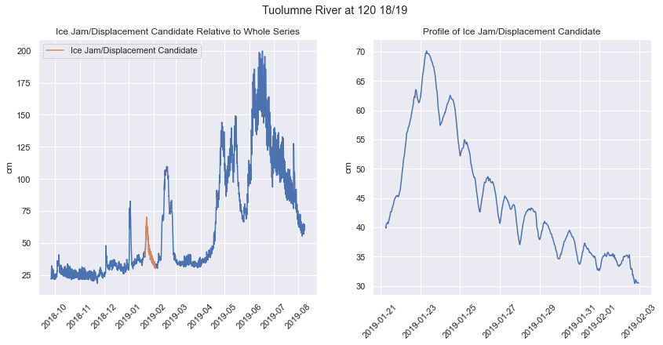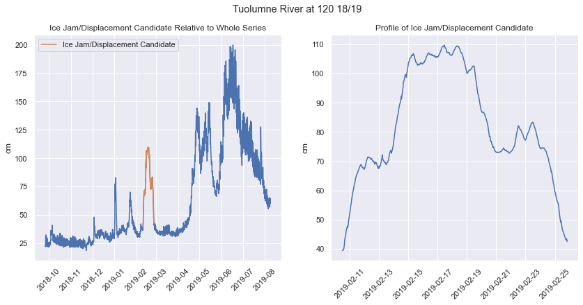
Figure 12 Selected example spikes from Tuolumne River at highway 120 (18/19). The first example (left) was deemed to be a rain event due to the clear exponential decay. The second example (right) was deemed to be an ice jam due to the duration and unusual “stepped” profile. Notice here that the magnitude of the rain event and ice dam are similar, so other criteria were used.

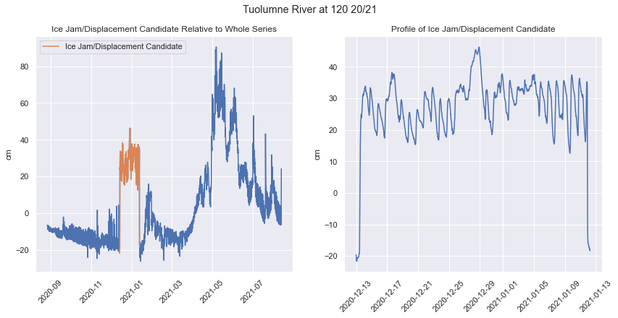
Figure 13 Selected example spike from Tuolumne River at Highway 120 (20/21). The spike was deemed to be an ice jam due to the prolonged nature and jagged top.

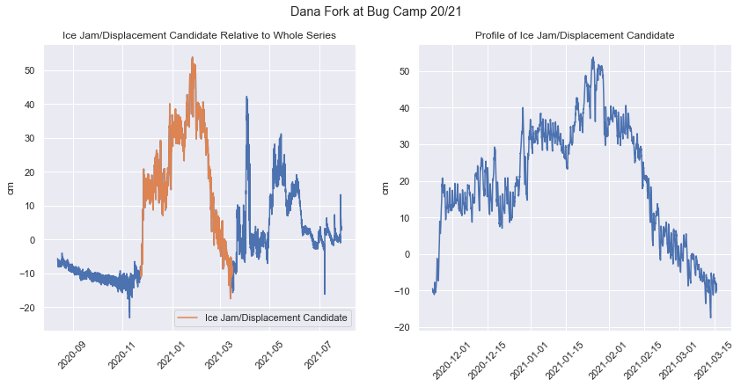
Figure 14 Selected example spike from Dana Fork at Bug Camp (20/21). The spike was deemed to be an ice jam due to the large magnitude (larger than spring melt!) and huge duration.

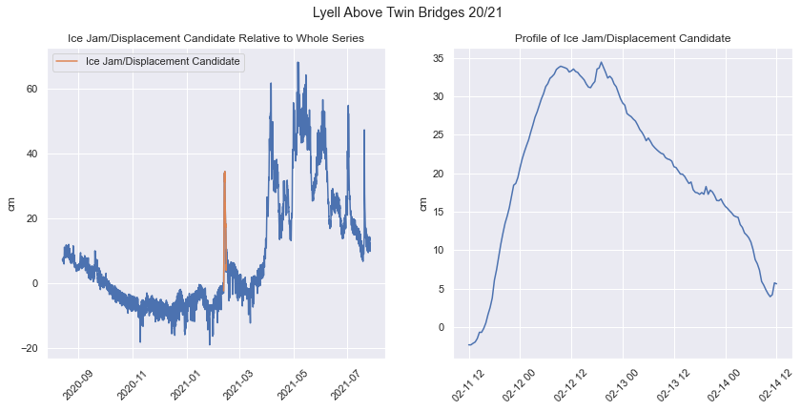
Figure 15 Selected example spike from Lyell Above Twin Bridges (20/21). The spike was deemed to be a dual rain/early season melt event after some deliberation. The spike duration is probably too small to be an ice jam. Time lapse imagery at Dana@Bug for the same time interval does not reveal any obvious melting, but air temperature at TUM snow tower at that period in time shows a slight warming trend and the spikes coincides with a precip.

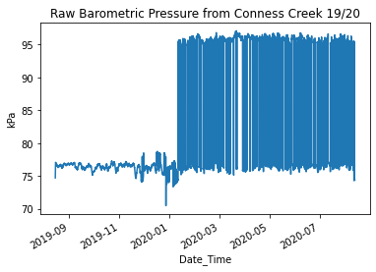
Figure 16 Selected sensor (Barologger) malfunction example from Conness Creek (19/20). Notice how the malfunction continues for the rest of the series.

Splitting datasets
Occasionally there is a disturbance at a field site that causes a Levelogger to become displaced but not damaged. When this happens, the logger still correctly captures natural variations in stream level (stage) but has some constant offset relative to the rest of the time series. The data before and after the shift is still useful, but the time series must be split into two segments so that different offsets can be applied during the stitching and offsetting step. Figure 17 depicts a sensor shift that occurred at Dana Fork at Bug Camp (20/21). Notice the distinct sharp decrease in pressure over a 30-minute interval that suggests some kind of disturbance occurred.

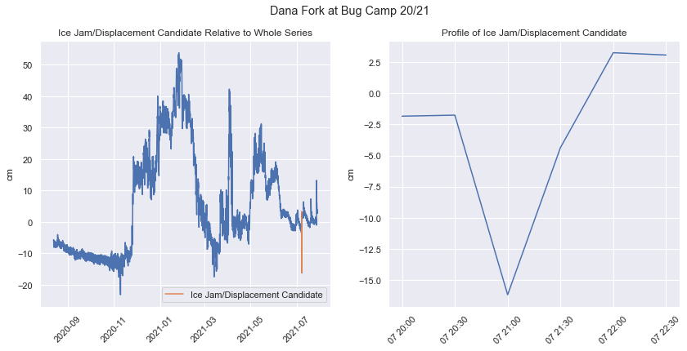
Figure 17 Apparent sensor shift at the Dana Fork at Bug Camp site (20/21).

Offsetting and stitching datasets
Once all Levelogger data has been cleaned, (1) the Levelogger time series (or segments if data from one year was split) must be offset so they capture stream stage on the same scale used for manual stage measurements and (2) the time series from each year must be stitched together to create one continuous time series.

I found the offsetting step to be somewhat confusing, so I will try to motivate in greater detail here.
- Leveloggers measure changes in pressure in the water column (and atmosphere) in units of cm H₂O. Therefore, there is an equivalence between changes in pressure and the level of the stream (i.e. Leveloggers measure the height of the stream with respect to the instrument).
- Field technicians measure stage (the level of the water) with respect to some reference point (e.g. a tape down bolt or a staff plate). Rating curves are developed using these stage measurements.
- Both measurements capture the height of the water, but with respect to different reference points.
- To get the measurements to match (i.e. to get the Levelogger measurements to match manual stage measurements), the Levelogger time series must be offset by some constant amount.

In theory, after offsetting each individual time series, the data from each year should line up. However, due to time gaps between the end of time series and error in manual stage measurements, this is often not the case. Typically the stitching and offsetting steps need to be completed in tandem to get the time series to line up and closely match manual stage measurements. It becomes an art as much as a science.

There are several strategies for offsetting and stitching the datasets (in order of preference).
- When possible, offset the time series so that it aligns with the previous year of data. Note, this strategy only works if the previous year of data was correctly offset (e.g., if the previous year of data was from a published data set).
- For each manual stage measurement, compute the difference between the manual stage measurement and the corresponding data point in the time series. Offset the Levelogger time series by the mean or median difference.
- As needed, visually/qualitatively adjust the time series so they “fit” both the manual measurements and adjacent time series.

Note: When possible, it is best to the vented datasets since they span a greater period of time and require less stitching.

Review the examples here to get a better idea of the stitching/offsetting process.

Stuck? Try these things
- Refer to previously published notebooks, datafiles, and metadata available here
- Reach out to someone who works/has worked in Tuolumne
  - Joe Ammatelli
  - Rachel Hallnan
  - Hannah Besso
- Reach out to Jessica
- Refer to the Site History Notes section for more context

Step by Step Guidance

1. Getting Set Up
Note: examples illustrating directory structure continue to the color convention previously used. /<dir_name> denotes a directory, indents denote a subdirectory, and files are written in plain text.

1a. Create progress spreadsheet
Create some sort of document that clearly shows what phase of post-processing you are at for each site/year. Refer to the “Bookkeeping” section of this document for a discussion of the progress spreadsheet I used.

1b. Create project directory
Create a project directory (folder) in a convenient place on your computer and give it a descriptive name. This directory is where you will store all data and code used for the post-processing workflow. For example, if you’re processing data collected in 2019, 2020, and 2021, you’re project directory might be

/tum_qc_19-21

1c. Configure Python environment
Create a new conda environment for the project. Activate the environment and add the following packages (version shouldn’t matter): numpy, pandas, xarray, matplotlib, seaborn. If you are using Jupyter Notebook, also install the package ‘notebook’. Note that you will need to activate this environment every time you work with the notebooks.

There are lots of resources on the web for creating and activating conda environments and installing packages. Consider starting here if you are not familiar.

1d. Clone code repository
In the terminal, navigate to your project directory and clone the Tuolumne post-processing toolkit repository with the following command:

git clone https://github.com/j-amma/tum_hydro_qc.git

Now, within the project directory you should see a new subdirectory called /tum_hydro_qc that contains all of the source code and template notebooks. Continuing the example above, it will look like:

/tum_qc_19-21
/tum_hydro_qc
/init
…
/src
…
/templates
…

1e. Initialize directories
Open the dir_setup.ipynb file in the /init subdirectory. Follow the instructions in the notebook and run all of the code cells. This notebook will create directories used for storing all notebooks, input data, and output data. In particular, a directory will be created for each year of data. After running the notebook, the project directory will look something like:

/tum_qc_19-21
/tum_hydro_qc
/compiled_data
/published
/stage
/stageQ
/init
…
/output
/data
/metadata
/notebooks
/ratingcurve
/stitch_discharge
/data
/notebooks
/src
…
/templates
…
/unvented_2019
/barocorrected
/normalized_raw
/raw
/unvented_2020
/barocorrected
/normalized_raw
/raw
/unvented_2021
/barocorrected
/normalized_raw
/raw
/vented
/data
/notebooks

1f. Prepare datasets

Unvented level and baro time series
Within the project directory, create a directory for each year of raw data. For example, if you have data collected in summers 2019, 2020, and 2021, your project directory might look something like this:

/tum_qc_19-21
/tum_hydro_qc
…
/tum_raw_19
/tum_raw_20
/tum_raw_21

Then, for each site of interest (see list above), make a copy of the raw Levelogger data file provided by Yosemite and put it in the corresponding raw data folder. Also copy over all Barologger files. Note that at this point, all files will have the original name given by the Yosemite staff. Continuing the example above (and only illustrating the contents of the /tum_raw_21 directory)

/tum_qc_19-21
/tum_hydro_qc
…
/tum_raw_19
…
/tum_raw_20
…
/tum_raw_21
BugLabBaro_Barologger_20210812.csv
ConnessCrk_Barologger_20210812.csv
DanaFrkBugCamp_Levelogger_20210728.csv
DelaneyCrkAbvPCT_Levelogger_20210726.csv
LyellAbvTwinBridges_Levelogger_20210726.csv
LyellBlwMaclure_Barologger_20210811.csv
LyellBlwMaclure_Levelogger_20210811.csv
Tuolumne120_Levelogger_20210812.csv

Vented level datasets
Copy all vented Levelogger datasets over to the /<project_name>/tum_hydro_qc/vented/data/raw/ directory. Generally these datasets will have a name of the form <sitename>_<ID>_T15min_<collection date> and will have file type .dat or .txt.

For example:
- DanaFk._297_T15min_20210707.txt
- Tuolumne120_324_T15min_20210812.dat

Stage and Stage-Q Pair Spreadsheets
Stage-discharge pairs collected by Yosemite technicians are compiled into an excel spreadsheet (in previous years it was called TM_Streamgaging_Tracker_<year>.xlsx) that, unfortunately, can be difficult to parse and query in Python. Furthermore, there is typically no spreadsheet that includes all stage measurements collected in the field.

Thus, the analyst needs to create several new data files.
- For each year of data, create a .csv file (or spreadsheet that you save as a .csv) that stores the following tuples: Site Name, Field visit date, Field task, Q Method, Stage (ft), Measured Q (cfs), Gage maintenance notes. This data is used to validate the rating curves. Transfer the appropriate data from TM_Streamgaging_Tracker_<year>.xlsx to this new spreadsheet. For the “Site Name” column, make sure to store the short site name (needed for reading the data). Give the file a descriptive name, and store it in

/<project_name>/tum_hydro_qc/compiled_data/stageQ/tum_stageQ_<year>.csv

For example, stage-Q pairs for the year 2020 would be compiled as follows, as shown in Figure 18.

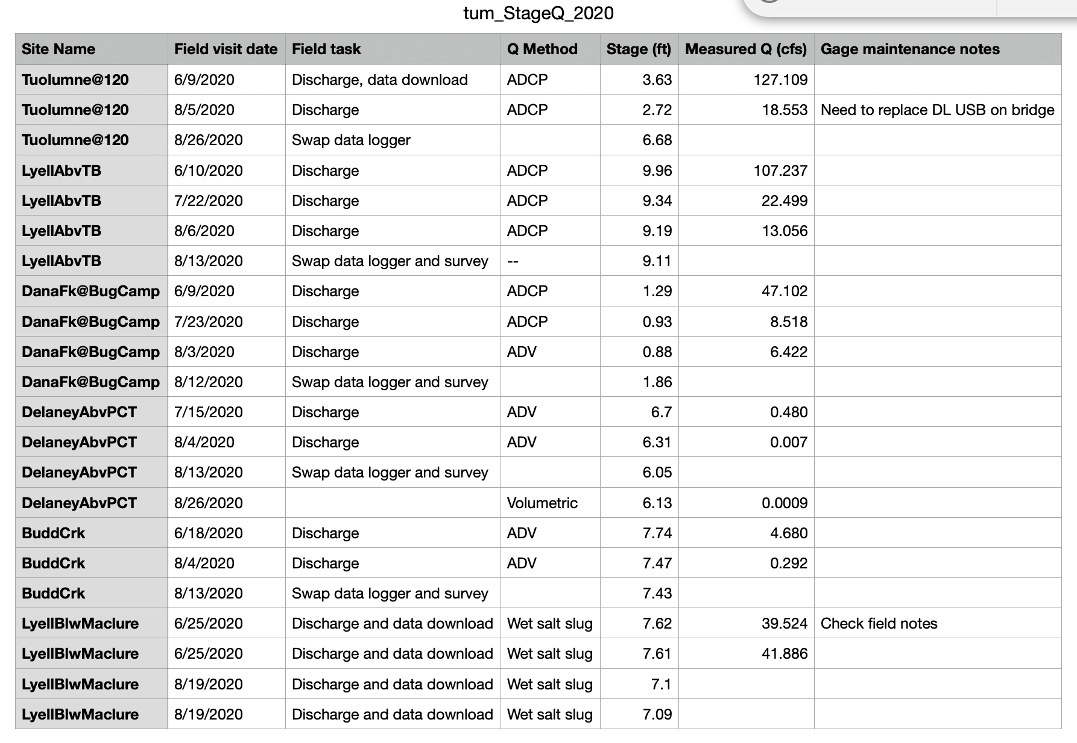
Figure 18 Example of stage-Q pair spreadsheet.

- Create a .csv file (or spreadsheet that you save as a .csv) that stores all stage field measurements and has the following headers: site, date, time (pdt), stage (ft), notes. Note: There may be an existing spreadsheet that you can simply append new data (the one I created is called stage_19-21.csv and is located in the /compiled_data/stage directory)! Now take a deep breath, because the next step is tedious. Manually go through all available field notes (from all years of data) and compile the stage measurements into this spreadsheet. Save the file in:

/<project_name>/tum_hydro_qc/compiled_data/stage/tum_stage_<timespan>.csv

For example, Figure 19 shows how you would compile stage data.
Note: this example does not show data for all sites, but yours should!

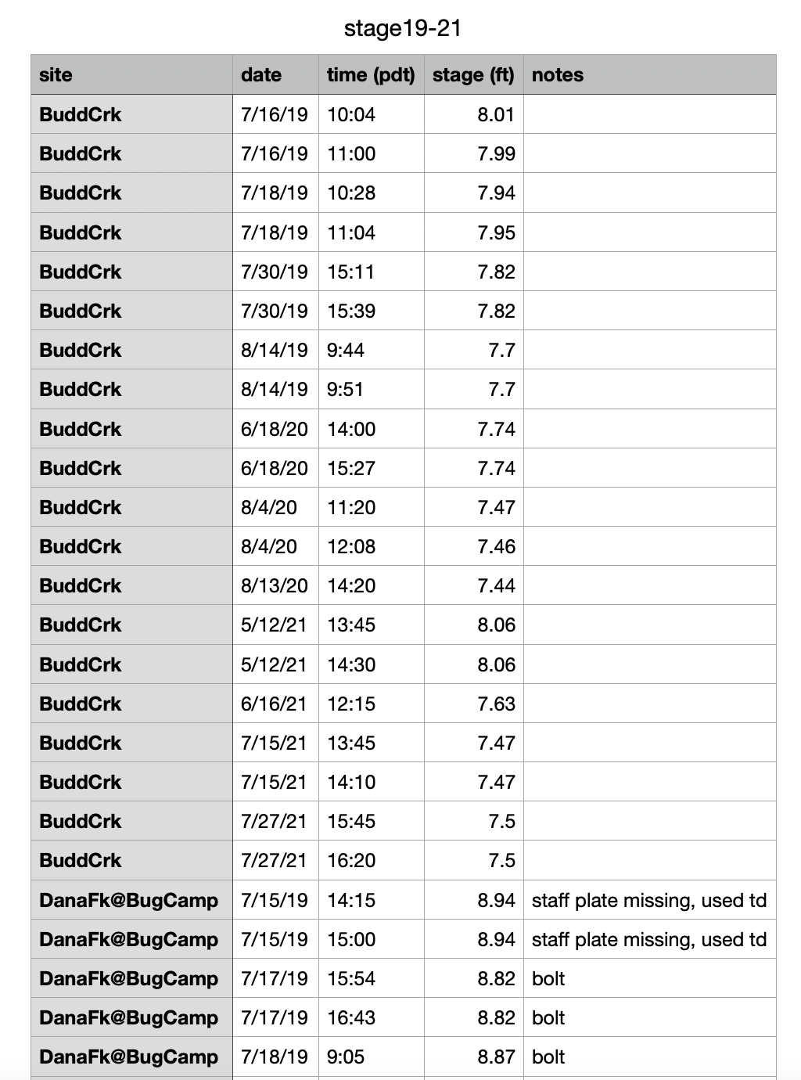

Figure 19 Example of how to compile stage data.

1g. Standardize raw data
Open the normalize_level_baro.ipynb file in the /init subdirectory. Follow the instructions in the notebook and run all of the code cells. This notebook will ingest the raw Solinst data and reformat it so that it conforms to the workflow conventions and is easier to work with. The notebook will also create a log .txt file for each input file and will store the original file metadata there. After running the notebook, verify that the raw input data, reformatted data, and logs have been correctly added to the /raw, /normalized_raw, and /log subdirectories, respectively, of each /unvented_<year> directory that was created in step 1e. At this point, the project directory has been set up, all data files are correctly formatted and located in the expected directory and you are ready to start cleaning the data.

2. Process Vented Stage (Level) Time Series
Begin by cleaning any available vented solinst data. When possible, it is desirable to append the vented time series to the published dataset because (1) you don’t have to deal with any baro-correction shenanigans, which often involve some amount of approximation or theoretical correction, and (2) the data spans multiple years, so you do not need to stitch and offset multiple segments. Unfortunately, not all sites have vented loggers, and the vented loggers are still susceptible to malfunctions, so you will still have to complete step 3.

For each vented dataset, make a copy of the vented_postprocessing_template.ipynb notebook. Replace the notebook name with <short site name>_vented_postprocessing.ipynb and move it to the /<project_name>/tum_hydro_qc/vented/notebooks/ directory.

For each notebook, follow the instructions and run all of the code cells. Verify the output is saved in the /<project_name>/tum_hydro_qc/vented/data/processed/ directory.

Refer to the Foundations section for a discussion of flagging ice jams and splitting the datasets.

3. Process Unvented Stage (Level) Time Series

3a. Choose year of data to process
I recommend processing one year of data at a time (i.e., all sites from the same collection campaign). This is advisable because (1) you don’t have to jump between different barometric pressure datasets and (2) cross-referencing sites from the same year can be useful for identifying spurious data segments.

3b. Choose barometric pressure data
Next, choose a barometric pressure data set to use for baro-correction.

Start by seeing if there is a suitable Barologger dataset. Often Jessica prefers using the same barometric pressure time series for the baro-correction step of all sites from a given year. Thus, if this is the case, in order to use one of the available Barologger datasets, it must not have any obvious errors and must span (i.e. start before and end after) the Levelogger time series from each site. If no such Barologger time series exists, have a conversation with Jessica about how you should proceed. One option would be to use several Barologger datasets. Another option would be to use reanalysis pressure data for the region.

The baro_prep_template.ipynb notebook facilitates choosing your barometric pressure dataset.
Make a copy of the notebook, replace the notebook name with baro_prep_<year>.ipynb and move it to the /<project_name>/tum_hydro_qc/unvented_<year>/notebooks/ directory.

Open the notebook and follow the instructions.

3c. Process time series for each site
Once you have a barometric pressure time series, you are ready to start cleaning the Levelogger data.

For each unvented dataset, make a copy of the solinst_levelogger_postprocess_template.ipynb notebook. Replace the notebook name with
<shortname>_solinst_levelogger_postprocess.ipynb and move it to the /<project_name>/tum_hydro_qc/unvented_<year>/notebooks/ directory.

Follow the instructions and run all cells to complete the notebook. Verify the output is saved in the /<project_name>/tum_hydro_qc/unvented_year/data/barocorrected/ directory.

Refer to the Foundations section for a discussion of trimming, flagging ice jams, and splitting the datasets.

3d. Update progress spreadsheet
Keep track of your progress as you go. Make note of what step you are on for each site.

3e. Repeat 3a-3c for all years of unprocessed data

4. Inspect Rating Curves and Stage-Q Pairs
At this point you have successfully inspected and cleaned all (unvented and vented) Levelogger time series data. Before you can use the previously established rating curves to convert the stage time series to discharge time series, you need to verify the rating curves are still valid. One way to do this is to plot stage-Q pairs on top of the rating curve to visually assess if the curve correctly describes the pairs. This is why you painstakingly compiled all the stage-Q pairs in step 1f!

Make a copy of the rating_curve_assessment_template.ipynb. Replace the notebook name with
rating_curve_assessment_<startyear>-<endyear>.ipynb and move it to the /<project_name>/tum_hydro_qc/ratingcurve/ directory. This notebook loads data you compiled in step 1f and plots it with the established rating curves, which were copied from a previous report and generated using the BaRatin rating curve software. Follow the instructions in the notebook and run all the cells. If a rating curve does not adequately represent the stage-Q relationship, have a discussion with Jessica about how to proceed. Also refer to the previously conducted rating curve analyses for additional stage-Q data and clues on how the rating curve may be evolving. Field notes and discussions with Yosemite Hydro staff about disruptive events (e.g., a change in channel morphology due to a large flood) may also lend clues about whether the rating curve is valid. To change a rating curve, edit the appropriate function definition in the config.py file located in the /src directory.

5. Stitch and Offset Time Series, Convert Stage to Q
Finally, the time has come to generate a discharge time series using the quality-controlled Levelogger data and the verified rating curves. Refer to the foundation section for a complete discussion of approaches for stitching and offseting the time series.

For each site, make a copy of the timeseries_stitching_template.ipynb notebook and place it in the /<project_name>/tum_hydro_qc/stitch_discharge/notebooks/ directory. Name each notebook <short_site_name>_<start_year>-<end_year>_stitching.ipynb.

For each site/notebook, follow the instructions and run all cells to complete the notebook. Verify the output is saved in the /<project_name>/tum_hydro_qc/stitch_discharge/data/processed/ directory.

For a sanity check, you can compare the sum of discharge from upstream sites to the discharge of a downstream site.

6. Append Time Series to the Previously Published Dataset
The last remaining “processing” step is to combine the old and new datasets.

For each site, make a copy of the combine_datasets_template.ipynb notebook and place it in the /<project_name>/tum_hydro_qc/output/notebooks/ directory. Name each notebook <short_site_name>_combine_datasets.ipynb.

For each site/notebook, follow the instructions and run all cells to complete the notebook. Verify the output is saved in the /<project_name>/tum_hydro_qc/output/data/processed/ directory.

7. Generate Metadata
In order to publish the new datasets, you need to generate metadata for each site/dataset. The contents of the metadata vary from platform to platform, and thus there is no template notebook for this step. However, for the 2019-2021 data, I created a notebook (see here) that automates the generation of metadata since there is considerable redundancy between the metadata files for each site. This could be a good starting point if you need to generate similar metadata files.

8. Save and Publish Data
Ensure the data is saved in a safe place (ideally more than one). Ask Jessica if she would like a copy. Have a discussion with Jessica about where/how to publish the dataset.

Create a repository in the UW Mountain Hydro Github for the project repository so all notebooks can be referenced.

Site Notes
Add updates and details regarding status and changes here.

Lyell Below Maclure
- Water year 2008 is missing due to a failed instrument.
- Starting late in water year 2012, a vented pressure transducer was also installed at the site.
- The channel cross-section is not believed to have changed during the period of record.
- Our corrected pressure, with associated offsets, is referenced to the 10 minus tape down from the 2015 bolt (most recent operational practice), in units of ft. (long history before that)

Lyell Above Twin Brides
- Previously, both a downstream and upstream site were maintained. This dataset only includes data from the upstream site; however, further data for the downstream site is available (if desired)
- Previously, no quality staff plate or datum existed for this location, so the barocorrected instrument-recorded stage was considered the stage of record and manual measurements of stage were not used as part of gaugings to determine rating curves.
- During summer 2015, a benchmark bolt was installed. Following the installation of the new benchmark, the top of the stilling tube was used for measuring stage.
- The channel cross-section is not believed to have changed between the start of the record and 2018. In the subsequent years channel-bank erosion has been observed.

Dana Fork at Bug Camp
- ​​Staff plate gage installed 2012
- CR1000 & CS450 P.T install: 6/26/2014
- Bolt benchmark install: 7/16/2015
- In 2019 staff plate washed away; used tapedown bolt instead
- Staff plate replaced at end of 2019, used for all subsequent measurements
- Water year 2020 missing data (vented sensor malfunction, not able to retrieve unvented data)
- The channel cross-section is not believed to have changed during the period of record.

Tuolumne River at 120
- Staff plate installed in 2006
- CR1000 & CS450 P.T installed 10/10/2012
- 6/25/19 it was observed the bottom portion of staff plate ripped off; the staff plate was replaced and resurveyed
- The record is believed to be stable through the present. It is expected the site will be temporarily uninstalled (and reinstalled) during late summer 2022 for construction on the Tioga Bridge

Budd Creek
- As of 2022, there is no developed rating curve since it is a relatively new site. Waiting for more stageQ paire to develop the rating curve.
  - Levelogger data from 2019-2021 has been cleaned. An analyst needs to go back and stitch, offset, and compute discharge.

Delaney Above PCT
- As of 2022, there is no developed rating curve since it is a relatively new site. Waiting for more stageQ paire to develop the rating curve.
  - Levelogger data from 2019-2021 has been cleaned. An analyst needs to go back and stitch, offset, and compute discharge.

