Post Fire Differences Between Vegetation Greenness and Tree Canopy Cover
  - Temporal patterns and mathematical prediction
Research report 25 October 2026 | English translation 26 October 2026

Abstract
Do vegetation regreening and changes in tree canopy cover follow the same trajectory after forest fires? This study uses fixed burned and control locations for 81 fires in the United States, with the three years before each fire as the baseline. Two remotely sensed indicators are calculated: LG is a reference-calibrated estimate of green cover, and ZP_TCC is the USFS tree canopy cover fraction. DE is the relative state of canopy cover minus the relative state of LG. Displayed values are multiplied by 100 and expressed in points.
Quadratic functions are fitted using 36 fires; 37 fires are used for retrospective testing and eight for supplementary checks of available observations. The study compares quadratic functions with an amplitude cap correction that uses actual observations from the first year after each fire. Predictions cover post-fire years 1–8, while errors are evaluated only for years 2–8.
When first-year ZP_TCC is outside 46–64 points, its curve receives the full first-year offset; within that interval, it receives one quarter of the offset. Only when ZP_TCC is outside the interval and the absolute first-year LG error is at least 12 points is the LG offset capped at the magnitude of the ZP_TCC shift, retaining the direction of the LG error. Other LG corrections decay with time. Across the 37 test fires, RMSE is 8.56, 8.42 and 8.60 points for LG, ZP_TCC and DE, respectively; the corresponding R² values are approximately 0.616, 0.621 and 0.262.
In training cross-validation, the correction reduces LG and ZP_TCC errors, but DE RMSE increases from 8.71 points for the quadratic function to 8.88 points. In retrospective testing, DE RMSE instead decreases from 9.59 to 8.60 points. This difference between evaluation samples means that a general predictive advantage has not been established.
Actual first-year inputs and subsequent predictions are provided for Park, Dixie, Caldor and Creek. Predictions are restricted to post-fire years 1–8, and scoring to years 2–8. They do not represent complete ecological recovery of a forest.
Keywords Forest fire Vegetation greenness Tree canopy cover First-year correction Predictive performance

1 Introduction
Herbs, shrubs, resprouts and surviving tree crowns can all contribute green cover, so green cover alone cannot represent the ecological recovery of a forest. This study uses tree canopy cover as a simplified indicator of recovery. Comparing the two relative states allows differences between regreening and canopy change to be examined. An average function provides a reference, while actual first-year observations may help identify how far an individual fire departs from that average curve.
The study tests whether first-year observations help predict remotely sensed relative states over the following seven years. Training validation and retrospective test results are reported separately. Region, climate and regeneration strategy may affect trajectories, but the shape of a fitted function is not interpreted as evidence of an ecological recovery mechanism.

2 Indicators and relative states

2.1 The physical structural target and its practical proxy
The theoretical physical indicator ZP is the basal area density of living trees with diameter at breast height of at least 10 cm, measured in square metres per hectare:
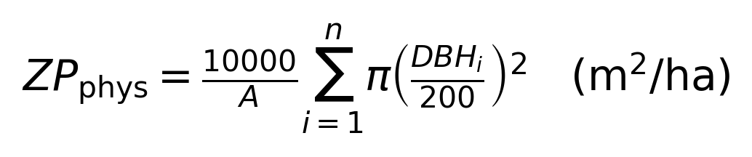
It can be measured directly through field inventories of individual trees. However, a sufficiently validated database is not currently available for all study fires. The time model therefore uses ZP_TCC = TCC/100, the tree canopy cover fraction. It does not represent live-tree counts, tree height or basal area. [1]

2.2 Estimating green cover
LG is calibrated against DIRECT green-cover references. N and E denote MODIS NDVI and EVI, respectively: [2–3]
The coefficients in the LG formula come from calibration against green-cover references and are not adjusted when the time functions are fitted. The clip operation bounds the raw green-cover estimate between 0 and 1. LG shows bias when transferred to airborne reference data and is not ground truth for every fire. NDVI, EVI, stem diameter and the other measurement quantities are explained in Appendix A.

2.3 The three-year pre-fire baseline and DE
I_k(t) and C_k(t) are the annual means at fixed burned and control locations, respectively. Their ratio q is calculated first, then divided by b, the arithmetic mean of q over the three pre-fire years:
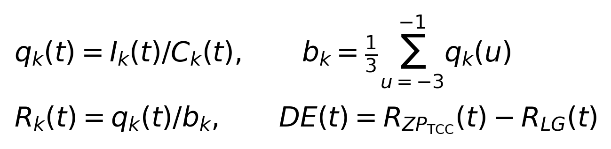
LG and canopy cover each use their own baseline. R = 1 means only that the indicator has returned to its relative pre-fire reference; it does not demonstrate complete ecological recovery. R may exceed 1 and is not truncated. Negative DE means that the relative state of LG is higher; positive DE means that the relative state of canopy cover is higher.
All displayed values are multiplied by 100 and expressed in points. The thresholds of 46 and 64 points refer to displayed R_ZP_TCC values, not raw TCC values of 46% or 64%. The 12-point threshold refers to the absolute prediction error in the first-year relative state of LG. DE is not a direct difference between two recovery rates.

3 Data and study scope

3.1 Data sources and fixed sampling locations
The study dataset includes 81 forest fires in the United States, 636 post-fire annual states and 9,564 fixed locations. Of these fires, 36 are used to fit the functions, 37 for retrospective testing and the remaining eight for supplementary observation checks. [4–6]
MOD13Q1.061 provides NDVI and EVI at 250 m resolution in 16-day composites. Records from June–August with SummaryQA of 0 or 1 are selected; their medians form the annual summer indices. The USFS Science TCC product, version 2025-6, has 30 m resolution. Valid cover values with data_mask = 1 are first averaged onto the 250 m grid and then across the fixed locations. [1–2]
The same locations are used for the three pre-fire years and every post-fire year. Missing observations remain missing and are not replaced by predictions. Checks of control-area disturbance, low or unstable baselines, and product years are retained. This official TCC version covers 1985–2025, so LG observations may be available for 2026 while TCC is still missing. [1]

3.2 Training and test samples
All 36 fitting fires have complete eight-year records and declining DE trajectories. The uses of the 37 retrospective test fires and eight supplementary records are shown in Table 1. Because the first year is a correction input, prediction errors are calculated from year 2 onward.
Sample use | Fires | Observations and evaluation
Fitting and cross-validation | 36 | Complete eight-year records
Retrospective test | 37 | Years 2–8 evaluated
Supplementary observations | 8 | Available years checked

Table 1. Uses of the study samples. Complete eight-year observations are available for 77 fires. Carr, Creek, Dixie and Caldor have not yet reached eight years of observation. Their available observations are used for supplementary checks, and future years contain predictions only.
Training cross-validation, the 37-fire retrospective test and supplementary observation checks are reported separately. RMSE, MAE, bias, SD, R² and prediction-interval coverage are identified with their corresponding sample and time window.

4 Quadratic functions and first-year information

4.1 Fitting and validation
The quadratic functions are fitted to the 36 training fires, with equal total weight for each fire's eight-year record. Training validation is grouped by ignition year: all training fires that began in the same year are held out together, and functions fitted to the other years predict those held-out fires. [10]
Separate quadratic functions are fitted for LG and ZP_TCC; predicted DE is obtained by subtracting the two components. The quadratic functions describe the average trajectory of the training sample and apply only to post-fire years 1–8.
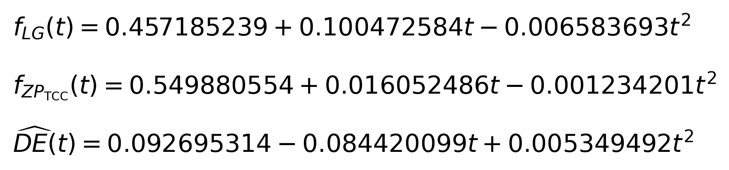
The three expressions above are the two quadratic functions and their difference; all outputs are relative states. First-year observations are then used to add corrections according to the rules below, producing a prediction function for each fire.

4.2 Prediction after observing the first year
Let e_k be the difference between a fire's actual first-year relative state and the function's first-year prediction:
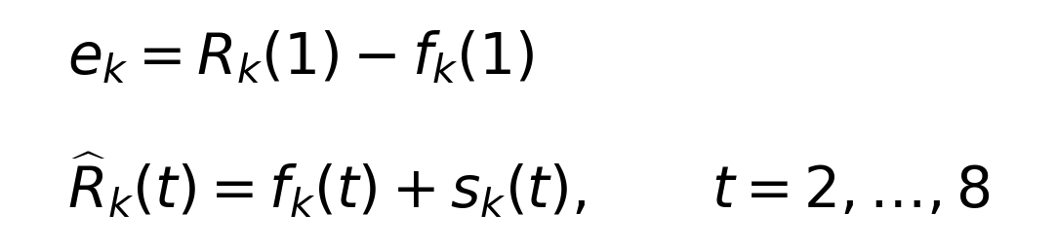
The correction uses the actual observation at t = 1, but evaluation includes only t = 2–8. The amplitude cap does not force the LG curve through the first-year observation, and the first year is excluded from predictive accuracy. Relative states and prediction ranges are not truncated to 0–100 points.
First-year information may contain real initial differences as well as cloud shadows, product errors and changes in the controls. The correction is therefore a mathematical hypothesis whose usefulness in later years must be tested; it is not automatically an ecological mechanism.

4.3 Piecewise first-year correction rules
Let s_ZP and s_LG be the corrections added to the two quadratic functions. If first-year ZP_TCC lies outside [0.46, 0.64], s_ZP = e_ZP; within that interval, s_ZP = 0.25e_ZP. LG is corrected as shown in Table 2.
Indicator | Correction when the condition is met | Otherwise
ZP | R_ZP(1) < 0.46 or > 0.64:  s_ZP = e_ZP | s_ZP = 0.25e_ZP
LG | ZP outside the interval and |e_LG| ≥ 0.12:  s_LG = sign(e_LG) × min(|e_LG|, |s_ZP|) | s_LG = e_LG × 0.5^(t−1)

Table 2. Amplitude cap correction. When the stated condition is met, s_LG = sign(e_LG) × min(|e_LG|, |s_ZP|). The sign function preserves the direction of the LG error; min takes the smaller absolute magnitude. Otherwise, the LG correction decays. A constant vertical shift changes only the intercept. DE is always obtained by subtracting the component predictions.

5 Observed trajectories and prediction errors

5.1 Observed post-fire trajectories
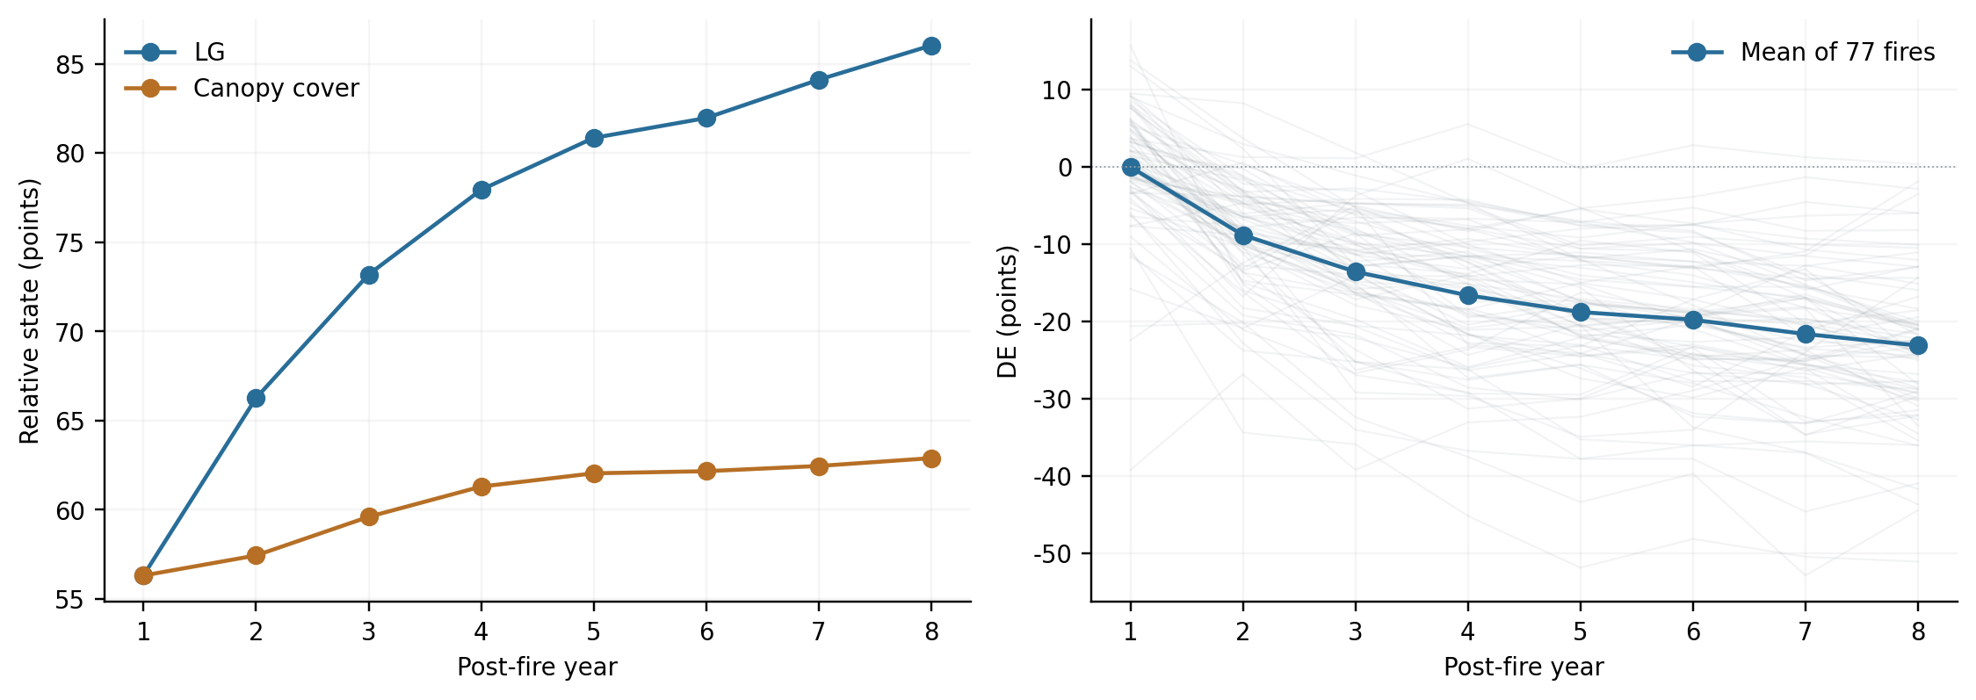
Figure 1. The 77 fires with complete eight-year observations. The left panel shows mean relative states of LG and canopy cover; the right panel shows each fire's DE and mean DE. Each fire contributes one event mean per year. Values are in points.
Post-fire year | Mean LG | Mean canopy cover | Mean DE
1 | 56.33 | 56.31 | -0.01
8 | 86.02 | 62.89 | -23.13

These means use the same 77 fires with complete eight-year records, avoiding changes in annual sample size that could distort the mean trajectory. Differences between fires remain substantial: DE declines in some fires, stays approximately unchanged in others and increases in others. The average curve cannot represent every fire.
Green vegetation recovery and canopy cover may be influenced by different processes. However, the cover difference alone cannot identify the specific contributions of seedling recruitment, tree mortality, logging or climate.

5.2 Training cross-validation
Method | LG RMSE | Canopy-cover RMSE | DE RMSE
Quadratic function | 10.67 | 11.29 | 8.71
Amplitude cap correction | 9.26 | 7.08 | 8.88

Table 3. Cross-validation by ignition year for the 36 training fires, evaluated over years 2–8, in points. The correction reduces LG RMSE from 10.67 to 9.26 points and canopy-cover RMSE from 11.29 to 7.08 points. DE RMSE rises from 8.71 to 8.88 points, showing no improvement.

5.3 Retrospective testing
Method | LG RMSE | Canopy-cover RMSE | DE RMSE
Quadratic function | 12.66 | 13.65 | 9.59
Amplitude cap correction | 8.56 | 8.42 | 8.60

Table 4. RMSE over years 2–8 for the 37 test fires, in points. The first year is used as a correction input and is excluded from prediction errors.
The amplitude cap correction reduces test RMSE from 12.66 to 8.56 points for LG, from 13.65 to 8.42 points for canopy cover, and from 9.59 to 8.60 points for DE.
This is a retrospective analysis, and study information also contributed to determining the correction rules. These results therefore do not constitute a strictly prospective blind test. The inconsistent DE performance between training validation and retrospective testing means that general applicability to new fires remains to be tested.

5.4 RMSE and R²
Target | Method | RMSE | MAE | Bias | R²
LG | Quadratic function | 12.66 | 9.05 | -1.48 | 0.160
Canopy cover | Quadratic function | 13.65 | 10.42 | -1.38 | 0.005
DE | Quadratic function | 9.59 | 7.27 | 0.10 | 0.081
LG | Amplitude cap correction | 8.56 | 6.88 | -1.66 | 0.616
Canopy cover | Amplitude cap correction | 8.42 | 6.12 | -2.57 | 0.621
DE | Amplitude cap correction | 8.60 | 6.95 | -0.91 | 0.262

Table 5. Results for years 2–8. Bias = prediction − observation. RMSE, MAE and bias are in points; R² is dimensionless. For the same observations, SD is 13.82 points for LG, 13.68 for ZP_TCC and 10.00 for DE.
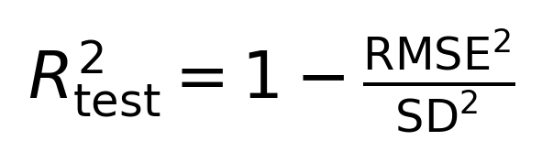
Here, SD is defined from the descriptive population variance using the same equal-fire weights as RMSE. The relationship shown is therefore an equality under this definition. An SD based on a different sample or an N−1 denominator cannot be substituted without adjustment.
R² = 1 indicates no prediction error. A value of 0 indicates the same squared error as using the mean of this set of actual observations; negative values indicate worse performance. That observed mean is a retrospective statistical reference, not a value known when a forecast is made.
R² for the amplitude cap correction is approximately 0.616 for LG, 0.621 for ZP_TCC and 0.262 for DE. The DE squared error is lower than the retrospective reference based on the mean of these observations. However, R² is neither a hit rate nor a proportion of ecological mechanisms explained.
Resampling whole ignition-year groups gives a canopy-cover RMSE difference of −5.23 points for the correction relative to the quadratic function, with a 95% range of −8.96 to −1.50 points. For DE, the difference is −1.00 point, with a range of −3.76 to 0.64 points. These ranges describe uncertainty in this sample.

5.5 Predictive accuracy by year
Table 6 uses the same 37 fires. Errors and SD are in points; R² is calculated using that year's observed SD. The first year is an input and is excluded from predictive accuracy.
Post-fire year | Quadratic RMSE | Corrected RMSE | Observed SD | Corrected R²
2 | 14.28 | 7.80 | 13.88 | 0.684
3 | 14.16 | 8.47 | 13.77 | 0.621
4 | 14.27 | 9.83 | 13.97 | 0.505
5 | 12.54 | 9.13 | 12.50 | 0.467
6 | 11.58 | 8.24 | 11.54 | 0.490
7 | 10.81 | 7.86 | 10.79 | 0.469
8 | 10.28 | 8.41 | 10.19 | 0.319

Table 6a. Annual LG errors and R².
Post-fire year | Quadratic RMSE | Corrected RMSE | Observed SD | Corrected R²
2 | 13.97 | 4.23 | 13.91 | 0.908
3 | 13.75 | 6.43 | 13.74 | 0.781
4 | 13.36 | 8.11 | 13.24 | 0.625
5 | 13.17 | 8.75 | 13.03 | 0.549
6 | 13.26 | 9.27 | 13.13 | 0.502
7 | 13.75 | 9.80 | 13.58 | 0.479
8 | 14.27 | 10.63 | 13.99 | 0.423

Table 6b. Annual canopy-cover errors and R². Annual SD includes only differences among fires at the same post-fire age. Overall SD also includes change across the seven years, so overall R² cannot replace evaluation of each year.

5.6 Annual DE errors and the role of the difference
Post-fire year | Quadratic RMSE | Corrected RMSE | Observed SD | Corrected R²
2 | 8.48 | 7.02 | 7.07 | 0.015
3 | 8.94 | 7.93 | 8.47 | 0.123
4 | 9.54 | 8.34 | 9.47 | 0.225
5 | 9.90 | 9.03 | 9.86 | 0.160
6 | 9.75 | 8.70 | 9.35 | 0.133
7 | 9.92 | 9.25 | 9.49 | 0.052
8 | 10.48 | 9.63 | 10.38 | 0.139

Table 6c. Annual DE performance. Good performance in one year does not imply accurate prediction throughout the window or for every fire.
The DE prediction error equals the ZP_TCC error minus the LG error. Large differences between the two corrections can further amplify the error in their difference. Capping the LG shift can reduce part of this effect, but does not imply that the two actual states must be identical or guarantee improvement in DE for every fire.
Patterns in DE remain worth studying. However, the current difference does not automatically remove effects of region, climate, tree species or measurement error, and it cannot be interpreted as a direct difference in recovery rates.

5.7 Empirical prediction ranges
The 80%, 90% and 95% empirical ranges use absolute corrected-prediction errors from the 36 training fires held out by ignition year. After sorting the errors, the ceil[(36 + 1) × target coverage]th value is used as the half-width; ceil means rounding upward. Every case uses the same half-width for a given indicator, year and target coverage.
Half-widths are calculated from training errors, while actual coverage is calculated from the 37-fire retrospective test. With only 36 training fires, the 95% target uses the largest held-out training error, producing wide ranges in some years. These empirical ranges do not guarantee the stated coverage for new events. No range is drawn for the first year.
A separate atlas shows the quadratic functions, amplitude cap corrections and actual observations for all 81 fires. Each figure identifies how that fire is used in the study.

6 Applying the fixed functions to recent fires

6.1 Available first-year records
Park 2024 uses NDVI, EVI and TCC records from 120 fixed locations, with the same LG formula, TCC fraction, burned-to-control ratios and three-year pre-fire baseline. Creek 2020, and Dixie and Caldor 2021, use the same indicators and prediction rules. [11–14]
Fire and first observed year | First-year LG | First-year ZP_TCC | Correction applied
CREEK 2021 | 46.69 | 54.07 | LG decay; one-quarter ZP shift
CALDOR 2022 | 43.48 | 53.37 | LG decay; one-quarter ZP shift
DIXIE 2022 | 37.04 | 43.32 | LG cap; full ZP shift
PARK 2025 | 27.76 | 31.65 | LG cap; full ZP shift

Table 7. First-year inputs are relative states in points. Dixie and Park satisfy both conditions: ZP_TCC is outside the interval and the absolute LG error is at least 12 points. Their LG correction is capped. Creek and Caldor have ZP_TCC within the interval, so this LG branch is not triggered.
These four fires belong to neither the 36-fire fitting sample nor the 37-fire main test sample. Creek, Dixie and Caldor are supplementary database records; Park is a recent application case. Because their sources and observation lengths differ, available subsequent observations are checked separately.
Gifford and Green 2025 have LG observations for 2026. However, the same TCC product version has no first-year canopy-cover record for 2026, so the complete correction inputs required by this method are not yet available.

6.2 Trajectories for Park and Dixie
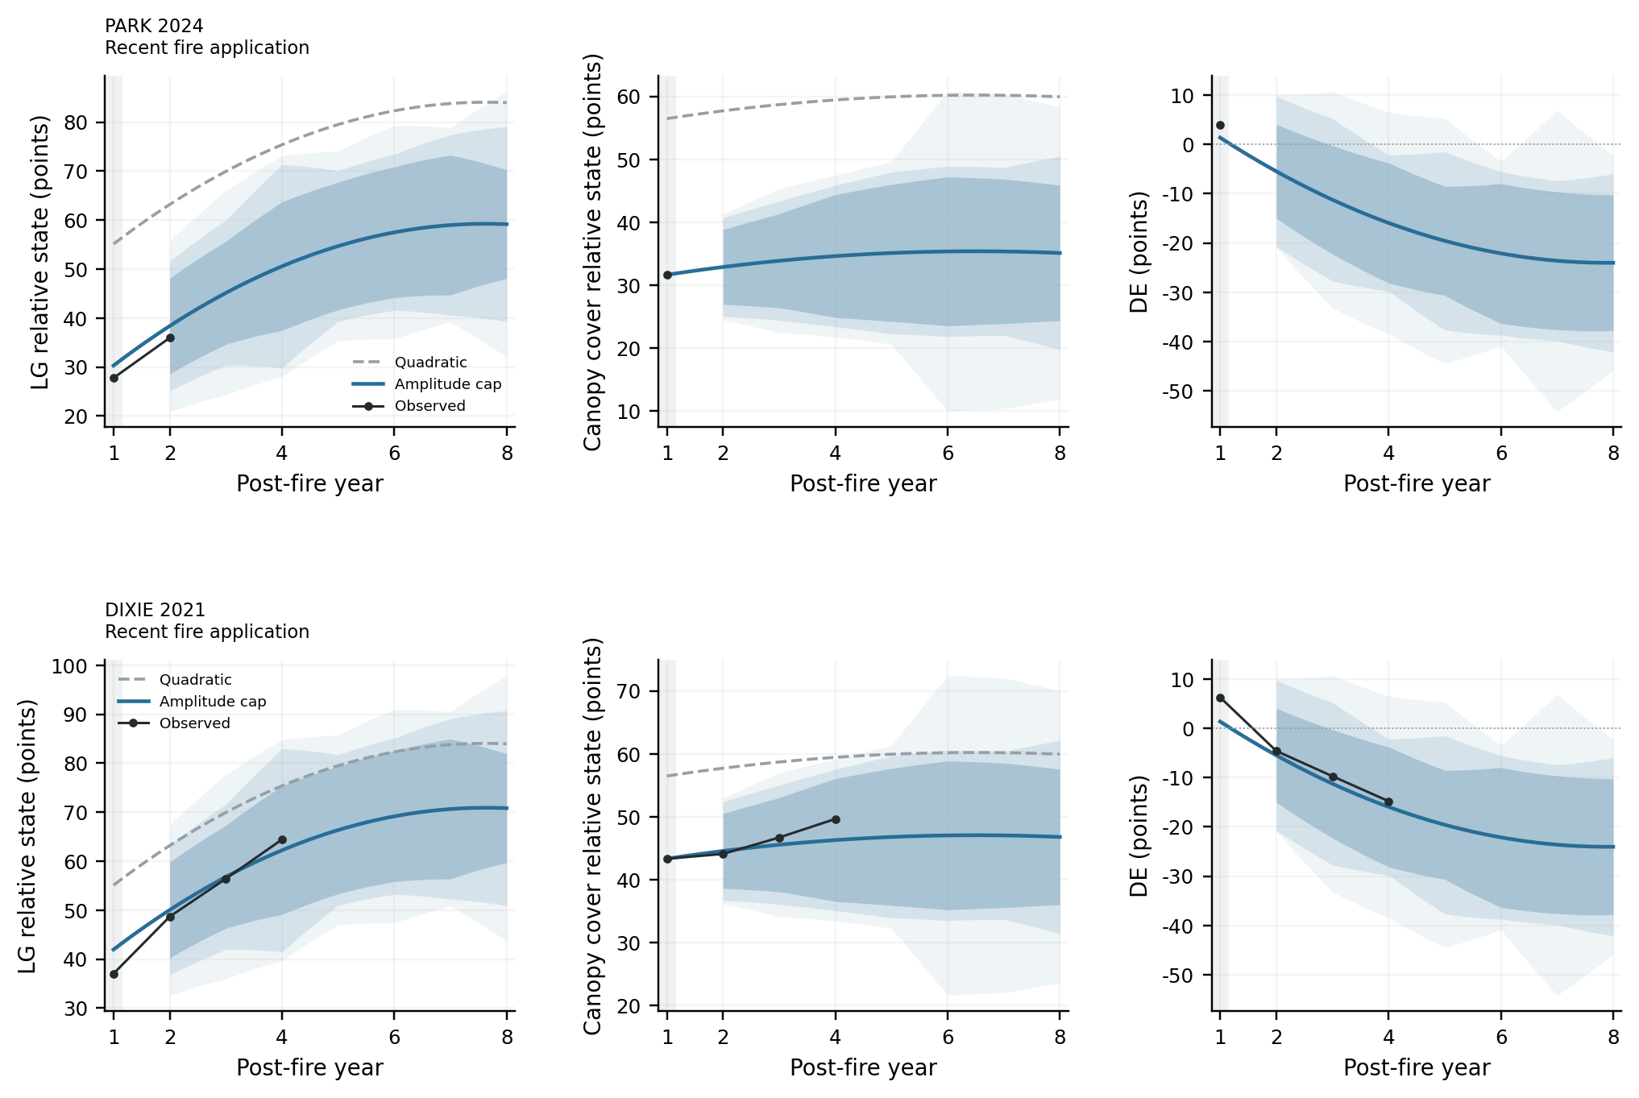
Figure 2. Dashed grey lines show the quadratic functions, blue lines the amplitude cap correction, and black points the actual remotely sensed observations.
Park and Dixie receive the full ZP_TCC shift. Their LG shifts retain the direction of the LG error and do not exceed the ZP_TCC shift in magnitude. The first-year LG prediction need not pass through the observation. Park's actual second-year LG is 35.95 points; the corrected prediction is 38.36 points and the quadratic prediction 63.18 points. TCC is still missing for that year, preventing validation of DE.
Future observations are left missing. Shading shows empirical ranges derived from held-out training errors; it is not a guarantee of the stated probability for these recent fires.

6.3 Trajectories for Caldor and Creek
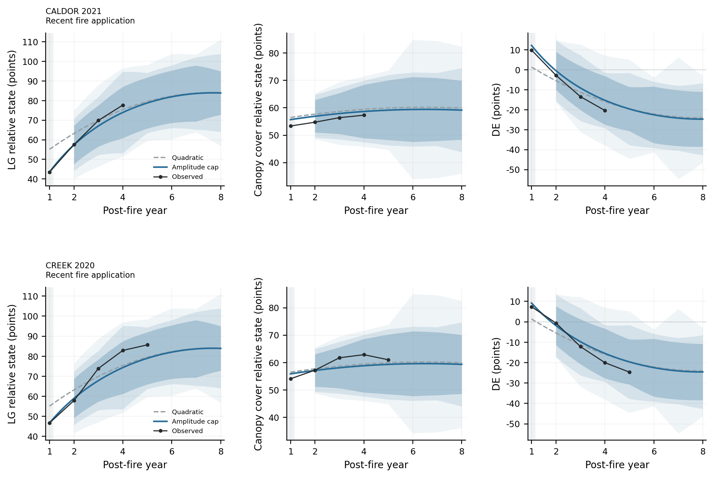
Figure 3. Line meanings are the same as in Figure 2. First-year ZP_TCC is within 46–64 points for both fires, so only one quarter of its offset is retained. LG does not meet the outside-interval condition and uses the decaying correction.
Overprediction and underprediction remain in the available years. Observations and predictions are checked individually for the years with actual data.
Predictions are limited to post-fire years 1–8. Year 8 is 2028 for Creek, 2029 for Dixie and Caldor, and 2032 for Park.

6.4 Numerical predictions and limits of application
Fire and eighth-year calendar date | LG prediction | ZP prediction | DE prediction
PARK 2032 | 59.14 | 35.11 | -24.03
DIXIE 2029 | 70.81 | 46.78 | -24.03
CALDOR 2029 | 83.87 | 59.16 | -24.71
CREEK 2028 | 83.90 | 59.33 | -24.56

Table 8. Amplitude cap predictions for post-fire year 8, in points. DE is obtained by subtracting the two indicators, not by fitting another function. All predictions for years 2–8 and available observations are listed separately in the data tables.
The recent cases are not used to fit the functions. Their available observations from years 2–8 are checked individually, with results reported separately from the 37-fire retrospective test.
The shift, cap and decay of first-year offsets are mathematical hypotheses to be tested. They do not prove that an ecological process maintains a fixed difference. Missing actual TCC values are not filled with predictions.

7 Measurement evidence and study limitations

7.1 Independent evidence for the physical structural target
NEON individual-tree records allow 330 live-tree basal-area surveys from 32 sites to be recalculated. In the common set of 309 level references from 29 sites, a multisource model shows some improvement. For 56 paired changes at the same locations across 21 sites, it does not consistently outperform simple methods. Those repeat-measurement pairs are not 56 independent fires. [7–9]
TCC fraction is therefore used as a direct remotely sensed proxy. Airborne height and spectral measurements are not combined and presented as actual live-tree basal area. LiDAR may include standing dead trees; canopy cover, live-tree counts, height and basal area are not interchangeable.
The fixed LG calibration contains only 19 references in 11 spatial groups. In an airborne transfer check involving 131 small-plot records from 21 sites, RMSE for the measured level is approximately 0.310 and bias approximately −0.284. Spatial scale, season and classification rules differ, and some discrepancies cannot be attributed to a single cause. Normalization does not guarantee removal of bias that changes with fire effects or vegetation composition.

7.2 Training coverage and contrasting trajectories
The training sample consists of 36 fires with declining DE trajectories and does not cover all possible patterns of change. Test fires with approximately unchanged or increasing DE still show substantial bias, demonstrating limits to the model's applicability.
There is no independent evidence that approximately unchanged or increasing DE must result from external disturbance. The amplitude cap correction has lower overall DE error in these 37 test fires, but substantial errors remain for unchanged and increasing trajectories. Overall improvement should not be interpreted as suitability for every trajectory.

7.3 Limits of validation and extrapolation
The model and correction rules derive from retrospective study information; the current evaluation does not satisfy the conditions of a strictly prospective blind test. The 36 training fires span 10 ignition-year groups. The limited number of events and incomplete trajectory coverage leave considerable uncertainty in the assessment of predictive performance.
Predictions are strictly restricted to post-fire years 1–8. Product errors, spatial correlation, shared regional climate, changes in controls and subsequent disturbances may all influence results. Remotely sensed associations and function shapes alone cannot establish ecological causal mechanisms.

8 Conclusions
LG and canopy cover are distinct remotely sensed indicators. The 77 fires with complete eight-year records show different mean temporal trajectories for the two indicators. Individual DE trajectories may decline, stay approximately unchanged or increase; the mean curve cannot represent every event.
Across the 37 retrospective test fires, amplitude cap RMSE is 8.56 points for LG, 8.42 for canopy cover and 8.60 for DE, with R² approximately 0.616, 0.621 and 0.262. All three errors are lower than for the quadratic functions. In training validation, however, DE error is slightly higher than for the quadratic function, so a general predictive advantage cannot yet be confirmed.
The amplitude cap correction uses first-year observations and limits the LG shift under fixed conditions, preserving its direction while avoiding excessive separation of the two corrections. It adjusts mathematical predictions of remotely sensed relative states and cannot replace independent measurements of actual forest structure or ecological processes.
Applications to four recent fires illustrate the calculation and the limits of available observations. Physical ZP, the canopy-cover proxy and estimated green cover have different meanings. The conclusions are restricted to relative changes in these observed indicators within eight years after fire.

Author contributions and use of AI tools
The author formulated the research questions and objectives, determined the indicators and model forms, proposed the first-year correction and amplitude cap approach, selected the adopted method, and reviewed the interpretation and research conclusions.
ChatGPT assisted with collecting public data and literature, processing and checking data, and writing programs for data acquisition, statistical calculation, plotting and reproduction. It also organized research materials at the author's request. The author reviews and takes responsibility for the final content and conclusions.

9 References and data sources
[1] US Forest Service. Tree Canopy Cover, Product Version 2025-6. Annual Science tree canopy cover, data_mask and product fields. Source
[2] Didan K. MOD13Q1.061 Terra Vegetation Indices 16-Day L3 Global 250m SIN Grid. NASA LP DAAC. DOI 10.5067/MODIS/MOD13Q1.061. Source
[3] Camacho F, Sánchez-Zapero J, Fang H, Weiss M, Brown L. CEOS LPV DIRECT V2.1: A database of upscaled LAI, FAPAR and Fcover values for satellite biophysical product validation. 2024. DOI 10.5281/zenodo.11235157. Source
[4] USGS and USFS. Monitoring Trends in Burn Severity. Fire perimeters and classified burn-severity data. Source
[5] NASA MOD44B.061. Vegetation Continuous Fields Yearly L3 Global 250m SIN Grid. Used for forest screening and the sampling grid, not as the main TCC target.
[6] NASA MCD12Q1.061. Land Cover Type Yearly Global 500m. Records of pre-fire forest classes. Source
[7] NEON. Vegetation Structure, DP1.10098.001, RELEASE-2026. The study retains the actual release records and individual-tree measurements. Source
[8] NEON. Vegetation Structure User Guide, revision E.1, 2024-11-26. Diameter, tree status, survey area and plot layout. Source
[9] NEON. Canopy Height Model CHM 001 and Hyperspectral Reflectance HSI 002. Airborne structural and green-cover references; only observations meeting instrument-quality and spatial and temporal matching requirements enter the corresponding measurement analyses. Source
[10] Roberts D R et al. Cross-validation strategies for data with temporal, spatial, hierarchical, or phylogenetic structure. Ecography, 2017, 40: 913–929. DOI 10.1111/ecog.02881. Source
[11] CAL FIRE. Park Fire, started 24 July 2024. Source
[12] CAL FIRE. Dixie Fire, started 13 July 2021. Source
[13] CAL FIRE. Caldor Fire, started 14 August 2021. Source
[14] CAL FIRE. Creek Fire, started 4 September 2020. Source
The recent-event information and TCC year coverage were checked on 24 October 2026. Verifying fire dates does not establish the availability of ecological ground truth. Numerical predictions use fixed-location remotely sensed data from the recorded product versions.

Appendix A Definitions of indicators and calculation quantities

A.1 NDVI EVI and LG
Reflectance ρ is the ratio of reflected to incoming radiation in a spectral band. ρ_R denotes red reflectance, ρ_NIR near-infrared reflectance, and ρ_B blue reflectance. Green leaves respond differently in the red and near-infrared bands; NDVI uses this difference. EVI adds a blue band and correction terms to reduce some atmospheric and background effects. Neither index measures live-tree counts or the extent of ecological recovery.
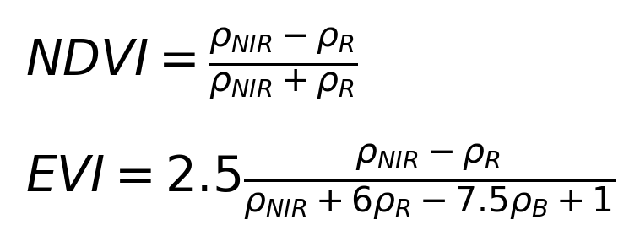
Raw MOD13Q1 NDVI and EVI values are multiplied by 0.0001 to obtain index values. Records from June–August with SummaryQA of 0 or 1 are selected, and NDVI and EVI medians are calculated separately. Counts with the stricter QA value of 0 are also recorded. Most locations have six usable composite records per year, with a minimum of three. The number of composites is not the number of actual cloud-free days.
The fixed LG formula is shown below. N and E denote NDVI and EVI as defined above. The clip operation sets estimates below 0 to 0 and above 1 to 1, preserving the bounded definition of estimated green cover. It acts only on raw LG, not on the relative state R or DE.
The two LG coefficients are calibrated against DIRECT references. Spatially grouped validation using 19 records in 11 spatial groups gives RMSE of approximately 0.114, compared with approximately 0.129 for NDVI alone. The reference sample is small, and the clear bias in airborne transfer testing indicates limited measurement applicability.

A.2 TCC and ZP_TCC
TCC is percentage tree canopy cover; ZP_TCC = TCC/100 is the corresponding fraction between 0 and 1. For example, TCC = 60 means 60% canopy cover and ZP_TCC = 0.60. Neither is yet a normalized relative state. The Science_Percent_Tree_Canopy_Cover field with data_mask = 1 is used. This differs from the similarly named NLCD cover product, which undergoes further post-processing.
Valid 30 m cover values are area-averaged onto the 250 m grid, then averaged across fixed locations. Some grid cells have valid values over only part of their 30 m area; valid-area fractions are retained in the quality records.
The TCC product-error field cannot be interpreted directly as error in live-tree basal area. It is not used to weight the time regression, and a change in cover is not automatically interpreted as the death or establishment of an individual tree.

A.3 Physical ZP and field inventories
A is the actual surveyed area in square metres; DBH_i is the diameter at breast height, in centimetres, of the ith eligible living tree; n is the number of eligible living trees in the surveyed area. Each tree's basal area is π(DBH_i/200)² square metres. Multiplying the sum by 10,000/A converts it to square metres per hectare. Identifiable stems of multistem trees are handled according to the inventory protocol. Missing trees or unknown status are not treated as deaths.
Diameter at breast height is normally measured 130 cm above ground. For unusual tree forms, the protocol specifies a recorded measurement position. Changes in that position between surveys can affect diameter differences, so not every difference can be interpreted as growth. Physical ZP can be calculated directly from individual-tree inventories; the limitation is inadequate field coverage and remote-sensing retrieval across the full database, not an inability to measure it.

A.4 Numerical meaning of relative states
I_k(t) and C_k(t) are the annual means of indicator k at fixed burned and control locations. q_k = I_k/C_k; b_k is the arithmetic mean of q over the three pre-fire years; R_k = q_k/b_k. Here t = 1 means the calendar year after the ignition year. Negative years define the baseline; t = 0 is excluded from the main time predictions.
For example, if an indicator's mean pre-fire burned-to-control ratio is 0.80 and its ratio in a post-fire year is 0.64, then R = 0.64/0.80 = 0.80, displayed as 80 points. This is neither raw cover of 80% nor 80% recovery of the whole ecosystem. If the control also declines, the relative state may be higher than suggested by the burned-area value alone.
DE = R_ZP_TCC − R_LG, multiplied by 100 for display in points. Because the two indicators are normalized separately, equal relative states do not imply equal raw cover values. DE does not contain a time derivative and cannot directly be called a difference in recovery rates.
The baseline coefficient of variation is the sample standard deviation of q over the three pre-fire years divided by the absolute value of its mean. It checks reference stability. A low-baseline threshold of 0.05 and coefficient-of-variation threshold of 20% were set as quality flags before calculation, not as reasons to delete unusual fires.

A.5 Errors and uncertainty ranges
Squared, absolute and signed errors are first averaged across the available years within each fire and then across fires. RMSE is the square root of mean squared error; MAE is mean absolute error; bias is mean signed error. Observed SD uses the same equal-fire weighting, keeping it on the same scale as RMSE.
Resampling draws ignition-year groups, with fires from the same year entering together. The procedure is repeated 10,000 times; the 2.5% and 97.5% quantiles define a 95% range. This describes sample uncertainty, does not establish that every fire is independent, and does not remove systematic product bias. Ranges in the main case figures are conditional empirical ranges for individual predictions, not confidence intervals for the population mean.

Appendix B Training and main test fires
Training fire | Year | Test fire | Year
POWER | 2004 | NUTALL COMPLEX (NUTALL) | 2004
I-90 COMPLEX (TARKIO) | 2005 | WILLOW | 2004
VALLEY ROAD | 2005 | BLOSSOM | 2005
CAVITY LAKE | 2006 | SIGNAL ROCK | 2005
HEAVENS GATE COMPLEX (BLACK BUTTE) | 2006 | COLUMBIA COMPLEX | 2006
SOUTHFORK COMPLEX (COUGAR) | 2006 | JUNGLE | 2006
THORN CREEK | 2006 | RED EAGLE | 2006
CORPORAL | 2007 | TATOOSH COMPLEX | 2006
MOONLIGHT | 2007 | BRUSH CREEK | 2007
RAILLEY MOUNTAIN | 2007 | CASTLE ROCK | 2007
ROMBO MOUNTAIN | 2007 | CHIPPY CREEK | 2007
SHOWER BATH COMPLEX (SHOWER BATH) | 2007 | CONFLUENCE COMPLEX (CLEAR SAGE) | 2007
SLIDE | 2007 | ELK COMPLEX (KING CREEK 2) | 2007
CANYON COMPLEX (SCOTCH) | 2008 | GRAYS CREEK | 2007
IRON AND ALPS COMPLEXES (EAGLE) | 2008 | JOCKO LAKES | 2007
LIME COMPLEX (LIME) | 2008 | MANILA CREEK | 2007
LIME COMPLEX (MINERS) | 2008 | CHALK | 2008
SHU LIGHTNING COMPLEX (MOON) | 2008 | CORRAL | 2008

Of the fires listed, 36 are used for fitting and training cross-validation, and 37 for retrospective testing. The eight supplementary records and the uses of all 81 fires are recorded in data/events.csv.

Appendix B Training and test fires continued
Training fire | Year | Test fire | Year
FREEZE OUT | 2012 | IRON AND ALPS COMPLEXES (IRONSIDE) | 2008
MILLIE | 2012 | RATTLE | 2008
MUSTANG COMPLEX | 2012 | YOLLA BOLLY COMPLEX (IRON) | 2008
READING | 2012 | BRUSHY MOUNTAIN | 2009
WHITEWATER-BALDY | 2012 | HIGHWAY 31 | 2009
AMERICAN | 2013 | LA BREA | 2009
MILE MARKER 28 | 2013 | NORTH FORK COMPLEX | 2009
RIM | 2013 | SCHULTZ | 2010
WHISKEY | 2013 | CHIPS | 2012
KING | 2014 | NORTH PASS | 2012
MAN | 2014 | DAY | 2014
ROUGH | 2015 | HAPPY CAMP COMPLEX | 2014
SLIDE | 2015 | WHISKEY COMPLEX | 2014
TRAIL CREEK | 2015 | ELDORADO | 2015
WOLVERINE | 2015 | TOWER | 2015
DEEP CREEK | 2017 | COPPER KING | 2016
HELENA | 2017 | BRIANHEAD | 2017
JULY | 2017 | HANOVER | 2017
— | — | SCALP | 2017

Training cross-validation is grouped by ignition year. Retrospective testing uses the quadratic functions fitted to all 36 training fires and the same correction rules.

Appendix C Empirical prediction ranges for DE
Post-fire year | 80% target | 90% target | 95% target
2 | ±9.54／81.1% | ±15.26／100.0% | ±15.45／100.0%
3 | ±11.01／83.8% | ±16.49／97.3% | ±21.95／100.0%
4 | ±12.18／89.2% | ±13.83／91.9% | ±22.52／100.0%
5 | ±11.07／73.0% | ±18.09／97.3% | ±24.87／100.0%
6 | ±14.17／89.2% | ±16.59／94.6% | ±18.74／100.0%
7 | ±13.98／86.5% | ±16.23／91.9% | ±30.56／100.0%
8 | ±13.78／83.8% | ±18.04／94.6% | ±21.78／97.3%

Each cell gives the fixed half-width in points / actual coverage in the 37 test fires. Every case uses the same half-width for a given indicator and year.
These are cumulative coverage targets, not guaranteed probabilities. No range is drawn for the first year, and intervals are not truncated to 0–100 points. Widths come from training held-out errors under the fixed rules and are not adjusted using test residuals.

Appendix C Empirical prediction ranges for LG
Post-fire year | 80% target | 90% target | 95% target
2 | ±9.78／83.8% | ±13.26／86.5% | ±17.42／97.3%
3 | ±10.50／75.7% | ±14.80／94.6% | ±20.82／100.0%
4 | ±13.12／78.4% | ±20.76／97.3% | ±22.54／97.3%
5 | ±13.02／89.2% | ±15.36／97.3% | ±19.37／97.3%
6 | ±13.35／86.5% | ±15.95／97.3% | ±21.79／100.0%
7 | ±14.28／91.9% | ±18.42／100.0% | ±19.85／100.0%
8 | ±11.10／75.7% | ±19.91／100.0% | ±27.09／100.0%

Each cell gives the fixed half-width in points / actual coverage in the 37 test fires. Every case uses the same half-width for a given indicator and year.
These are cumulative coverage targets, not guaranteed probabilities. No range is drawn for the first year, and intervals are not truncated to 0–100 points. Widths come from training held-out errors under the fixed rules and are not adjusted using test residuals.

Appendix C Empirical prediction ranges for canopy cover
Post-fire year | 80% target | 90% target | 95% target
2 | ±5.94／83.8% | ±7.82／94.6% | ±8.41／97.3%
3 | ±7.47／81.1% | ±9.47／91.9% | ±11.43／91.9%
4 | ±9.76／81.1% | ±11.23／83.8% | ±12.84／89.2%
5 | ±10.89／81.1% | ±12.85／89.2% | ±14.51／89.2%
6 | ±11.84／83.8% | ±13.52／89.2% | ±25.41／100.0%
7 | ±11.50／81.1% | ±13.34／89.2% | ±25.01／94.6%
8 | ±10.77／78.4% | ±15.35／89.2% | ±23.20／91.9%

Each cell gives the fixed half-width in points / actual coverage in the 37 test fires. Every case uses the same half-width for a given indicator and year.
These are cumulative coverage targets, not guaranteed probabilities. No range is drawn for the first year, and intervals are not truncated to 0–100 points. Widths come from training held-out errors under the fixed rules and are not adjusted using test residuals.

Appendix D Calculating and interpreting R²
For the same prediction errors, squared errors are first averaged within each fire and then equally across fires to obtain MSE. RMSE is its square root. The observed mean and variance are calculated using the same weights, and SD is the square root of that variance.
This study uses descriptive population variance without an N−1 adjustment. The displayed ratio therefore equals 1 minus the weighted residual sum of squares divided by the weighted total sum of squares. RMSE or SD values cannot be mixed across different weights, time windows or samples.
Overall R² for years 2–8 and annual R² are reported separately. Overall SD includes temporal change and differences among fires; annual SD describes only differences among fires in that year. Negative R² values are retained: they indicate larger squared error than using the mean of the actual observations in that sample.
R² is not a probability of prediction success, does not establish ecological causal mechanisms, and is not an error measure for physical ZP. Small samples or groups with very low SD can make the ratio unstable, so RMSE, MAE, bias, SD and actual sample sizes are also reported.

Appendix E Reproducibility materials
Reproduction programs are in analysis/forest_recovery. The data directory contains fixed locations, annual satellite values for each location, event uses, recent observations and measurement references. model.json stores indicator coefficients, quadratic-function coefficients and correction parameters.
rebuild_measurements.py calculates LG, canopy cover, burned and control means, and relative states. analyze.py calculates predictions, errors and empirical intervals for the quadratic functions and amplitude cap correction. make_figures.py generates figures; build_report.py and build_manual.py assemble the report and technical manual.
predict.py uses first-year relative states of LG and ZP_TCC to output predictions and empirical ranges for years 2–8. verify.py checks the indicators, functions, plots and error calculations. Full programs and data excerpts are provided in forest_v5_code_and_evidence.pdf.
results/model_metrics.csv and annual_metrics.csv record RMSE, MAE, bias, SD and R². interval_half_widths.csv and test_interval_coverage.csv record half-widths and actual coverage, respectively. Each file identifies the corresponding sample and prediction method.
all_case_predictions.csv stores predictions for years 1–8 and available observations for all 81 fires. recent_predictions.csv records applications to the four recent fires. plot_values.csv corresponds to the plotted values. Missing observations remain empty.
The archive contains executable programs, a data dictionary and file checksums. Data-evidence figures are generated from actual CSV records with their sources identified. They support checking the calculations and are not independent field observations.

