{{report.title}}
{{folder.name}}
Synthèse exécutive
{{folder.executiveSummary.synthese_executive}}

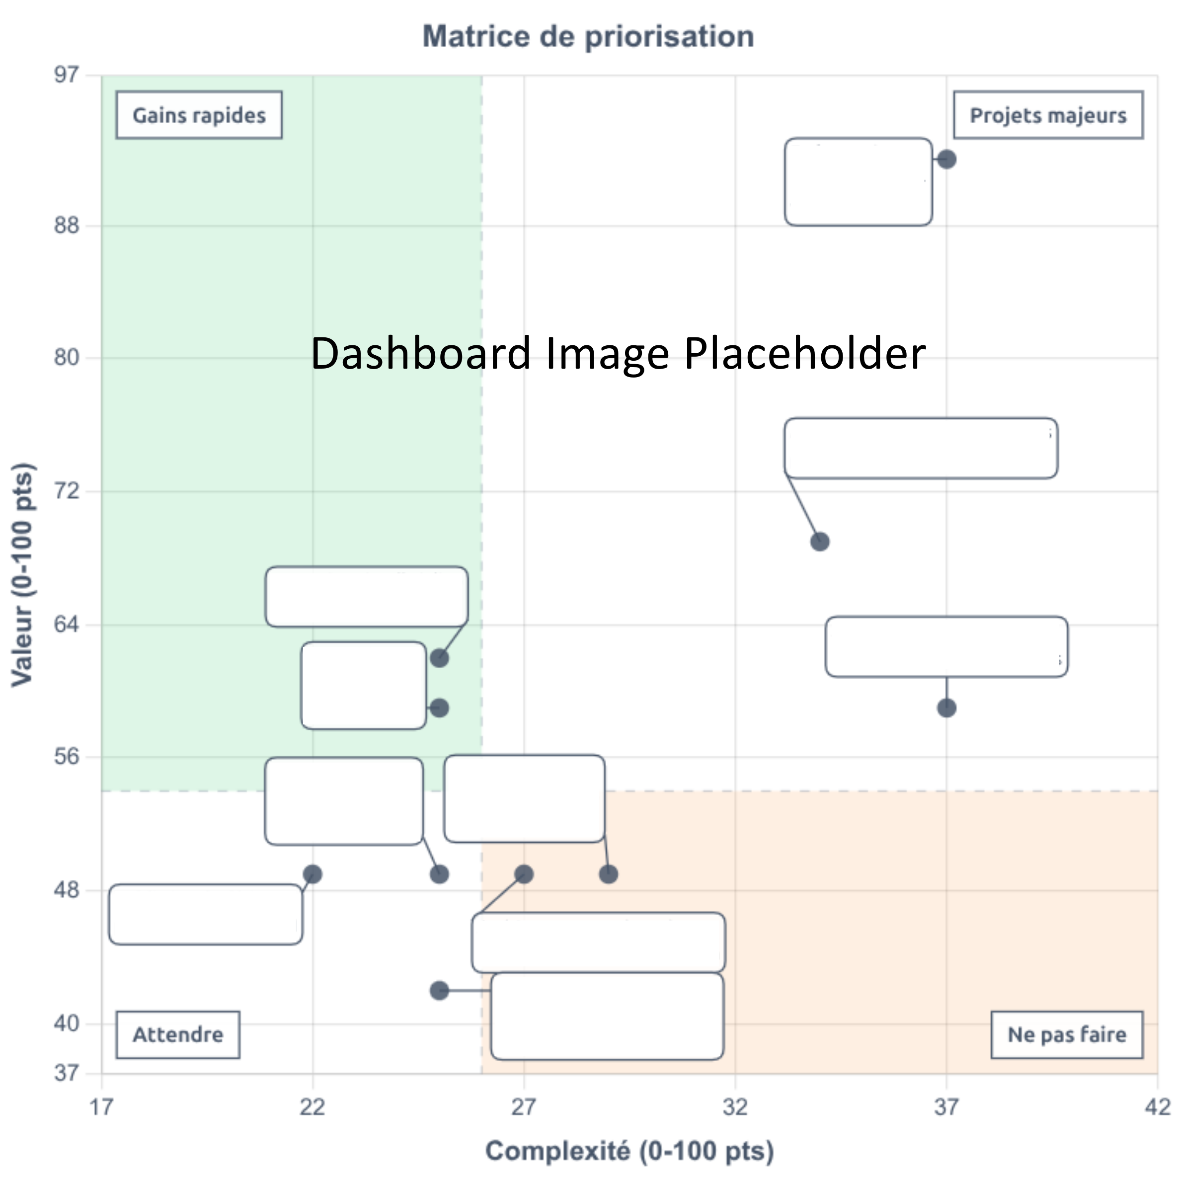

Introduction
{{folder.executiveSummary.introduction}}

Sommaire
Introduction 2
Analyse 4
Recommandations 5
Références 6
{{annex.subtitle}} 7

Analyse
{{folder.executiveSummary.analyse}}

Recommandations
{{folder.executiveSummary.recommandation}}

Références
{{FOR ref IN (folder.executiveSummary.references || [])}}
- {{$ref.link}}
{{END-FOR ref}}
{{annex.title}}

{{annex.subtitle}}
{{FOR uc IN (usecases || [])}}
{{INCLUDE template.usecase-onepage.docx WITH ($uc.data || $uc)}}
{{END-FOR uc}}

