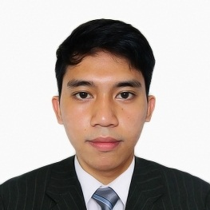

**OBJECTIVE:**

To grow along with the organization and become a professional of excellent repute by effectively contributing towards the goal of Organization.

**SKILLS:**

* HTML/HTML5
* CSS/CSS3
* Javascript
* JQuery
* PHP
* MySQL
* Photoshop
* Illustrator
* Microsoft Office

**LANGUAGE:**

* Filipino
* English

*I hereby certify that the above information is true and correct to the best of my knowledge and belief.*

ERIC B. REYES

Applicant

**ERIC BERMEJO REYES**

#45 Miranda Compound, Talon 1, Las Piñas City

09470402459 | 09777352530

[eric.bermejo.reyes@gmail.com](mailto:eric.bermejo.reyes@gmail.com)

**PERSONAL DATA:**

|  |  |
| --- | --- |
| Birth Date: June 8, 1994  Birth Place: Legazpi City, Bicol  Age: 22 years old  Gender: Male | Civil Status: Single  Nationality: Filipino  Religion: Roman Catholic |
|  |  |

**EDUCATION:**

Tertiary **Computer Arts and Technological College** 2011-2015

Bachelor of Science in Information Technology

*Balintawak Street, Albay District, Legazpi City*

Secondary **Daraga** **National High School** 2007-2011

*Daraga, Albay*

Elementary **Bagumbayan** **Central School** 2001-2007

*Washington Drive, Legazpi City*

**EXPERIENCE:**

**Web Designer**, Personiv, June 2015 – Present

*6F Aeon Center Bldg. North Bridgeway, Northgate Cyberzone, Alabang, Muntinlupa City*

* Web / Graphic Design
* Web Modification
* Content Management

**CHARACTER REFERENCE:**

MICHAEL ANNOVA | 09162112955

Web Designer - Personiv

JEJOMAR DORONGON | 09954286810

Web Designer - Personiv

AUBREY GONZALES | 09052106125

Web Designer - Personiv