Exercise #1

- Write the complete SQL statement for creating a new database called addressbook
*create database addressbook;
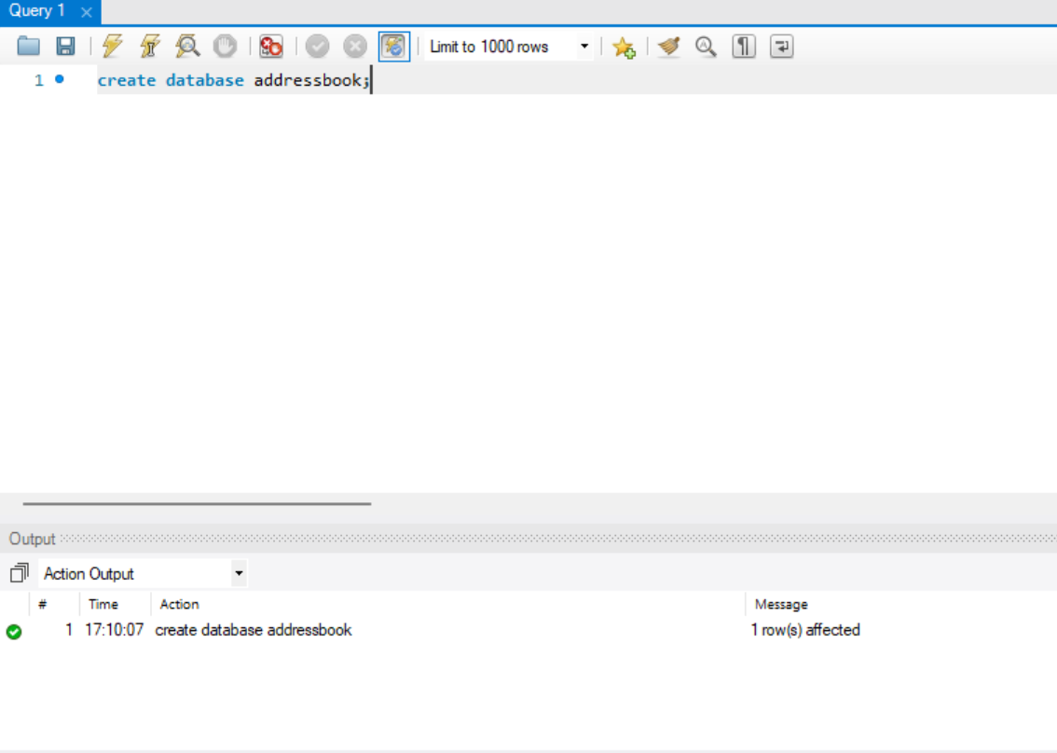

- Which statement is used to list the information about a table? How do you use this statement?

DESCRIBE statement.
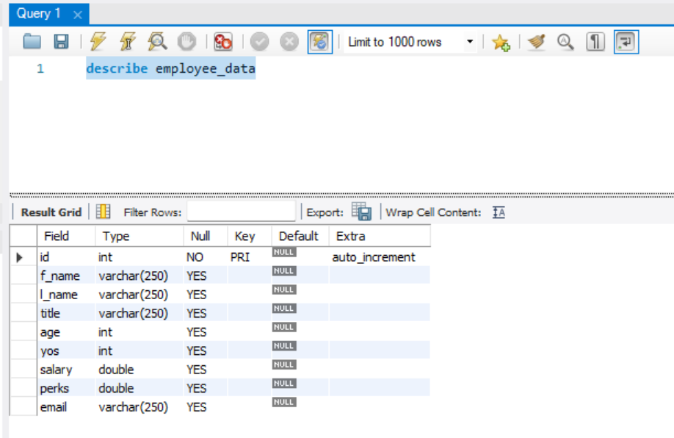

- How would you list all the databases available on the system?
SHOW DATABASES;
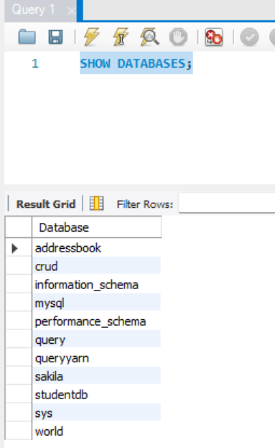

- Write the statement for inserting the following data in employee data table
insert into employee_data values(null,"Rudolf","Reindeer","Business Analyst","34","2","95000","17000","rudolf@bugnet.com")
- Give two forms of the select statement that will list all the data in employee_data table.
SELECT * from employee_data;
SELECT f_name, l_name, title, age, yos, salary, perks, email from employee_data;
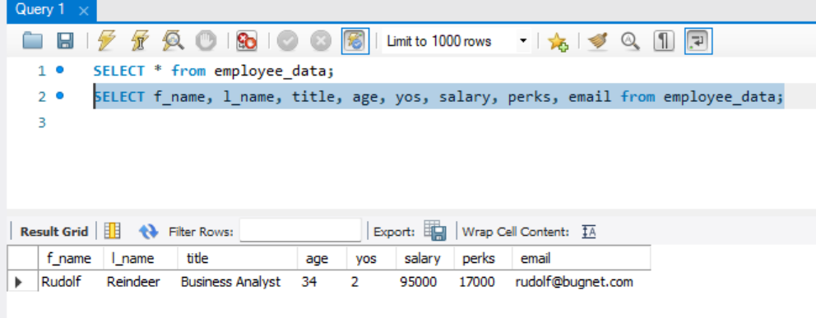
- What will select f_name, email from employee_data; display?
Will return all data from table but only display the first name and email
- Write the stamen for listing data from salary, perks,and yos, columns of employee-data table.
SELECT salary, perks, yos from employee_data;
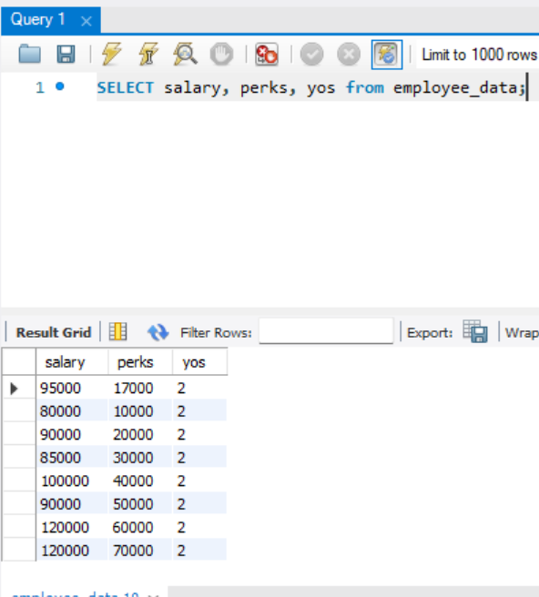
- How can you find the number of rows in a table using the select statement?

select count(id) as number_of_rows from employee_data;
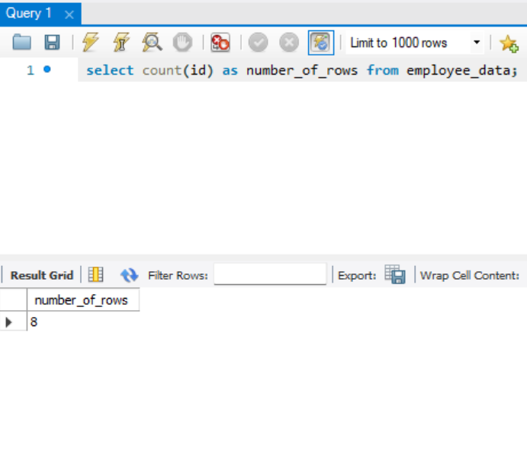
- What will select salary, i_name from employee_data; display?
Returns all data from table but only displays the salary and last name

