***First paragraph :***

The purpose of the assignment was the following:-

* Creating a summary Data Frame of the key metrics for the ride-sharing data by city type.
* creating a multiple-line graph that shows the total fares for each week by each city type.
* submitting a written report on the results of the new analysis,
* challenges you encountered and overcame, and any future recommendations for analysis.

Technical Analysis Deliverable 1: The summary Data Frame was created by merging the 2 datasets:-

* + Ride Data
  + City Data

#### Technical Analysis Deliverable 2: Multiple-Line Plot for the Sum of the Fares for Each City Type In this Analysis using acquired skills the sum of Fares for each city is plotted through line graph.

The summary Data Frame was created by merging the 2 datasets :-

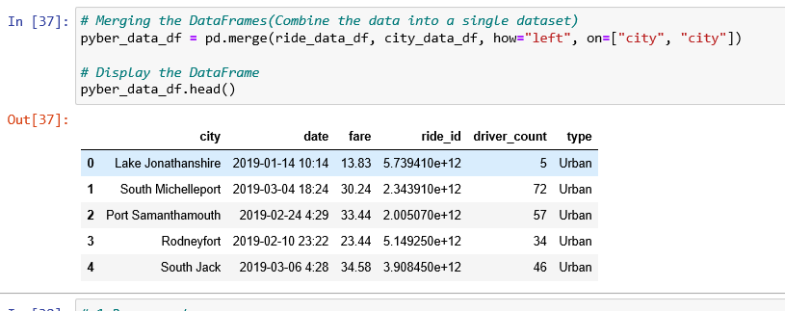

#### In this Analysis using acquired skills the sum of Fares for each city is plotted through line graph

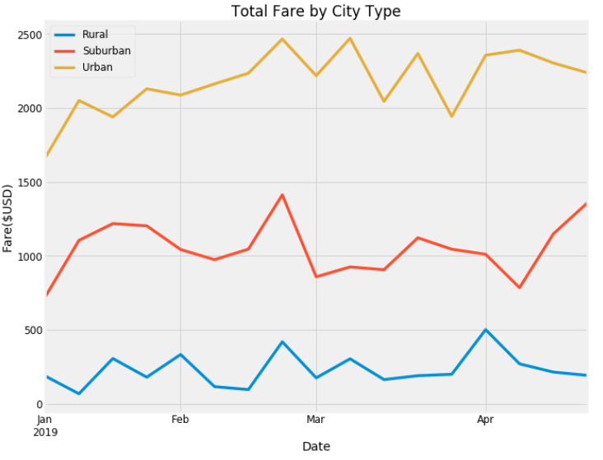

The final reports show that the “Total fare” from Jan, 2019- April 2019 is highest in Urban cities, Medium in Suburban cities and Lowest in Rural Cities.

*Second paragraph : -*

**Challenges:** -

The data Type for the Date was not compatible to elicit it in graph

**Solution:** Had to convert “Date” column data type from String to Datetime.

There were few challenges but over all it was a great learning experience.

*Third paragraph : -*

* There is a huge gap in the fare rates between Rural cities and Urban cities.
* We must investigate the factors that influence this gap and make this gap huge and take actions to correct it.
* The reason we may have for this huge gap could be because of lesser rides in Rural cities and more rides in Urban cities.
* It could be because in urban cities people travel much more than rural cities.