Childhood Cancer Genetic Risk Surveillance System
A simple software tool that reminds doctors and parents when a child with a known cancer-risk gene needs their next check-up
Prepared by: Harini
Second-Year B.Sc. Computer Science
Mini Project Report

1. What Is the Idea?
Some children are born with a gene mutation passed down from a parent. This is called a 'genetic predisposition' - it does not guarantee cancer, but it raises the chance of a specific type appearing in childhood.
Doctors already know, for several such mutations, exactly which tests a child needs, starting at what age, and how often. This information is published in medical guidelines. The problem is that applying it to one specific child - working out real calendar dates over many years - is currently done manually.

2. The Problem
A doctor or parent has to remember, year after year, which test is due next for a child with a known mutation. If a test is delayed or forgotten, an early warning sign of cancer could be missed - reducing the chances of catching it at a treatable stage.

3. The Solution (This Project)
A backend software system was built that removes this manual work. You give it a child's date of birth and their diagnosed genetic condition, and it automatically generates a complete, dated test calendar for that specific child - from birth up to age 18 - marking each test as already 'done' or still 'pending'.

4. Where the Data Came From
No new medical knowledge was discovered for this project. Five well-known, already-published genetic conditions and their screening guidelines (such as those discussed by the AACR Childhood Cancer Predisposition Workshop) were selected and stored in the system's database: Li-Fraumeni Syndrome, Retinoblastoma Predisposition, DICER1 Syndrome, MEN2, and Beckwith-Wiedemann Syndrome.

5. How It Works
The diagram below shows the complete process, from entering a child's details to viewing their finished schedule:
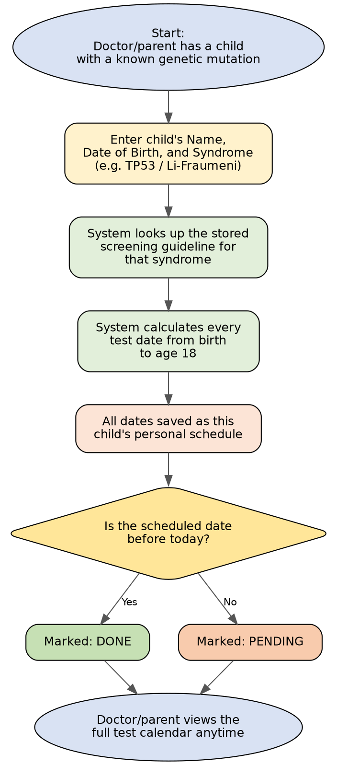
Figure 1: Process flow - from entering a child's details to viewing their generated, dated test schedule.

6. How the Data Is Organised (Database Design)
The system stores its information in 5 connected tables. 'syndromes' is the central table - each syndrome has its own list of cancer risks and its own screening protocol (tests + frequency). Each registered child is linked to one syndrome, and each child gets their own generated schedule.
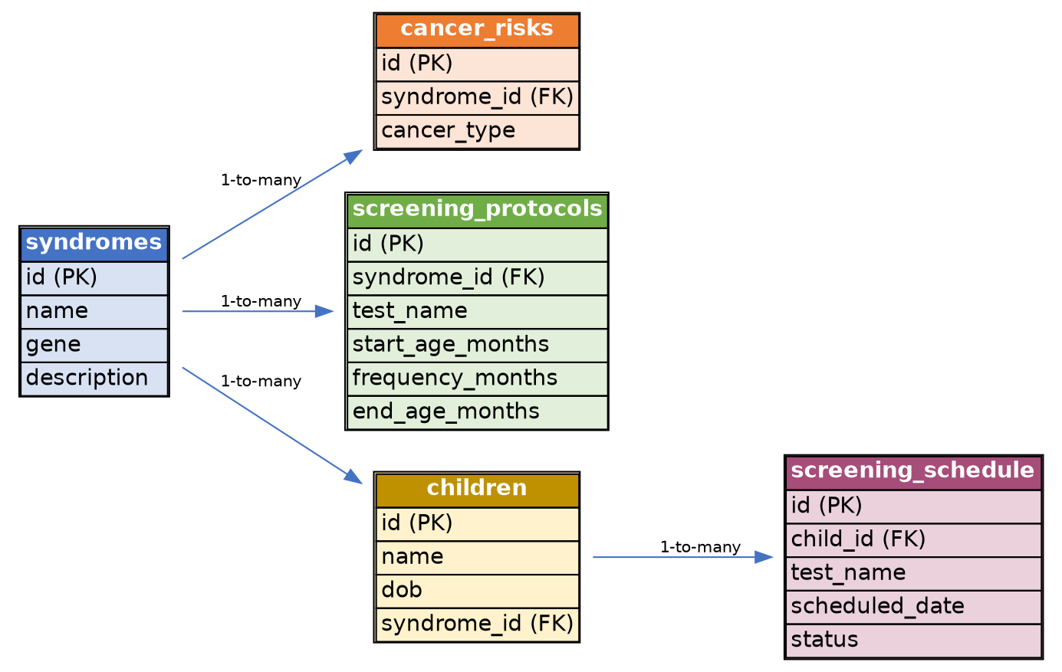
Figure 2: Entity-Relationship (ER) diagram showing the 5 database tables and how they connect to each other.

7. The 5 Genetic Conditions Stored in the System
This is the actual list returned by the running system:
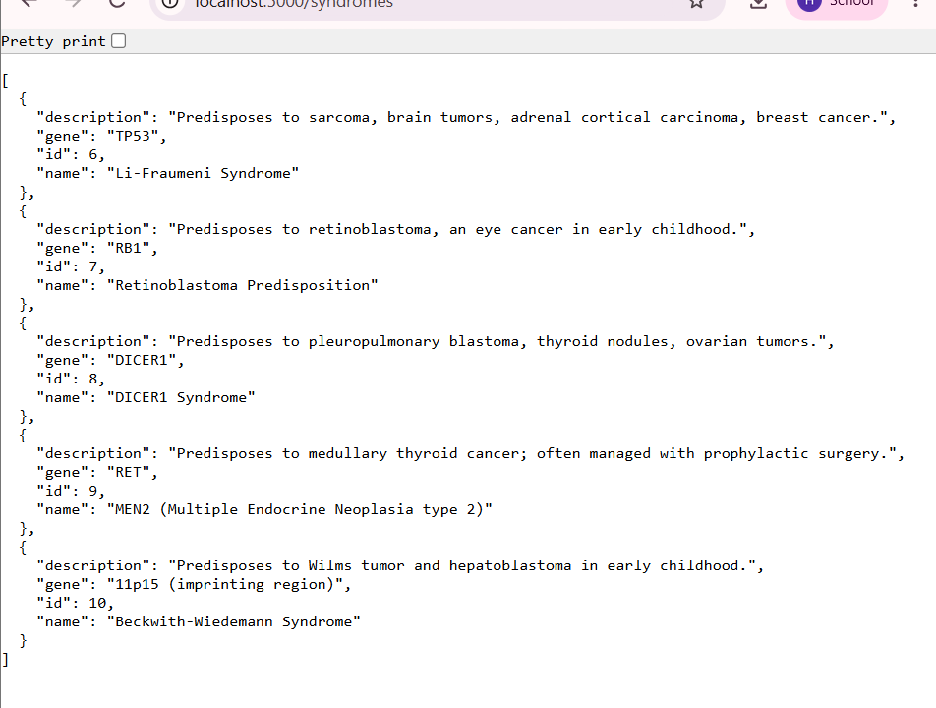
Figure 3: The 5 genetic conditions stored in the system, each with its associated gene and a short description of the cancer risk it carries.
In simple terms, this is what each one means:
Condition Name | Gene Involved | What It Means (Simple)
Li-Fraumeni Syndrome | TP53 | Raises the risk of several cancers, including sarcoma and brain tumors.
Retinoblastoma Predisposition | RB1 | Raises the risk of an eye cancer that appears in early childhood.
DICER1 Syndrome | DICER1 | Raises the risk of a rare lung tumor, plus thyroid and ovarian growths.
MEN2 | RET | Raises the risk of thyroid cancer; sometimes managed with early surgery.
Beckwith-Wiedemann Syndrome | 11p15 region | Raises the risk of a kidney tumor (Wilms tumor) and a liver tumor.

8. Demonstration: Adding a Child and Generating Her Schedule
To test the system, a sample child named 'Priya' was entered, with a date of birth of 10 June 2020 and the Li-Fraumeni Syndrome. The system automatically generated her entire test schedule. A short sample of it looks like this:
Date | Test | Status
10 Jun 2020 | Whole-body MRI | Done (in the past)
10 Jun 2020 | Abdominal Ultrasound | Done (in the past)
10 Jun 2020 | Blood Test (CBC) | Done (in the past)
10 Sep 2020 | Abdominal Ultrasound | Done (in the past)
10 Oct 2020 | Blood Test (CBC) | Done (in the past)
... | ... (continues every few months) ... | ...
10 Oct 2026 | Blood Test (CBC) | Pending (upcoming)
10 Dec 2026 | Abdominal Ultrasound | Pending (upcoming)
10 Jun 2027 | Whole-body MRI | Pending (upcoming)
... | ... (continues until she turns 18) ... | ...

In total, the system generated over 150 individual, correctly dated test entries for this one child - covering three different tests, each with its own frequency, without a single manual calculation.

9. Proof the System Actually Runs
The screenshot below shows the system running on a real computer: commands sent to the program ('curl' requests) and the program's replies confirming a child was added and a schedule generated, alongside the one-time environment setup.
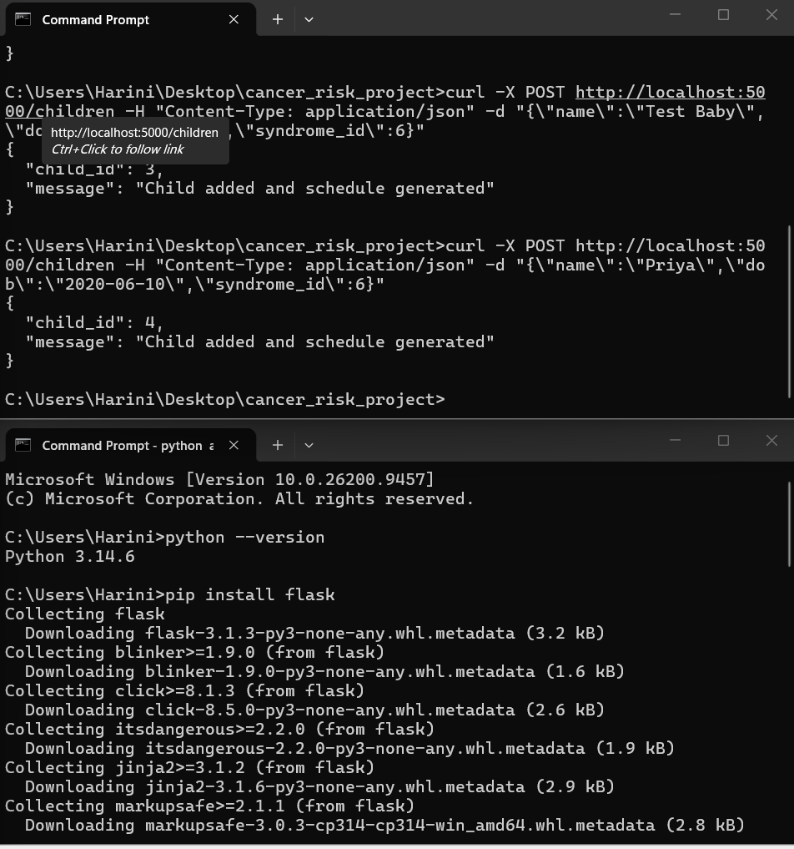
Figure 4: Command-line proof that the system successfully accepted new children and generated their schedules.

10. Technical Summary (Tech Stack)
- Python + Flask - used to build the backend API that receives requests and sends back data.
- SQLite - a lightweight database used to store the 5 tables shown in the ER diagram.
- Core logic - a scheduling function reads a syndrome's protocol (start age, frequency, end age) and steps forward in fixed intervals from the child's real date of birth, converting each step into an exact calendar date.
- API endpoints - list all syndromes, view one syndrome's detail, register a new child (auto-generates their schedule), view a child's full schedule, or view only their upcoming tests.

11. What Was Proven by Testing
- A Retinoblastoma child correctly received a single repeating test (Eye Exam, every 2 months until age 4).
- A Li-Fraumeni child correctly received three different, independently-timed tests running in parallel through to age 18.
- In both cases, past dates were automatically marked 'done' and future dates 'pending', based on today's real date.

12. What This Project Does NOT Do
- It does not discover any new gene or new cancer risk - it only uses conditions already known and published by doctors.
- It does not diagnose a child or replace a doctor - it only reminds when an already-recommended test is due.
- It only works for children with a known genetic condition; most childhood cancers have no known inherited cause and are outside this system's scope.

13. What Could Be Added Next
- A button for a doctor to mark a test as completed.
- Automatic email or SMS reminders before each test is due.
- A simple, visual calendar screen for parents to check easily.
- Getting the guideline data checked and validated by a real doctor or geneticist before any real-world use.

14. Why This Project Is Useful
- It is a real, working, healthcare-related backend project - a strong addition to a portfolio.
- It demonstrates the ability to turn a real-world problem and published guidelines into a functioning software system.
- The risk-flagging idea behind it is similar to logic used in fraud-detection/risk-scoring engines, connecting backend development with a fintech-style approach applied to a healthcare problem.

15. Conclusion
This project shows that a small, focused software system can take existing medical knowledge and turn it into something genuinely useful and easy to use - without needing to be a doctor or medical researcher to build it. It is a realistic, complete example of how a Computer Science student can apply backend development skills to a real-world healthcare problem.

