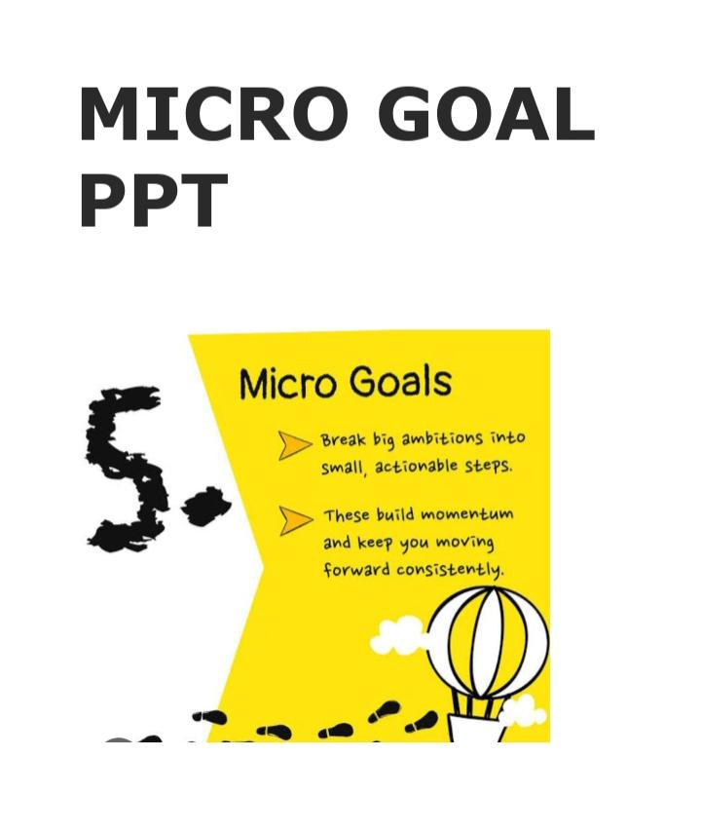

Slide 1 – Title Slide

Micro Goal Tracking System
Naan Mudhalvan Project
Team leader: Haripriya.R
Team members:
- Abinaya.R
- Basilath unnisha.J
- Jagadeeswari.D
- Karthika.R

College Name: valliammal college for women
Department and year: 2- BCA

Slide 2 – Introduct ion

The Micro Goal Tracking System helps users manage small daily goals.
This application allows users to:
- Create personal goals
- Track daily progress
- Complete tasks efficiently
- Improve productivity
- The system is built using frontend and backend technologies.

Slide 3 – Problem Statement

“If you don’t measure progress, you cannot improve.”

Many people face problems such as:
- Forgetting daily tasks
- Lack of motivation
- Difficulty tracking progress
- No simple system for goal management
- This project solves these problems by providing a goal tracking platform.

Silde 4: Objectives
“Setting small goals is the first step toward big success.”
The main objectives of this project are:
- To help users set micro goals
- To track daily progress
- To improve productivity
- To provide a simple user interface

Slide 5 – Technologies Used
“Technology turns ideas into reality.”
Frontend Technologies:
- HTML
- CSS
- JavaScript
- Bootstrap / React
Backend Technologies:
Java / Node.js / Python
Database:
MySQL / MongoDB

“Innovation grows when technology meets creativity.”

Slide 6 – Frontend Developer Role

“Design is where user experience begins.”

Responsibilities:

- Design user interface
- Create login and registration pages
- Build user dashboard
- Display goal progress
- Connect frontend with backend APIs

“A good interface makes technology easy for everyone.”

Slide 7 – Backend Developer Role

“The backend is the brain of every application.”

Responsibilities:
- Develop server-side logic
- Manage user authentication
- Store data in database
- Create APIs for frontend communication
- Ensure data security

Silde 8: Coding:

Let goals=[]
Let streak=0

Function addGoal(){

Const input=document.getElementById(“goalInput”)

If(input.value===””) return

Const goal={
Text:input.value,
Completed:false
}

Goals.push(goal)

Input.value=””

"name": "microgoal_project",
"version": "1.0.0",
"description": "🌟 MICROGOAL Tracker Web App 🌟",
"main": "server.js",
"scripts": {
"start": "node server.js"
},
"keywords": [
"microgoal",
"tracker",
"webapp"
],
"author": "YourName",
"license": "ISC",
"dependencies": {
"cors": "^2.8.6",
"express": "^4.22.1"
}
}
Const express = require(‘express’);
Const app = express();

App.use(express.json());
App.use(express.static(‘public’));

Let goals = [];

App.post(‘/add-goal’, (req, res) => {
Const { goal } = req.body;
If(goal.trim() !== “”) goals.push({ text: goal, done: false });
Res.json({ success: true });
});

App.post(‘/toggle-goal’, (req, res) => {
Const { index } = req.body;
If(goals[index]) goals[index].done = !goals[index].done;
Res.json({ success: true });
});

<!DOCTYPE html>
<html lang=”en”>
<head>
<meta charset=”UTF-8”>
<title>MicroGoal</title>
<link rel=”stylesheet” href=”style.css”>
</head>

<body>

<div class=”app”>

<header>
<h1> MicroGoal</h1>
<p>Small Goals • Big Success</p>

<button id=”darkModeBtn”> Dark Mode</button>
</header>

<div class=”goalInput”>
<input type=”text” id=”goalInput” placeholder=”Enter your goal…”>
<button onclick=”addGoal()”>Add Goal</button>
</div>

<div class=”progressBox”>
<p>Progress</p>
<div class=”progressBar”>
<div id=”progressFill”></div>
</div>
</div>

<ul id=”goalList”></ul>

<div class=”streakBox”>
Daily Streak: <span id=”streak”>0</span> days
</div>

<p class=”motivation”>Stay focused. Stay consistent. </p>

</div>

<script src=”script.js”></script>

</body>
</html>
Let goals=[]
Let streak=0

Function addGoal(){

Const input=document.getElementById(“goalInput”)

If(input.value===””) return

Const goal={
Text:input.value,
Completed:false
}

Goals.push(goal)

Input.value=””

renderGoals()

}

Function renderGoals(){

Const list=document.getElementById(“goalList”)

List.innerHTML=””

Let completedCount=0

Goals.forEach((goal,index)=>{

Const li=document.createElement(“li”)

If(goal.completed){
li.classList.add(“completed”)
completedCount++
}

li.innerHTML=`
<span onclick=”toggleGoal(${index})”>${goal.text}</span>
<div>
<button onclick=”toggleGoal(${index})”>✅</button>
<button onclick=”deleteGoal(${index})”></button>
</div>
`

List.appendChild(li)

})

updateProgress(completedCount)

}

Function toggleGoal(index){

Goals[index].completed=!goals[index].completed

renderGoals()

}

Function deleteGoal(index){

Goals.splice(index,1)

renderGoals()

}

Function updateProgress(completed){

Const percent=(completed/goals.length)*100 || 0

Document.getElementById(“progressFill”).style.width=percent+”%”

If(percent===100 && goals.length>0){
Streak++
Document.getElementById(“streak”).innerText=streak
}

}

Document.getElementById(“darkModeBtn”).onclick=function(){
Document.body.classList.toggle(“dark”)
}

Silde 9: Output:

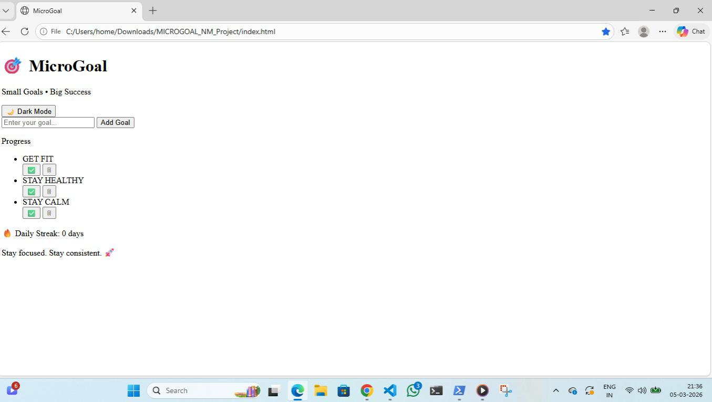

Silde 10:System Architecture

“A strong structure builds a strong system.”

Architecture Flow:
User → Frontend → Backend → Database

Explanation:
- User interacts with the Frontend interface
- Frontend sends requests to Backend server
- Backend processes the request
- Data is stored or retrieved from Database

Slide 11 – Advantages

“Simple tools can create powerful results.”

Advantages of the system:
- Easy goal tracking
- Improves productivity
- Simple user interface
- Secure data management

“Efficiency comes from simplicity.”

Silde 12: Conclusion

“Small steps every day lead to great achievements.”

The Micro Goal Tracking System helps users manage their daily goals efficiently.
By integrating frontend and backend technologies, the system provides a smooth user experience.

“Great success begins with small consistent goals

Thank you

