Cookbook
website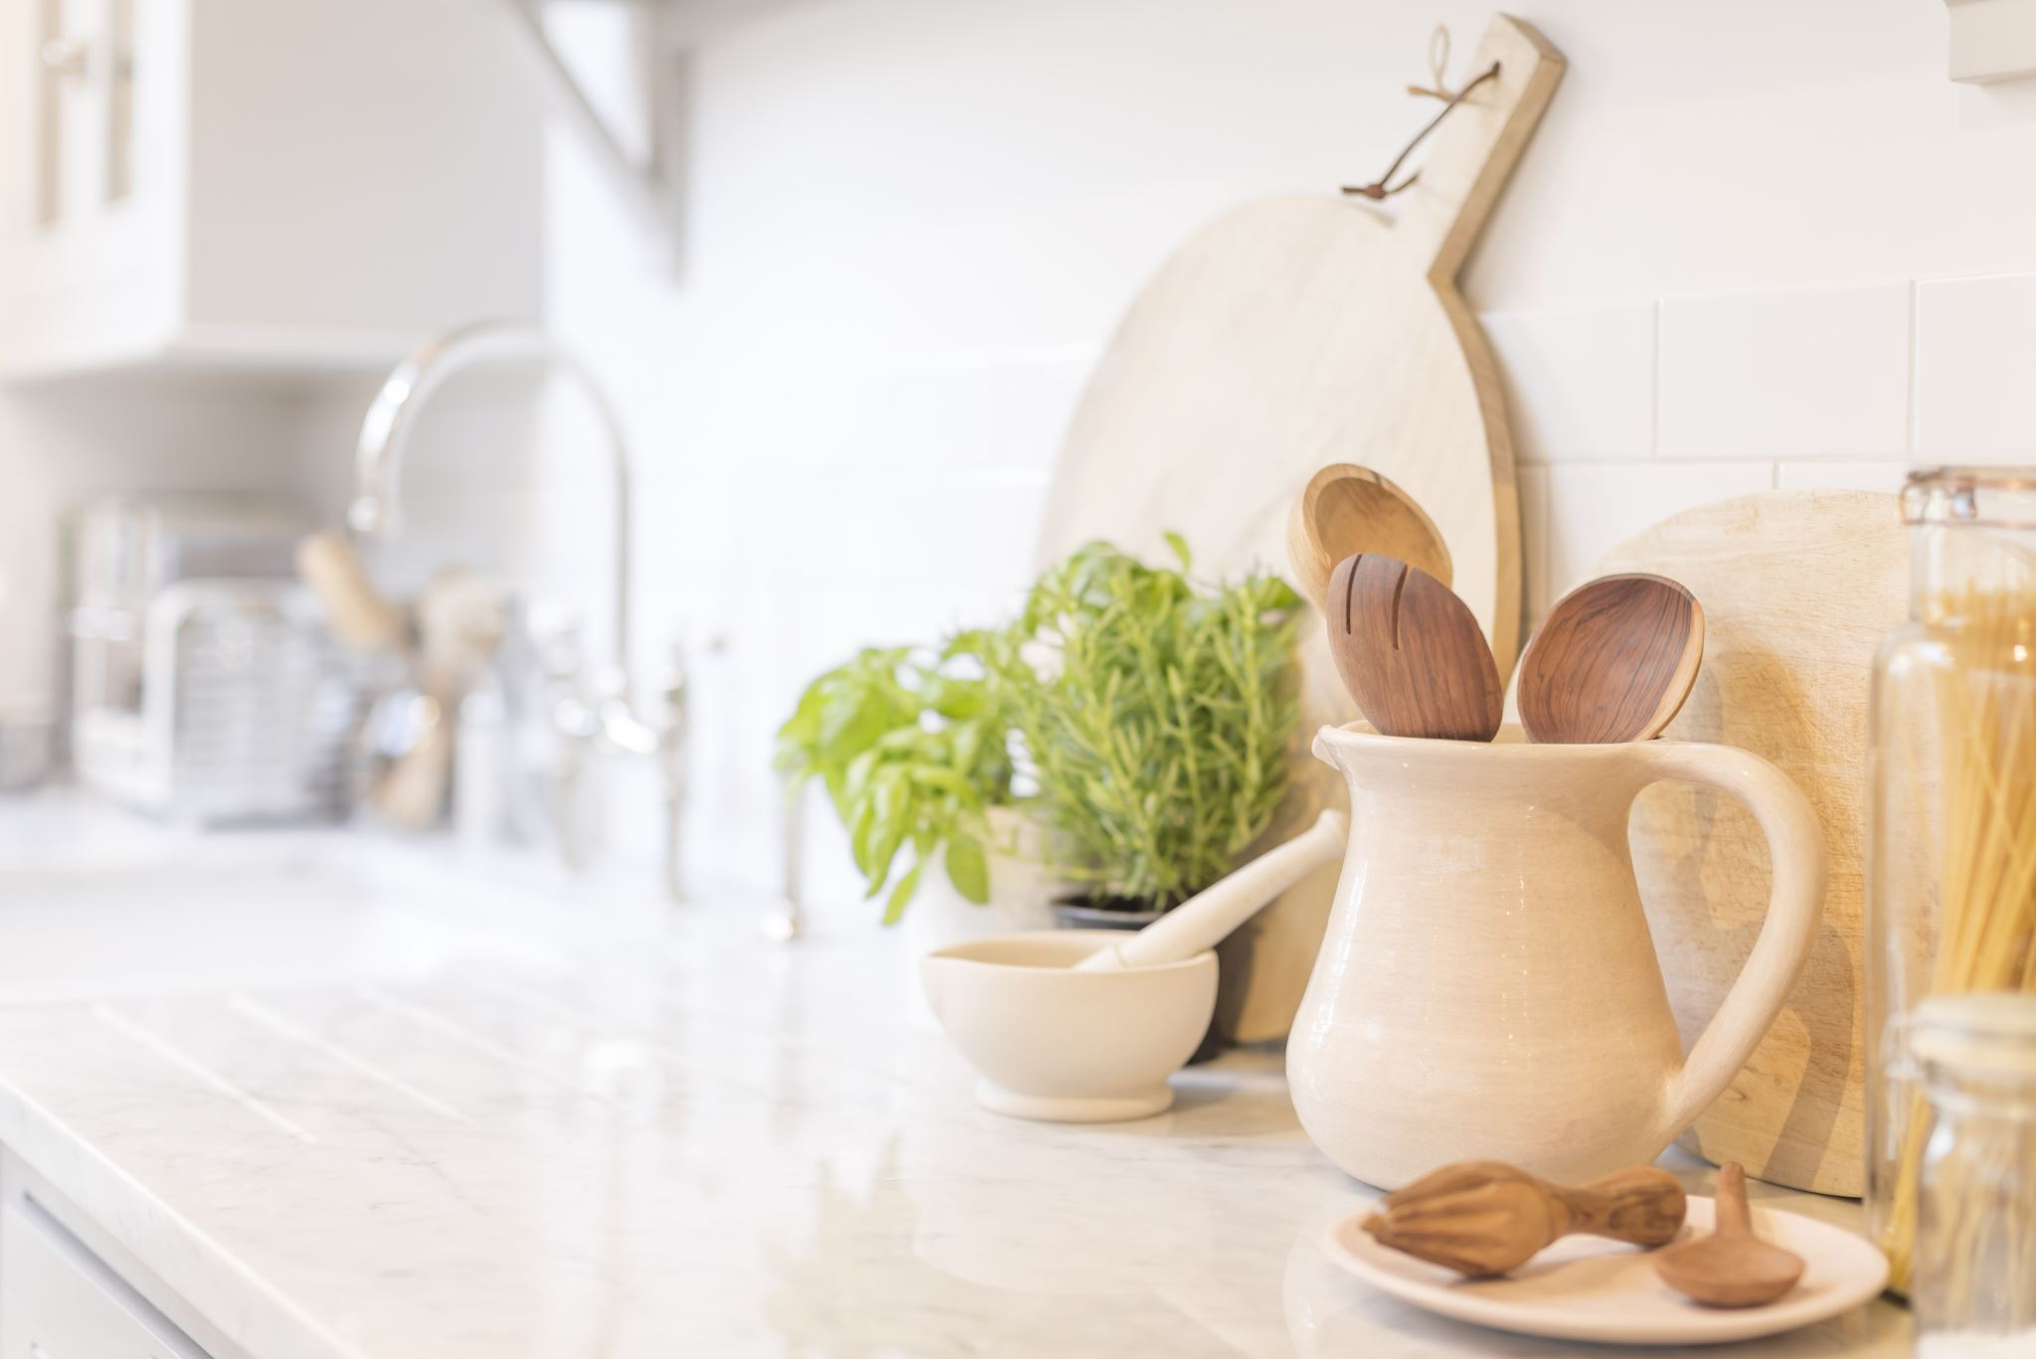

TEAM MEMBERS
•HARIPRIYA.R
•KARTHIKA.R
•JAGADEESHWARI.D
•MONISHA.S
•MADHUSREE.S

PURPOSE:
Provide Instructions – It gives step-by-step guidance for preparing dishes, making cooking easier for beginners and helpful for experienced cooks.
Preserve Recipes – It records traditional, family, or cultural recipes so they won’t be forgotten and can be passed down to future generations.
Inspire Creativity – Cookbooks introduce new cuisines, techniques, and ingredients, inspiring people to try different styles of cooking.
Promote Healthy Eating – Many cookbooks focus on nutrition, diet plans, or specific health needs (e.g., diabetic-friendly, vegan, gluten-free).
Cultural Sharing – They serve as a window into different cultures, showcasing food traditions and stories behind dishes.
Educational Tool – Helps readers learn about cooking methods, measurements, ingredient substitutions, and kitchen skills.
FEATURES:
Collection of Recipes – Step-by-step instructions for preparing different dishes.
Ingredients List – Clear mention of ingredients with exact quantities.
Cooking Instructions – Easy-to-follow steps, often with tips or variations.
Measurements & Conversions – Standard units of measurement (cups, grams, spoons).
Categorization – Recipes grouped by type (starters, main course, desserts, etc.).
Pictures/Illustrations – Images of dishes to guide presentation and attract readers.
Cooking Techniques – Explanation of methods like baking, boiling, frying, grilling.
Nutritional Information – Some cookbooks provide calories, vitamins, or diet suitability

Architecture
Components structure:
1. Front Matter
Title Page – Name of the cookbook, author, and publisher.
Dedication/Preface/Introduction – Purpose of the book, author’s notes, or background.
Table of Contents – Organized list of chapters or recipe categories.
2. Main Body
Chapters/Sections – Recipes grouped (e.g., Breakfast, Snacks, Main Dishes, Desserts).
Recipes – Each recipe usually has:
Title of the dish
Ingredients list
Step-by-step instructions
Cooking time & servings
Nutritional facts (optional)
Tips/Variations
Pictures/Illustrations
3. Back Matter
Glossary – Cooking terms explained.
Index – Alphabetical list of recipes for quick search.
References/Notes – Additional sources or acknowledgments.

State management:
User Preferences – Selected theme (dark/light mode), favorite cuisines.
Recipe Data – Which recipe is being viewed, added, or edited.
Search & Filters – Selected categories (e.g., vegetarian, dessert).
Shopping List – Ingredients saved for later.
Progress – Steps completed while following a recipe.

Folder structure:
project-name/
│
├── public/ # Static files (index.html, favicon, images)
│ └── index.html
│
├── src/ # Main source code
│ ├── assets/ # Images, icons, fonts, CSS files
│ ├── components/ # Reusable UI components (Button, Navbar, etc.)
│ ├── pages/ # Full pages/screens (Home, About, Login, etc.)
│ ├── hooks/ # Custom React hooks (useAuth, useFetch, etc.)
│ ├── services/ # API calls or external services
│ ├── utils/ # Helper functions (formatDate, validations, etc.)
│ ├── App.js # Root component
│ ├── index.js # Entry point (renders React app)
│ └── styles/ # Global styles (CSS, SCSS, Tailwind configs, etc.)
│
├── .env # Environment variables (API keys, secrets)
├── package.json # Project dependencies and scripts
├── README.md # Project documentation
└── node_modules/ # Installed dependencies (auto-generated

Styling:
CSS Frameworks:
CSS Frameworks in a Cookbook Website
A CSS framework is a pre-prepared library of CSS styles that helps you design a cookbook site quickly with a neat and professional look.
🔑 Role of CSS Frameworks in a Cookbook Project
Ready-made Styles – Provides pre-designed buttons, forms, grids, and navigation bars.
Responsive Design – Ensures recipes, images, and layout look good on mobile, tablet, and desktop.
Consistency – All recipe pages look uniform in style.
Faster Development – Saves time; no need to write all CSS from scratch.
Customizable Themes – Easy to change colors, fonts, and layouts to match the cookbook theme.
HTML:
📌 HTML Usage in Cookbook Project
Page Structure
Creates the basic layout of the cookbook (Home page, Recipe list, About page, Contact page).
Uses elements like <header>, <nav>, <main>, <section>, <footer>.
Recipe Listing
Recipes are displayed using <ul> (unordered lists) or <ol> (ordered lists).
Each recipe can be a <div> or <article> with title, image, and description.
Headings & Titles
<h1>, <h2>, <h3> used for recipe names, ingredients, and instructions.
Ingredients Section
Ingredients shown with lists <ul> and <li>.

CODE COVERAGE:
🔹 What is Code Coverage?
Code coverage is a software testing metric that measures how much of your code is executed when running tests.
It’s mainly used in programming projects (JavaScript, Python, Java, etc.), not in plain HTML.
For HTML/CSS only, you don’t have code execution — so "coverage" doesn’t apply directly.
But if you add JavaScript to your cookbook project (for interactivity), you can measure test coverage using tools like:
Jest + Istanbul (nyc) for JavaScript
Playwright / Cypress for UI testing
🔹 Example in JavaScript (Cookbook Project)
Suppose you add a small JavaScript function in your cookbook project:
Copy code
Html
<script>
function calculateIngredients(servings) {
return servings * 2; // example: 2 slices of bread per serving
}
</script>
Then you write a test (using Jest):
Copy code
Javascript
const { calculateIngredients } = require('./cookbook.js');

test('calculates ingredients correctly', () => {
expect(calculateIngredients(3)).toBe(6);
});
If you run with coverage:
Copy code
Bash
npx jest --coverage
You’d get a report showing how much of your code was tested.
🔹 Code Coverage Report (Sample Output)
Copy code

File | % Stmts | % Branch | % Funcs | % Lines
-----------------|---------|----------|---------|---------
All files | 100 | 100 | 100 | 100
cookbook.js | 100 | 100 | 100 | 100
KNOWN ISSUSE:
✅ Fix and complete the code (working navigation + finished recipes),
📌 Or just point out best practices (like semantic HTML, accessibility, structure improvements) without rewriting everything?

CODING:
<!DOCTYPE html>
<html lang="en">
<head>
<meta charset="UTF-8">
<meta name="viewport" content="width=device-width, initial-scale=1.0">
<title>Cookbook</title>
<style>
body {
font-family: Arial, sans-serif;
}
.header {
background-color: #f0f0f0;
padding: 20px;
text-align: center;
}
.recipe {
background-color: #fff;
padding: 20px;
border: 1px solid #ddd;
margin-bottom: 20px;
box-shadow: 0 0 10px rgba(0, 0, 0, 0.1);
}
.recipe img {
width: 100%;
height: 200px;
object-fit: cover;
border-radius: 10px;
}
.category {
background-color: #f0f0f0;
padding: 10px;
margin-bottom: 10px;
border: 1px solid #ddd;
}
.category ul {
list-style: none;
padding: 0;
margin: 0;
}
.category li {
display: inline-block;
margin-right: 20px;
}
.category a {
text-decoration: none;
color: #337ab7;
}
</style>
</head>
<body>
<div class="header">
<h1>Cookbook</h1>
<nav>
<ul>
<li><a href="
<li><a href="#lunch">Lunch</a></li>
<li><a href="
</ul>
</nav>
</div>
<main>
<section id="breakfast">
<h2>Breakfast Recipes</h2>
<div class="recipe">
<h3>Avocado Toast</h3>
<img src="avocado-toast.jpg" alt="Avocado Toast">
<p>Description: A simple and delicious breakfast recipe.</p>
<p>Ingredients:</p>
<ul>
<li>2 slices of bread</li>
<li>1 avocado</li>
<li>Salt and pepper to taste</li>
</ul>
<p>Instructions:</p>
<ol>
<li>Toast the bread.</li>
<li>Mash the avocado.</li>
<li>Spread the avocado on the toast.</li>
</ol>
</div>
<div class="recipe">
<h3>Omelette</h3>
<img src="omelette.jpg" alt="Omelette">
<p>Description: A classic breakfast recipe.</p>
<p>Ingredients:</p>
<ul>
<li>2 eggs</li>
<li>1 cup of shredded cheese</li>
<li>Salt and pepper to taste</li>
</ul>
<p>Instructions:</p>
<ol>
<li>Beat the eggs.</li>
<li>Add the cheese.</li>
<li>Cook in a pan.</li>
</ol>
</div>
</section>
<section id="lunch">
<h2>Lunch Recipes</h2>
<div class="recipe">
<h3>Grilled Chicken Sandwich</h3>
<img src="grilled-chicken-sandwich.jpg" alt="Grilled Chicken Sandwich">
<p>Description: A simple and delicious lunch recipe.</p>
<p>Ingredients:</p>
<ul>
<li>4 boneless chicken breasts</li>
<li>4 hamburger buns</li>
<li>Lettuce, tomato, and mayonnaise</li>
</ul>
<p>Instructions:</p>
<ol>
<li>Grill the chicken.</li>
<li>Assemble the sandwich.</li>
<li>Serve and enjoy.</li>
</ol>
</div>
<div class="recipe">
<h3>Tomato Soup</h3>
<img src="tomato-soup.jpg" alt="Tomato Soup">
<p>Description: A comforting and delicious soup recipe.</p>
<p>Ingredients:</p>
<ul>
<li>2 cups of chopped tomatoes</li>
OUTPUT:

Cookbook
- Lunch

Breakfast Recipes

Avocado Toast
Description: A simple and delicious breakfast recipe.
Ingredients:
  - 2 slices of bread
  - 1 avocado
  - Salt and pepper to taste
Instructions:
  - Toast the bread.
  - Mash the avocado.
  - Spread the avocado on the toast.

Omelette
Description: A classic breakfast recipe.
Ingredients:
  - 2 eggs
  - 1 cup of shredded cheese
  - Salt and pepper to taste
Instructions:
  - Beat the eggs.
  - Add the cheese.
  - Cook in a pan.

Lunch Recipes

Grilled Chicken Sandwich
Description: A simple and delicious lunch recipe.
Ingredients:
  - 4 boneless chicken breasts
  - 4 hamburger buns
  - Lettuce, tomato, and mayonnaise
Instructions:
  - Grill the chicken.
  - Assemble the sandwich.
  - Serve and enjoy.

Tomato Soup
Description: A comforting and delicious soup recipe.
Ingredients:
  - 2 cups of chopped tomatoes

Cookbook
- Lunch

Breakfast Recipes

Avocado Toast
Description: A simple and delicious breakfast recipe.
Ingredients:
  - 2 slices of bread
  - 1 avocado
  - Salt and pepper to taste
Instructions:
  - Toast the bread.
  - Mash the avocado.
  - Spread the avocado on the toast.

Omelette
Description: A classic breakfast recipe.
Ingredients:
  - 2 eggs
  - 1 cup of shredded cheese
  - Salt and pepper to taste
Instructions:
  - Beat the eggs.
  - Add the cheese.
  - Cook in a pan.

Lunch Recipes

Grilled Chicken Sandwich
Description: A simple and delicious lunch recipe.
Ingredients:
  - 4 boneless chicken breasts
  - 4 hamburger buns
  - Lettuce, tomato, and mayonnaise
Instructions:
  - Grill the chicken.
  - Assemble the sandwich.
  - Serve and enjoy.

Tomato Soup
Description: A comforting and delicious soup recipe.
Ingredients:
  - 2 cups of chopped tomatoes

FUTURE ENHANCEMENTS:
🔹 Future Enhancements for Cookbook Project
1. Search & Filter Recipes
Add a search bar to quickly find recipes by name or ingredient.
Example: typing "tomato" shows Tomato Soup and Tomato Pasta.
Categories & Navigation
Organize recipes by Breakfast, Lunch, Dinner, Snacks, Desserts.
Add clickable category tabs or dropdown navigation.
3. Add Recipe Form
Allow users to add their own recipes through a form.
Store new recipes in localStorage (so they persist without a database).
4. Responsive Design
Use CSS Grid or Flexbox to make the layout mobile-friendly.
Recipes should look good on phones, tablets, and desktops.
5. Dark Mode Toggle
Add a button to switch between light and dark themes.
Copy code
Html
<button onclick="document.body.classList.toggle('dark')">🌙 Dark Mode</button>
<style>
.dark {
background-color: #222;
color: #f5f5f5;
}
</style>
6. Interactive Features
Rating system ⭐⭐⭐⭐⭐
Like / Favorite button ❤️ to save favorite recipes
Step-by-step slideshow for instructions
7. Backend Integration (Advanced)
Connect to a backend (Node.js, Firebase, or Django) to store recipes.
Enable user accounts so people can log in and share recipes.
👉 These features will slowly transform your static cookbook into a full-featured recipe web app.

THANKYOU

