

CallDr Central Nursing Station Role

**Contents**

The Nursing Station Role 2

Log In to CallDr Central 2

Navigate to the Home Screen 2

Call a Provider in for Duty 2

Obtain Provider Contact Information 4

Tips, Tricks and Contacting Us 5



Fractal OnCall Solutions, LLC.

Mobile Medical Collaboration Solutions

2440 E. Tudor #240 Anchorage, AK 9950

# The Nursing Station Role

The Nursing Station role allows hospital staff to call an on-call provider in for duty or obtain a provider’s contact information in order to discuss inpatient care without making an EMTALA call.

The only functionality available to this role beyond what is available to all other CallDr Central users is that Nursing Station users will be able to enter their initials in the **Confirm Contact for Duty** pop-up window after contacting or attempting to contact a provider.

## Log In to CallDr Central

Nursing Station users are not required to provide a username and password. They can access CallDr Central directly by double-clicking the CallDr Central icon on the computer or kiosk desktop to open the application in a new web browser window.

## Navigate to the Home Screen

The **Home** screen for Nursing Station users defaults to the **EMTALA Schedule**. The schedule defaults to the current day and the user’s hospital.

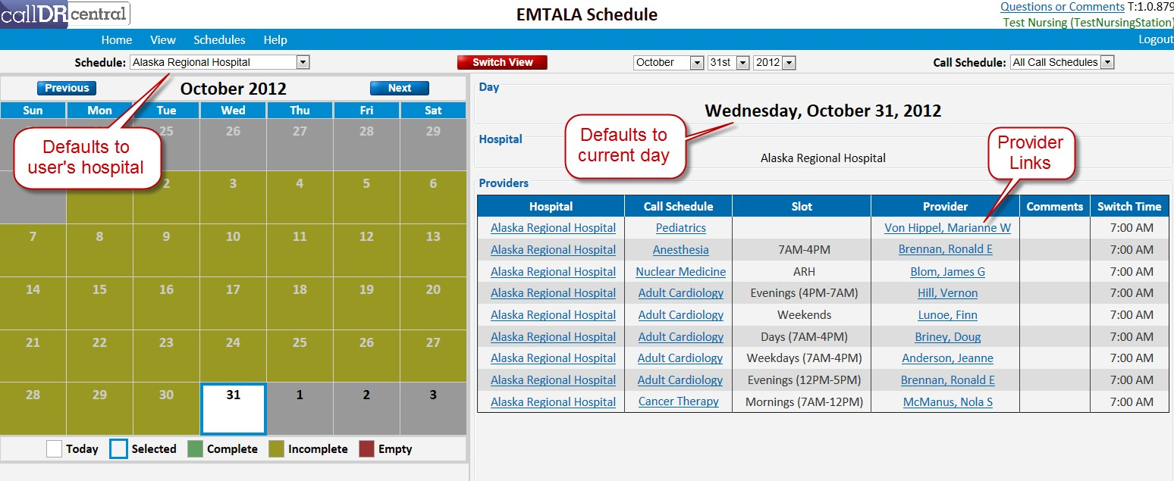

To return to the **Home** screen after navigating to another screen, click **Home** on the menu item bar.

## Call a Provider in for Duty

Follow these steps to call a provider in for duty:

1. On the **Schedules** menu, click either **Today’s EMTALA Schedule** or **EMTALA Schedule**. The system displays the schedule for the current day:

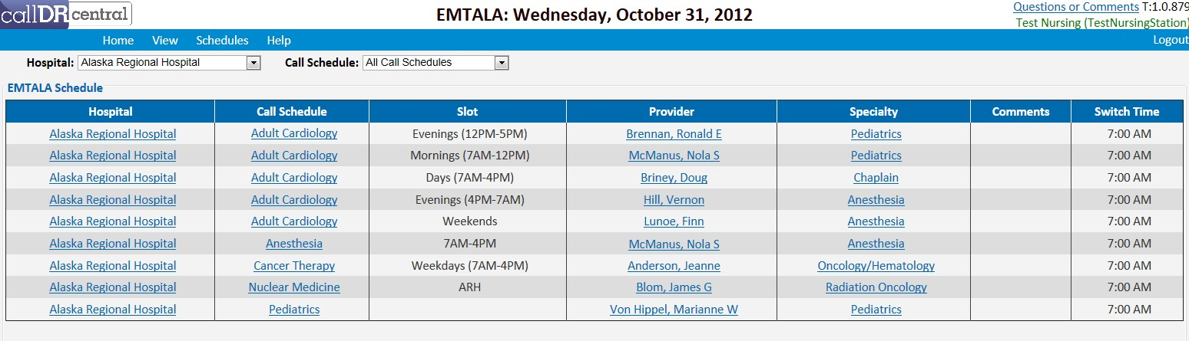

1. Click a provider’s name to display the contact information for that provider. The system displays the **Provider Information** pop-up window:

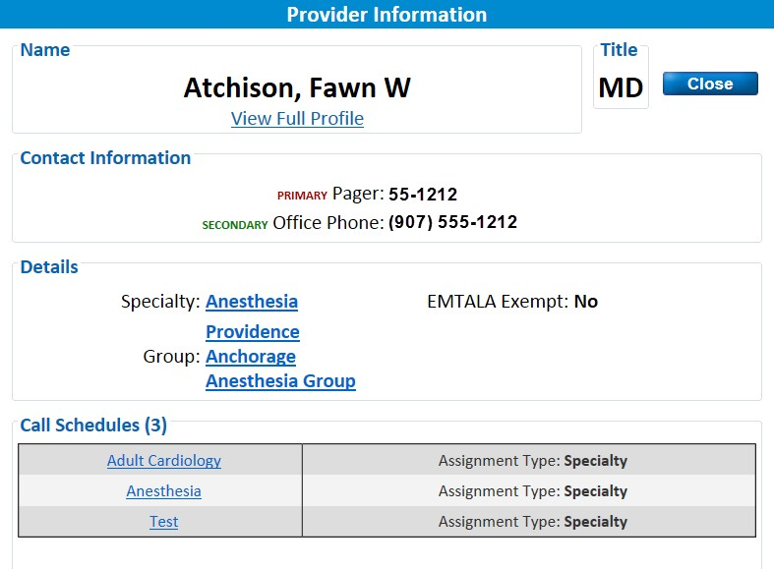

1. After contacting the provider, click the **Confirm Contact** button to the right of the phone number used to contact the provider. The system displays the **Confirm Contact for Duty** dialog box:

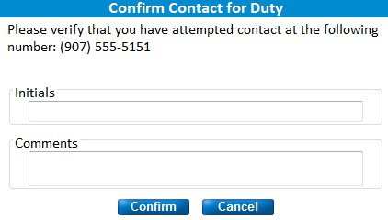

1. Enter your initials in the **Initials** field (mandatory) and comments in the **Comments** field (optional).
2. Click **Confirm** to submit the confirmation. The system displays the **Contact Logging** confirmation dialog box:

6.

Click

**OK**

to return to the previous screen.

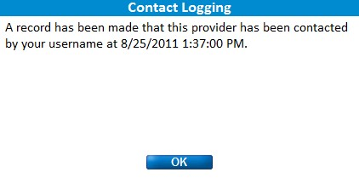

## Obtain Provider Contact Information

Nursing Station users often need to call a provider to discuss inpatient care without calling the provider in for EMTALA duty. *If the provider is not being called in for EMTALA duty, then the contact does not need to be recorded*. Follow these steps to obtain a provider’s contact information when not calling the provider in for EMTALA duty:

1. On the **View** menu, click **Providers** to view the **View Providers** screen. The system displays a list of providers on the left side of the screen:

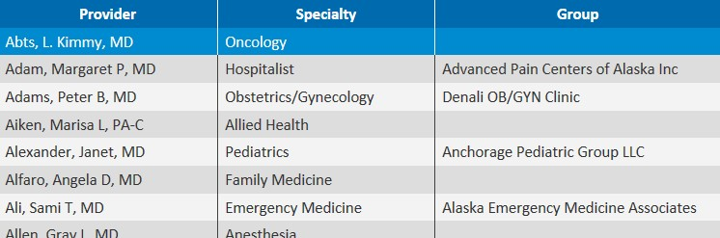

1. Enter search criteria in the **Name**, **Specialty Name**, or **Call Schedule Name** field and press **Enter** to filter, or filter by making a selection from the **Group** dropdown list. The number of results defaults to 50, but can be changed using the **Results** dropdown list.
2. Click anywhere on a provider’s row to display the information for that provider on the right side of the screen:

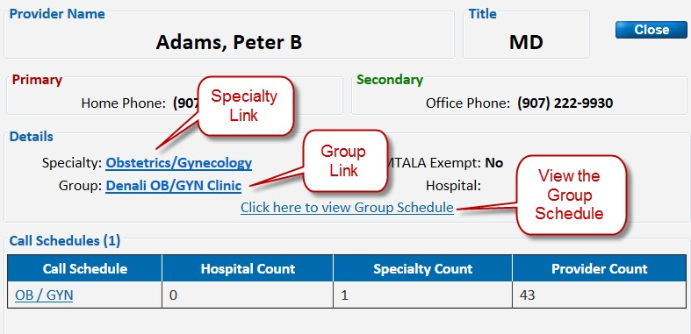

# Tips, Tricks and Contacting Us

**ALWAYS press the Save Button to save any changes you need saved!**

**The Blue menu bar at the top is your method to navigate around.**

Set your browser home page to <Http://www.calldrcentral.com>

This will allow you to quickly and easily launch the application.

Each browser is different:

IE – Click on the Gear Icon at the top right, Internet Options, and enter <http://www.calldrcentral.com> in the Homepage box, and click OK.

Chrome –

FireFox – Click on the FireFox option, upper left menu, and enter <http://www.calldrcentral.com> in the Homepage box and click OK.

Safari – (iMac) Click or Tap the Safari menu option, Preferences and enter <http://www.calldrcentral.com> in the Homepage box then exit button.

Add a short cut on your desktop

Windows. Go to the Desktop. Right Click on the desktop. Select New. Select Short cut. Enter <http://www.calldrcentral.com>. Click Next. Enter a description for the short cut. Click ok. Short Cut will be on your desktop.

iMac – To be determined.

If you are on a shared computer, do not leave the application without logging out.

If you are on a shared computer, do not let the browser store your login information.

If your session times out, you will need to re-login.

If you make a mistake, you can use the back button on your browser to discard the changes, but once you press the Save button, you cannot undo the changes.

Verify that your email address is correct.

Verify that your phone number is correct.

**Tech Support**

If there is an issue or problem with the data that is in the system, please first call your application/database administrator. If the issue is not urgent, you can always leave us a message using the Questions or Comments link at the top right of the system. If the system is not working properly or you get an error that the web page cannot be found -

Call US!

1-907-248-2537