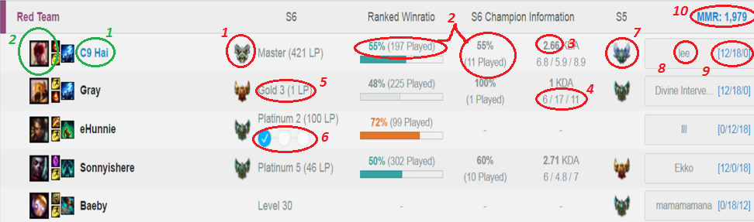

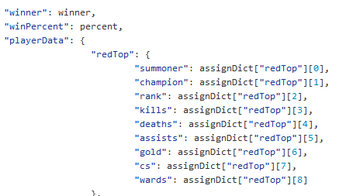

**1 “summoner”**

**2 picture of “champion” from** [**http://gameinfo.na.leagueoflegends.com/en/game-info/champions/**](http://gameinfo.na.leagueoflegends.com/en/game-info/champions/)

http://a.deviantart.net/avatars/p/a/pay-attention.png?1





 **xxxxxxxxx** http://a.deviantart.net/avatars/p/a/pay-attention.png?1**(xxxx)** https://yoo.rs/media/uploads/5774/images/photo.jpg.png**(xxx)** http://i.imgur.com/2kwycth.png**(xxx)**

**(champion) (Summoner) (rank) (K/D/A) (Gold) (Minions) (wards)**

**Picture Link**

1. <http://orig04.deviantart.net/6a92/f/2015/258/b/e/miss_fortune_wallpaper_by_wacalac-d99oc2z.jpg>
2. [**https://www.freelancer.com/api/messages/0.1/messages/412563949/aetherwing_kayle_wallpaper_by_wacalac-d99obvg.jpg**](https://www.freelancer.com/api/messages/0.1/messages/412563949/aetherwing_kayle_wallpaper_by_wacalac-d99obvg.jpg)