**Ryan Hayes**

**EclEmmaLab**

**Step 1:**

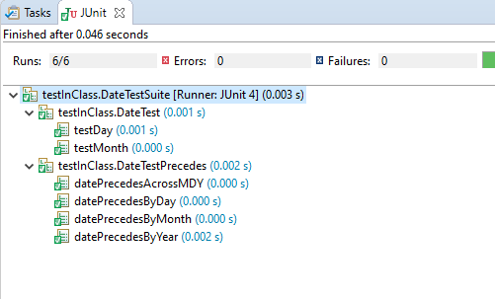

**Step 2:**

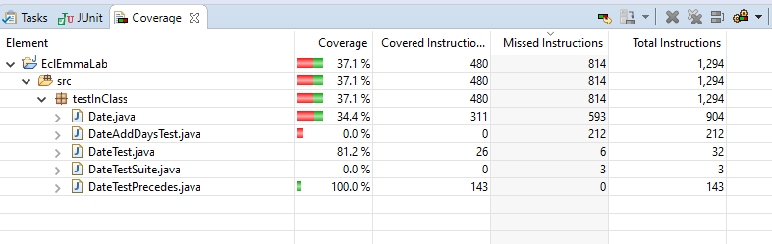

**Step 3:**

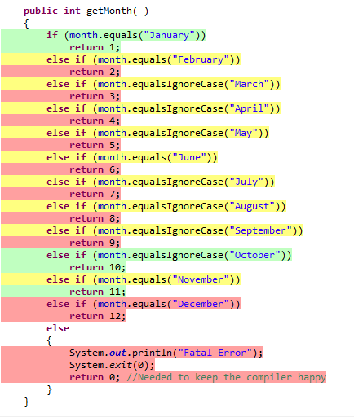

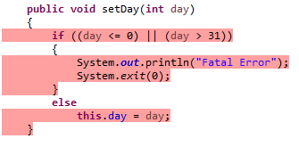

**Step 4:**

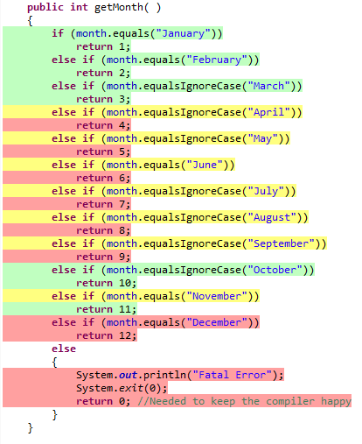

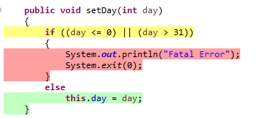

**In getMonth, the cases for February and March are now covered. The boundaries for setDay were not yet covered, but the else case to set the day has now been covered.**

**Step 5:**

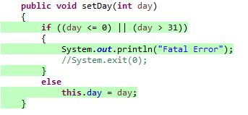

**Step 6:**

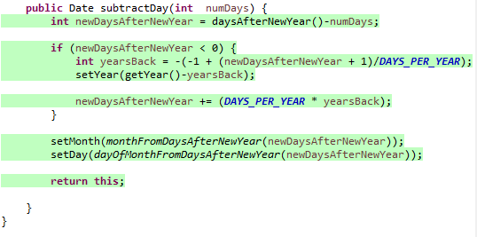

**Step 7:**

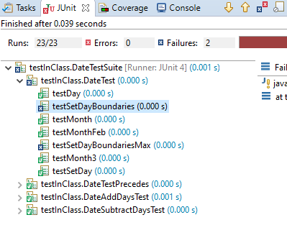

**Step 8:**

