ACTIVITY 2; NETWORKING 2
Name: Cabilangan, Dave Joseph A. | Professor: Engr. Jed G. Concepcion, MBA, MIT
Year and Section: BSIT - 3A | Submitted: August 12, 2026

Module 2: Routing Concepts

ACTIVITY NO. 1:
- Using Cisco Packet Tracer. Configure a functional routing path between two separate Local Area Networks (LANs) using Cisco routers. Write your observation to the box provided.
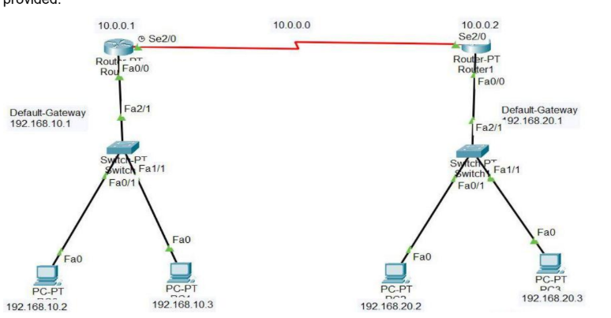

Two LANs via Serial Link
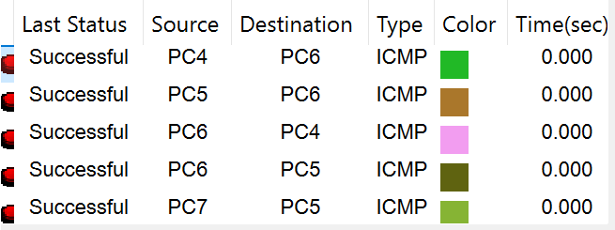
Two routers (Router0 & Router1) are connected through a serial WAN link, each also connected to its own LAN switch/PCs. You configure IP addresses on the FastEthernet interfaces (LAN side) and Serial interfaces (WAN side), then add static routes on each router pointing to the other's LAN network. Once configured, PCs on one LAN can ping PCs on the other LAN, proving that static routing successfully connects two separate networks through a single point-to-point link.

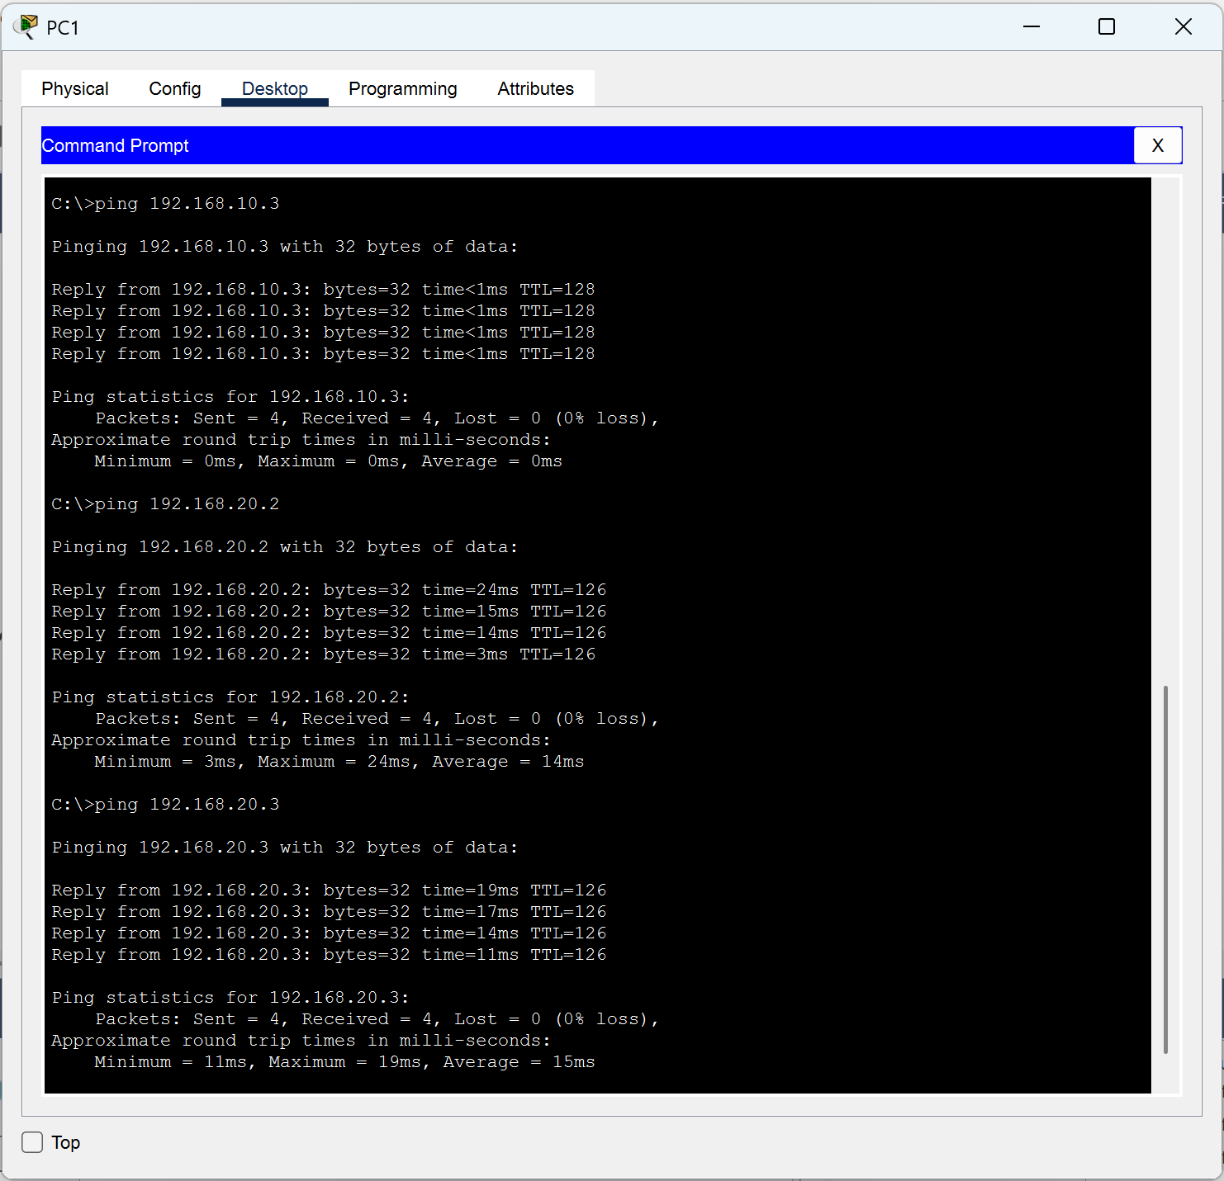
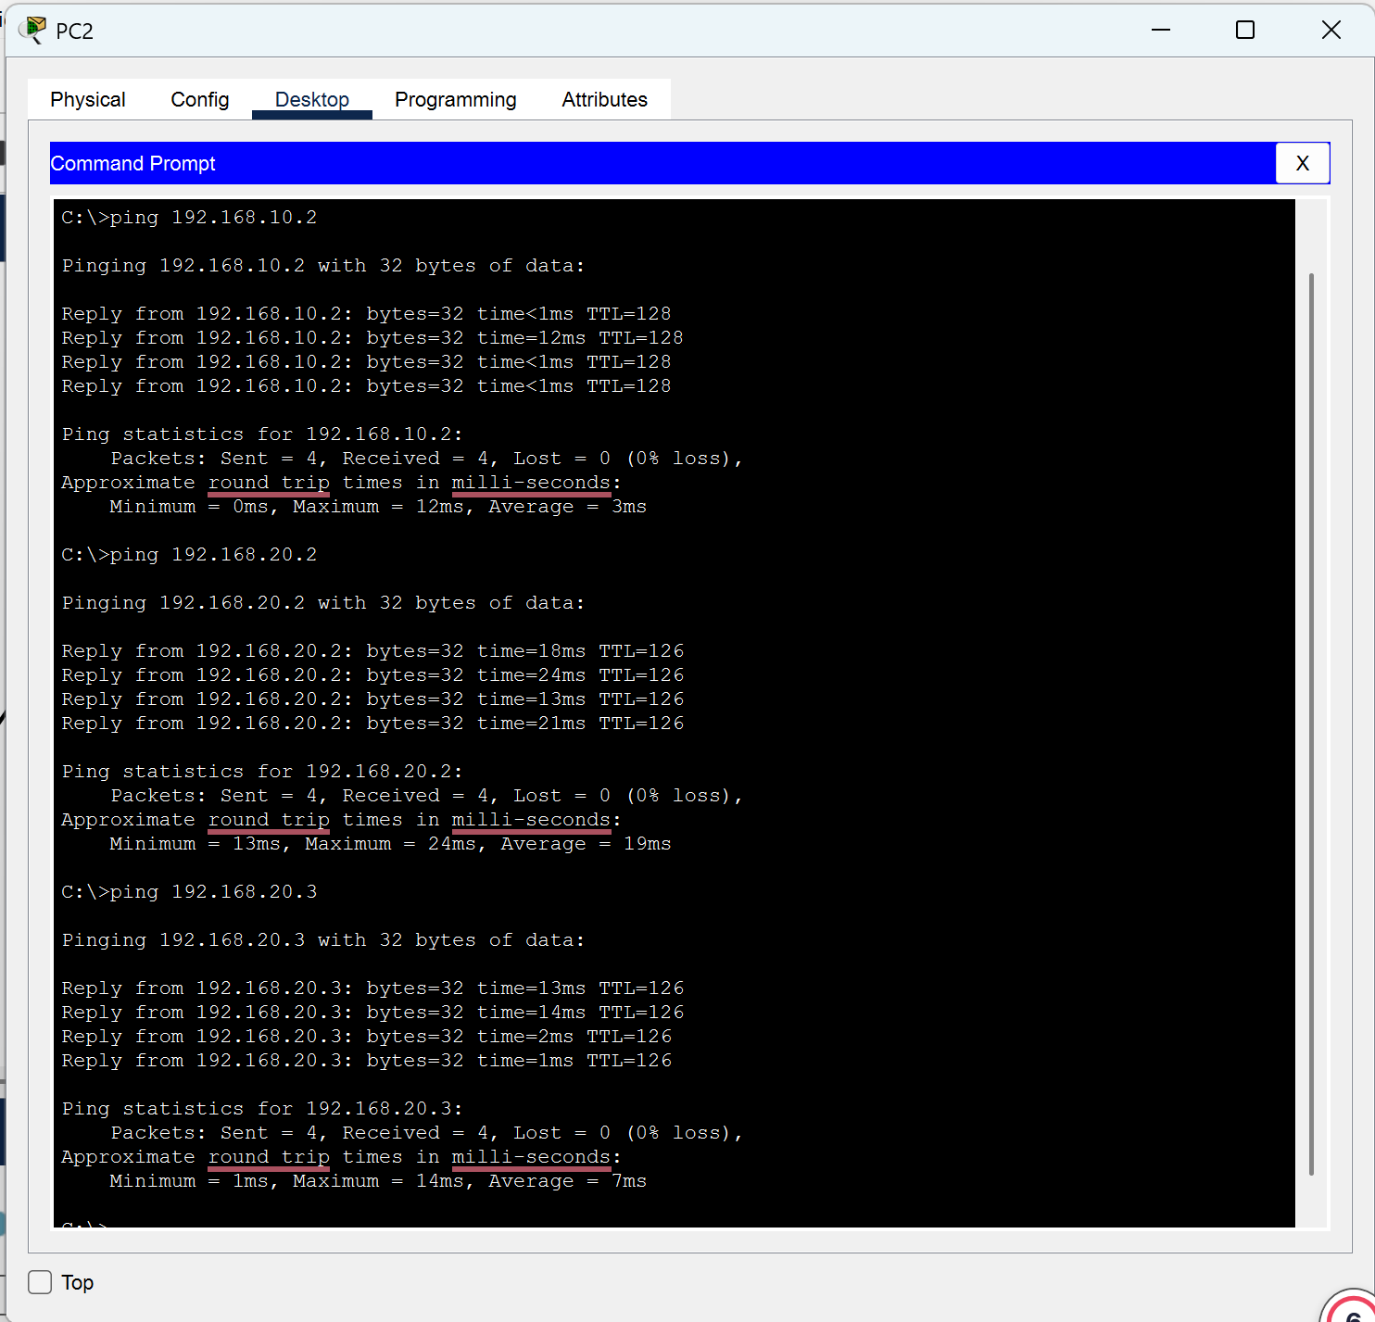

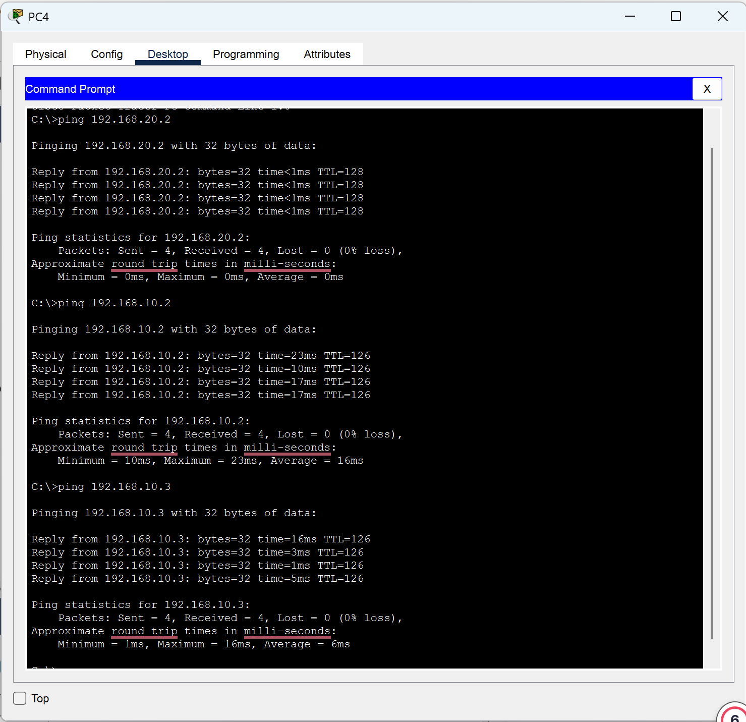
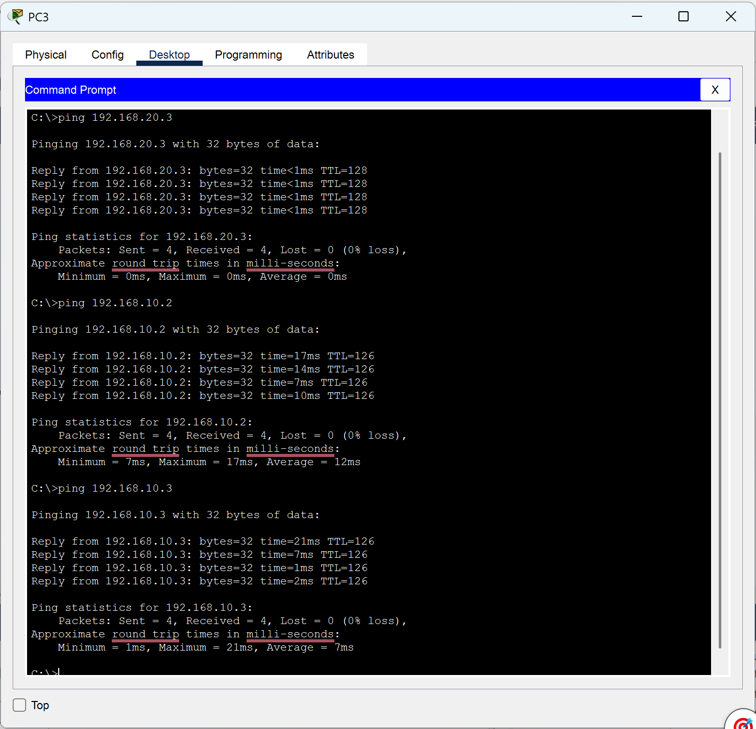

Instructor’s Signature: _______________________________________

Date: _______________________________________

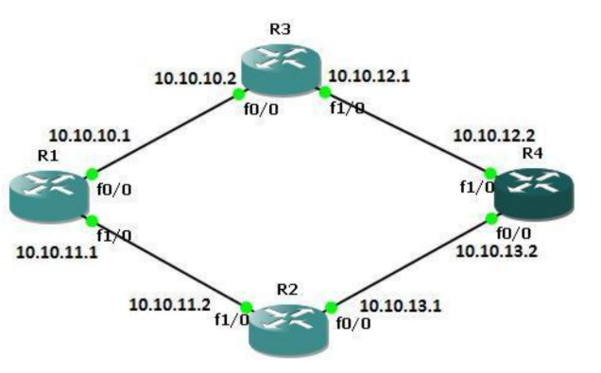
- Using Cisco Packet Tracer. Configure a functional routing path between Cisco routers, and verify the connectivity using ping command. Write your observation on the box provided.

Four-Router Ring/Mesh (R1–R2–R3–R4)
Four routers form a diamond-shaped ring, connected only to each other (no PCs). Since no router is directly connected to all others (e.g., R1 and R4 aren't directly linked), you use dynamic routing (RIP v2) so each router automatically learns paths to non-adjacent networks. After configuring IPs and enabling RIP with no auto-summary, routing tables show connected (C) and RIP-learned (R) routes, and pings between non-adjacent routers succeed proving traffic can travel multiple hops automatically without manual route entries.

Instructor’s Signature: _______________________________________

Date: _______________________________________

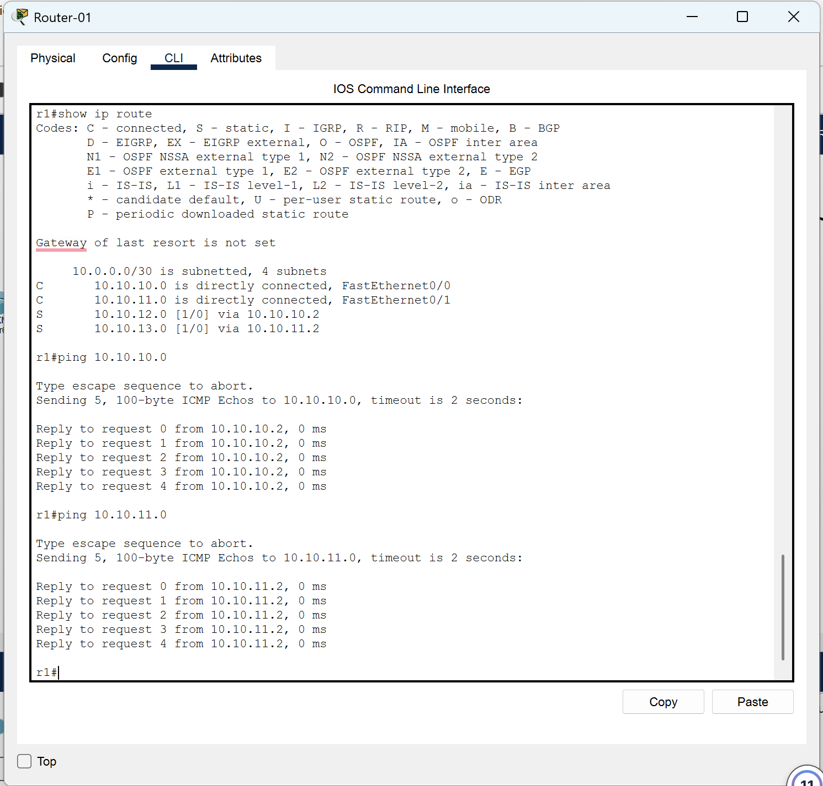
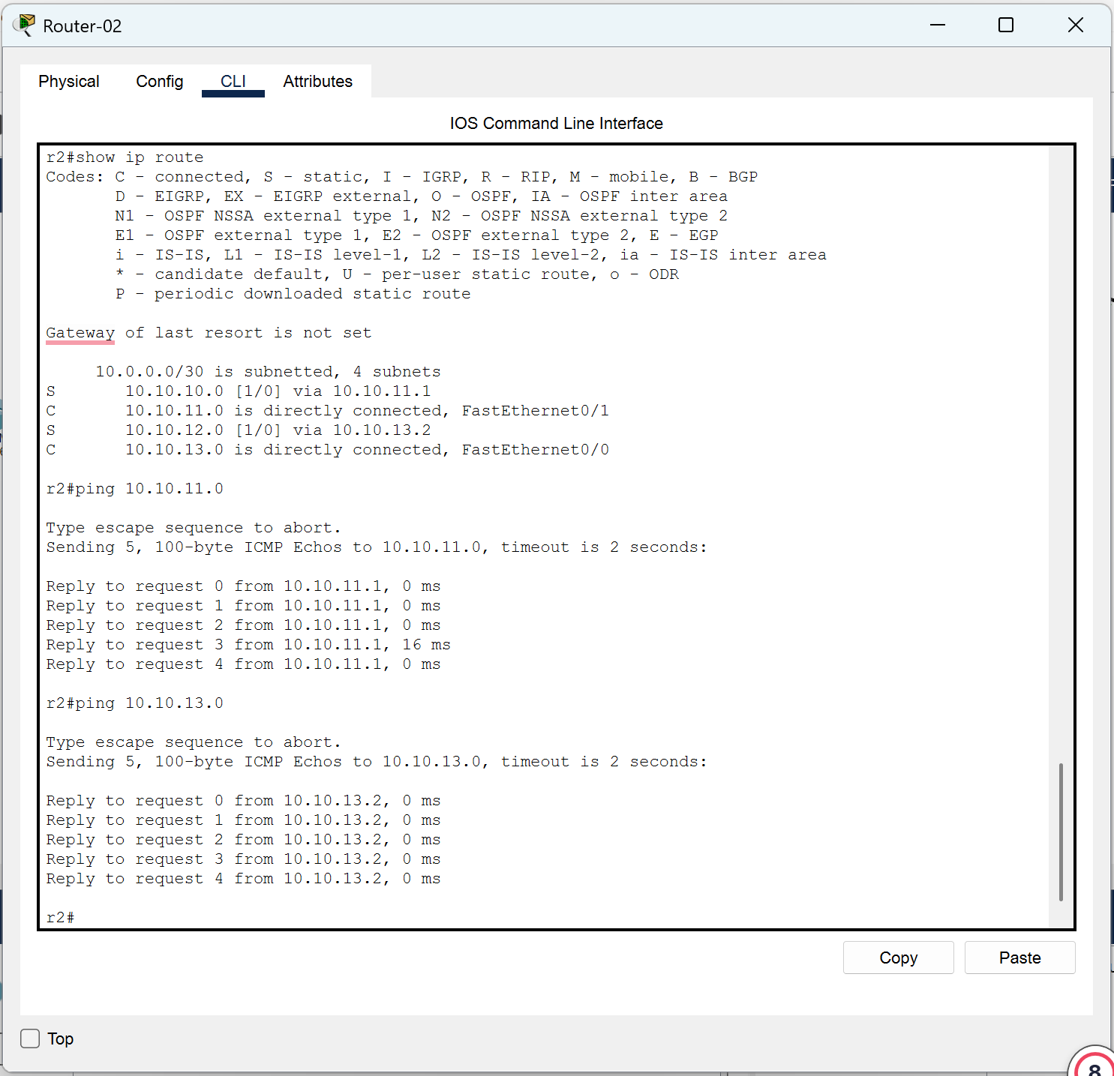

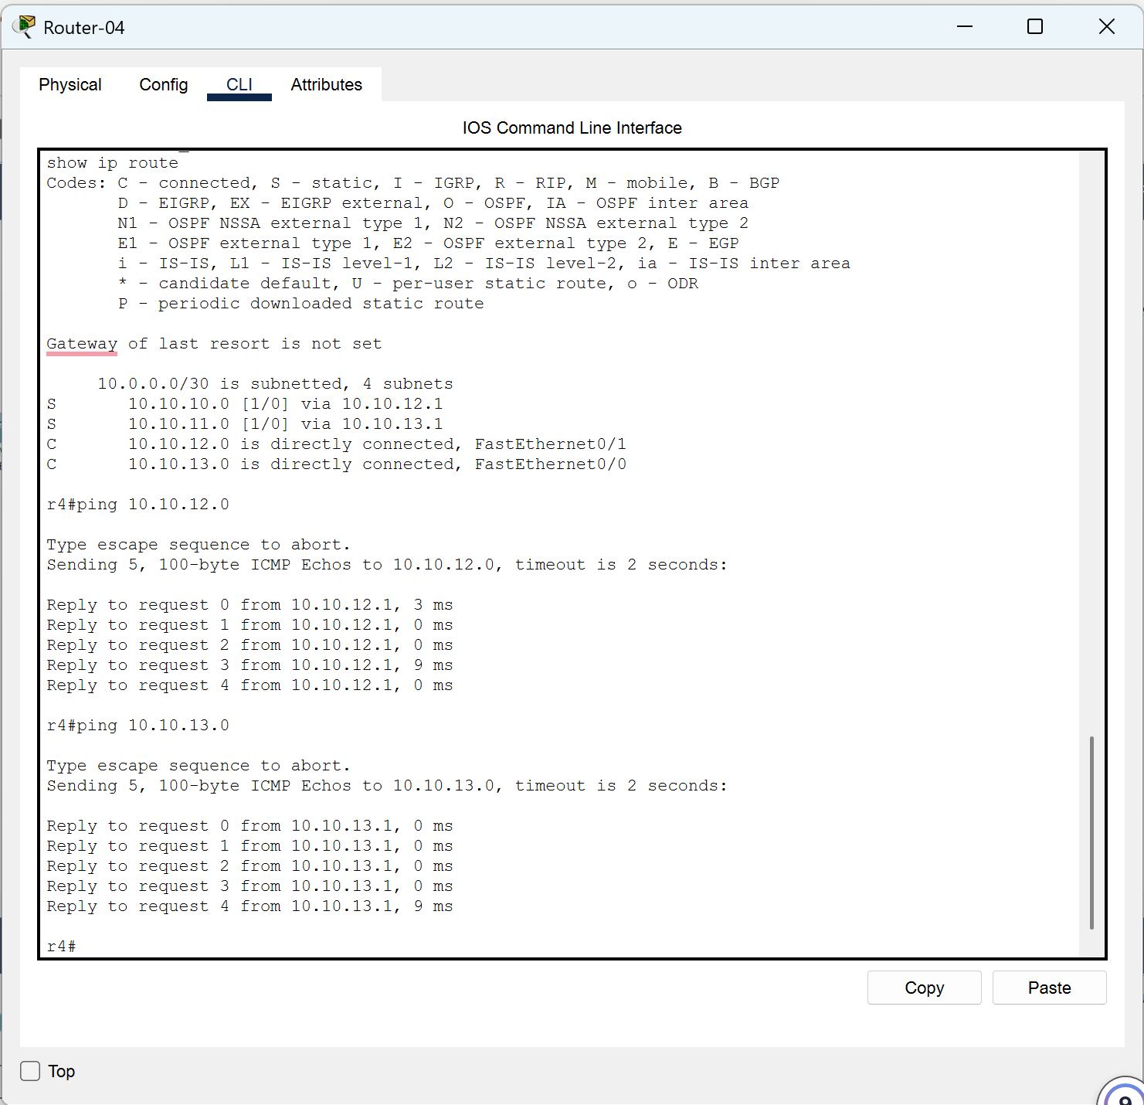
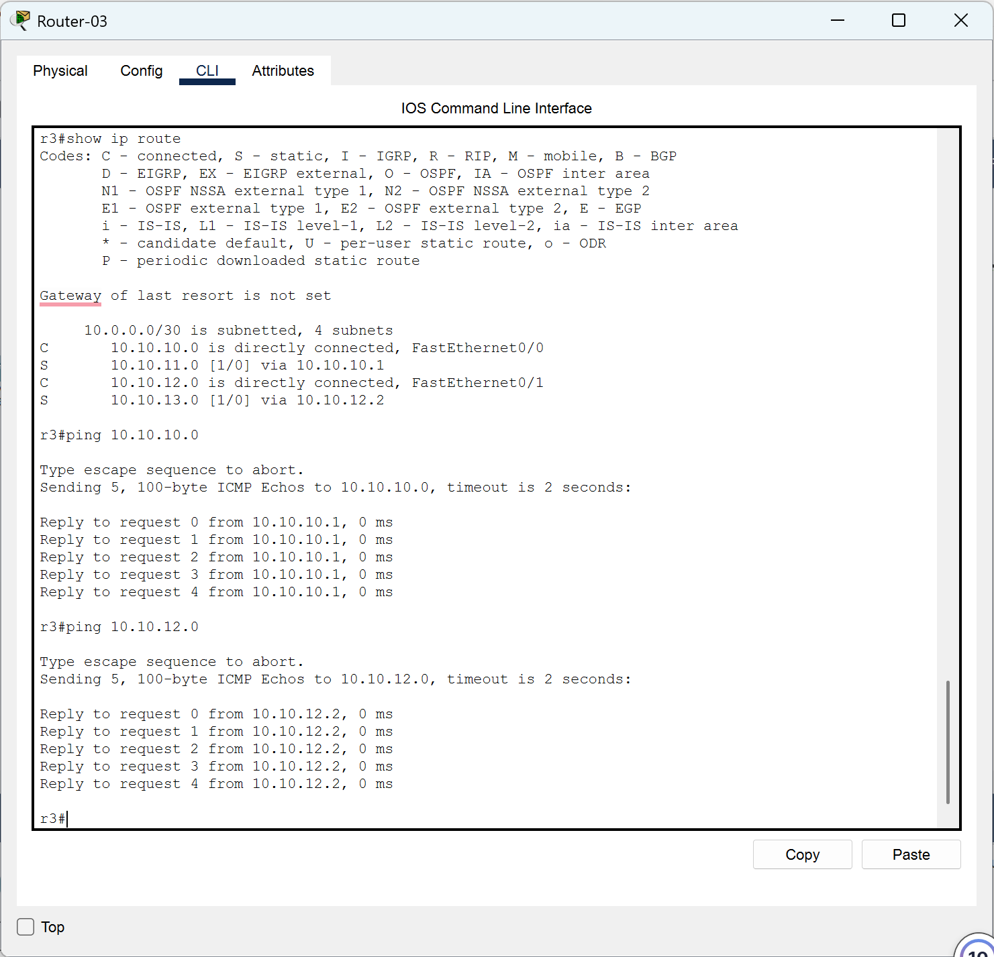

Instructor’s Signature: _______________________________________

Date: _______________________________________

- Using Cisco Packet Tracer. Configure a functional routing path between Cisco routers, and verify the connectivity using ping command between PC1 and Server 2. Writeyour observation on the box provided.
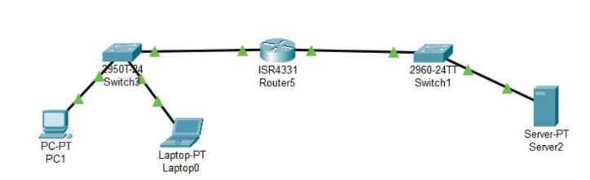

PC1 to Server2 through Router5
A simpler topology: PC1 & Laptop0 sit on one LAN, Server2 sits on another LAN, and Router5 connects both via two of its interfaces (Gi0/0 and Gi0/1). Since both networks are directly connected to the same router, no static or dynamic routing is even needed Router5 routes between them automatically. After assigning correct IPs/gateways to the PCs and server, a ping from PC1 to Server2 succeeds.

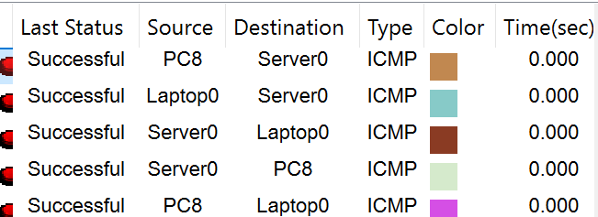

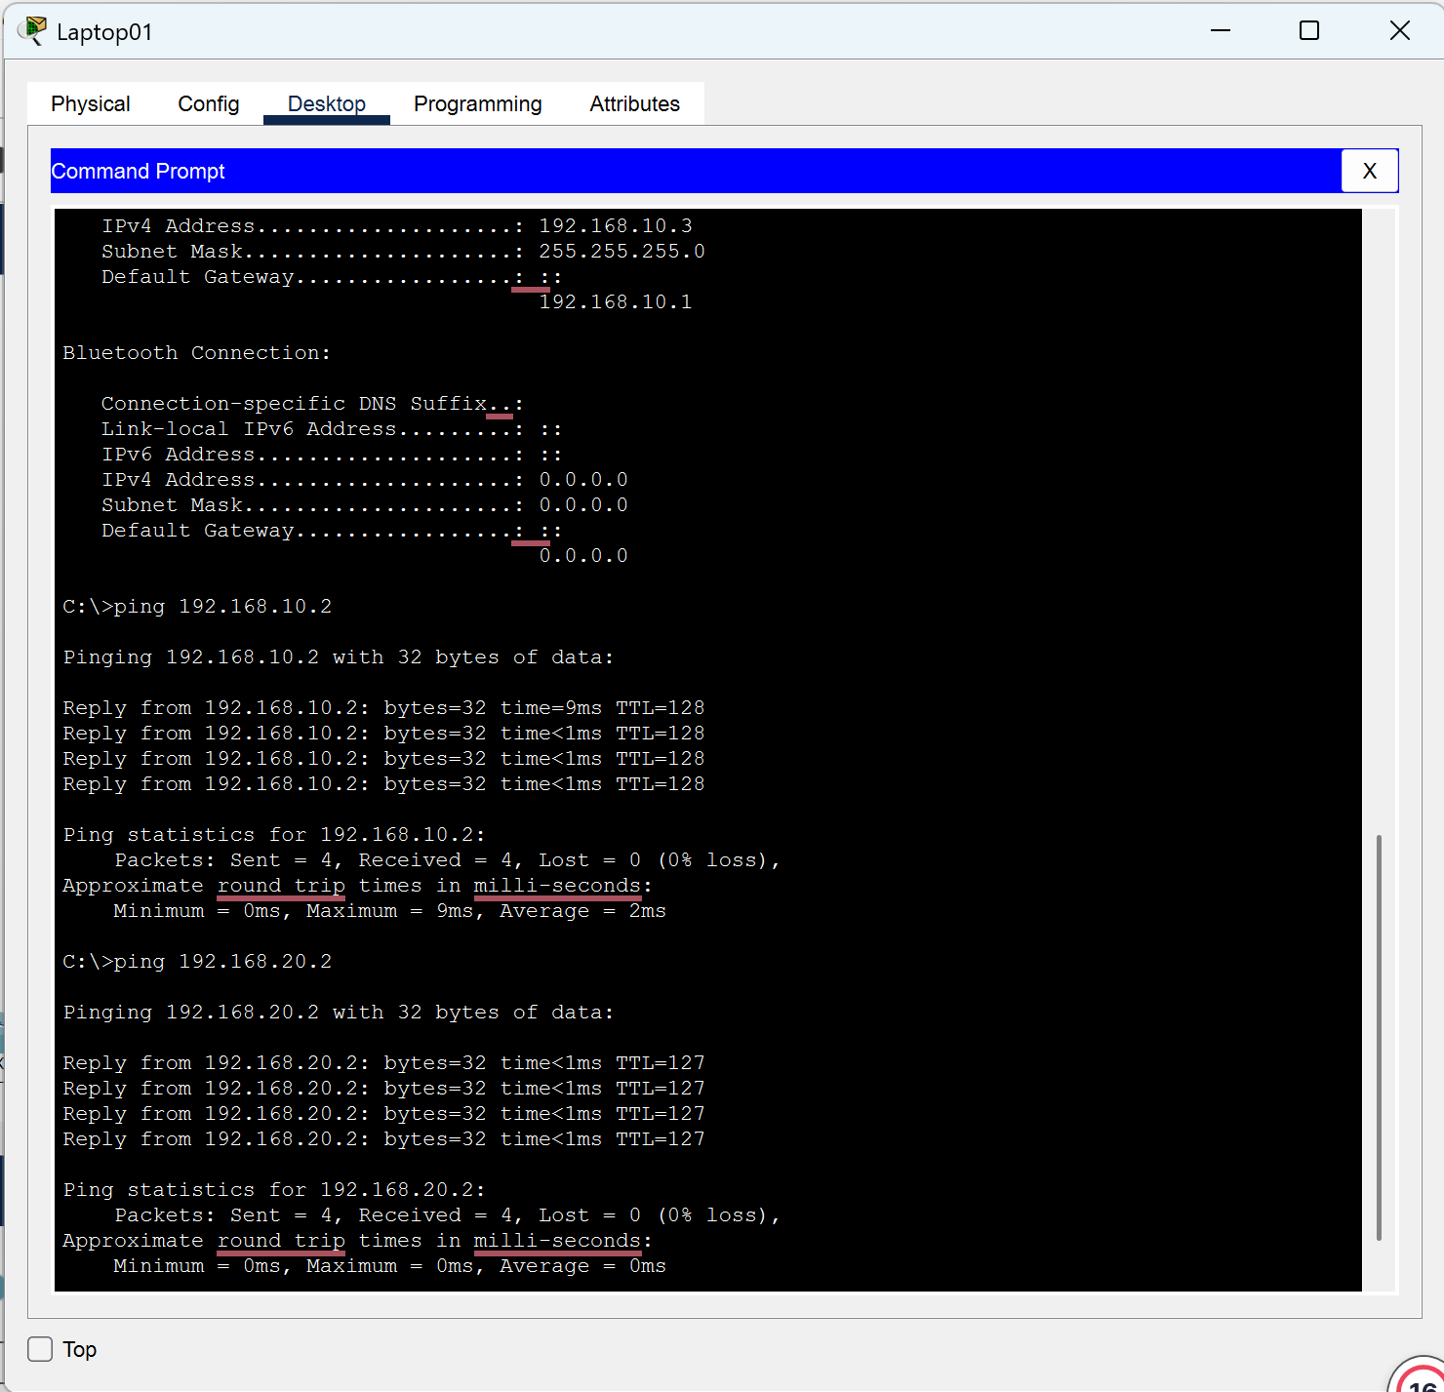
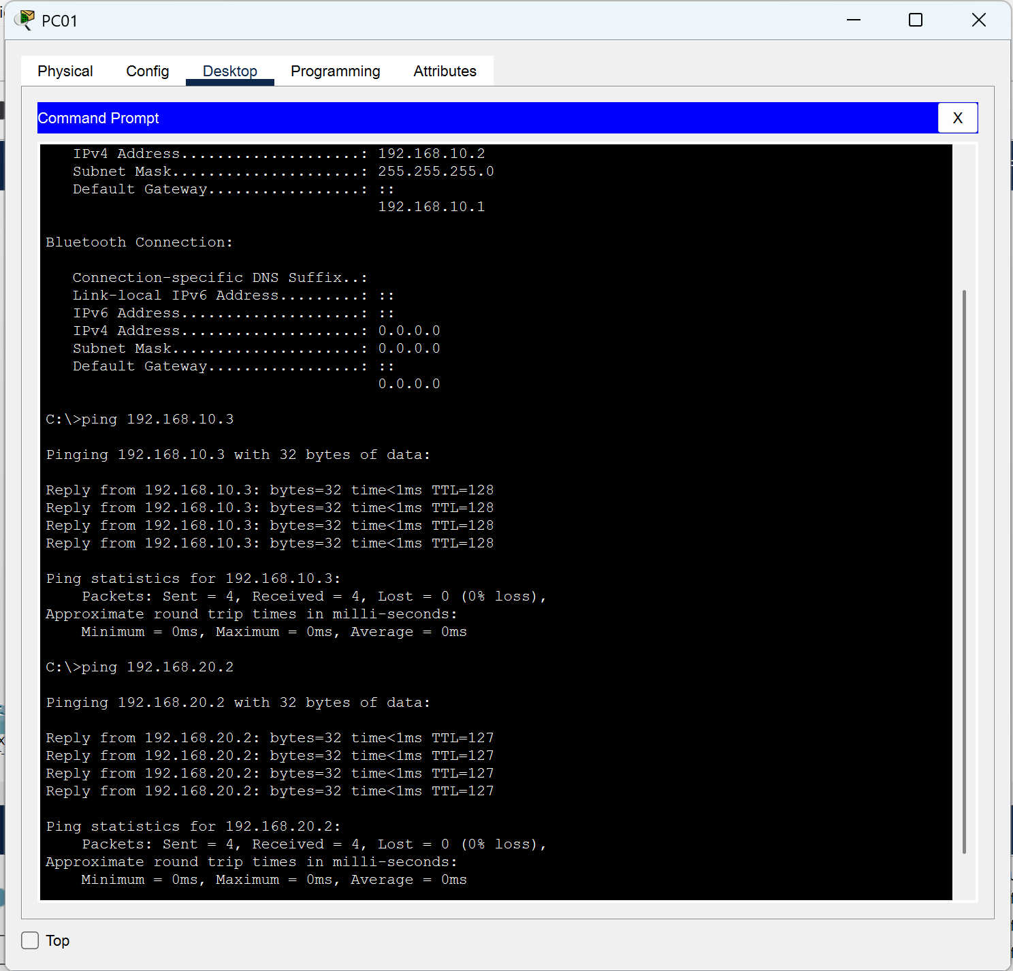

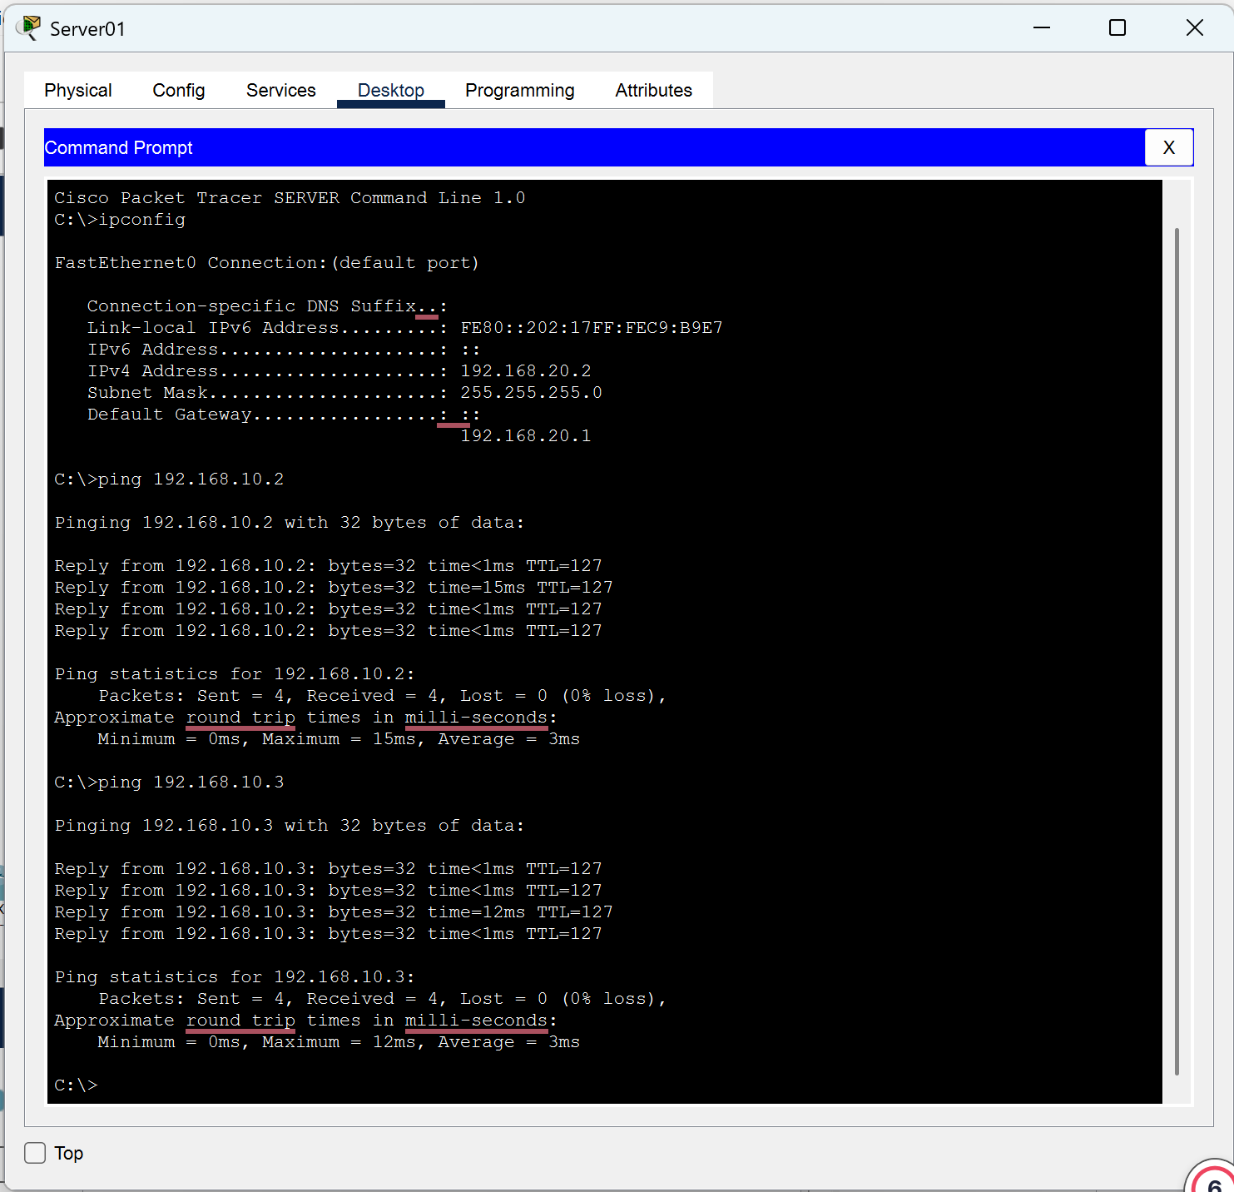

Instructor’s Signature: _______________________________________

Date: _______________________________________

- What are the difference between Static routing and Dynamic Routing? Write your answer to the box provided

STATIC ROUTING
Static routing is when a network administrator manually configures each route in a router's routing table, specifying the exact path data should take to reach a particular network. The router doesn't calculate or discover anything on its own — it simply follows the instructions it was given, and those instructions never change unless someone manually edits them.
Advantages:
- No CPU overhead - because routes are hardcoded, the router doesn't spend processing power or memory calculating paths, which is useful on lower-end hardware.
- Predictable traffic - since the path never changes, outbound data always takes the exact same route, which makes troubleshooting and traffic analysis easier.
- Higher security - no routing protocol is broadcasting network topology information across the wire, which reduces the risk of an attacker intercepting or spoofing route information.
Disadvantages:
- Not scalable - in a network with many routers and subnets, manually typing a route for every possible destination becomes extremely time-consuming and error-prone.
- No redundancy or fault tolerance - if a link goes down, the router has no way to automatically reroute traffic through another path. The connection simply breaks until a human manually intervenes.

Instructor’s Signature: _______________________________________

Date: _______________________________________

- High maintenance - every time the network changes (a new subnet is added, a link is removed, etc.), an administrator has to log into potentially every affected router and update the static routes by hand.
DYNAMIC ROUNTING
Dynamic routing is when routers use routing protocols (such as RIP, OSPF, or BGP) to automatically communicate with neighboring routers, share information about the networks they know, and calculate the best path to each destination in real time. Instead of a human typing in routes, the routers essentially "talk" to each other and build their routing tables on their own.
Advantages:
- High scalability - routers automatically discover new networks and share that information with peer routers, so you can add hundreds of devices to the network without manually reconfiguring every router.
- Automatic rerouting (fault tolerance) - if a link or router fails, the routing protocol detects the failure almost instantly, recalculates a backup path, and keeps traffic flowing without any human intervention.
- Simpler long-term management - once the initial configuration is done (enabling the protocol and specifying which networks to advertise), the network largely maintains its own topology map going forward.
Disadvantages (not explicitly listed in your material, but worth knowing):
- Higher CPU/memory usage - routers must constantly calculate and update paths.
- Less predictable - traffic paths can change dynamically based on network conditions, making troubleshooting slightly harder.
- Slightly less secure - routing updates are broadcast/multicast across the network, which could be intercepted or spoofed if not properly secured (e.g., with authentication).

Instructor’s Signature: _______________________________________

Date: _______________________________________

