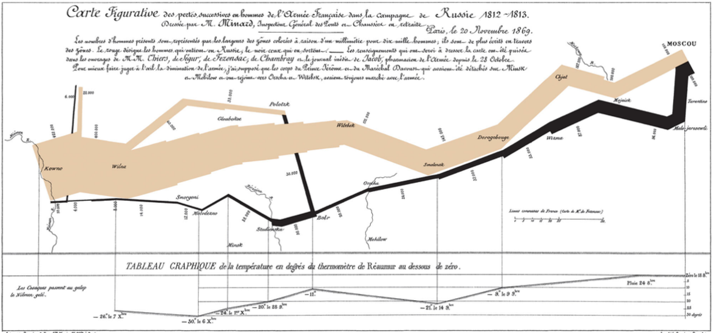

Cricket world cup (2015)

Stadium attendance

Viewership per game

Viewership

Finals

Number of teams playing cricket world cup