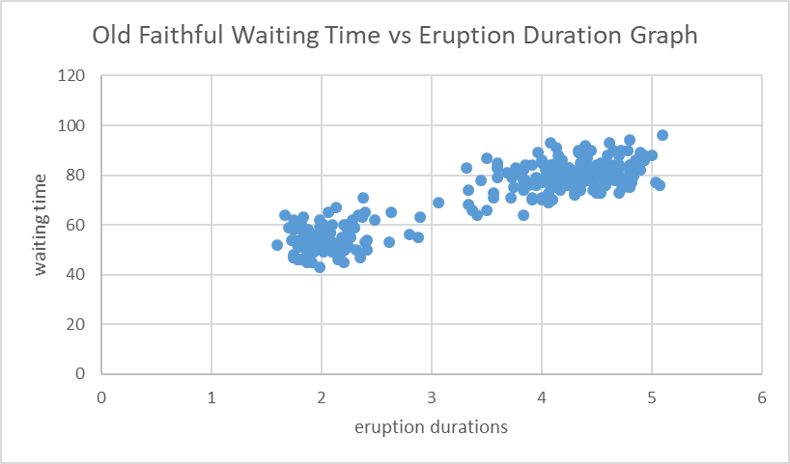

1. Correlation Coefficient (*r*) = 0.9
2. regression model 🡪 ŷ = β0 + β1x

🡪 y = 10.73x + 33.474

1. β0 = 33.474
2. β1 = 10.73
3. Coeﬃcient of determination *r2 =* 0.8115

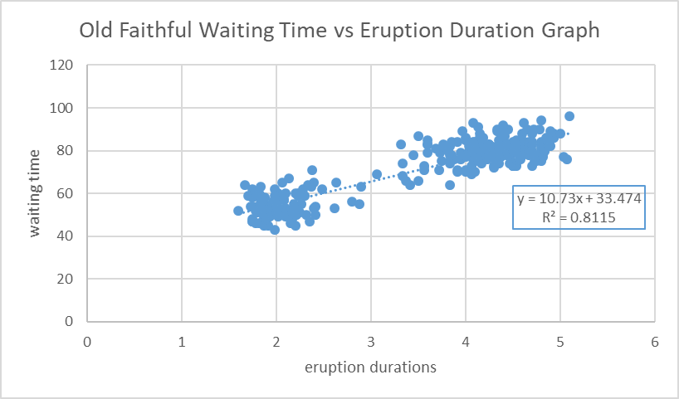

1. The data is “Homoscedastic” which means that there is homogeneity in variance.
2. The waiting time until the next eruption after one 4.0 minutes in duration should be approximately 79.



ŷ = β0 + β1x1 **+** β2x2 + β3x3 + β4x4

y = -0.0376 – 0.066x1 - 3.9x2 + 0.185x3 + 9.6x4

1. Coeﬃcient t statistics and p-values:



1. Coeﬃcient of multiple determination R2:

* R2 for Tank Temp (x1) = 0.697
* R2 for Tank Pressure (x2) = 0.755
* R2 for Gasoline Temp (x3) = 0.7644
* R2 for Gasoline Pressure (x4) = 0.8373

1. Root mean square error (RMSE) of the training data set = 1602.586439
2. Root mean square error (RMSE) of the testing data set = 8.082570983