Stevens Institute of Technology

SYS-601 Homework #7

# Due Apr. 2 2018

7.1 Revisiting Super Bowl Coin Flips [10 points]

(a) 3 pts If the coin were fair (50/50 chance of winning a flip), what is the theoretical:

(i) Probability mass function p(x) (Hint: don't over-think this)

$$p\left(x\right)=\left\{\begin{aligned}0.5 x=1 or x=0 \\ 0 x ≠0 and x≠1\end{aligned}\right.$$

(ii) Population mean

$$μ_{0}=0.5*1+0.5*0=0.5$$

(iii) Population standard deviation or variance

$$σ_{0}=0.5*{\left(1-0.5\right)}^{2}+0.5*{\left(0-0.5\right)}^{2}=0.25$$

(b) 2 pts Compute the following for N = 52 observed values of X in superbowl.csv:

(i) Sample mean _x

$$\overline{x}=0.327$$

(ii) Sample standard deviation or variance

$$s_{x}=0.22$$

(c) 2 pts Create a plot of the PDF f(_x) for values 0 ≤ _x ≤ 1 using the Central Limit Theorem to model the distribution of sample means for N = 52 trials.

$$μ_{\overline{x}}=0.5,$$

$$σ_{\overline{x}}=\frac{σ_{0}}{\sqrt{N}}=\frac{0.25}{\sqrt{52}}=0.0347$$

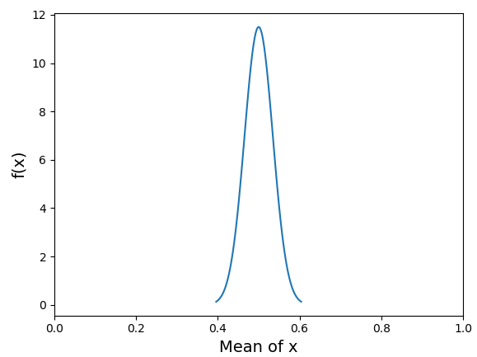

(d) 2 pts Perform a hypothesis test for the following: Report the p-value and determine whether H0 can be rejected at α = 0:05.

All the 52 samples are independent, and N is big enough. Therefore, it can be tested by z Test for population mean.

$H_{0}: μ_{x}=μ_{0}=0.5$ ${ H}_{α}: μ_{x}≠μ_{0}=0.5$

$z_{0.025}=1.96 z_{0.975}=-1.96$

$$z=\frac{\overline{x}-0.5}{\frac{σ_{0}}{\sqrt{N}}}=-4.98$$

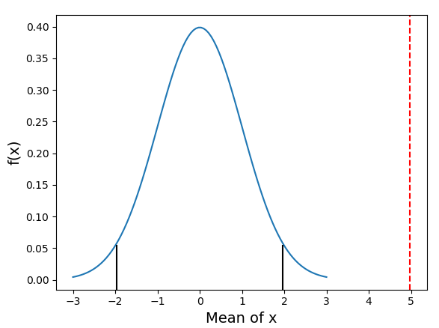

**Reject H0!**

It’s two-tailed test

$$p=2*\left(1-F_{norm}\left(4.98\right)\right)=6.36E\text{-7}$$

It means there is 0.000064% chance of more extreme samples under H0

(e) 1 pt What can you conclude about the validity of the Superbowl coin flip?

Someone cheated on the coin.

7.2 GRE Tutoring Service [10 points]

A $1799 tutoring service advertises a significant increase in verbal reasoning GRE score. The attached file gre.csv contains a set of N = 100 samples of pre- and post-test scores for participating students.

(a) 3 pts Assuming the pre- and post-test data are not related (i.e. randomly ordered), perform a hypothesis test for the following:

H0: µpre = µpost

Ha: µpre < µpost

Report the p-value and determine whether H0 can be rejected at α = 0:05.

|  |  |  |  |
| --- | --- | --- | --- |
| Pre |  | Post |  |
| N | 100 | N | 100 |
| Mean µpre | 149.08 | Mean µpost | 150.90 |
| Standard deviation σpre | 8.83 | Standard deviation σpost | 10.31 |

They are independent samples and the number of them is large enough, so it’s can be tested by z Test.

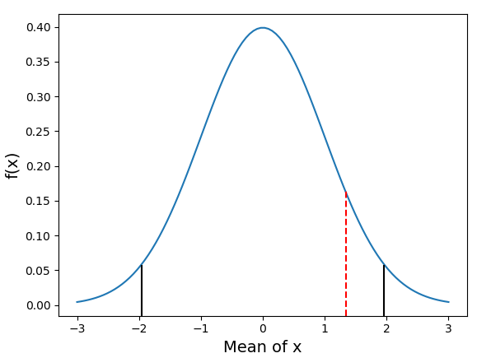Assume:

$$H_{0}: μ_{pre}=μ_{post}$$

$$H_{α}: μ_{pre}<μ_{post}$$

Then:

$$z= \frac{\left(150.9-149.08\right)-0}{\sqrt{\frac{{10.31}^{2}}{100}+\frac{{8.83}^{2}}{100}}}=1.34$$

$\left(z_{1-\frac{α}{2}} , z_{α}\right)=(-1.96 , 1.96)$

It’s one-tail test:

$p=1-0.91=0.09$

It means only 9% chance difference between post- and pre- test average grade is larger than 1.82 points. The result is statistically significant. Assumption could not be rejected.

(b) 1 pt Do the results in (a) support the tutoring service's advertising claim?

I don’t think it support the claim. In this case,

(c) 3 pts Assuming the pre- and post-test data are related (i.e. paired from the same student), perform a hypothesis test for the following:

H0: µpre = µpost

Ha: µpre < µpost

Report the p-value and determine whether H0 can be rejected at α = 0:05.

Use t Test

$t_{N-1}=2.75$, degree freedom: 99

It’s one-tail test:

$p=0.9964$

$$t_{\frac{α}{2}, N-1}=1.984$$

It means 99.64% chance difference between post- and pre- test average grade is larger than 1.82 points. The result is practically significant. Assumption should be rejected.

(d) 1 pt Do the results in (c) support the tutoring service's advertising claim?

I think it supports the claim, since there is great probability that students could get higher points after the tutoring service.

(e) 2 pts Are the results in (c) practically significant? Would you buy the service? Why?