Computation Independent Models for Educational Content Representation
Carlo E. T. Oliveira1, Lívia M. Castro¹, Josefino C. M. Lima¹

1 PPGI-IM/NCE - Universidade Federal do Rio de Janeiro,
Cidade Universitária Rio de Janeiro, BrazilRio de Janeiro, Brazil
{carlo, clima}@nce.ufrj.br
liviamc@posgrad.nce.ufrj.br
Abstract. Knowledge representation has been one of the most challenging problems in computer science. Essentially, knowledge can be represented as collection of concepts and their relationship. In this context, we propose an UML approach as a suitable framework to develop Computation Independent Model representation. We typify this approach by the exploration of an educational domain: our UML approach operates like a DSL for educational storytelling. This new model takes into account actors, location objects and actions and also their relationships. The CIM can have as outcomes a plain textbook or a PIM and PSM, in order to implement either hypertext or interactive adventures. The CIM DSL can be used by teachers and students alike, which support a constructionist learning approach. This representation uses a new meta-knowledge modeling, sustaining cumulative knowledge edification as well as reuse and management.
Keywords: computation independent model; knowledge representation; model
transformations; constructionist education; metamodelling
1 Introduction - Representing Knowledge with Computation Independent Models
The computation independent modelling viewpoint [1] focuses in capturing all the knowledge related to the business at high level. All the involved artefacts and their interrelations must be accounted for, and related in, many forms of requirement reports. The CIM recounts the business concepts and operational process embodied in the actions of their everyday agents in a format that can be communicated to external observers. This is the very representation of knowledge, the cultural substrate where the organization stands on. The intent of the so constructed CIM model is to reproduce and perpetuate the business in a computational format.
With the CIM, we can understand that the knowledge is the business, because this knowledge is the business identity that differentiates it from any other and stands for the business itself when implemented into a software application.
However, there is also the situation where the knowledge is the business, when knowledge is the environment and the main artefact pervading all business operations. Modelling this kind of business is to understand and capture knowledge itself as the main requirement that must be implemented. A model like that is the sufficient implementation of the knowledge business, since its purpose is that knowledge can be understood, reproduced and acted upon.
Knowledge representation and reconstruction [2] is the business of education. Education can be viewed as a process of modelling the world where we live so to understand it and reproduce this understanding into other individuals. A model of the world is represented in books and presented in classrooms. This model, as any other computation independent model, has the intent of passing the knowledge as it must be understood and implemented by the readers.
The CIM level, being a high abstraction, does not imply in any representation format, since it must accommodate to whichever format is better to pass the information. Although this being very flexible and productive, a new gap is formed as a different representation come into play. Convenient standards can come in hand to easily convey the information across. One good example is mathematical notation that is universally accepted and understood. Given a suitable education on the format, anyone can read and interpret a mathematical equation. Equations can be even automatically translated into a computer programming language representation and executed[3].
2 Survey - Models and Knowledge Representation
Knowledge Representation (KR) has been one of the most challenging problems in computer science and it possibly is the main concept in artificial intelligence (AI)[4]. KR lies on a representational adequacy (the ability to represent the target knowledge) and on an inferential adequacy (new knowledge arising from the represented knowledge). These adequacies depend on techniques used to represent knowledge. In AI, researchers look for the best technique that might enable computers with human’s abilities (e.g., to extract new knowledge -or inferences- from a represented knowledge). Some of these techniques are: a. Expressions (equations): attribute driven and the Inference Method (IM) = algebra; b. Rule-based: event -or attribute- driven and IM = production rules; c. Automata (regular grammars): event -or attribute- driven and IM = production rules; d. Script (procedural): event driven and IM = dispatcher; e. Object-oriented: attribute driven and IM = inheritance; f. intelligent agents: event driven and IM = blackboard; g. Case-based: event driven and IM = pattern matching; h. Semantic network: relationship driven and IM = relational rules; i. Frames: event driven and IM = daemons. Of course, KR is not a whole description of the aimed knowledge and there is no representation technique that can serve all domains. Therefore, a suitable choice of a technique may enable the domain to be represented, but a faulty choice nullifies the representation endeavor. The achievement of a system that must support multiple domains depends on the choice of an appropriate knowledge representation format. Different knowledge require both diverse representations (hybrid representation systems) and several kinds of reasoning (multiple inference engines and dispatching systems). System’ modules responsible for acquisition and maintenance of knowledge are usually hard-coded to a particular domain through pre-defined knowledge (this is frequently addressed with intelligent user interface).
The most known pragmatic models of knowledge representation are: the simple relational knowledge and the inheritable knowledge. The relational model is used to represent facts about objects in databases through columns. Although this model gives little opportunity for inference it has been used as the knowledge basis for inferences engines. The inheritable model, which allows inferences more easily, links objects to attributes and their values, and organizes the data throughout a hierarchy of classes (elements inherit values from being members of a class). The semantic network showed in the figure 1 is an example of this model, and, as a directed graph, consists of vertices (or nodes) for concept representation and edges (or labeled arcs) representing semantic relations between concepts.
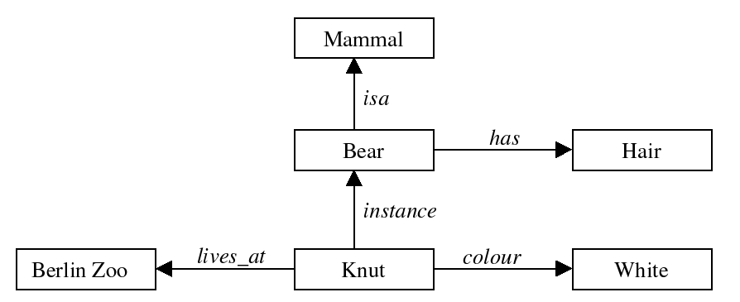
Fig. 1. A semantic network.
Declarative and procedural knowledge representations are present in several KR systems. In declarative representation, which has a static behavior, knowledge about objects, states and their relationships are explicit (a program is required to know what to do with knowledge). In procedural representation the knowledge has the control information embedded inside it (an interpreter is required to follow the instructions specified within the knowledge). Logics have also been used in KR, especially predicate logic that has a very similitude with semantic nets. For instance, the arc labeled isa connecting the nodes bear and mammal can be expressed by isa(bear, mammal); the arc labeled instance connecting the nodes knut and bear can be expressed by instance(knut, bear) and so on. Inference process in a semantic net is commonly done by following arcs between nodes using either an intersection search or inheritance. The intersection search spreads activation out of two nodes finding their intersection and, by consequence, finding relationships among objects (a visited node is assigned by a tag). The main advantage of this search is the entity-based organization and a fast parallel implementation. The main disadvantage is that over-structured domains require highly-structured networks. The inheritance process, which allows dealing with default reasoning, is normally implemented by mechanisms based on the isa and instance links with propagation of definition values along these links. Successful KR systems use the inheritance process.
UML[6], Petri nets[7] and concept graphs[8] are very convenient techniques for graphical representation of knowledge. Common logic[9], knowledge interchange format[10], web ontology language[11,12] and topic maps[13] are examples of standards that have been used both in the industry and university circles. Particularly, UML has been frequently used as a language for modeling ontologies for Web resources and the knowledge enclosed within them. Java classes have been implemented in order to represent concepts in ontologies, providing a suitable apparatus to share knowledge on the Web [14]. An ontology is an explicit specification of a conceptualization, and ontologies have been used as a way of specifying content-specific agreements for the sharing and reuse of knowledge among software entities. Pragmatically, ontological commitments might be seen as properties for a collection of agents that can communicate about a domain without obligatorily referring to a shared theory. Knowledge can be added to the agent’s repository by observing their actions. An increase of knowledge might enhance the agent in such way that it can achieve its goal acting “rationally”. Additionally, UML has assisted the development of model-driven technologies such as model-driven development (MDD), model-driven engineering (MDE) and mode-driven architecture (MDA).
The models adopted by G-Net[15] and GNOWSYS[16] are well known. The G-Net model uses a mixed-type knowledge hierarchy in order to model both static semantic knowledge and dynamic control knowledge. Semantic knowledge are dealt by inheritance reasoning and recognition reasoning algorithms, dynamic knowledge are dealt by an event-driven reasoning, and the coordination and control are dealt by a table reasoning. GNOWSYS represents declarative and procedural knowledge by component classes and uses an object-oriented distributed database as repository of the represented knowledge schemes. The GNOSYS community portal, which allows the drawing of concept graphs and inferences from a knowledge base, has been used by learning purposes: each node in an expert’s conceptual scheme refers to one or more learnable resources (e.g. lessons, figures etc.) or others resources accessible on the Internet. The GNOSYS model uses a choice of well known models of knowledge representation, specially standard first order logic for declarative knowledge, UML[17,14] for representing object oriented modeling[6], Petri Net Markup Language[7] for procedural representation and processes, and standard upper ontology for discourse of highly abstract meta level[16].
3 Problem – Knowledge Representation and UML CIM Models
Knowledge Representation (KR) might be understood as a medium of human expression[19]. For educational purposes, KR can be used to assess the diffusion of knowledge. Like a book, KR technologies allow human knowledge be represented and then shared. Several kinds of knowledge representation techniques have been engendered, sometimes in order to satisfy a set of particular requirements. For instance, [20] shows a natural language processor for textual-information management; [21] describes a knowledge representation schema for design; [22] presents a system for generating stories from a source code.
In order to enable the educational context, the involved KR should be done incrementally; this would support the development of a multiplicative basis. Unfortunately, most of current KR systems do not have a common interface and also do not take into account the plethora of different techniques employed for modeling knowledge in other systems.
Besides being non incremental, these representations barely evolve into computational models. Much knowledge is represented in a static model, which is not used to generate forms of communicating and spreading it through the world. This attempt would be more successful if each representation was transformed in a suitable understandable format in order to enhance its communication effectiveness.
For instance, an ontology is a specification of a conceptualization[23]. Ontologies have been broadly used to represent knowledge of a domain ([24] [25] [26] [27]). Nevertheless, ontology descriptions are lengthy and hard to understand, mainly by non-specialists.
The Unified Modeling Language (UML) [17] has as main purpose the standardization of modeling. We propose UML as a skillful KR technique. The UML can support intuitive and incremental representation by the development and adoption of patterns as well as the unified standards proposed by the language. Therefore, in order to reach a universal and multiplicative basis, using incremental and reusable methods it is necessary to unify the technique for KR and to adopt patterns. Additionally, adopting one universal language, KR will be available for a wider audience and not only for specialists.
4 Architecture – A Model Driven Architecture for Knowledge Representation
Knowledge has been modelled with several tools, from petri nets to UML diagrams. Even as UML diagrams, they are platform dependent implementations of a higher form, namely ontologies or knowledge bases. In any of these approaches, knowledge is handled as a constituent of a large corpus, encompassing a sub-field of Science or Technology. Handling knowledge in such large grains requires a team of specialist to build and validate the knowledge representation. However, knowledge can be build from smaller fragments, in a bottom up construction. This kind of small grain knowledge does only requires a focal point understanding of a simple concept.
Taking on example, a knowledge domain can be constrained to be enclosed in a single phrase: "A body immersed in a fluid experiences a buoyant force equal to the weight of the displaced fluid". Modelling such a knowledge require a few elements that can be easily accommodated in a UML diagram. A UML profile can be defined to represent the elements and relationships in a small scale ontology.
This work proposes a very simple example of using computation independent models to capture knowledge in a storytelling paradigm. The elements in the story can be assigned to simple roles, namely actor, location, object, verb and action. Relationships between elements can be stereotyped with simple roles as origin, target, subject, assertion, imply, hold, certificate. The words of a phrase can then be modelled into CIM elements and relations are drawn between them, assigning the semantics with role stereotypes.
This representation is better understood with an example: A Fable - “the Crow and the Pitcher”. This fable is about a crow which was looking for water in a valley. However, everything he could see around was a dry river. The crow was thirsty and then he saw a pitcher. There was water inside it, but the crow could not reach the water. Flying around the valley he saw some pebbles on the dry river bed, and decided to catch them. The crow poured the pebbles into the pitcher, rising the water level so he could drink it and fly back into the sky.
Now we can represent the words in the UML diagram as a conceptual map, as shown in figure 2. The diagram is a an excerpt sampling relevant features of the whole story.
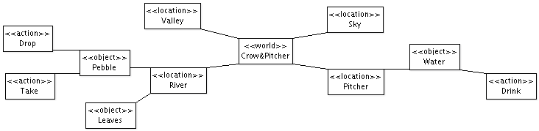
Fig. 2. The crow and the Pitcher fable represented as a conceptual map.
This diagram can be split into smaller ones, representing the scenarios, modeling each portion of the story in more detail. One of them represent the continence principle: an object can be contained in another. Examining the fable world, we can select the locations were it rolls through, as follows in figure 3. The modifier “hold” denotes continence between the elements.
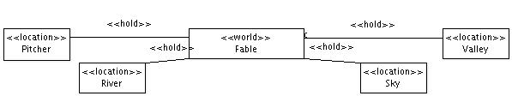
Fig. 3. The fable world and its locations.
In the scene of the river (figure 4) we can see some pebbles; their purpose in the story is to be picked up by the crow. It can illustrate the principle of implication and transitiveness. Transitiveness is the grammatical figure where the verb transfers its action to a noun.
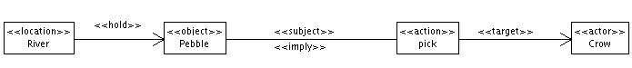
Fig. 4. The river scene diagram.
The river holds pebbles, that in the story imply a pick action (pebbles can be picked) which the consequence is a transitiveness where pebble is the subject and crow is the target (the pebble is picked up by the crow).
In the valley scene we can see the crow multiple flight possibilities: the pitcher, river or valley, which illustrate the multiple transitiveness principle (figure 5).
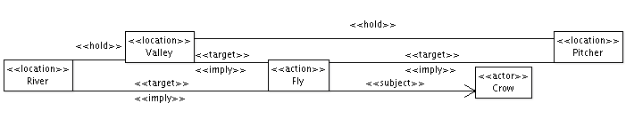
Fig. 5. The valley scene diagram.
The fly action has only a subject ,the crow, but there are many targets that the crow can fly to, namely the the pitcher, river or valley. The implication means that these places can be flown to.
In the pitcher scenario a condition must be met for the goodness of an action. If this action is ever to happen, a conditioning action must settle the proper requisites (figure 6).
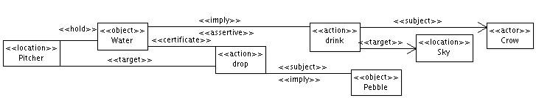
Fig. 6. The pitcher scene diagram.
Whence the subject crow has drunk some water, he can fly happily into his sky target, but the drink action must assert that water is in reach. As the crow drops his subject pebble into the targeted pitcher, a conditioning event certifies that water is available to further action.
Stereotypes allow to establish roles and interaction. There are two simple collections of stereotypes: one for elements and other for relations. They form a very simple ontology of storytelling, based on the grammatical principles ruling natural language. The CIM model just explicitates the semantics of the language and embodies the representation with simple logical constructs.
From this small set of principles other higher level principles can be derived; observed recurring patterns can be named and incorporated as a higher level knowledge base. The simple principles form a meta-model to higher level knowledge principles. Once formed, this higher level knowledge base form the meta-model of a higher expressivity knowledge language.
A knowledge base is built on top of the initial principles meta-model; building knowledge bottom up implies in the creation of more expressive principles constituted by the simpler ones. Figure 7 shows an example where a travel is an action which subject is an actor and the target is a location.
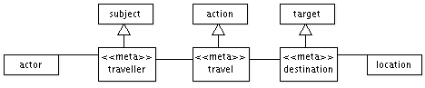
Fig. 7. Meta knowledge in travel construct diagram
This diagram defines «travel» as a specialized action and two new relation stereotypes «traveller» and «destination» as specializations of subject and target, but can only apply in associations to actor and location respectively. Travel constitutes a more expressive stereotype than the generic action and consequentially more constrained in its use. A disposal is an action which subject is an object and the target is a location. The subject is initially under the hold of an actor.
The higher level principles form an extended meta-model allowing for new advanced semantic constructs; accumulated meta-knowledge allows the expansion and refinement of knowledge. The diagram in Fig 8 shows new concepts constructed using the primitive stereotypes as a meta-model. Just below the new concepts integrate the new meta-model to express an application of the Archimedes Principle. The Archimedean principle builds upon the knowledge that buoyancy is assertive on fluid displacement certified by an immersive action.
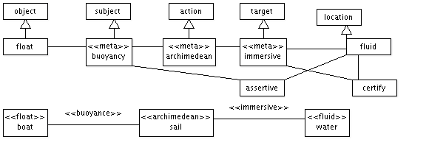
Fig. 8. High level diagram
The meta-knowledge constitutes a qualified representation of acquired knowledge. The knowledge is preserved across the boundaries of current representation and can be applied to new storytelling situations where the same pattern applies. Knowledge is not only preserved but also qualified, because is built upon recognisable primitive principles. The acknowledged semantics of the primitive principles are the basic operators which reconstructs the complex semantics of higher principles.
5 Solution – A UML Profile and Model Transformations for PIM and PSM Levels
The knowledge model is represented in a UML diagram as a CIM that can be handled through its MOF XMI instance. Knowledge handling requires an application domain where the model will crystallize into a an object oriented model. A new UML profile adhering to object oriented constructs is the basis for a target Platform Independent Model. The constraints in this profile are defined by de UML meta-model, defining classifiers, relations and other elements in compliance to object oriented analysis.
UML represented as XMI is a machine readable specification holding the knowledge specification. However, the model extracted from the CIM level has no indication of use for any kind of computation; a model transformation must be executed into a known computational format.
The storytelling knowledge may be mapped onto some traditional representations: a book, an hypertext, a computer game. Those formats are supported by a variety of computational implementations. A different PIM can be created for each representation an then mapped to a PSM contemplating the target architecture.

5.1 Transformations toward a Publishing Independent Model
Knowledge represented in a book requires unrolling the model into a single sequence. PIM representation translates the conceptual CIM model into headings and paragraphs. At this level, the user can modify and annotate the model to sort the text sequence, remove or complement text to achieve a good literate style.
Here we present an example of publishing with OpenOffice Uno [28] specific model. A PSM level can be devised to conform to a word processing application. Elements are converted to com.sun.star entities Document, Text and Paragraph; extra entities are provided to format Headings, Summary, Headers and Footers. Model transformation will convert the PSM into OpenOffice Writer Uno commands. A sample Python UNO script that can derive from OpenOffice PSM is shown bellow, and the generated OpenOffice document is presented in figure 9.
Python script derived from OpenOffice PSM.
class UnoSection:
def paragraph(self,value):
doc.Text.insertString(cursor, value, False)
doc.Text.insertControlCharacter(
cursor, PARAGRAPH_BREAK, False)
def publish(self):
cursor.ParaStyleName = "Heading 2"
self.paragraph(self.title)
self.paragraph(self.text)
class UnoTextValley(UnoSection):
title="The Crow Flies to the Valley"
text="The valley is still green,” +\
“despites the long lasting draught"
class UnoTextRiver(UnoSection):
title="The Crow Flies to the River"
text="To his dismay, he can see only a dry river bed"
class UnoDocumentCrowAndPitcher:
def publish(self):
UnoTextValley().publish()
UnoTextRiver().publish()
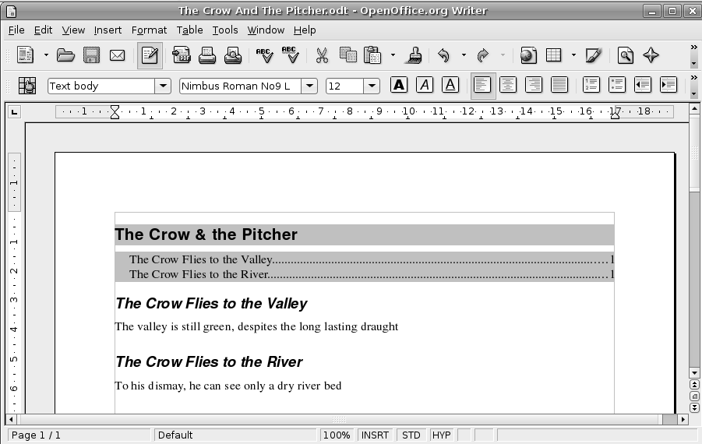
Fig. 9. OpenOffice document generated from OpenOffice PSM.

5.2 An Hipertext / adventure Game PIM
In another example, the storytelling can be converted into an adventure Game; storytelling knowledge must be converted into a PIM representing an abstract syntax tree of a quasi-natural language interpreter. Parsing CIM structure into MOF types is done by a model transformation script written in Python:
Excerpt of the code used for parsing CIM structure into MOF types.
def parse(self, dom):
model = self.mofmodel
nameSpace = 'org.omg.xmi.namespace.UML'
[ model.update({element:self.makeMofTypeInstance(element)})
or model[element].register(model,element.parentNode)
for moftype in self.MOFTypes
for element in dom.getElementsByTagNameNS(nameSpace,moftype)
]
[ element.aggregate()
for element in model.values()
]
return model
Principle relationships unfold to form the syntactic trees. The following model transformation code traverses the Principle Knowledge Base unfolding the abstract syntax tree grammar structure for each action element.
class MofActionPatternDiscriminator(dict):
.......
def actionPatternMatchAndUnfold(
self,actionNode,actionRelationTree):
self.discriminatedActionPatternSet=[
principleDescriptor for principleDescriptor,
principleSemanticPattern in
self.principleKnowledgeBase.iteritems()
if self.detectSemanticPattern(
principleSemanticPattern,actionRelationTree)]
if self.discriminatedActionPatternSet:
return self.buildUnfoldedAbstracSyntaticTree(
actionNode,self.discriminatedActionPatternSet)
return EMPTY_AST # no action unfolded

5.4 Implementing into platform specifics of a MUD Engine
Model transformations are done here into platform specifics of Pyndorama Zork-like MUD Engine [29]. Pyndorama is a MUD engine for constructionist learning; it is a game where students can participate both as players and as constructors of adventures. It is based on concepts of constructionism [30] which says that learners are particularly likely to make new ideas when they are actively engaged in making some type of external artifact which they can reflect upon and share with others. In this case, this external artifact is an adventure that students can design and use to challenge his/her classmates.
Pyndorama uses a Zork-like[31] natural language engine and adventures are designed using a conceptual map (figure 10).
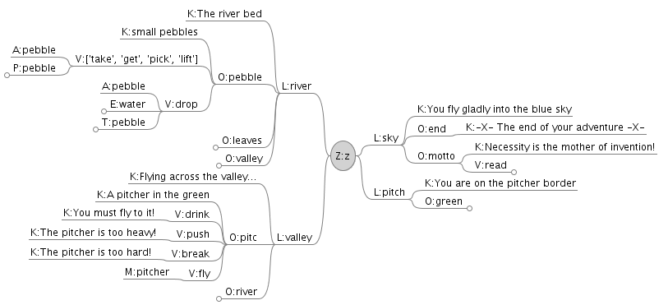
Fig. 10. Pyndorama's conceptual map.
Model transformation from the adventure PIM results in a PSM equivalent to the map notation, shown in figure 11.
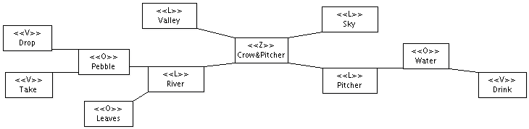
Fig. 11. Pyndorama's PSM.
The adventure can be played on the internet or in OLPC XO. The web interface is constructed using Kid template [32] (figure 12); for OLPC XO[33] it has been translated into GTK [34] following the OLPC specifications.
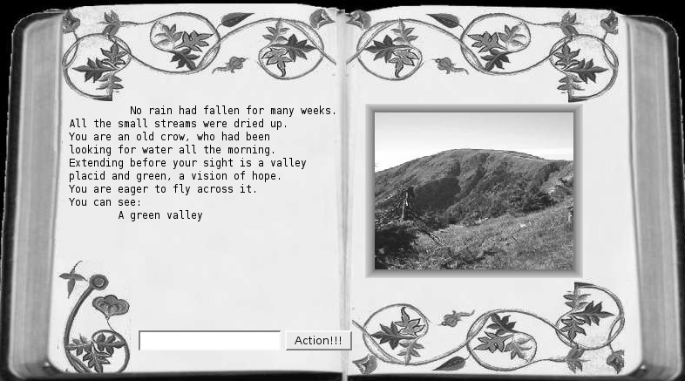
Fig. 12. The game ready to be played inside a web browser.
6 Conclusion – A Reusable Knowledge Representation with Computational Implementations
Knowledge representation has been under heavy research impetus from scientific community, fostered by a pressing need to preserve and propagate scientific achievements. Many relevant works have embodied Academy and enterprise with efficient tools to model and share critical knowledge. These tools are, in fact, judiciously adequated to the highly demanding requisites of these applications. On the other hand, many other less exacting applications may fall short of benefiting from such developments due to a steep learning curve or lack of expertise critical mass.
Educators at fundamental scholar levels might benefit of a knowledge representation approach that is simple to learn, standardized in its format and supported by widely available tools. Purveying to this needs, this work introduces a simple UML notation proposal to capture knowledge representation on very small grained domains. The small grain premise mitigates the need of a expert team to manage and validate knowledge domain ontologies and instead provides for incremental knowledge base construction.
The KR rendered in UML format results in a concise representation readily acknowledged and apprehended through a diagram inspection. The notation is simple enough to train students and teachers from diverse knowledge areas. Experiments with teenagers have resulted in successful representations, that pervaded through all model transformation process end in playable Pyndorama adventures. At the time of this printing the results are available at http://pyndorama.nce.ufrj.br in the form of the Labirinto adventure.
The incremental nature of knowledge construction is an important result, since storytelling knowledge can cumulatively build on top of existing knowledge. The meta-knowledge facility provides for the creation of higher level specialized semantics, incorporating new expressivity into the knowledge base. The knowledge base can expand on demand not only in terms of knowledge amount but in semantic quality. Higher level semantics can retrace back on the underlying terms all they way down to the primitive meta-model principles. This constitutes a self-referencing mechanism which mostly precludes the need for manually provision of semantics for new terms since the meaning can be reconstructed by the traversal of the definition tree.
The constructed model can be reused on several learning activities, by rendering it through an appropriate multilevel MDA process. Platform independent models can be designed to accommodate the diversity of available educational tools and then provided with specialized platform implementations. This work provides a coarse proof of concept of the feasibility of such reuse, that can be refined in further research. Another promising form of reuse can be prospected by refining grammatical constructs to a greater extent. The resulting model can be engineered with transformation into a UNL[35] language representation platform. This should provide highly accurate translation of knowledge into several languages.
References
1. Miller, J., Mukerji, J.: MDA Guide Version 1.0. OMG Document: omg/2003-05-01 (2003)
2. Demo, P.: Professor do Futuro e Reconstrução do Conhecimento, Vozes, Petrópolis, Rio de Janeiro (2004)
3. Heck, A.:Introduction to Maple: 3rd ed., XVI, 828 p., 160 illus., Hardcover
ISBN: 978-0-387-00230-9 (2003)
4. Sowa, J.: Knowledge Representation: Logical, Philosophical and Computational Foundations. Brooks/Cole, USA (2003)
5. www.acm.org
6. Object Management Group: Unified modeling language. (http://www.uml.org/)
7. Weber, M., Kindler, E.: The petri net markup language. Technical report, Petri Net Technology for Communication Based Systems (2002)
8. Sowa, J.: Conceptual Structures: Information Processing in Mind and Machine. Addison-Wesley Publishing Company, USA (1984)
9. CL Working Group: Abstract syntax and semantics: Common logic working group (2003)
10. KIF: Knowledge interchange format. (http://logic.stanford.edu/kif/dpans.html) Draft proposed American National Standard, NCITS.T2/98-004.
11. Berners-Lee, T.: Foreword. In Fensel, D., Hendler, J., Lieberman, H., Wahlster, W., eds.: Spinning the Semantic Web. The MIT Press, Cambridge, Massachusetts (2003)
12. Antoniou, G., van Harmelen, F.: A Semantic Web Primer. The MIT Press, Cambridge, Massachusetts (2004)
13. XTM: XML topic maps. (http://www.topicmaps.org/)
14. Stephen Cranefield. Networked Knowledge Representation and Exchange using UML and RDF. Journal of digital information, volume1 issue 8.
15. Y. Deng, S. Chang: A G-Net Model for Knowledge Representation and Reasoning. IEEE Transactions on Knowledge and Data Engineering. Volume 2 , Issue 3 , pp 295-310 (1990)
16. Nagarjuna G.: GNOWSYS: A System for Semantic Computing. http://www.gnu.org/software/gnowsys/GNOWSYS_files/cpv2/cpv2.html
17. Object Management Group: Unified modeling language. (http://www.uml.org/)
18. Working Group: Standard upper ontology. http://suo.ieee.org/ (2003) IEEE P1600.1.
19. Davis, R., Shrobe, H., Szolovits, P.: What is a Knowledge Representation?. AI Magazine, Volume 14, Issue 1, pp 17-33 (1993)
20. Liu, H., Singh, P.: ConceptNet — a practical commonsense reasoning tool-kit. BT Technology Journal, Volume 22, Issue 14 (2004)
21. Gero, J.: Design Prototypes: A Knowledge Representation Schema for Design. AI Magazine, Volume 11, Issue 4, pp 26-36 (1990)
22. Inform: A Design System for Interactive Fiction. (http://www.inform-fiction.org/inform6.html)
23. Gruber, T. R.: A Translation Approach to Portable Ontology Specifications. Knowledge Acquisition, Volume 5, Issue 2, pp 199-220 (1993)
24. Gruber, T. R.: Toward Principles for the Design of Ontologies Used for Knowledge Sharing. Technical Report KSL 93-04, Knowledge Systems Laboratory, Stanford University (1993)
25. The Gene Ontology. (http://www.geneontology.org/)
26. Miller, G.: WordNet: a lexical database for English. Communications of the ACM, Volume 38, Issue 11, pp 39-41 (1995)
27. Plant Ontology Consortium. (http://www.plantontology.org/)
28. Uno - Universal Network Objects. (http://udk.openoffice.org/)
29. Castro, L., Oliveira, C., Mota, L.: Pyndorama: Learning and Having Fun in a Web Communinty. WBC 2007 IADIS international conference on Web-Based Communities Salamanca, Spain (www.iadis.org/WBC2007) (2007)
30. Kafai, B., Resnick, M.: Introduction, Constructionism in Practice: designing, thinking, and learning in a digital world / edited by Kafai, Y. and Resnick, M. Lawrence Erlbaum Associates, Inc., Mahwah, New Jersey, EUA. (1996)
31. P. David Lebling, Marc S. Blank, and Timothy A. Anderson. Zork: A computerized fantasy
simulation game. IEEE Computer, Volume 12, Issue 4. pp 51-59 (1979)
32. Kid Templating. (http://kid-templating.org/)
33. Rowell, L.: Reinventing the PC. ACM Press, Volume 11, Issue 1, pp 18-25. (2007)
34. The GIMP Toolkit. (http://www.gtk.org/)
35. UNL 2005 Specifications. (http://www.undl.org/unlsys/unl/unl2005/UNLSystem.htm)

Section I.2.4 of the ACM Computing Classification System [5]: Knowledge representation formalisms and methods.
gnowledge.org

