RESEARCH REPORT
The Economic Impact of COVID-19 on the Global Airline Industry
Revenue, profitability, traffic and employment, 2019 to 2023
Prepared using Microsoft Word, Excel and PowerPoint
Companion files: COVID19_Economic_Impact_Data.xlsx and COVID19_Economic_Impact_Presentation.pptx

Executive Summary
The COVID-19 pandemic was the largest shock the global airline industry has faced. Border closures and travel restrictions removed most demand almost overnight. This report measures that impact using published data from IATA, ICAO, ATAG and Oxford Economics, and tracks how far the industry had recovered by 2023.

Key findings
- Revenue fell from US$838 billion in 2019 to US$384 billion in 2020, a drop of 54.2%.
- The industry moved from a US$26.4 billion net profit in 2019 to a record net loss of US$137.7 billion in 2020, and stayed loss-making until 2023.
- Daily passengers fell from 12.4 million to 5.0 million (-59.7%) and daily flights from 106,600 to 46,400 (-56.5%).
- Direct aviation employment was estimated to have fallen by about 21% by the end of 2021, roughly 2.3 million jobs.
- Revenue recovered to an estimated US$908 billion in 2023, about 108% of 2019, and net profit returned to an estimated US$27.4 billion.

Recommendations in brief
Airlines should build stronger cash reserves and flexible cost structures; governments should coordinate border rules and target support carefully; and workers and businesses that depend on aviation should diversify. Section 8 explains each point.

1. Introduction
Air transport connects people, goods and economies. Before the pandemic, aviation supported tens of millions of jobs worldwide, and airlines had just completed several years of steady profits. When COVID-19 spread in early 2020, governments closed borders and imposed quarantines, and passenger demand collapsed.
This report analyses the economic effects of the pandemic on one specific industry, the global airline industry. It asks three questions: how large were the losses in revenue and profit, how did traffic and employment respond, and what lessons follow for businesses and policy makers? The industry was chosen because its data is reported consistently by industry bodies, and because it shows both the depth of the crisis and the pace of the recovery.

2. Methodology
The study uses secondary data from published sources. No new survey data was collected.
Item | Approach
Industry studied | Global commercial airline industry
Period | 2019 (pre-pandemic baseline) to 2023 (estimate)
Indicators | Revenue, net profit, EBIT margin, daily passengers and flights, direct aviation jobs by region
Sources | IATA industry statistics fact sheets (2023, 2024); IATA and ICAO State of Aviation presentations (2023); ATAG / Oxford Economics COVID-19 fact sheet (2021)
Tools | Excel for data, formulas and charts; Word for this report; PowerPoint for the presentation
Calculations | Percentage changes and recovery ratios calculated in Excel using 2019 as the base year (2019 = 100%)

Limitations: figures are revised between IATA releases, 2023 values are estimates, and employment figures come from a modelled 2021 analysis rather than a count of actual layoffs. The employment numbers cover direct aviation jobs only; they do not include the wider tourism and supply-chain jobs that aviation also supports.

3. Findings: Revenue and Profitability

3.1 Revenue
Airline revenue fell by 54.2% in 2020. It then recovered unevenly: 61% of the 2019 level in 2021, 88% in 2022, and an estimated 108% in 2023.
Year | Revenue (US$ bn) | Change vs 2019 | Change YoY | % of 2019
2019 | 838 | - | - | 100.0%
2020 | 384 | -54.2% | -54.2% | 45.8%
2021 | 513 | -38.8% | +33.6% | 61.2%
2022 | 738 | -11.9% | +43.9% | 88.1%
2023E | 908 | +8.4% | +23.0% | 108.4%
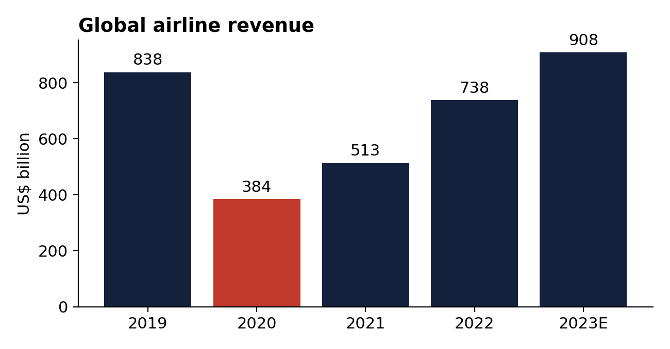
Figure 1: Global airline revenue, US$ billion (IATA, June 2024)

3.2 Net profit
The profit swing was sharper than the revenue drop because airlines have large fixed costs, including aircraft leases, staff and airport charges, that continue when planes are grounded. Net profit moved from US$26.4 billion in 2019 to a loss of US$137.7 billion in 2020. Losses narrowed to US$40.4 billion in 2021 and US$3.5 billion in 2022, and the industry returned to an estimated profit of US$27.4 billion in 2023.
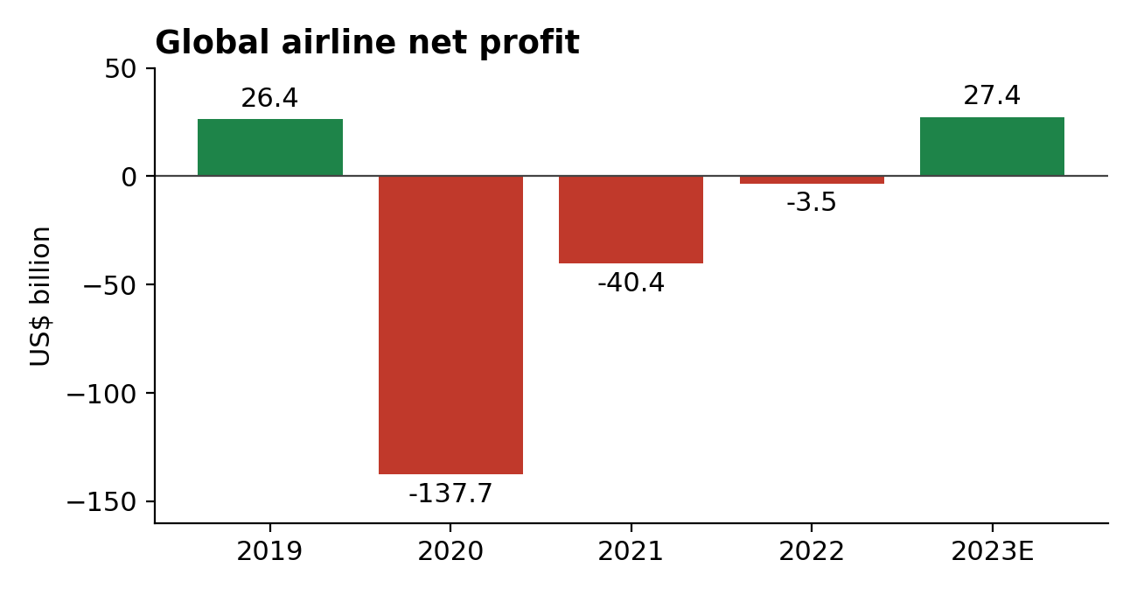
Figure 2: Global airline net profit, US$ billion (IATA)
The EBIT margin followed the same path: about -28.8% in 2020, -8.5% in 2021, 1.5% in 2022 and an estimated 5.7% in 2023. Net profit margins remain thin: the 2023 estimate of US$27.4 billion is about 3% of revenue.

4. Findings: Traffic
Year | Daily passengers (million) | Daily flights | Passengers as % of 2019
2019 | 12.4 | 106,600 | 100.0%
2020 | 5.0 | 46,400 | 40.3%
2021 | 6.0 | 54,900 | 48.4%
2022 | 9.4 | 76,300 | 75.8%

Passenger numbers were hit harder than flights because airlines kept running flights with few passengers, and because cargo flights continued. Cargo helped airlines: IATA reports that cargo revenue stayed higher than before the pandemic as passenger revenue recovered. Recovery also varied by region. IATA noted that Asia-Pacific traffic was still only 58% of its pre-COVID level in February 2023 because travel restrictions there were lifted later than elsewhere.
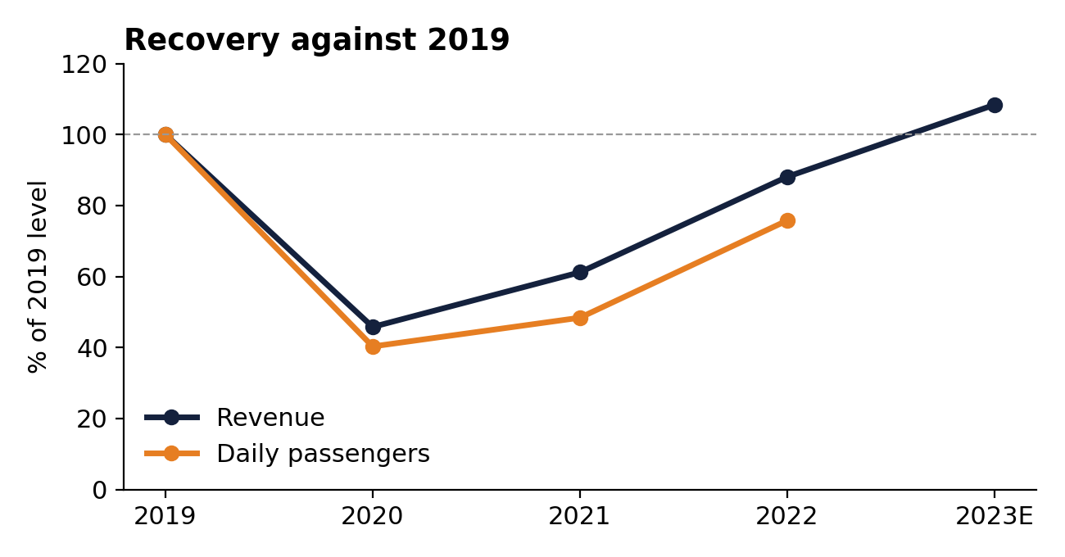
Figure 3: Revenue and passenger recovery, 2019 = 100%

5. Findings: Employment
ATAG and Oxford Economics estimated that direct aviation jobs, at airlines, airports, manufacturers and air traffic management, would fall from about 11.3 million before COVID-19 to 9.0 million by the end of 2021, a reduction of about 2.3 million jobs or 21%. The fall was between 15% and 23% in every region. Counting jobs supported indirectly, including in tourism, the same analysis put 44.6 million of the 87.7 million jobs normally supported by aviation at risk.
Region | Pre-COVID (m) | End-2021 (m) | Change
Africa | 0.440 | 0.374 | -15.0%
Asia-Pacific | 4.200 | 3.400 | -19.0%
Europe | 2.700 | 2.100 | -22.2%
Latin America & Caribbean | 0.722 | 0.563 | -22.0%
Middle East | 0.595 | 0.480 | -19.3%
North America | 2.700 | 2.100 | -22.2%
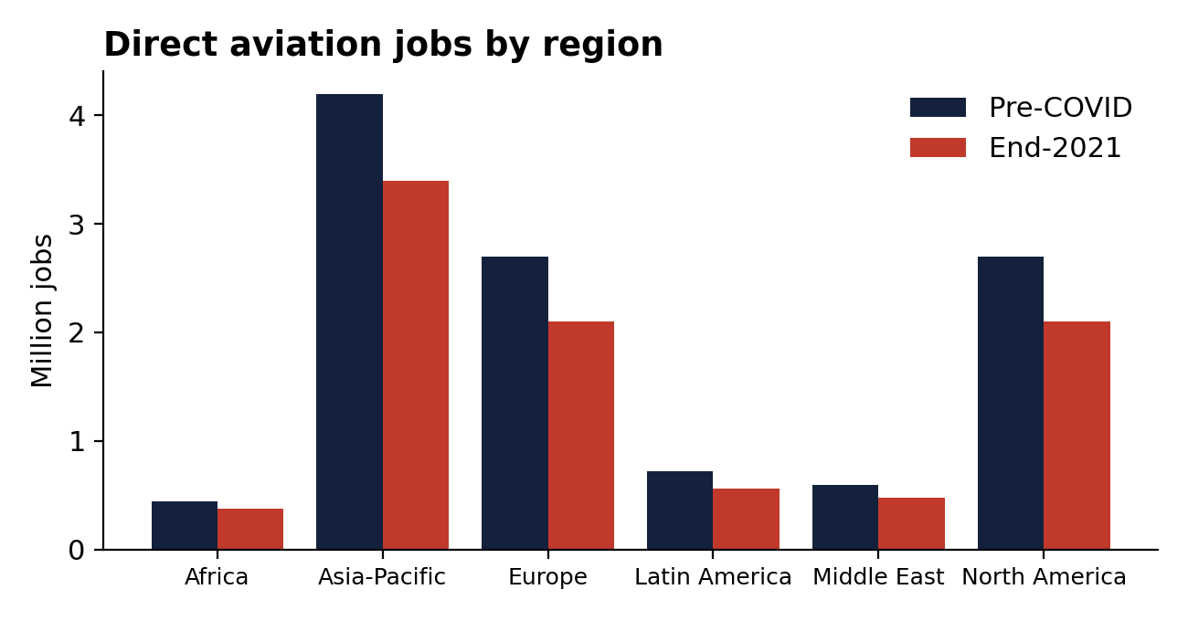
Figure 4: Direct aviation jobs by region, million (ATAG / Oxford Economics)

6. Discussion
Three patterns stand out. First, the shock was global and fast: every region lost between 15% and 23% of direct aviation jobs. Second, losses were deepest in profit rather than in revenue, which shows how much fixed costs magnify a fall in demand. Third, recovery depended on policy: regions that reopened borders earlier recovered earlier.
Revenue overtook its 2019 level in 2023, but this does not mean the industry returned to normal. Airlines carried debt taken on during the crisis, and margins remain thin compared with the cost of what was lost. IATA also estimated that travel "lost" between 2020 and 2022 was equal to 1.8 times the traffic of 2019.

7. Conclusion
COVID-19 cut airline revenue by more than half in a single year, produced the largest loss in the industry's history, removed about a fifth of direct aviation jobs, and took three years for revenue to recover. The industry has since returned to profit, but the crisis exposed how exposed a high-fixed-cost industry is to sudden demand shocks and to government travel decisions.

8. Recommendations

For airlines
- Hold larger cash reserves and keep access to credit so that the next shock does not force emergency borrowing.
- Build flexibility into costs, for example through leased capacity and flexible staffing, so costs can fall when demand does.
- Keep a strong cargo business, which cushioned revenue during the crisis.

For governments
- Coordinate border and testing rules between countries so that travel can restart together.
- Target support at keeping jobs and critical connectivity, with clear conditions and time limits.

For workers and dependent businesses
- Diversify skills and income sources in regions and businesses that rely heavily on air travel.

References
- IATA, Industry Statistics Fact Sheet, June 2024. www.iata.org
- IATA, Industry Statistics Fact Sheet, June 2023. www.iata.org
- IATA and ICAO, State of Aviation Post COVID-19 presentations, 2023. www.icao.int
- ATAG and Oxford Economics, COVID-19 Analysis Fact Sheet (update September 2021). atag.org

