Screenshots of All the Crucial Steps of This Activity

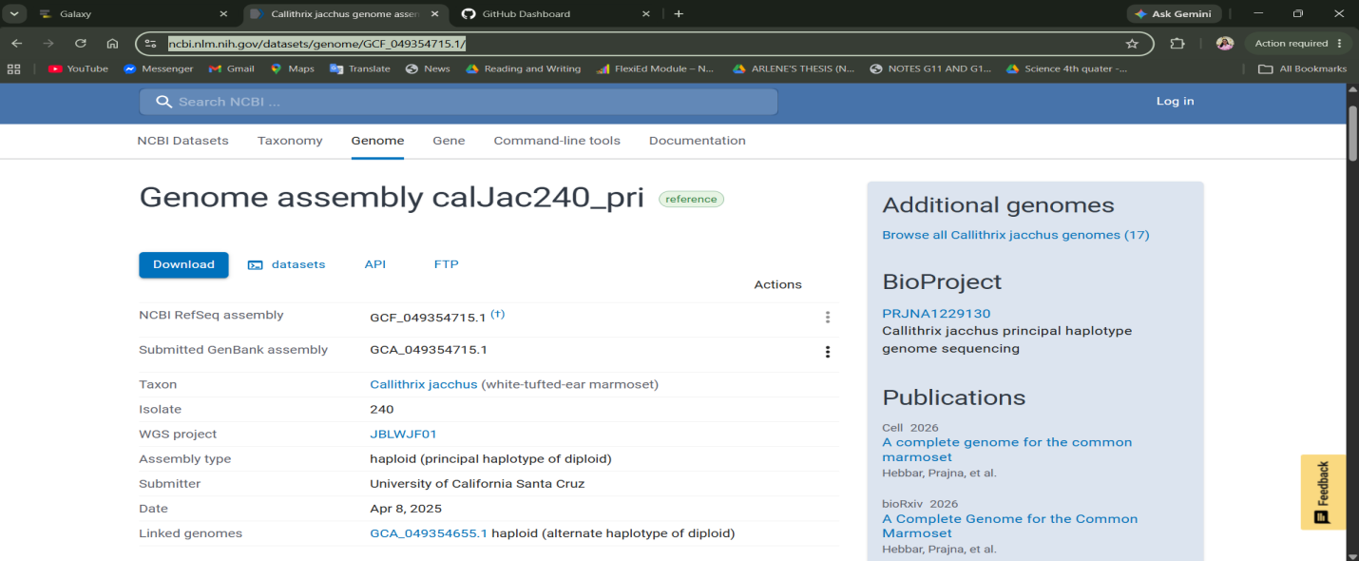
Figure 1. This shows the source of the whole genome sequence (NCBI)

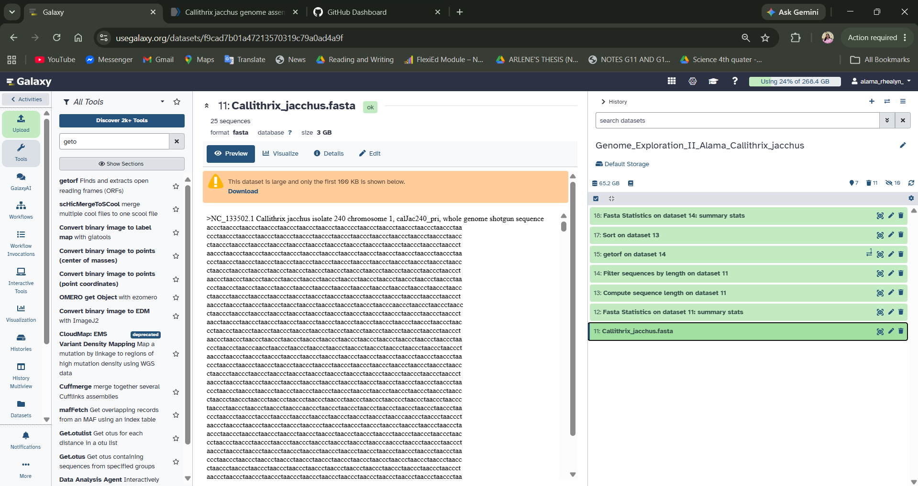
Figure 2. This shows the genome sequence sitting in the usegalaxy history

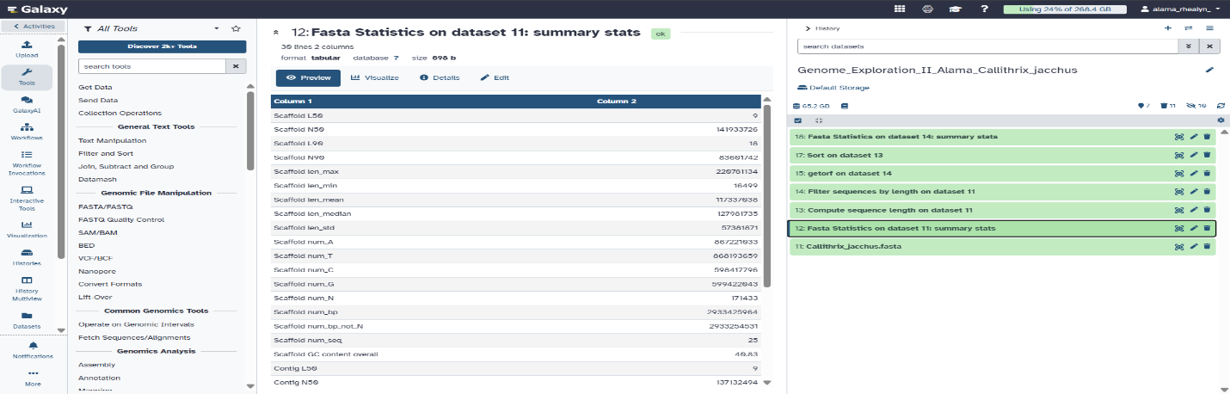
Figure 3. I used Fasta statistics for this step

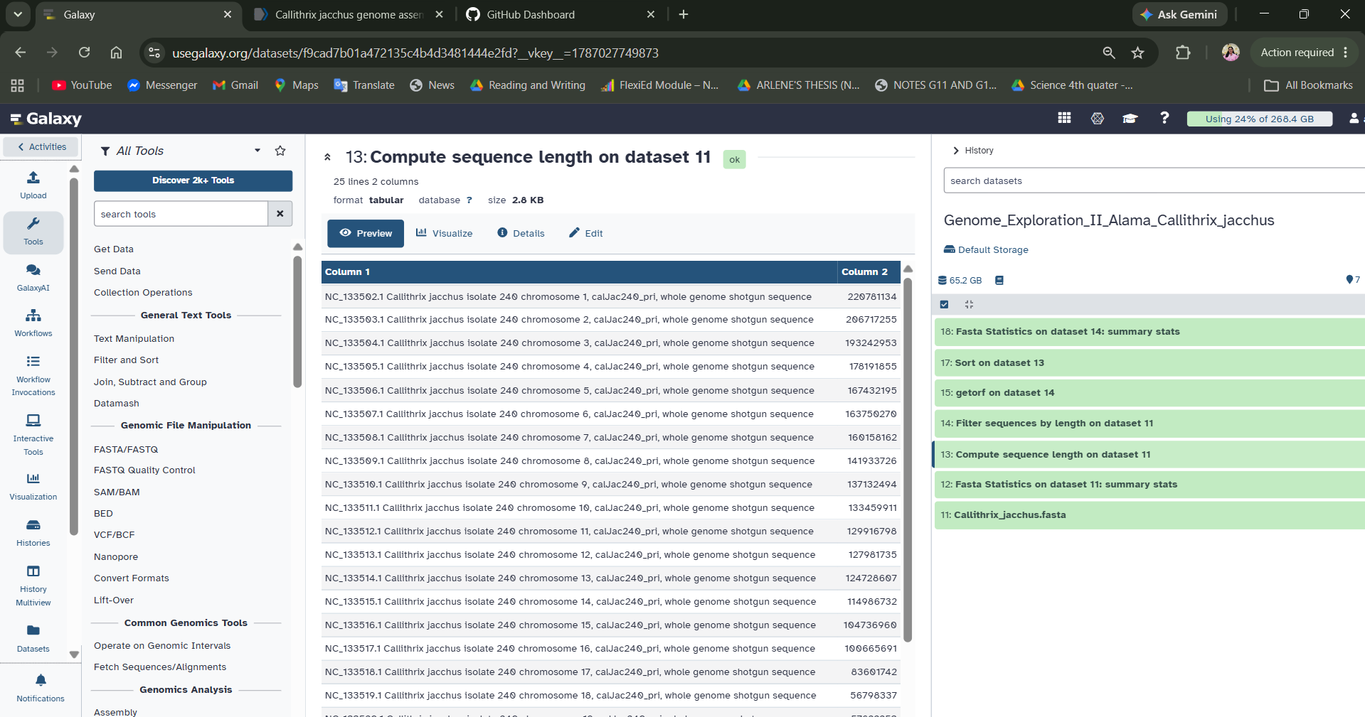
Figure 4. Followed by compute sequence length

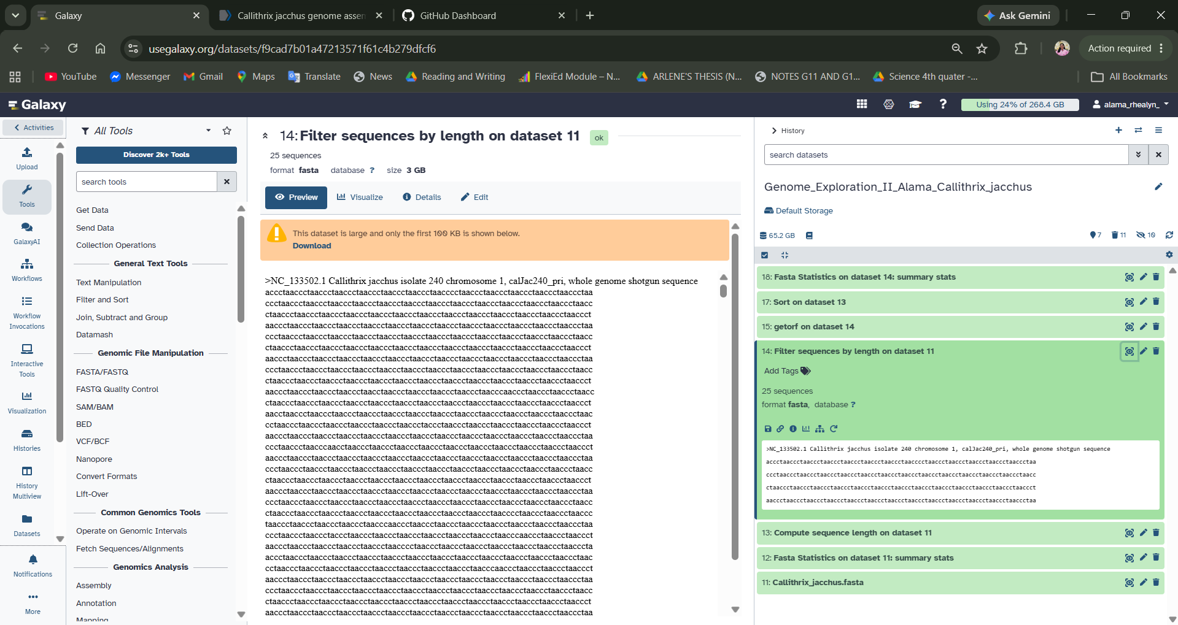
.
Figure 5. Filtering sequences by length

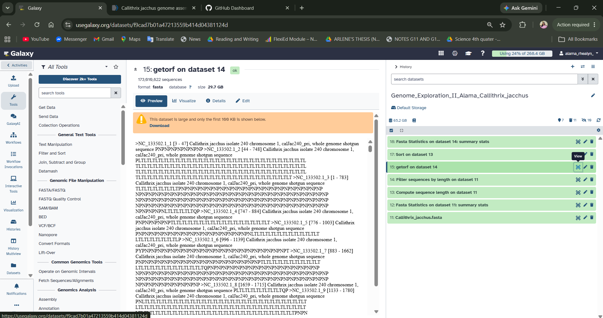
Figure 6. Results of getorf

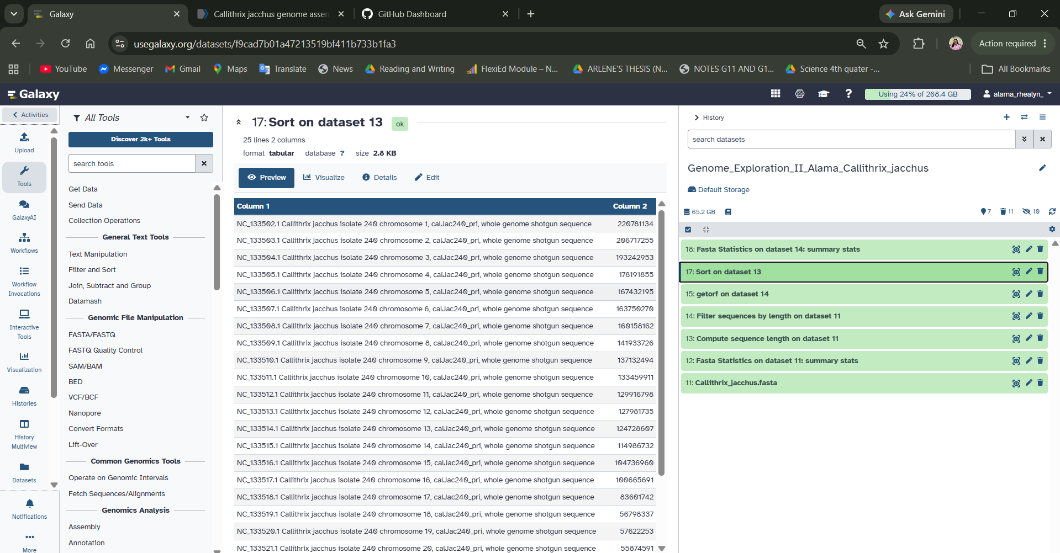
Figures 7. Results of sort

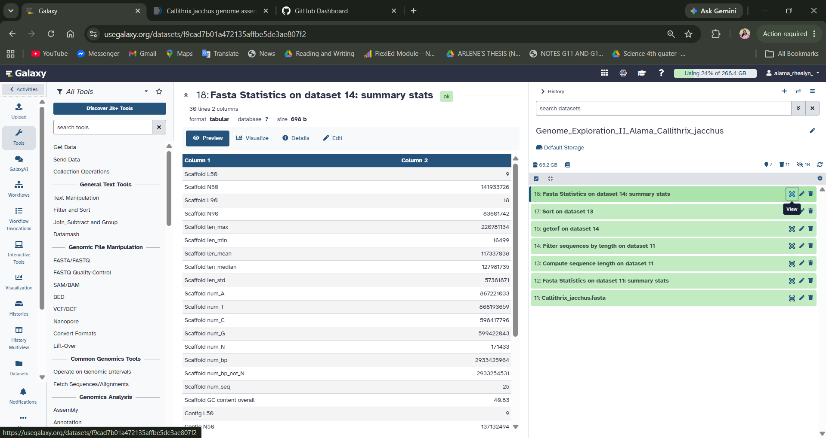
Figure 8. Fasta statistics of the Filtered sequence by length

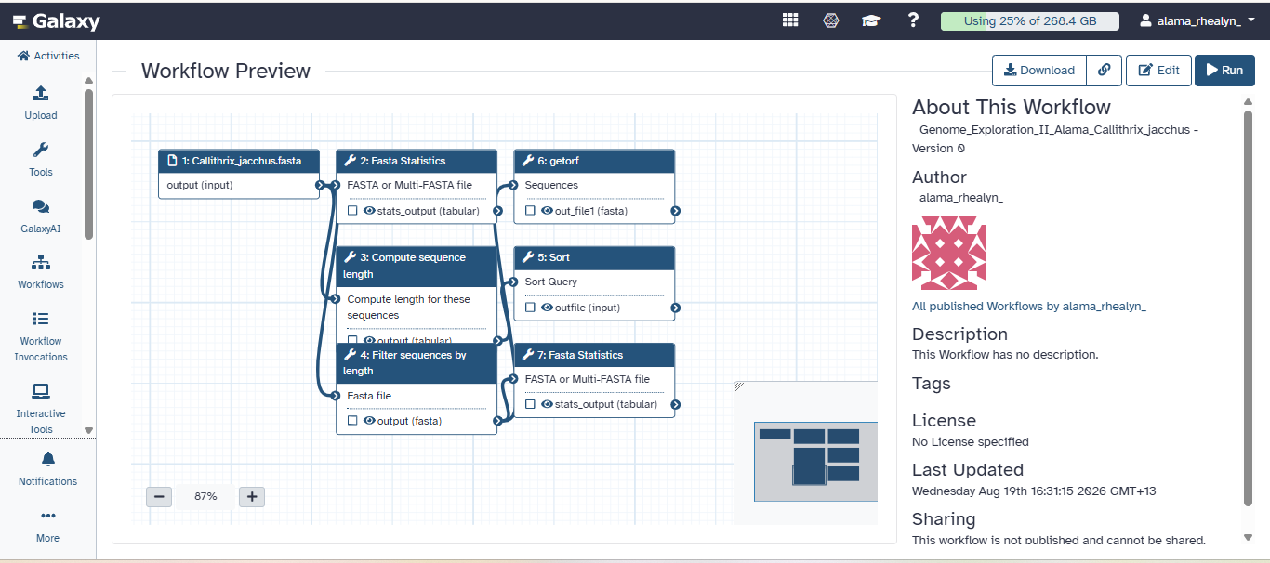
Figure 9. Workflow

