Name: Rhea Nair

Roll: 16010122316

Batch: C-3

Case Study on Please Build : A Build Automation Tool
1. Introduction
The DevOps lifecycle involves several stages such as version control, continuous integration, deployment, configuration management, infrastructure as code, and monitoring. While mainstream tools like Git, Jenkins, Docker, and Kubernetes dominate the industry, this case study focuses on exploring an alternative tool for build automation – Please Build. The aim is to gain exposure to lesser-known tools and evaluate their effectiveness compared to conventional solutions.

2. Tool Selection: Please Build
Please Build is an open-source build system designed for performance and scalability. It provides a simple and fast way to manage builds in multi-language monorepo environments. Compared to tools like Bazel or Gradle, Please Build offers a lightweight setup and a highly reproducible build process. This makes it an excellent candidate to explore as an alternative tool in the DevOps lifecycle.

3. Implementation

3.1 Installation
The following commands were used to install Please Build on a Linux environment:
```bash
curl -s https://get.please.build | bash
source ~/.profile
echo 'export PATH=$PATH:~/.please' >> ~/.bashrc
source ~/.bashrc
plz --version
```
Output:
```
Please version 17.19.1
```
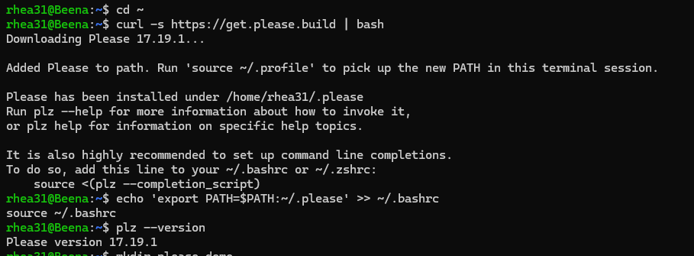

3.2 Project Setup
A demo project was created with the following structure:
```text
please-demo/
│── BUILD # Please build definitions
│── main.py # Simple Python script
│── test_example.py # Unit tests
│── pleasew # Wrapper script for Please
│── plugins/ # Installed plugins
└── plz-out/ # Build outputs
```
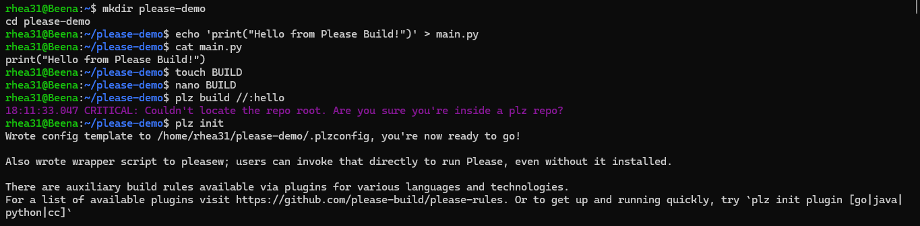
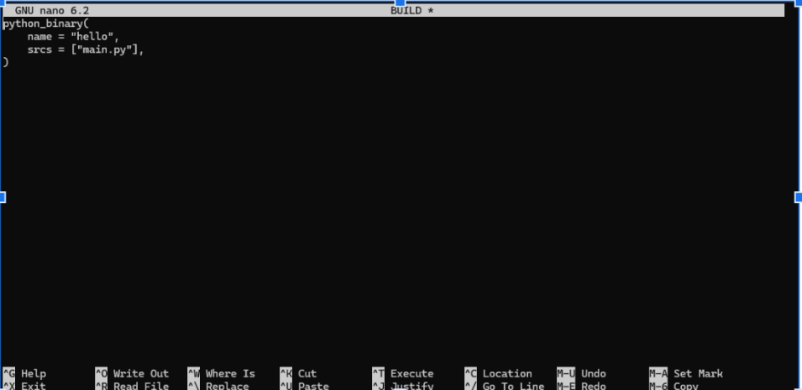

3.3 Build & Run
The build target was defined in the BUILD file using `python_binary`. The project was built and executed as follows:
```bash
plz build //:hello
plz run //:hello
```
Output:
```
Hello from Please Build!
```
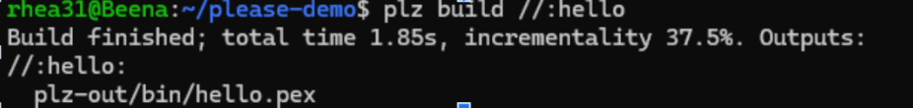
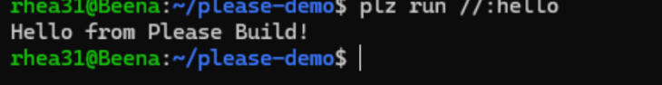

3.4 Testing
Unit tests were added using Python's unittest framework. The BUILD file was configured with `python_test` to include the test source files. The following command executed the tests:
```bash
plz test //...
```
Output:
```
//:example_test 2 tests run in 149ms; 2 passed
```
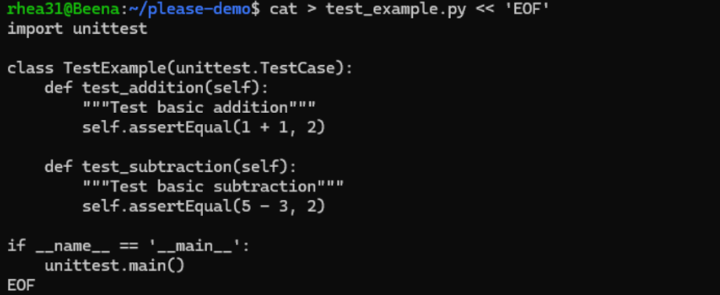
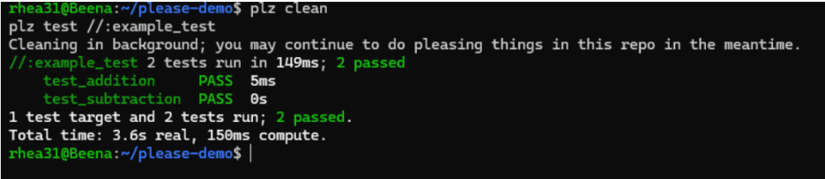

4. Comparison & Evaluation
Feature | Please Build | Bazel | Gradle
Language Support | Multi-language | Multi-language | Primarily JVM (with plugins)
Performance | Very fast incremental builds | Fast | Moderate
Ease of Setup | Simple, single binary | Requires config | Requires JVM & plugins
Monorepo Support | Excellent | Excellent | Limited
Extensibility | Plugins + custom rules | Rules | Plugins

5. Challenges Faced & Solutions
- Initial error: `Couldn't locate the repo root` → Solved by running `plz init`.
- Error: `name 'python_binary' is not defined` → Solved by initializing the Python plugin.
- Error: `Missing required argument: main` → Fixed by specifying the correct `main` source file.
- Error: `file does not exist` → Fixed by cleaning and rebuilding.

6. Outcome / Key Learnings
Through this implementation, the following outcomes were achieved:
- Successfully installed and configured Please Build.
- Implemented and executed a Python project with build automation.
- Integrated and ran unit tests through Please Build.
- Compared Please Build against mainstream tools like Bazel and Gradle.
Key Learnings:
- Please Build is fast and simple to set up.
- It provides strong support for monorepos and reproducible builds.
- Smaller community support compared to Bazel or Gradle.
- Ideal for teams seeking lightweight build systems.

7. Conclusion
This case study successfully demonstrated the installation, setup, and usage of Please Build as an alternative DevOps tool for build automation. The hands-on implementation highlighted its advantages in speed and reproducibility, while also acknowledging its limitations in terms of adoption and ecosystem support. Overall, Please Build serves as a strong lightweight alternative to conventional tools.

8. References
- Official Please Documentation: https://please.build/
- Please GitHub Repository: https://github.com/thought-machine/please

