Deepfake Detection Framework - Project Report

1. Project Overview
We have built a Hybrid Deepfake Detection Framework capable of identifying manipulations in multimedia content. The system leverages a multimodal architecture that fuses:
- Video Branch: Uses ResNet18 for spatial feature extraction and Bi-Directional LSTM for temporal modeling.
- Audio Branch: Uses a 2D CNN (ResNet-style) to analyze Mel-Spectrograms.
- Fusion Layer: Combines both streams to make a final decision.

2. Dataset & Training
- Dataset: Sampled from `FakeAVCeleb_v1.2`.
- Training Size: Balanced subset of ~600 videos.
- Preprocessing:
- Faces: Extracted ~10 frames per video using Haar Cascades.
- Audio: Converted to Mel-Spectrograms (128 mel bands).

3. Evaluation Results
The model was evaluated on a held-out test set (unseen videos).
Metric | Score | Interpretation
**Accuracy** | **87.67%** | The model correctly classified 87.67% of test videos.
**AUC Score** | **0.9609** | Excellent discriminative ability between Real and Fake classes.

Visualizations
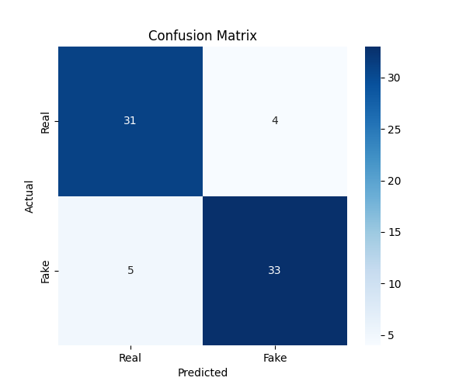
- Shows True Positives, True Negatives, False Positives, and False Negatives.
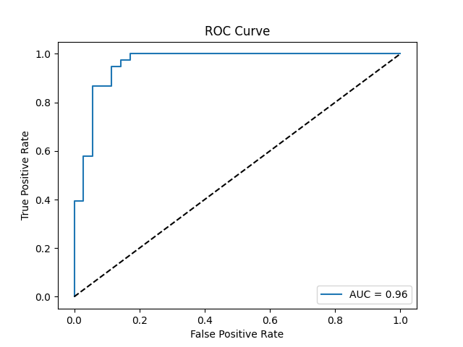
- Illustrates the trade-off between sensitivity and specificity.

