**Wistron InfoComm (Czech), s.r.o.**

**Tuřanka 106  
627 00 Brno – Slatina  
Czech Republic**

**10/17/2011**

E-HR Recruitment System System Analysis

A Software Requirement Specification for Human Resource Management Recruitment System - Wistron Infocomm CZ.

**Prepared by:**

Rhea Prokop, IT Developer  
  
**Approved by:**

Ondrej Uhlir, Project Manager   
 Leazanda Guzman, IT Supervisor  
  
**Reviewed by:**

Claire Chang, IT Manager

**Table of Contents**

|  |  |
| --- | --- |
| Table Of Contents | **2** |
| Revision History | **2** |
| 1. Introduction | **3** |
| 1.1 Purpose of the system | **4** |
| 1.2 Scope of the system | **4** |
| 1.3 Objectives | **5** |
| 2. Existing System | **5** |
| 3. Proposed System | **7** |
| 3.1 System Models | **8** |
| 3.1.1 Process Flow | **8** |
| 3.1.2 UML Use Case Diagram | **13** |
| 3.1.3 UML Class Diagram | **16** |
| 4. Gantt Chart | **14** |
| 5. Terms & Definition | **17** |

Revision History

|  |  |  |  |
| --- | --- | --- | --- |
| **Name** | **Date** | **Reason For Changes** | **Version** |
| Rhea Prokop | 17/10/11 | Initial Release | 1.0 |
|  |  |  |  |
|  |  |  |  |
|  |  |  |  |
|  |  |  |  |
|  |  |  |  |
|  |  |  |  |

1. **Introduction**

This Software Requirement Specification provides a complete definition of functions and the process of Wistron Infocomm CZ - Human Resource Department's E-Recruitment System. This document will discuss the purposes and features of the E-Recruitment system. This document is intended for the project manager , developers and other stakeholders.

1.1 **Purpose of the system**

E-Recruitment system will have two main purposes:

1. Line Leaders, Supervisors or Managers who are in need of new employee(s) may inform the Human Resource Department through the E-Recruitment System.
2. A database of résumé/curriculum vitae (CV) candidates / future employees.

The approval of request for new employee(s), recruitment, selection, hiring of candidate(s) and training of new employee(s) will now be done automatically through the E-Recruitment System.

1.2 **Scope of the system**

E-Recruitment System is mainly designed to allow Line Leaders, Supervisors and Managers to request a new employee through the system's Request Form. Through this form, they will be able to inform Wistron Infocomm's HR Recruiter about the qualifications of the candidate(s) that they prefer. Using Oracle database, and through E-Recruitment system interface, HR Recruiter will be able to manage these requests.   
  
The HR Recruiter will also be able to create a new record of prospect employee(s) / candidate(s) into the database and update or delete an existing candidate record(s).

1.3 **Objectives**

The goal is not to re-invent the wheel but to concentrate on the standard hiring process of Wistron Infocomm CZ and be able to provide improvement to the current process.

1. **Existing System**

Line Leaders, Supervisors or Managers if needing a new employee(s) fill up a paper-based form called **Manpower Requisition Form** to inform the Human Resource Department – Recruitment section that they are in need of an employee replacement or additional manpower. This paper-based request would then be passed through different persons for approval purposes. The request details would then be posted to job agencies for prospective candidate(s) to apply.  
  
Résumés /curriculum vitaes (CV) that were submitted to Wistron Infocomm HR-Recruitment would then be filed to computer folder until they find one that is apt to the Line Leaders, Supervisors or Managers‘ request. Currently, the Human Resource Department does not have an automated record keeping of candidate. Searching through files of résumé /curriculum vitaes (CV) and reviewing its content one by one lengthens the hiring process.

**Sample of an Existing Manpower Requisition Form (**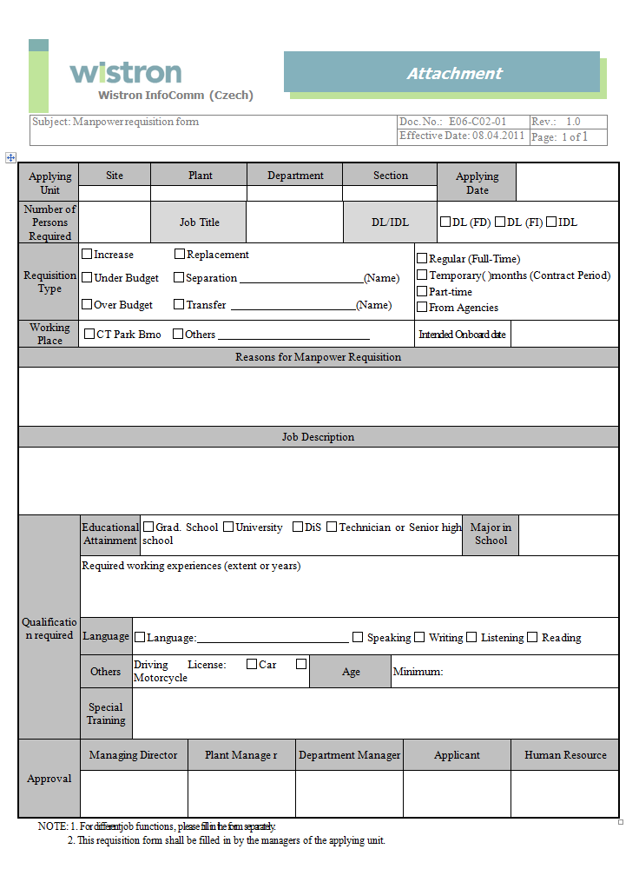

1. **Proposed System**

Through the E-Recruitment System, the Requestors if needing a new employee fill up the a request form. The Requestor will have an option to select whether he/she would like to request employee(s) from Agency. The system then informs the HR-Reviewer who will review the contents of the Requestor’s request. The HR-Reviewer then decides whether the request is to be approved, to be rejected or should then be returned to Requestor for changes. If the HR-Reviewer approves the request, he/she then assigns the following Person-In-Charge: HR-Recruiter, HR-Trainer and PS-Encoder.

Upon assigning the PIC, the system then sends an email notification to the following persons for the approval of the Requestor’s request:   
  
1. Department Manager

2. HR Manager (If Request of candidate is not from agency)

3. Plant Manager

4. General Manager

After the approval process, the system then sends email notification to the HR-Recruiter to process recruitment optionally finding candidate(s) to the candidate database. The HR-Recruiter then process the selection and hiring of new employee(s).   
  
Upon confirmation of new employee, the HR-Recruiter then informs the HR-Trainer and the Requestor about the number of candidate recruited (if multiple hiring) and their onboard date. The HR-Recruiter also informs the Requestor about the number of candidate(s) left to be hired.  
  
The system then sends data to the PS Database generating a new Employee ID for the new employee(s).

**3.1 System Models  
3.1.1 Process Flow**  
Approval Flow - A  
  
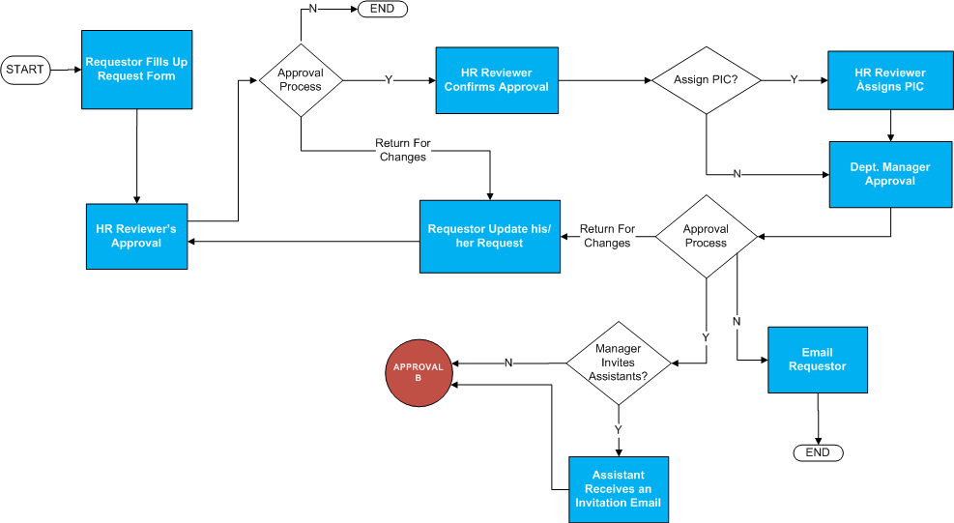

Approval Flow – B  
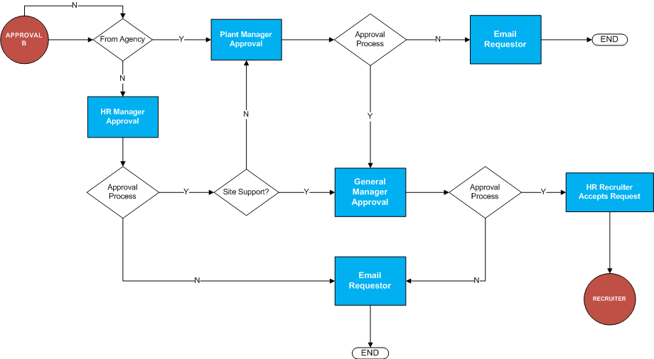

Recruiter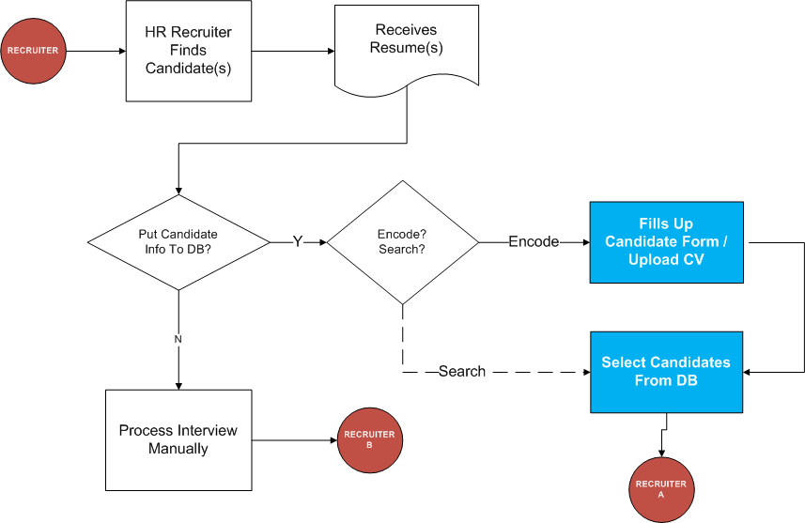Recruiter A  
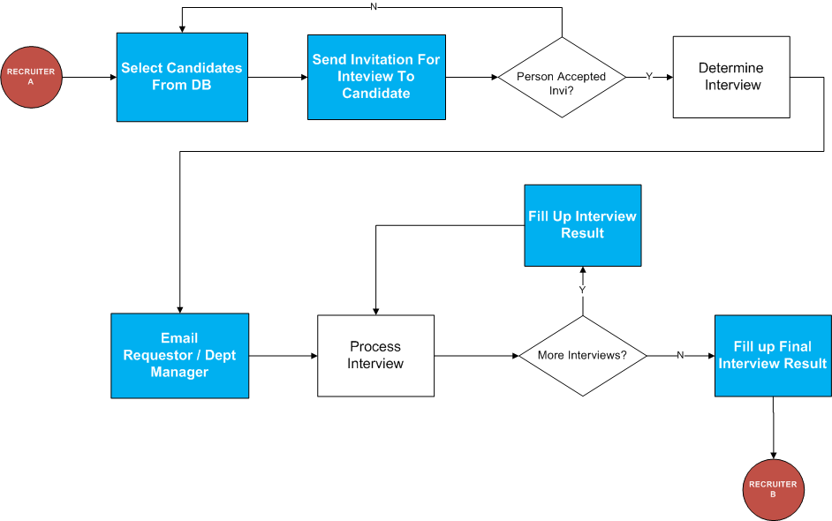

Recruiter B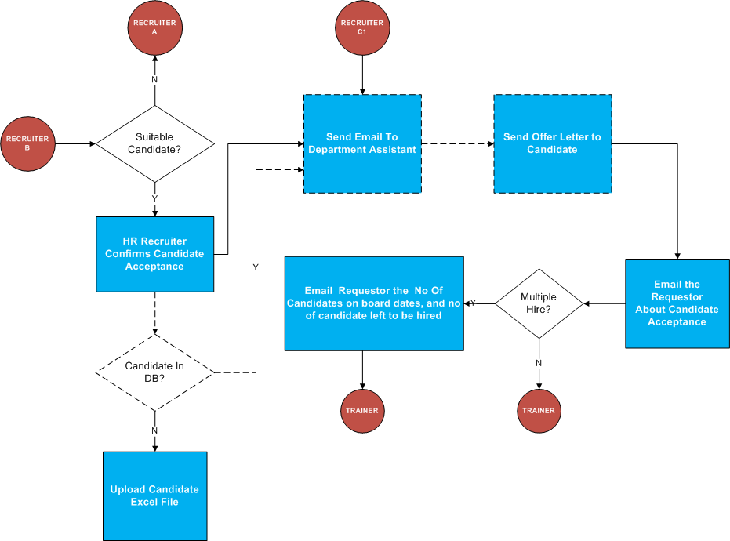

Trainer

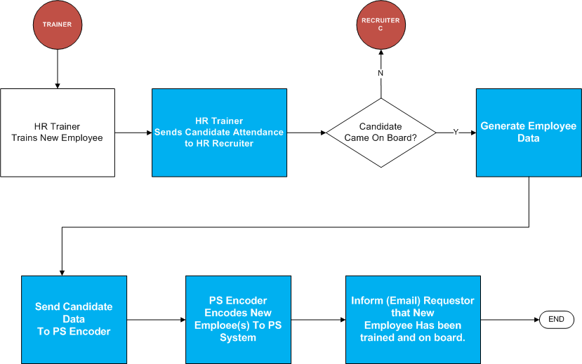

Recruiter C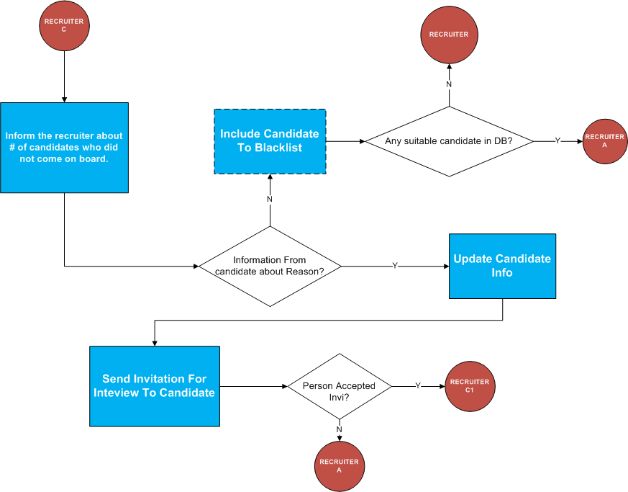

**3.1.2 Use Case Diagram**

Case Diagram I  
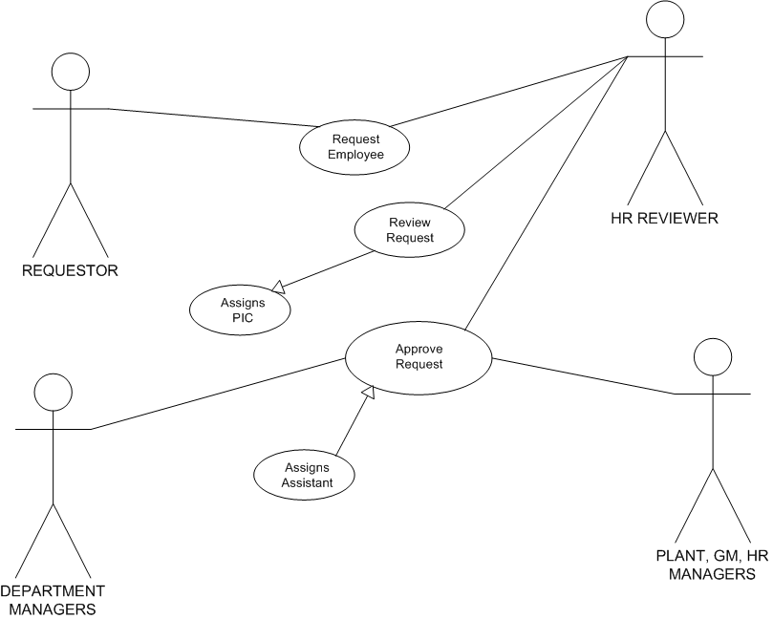

Case Diagram II  
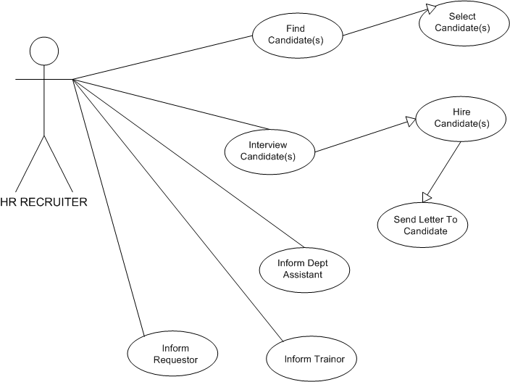

Case Diagram III

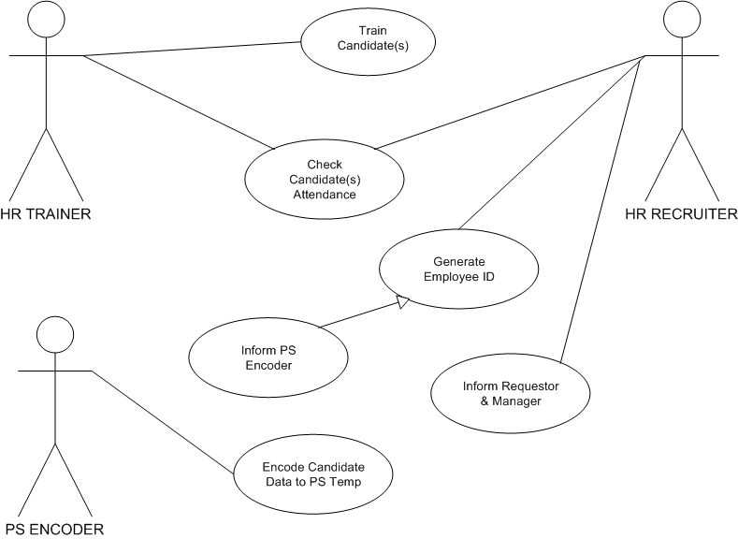

**3.1.2 UML Class Diagram**

**4. Gantt Chart**



**5. Terms & Definitions**

**Requestor** - Line Leader/Supervisor/Manager

**Agency / Non Agency** - Requestor is requesting candidate(s) from agency

**Site Support** – FI, IT, HR, Logistic, GA, Facility