Subject:  System Design for E-HR: Recruitment Application |  |  |  |  |  |  | Rev.: 1.0
 |  |  |  | Effective Date: 2011/12/15 |  |  | Revision Status
Description:  - Architecture  - Logic  - System Specs  - General  - Client Side  - Server Side  - Security Specs  - Logging  - Database  - Tables Definition |  |  |  |  |  |  | Page | Rev.
Reason for Change:
Copy to(All contents):

Copy(Cover sheet):

Approved by/  [Claire Chang] | Reviewed by/ Ondrej Uljir, Leazanda Guzman |  |  |  |  | Prepared by/  [Rhea Prokop]
Approved by/  [Claire Chang] | Original Request:  [Link to Request in sharepoint]

Revision History

Revise date | Version | Modified by | Purpose
11.30.2011 | 1.0 | [Rhea Prokop] | Initial Release

- Architecture
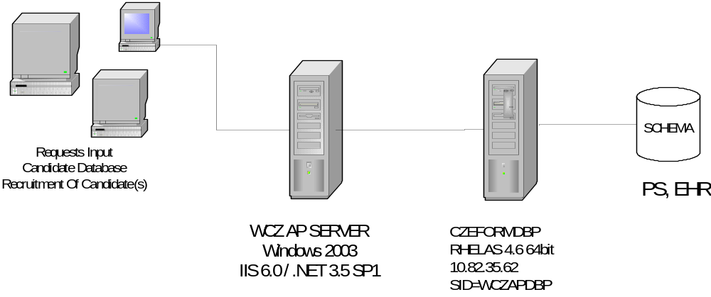
- Logic

System-level sequence diagram.
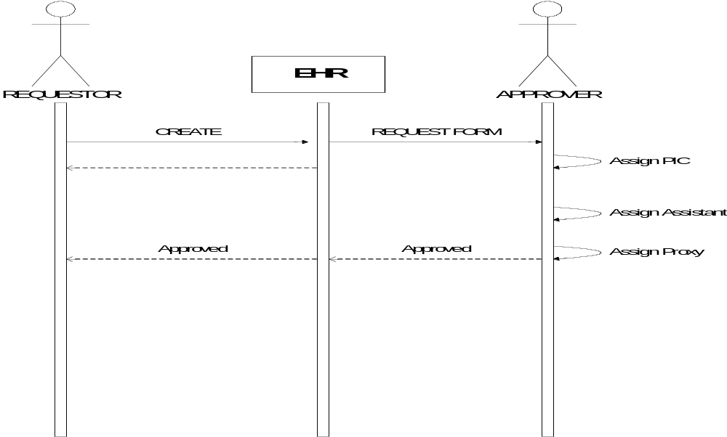

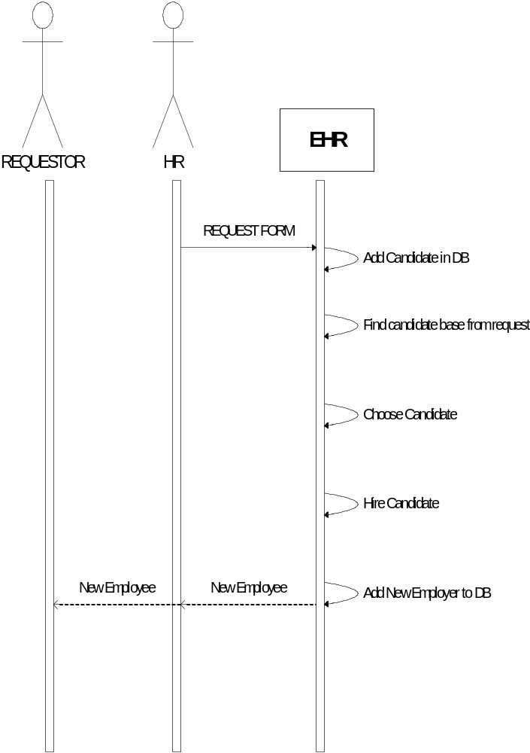

- System Specs.
  - General

Preliminary System Check List | Responses- Select all that apply
Application Architecture | __SOA _ _3/N Tier _ x Other(Object-oriented analysis and design)
Processing Type | __OLTP __OLAP __Other(specify)
Application Access Requirements | __Internet _x_Intranet __Extranet __Other(specify)
Development Platform | __J2EE _x_.Net __Other(specify)
Service Interface Techniques | __ Web Services _x_Interface Located on Web Server  __ .Net Remote
System Integration Technologies | __XML __Web Services __Messaging __EEDI __CORBA  __IIOP __Connectors/Adaptors __Secure FTP  __Others (Specify)
Source Code Management Tools | _x_Yes (Subversion)  __No
Application Testing Tools | _x_Yes  __No

  - Client Side

Presentation Tier (Client Side) Check List | Responses- Select all that apply
Client Platforms | _x_Desktop _x_Laptop __Tablet __ThinClient __PDA  __Web/SmartPhone __Other(Specify)
Client Operation Systems | _x_Microsoft __Linux __Microsoft CE __Palm  _Other (Specify)
Recommended Client Connection Speed
Wireless Technology | __WLAN __802.11b __802.11g __NA  __Other(specify)
Browsers and Versions Supported | _x_Internet Explorer (7.0, 8.0, 9.0)  _x_Others (Firefox Mozilla 8)
Client Side Languages | _x_HTML __XML __XSL __XLST  _x_C# __C++ __VB6 __VB.Net  _x_JavaScript __VBScript  __Other (Specify)
Browser Technologies | _x_HTML __XHTML __Server Side Includes  __ActiveX Controls __Java Applets  _x_Ajax __Infragistics  __Other(Specify)
Application State | __Cookies  __Non Persistent Cookies  __Persistent Cookies  __Encrypted  _x_Session ID __Hidden Fields  __Other (Specify)

  - Server Side

Presentation Tier (Server Side) Check List | Responses- Select all that apply
Web Server Operating System | _x_Windows __Linux  Specify version:
Web Server Software | __Apache _x_Microsoft __Other  Specify Version:
Web Server Languages | __Server Side Extensions __VB.NET __Java  __Java _x_Other (ASP.NET)
Web Server Specifications | Configuration:  Number of Servers: CPUs/Server: 2 CPU Type__  CPU Speed____ Amount of RAM__
Browsers and Versions Supported
Client Side Languages
Browser Technologies | _x_HTML __XHTML __Server Side Includes  __ActiveX Controls __Java Applets  _x_Ajax __Infragistics  __Other(Specify)
Application State | __Cookies  __Non Persistent Cookies  __Persistent Cookies  __Encrypted  _x_Session ID __Hidden Fields  __Other (Specify)

- Data Spec

Data Tier CheckList | Responses- Select all that apply
Database Server Software | __Microsoft _x_Oracle __Other(Specify)  Specify Version:
Database Server Access | __ADO.NET __ODBC _x_OLE/DB  __SQL*NET __JDBC __SQLJ  __DB2 Connect  __Other(Specify)
Database Languages (Data Tier) | __T/SQL __PL/SQL Other(Specify)
Database Server Stored Procedures | Stored Procedures used for Business Rules:  __Yes _x_No  Stored Procedures used for Data Access Only:  __Yes _x_No
Data Migration Planned | __Yes __No
Database Userids defined by user role | One Database Userid for entire application:  __Yes _x_No  One Database Userid for each user role  _x_Yes __No  One Database Userid for each user  _x_Yes __No
Database Userids Password | Password comply with IRMC Password policy and standard:  _x_Yes __No  Passwords are not exposed in any way in application code:  _x_Yes __No

Table Definitions
