Thesis Analysis

Rhea Sarma

11 January, 2025

Table of Contents

Checking the relationship between BIS, BAS, meal intake and EAH intake variables.

**AIM 1 : Does BIS and BAS influences eating in absence of hunger?**

library(haven)  
library(dplyr)

##   
## Attaching package: 'dplyr'

## The following objects are masked from 'package:stats':  
##   
## filter, lag

## The following objects are masked from 'package:base':  
##   
## intersect, setdiff, setequal, union

library(ggplot2)

1. Load dataset

thesis_data<-read.csv("~/Desktop/Rhea MS thesis/MS_thesis/data/thesis_data.csv")

1. My IV’s of interest are bis bas bas_funseeking bas_drive bas_rewardresp

My DV’s of interest are meal_grams_consumed meal_kcal_consumed eah_grams_consumed_foodonly eah_kcal_consumed

1. Checking normality and homogeneity of variance assumptions and conducting visualizations

# For variable BIS  
qqnorm(thesis_data$bis)  
qqline(thesis_data$bis)

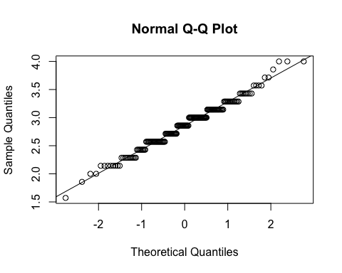

shapiro.test(thesis_data$bis) #met normality

##   
## Shapiro-Wilk normality test  
##   
## data: thesis_data$bis  
## W = 0.98488, p-value = 0.05538

#Visualizing BIS data by Study, boxplot and histogram  
ggplot(thesis_data, aes(x=Study, y=bis)) +   
geom_boxplot() +  
geom_jitter(height = NULL) #jitters add all the data points

## Warning: Removed 4 rows containing non-finite outside the scale range  
## (`stat_boxplot()`).

## Warning: Removed 4 rows containing missing values or values outside the scale range  
## (`geom_point()`).

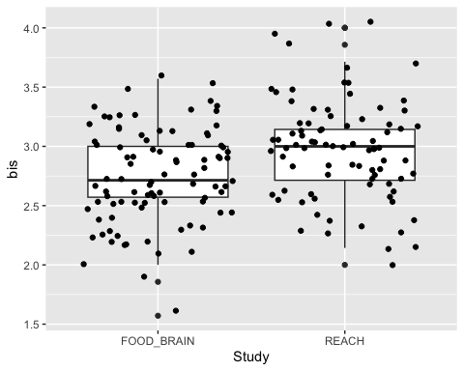

ggplot(thesis_data,aes(bis))+geom_histogram(bins=15)+facet_grid(.~Study)

## Warning: Removed 4 rows containing non-finite outside the scale range  
## (`stat_bin()`).

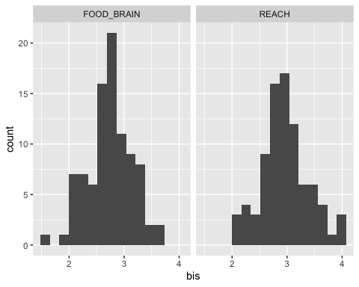

# For variable BAS  
qqnorm(thesis_data$bas)  
qqline(thesis_data$bas)

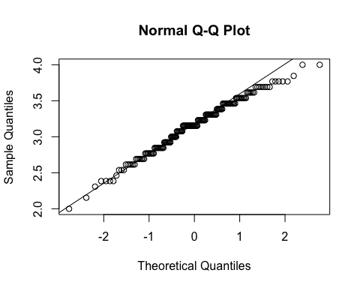

shapiro.test(thesis_data$bas) #met normality

##   
## Shapiro-Wilk normality test  
##   
## data: thesis_data$bas  
## W = 0.986, p-value = 0.07642

#Visualizing BAS data by Study, boxplot and histogram  
ggplot(thesis_data, aes(x=Study, y=bas)) +   
geom_boxplot() +  
geom_jitter(height = NULL)

## Warning: Removed 3 rows containing non-finite outside the scale range  
## (`stat_boxplot()`).

## Warning: Removed 3 rows containing missing values or values outside the scale range  
## (`geom_point()`).

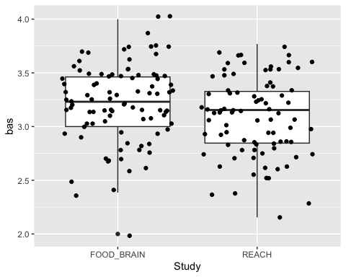

ggplot(thesis_data,aes(bas))+geom_histogram(bins=15)+facet_grid(.~Study)

## Warning: Removed 3 rows containing non-finite outside the scale range  
## (`stat_bin()`).

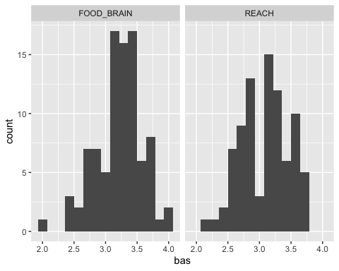

# For variable BAS funseeking  
qqnorm(thesis_data$bas_funseeking)  
qqline(thesis_data$bas_funseeking)

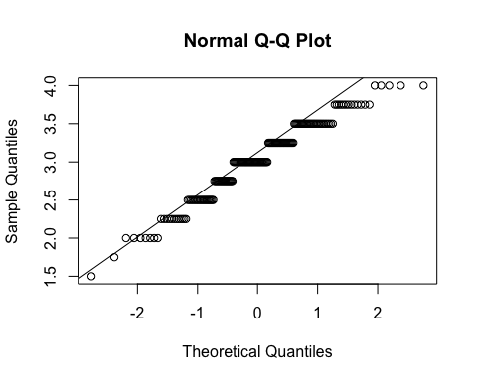

shapiro.test(thesis_data$bas_funseeking) #not normal

##   
## Shapiro-Wilk normality test  
##   
## data: thesis_data$bas_funseeking  
## W = 0.96485, p-value = 0.0002044

#Visualizing BAS funseeking data by Study, boxplot and histogram  
ggplot(thesis_data, aes(x=Study, y=bas_funseeking)) + geom_boxplot() + geom_jitter(height = NULL)

## Warning: Removed 3 rows containing non-finite outside the scale range  
## (`stat_boxplot()`).  
## Removed 3 rows containing missing values or values outside the scale range  
## (`geom_point()`).

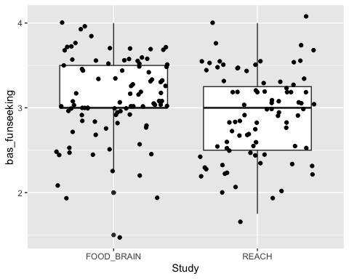

ggplot(thesis_data,aes(bas_funseeking))+geom_histogram(bins=15)+facet_grid(.~Study)

## Warning: Removed 3 rows containing non-finite outside the scale range  
## (`stat_bin()`).

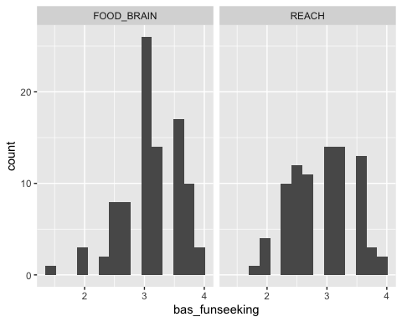

# For variable BAS drive  
qqnorm(thesis_data$bas_drive)  
qqline(thesis_data$bas_drive)

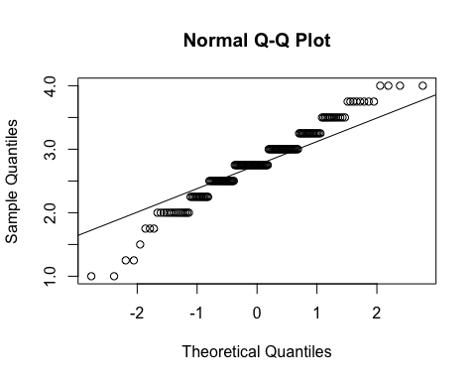

shapiro.test(thesis_data$bas_drive) #not normal

##   
## Shapiro-Wilk normality test  
##   
## data: thesis_data$bas_drive  
## W = 0.9687, p-value = 0.0005395

#Visualizing BAS drive data by Study, boxplot and histogram  
ggplot(thesis_data, aes(x=Study, y=bas_drive)) + geom_boxplot() + geom_jitter(height = NULL)

## Warning: Removed 3 rows containing non-finite outside the scale range  
## (`stat_boxplot()`).  
## Removed 3 rows containing missing values or values outside the scale range  
## (`geom_point()`).

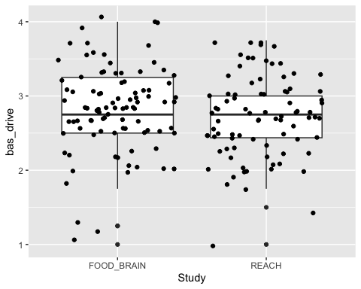

ggplot(thesis_data,aes(bas_drive))+geom_histogram(bins=15)+facet_grid(.~Study)

## Warning: Removed 3 rows containing non-finite outside the scale range  
## (`stat_bin()`).

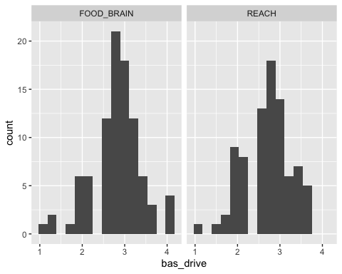

# For variable BAS reward responsive  
qqnorm(thesis_data$bas_rewardresp)  
qqline(thesis_data$bas_rewardresp)

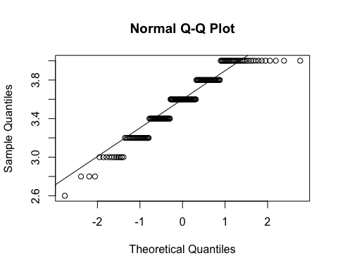

shapiro.test(thesis_data$bas_rewardresp) #not normal

##   
## Shapiro-Wilk normality test  
##   
## data: thesis_data$bas_rewardresp  
## W = 0.92994, p-value = 1.603e-07

#Visualizing BAS reward responsive data by Study, boxplot and histogram  
ggplot(thesis_data, aes(x=Study, y=bas_rewardresp)) + geom_boxplot() + geom_jitter(height = NULL)

## Warning: Removed 3 rows containing non-finite outside the scale range  
## (`stat_boxplot()`).  
## Removed 3 rows containing missing values or values outside the scale range  
## (`geom_point()`).

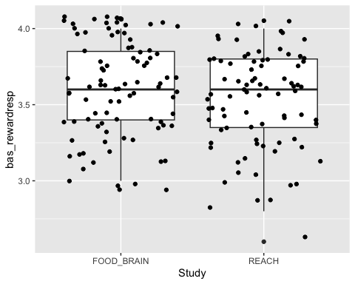

ggplot(thesis_data,aes(bas_rewardresp))+geom_histogram(bins=15)+facet_grid(.~Study)

## Warning: Removed 3 rows containing non-finite outside the scale range  
## (`stat_bin()`).

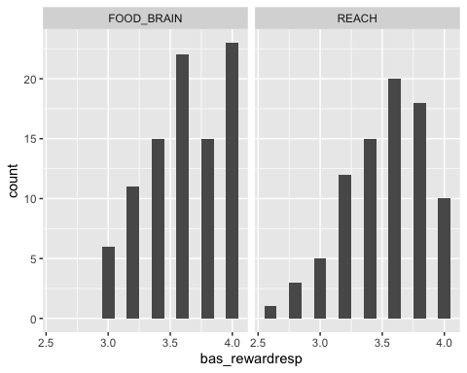

# For variable Meal consumed in grams  
qqnorm(thesis_data$meal_grams_consumed)  
qqline(thesis_data$meal_grams_consumed)

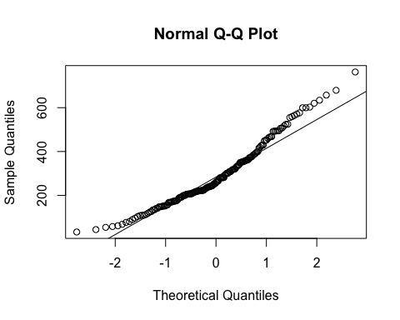

shapiro.test(thesis_data$meal_grams_consumed) #not normal

##   
## Shapiro-Wilk normality test  
##   
## data: thesis_data$meal_grams_consumed  
## W = 0.95722, p-value = 3.579e-05

#Visualizing Meal consumed in grams data by Study, boxplot and histogram  
ggplot(thesis_data, aes(x=Study, y=meal_grams_consumed)) + geom_boxplot() + geom_jitter(height = NULL)

## Warning: Removed 4 rows containing non-finite outside the scale range  
## (`stat_boxplot()`).

## Warning: Removed 4 rows containing missing values or values outside the scale range  
## (`geom_point()`).

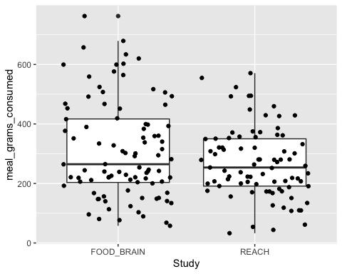

ggplot(thesis_data,aes(meal_grams_consumed))+geom_histogram(bins=15)+facet_grid(.~Study)

## Warning: Removed 4 rows containing non-finite outside the scale range  
## (`stat_bin()`).

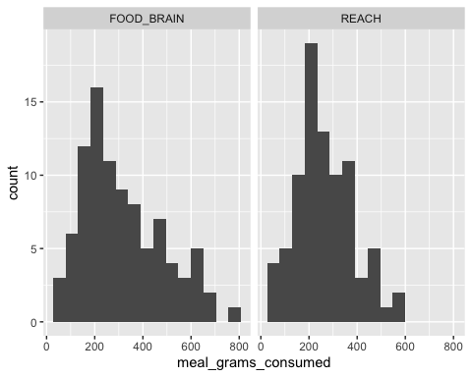

# For variable Meal consumed in kcal  
qqnorm(thesis_data$meal_kcal_consumed)  
qqline(thesis_data$meal_kcal_consumed)

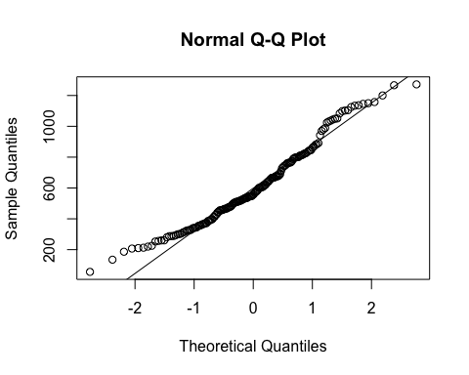

shapiro.test(thesis_data$meal_kcal_consumed) #not normal

##   
## Shapiro-Wilk normality test  
##   
## data: thesis_data$meal_kcal_consumed  
## W = 0.96846, p-value = 0.0005531

#Visualizing Meal consumed in kcal data by Study, boxplot and histogram  
ggplot(thesis_data, aes(x=Study, y=meal_kcal_consumed)) + geom_boxplot() + geom_jitter(height = NULL)

## Warning: Removed 5 rows containing non-finite outside the scale range  
## (`stat_boxplot()`).

## Warning: Removed 5 rows containing missing values or values outside the scale range  
## (`geom_point()`).

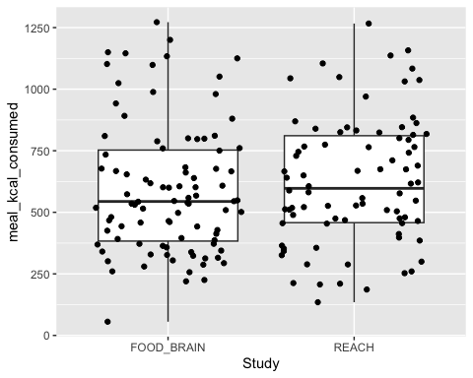

ggplot(thesis_data,aes(meal_kcal_consumed))+geom_histogram(bins=15)+facet_grid(.~Study)

## Warning: Removed 5 rows containing non-finite outside the scale range  
## (`stat_bin()`).

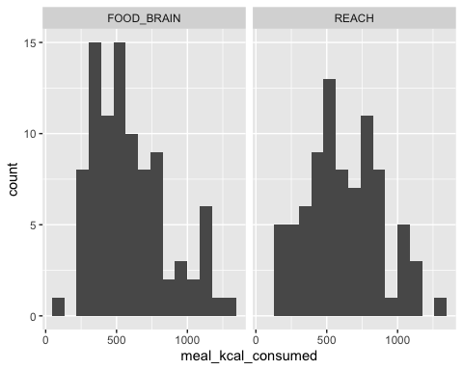

# For variable EAH consumed in grams  
qqnorm(thesis_data$eah_grams_consumed_foodonly)  
qqline(thesis_data$eah_grams_consumed_foodonly)

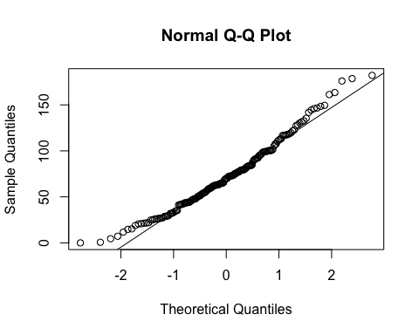

shapiro.test(thesis_data$eah_grams_consumed_foodonly) #not normal

##   
## Shapiro-Wilk normality test  
##   
## data: thesis_data$eah_grams_consumed_foodonly  
## W = 0.97611, p-value = 0.003732

#Visualizing EAH consumed in grams data by Study, boxplot and histogram  
ggplot(thesis_data, aes(x=Study, y=eah_grams_consumed_foodonly)) + geom_boxplot() + geom_jitter(height = NULL)

## Warning: Removed 1 row containing non-finite outside the scale range  
## (`stat_boxplot()`).

## Warning: Removed 1 row containing missing values or values outside the scale range  
## (`geom_point()`).

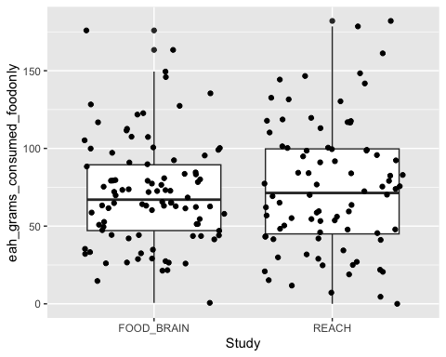

ggplot(thesis_data,aes(eah_grams_consumed_foodonly))+geom_histogram(bins=15)+facet_grid(.~Study)

## Warning: Removed 1 row containing non-finite outside the scale range  
## (`stat_bin()`).

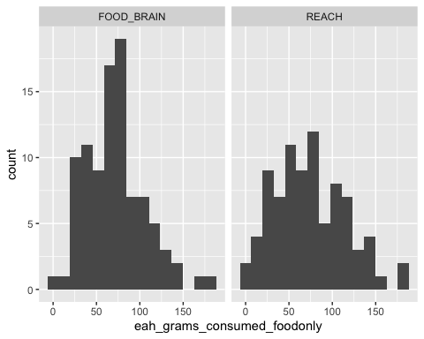

# For variable EAH consumed in kcal  
qqnorm(thesis_data$eah_kcal_consumed)  
qqline(thesis_data$eah_kcal_consumed)

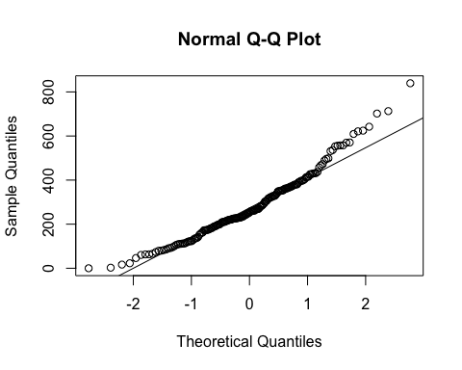

shapiro.test(thesis_data$eah_kcal_consumed) #not normal

##   
## Shapiro-Wilk normality test  
##   
## data: thesis_data$eah_kcal_consumed  
## W = 0.96228, p-value = 9.95e-05

#Visualizing EAH consumed in kcal data by Study, boxplot and histogram  
ggplot(thesis_data, aes(x=Study, y=eah_kcal_consumed)) + geom_boxplot() + geom_jitter(height = NULL)

## Warning: Removed 1 row containing non-finite outside the scale range (`stat_boxplot()`).  
## Removed 1 row containing missing values or values outside the scale range  
## (`geom_point()`).

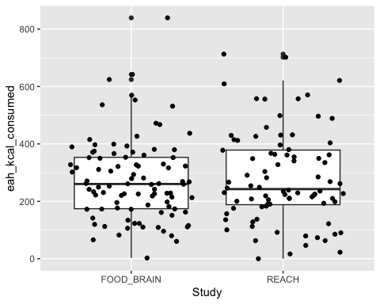

ggplot(thesis_data,aes(eah_kcal_consumed))+geom_histogram(bins=15)+facet_grid(.~Study)

## Warning: Removed 1 row containing non-finite outside the scale range  
## (`stat_bin()`).

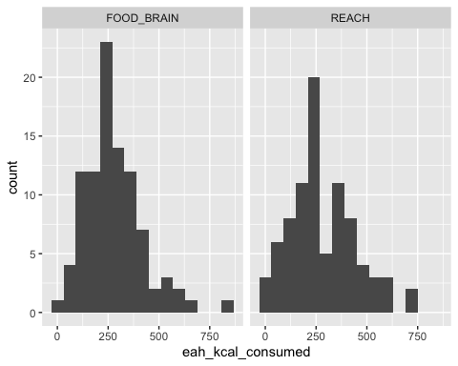

While some of the variables didn’t pass the shapiro normality test but after looking at the qqplots of these variables we can consider them as normal.

3.Corrplots

library(corrplot)

## corrplot 0.95 loaded

cor_all <- cor(thesis_data[c("bis", "bas","bas_funseeking","bas_drive", "bas_rewardresp", "pre_eah_fullness", "meal_grams_consumed","meal_kcal_consumed","eah_kcal_consumed", "eah_grams_consumed_foodonly")], use = "pairwise.complete.obs")  
  
cor_reach <- cor(thesis_data[thesis_data$Study == "REACH", c("bis", "bas","bas_funseeking","bas_drive", "bas_rewardresp", "pre_eah_fullness", "meal_grams_consumed","meal_kcal_consumed","eah_kcal_consumed", "eah_grams_consumed_foodonly")], use = "pairwise.complete.obs")  
  
cor_fb <- cor(thesis_data[thesis_data$Study == "FOOD_BRAIN", c("bis", "bas","bas_funseeking","bas_drive", "bas_rewardresp", "pre_eah_fullness", "meal_grams_consumed","meal_kcal_consumed","eah_kcal_consumed", "eah_grams_consumed_foodonly")], use = "pairwise.complete.obs")  
  
  
corrplot(cor_all, type = "upper", order = "hclust",   
 tl.col = "black", tl.srt = 45)

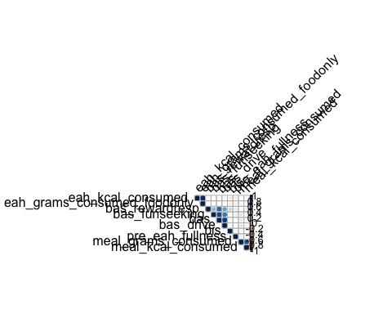

corrplot(cor_reach, type = "upper", order = "hclust",   
 tl.col = "black", tl.srt = 45)

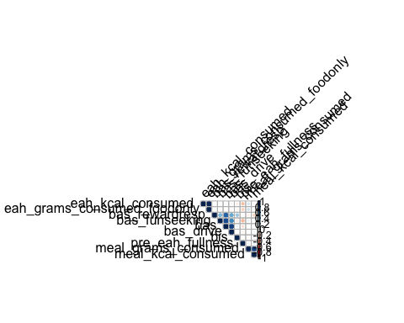

corrplot(cor_fb, type = "upper", order = "hclust",   
 tl.col = "black", tl.srt = 45)

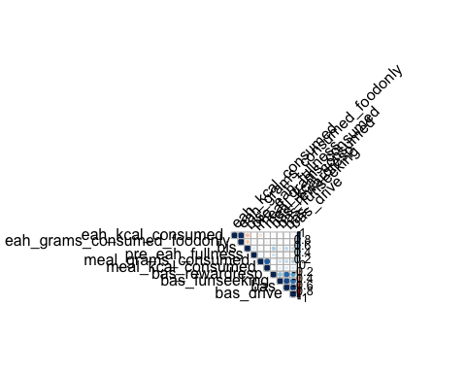

# 1. Relationship between BIS and EAH  
  
## BIS is not associated with EAH gram intake  
cor.test(thesis_data$bis, thesis_data$eah_grams_consumed_foodonly, use = "pairwise.complete.obs")

##   
## Pearson's product-moment correlation  
##   
## data: thesis_data$bis and thesis_data$eah_grams_consumed_foodonly  
## t = -1.4532, df = 172, p-value = 0.148  
## alternative hypothesis: true correlation is not equal to 0  
## 95 percent confidence interval:  
## -0.25472716 0.03928264  
## sample estimates:  
## cor   
## -0.1101308

## BIS is associated with EAH kcal intake  
cor.test(thesis_data$bis, thesis_data$eah_kcal_consumed, use = "pairwise.complete.obs")

##   
## Pearson's product-moment correlation  
##   
## data: thesis_data$bis and thesis_data$eah_kcal_consumed  
## t = -2.0264, df = 172, p-value = 0.04427  
## alternative hypothesis: true correlation is not equal to 0  
## 95 percent confidence interval:  
## -0.294774354 -0.004022544  
## sample estimates:  
## cor   
## -0.152701

#2. Relationship between BAS and EAH  
  
## BAS is not associated with EAH gram intake   
cor.test(thesis_data$bis, thesis_data$eah_grams_consumed_foodonly, use = "pairwise.complete.obs")

##   
## Pearson's product-moment correlation  
##   
## data: thesis_data$bis and thesis_data$eah_grams_consumed_foodonly  
## t = -1.4532, df = 172, p-value = 0.148  
## alternative hypothesis: true correlation is not equal to 0  
## 95 percent confidence interval:  
## -0.25472716 0.03928264  
## sample estimates:  
## cor   
## -0.1101308

## BAS is not associated with EAH kcal intake  
cor.test(thesis_data$bas, thesis_data$eah_kcal_consumed, use = "pairwise.complete.obs")

##   
## Pearson's product-moment correlation  
##   
## data: thesis_data$bas and thesis_data$eah_kcal_consumed  
## t = -0.34611, df = 173, p-value = 0.7297  
## alternative hypothesis: true correlation is not equal to 0  
## 95 percent confidence interval:  
## -0.1739694 0.1225161  
## sample estimates:  
## cor   
## -0.02630509

#3. Relationship between BAS funseeking and EAH  
  
## BAS funseeking is not associated with EAH gram intake   
cor.test(thesis_data$bas_funseeking, thesis_data$eah_grams_consumed_foodonly, use = "pairwise.complete.obs")

##   
## Pearson's product-moment correlation  
##   
## data: thesis_data$bas_funseeking and thesis_data$eah_grams_consumed_foodonly  
## t = -0.18597, df = 173, p-value = 0.8527  
## alternative hypothesis: true correlation is not equal to 0  
## 95 percent confidence interval:  
## -0.1621409 0.1344873  
## sample estimates:  
## cor   
## -0.01413783

## BAS funseeking is not associated with EAH kcal intake  
cor.test(thesis_data$bas_funseeking, thesis_data$eah_kcal_consumed, use = "pairwise.complete.obs")

##   
## Pearson's product-moment correlation  
##   
## data: thesis_data$bas_funseeking and thesis_data$eah_kcal_consumed  
## t = -0.34928, df = 173, p-value = 0.7273  
## alternative hypothesis: true correlation is not equal to 0  
## 95 percent confidence interval:  
## -0.1742029 0.1222788  
## sample estimates:  
## cor   
## -0.0265458

#4. Relationship between BAS drive and EAH  
  
## BAS drive is not associated with EAH gram intake  
cor.test(thesis_data$bas_drive,thesis_data$eah_grams_consumed_foodonly, use = "pairwise.complete.obs")

##   
## Pearson's product-moment correlation  
##   
## data: thesis_data$bas_drive and thesis_data$eah_grams_consumed_foodonly  
## t = -0.23044, df = 173, p-value = 0.818  
## alternative hypothesis: true correlation is not equal to 0  
## 95 percent confidence interval:  
## -0.1654303 0.1311669  
## sample estimates:  
## cor   
## -0.01751707

## BAS drive is not associated with EAH kcal intake  
cor.test(thesis_data$bas_drive, thesis_data$eah_kcal_consumed, use = "pairwise.complete.obs")

##   
## Pearson's product-moment correlation  
##   
## data: thesis_data$bas_drive and thesis_data$eah_kcal_consumed  
## t = -0.58045, df = 173, p-value = 0.5624  
## alternative hypothesis: true correlation is not equal to 0  
## 95 percent confidence interval:  
## -0.1911803 0.1049419  
## sample estimates:  
## cor   
## -0.04408754

#5. Relationship between BAS reward responsive and EAH  
  
## BAS reward responsive is not associated with EAH gram intake   
cor.test(thesis_data$bas_rewardresp, thesis_data$eah_grams_consumed_foodonly, use = "pairwise.complete.obs")

##   
## Pearson's product-moment correlation  
##   
## data: thesis_data$bas_rewardresp and thesis_data$eah_grams_consumed_foodonly  
## t = 0.47405, df = 173, p-value = 0.6361  
## alternative hypothesis: true correlation is not equal to 0  
## 95 percent confidence interval:  
## -0.1129282 0.1833816  
## sample estimates:  
## cor   
## 0.03601829

## BAS reward responsive is not associated with EAH kcal intake  
cor.test(thesis_data$bas_rewardresp, thesis_data$eah_kcal_consumed, use = "pairwise.complete.obs")

##   
## Pearson's product-moment correlation  
##   
## data: thesis_data$bas_rewardresp and thesis_data$eah_kcal_consumed  
## t = 0.2106, df = 173, p-value = 0.8334  
## alternative hypothesis: true correlation is not equal to 0  
## 95 percent confidence interval:  
## -0.1326488 0.1639631  
## sample estimates:  
## cor   
## 0.01600938

Based on the correlations and corr plots we can see that bis is negativley related with eah_kcal_consumed

1. Conducting levene’s test on bis and eah_kcal_consumed by Study and then t-test on bis and eah_kcal_consumed to see if there is study effect.

library(car)

## Loading required package: carData

##   
## Attaching package: 'car'

## The following object is masked from 'package:dplyr':  
##   
## recode

#For bis  
leveneTest(  
bis~as.factor(Study), data=thesis_data)

## Levene's Test for Homogeneity of Variance (center = median)  
## Df F value Pr(>F)  
## group 1 0.0027 0.9584  
## 173

#For eah_kcal_consumed  
leveneTest(  
eah_kcal_consumed~as.factor(Study), data=thesis_data)

## Levene's Test for Homogeneity of Variance (center = median)  
## Df F value Pr(>F)  
## group 1 1.5361 0.2169  
## 176

#Assumptions for homegenity in variances are met  
  
#Conducting indepedent t-test on bis to see study effect  
t.test(thesis_data[thesis_data$Study == "REACH",]$bis, thesis_data[thesis_data$Study == "FOOD_BRAIN",]$bis, alternative = "two.sided", var.equal = TRUE)

##   
## Two Sample t-test  
##   
## data: thesis_data[thesis_data$Study == "REACH", ]$bis and thesis_data[thesis_data$Study == "FOOD_BRAIN", ]$bis  
## t = 3.6665, df = 173, p-value = 0.000327  
## alternative hypothesis: true difference in means is not equal to 0  
## 95 percent confidence interval:  
## 0.1057088 0.3522326  
## sample estimates:  
## mean of x mean of y   
## 2.97619 2.74722

#Conducting indepedent t-test on bis to see study effect  
t.test(thesis_data[thesis_data$Study == "REACH",]$eah_kcal_consumed, thesis_data[thesis_data$Study == "FOOD_BRAIN",]$eah_kcal_consumed, alternative = "two.sided", var.equal = TRUE)

##   
## Two Sample t-test  
##   
## data: thesis_data[thesis_data$Study == "REACH", ]$eah_kcal_consumed and thesis_data[thesis_data$Study == "FOOD_BRAIN", ]$eah_kcal_consumed  
## t = 0.23976, df = 176, p-value = 0.8108  
## alternative hypothesis: true difference in means is not equal to 0  
## 95 percent confidence interval:  
## -39.40483 50.30346  
## sample estimates:  
## mean of x mean of y   
## 282.5406 277.0913

#Visualizing   
ggplot(thesis_data, aes(x=Study, y=bis)) +   
geom_boxplot() +  
geom_jitter(height = NULL)

## Warning: Removed 4 rows containing non-finite outside the scale range  
## (`stat_boxplot()`).

## Warning: Removed 4 rows containing missing values or values outside the scale range  
## (`geom_point()`).

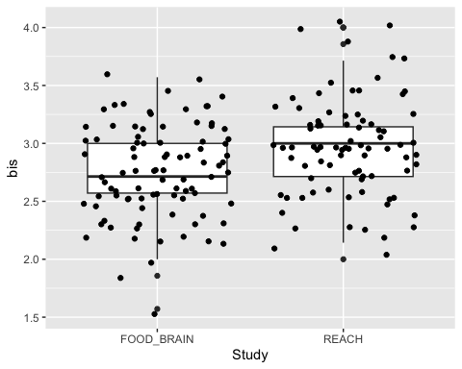

ggplot(thesis_data, aes(x=Study, y=eah_kcal_consumed)) +   
 geom_boxplot() +   
 geom_jitter(height = NULL)

## Warning: Removed 1 row containing non-finite outside the scale range  
## (`stat_boxplot()`).

## Warning: Removed 1 row containing missing values or values outside the scale range  
## (`geom_point()`).

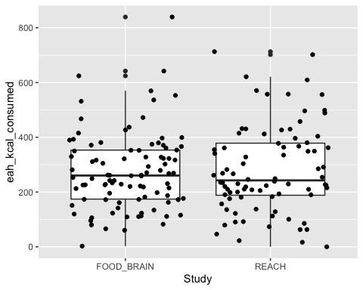

thesis_data$Age.in.years

## [1] 8.30 9.60 9.80 7.30 8.50 8.80 8.10 8.00 7.60 9.40 7.70 7.60 7.80 7.30 9.60  
## [16] 9.10 8.20 8.80 8.50 8.40 9.20 7.40 9.70 8.20 7.70 8.70 8.10 7.60 8.80 7.70  
## [31] 9.90 8.50 8.90 9.50 7.50 7.30 8.00 8.40 8.60 7.20 8.80 8.80 7.70 7.70 NA  
## [46] 9.30 7.70 7.80 9.80 7.10 7.30 8.20 7.70 8.00 7.60 8.70 8.10 8.30 7.20 9.20  
## [61] 9.60 9.50 7.20 9.40 8.20 7.30 8.60 8.80 8.80 9.90 7.30 8.30 8.00 8.40 7.20  
## [76] 9.20 8.90 7.40 7.80 8.50 9.20 7.10 9.80 7.70 8.84 7.46 7.07 7.38 7.82 7.03  
## [91] 8.65 7.18 7.68 7.00 7.48 8.22 7.67 7.39 7.18 7.77 8.81 7.68 7.79 8.32 7.25  
## [106] 7.26 8.12 7.47 7.06 7.22 7.25 8.66 8.99 7.40 7.36 7.47 7.53 7.02 8.81 8.48  
## [121] 8.14 7.34 7.86 8.92 8.26 7.79 8.47 8.33 7.05 8.91 7.17 8.24 7.33 7.41 7.24  
## [136] 7.86 8.30 8.50 7.53 7.73 7.97 8.50 8.41 8.41 8.58 8.32 7.86 7.23 7.17 8.44  
## [151] 8.71 8.61 7.44 8.51 8.07 7.33 7.26 7.33 7.42 7.80 8.44 8.63 7.36 8.51 7.84  
## [166] 7.14 8.30 8.79 8.91 7.25 7.99 8.16 7.22 7.03 7.93 7.04 7.51 8.96 7.58

Based on these results, BIS scores are higher in REACH study and EAH consumption in kcal was similar in both the studies.

1. Linear regressions predicting EAH with covariates [sex + child bmi + age in years+ pre eah fullness, income] (no interactions) – no effects

model1 <- lm(eah_kcal_consumed ~ bis + Sex + Age.in.years + Child.BMI + Income + pre_eah_fullness, data = thesis_data)  
summary(model1)

##   
## Call:  
## lm(formula = eah_kcal_consumed ~ bis + Sex + Age.in.years + Child.BMI +   
## Income + pre_eah_fullness, data = thesis_data)  
##   
## Residuals:  
## Min 1Q Median 3Q Max   
## -323.69 -104.78 -21.01 86.86 510.66   
##   
## Coefficients:  
## Estimate Std. Error t value Pr(>|t|)   
## (Intercept) -45.4120 202.0066 -0.225 0.8224   
## bis -59.3086 28.3446 -2.092 0.0380 *  
## SexMale 23.8666 23.8026 1.003 0.3175   
## Age.in.years 38.7347 17.2203 2.249 0.0259 *  
## Child.BMI 7.4366 8.2491 0.902 0.3687   
## Income>$100,000 110.8061 108.2938 1.023 0.3078   
## Income$20,000-$35,000 99.4185 125.0848 0.795 0.4279   
## Income$36,000-$50,000 162.0122 115.3090 1.405 0.1620   
## Income$51,000-$75,000 110.9349 110.5712 1.003 0.3172   
## Income$76,000-$100,000 90.7284 109.3554 0.830 0.4080   
## pre_eah_fullness -0.6637 0.3435 -1.932 0.0551 .  
## ---  
## Signif. codes: 0 '***' 0.001 '**' 0.01 '*' 0.05 '.' 0.1 ' ' 1  
##   
## Residual standard error: 149.8 on 159 degrees of freedom  
## (9 observations deleted due to missingness)  
## Multiple R-squared: 0.1077, Adjusted R-squared: 0.0516   
## F-statistic: 1.919 on 10 and 159 DF, p-value: 0.04608

Based on the summary of the model of this multiple regression model we can see that higher BIS scores predicts a lower food intake in kcal ( B=-60, p=0.04) in EAH paradigm.

**AIM 2: Does maternal risk status moderates the relationship between BIS, BAS and EAH**

#Conducting 2 way ANOVA to see the effect of maternal risk status on EAH in kcal across both the studies  
  
thesis_data$Maternal.risk.status <- as.factor(thesis_data$Maternal.risk.status)  
thesis_data$Study <- as.factor(thesis_data$Study)  
  
anova_model <- aov(eah_kcal_consumed ~ Maternal.risk.status * Study, data = thesis_data)  
summary(anova_model)

## Df Sum Sq Mean Sq F value Pr(>F)  
## Maternal.risk.status 1 702 702 0.030 0.862  
## Study 1 530 530 0.023 0.880  
## Maternal.risk.status:Study 1 655 655 0.028 0.867  
## Residuals 173 4009072 23174   
## 2 observations deleted due to missingness

#Visualization  
maternal_data <- thesis_data %>% filter(!is.na(Study), !is.na(Maternal.risk.status))  
library(ggplot2)  
ggplot(maternal_data, aes(x = Study, y = eah_kcal_consumed, fill = Maternal.risk.status)) +  
 geom_boxplot() +  
 labs(title = "Effect of Maternal Risk Status on EAH Intake Across Studies",  
 x = "Study",  
 y = "EAH Intake (grams)",  
 fill = "Maternal Risk Status")

## Warning: Removed 1 row containing non-finite outside the scale range  
## (`stat_boxplot()`).

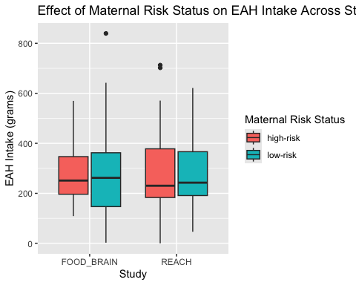

There wasn’t any main effect of maternal risk status ( p=0.87) and study(p=0.89) on EAH intake. Moreover, there wasn’t any interaction effect between maternal risk status and study on EAH intake (p=0.87). Hence we can conclude that effect of maternal risk status on EAH paradigm was consistent in both the studies.

#Conducting moderation analysis adjusting for covariates  
lm_eah_kcal_risk <- lm(eah_kcal_consumed ~ bis*Maternal.risk.status + pre_eah_fullness + Study + Child.BMI + Age.in.years + Sex + Income, data = thesis_data)  
  
summary(lm_eah_kcal_risk)

##   
## Call:  
## lm(formula = eah_kcal_consumed ~ bis * Maternal.risk.status +   
## pre_eah_fullness + Study + Child.BMI + Age.in.years + Sex +   
## Income, data = thesis_data)  
##   
## Residuals:  
## Min 1Q Median 3Q Max   
## -324.31 -93.64 -22.07 79.93 464.74   
##   
## Coefficients:  
## Estimate Std. Error t value Pr(>|t|)   
## (Intercept) -185.0340 222.3309 -0.832 0.4066   
## bis 5.2541 39.8523 0.132 0.8953   
## Maternal.risk.statuslow-risk 362.4266 158.3605 2.289 0.0235 *  
## pre_eah_fullness -0.7023 0.3444 -2.039 0.0431 *  
## StudyREACH -9.8158 25.7839 -0.381 0.7040   
## Child.BMI 6.6367 8.5817 0.773 0.4405   
## Age.in.years 41.6538 17.7052 2.353 0.0199 *  
## SexMale 26.8206 23.7586 1.129 0.2607   
## Income>$100,000 66.6211 109.1398 0.610 0.5425   
## Income$20,000-$35,000 46.2477 125.7886 0.368 0.7136   
## Income$36,000-$50,000 102.8750 116.4163 0.884 0.3782   
## Income$51,000-$75,000 62.6119 111.2272 0.563 0.5743   
## Income$76,000-$100,000 40.9441 110.2610 0.371 0.7109   
## bis:Maternal.risk.statuslow-risk -131.0926 54.3772 -2.411 0.0171 *  
## ---  
## Signif. codes: 0 '***' 0.001 '**' 0.01 '*' 0.05 '.' 0.1 ' ' 1  
##   
## Residual standard error: 148.3 on 155 degrees of freedom  
## (10 observations deleted due to missingness)  
## Multiple R-squared: 0.1424, Adjusted R-squared: 0.07048   
## F-statistic: 1.98 on 13 and 155 DF, p-value: 0.02573

After adjusting for sex, child age, child bmi, parent income, Pre EAH fullness scores and study, we conducted moderation analysis. The results revealed a significant interaction between BIS_total and maternal risk status but only for children with low-risk of obesity (B= -131.1, p=0.02), indicating that children at low risk for obesity, a 1 unit increase in BIS corresponds to 131 less kcal consumed during EAH , while children at high risk for obesity, the association between BIS and EAH is not significant.

Making plots

# remove rows with missing values for model variables -- will make it easier to save predicted values to model dataset  
MISSING <- is.na(thesis_data$eah_kcal_consumed) |  
 is.na(thesis_data$bis) |  
 is.na(thesis_data$pre_eah_fullness) |  
 is.na(thesis_data$Study) |  
 is.na(thesis_data$Child.BMI) |  
 is.na(thesis_data$Age.in.years) |   
 is.na(thesis_data$Sex) | is.na(thesis_data$Maternal.risk.status)  
  
thesis_data_no_na <- subset(thesis_data,   
 subset = !MISSING)  
  
#Visualizations  
# plot kcal (raw values)  
ggplot(thesis_data, aes(x = bis, y = eah_kcal_consumed, color = factor(Maternal.risk.status))) +  
 geom_point() +  
 geom_smooth(method = "lm", se = TRUE, aes(group = Maternal.risk.status)) +  
 labs(x = "bis", y = "eah_kcal_consumed", color = "Maternal.risk.status") + ylim(0, 900)

## `geom_smooth()` using formula = 'y ~ x'

## Warning: Removed 5 rows containing non-finite outside the scale range  
## (`stat_smooth()`).

## Warning: Removed 5 rows containing missing values or values outside the scale range  
## (`geom_point()`).

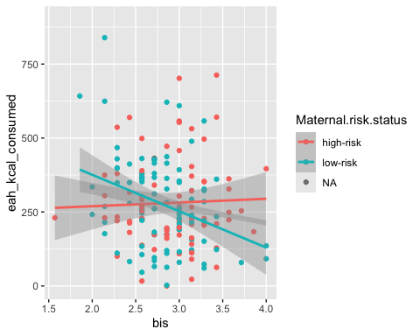

#3  
ggplot(thesis_data_no_na, aes(x = bis, y = eah_kcal_consumed, color = factor(Maternal.risk.status))) +  
 geom_point() +  
 geom_smooth(method = "lm", se = TRUE, aes(group = Maternal.risk.status)) +  
 labs(x = "bis", y = "eah_kcal_consumed (adjusted)", color = "Maternal.risk.status")

## `geom_smooth()` using formula = 'y ~ x'

