Character Sentiment → Neural Synchrony
Update for Hayoung — full rerun (July 2026)

What changed since we last met
I reran the whole pipeline end-to-end. It's deterministic (seeded), so the numbers below reproduce exactly. Three things are new:
- Step 1 was rebuilt. PCA now lives inside Step 1 with variance-explained per component and PC1 loadings (per your note), and every candidate target is carried in one file so switching the “headline” is a one-line change.
- The brain half now runs through Step 6. Jin's Figure 1 (distance) and Figure 2 (IS-RSA) are replicated, plus a same-cohort survey bridge and a group-level bridge.
- Two new notebooks test viewer “liking” → brain — the one analysis that actually shows an effect.
Headline
Shared character-affect sentiment (from the transcripts) does not drive shared brain activity — 04b finds 0 significant regions, and that test is underpowered anyway.
But shared liking (from the survey) does: 04c liking → 3 regions, 05 group-level liking → 1 region, where sentiment and PC1 find nothing.
The dissociation is interpretable precisely because Step 1 pinned down what the sentiment number is (character affect, not viewer attitude).

Your notes from last time — addressed
Everything highlighted in our last meeting doc, and where it landed:
Your note | Step | Status
“Variance per run, then averaged” | 0 | Done — variance computed per run then averaged
“Twitter-based models perform better / more emotionally representative” | 0, 1 | Confirmed — Twitter-RoBERTa wins (cv-R² 0.34); Twitter/transformer models cluster (agreement 0.84–0.90)
“PCA! explain variance per component; which traits load PC1; use to aggregate; sign-flip” | 1 | Done — PC1 = 43%, all-positive good-person axis; carried as a target; signs fixed
“Feel vs think about a character” | 1 | Addressed — PC2 = character-affect vs viewer-stance; PC3 = extraversion
“Replicate Jin Fig 1 & 2; skip aha button counts; interesting if different from Jin” | 3, 4 | Done — Fig 1 weak in ours (dissociation); Fig 2 gate validates
“Sentiment models distill something different” | 3, 4 | Done — sentiment dissociates from thought-content impressions
“Use delta CSVs: before/after movie-watching → brain” | 6 | Built; blocked on Jin's brain data (see blocker)
“If recreating brain figures is unclear, ask” | 4 | ASK HAYOUNG (blocker)
“Variance across characters and people helps understanding” | 0 | Done — variance-overview figure
“Extract sentiment from audio (CLAP)” | — | Parked (your “don't do now” side-quest)

Step 0 · Building the sentiment score
Eight classifiers score every reflection; valence = positive − negative. Per-model delta profiles (before vs after each run) are saved for Step 6.

Findings
- Where the variance lives (your note):
  - most of the signal moves within a person across runs, not across people. Across-character SD 0.22–0.26 vs across-participant SD 0.39–0.48 by group, and every model shows a within > between ratio of ~2.0–2.3. So the score is scene-driven — which is why we compute variance per run and then average.
- Models disagree (your “Twitter better” note):
  - the transformer/Twitter family agrees tightly — Twitter-RoBERTa ↔ BERTweet 0.90, ↔ RoBERTa-ZS 0.84 — while the lexicon models (VADER, NRC-VAD, Warriner) agree far less (0.30–0.53). Twitter-RoBERTa also wins the Step 1 contest, so we focus on it.

Within- vs between-person variance, by model
Model | Within SD | Between SD | Ratio
Twitter-RoBERTa | 0.461 | 0.211 | 2.19
RoBERTa-ZS | 0.713 | 0.317 | 2.25
SiEBERT | 0.867 | 0.383 | 2.26
Flair | 0.822 | 0.405 | 2.03
BERTweet | 0.544 | 0.261 | 2.08
VADER | 0.126 | 0.057 | 2.21
Warriner | 0.444 | 0.194 | 2.29
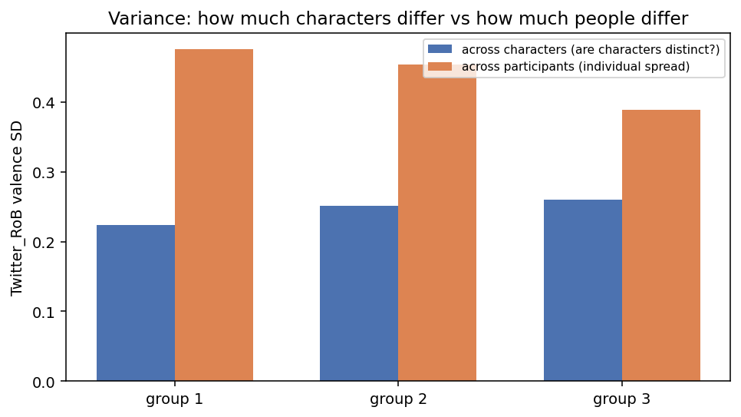
Figure 0a — variance across characters vs across participants, by group.
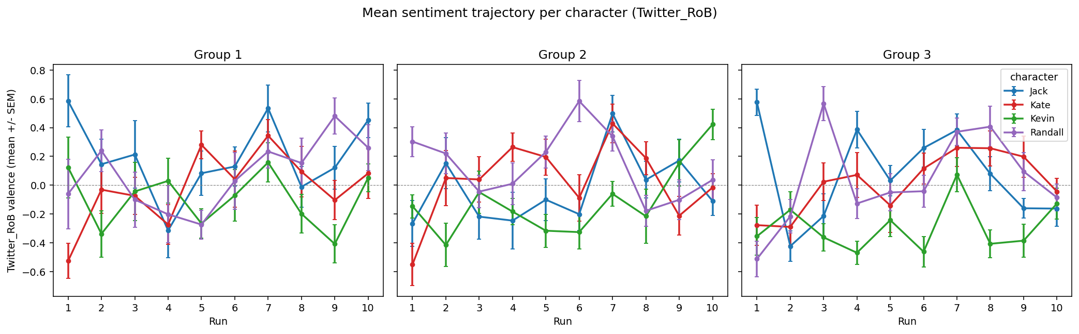
Figure 0b — mean sentiment trajectories with error bars.
Your note
“Variance per run then averaged” and “variance across characters/people helps understanding” — both are now the D1 figures above.

Step 1 · What the sentiment number actually measures (biggest update)

What's new here since last meeting
- PCA merged into Step 1 (§1.6b): explained variance per component plus loadings, with signs fixed so “+” always means more positive/agreement (your sign-flip note).
- One consolidated target file (01__targets.csv) carries every candidate — positive_emotion, like, affect_cluster, char_valence_composite, PC1 — so downstream steps just point at a column.
- Full model × target contest, a 16-item alignment scan, trait intercorrelation, and robustness were added.

Findings
- Model contest (honest leave-one-scramble-group-out cv-R² against the behavioral survey): Twitter-RoBERTa wins at 0.336.
- What the score tracks (item alignment): the affect items — positive emotion 0.34, emotionally stable 0.26, good relationship 0.25, warm 0.17 — while attitude/like is only 0.07 and extraverted/similar go negative. The score reads character affect, not viewer attitude.
- Best aggregate target:
  - an affect trio (positive-emotion + emotionally-stable + good-relationship) at 0.366 ≈ positive_emotion 0.336, both well above PC1 (0.19) and like (0.07).
- PCA:
  - PC1 = 43% of variance, an all-positive “good person” axis (loadings ~0.22–0.31 across warmth/trust/competence/affect; impulsive −0.11). PC2 = 11%, a character-affect vs viewer-stance contrast (positive_emotion −0.35, rational −0.32 vs like +0.27, empathize +0.33, understand +0.27, similar +0.35) — this is your feel-vs-think axis. PC3 = 7.5% (extraverted 0.73, impulsive 0.40).

Model contest — cv-R² across candidate targets
Model | positive_emotion | PC1 | affect_cluster
Twitter-RoBERTa | 0.336 | 0.190 | 0.366
RoBERTa-ZS | 0.255 | 0.097 | 0.284
BERTweet | 0.248 | 0.121 | 0.284
VADER | 0.191 | −0.002 | 0.210
Warriner | 0.132 | 0.033 | 0.159
Flair | 0.088 | 0.110 | 0.157
SiEBERT | 0.012 | 0.034 | 0.063
NRC-VAD | −0.026 | −0.095 | −0.009

Aggregate-target sweep (Twitter-RoBERTa, cv-R²)
Candidate target | cv-R²
affect trio (posE + emo-stable + good-rel) | 0.366
affect pair (posE + emo-stable) | 0.349
positive emotion (single) | 0.336
character statements (3) | 0.324
character bundle (all 12) | 0.206
PC1 (PCA aggregate) | 0.190
competence (compet+intel+rational) | 0.177
warmth (warm+agreeable+trust) | 0.114
like (single, attitude) | 0.070
stance / last-section (original plan) | −0.021
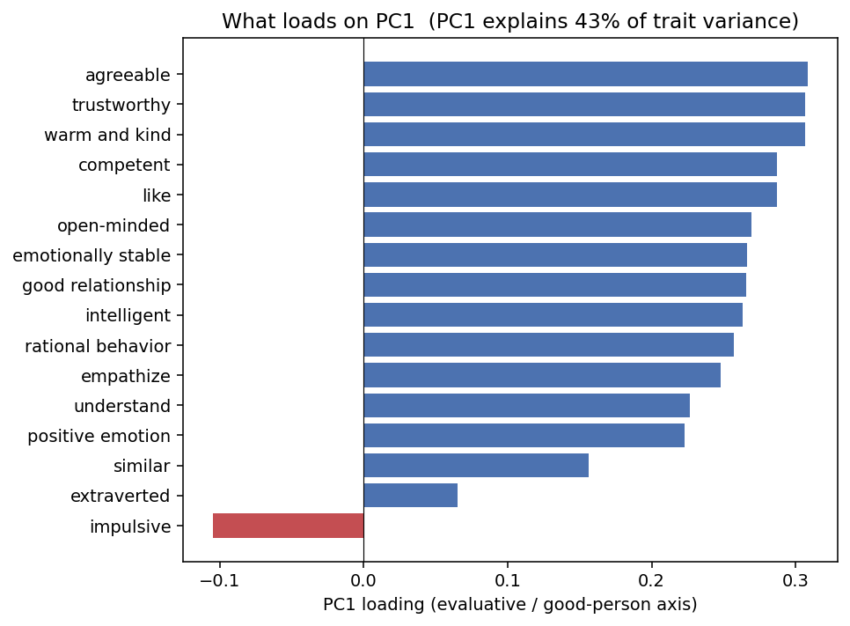
Figure 1a — PC1 loadings: an all-positive “good person” axis (43% of variance).
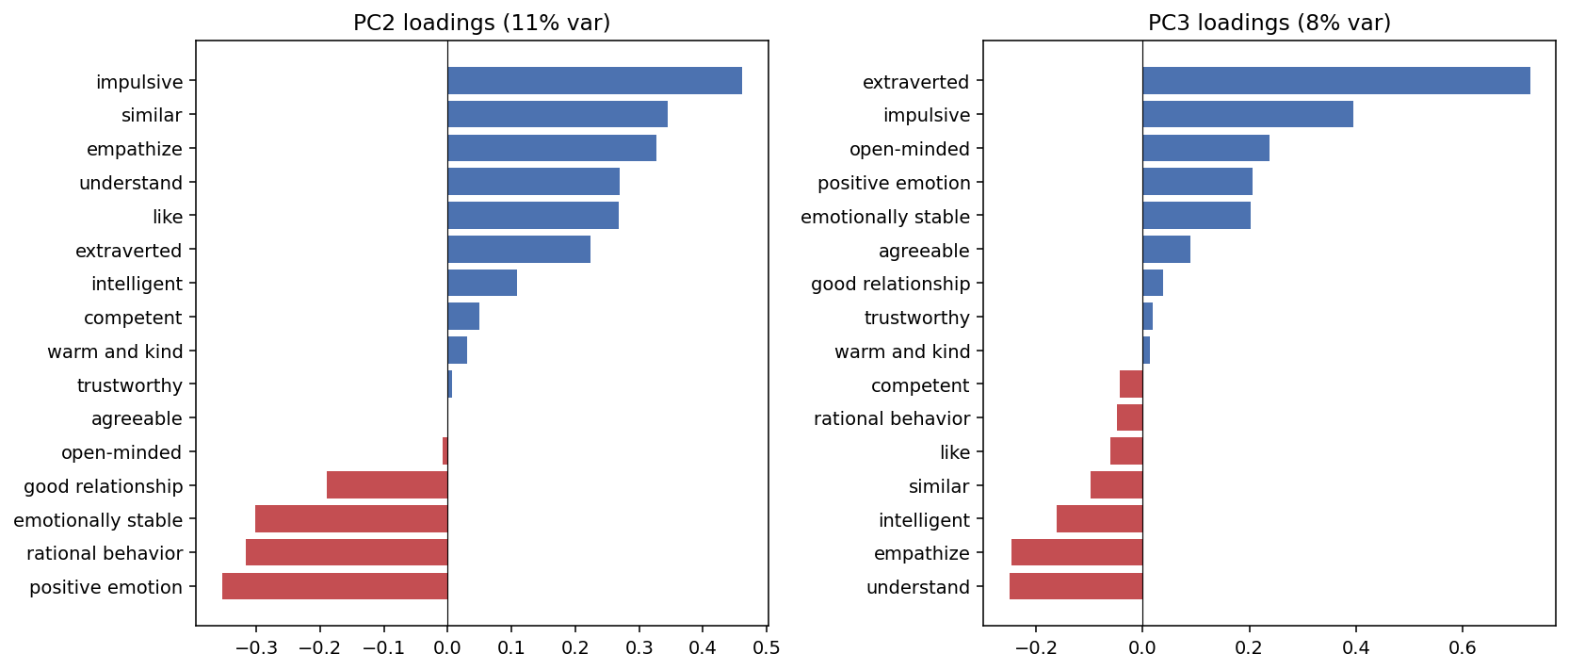
Figure 1b — PC2 (character-affect vs viewer-stance = your feel/think axis) and PC3 (extraversion).
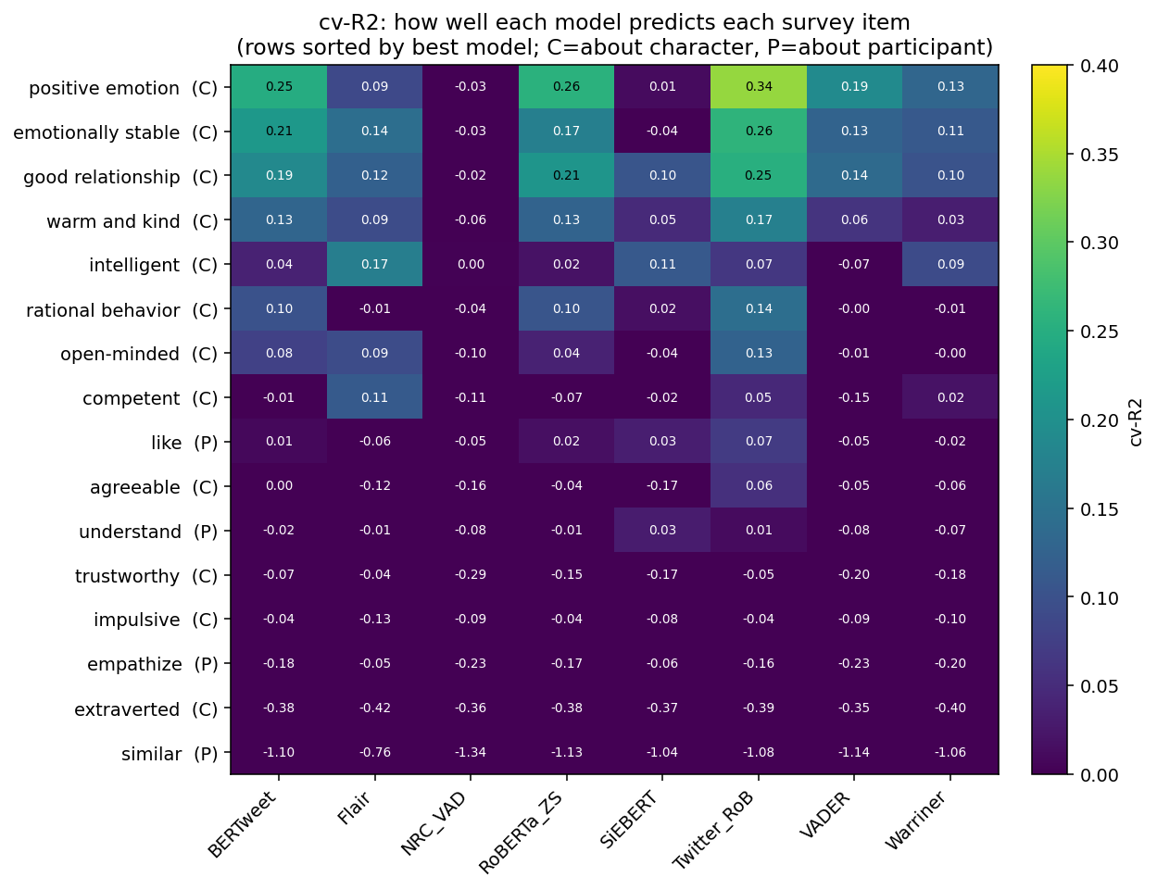
Figure 1c — which survey items each model tracks; affect items align best.
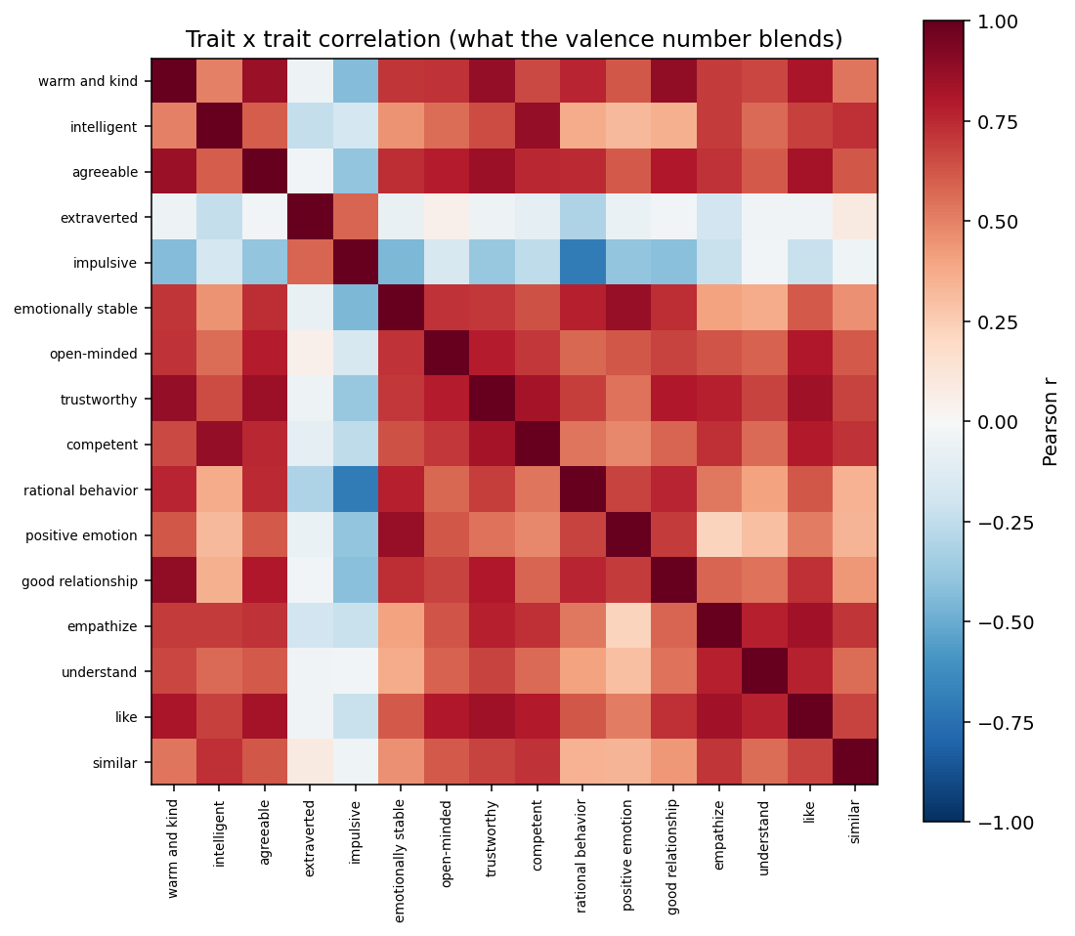
Figure 1d — trait intercorrelations (the halo structure behind PC1).
Your notes
“PCA — explain variance per component, which traits contribute to PC1, use to aggregate, flip signs” — all done above (variance table, PC1 loadings, PC1 carried as a target, signs fixed).
“Feel vs think about a character” — that's PC2 (affect vs stance) and PC3 (extraversion).
ASK HAYOUNG
Which is the headline target? positive_emotion (or the essentially-tied affect trio) vs PC1 vs like.
Why it's a blocker: the choice fixes which sentiment structure feeds every brain test. I carry all candidates in 01__targets.csv, so it's a one-line switch once you decide — but the brain results are only interpretable relative to a named target.

Step 2 · The scan group's own post-scan survey (Track B)
The broken 01e is fixed and renumbered to 02. This validates the sentiment score against the fMRI participants' own survey (same cohort), rather than the separate behavioral cohort used in Step 1.

Findings (n = 128)
- Averaged sentiment (val_mean) tracks character valence 0.54, the 16-item valence 0.51, character-emotion 0.40, participant-stance 0.37, and `like` 0.34 — all positive here, unlike Step 1 where like ≈ 0.
- End-state sentiment (val_final) is much weaker (0.13–0.17): the running average beats the last snapshot.
- First hint that stance matters:
  - liking is a real signal when measured on the same cohort — which is exactly what the brain results (Steps 4c/5) pick up.
Construct | vs val_mean (ρ) | vs val_final (ρ)
character valence (full) | 0.542 | 0.133
character valence (16-item) | 0.508 | 0.167
character emotion | 0.397 | 0.172
participant stance | 0.366 | 0.149
like | 0.341 | 0.156

Step 3 · Jin's Figure 1 — the distance effect
The stray NLA cell (that work is a separate repo) was removed; a verdict cell and scope note were added. Jin's claim: impressions from nearby runs should be more similar than from distant runs.

Findings
- Distance effect in our sentiment: Spearman ρ = −0.039 (essentially none).
- Within-person similarity 0.693 vs between-person 0.662, Wilcoxon p = 0.054 — only marginally self-similar, much weaker than Jin's reliable impression effect.
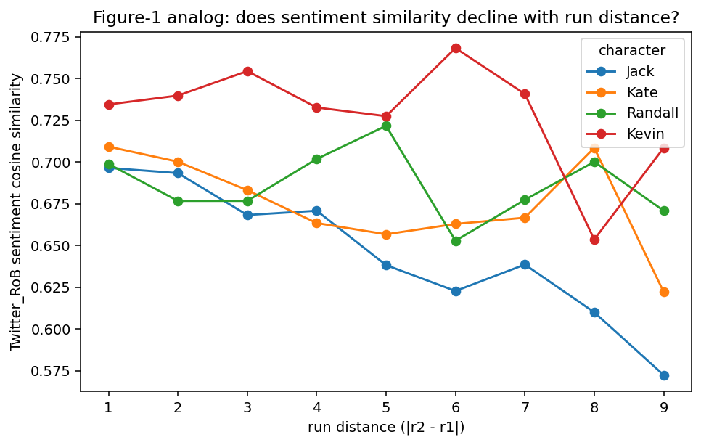
Figure 3 — sentiment similarity vs run distance (near-flat).
Your notes
“Replicate Jin's Fig 1 (distance)” — done. “Interesting if my findings differ from Jin's” — they do: ours is weak.
That's the point of “sentiment distills something different”: the sentiment representation is low-reliability and dissociates from thought-content impressions.

Step 4 · Jin's Figure 2 — IS-RSA (does a shared representation predict shared brain activity?)
IS-RSA (inter-subject representational similarity analysis) asks one question: when two people form a more similar impression of the characters, do their brains also respond more similarly? It builds one “who-is-similar-to-whom” table from the behavior and one from the brain (across 116 regions), then tests whether the two tables line up. We re-implemented Jin's version of this test from his public code (his step03 / step04) so we could run the identical analysis with our sentiment score swapped in for his impression measure. We used the same settings he did: the same random-seed routine, the same brain atlas (Schaefer-100 + Tian-16), the same way of combining the before- and after-movie p-values, and the same significance threshold (FDR q < 0.01).

4a — Does our re-implementation reproduce Jin's result? (the gate)
Before trusting our code on the sentiment score, we ran a control: we fed Jin's own impression data through our re-implementation of his pipeline. If it reproduces the brain regions he published, the port is trustworthy; if it doesn't, any later null could just be a bug in our code rather than a real finding.
It reproduced his effect — but only partially. We recovered a subset of his regions, not all of them:
 | Jin's significant regions | Ours | Overlap
After-movie | [9, 28, 60, 64, 97, 98] (6) | [9, 60, 64, 98] (4) | 4 — all of ours are his
Before-movie | [4, 50, 64, 88, 98, 99] (6) | [64, 99] (2) | 2 — both of ours are his
So this is not an exact replication. Every region we found is one Jin also found — we produced no regions he didn't — but we missed 2 of his 6 after-movie regions and 4 of his 6 before-movie regions.
Why we think we fell short (hypotheses):
- We run on a smaller group of people. Our brain analysis uses only the 29 participants who overlap across the two scramble splits; Jin's published numbers come from a fuller sample. Fewer people means less statistical power, so his weaker regions fall below our significance line and drop out.
- The test is threshold-sensitive. Significance is decided by a resampling (bootstrap) test at a strict cutoff (FDR q < 0.01). Any region whose effect sits right near that line flips in or out with a small change in sample or random draw — exactly the borderline regions we'd expect to lose first.
- It is not a code or settings mismatch. We matched Jin's random seed, atlas, and thresholds, so the gap points to sample size / power, not an error in the port.
What that means for the results we did get:
- The pipeline is validated — conservatively. Because every region we recover is genuinely one of Jin's and we add no false ones, the method demonstrably works: it detects a real brain–behavior link when one is present. That is what makes the sentiment run in 4b trustworthy — a null there can't be dismissed as “the code doesn't work.”
- But read our region lists as a floor, not the full picture. We recover a conservative subset, so wherever we report significant regions we are probably under-counting, not over-counting. Practically: a null (like 4b) is meaningful (“we couldn't find it even though the pipeline can find real effects”), while our positive region lists (4a, 4c, 5) should be read as “at least these regions,” pending the fuller cohort.

4b — Sentiment IS-RSA
- 0 significant regions — no brain region's synchrony tracked shared sentiment (before-movie, after-movie, or the two combined). max|r| ≈ 0.05.
- This is “couldn't detect,” not “nothing is there.” Two independent ceilings cap what any test could have found. (a) Power: with 29 people we only had ~80% chance of catching an effect of size r ≈ 0.05 or bigger. (b) Reliability: the sentiment similarity table is itself noisy — split it in half and the halves agree at only 0.03, and the brain data agree at 0.127, so the largest *true* effect the data could even express is about √(0.127 × 0.030) ≈ 0.062. That ceiling sits barely above the ~0.05 we can detect. In plain terms: the run-by-run sentiment score is too unreliable for this test to have had a fair chance.

4c — Survey representations (same cohort, more reliable)
Representation | Sig. ROIs | max|r| | Cross-char reliability
like | 3 [24, 48, 60] | 0.175 | 0.196
PC1 | 1 [70] | 0.169 | 0.055
positive_emotion | 0 | 0.187 | 0.035
(end-state sentiment) | — | — | 0.195
Reliability caveat — how to read this table
Reliability here means how consistent a measure is with itself — if we split the data in half, do the two halves give the same “who-is-similar-to-whom” pattern? A measure can only correlate with the brain as strongly as it correlates with itself, so a noisy measure is capped low no matter what it captures. In the last column: like (0.196) and end-state sentiment (0.195) are moderately reliable, while PC1 (0.055) and positive_emotion (0.035) are close to noise.
A content difference would mean like beats positive_emotion because shared *liking* is genuinely more brain-relevant than shared *character-affect* — a difference in what is measured. But here the number of regions each one finds (3 / 1 / 0) lines up exactly with how reliable it is, so we can't yet separate the two explanations: like may win simply because it is measured more cleanly, not because its content matters more.
The clean test would compare like against end-state sentiment, which has almost the same reliability (~0.20) — so any difference there would be about content, not noise. That test hasn't been run (4b used the run-by-run sentiment, reliability 0.03, which isn't a fair match to like).
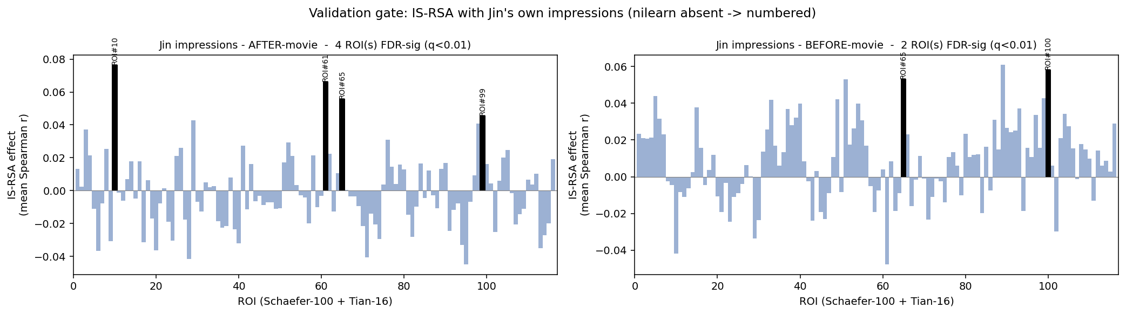
Figure 4a — gate: Jin's impressions IS-RSA (validates the port).
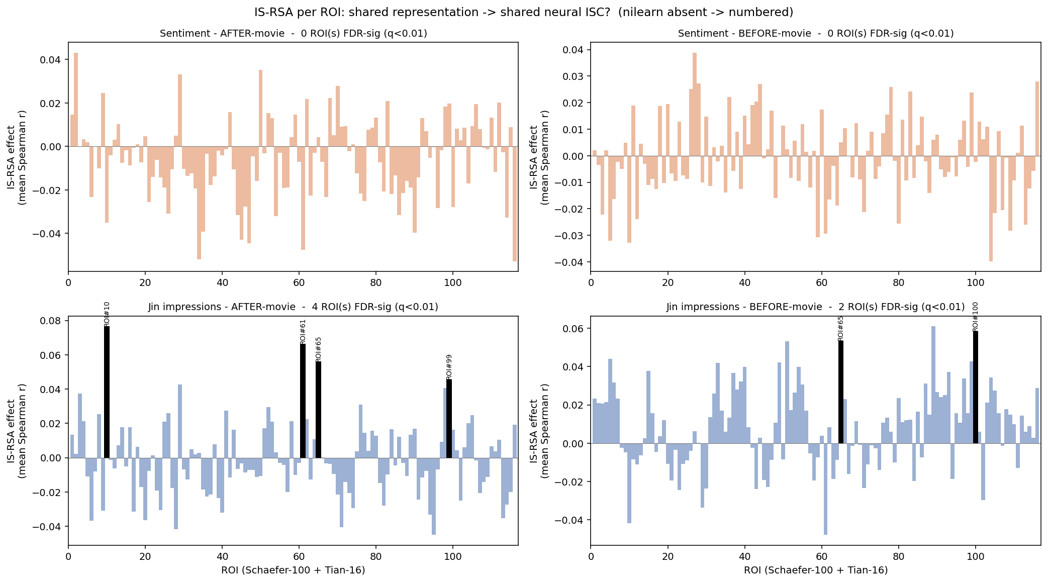
Figure 4b — sentiment vs impressions IS-RSA (sentiment finds nothing).
ASK HAYOUNG
(1) Recreating your colored brain-surface figures — I need Jin's environment / atlas surface templates. Blocker for making the figures look like his for the meeting.
(2) Neural load path — reuse Jin's precomputed neural similarity, or recompute from raw fMRI? Blocker because it determines whether 4c/06/07 can run at all and whether our numbers line up with his.

Step 5 · Group-level bridge (behavioral cohort → brain)
The only route from the separate behavioral (SONA) cohort to the brain, at the group level (3 groups) — coarse and descriptive.
- Group-average `like` → 1 region [91] (max|r| 0.299); PC1 and positive_emotion → 0.
- Same direction as 4c: shared liking co-varies with a group neural quantity where sentiment/PC1 do not.

Step 6 · Pattern-shift (your “delta CSVs → brain” idea)
This is exactly your note: use the before/after (delta) sentiment to predict neural pattern shifts across runs — the most direct test of whether updating an impression updates the brain.
- Behavioral side runs — the sentiment deltas are built and swapped into Jin's step08 structure.
- Neural side is blocked:
  - it needs Jin's neural pattern-shift file (data/brain/pattern_shift/1TR_nearbytp.npy) and a permutation-null file. Neither is in this repo and neither resolved on the rerun.
ASK HAYOUNG — hard blocker
Is the pattern-shift file (1TR_nearbytp.npy) + null in your/Jin's shared data, or do I generate it (his step06 needs data/brain/loaded_BOLD/ + scene_null.py)?
Why it's the key blocker: this is the single missing input that stops the most direct test of the main question from running. Everything else in Step 6 is ready.

Step 7 · Liking → brain (new)
Packages the individual + group like handle (from 4c and 5) as its own test. It ran fully and is consistent: shared liking is the one behavioral measure that tracks the brain. This is the positive half of the story — suggestive given the reliability caveat above.

Parked — audio sentiment (CLAP)
Your side-quest note (“don't do now, but interesting”): extract sentiment directly from the movie audio with CLAP and compare to the positive-emotion ratings. Noted for future; not built.

Questions for Hayoung — what's blocking me (and why)
- Step 6 brain data (hard blocker). The pattern-shift file + null aren't in the repo → the most direct test of the main question can't run. Is it in the shared data or do I generate it?
- Neural load path. Reuse Jin's precomputed neural similarity vs recompute from raw → gates whether 4c/6/7 run and whether numbers match his.
- Recreating your brain-surface figures. Need Jin's environment / atlas templates → blocks presentation figures matching his.
- Headline target. positive_emotion / affect-trio vs PC1 vs like → fixes which sentiment table is “the” brain test. All candidates are carried, so it's a one-line switch.
- How to read the 04b null. Underpowered / can't-detect vs a real dissociation — a framing call.
- Is the like → brain result reportable as suggestive given the reliability confound, and should I run the clean end-state-sentiment test to settle it?
- Confirm scope: the two surveys (16-item behavioral vs 35-item post-scan) and the character column order (Jack / Kate / Randall / Kevin).

