StashSage, New Trading App, Just Got Better
Greetings Exiles,
Firstly, thank you to the community for the support and feedback so far in the early beta stages of StashSage! We’re back with a big update!
Initial feedback suggested the price ranges in the red/yellow/green color bar (which I’m now calling the Price Aura) were too wide and it was difficult to choose an initial price. My initial recommendation was to start on the lower end of the range and use demand pings to “discover the true price” of the item. However, that drew some criticism, suggesting that strategy reinforces some of the problems innate to the POE trading ecosystem, where players don’t respond to pings and/or change the price after you’ve pinged them (which I don’t condone).
In response, the community suggested we develop a more direct price checker. I assume existing tools like Exile Exchange and Sidekick use straightforward HTTP requests to the trade website and display “similar” items based on a query the player is responsible for parameterizing. Players can look at cross sections of items (>=, ==, within X% of target item mods) and need to manually sift through the results to subjectively determine the price for their item. While this works for very valuable items with few competing items in the market, it’s challenging to do across many items, rare items, and for item categories you are unfamiliar with.
In response to this feedback, we are excited to release a new (2nd) overlay feature for StashSage called Price Mirror. It determines the 10 most similar items to yours and displays their values, mods, differences, and prices. StashSage reduces the amount of time you waste managing your inventory! Don’t want to do any tedious work? Just set the price at the median and get back to playing the game!
What is a “similar” item? TLDR: the definition is extremely subjective and varies by player.
- Is it an item with 6/6 same mods but very different values?
- Is it an item with 5/6 same mods with close values, and a single different mod?
Price Mirror resolves this automatically and allows you to make a simple judgment call without needing to manually run multiple queries, saving you time and sanity.

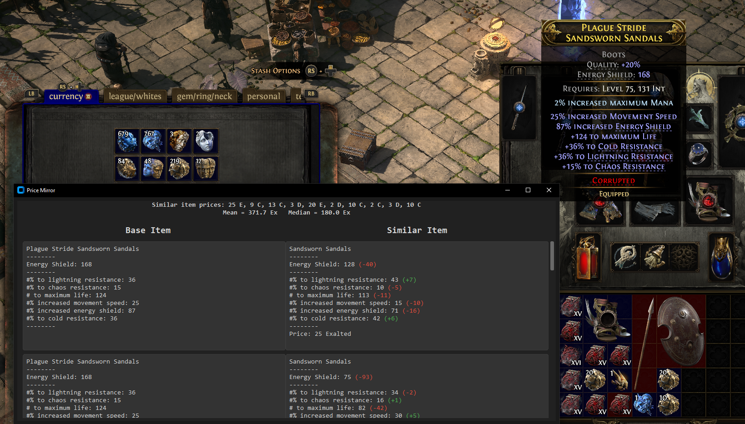

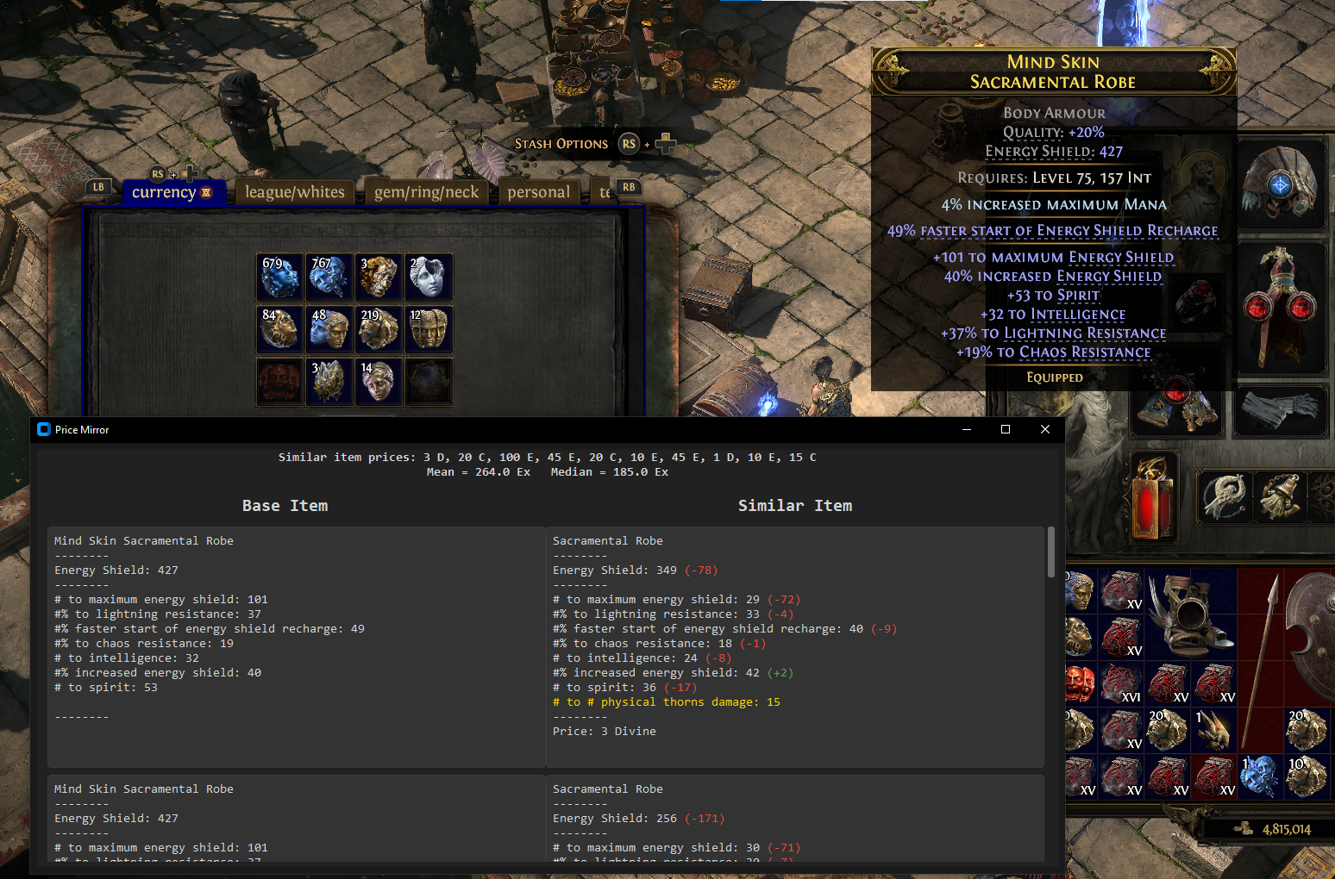
Watch the demo, download the app, and join the community of well-informed traders:
- YouTube: https://youtu.be/VmsiqPns4Ac
- GitHub: https://rheinze08.github.io/StashSage/
- Discord: https://discord.gg/hn3sqzJH
Thank you and I look forward to hearing your feedback!

