ERP SYSTEM
Module Marketing Brochure
A connected enterprise platform for finance, people, operations, investments, projects, maintenance, supply chain, customers, workflow, reporting and business intelligence.
MULTI-TENANT / WORKFLOW-LED / FINANCE-AWARE / BI-READY
This version includes representative main-grid and record-detail page visuals for every module.

WHAT THE SYSTEM BRINGS TOGETHER
One operational backbone
The ERP connects day-to-day work with the controls that govern cost, revenue, inventory movement, customer commitments, investment decisions, service work and approvals.
Prepared as a modular sales and stakeholder brochure for the ERP system.

MODULE PORTFOLIO
Enterprise functions in one platform
The module portfolio now includes Investment and Portfolio Management, and the reporting section is positioned as BI-ready for executive insight, drilldowns and performance analytics.
Finance Management  Control accounting, invoicing, payments, cash, budgets and GL-aware posting. | Human Resources & Payroll  Run employee records, payroll processing, payslips, approvals and statutory deductions. | Procurement  Manage requisitions, suppliers, purchase orders, tenders and business partners.
Inventory & Warehousing  Track stock, warehouses, transfers, requisitions, valuation and issue queues. | Sales & CRM  Convert leads, opportunities, customers, agreements and commercial handoffs into revenue. | Marketing  Plan campaigns, track audiences and connect market activity to sales outcomes.
Maintenance Management  Operate assets, job cards, work orders, technicians, tools, parts and quality checks. | Projects & Development  Coordinate projects, budgets, milestones, resources, variations and delivery reporting. | Investment & Portfolio Management  Monitor investment holdings, portfolio performance, risk, allocation and committee approvals.
Workflow Engine  Standardize approval, task, document and review steps across every workflow-enabled module. | Reporting, Dashboards & BI  Deliver dashboards, operational reports, BI views, drilldowns, exports and performance analytics. | Administration & Security  Centralize tenants, users, roles, permissions, policies, settings, audit and security controls.
Helpdesk & External Portal
Support employees, customers, partners and external users through guided service journeys.

BUSINESS VALUE
Control, insight and execution without disconnected handoffs
The ERP is strongest where work crosses departments: procurement into inventory, job cards into work orders, payroll into finance, projects into sales, investments into committee approvals, and BI dashboards into management decisions.
Financial control  GL-aware posting, AR/AP activity, cash visibility and budget discipline. | People and payroll governance  Sensitive payroll actions wrapped with approvals, documents and audit history.
Operational execution  Assets, stock, projects, service work and procurement queues managed end to end. | Investment oversight  Portfolio exposure, returns, risk and approval evidence in one governed process.
Workflow discipline  Approval and task steps reusable across modules instead of custom one-off logic. | BI-led decisions  Dashboards, KPI packs, drilldowns, exports and analytics for leadership visibility.

Capture | Review | Execute | Post | Analyze
Raise the transaction or request. | Route to workflow approvers or task owners. | Complete work, attach evidence and update records. | Create finance or operational impact. | Surface BI, KPIs and audit history.

MODULE SHOWCASE
Finance Management
Control accounting, invoicing, payments, cash, budgets and GL-aware posting.
Key capabilities  - General ledger and chart of accounts  - AR/AP invoices and payments  - Cash, budgeting and financial reporting  - Finance-backed master data for postings | How it helps  Teams get a focused workspace for everyday transactions, record review, document evidence, workflow history, exports and management visibility.

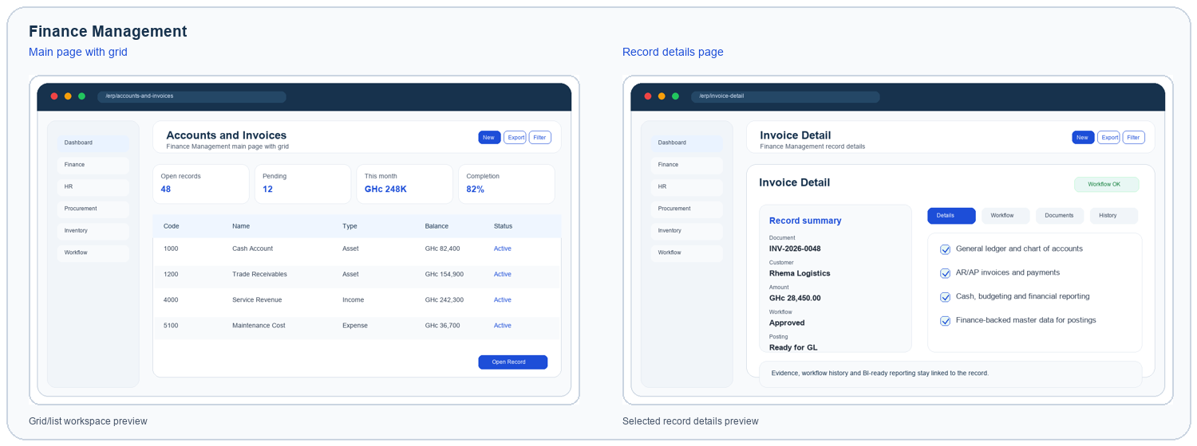
Visuals are representative page previews based on the ERP module surfaces.

MODULE SHOWCASE
Human Resources & Payroll
Run employee records, payroll processing, payslips, approvals and statutory deductions.
Key capabilities  - Employee records and payroll runs  - Allowances, deductions and tax reliefs  - Payslip generation and secure delivery  - Workflow-controlled payroll actions | How it helps  Teams get a focused workspace for everyday transactions, record review, document evidence, workflow history, exports and management visibility.

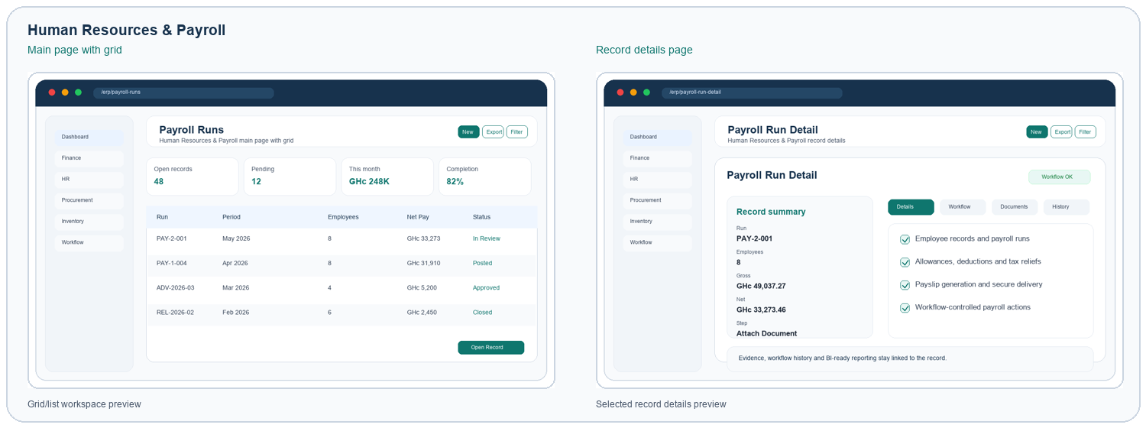
Visuals are representative page previews based on the ERP module surfaces.

MODULE SHOWCASE
Procurement
Manage requisitions, suppliers, purchase orders, tenders and business partners.
Key capabilities  - Purchase requisitions and approvals  - Supplier and business partner management  - Purchase orders and receiving handoff  - Audit-ready procurement records | How it helps  Teams get a focused workspace for everyday transactions, record review, document evidence, workflow history, exports and management visibility.

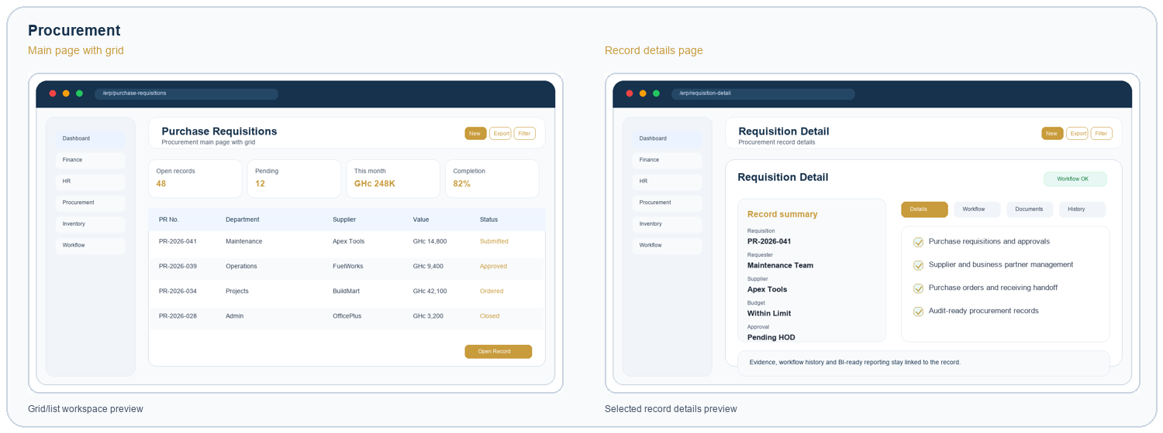
Visuals are representative page previews based on the ERP module surfaces.

MODULE SHOWCASE
Inventory & Warehousing
Track stock, warehouses, transfers, requisitions, valuation and issue queues.
Key capabilities  - Inventory item master and categories  - Warehouse stock and bin movements  - Transfers, requisitions and counts  - Stock valuation and availability views | How it helps  Teams get a focused workspace for everyday transactions, record review, document evidence, workflow history, exports and management visibility.

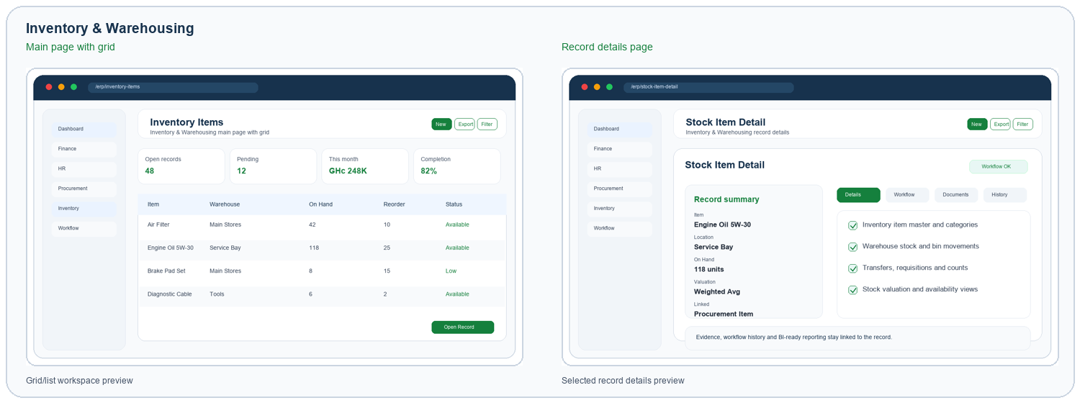
Visuals are representative page previews based on the ERP module surfaces.

MODULE SHOWCASE
Sales & CRM
Convert leads, opportunities, customers, agreements and commercial handoffs into revenue.
Key capabilities  - Leads, opportunities and customer accounts  - Sales agreements and renewals  - Forecasts and conversion tracking  - Customer reports and relationship history | How it helps  Teams get a focused workspace for everyday transactions, record review, document evidence, workflow history, exports and management visibility.

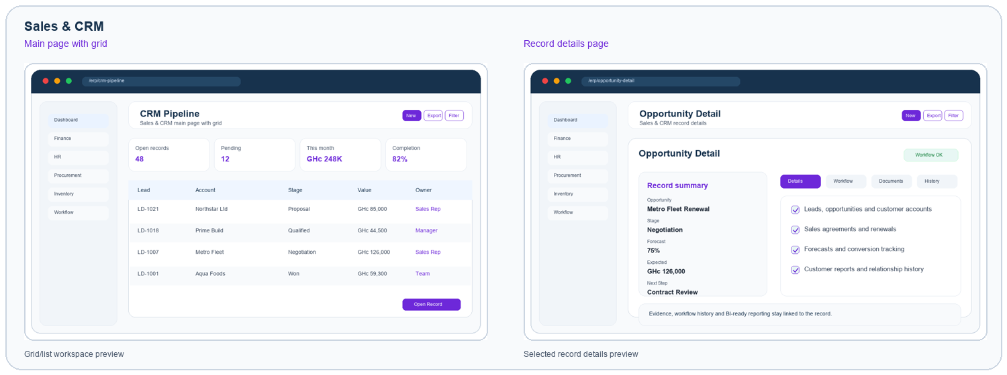
Visuals are representative page previews based on the ERP module surfaces.

MODULE SHOWCASE
Marketing
Plan campaigns, track audiences and connect market activity to sales outcomes.
Key capabilities  - Campaign planning and activity tracking  - Audience segmentation and responses  - Analytics-ready engagement records  - CRM handoff for qualified leads | How it helps  Teams get a focused workspace for everyday transactions, record review, document evidence, workflow history, exports and management visibility.

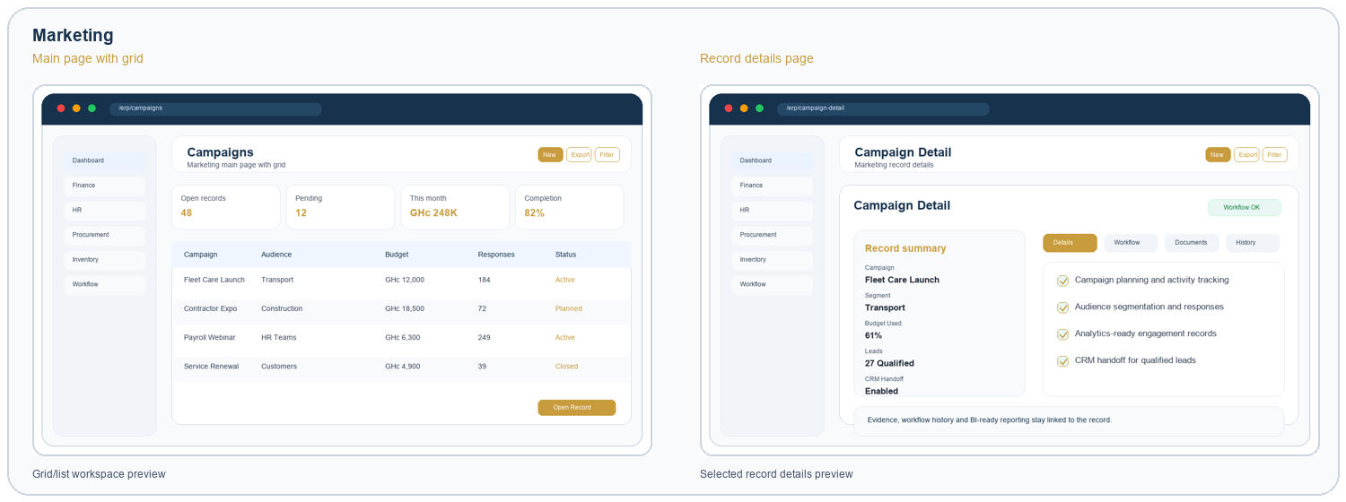
Visuals are representative page previews based on the ERP module surfaces.

MODULE SHOWCASE
Maintenance Management
Operate assets, job cards, work orders, technicians, tools, parts and quality checks.
Key capabilities  - Assets, job cards and work orders  - Technician scheduling and tool checkout  - Parts, labor, expenses and billing  - Inspection records and certificates | How it helps  Teams get a focused workspace for everyday transactions, record review, document evidence, workflow history, exports and management visibility.

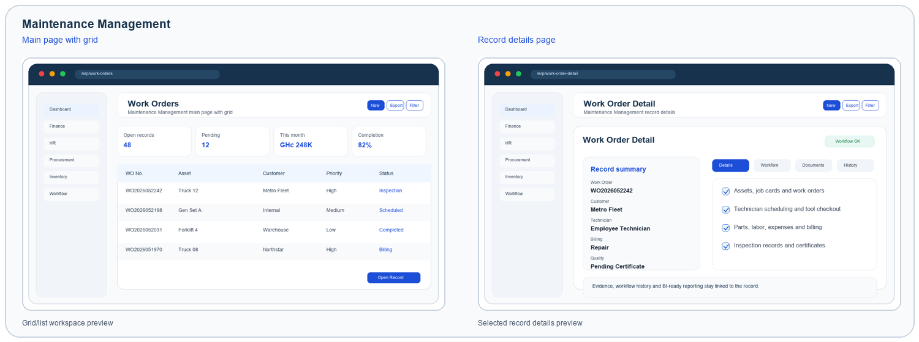
Visuals are representative page previews based on the ERP module surfaces.

MODULE SHOWCASE
Projects & Development
Coordinate projects, budgets, milestones, resources, variations and delivery reporting.
Key capabilities  - Project planning and budgets  - Milestones, tasks and resources  - Project billing and commercial progress  - Risks, issues and lessons learned | How it helps  Teams get a focused workspace for everyday transactions, record review, document evidence, workflow history, exports and management visibility.

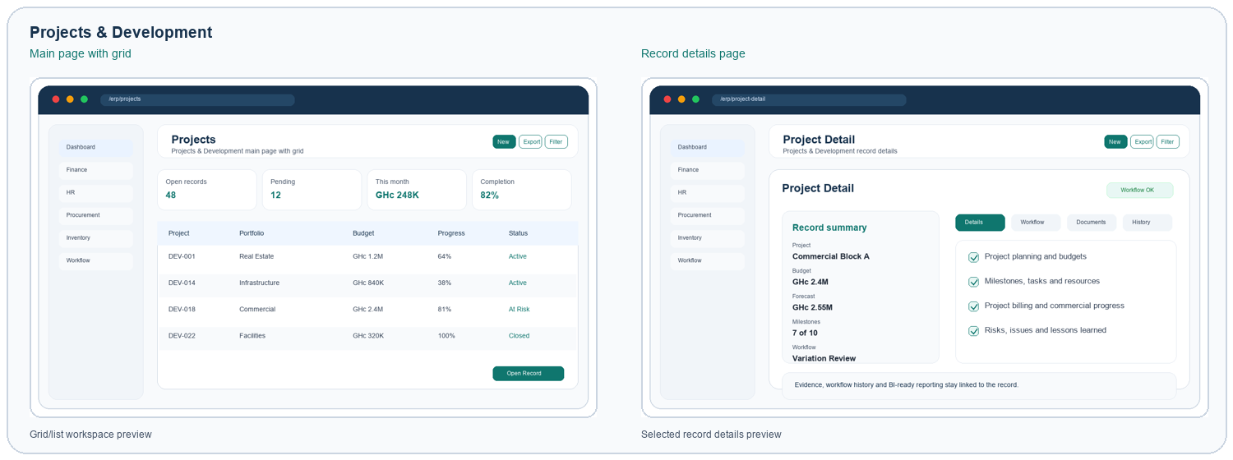
Visuals are representative page previews based on the ERP module surfaces.

MODULE SHOWCASE
Investment & Portfolio Management
Monitor investment holdings, portfolio performance, risk, allocation and committee approvals.
Key capabilities  - Investment register and holdings  - Portfolio allocation and concentration  - NAV, yield and performance tracking  - Risk, compliance and approval evidence | How it helps  Investment teams can track holdings, allocation, NAV, yield, risk concentration, compliance evidence and investment committee approvals alongside the rest of the ERP.

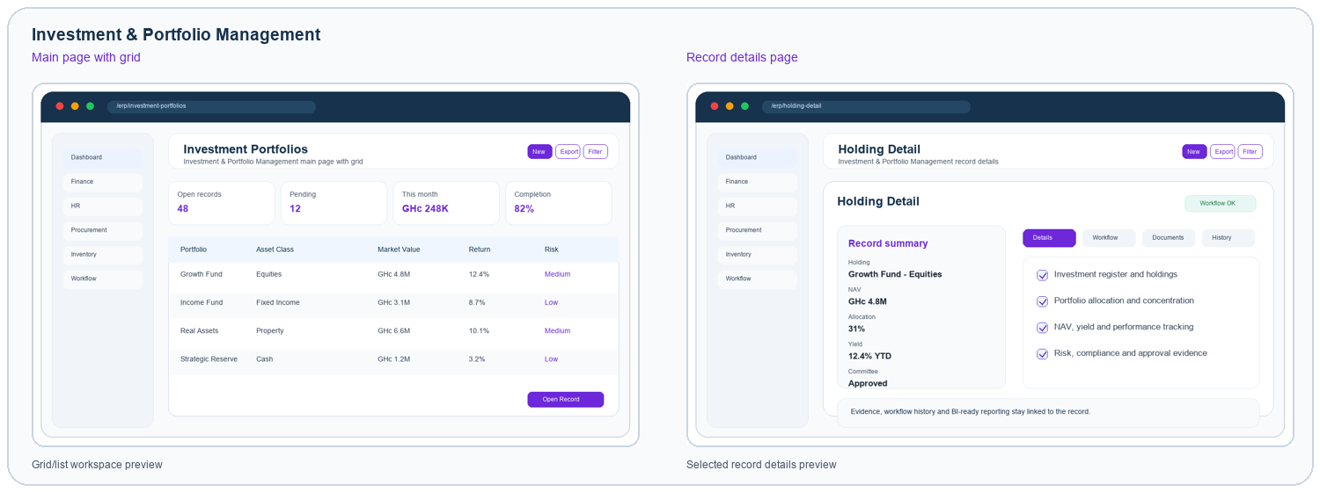
Visuals are representative page previews based on the ERP module surfaces.

MODULE SHOWCASE
Workflow Engine
Standardize approval, task, document and review steps across every workflow-enabled module.
Key capabilities  - Visual workflow definitions  - Approval and task nodes  - Document upload enforcement  - History, monitor and SLA visibility | How it helps  Teams get a focused workspace for everyday transactions, record review, document evidence, workflow history, exports and management visibility.

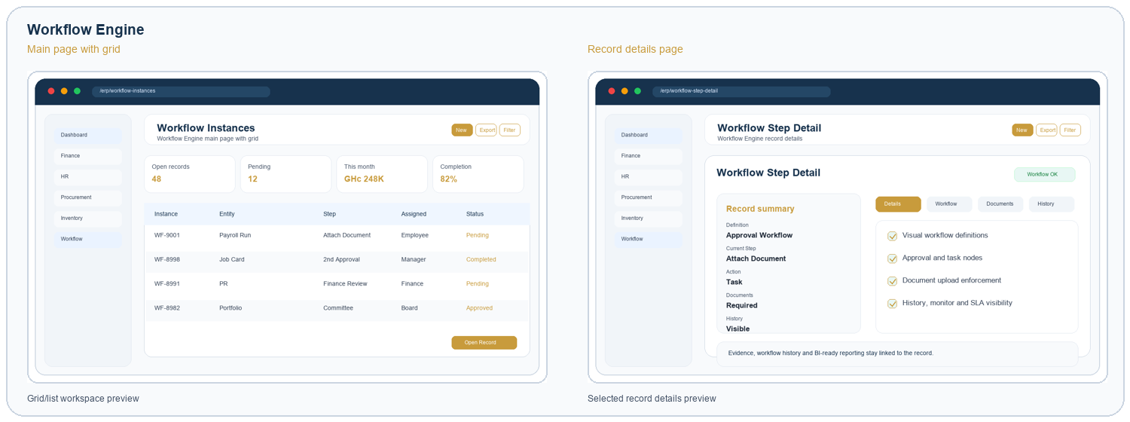
Visuals are representative page previews based on the ERP module surfaces.

MODULE SHOWCASE
Reporting, Dashboards & BI
Deliver dashboards, operational reports, BI views, drilldowns, exports and performance analytics.
Key capabilities  - Business intelligence dashboards  - KPI, trend and variance analytics  - Operational and finance report catalogs  - Exports, drilldowns and scheduled insight | How it helps  Executives and managers get BI-ready dashboards, live KPIs, report catalogs, trend analytics, drilldowns and exportable insight across operational and financial data.

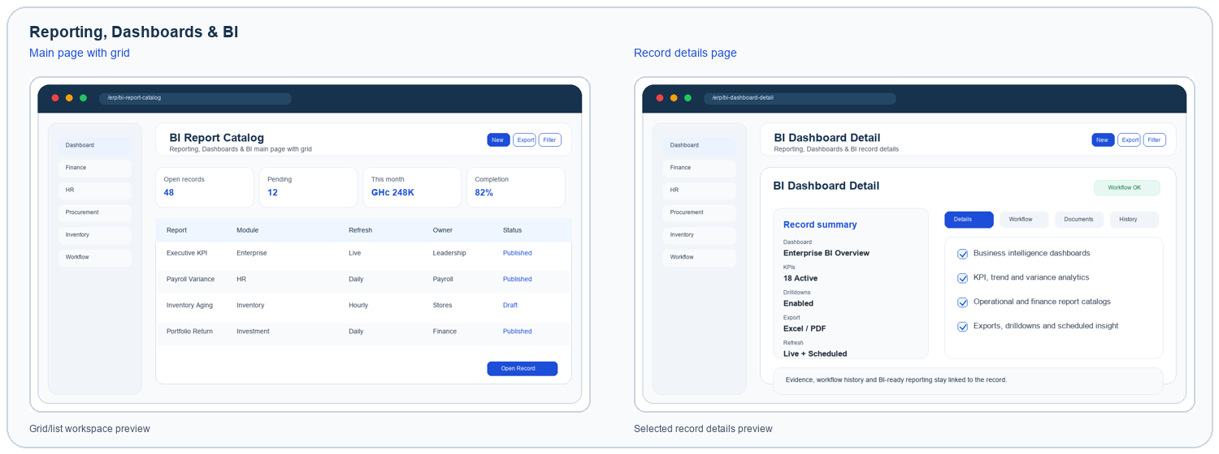
Visuals are representative page previews based on the ERP module surfaces.

MODULE SHOWCASE
Administration & Security
Centralize tenants, users, roles, permissions, policies, settings, audit and security controls.
Key capabilities  - Tenant and company administration  - Users, roles and RBAC permissions  - Email, password and system settings  - Audit logs and security monitoring | How it helps  Teams get a focused workspace for everyday transactions, record review, document evidence, workflow history, exports and management visibility.

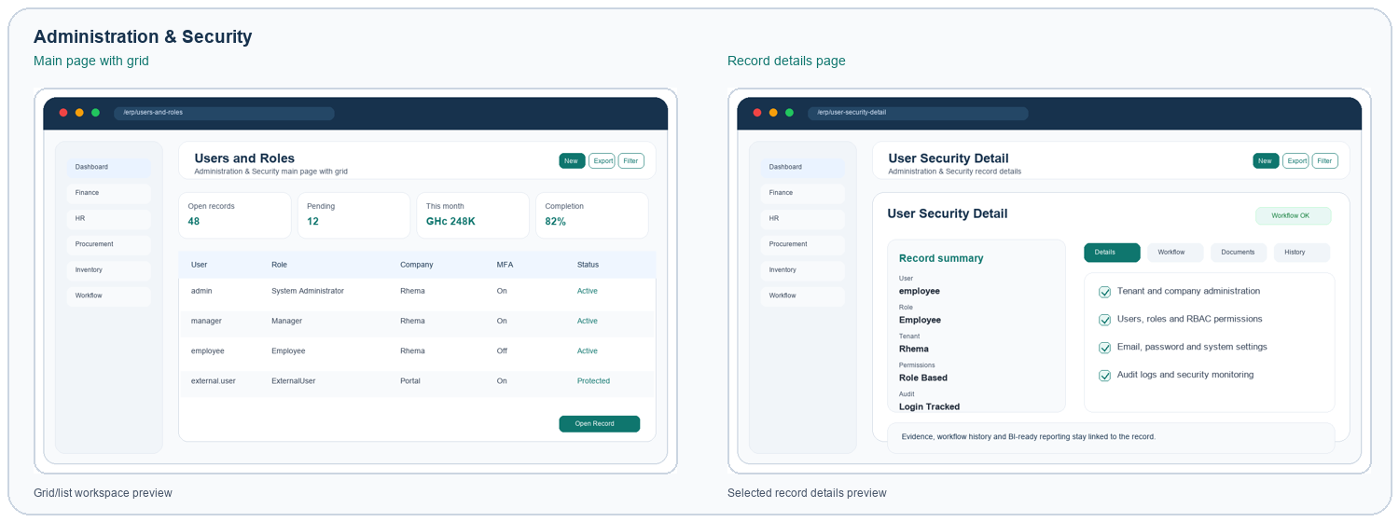
Visuals are representative page previews based on the ERP module surfaces.

MODULE SHOWCASE
Helpdesk & External Portal
Support employees, customers, partners and external users through guided service journeys.
Key capabilities  - Internal and external request intake  - Complaints, enquiries and knowledge base  - Portal access without exposing internal modules  - Notifications and follow-up queues | How it helps  Teams get a focused workspace for everyday transactions, record review, document evidence, workflow history, exports and management visibility.

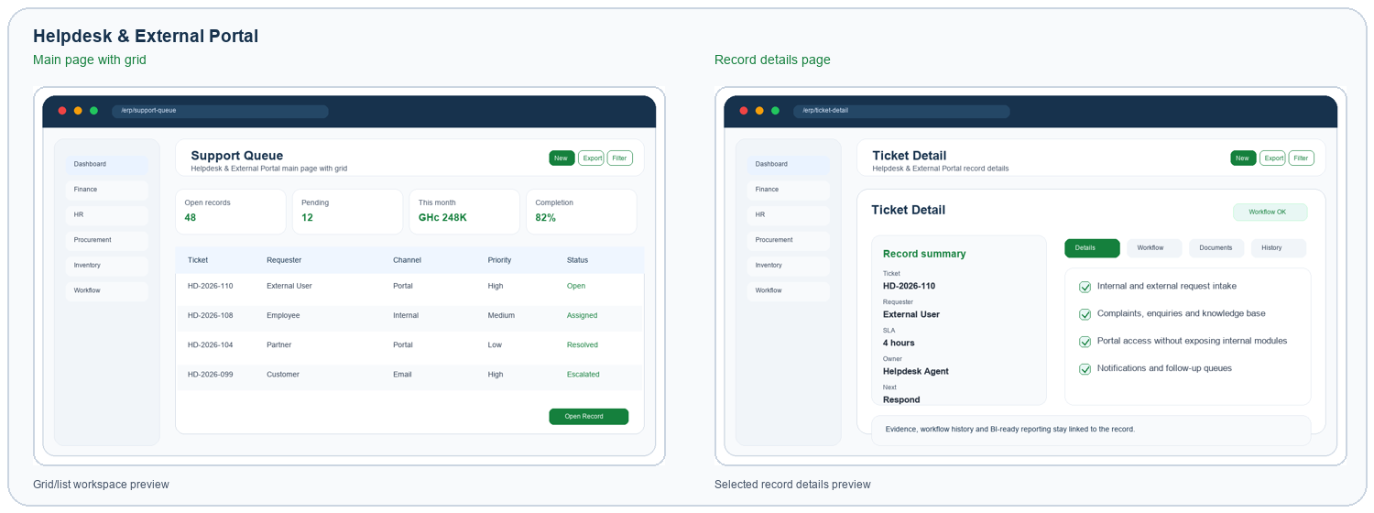
Visuals are representative page previews based on the ERP module surfaces.

POSITIONING
A modular platform for governed growth
The ERP supports a practical rollout path: start with the modules that remove the most friction, then expand into connected finance, operations, workflow, BI and investment oversight as adoption grows.
Connected operations | Finance, HR, procurement, inventory, sales, projects, maintenance, helpdesk and external users operate from shared records.
Governed decisions | Workflow definitions, role security, document evidence, audit logs and notifications keep approvals visible.
BI-ready management | Dashboards and reports become the control room for performance, exceptions, bottlenecks and future planning.
Investment oversight | Portfolio decisions can be tracked with risk, return, allocation and committee evidence.

Unify decisions, approvals, operations, portfolios and BI in one ERP platform.
A modular system that lets every department work in its own lane while leadership sees the whole enterprise picture.

