**CSC 196-V: Data Visualization**

**Interactive Design**

**Team Members:**

1. Abhinay Gupta Somisetty (Sac ID:301618980)
2. Hemanth Rachakonda ( Sac ID : 301616796)
3. Sheryl Bernard (Sac ID: 220270727)

**Guide on how to run the website:**

1. Unzip the folder and import as a new project in Webstorm.
2. You will be able to see the index.html file and folder structure like below.

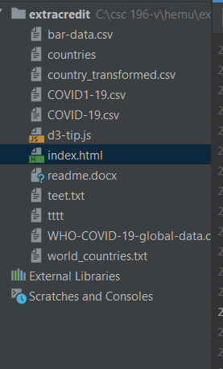

1. In the RUN menu you can select run index.html file.

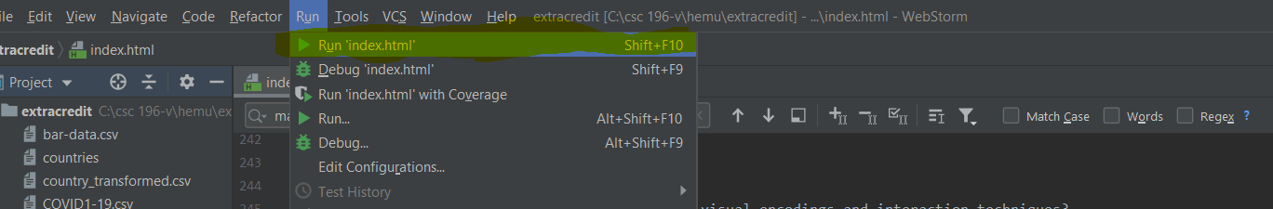

1. Once we click run it will navigate to the browser and you will be able to see a screen like below.

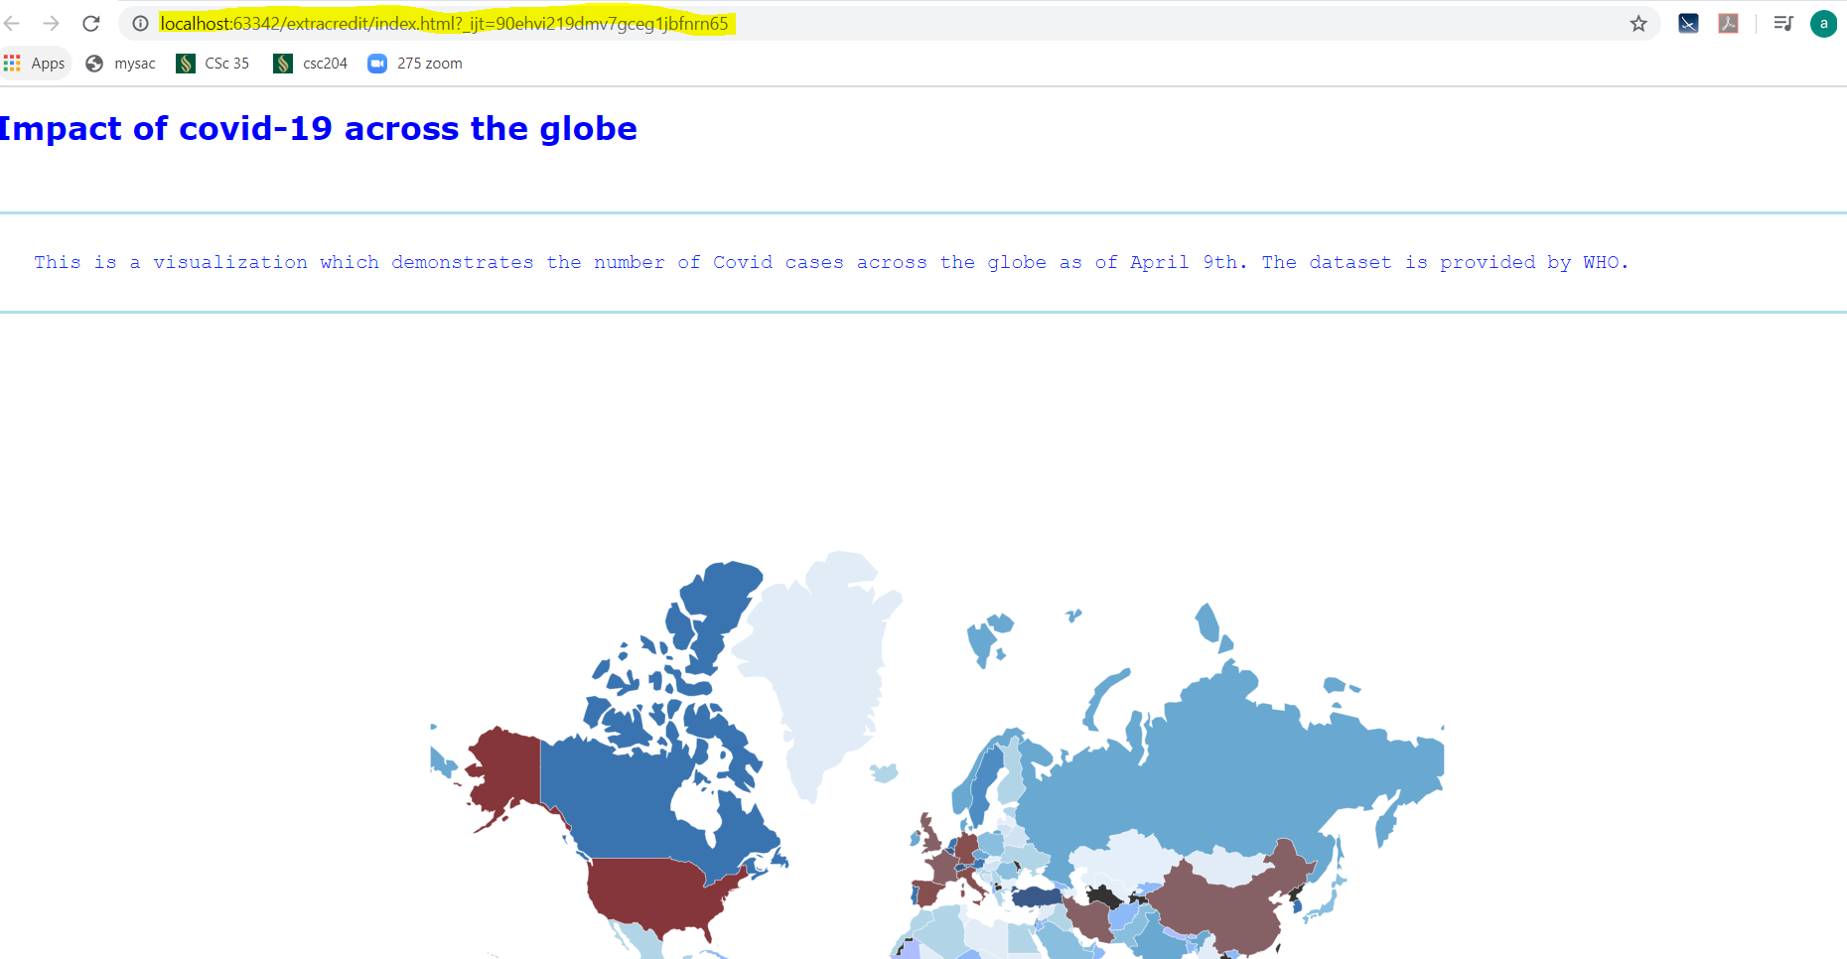

NOTE: There is missing data for few countries in WHO dataset. Only for those countries we are seeing black color on the map.