#G00940803 Robert Henderson isa562
Group: Macquynh Dang, Robert Henderson, Chang Huang, John Tigmo
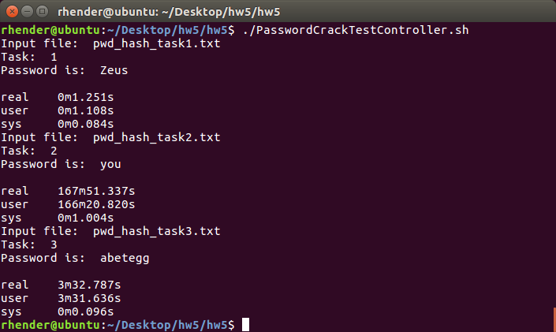

rhender@ubuntu:~/Desktop/hw5/hw5$ ./PasswordCrackTestController.sh
Input file: pwd_hash_task1.txt
Task: 1
Password is: Zeus

real 0m1.251s
user 0m1.108s
sys 0m0.084s
Input file: pwd_hash_task2.txt
Task: 2
Password is: you

real 167m51.337s
user 166m20.820s
sys 0m1.004s
Input file: pwd_hash_task3.txt
Task: 3
Password is: abetegg

real 3m32.787s
user 3m31.636s
sys 0m0.096s

PasswordCrackTestController.sh
prints the time it takes to execute Task1.sh script
prints the time it takes to execute Task2.sh script
prints the time it takes to execute Task3.sh script

Task1.sh
executes the task1 command –
python3 simple_unix_pwd_cracker.py -t 1 -i pwd_hash_task1.txt

Task2.sh
executes the task2 command –
python3 simple_unix_pwd_cracker.py -t 2 -i pwd_hash_task2.txt

Task3.sh
executes the task2 command –
python3 simple_unix_pwd_cracker.py -t 3 -i pwd_hash_task3.txt

