# Hack the Box Can I Has Crypto? Yes I Can.

Requires python 3 and requests package installed into env

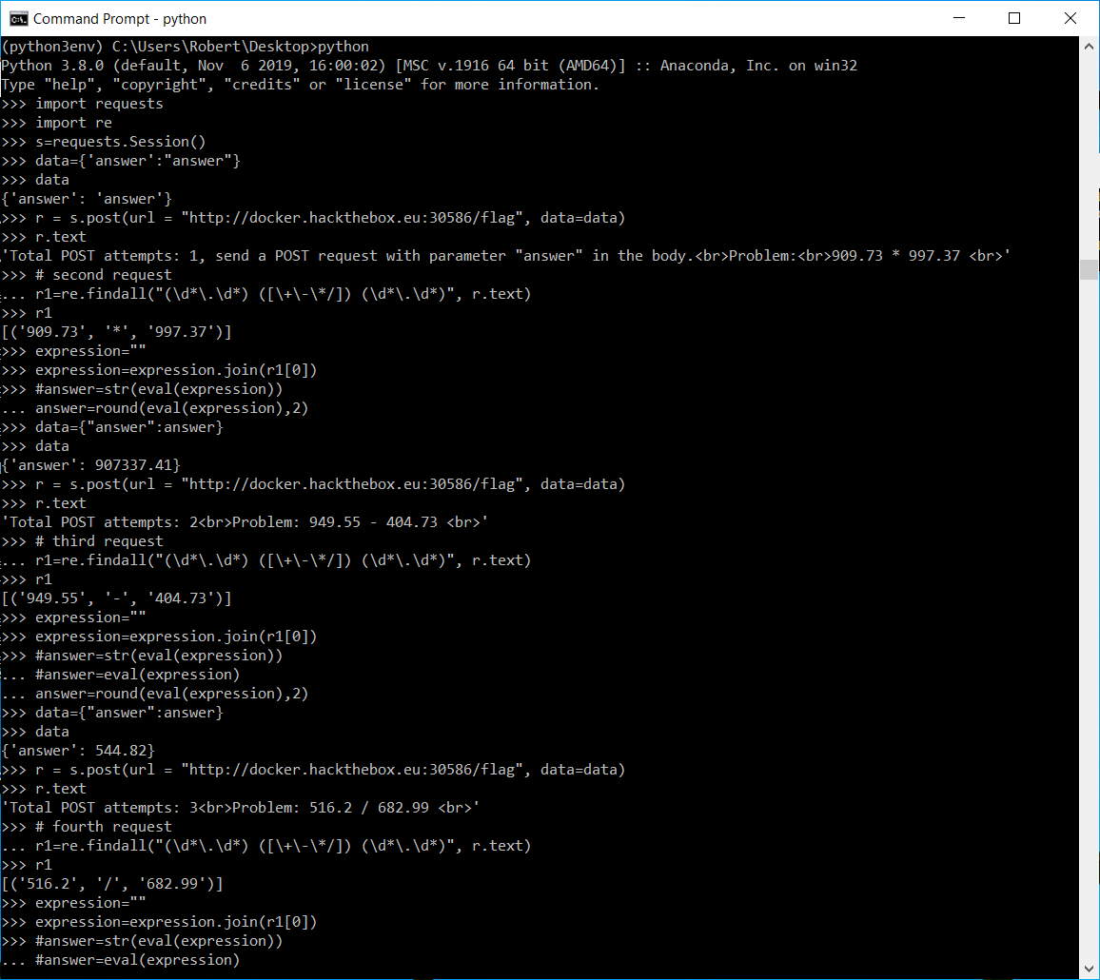

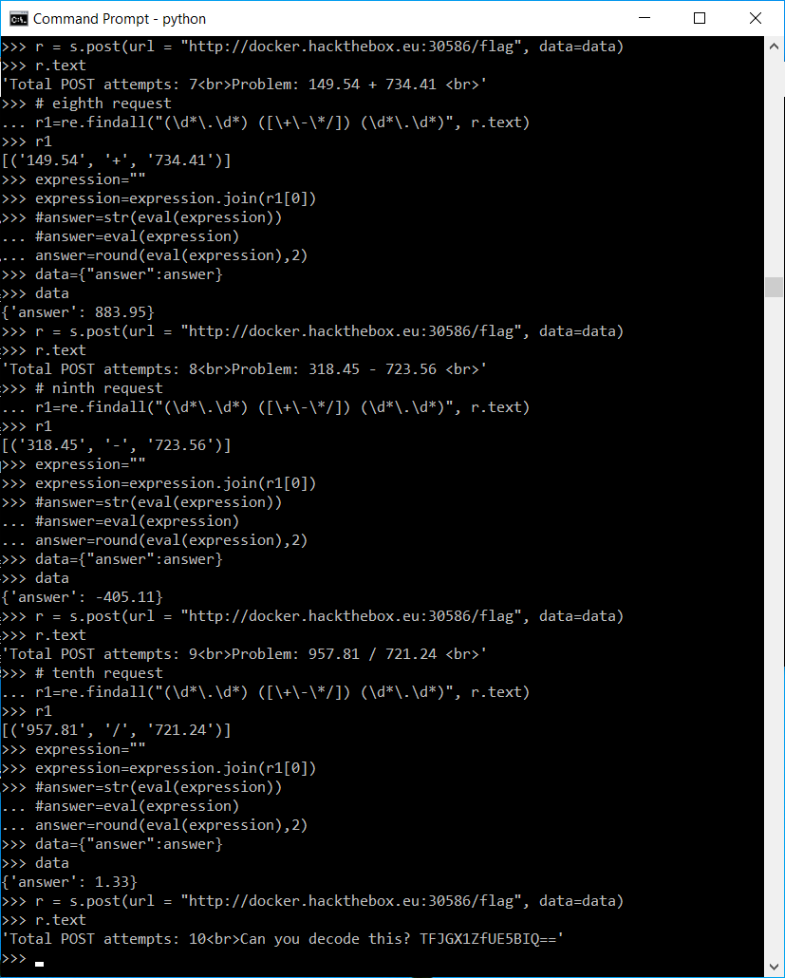

Final Step:

Final Step:

