Supplementary material
Hospitalizations for ambulatory care sensitive conditions in Ecuador, 2000–2024. Henriquez-Trujillo MC, Bonilla E, Henriquez-Trujillo AR.
Tables S4–S8 are provided as spreadsheet files: S4 joinpoint regression of all series; S5 segmented regression by ACSC group; S6 sensitivity analyses; S7 annual provincial age-standardized rates with 95% confidence intervals for 2000–2024; S8 annual indicators of geographic variation.
Table S1. ICD-10 codes of the 20 groups of ambulatory care sensitive conditions (ACSC), number of hospitalizations and age-standardized rates by period, Ecuador, 2000–2024.
Group | Condition | ICD-10 codes | Category | n 2000–2024 | % of ACSC | ASR 2000–2007 | ASR 2008–2014 | ASR 2015–2019 | ASR 2020–2024
1 | Anemia | D50 | Other acute | 19,951 | 0.5 | 2.4 | 5.0 | 8.2 | 6.7
2 | Angina pectoris | I20 | Chronic | 39,306 | 1.0 | 10.6 | 12.1 | 10.7 | 13.7
3 | Asthma | J45-J46 | Chronic | 70,906 | 1.9 | 22.9 | 20.2 | 14.4 | 11.4
4 | Nutritional deficiencies | E40-E46, E50-E64 | Other acute | 27,745 | 0.7 | 9.1 | 7.0 | 5.0 | 3.6
5 | Diabetes mellitus | E10-E14 | Chronic | 357,721 | 9.4 | 100.8 | 138.4 | 108.5 | 83.4
6 | Female pelvic inflammatory disease | N70-N73, N75-N76 | Other acute | 73,792 | 1.9 | 21.2 | 23.0 | 21.2 | 14.6
7 | Cerebrovascular diseases | I63-I67, I69, G45-G46 | Chronic | 174,416 | 4.6 | 55.8 | 59.4 | 51.4 | 45.6
8 | Lower respiratory tract diseases | J20-J21, J40-J44, J47 | Chronic | 214,413 | 5.7 | 49.6 | 70.0 | 64.7 | 40.2
9 | Immunization-preventable diseases | A17.0, A19, A33-A37, A95, B05-B06, B16, B26, G00.0 | Vaccine-preventable | 11,135 | 0.3 | 3.6 | 2.8 | 2.8 | 1.7
10 | Conditions related to prenatal and childbirth care | A50, O23, P35.0 | Infectious | 253,630 | 6.7 | 42.3 | 69.0 | 83.7 | 67.7
11 | Epilepsy | G40-G41 | Other acute | 80,692 | 2.1 | 12.2 | 19.3 | 26.9 | 25.6
12 | Infectious gastroenteritis and complications | A00-A09, E86 | Infectious | 990,268 | 26.1 | 304.3 | 290.3 | 204.1 | 128.8
13 | Hypertension | I10-I11 | Chronic | 178,021 | 4.7 | 71.7 | 73.3 | 41.8 | 29.4
14 | Ear, nose and throat infections | H66, J00-J03, J06, J31 | Infectious | 103,681 | 2.7 | 22.0 | 29.4 | 28.2 | 19.9
15 | Skin and subcutaneous tissue infections | A46, L01-L04, L08 | Infectious | 230,020 | 6.1 | 45.8 | 62.6 | 71.9 | 60.9
16 | Kidney and urinary tract infections | N10-N12, N30, N34, N39.0 | Infectious | 453,185 | 11.9 | 94.0 | 142.4 | 145.3 | 107.5
17 | Heart failure | I50, J81 | Chronic | 120,795 | 3.2 | 45.3 | 41.5 | 32.1 | 28.5
18 | Bacterial pneumonia | J13-J14, J15.3-J15.4, J15.8-J15.9, J18.1 | Vaccine-preventable | 125,140 | 3.3 | 15.1 | 23.8 | 53.8 | 40.2
19 | Gastrointestinal ulcer | K25-K28, K92.0-K92.2 | Other acute | 161,981 | 4.3 | 46.2 | 50.6 | 46.7 | 47.4
20 | Other avoidable conditions | A15-A16, A17.1-A17.9, A18, A51-A53, B50-B54, B77, I00-I02 | Vaccine-preventable | 105,762 | 2.8 | 64.6 | 20.2 | 13.9 | 12.0
Main diagnosis only. Three-character items include all subcategories; four-character items do not include records coded only with the three-character category. ASR: age-standardized rate per 100,000, projected 2022 population of Ecuador as standard.
Table S2. Age-standardized ACSC hospitalization rates by province of residence and period, Ecuador, 2000–2024.
 |  | Age-standardized rate per 100,000
Province | Region | 2000–2007 | 2008–2014 | 2015–2019 | 2020–2024 | 2000–2024 | APC 2011–2019, % (95%CI) | LISA
Morona Santiago | Amazon | 1,910.0 | 2,457.5 | 2,508.0 | 1,787.6 | 2,162.4 | −1.4 (−3.9 to 1.3) | HH
Pastaza | Amazon | 2,613.5 | 2,237.8 | 1,790.0 | 1,184.2 | 1,920.6 | −1.5 (−3.5 to 0.5) | HH
Napo | Amazon | 2,032.1 | 2,045.4 | 1,418.0 | 1,039.6 | 1,626.4 | −4.8 (−7.9 to −1.5) | NS
Zamora Chinchipe | Amazon | 1,332.1 | 1,694.5 | 1,757.3 | 1,549.2 | 1,571.8 | 2.1 (0.7 to 3.5) | NS
Cañar | Highlands | 1,265.4 | 1,560.7 | 1,521.1 | 1,186.7 | 1,376.9 | 0.0 (−1.9 to 1.9) | NS
Galápagos | Galápagos | 954.8 | 1,384.0 | 1,611.9 | 928.7 | 1,226.5 | −0.1 (−3.6 to 3.6) | –
El Oro | Coast | 1,237.9 | 1,382.6 | 1,344.6 | 851.1 | 1,193.7 | −1.7 (−4.7 to 1.4) | NS
Azuay | Highlands | 1,189.8 | 1,268.8 | 1,106.1 | 882.4 | 1,121.4 | −2.2 (−3.4 to −0.9) | NS
Tungurahua | Highlands | 980.3 | 1,337.5 | 1,202.8 | 951.5 | 1,112.6 | −2.6 (−4.8 to −0.3) | LH
Los Ríos | Coast | 1,314.5 | 1,276.3 | 1,134.8 | 717.9 | 1,108.2 | −2.9 (−4.8 to −1.0) | NS
Santo Domingo de los Tsáchilas | Coast | 1,026.1 | 1,132.2 | 1,087.4 | 972.9 | 1,052.6 | 0.2 (−2.5 to 3.1) | NS
Chimborazo | Highlands | 948.1 | 1,176.5 | 1,184.5 | 870.2 | 1,038.8 | −0.5 (−1.1 to 0.2) | NS
Esmeraldas | Coast | 1,267.6 | 1,082.2 | 948.2 | 790.4 | 1,023.3 | 0.4 (−3.1 to 4.1) | NS
Manabí | Coast | 1,001.8 | 1,274.7 | 950.9 | 795.3 | 1,011.4 | −6.0 (−8.3 to −3.7) | NS
Loja | Highlands | 887.5 | 1,217.4 | 1,064.9 | 853.4 | 1,008.0 | −2.7 (−4.9 to −0.4) | NS
Sucumbíos | Amazon | 890.3 | 1,066.8 | 1,247.1 | 756.5 | 987.5 | 0.5 (−4.0 to 5.2) | NS
Cotopaxi | Highlands | 989.3 | 1,184.8 | 1,107.3 | 646.0 | 980.8 | −2.0 (−3.6 to −0.3) | NS
Santa Elena | Coast | 774.6 | 1,070.4 | 1,217.9 | 752.0 | 948.5 | −0.9 (−4.0 to 2.3) | NS
Carchi | Highlands | 934.1 | 972.4 | 961.9 | 876.3 | 941.1 | 0.0 (−1.9 to 2.0) | NS
Imbabura | Highlands | 877.6 | 1,101.1 | 867.9 | 882.0 | 935.9 | −3.0 (−5.0 to −0.9) | NS
Pichincha | Highlands | 1,002.5 | 1,003.2 | 964.7 | 809.7 | 927.1 | 0.1 (−0.8 to 1.0) | NS
Guayas | Coast | 1,001.1 | 1,067.0 | 893.7 | 649.4 | 906.9 | −3.0 (−4.7 to −1.4) | NS
Bolívar | Highlands | 727.8 | 974.1 | 951.7 | 733.5 | 839.4 | −1.4 (−2.3 to −0.5) | NS
Orellana | Amazon | 726.3 | 1,018.3 | 837.0 | 625.7 | 800.3 | −3.6 (−6.1 to −1.1) | NS
Geographic variation
Extremal quotient |  | 3.60 | 2.53 | 3.00 | 2.86 | 2.70
Coefficient of variation, % |  | 38.3 | 30.0 | 30.9 | 29.8 | 29.4
Systematic component of variation |  | 16.6 | 10.8 | 13.4 | 12.8 | 11.1
Moran's I, contiguity (p) |  | 0.08 (0.103) | 0.26 (0.012) | 0.24 (0.013) | 0.30 (0.006) | 0.24 (0.017)
Moran's I, 4 nearest (p) |  | 0.02 (0.253) | 0.13 (0.072) | 0.10 (0.103) | 0.08 (0.139) | 0.09 (0.114)
Rates per 100,000 person-years. APC: annual percentage change 2011–2019 from a log-linear model. LISA: local Moran's I cluster for 2000–2024 at p < 0.05, queen contiguity (HH high-high; LH low-high; NS not significant; – no neighbours). Moran's I with 999 permutations; Galápagos excluded from contiguity statistics.
Table S3. Five most frequent ACSC diagnoses by age group and sex, Ecuador, 2000–2024.
Rank | ICD-10 | Diagnosis (INEC label) | n | % of ACSC in stratum | Crude rate per 100,000
0-14 years, men
1 | A09 | Diarrea y gastroenteritis de presunto origen infeccioso | 233,232 | 38.7 | 389.8
2 | J20 | Bronquitis aguda | 33,397 | 5.5 | 55.8
3 | J15.9 | Neumonía bacteriana, no especificada | 30,167 | 5.0 | 50.4
4 | L02 | Absceso cutáneo, furúnculo y ántrax | 24,224 | 4.0 | 40.5
5 | E86 | Depleción del volumen | 23,989 | 4.0 | 40.1
0-14 years, women
1 | A09 | Diarrea y gastroenteritis de presunto origen infeccioso | 193,703 | 34.6 | 337.4
2 | N39.0 | Infección de vías urinarias, sitio no especificado | 60,633 | 10.8 | 105.6
3 | J20 | Bronquitis aguda | 26,438 | 4.7 | 46.0
4 | J15.9 | Neumonía bacteriana, no especificada | 26,154 | 4.7 | 45.6
5 | E86 | Depleción del volumen | 21,466 | 3.8 | 37.4
15-64 years, men
1 | A09 | Diarrea y gastroenteritis de presunto origen infeccioso | 76,408 | 12.4 | 63.3
2 | E11 | Diabetes mellitus no insulinodependiente | 46,446 | 7.5 | 38.5
3 | K92.2 | Hemorragia gastrointestinal, no especificada | 36,426 | 5.9 | 30.2
4 | E14 | Diabetes mellitus, no especificada | 32,485 | 5.3 | 26.9
5 | I10 | Hipertensión esencial (primaria) | 30,596 | 5.0 | 25.4
15-64 years, women
1 | O23 | Infección de las vías genitourinarias en el embarazo | 245,249 | 21.9 | 200.3
2 | N39.0 | Infección de vías urinarias, sitio no especificado | 126,655 | 11.3 | 103.4
3 | A09 | Diarrea y gastroenteritis de presunto origen infeccioso | 100,706 | 9.0 | 82.2
4 | E11 | Diabetes mellitus no insulinodependiente | 54,385 | 4.9 | 44.4
5 | N12 | Nefritis tubulointersticial, no especificada como aguda o crónica | 54,134 | 4.8 | 44.2
65+ years, men
1 | I50 | Insuficiencia cardíaca | 39,422 | 9.6 | 353.5
2 | J44 | Otras enfermedades pulmonares obstructivas crónicas | 33,438 | 8.2 | 299.9
3 | I10 | Hipertensión esencial (primaria) | 31,590 | 7.7 | 283.3
4 | K92.2 | Hemorragia gastrointestinal, no especificada | 30,652 | 7.5 | 274.9
5 | E11 | Diabetes mellitus no insulinodependiente | 30,387 | 7.4 | 272.5
65+ years, women
1 | I10 | Hipertensión esencial (primaria) | 46,803 | 9.7 | 346.8
2 | E11 | Diabetes mellitus no insulinodependiente | 46,282 | 9.6 | 343.0
3 | N39.0 | Infección de vías urinarias, sitio no especificado | 42,057 | 8.7 | 311.7
4 | I50 | Insuficiencia cardíaca | 39,770 | 8.2 | 294.7
5 | A09 | Diarrea y gastroenteritis de presunto origen infeccioso | 34,254 | 7.1 | 253.8
Three-character ICD-10 categories, except where the ACSC list includes only one subcategory (J15.9, N39.0, K92.2). Diagnosis labels as published by INEC. Crude rates per 100,000 person-years.
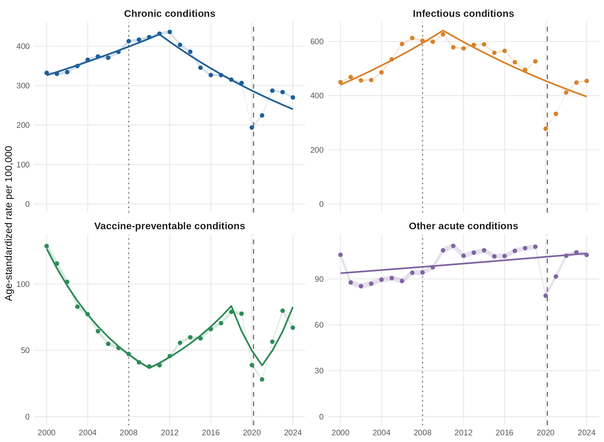
Figure S1. Age-standardized ACSC hospitalization rates by condition category, Ecuador, 2000–2024. Points with 95% confidence intervals; lines show joinpoint models. Dotted line: 2008; dashed line: March 2020.
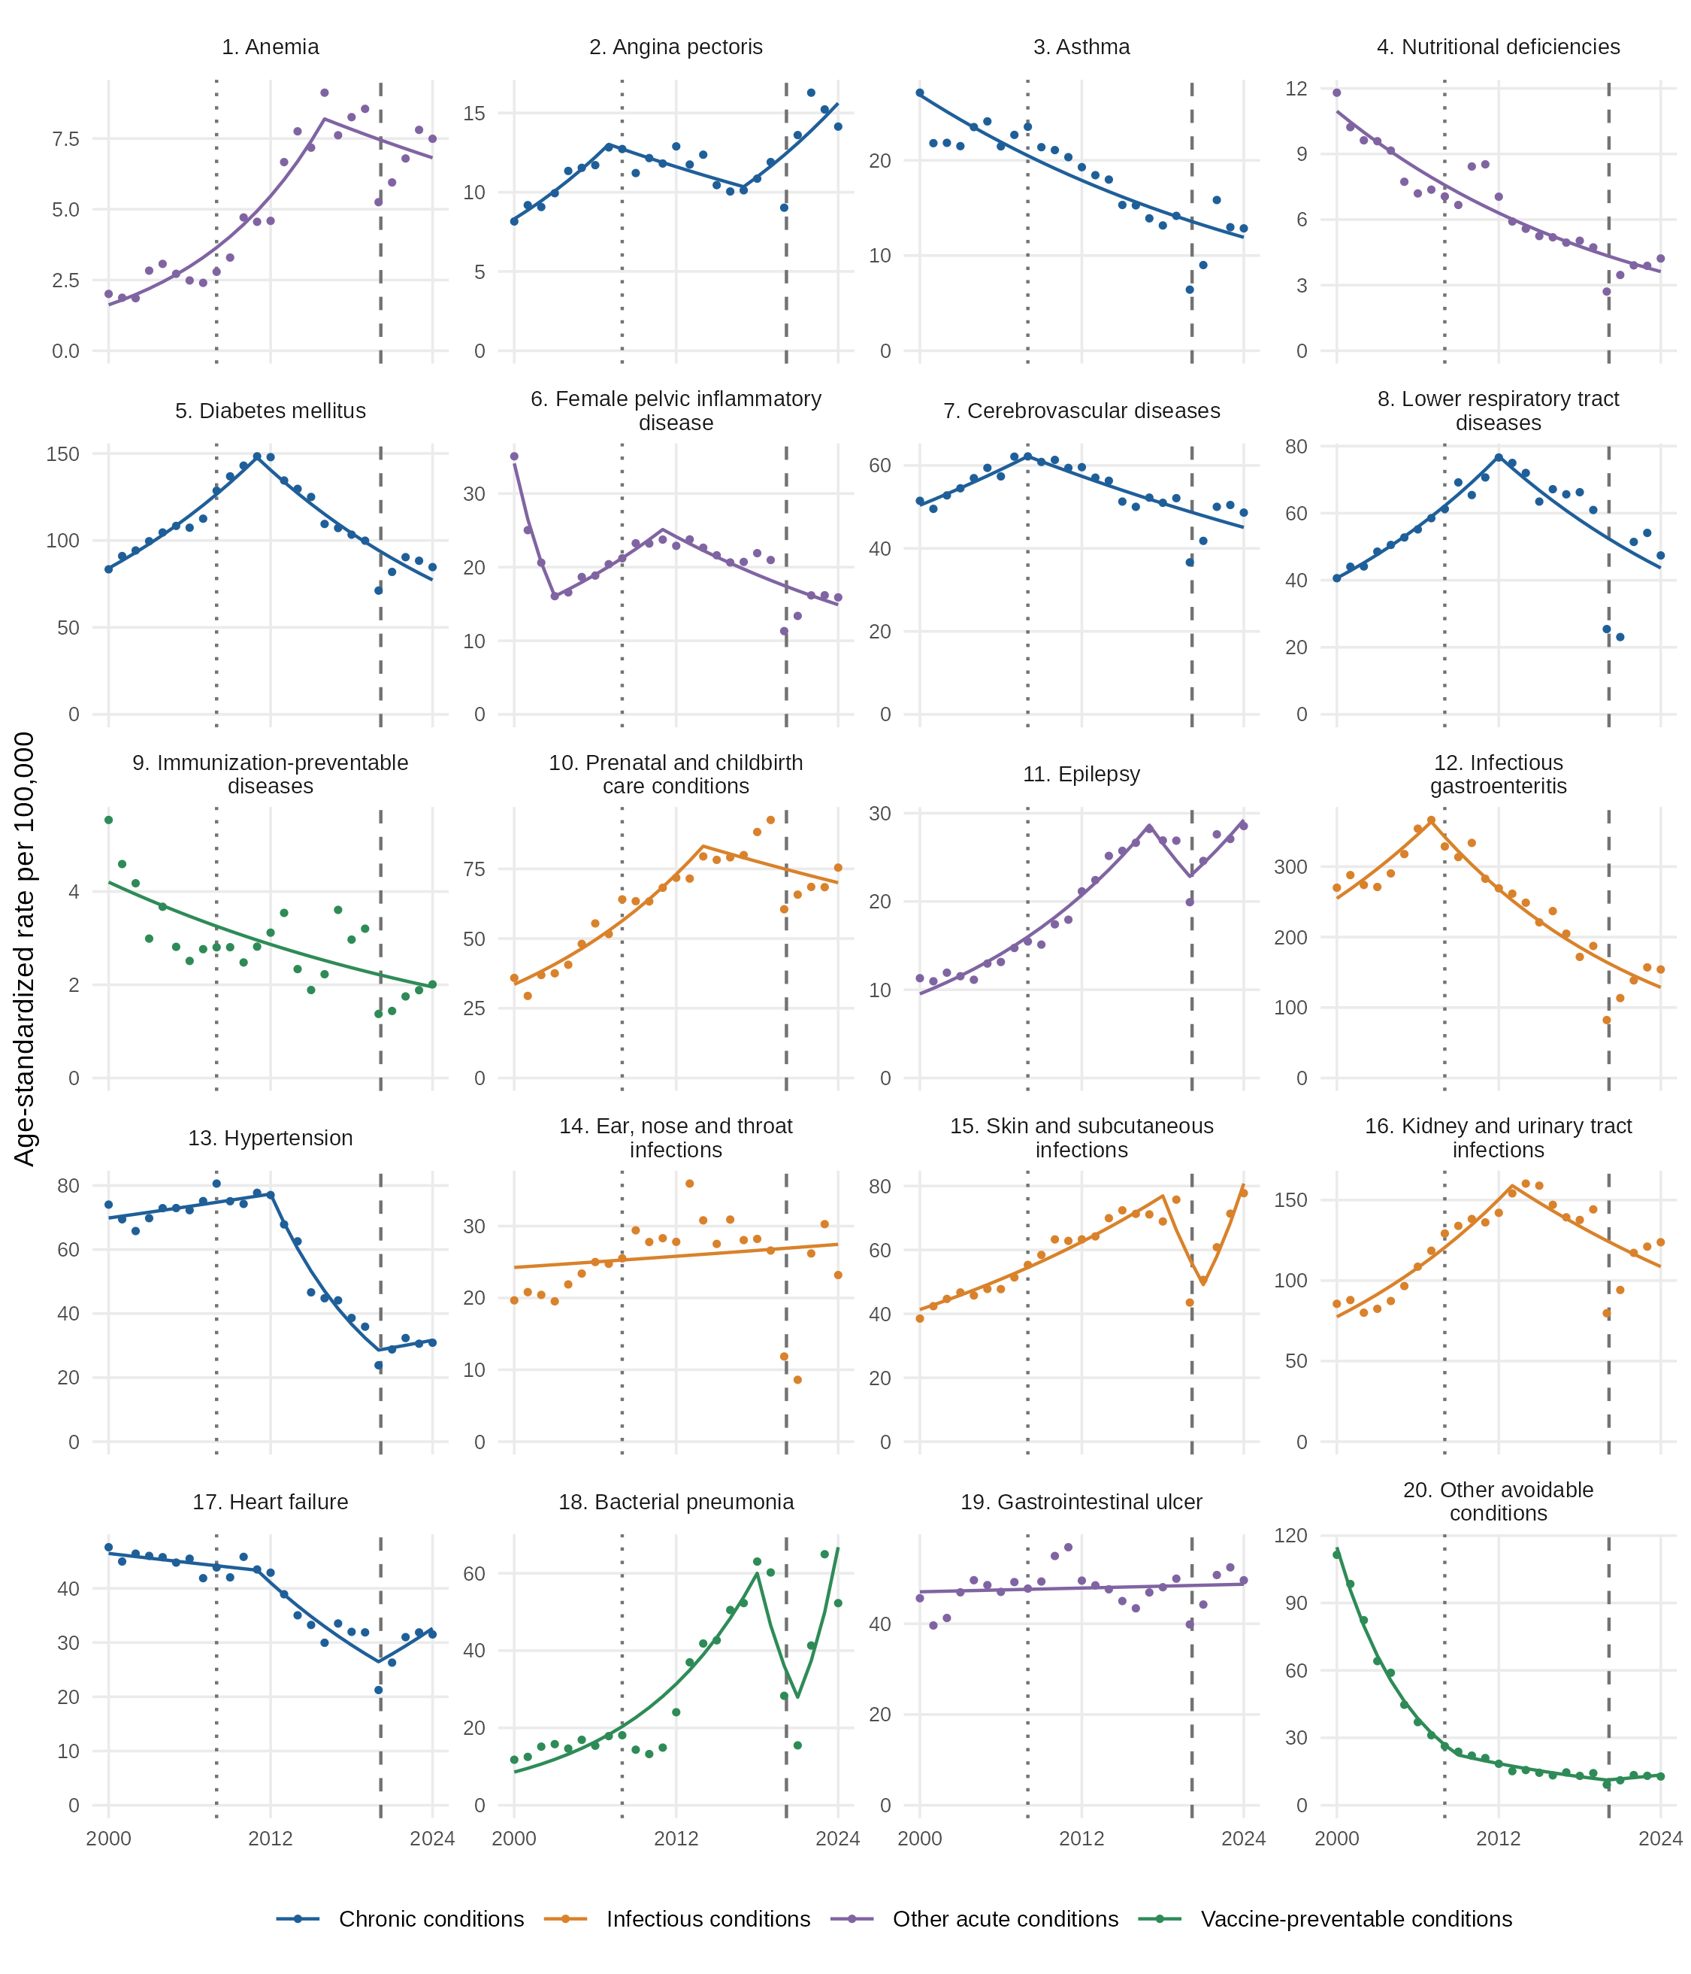
Figure S2. Age-standardized hospitalization rates by ACSC group, Ecuador, 2000–2024. Points show annual rates and lines the joinpoint models; vertical scales differ.
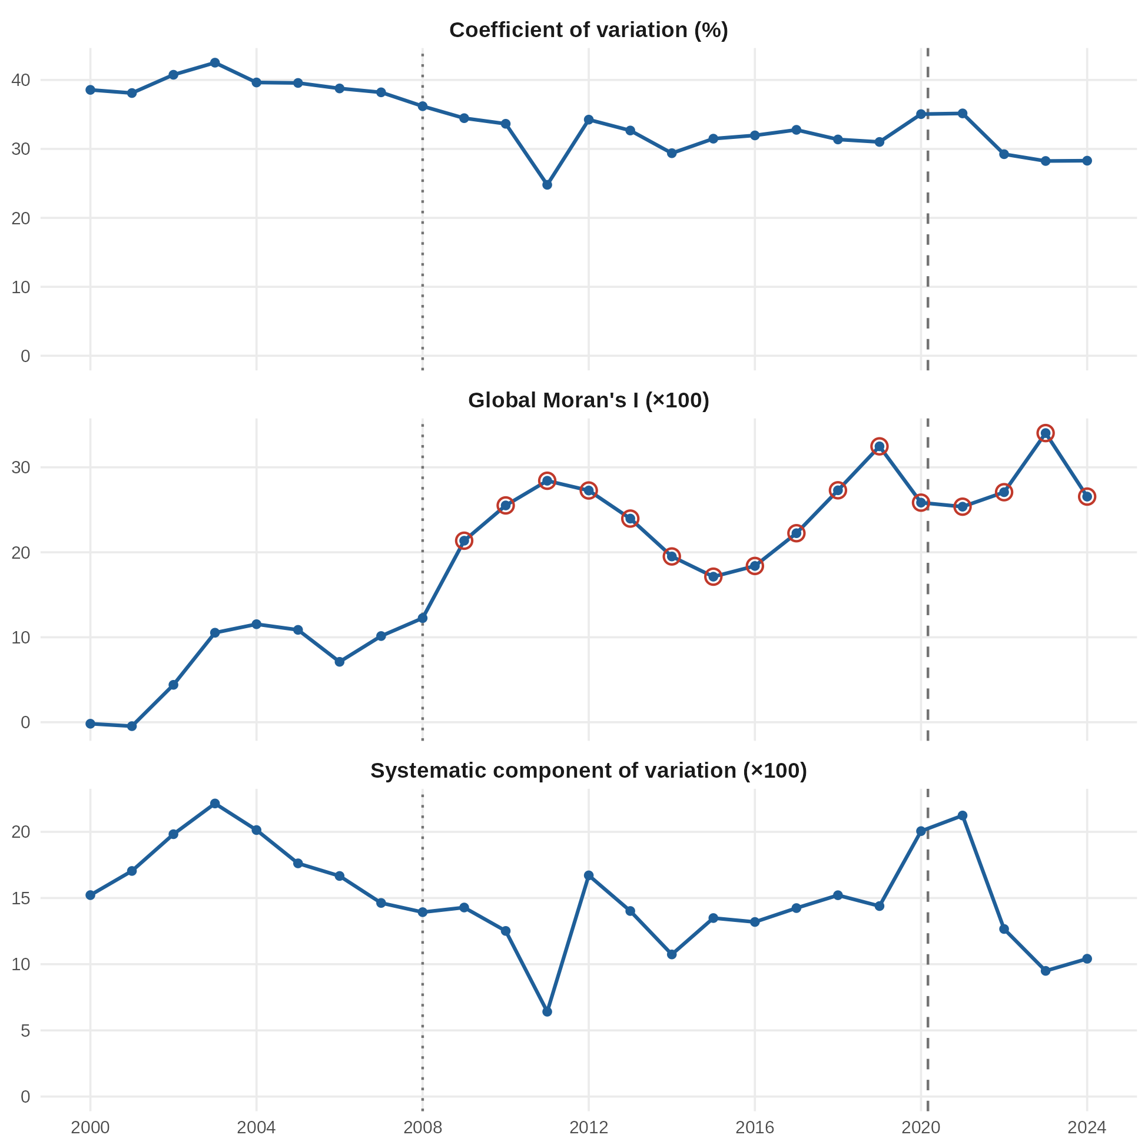
Figure S3. Geographic variation in provincial ACSC hospitalization rates, Ecuador, 2000–2024. Annual coefficient of variation, global Moran's I (circled where p < 0.05) and systematic component of variation.
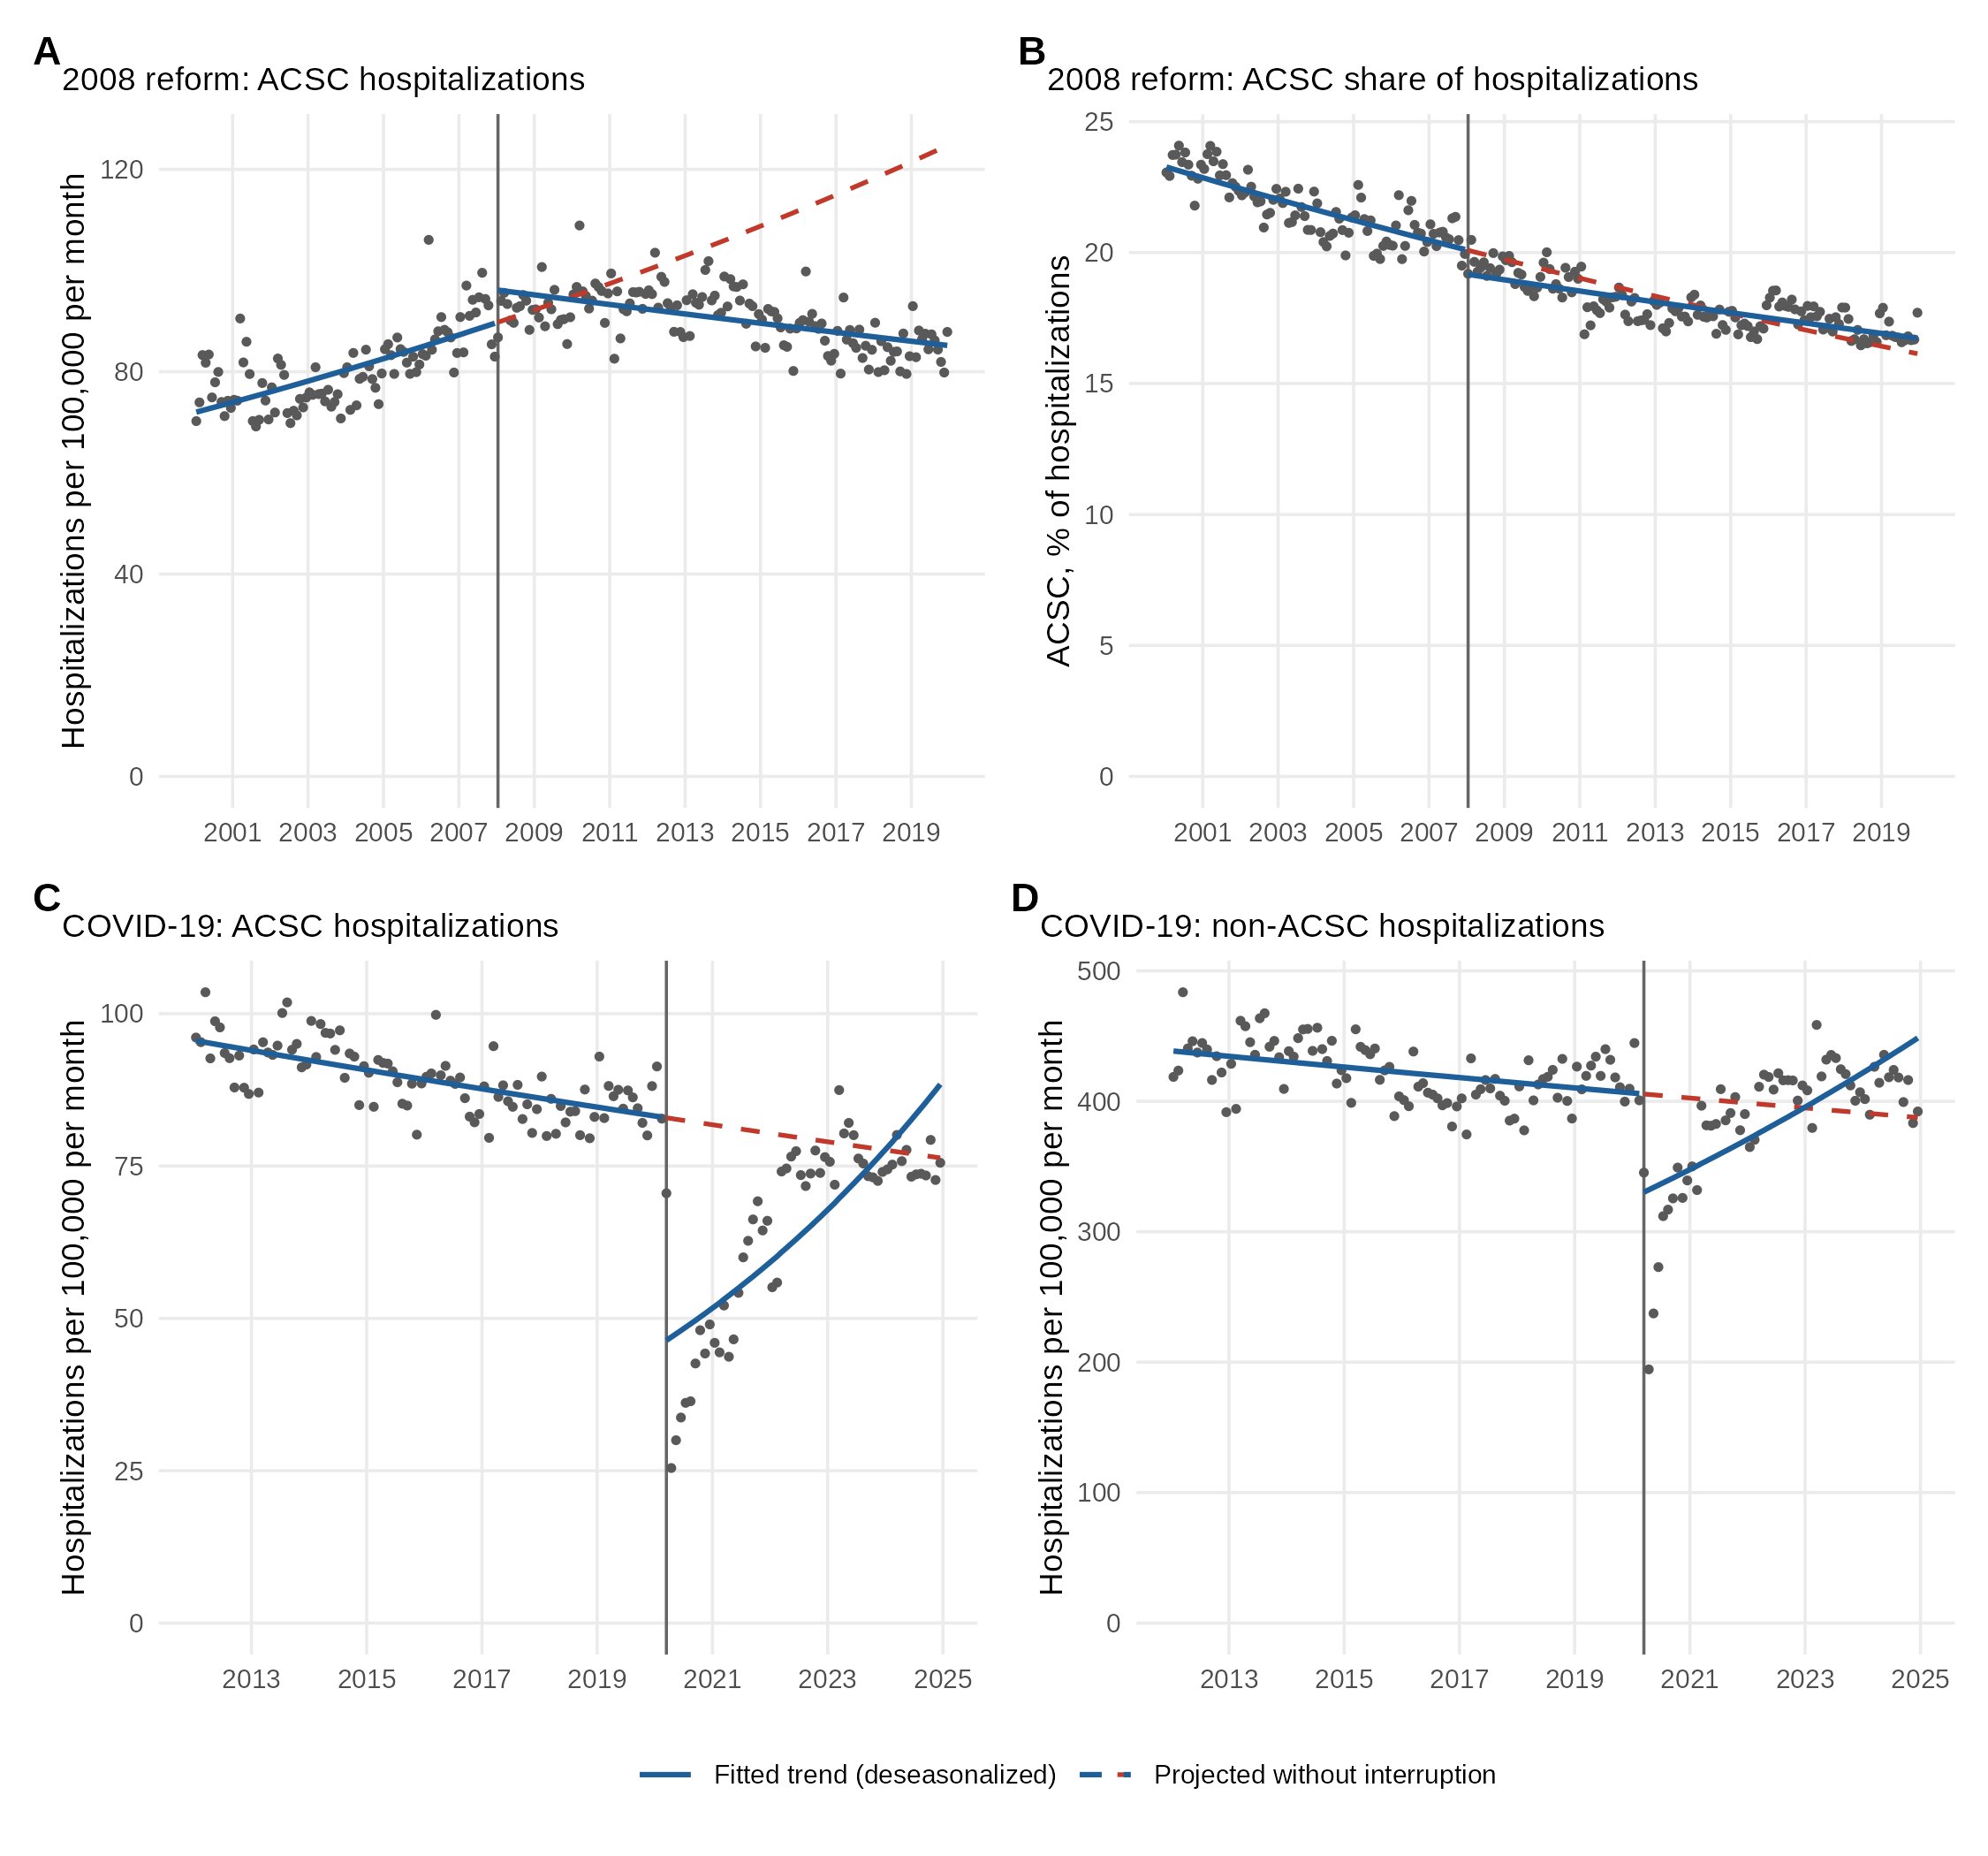
Figure S4. Segmented regression of monthly hospitalizations around the 2008 health reform and the onset of the COVID-19 pandemic. A: ACSC, 2000–2019. B: ACSC as a percentage of hospitalizations excluding deliveries, 2000–2019. C: ACSC and D: non-ACSC hospitalizations, 2012–2024. Solid lines: deseasonalized fitted trend; dashed lines: projection without the interruption.
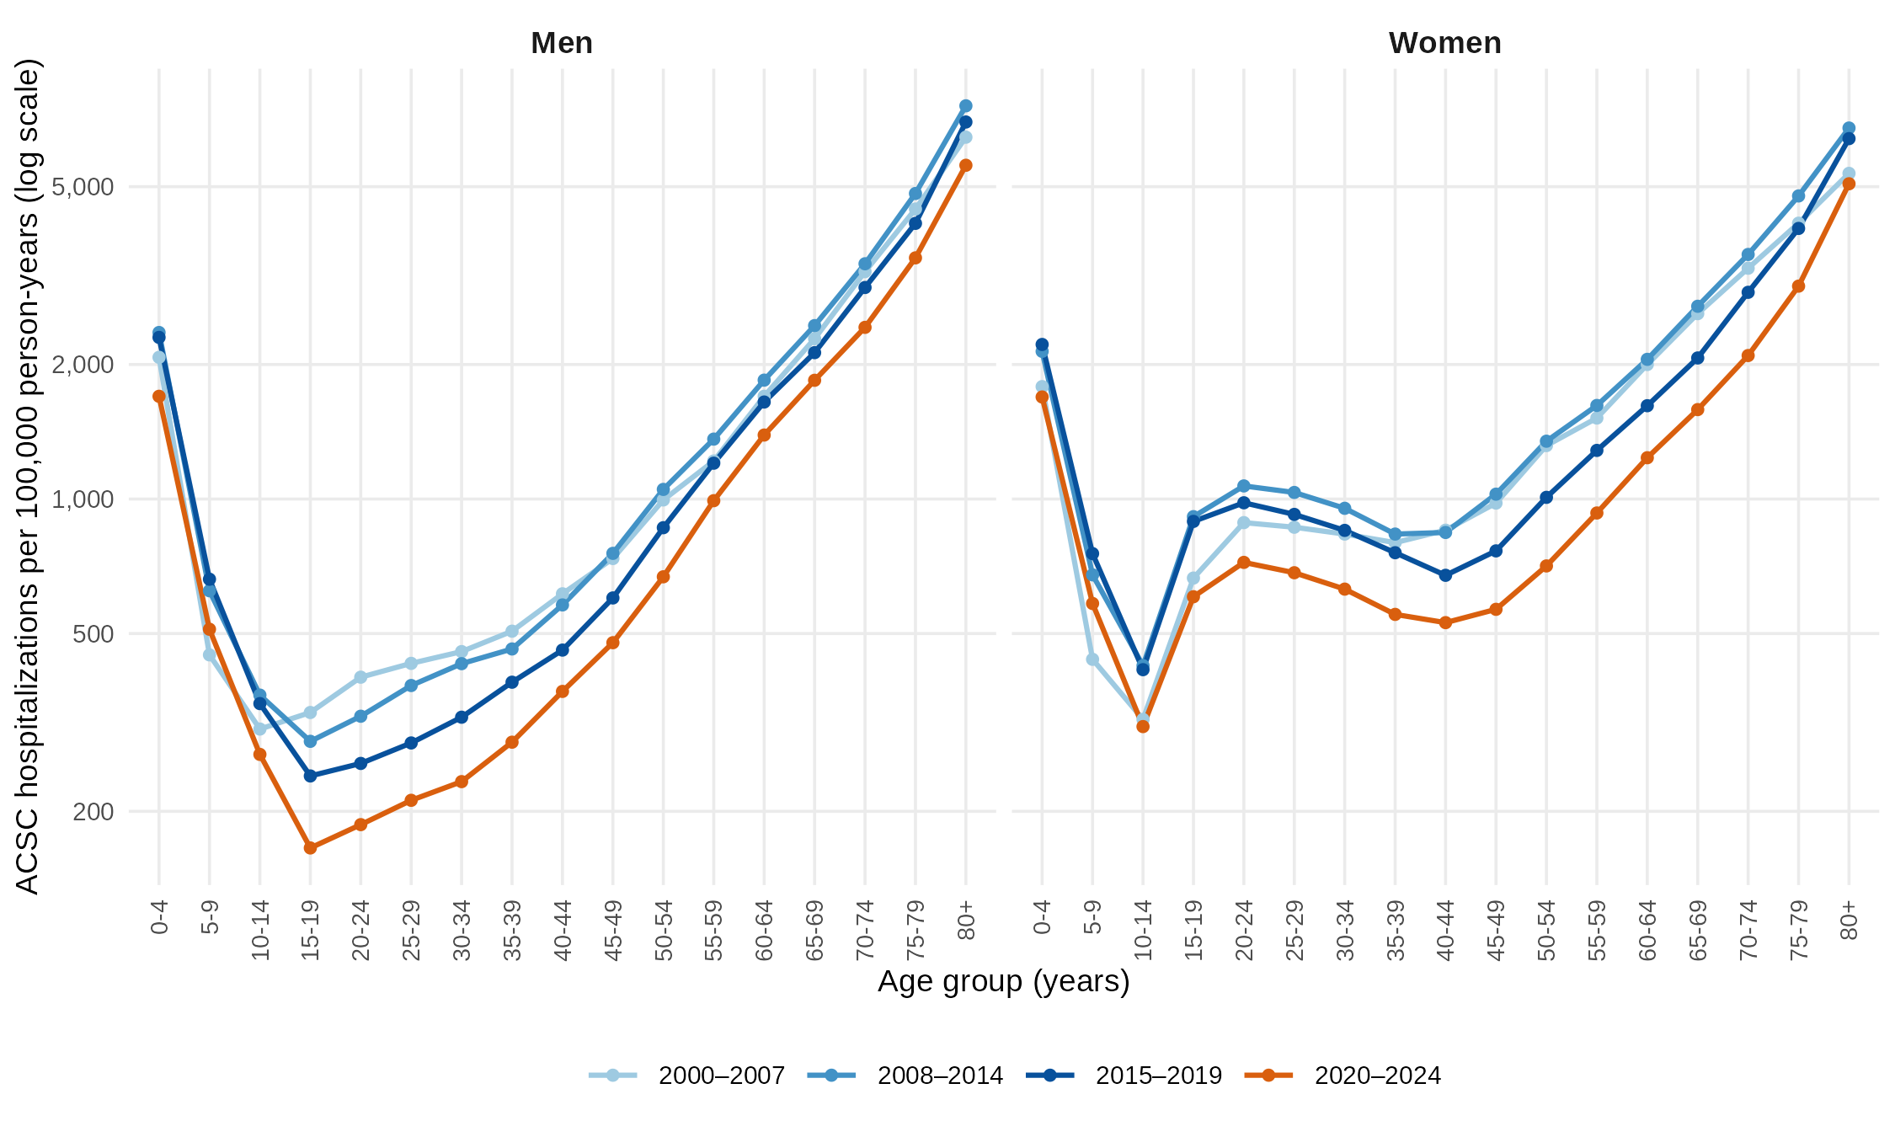
Figure S5. Age-specific ACSC hospitalization rates by sex and period, Ecuador, 2000–2024. Hospitalizations per 100,000 person-years, log scale.
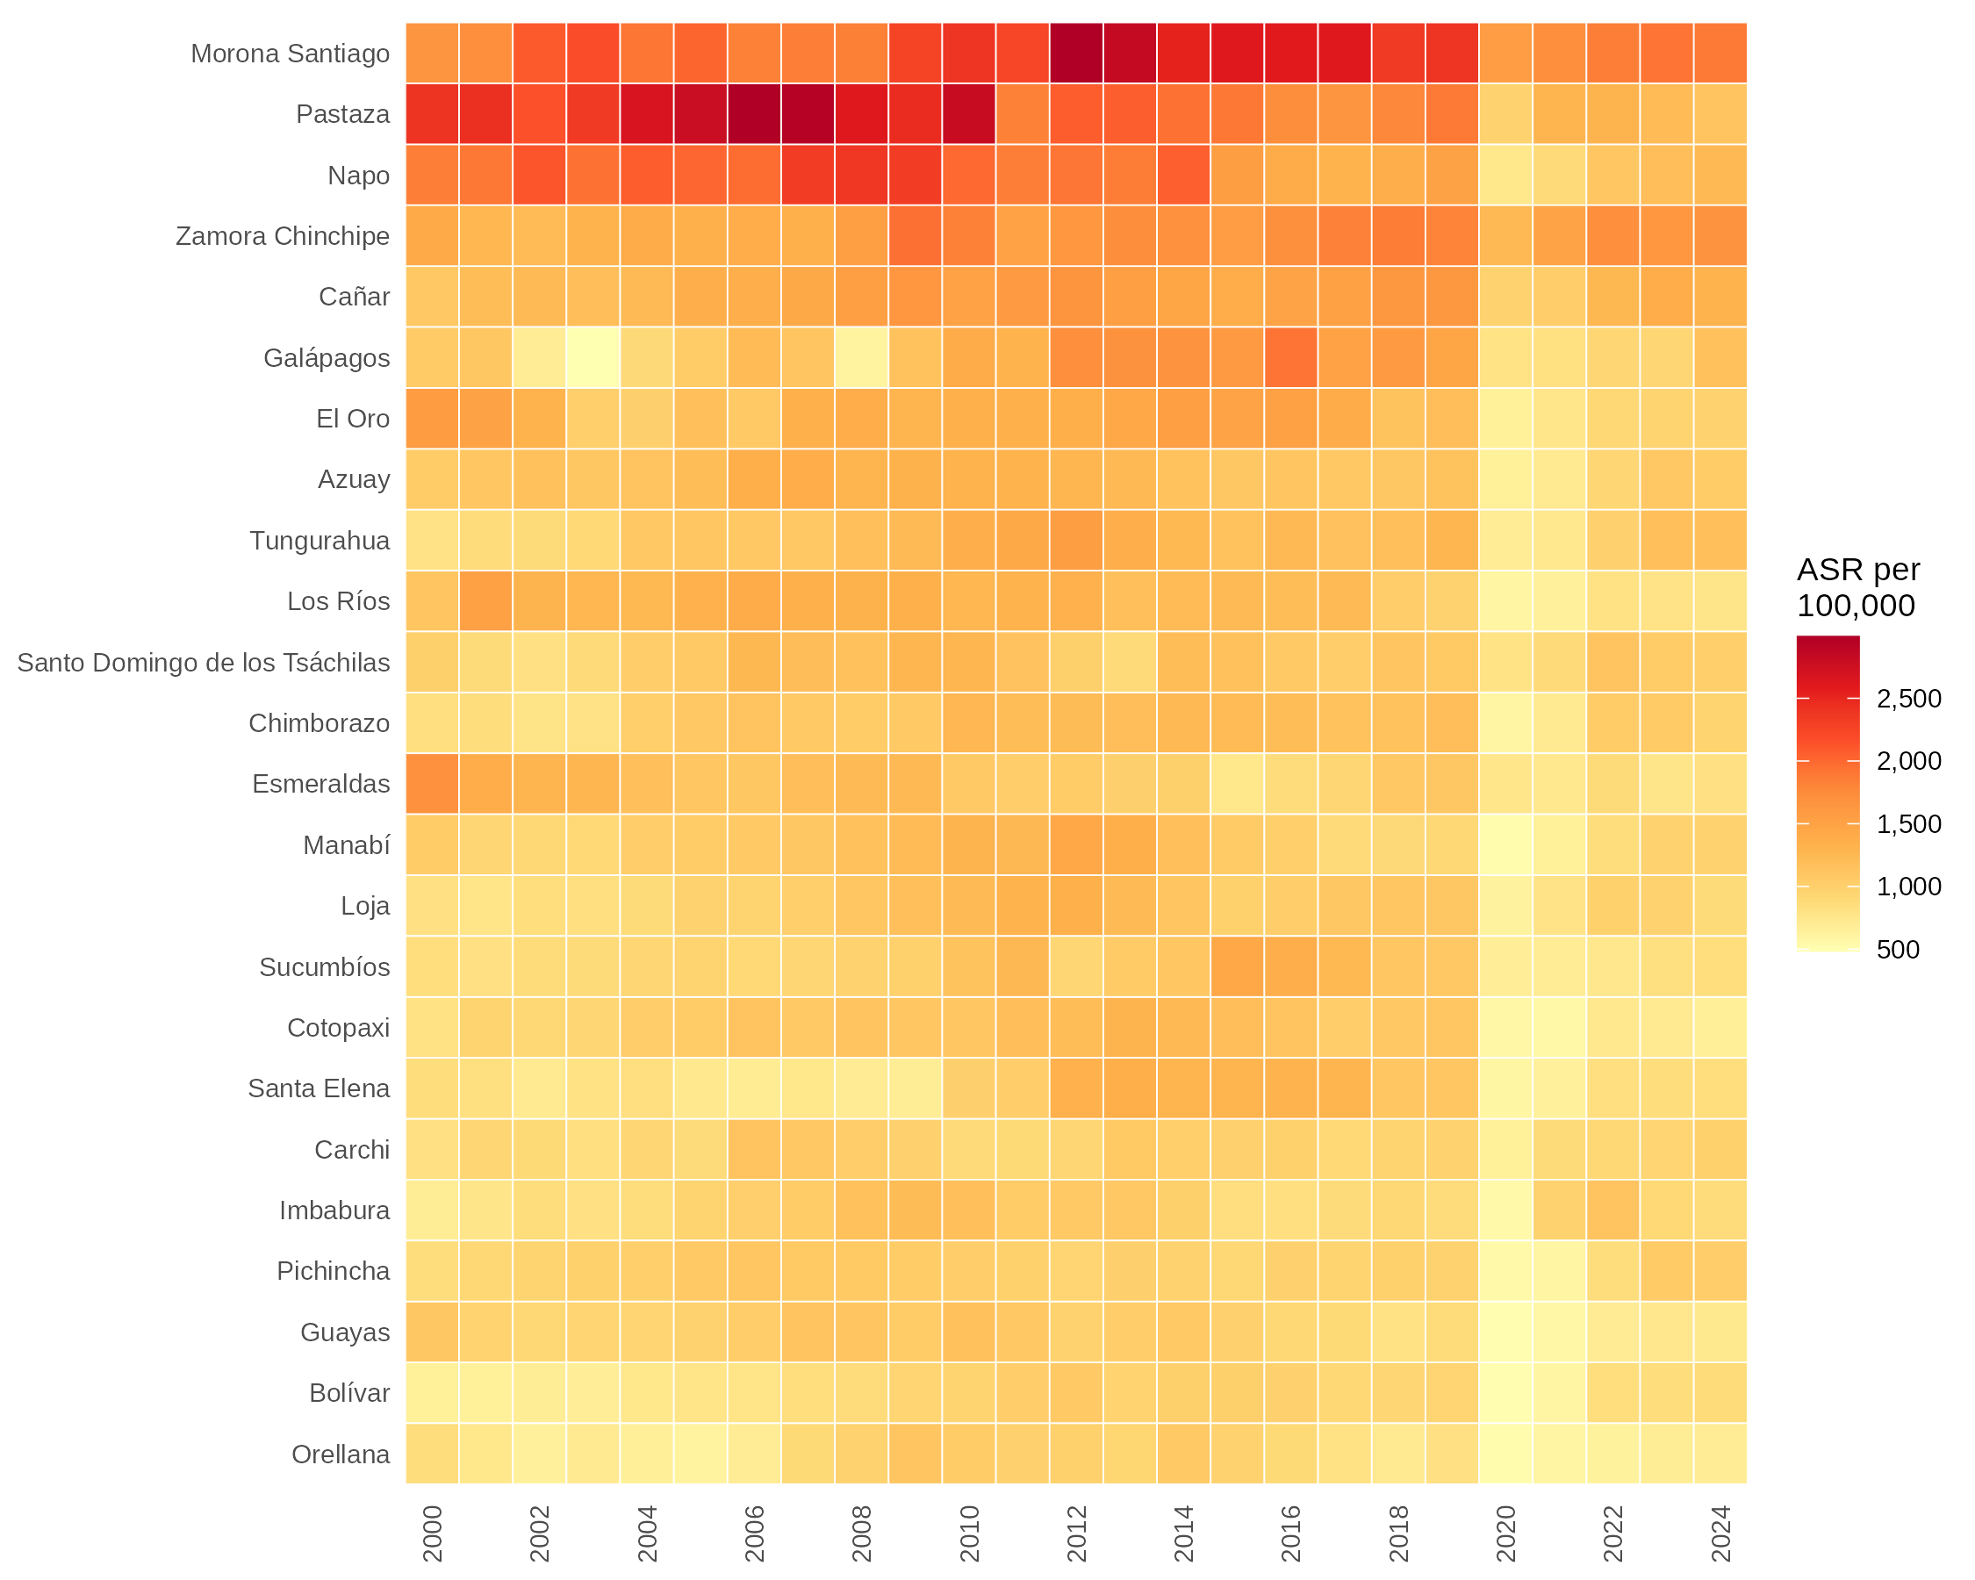
Figure S6. Annual age-standardized ACSC hospitalization rates by province, Ecuador, 2000–2024. Provinces ordered by their rate for the whole period.
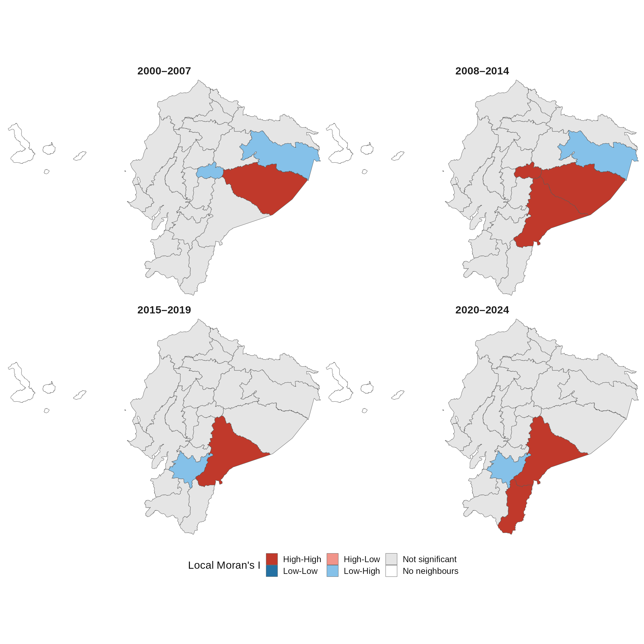
Figure S7. Local spatial clusters of ACSC hospitalization rates by period, Ecuador, 2000–2024. Local Moran's I clusters at p < 0.05, queen contiguity.

