Asset Management System– Oracle Connectivity Test

**URL:** <http://ampi-ams/>

**Asset Number to Test:** 25650, 119066, 26644, 117073

1. Open the **AMS URL** to **Google Chrome browser**
2. Then Click the ‘***Consigned***’ menu.

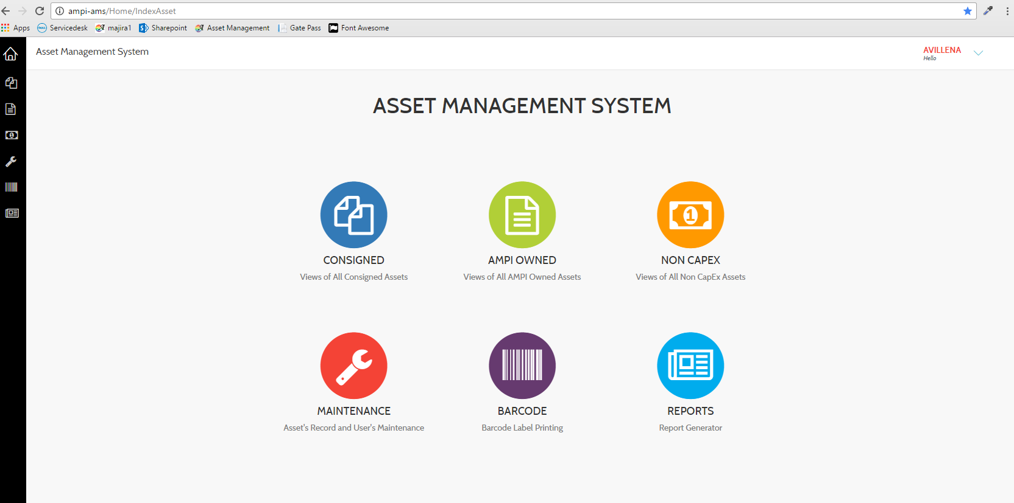

1. Click ‘***Add Record’*** button

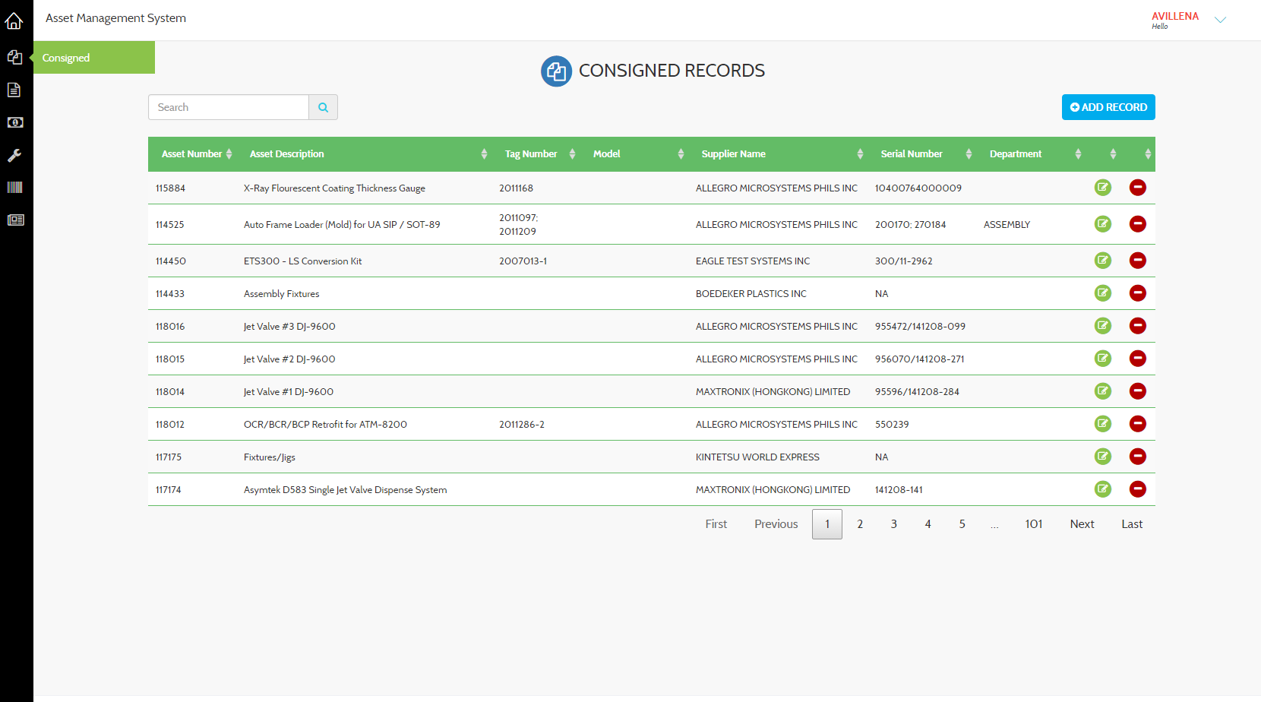

1. Enter *‘****Asset Number****’* to generate/load the Oracle Data.

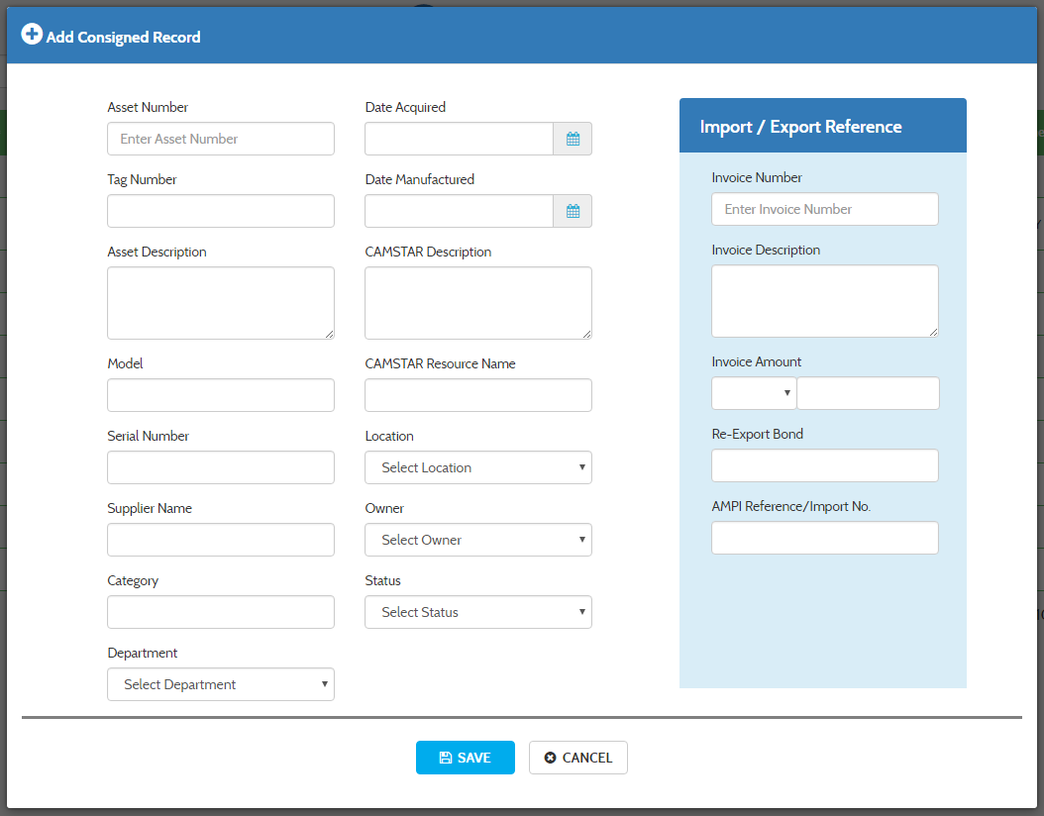

* **Successfully Connected to Oracle**

