GATE PASS

DESIGN DOCUMENT

AUTHOR:
Software Development Team

Table of Content

- Introduction………………………………………………………………………………………………………………………………………….00
  - Objective………………………………………………………………………………………………………………………………………….00
  - Scope………………………………………………………………………………………………………………………………………………..00
  - References………………………………………………………………………………………………………………………………………...00
  - Overview…………………………………………………………………………………………………………………………………………...00

- Architectural Design…………………………………………………………………………………………………………………………..…00
  - High Level and Interaction………………………………………………………………………………………………………………….00

- Component and Detail Design………………………………………………………………………………………………………..…….00
  - Entity Relationship………………………………………………………………………………………………………………………………00
  - Use Case Diagram………………………………………………………………………………………………………………………………00
  - Class Diagram………………………………………………………………………………………………………………………………….…00
  - Database Diagram………………………………………………………………………………………………………………………………00
  - Server Configuration……………………………………………………………………………………………………………………….…..00

IntroDuction

OBJECTIVES
- To Fix the bugs and Errors
- To improved UI/UX
- To have a ‘Maintenance’ module for Approver
- To have an Approval process tracking
- To have an Audit Trail / Transaction Logs
- To have a ‘Reports’ module

Scope
HERE!!!!!!!!!!

Reference – Current process of online Gatepass
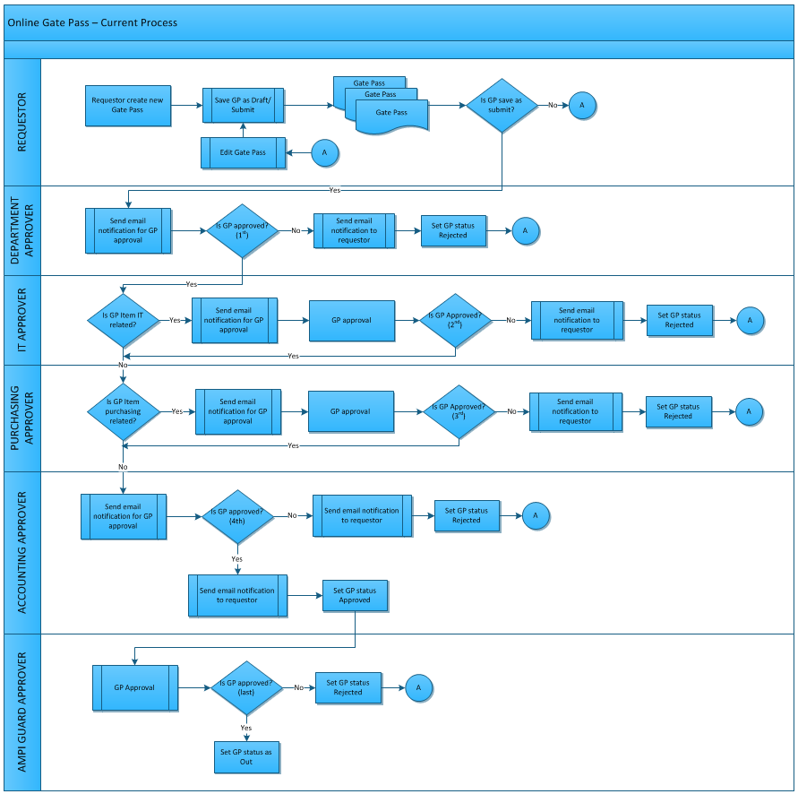

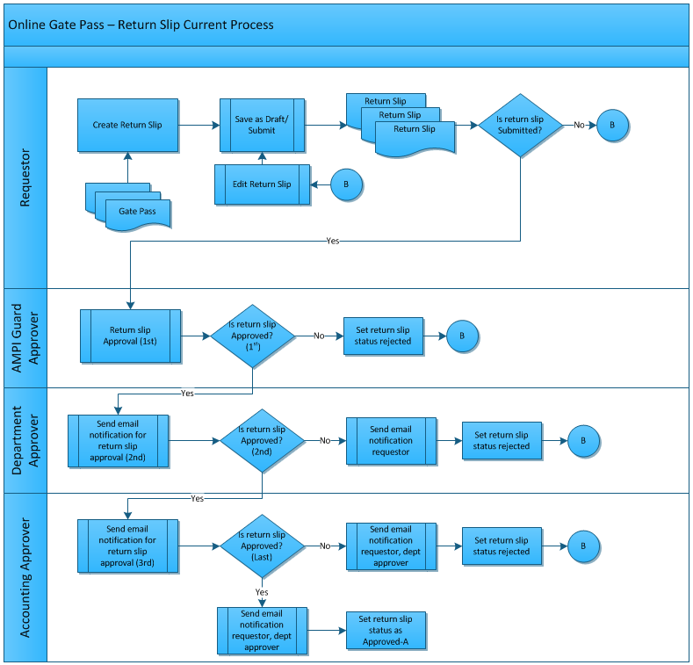

OverView – Gate pass Manual process
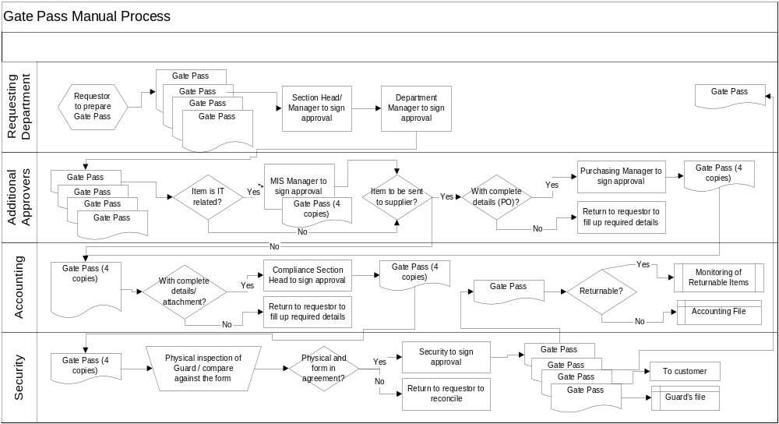

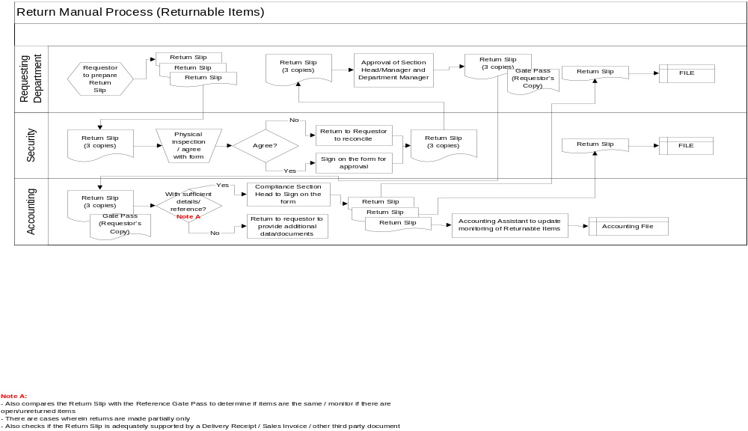

architictural design

High level and interaction

My transactions – Create Gate Pass As draft  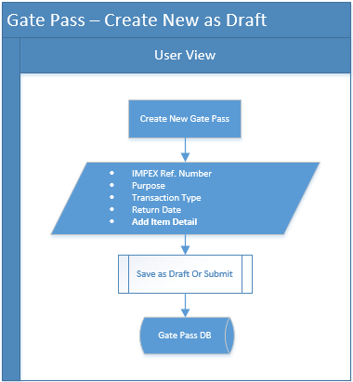  My Transaction (Save as Draft)  Primary Actor: User  - User Click the ‘Create New’ button in My Transaction module.  - Create New Gate Pass Request form show.  - The user need to fill up the required field details  - Then user click the ‘Add Item’ button to enter the required Item details then click ‘Save’.  - Then Click the ‘Save as Draft’ button.  My transactions – Return slip  - High Level chart here!!!!  My Transaction (Return slip)  Primary Actor: guard  - Guar can search the Return Slip details to easy to find the record  - Then guard click the ‘Item Details’ button to show the list of item details.  - Click the check box of the item you want to return.  - Then Click the ‘Return’ button.  - Confirmation modal will show  - Then click ‘Yes’ button to successfully return the item and the department and accounting approver will be notify through email.  My transactions – Attached file  - Attached high level chart here!!!!  My Transaction (Attached File)  Primary Actor: User  Note: The user can attached file per Gate Pass and per Add Items for reference, Only picture file (.jpg, .png) allowed for per Items while per Gate Pass any kind of files.  - Attached file per Gate Pass  - Click the ‘Choose file’ button to upload files  - Browse and select any kind of files then click ‘Open’ button  - Then files successfully uploaded  - Attached file per Items  - On the Add Item modal, User Click the ‘Choose file’ button  - Browse and select only picture file (.jpg and .png) then click ‘Open’ button  - Then picture successful uploaded | UI SCREENSHOT  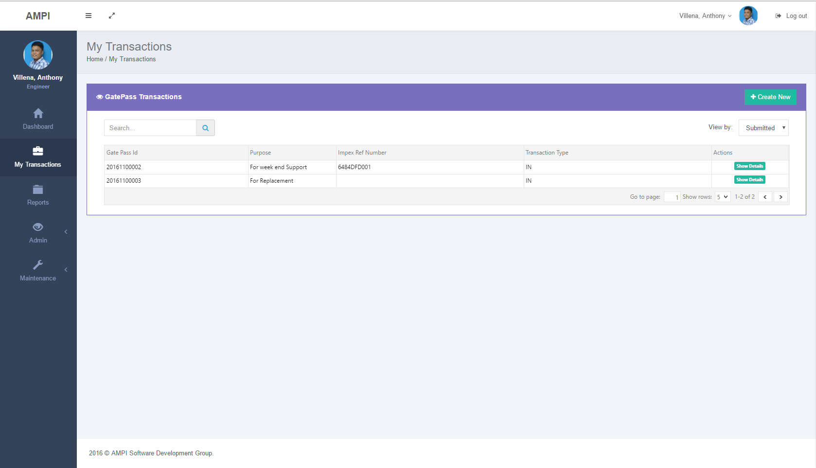  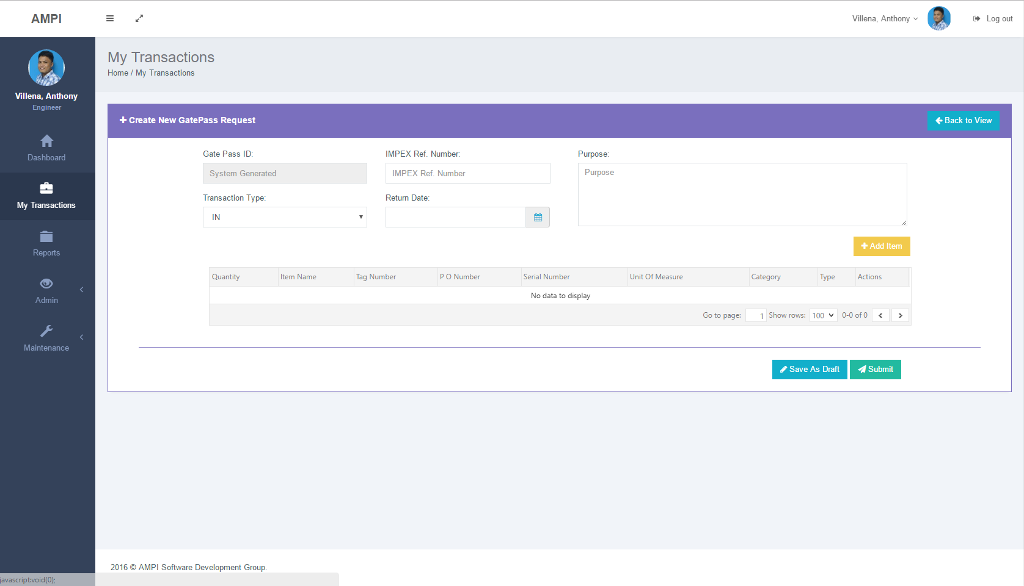  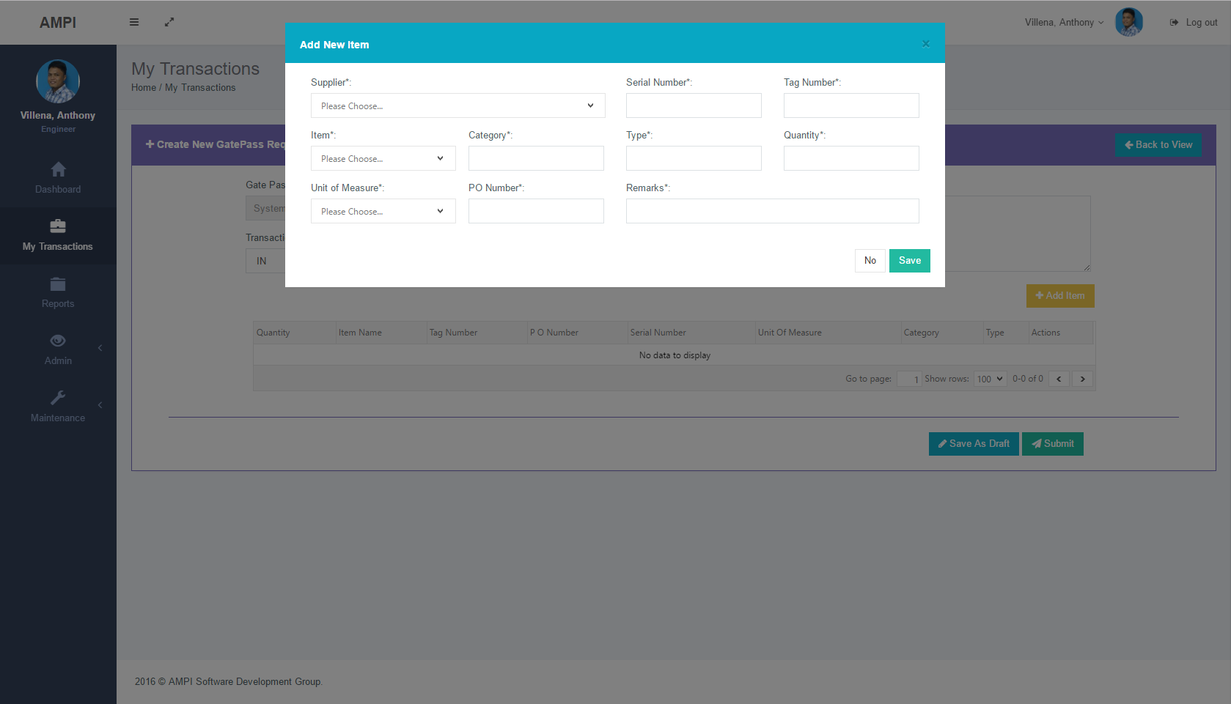  UI SCREENSHOT  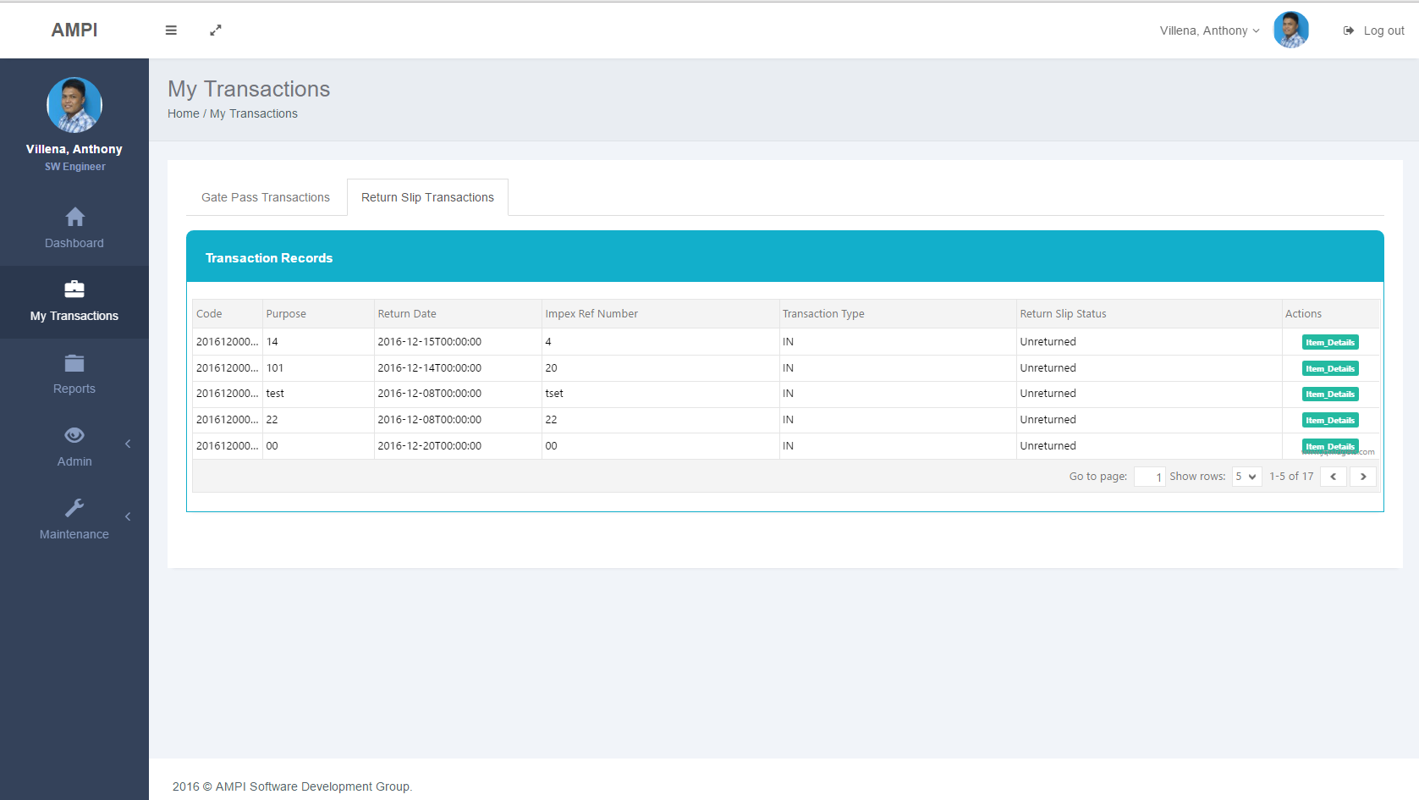  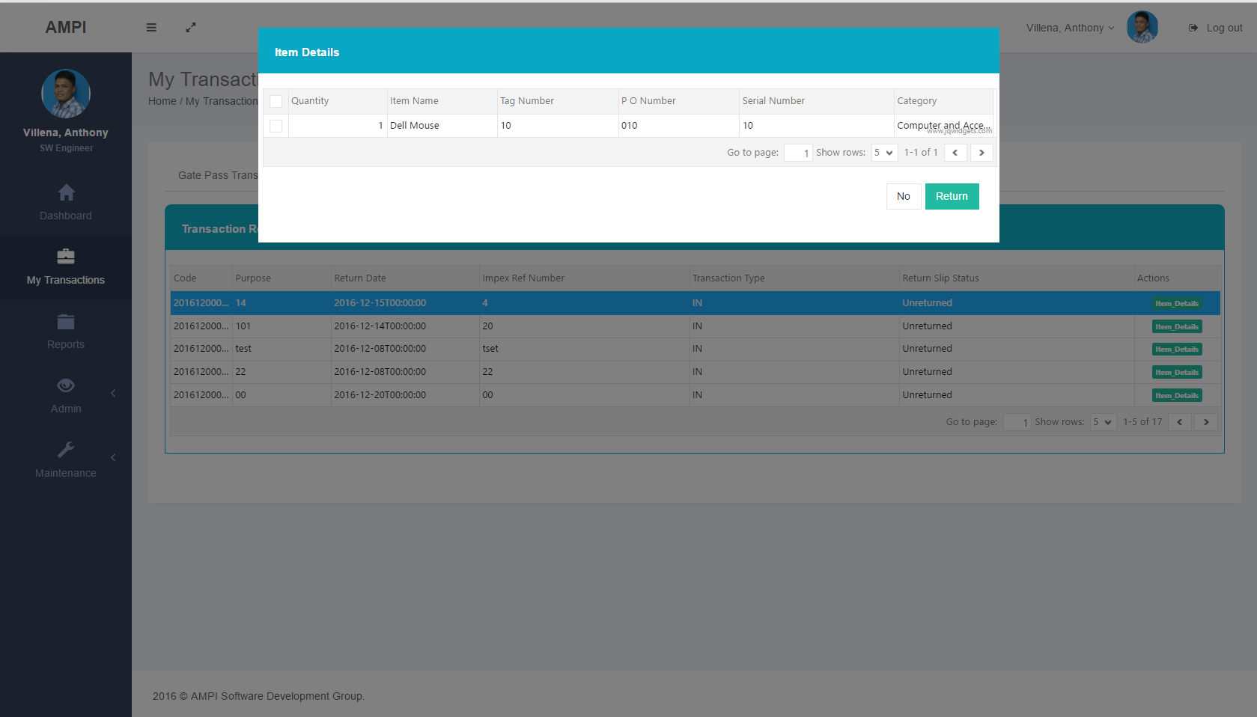  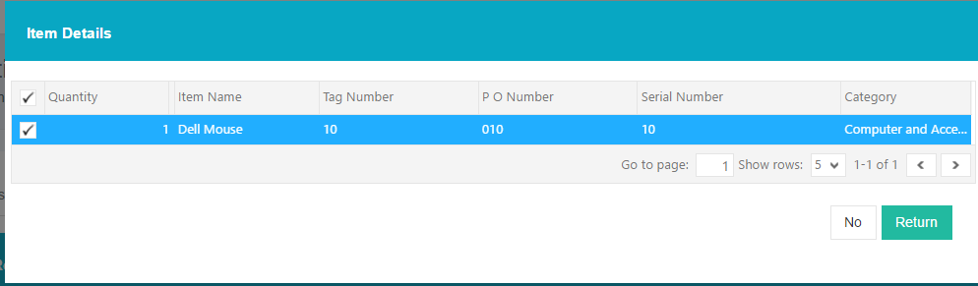  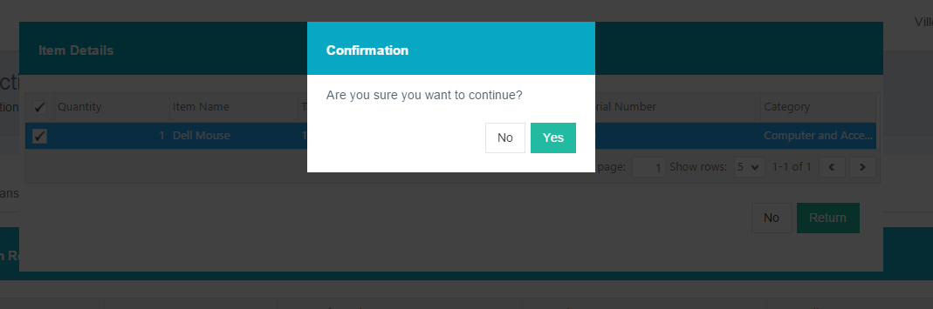  UI SCREENSHOT  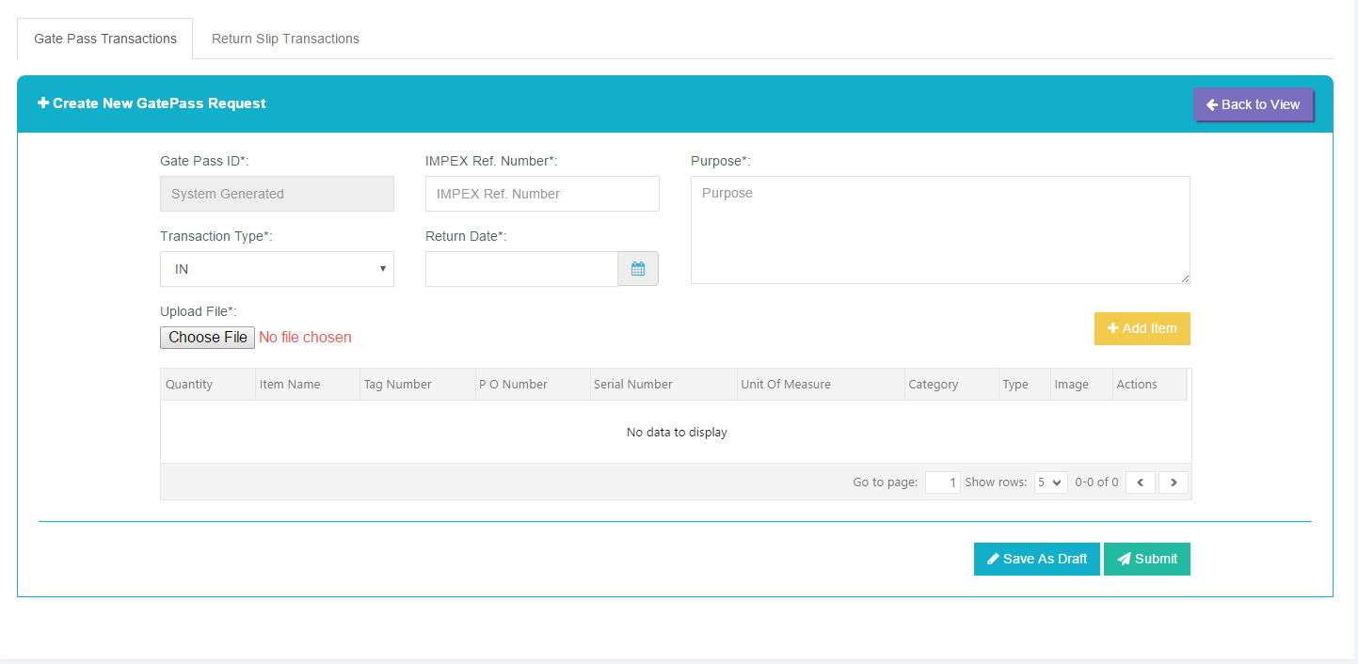  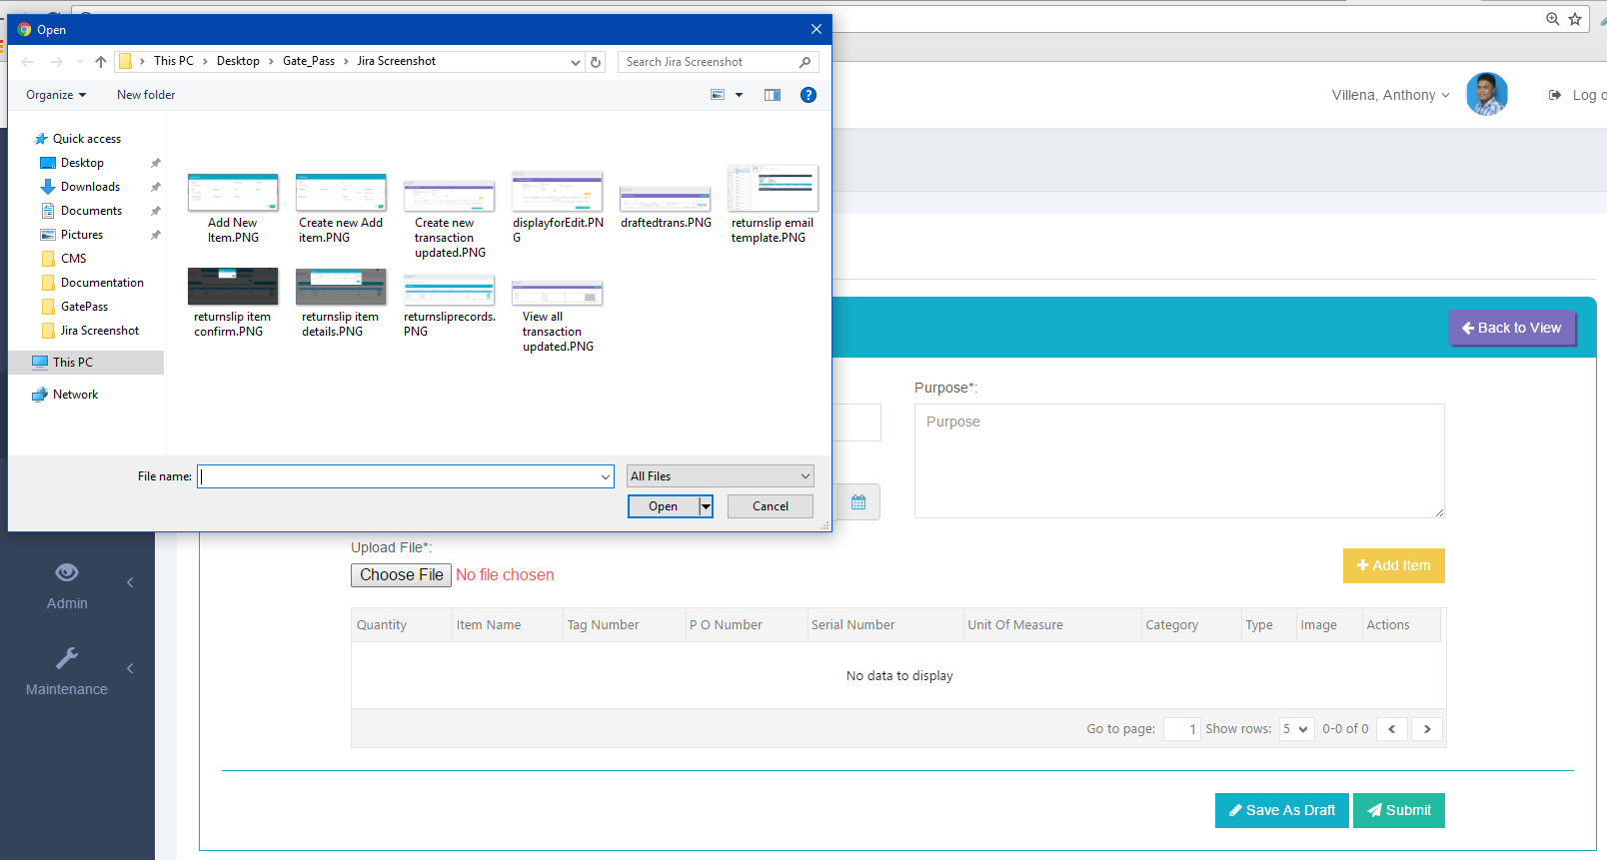  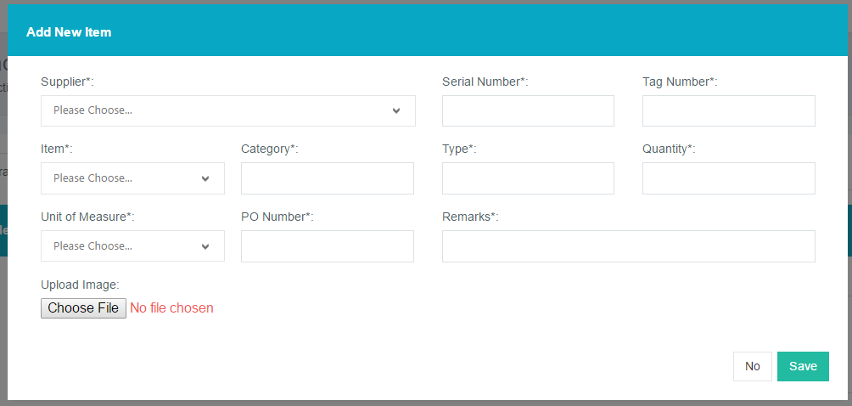  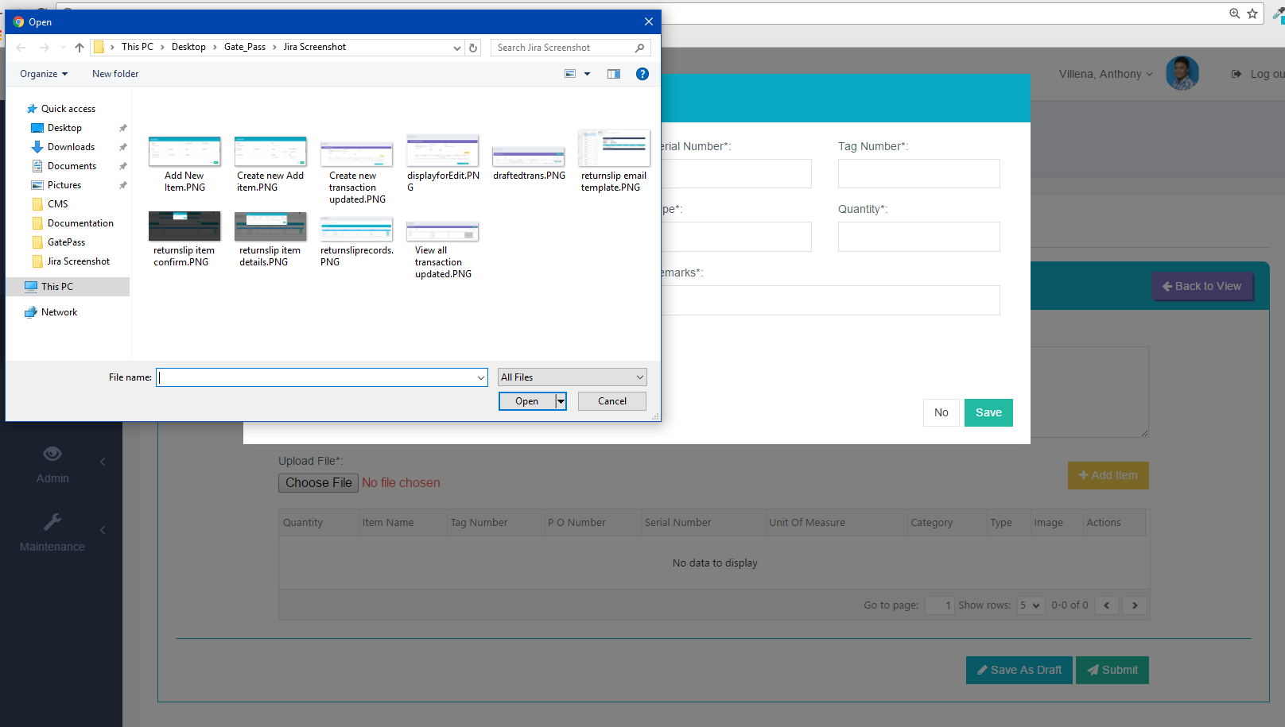

Maintenance – add, EDIT and INACTIVE supplier company  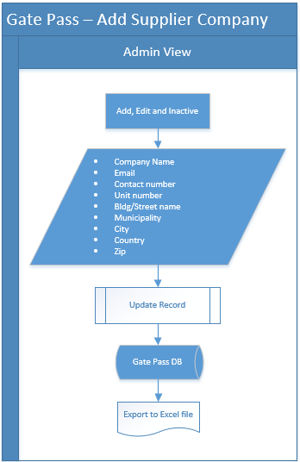  MAintenance (add, edit and inactive)  Primary Actor: admin  - Add Record  - Admin can Add record by clicking the ‘Add Record’ button.  - Then fill up the required company details  - Then click ‘Save’ button.  - Update Record  - Click the ‘Edit’ button to automatically load the details of the record you want to update  - Then edit the record you want to update  - Then click ‘Update’ button.  - Inactive Record  - Click the ‘inactive’ button  - Then confirmation modal will show  - Then click ‘Yes’ button to deactivate the record.  Maintenance – add, EDIT and INACTIVE Contact person  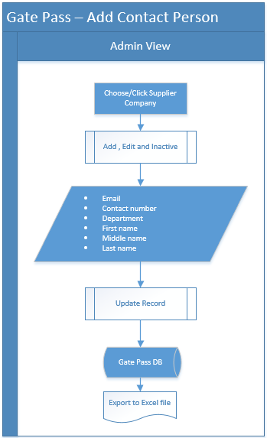  - Add Record  - Click the details of supplier company to the data grid you want to Add contact person details  - Then click ‘Add Records’ to show the Add record modal  - Then fill up the required fields of contact person  - Then click ‘Save’ button to add new records  - Update Record  - Click the ‘Edit’ button to automatically load the details of the record you want to update  - Then edit the record you want to update  - Then click ‘Update’ button.  - Inactive Record  - Click the ‘inactive’ button  - Then confirmation modal will show  - Then click ‘Yes’ button to deactivate the record  Maintenance – add, EDIT and INACTIVE Contact person  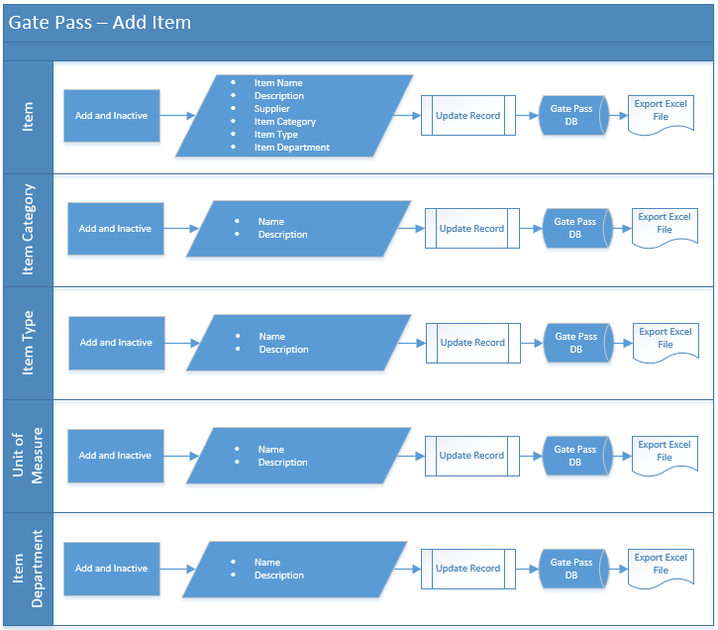  - Items, Item Category, Item Type, Unit of Measure and Item Department  - Add Items, Item Category, Item Type, Unit of Measure and Item Department  - Click ‘Add Record’ button to show the Add form modal  - Fill up the required field of Item details  - Then Click ‘Save’ button  - Add Items, Item Category, Item Type, Unit of Measure and Item Department  - Click the ‘Inactive’ button  - Confirmation modal will show  - Click ‘Yes’ button to deactivate the record | UI Screenshot  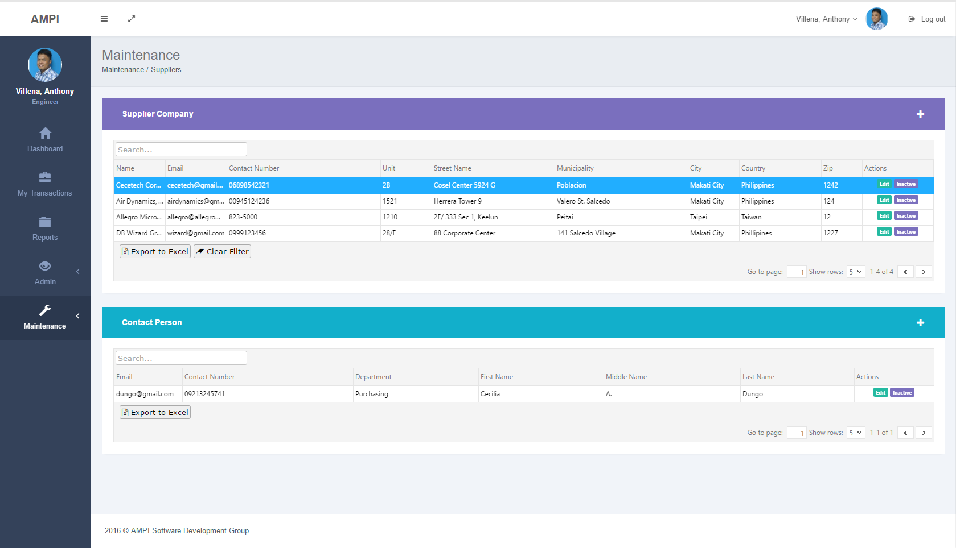  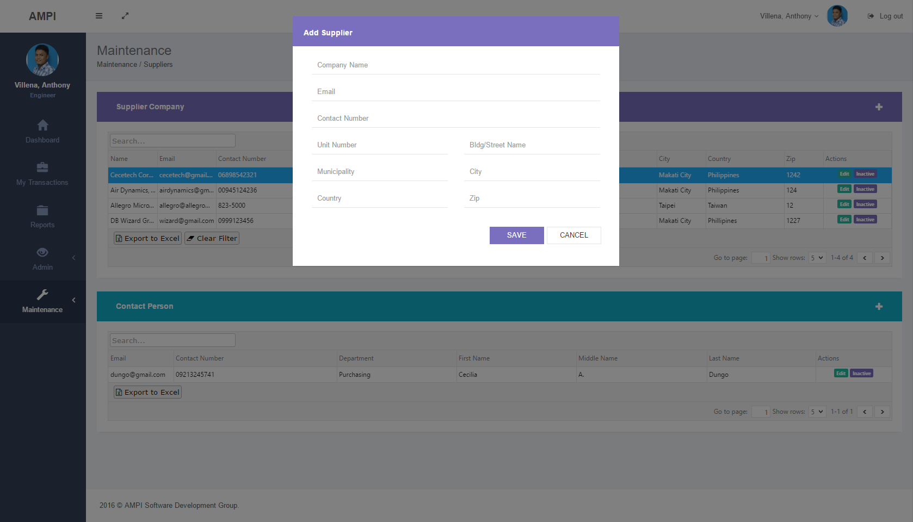  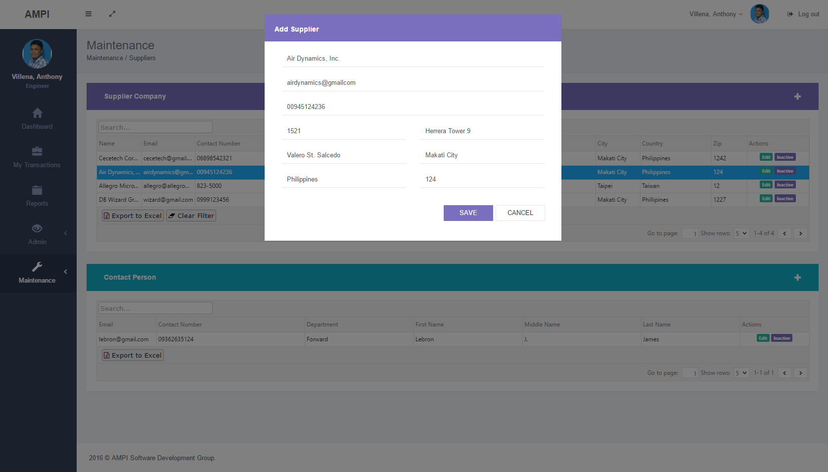  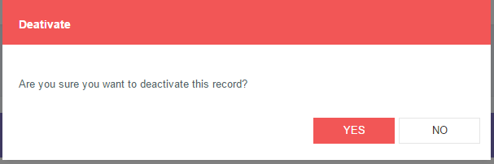  UI Screenshot  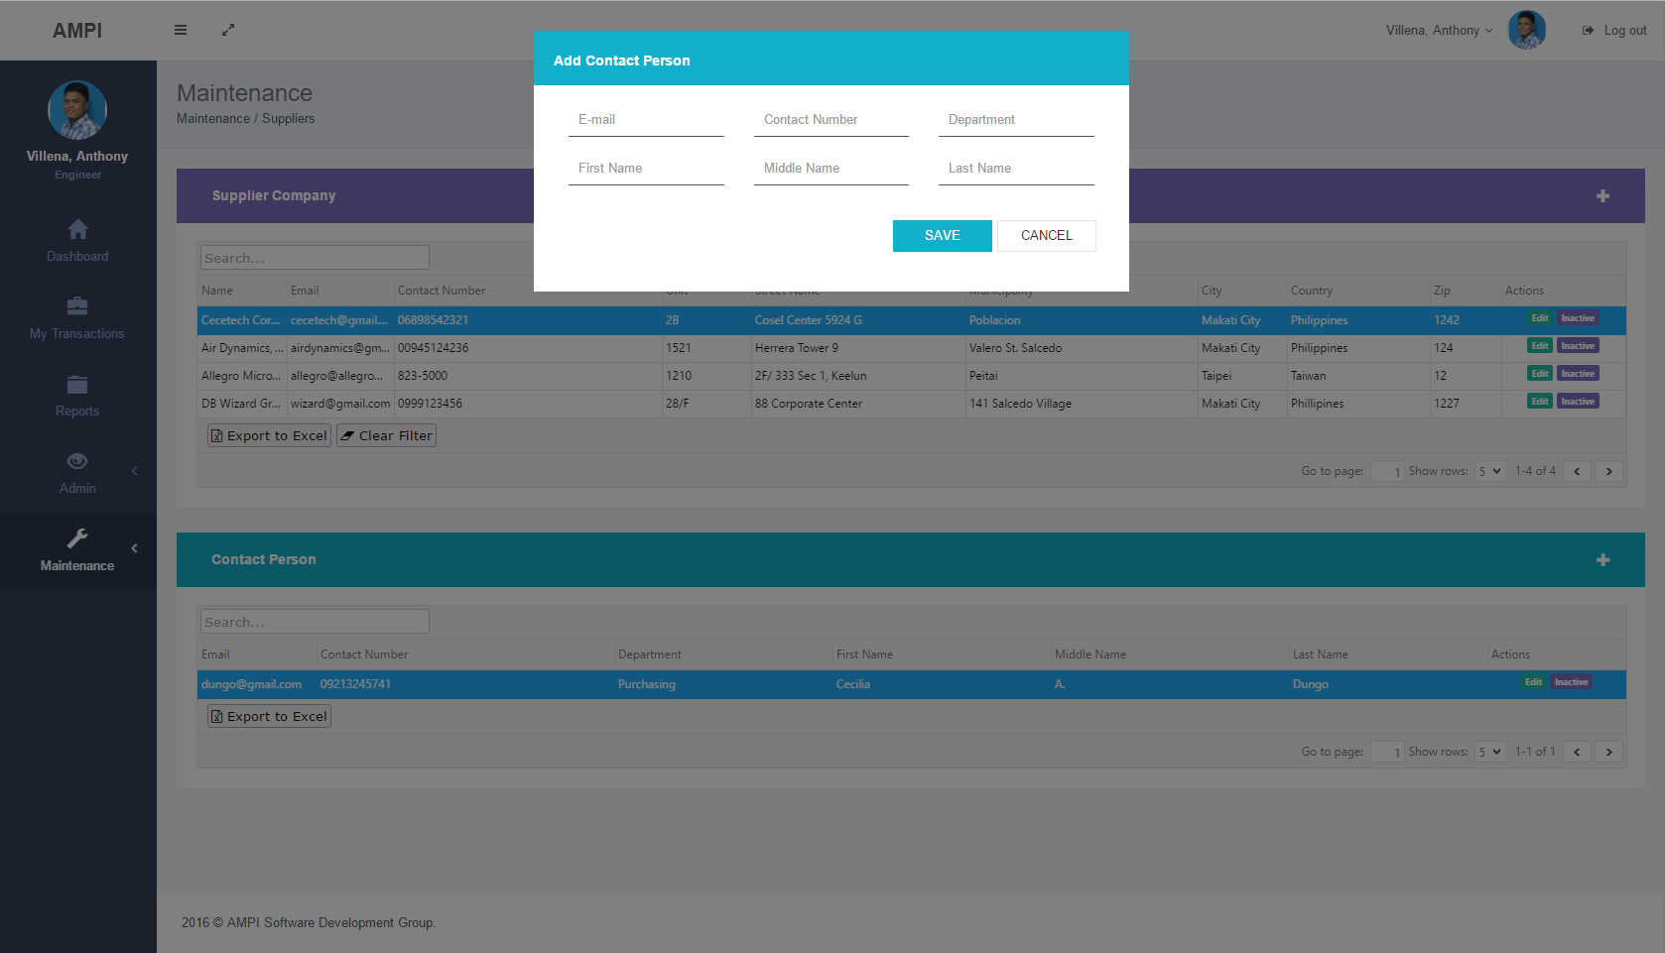  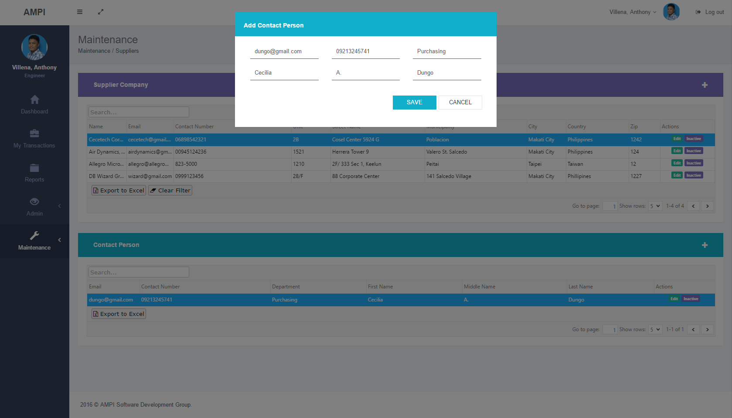  UI Screenshot  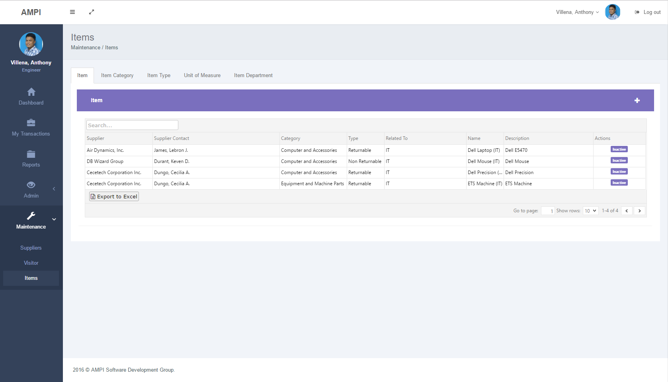  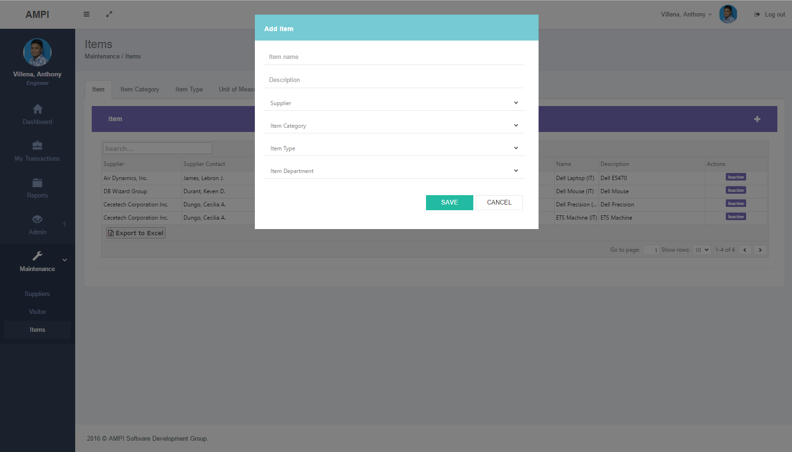  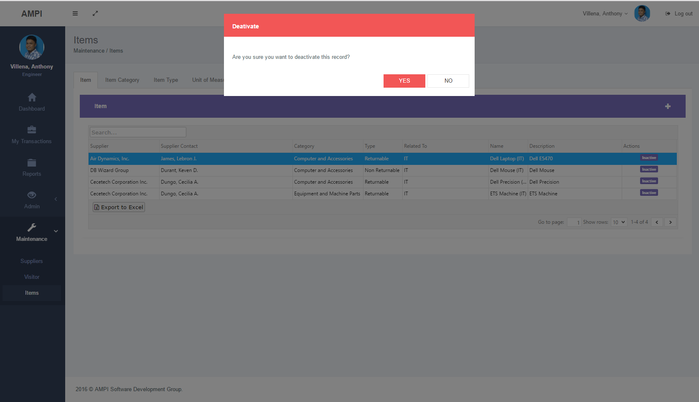

component and details design

entity Relationship
HERE!!!

Use Case Diagram
HERE!!!

class diagram
HERE!!!

database diagram
HERE!!!

server configuration
HERE!!!

