In a company-wide effort to reduce and manage LiRo’s WIP and ARs, the Accounting Department will provide a biweekly extract of the WIP and ARs to 1) Project Managers (PM), 2) Business Unit Heads (BUH), and 3) the Business Unit Financial Managers (BUFM). The WIP and AR Extract will highlight the projects where the WIP is either greater than 60 days and/or the ARs are greater than 90 days. Project Managers will be responsible for investigating the cause of the WIP and/or AR delays and for updating Vision with specific comments. The Business Unit Heads and/or Business Unit Financial Managers will be responsible for ensuring that Project Managers are following up on their WIP and ARs.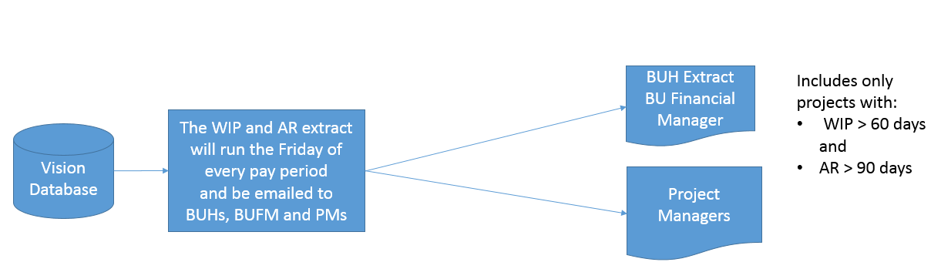

The data highlighted in pink are the data that require comment.

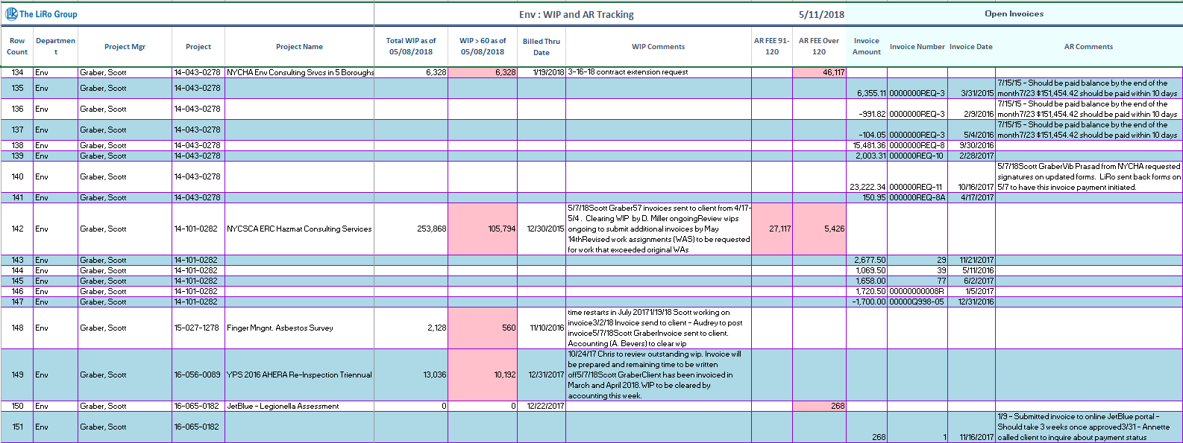

The data that causes the project to be included in the extract are shaded pink

The WIP comments from Vision are displayed at the project level

The AR comments from Vision are displayed for open invoices older than 120 days along with the invoice date, invoice number, and invoice amount

**Monthly WIP and AR Timeline for PMs:**

1. The WIP and AR Extract will run on the Friday of the week that the payroll runs.  The extract will include the comments you entered in Vision for:
   * WIP >60 days
   * AR >120 days
2. Project Managers shall review the new WIP and AR Extract biweekly and enter new comments in Vision as necessary, prior to the next scheduled extract.

**Procedures for entering WIP Comments into Vision:**

In the **Billing Status Notes** field enter:

* The current date
* Your name
* The cause of the delay
* The date of the next invoice
* The next invoice amount

If helpful, cut and paste the template below into the Billing Status Notes field and modify:

***Enter date*** – ***Enter name***;

Cause of invoice delay: ***Enter cause***;

Date invoice is expected to be issued: ***Enter date***;

Projected amount of next invoice: ***Enter amount***;

PM Action Plan: ***Enter proposed PM Action Plan***

In the **Change Order** fields enter:

* Change Order requested: ***Enter Yes or No***
* Date Change Order requested: ***Enter date***
* Dollar value of the Change Order:  ***Enter dollar value***
* Estimated date of approval: ***Enter date***
* Change Order notes: ***Enter additional notes pertaining to the Change Order***

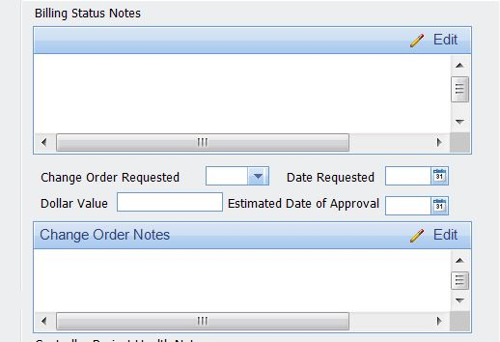

Enter the Change Order information into the change order fields:

1. If a Change Order is required provide change order status:
   1. Dollar Value of Change Order
   2. Date Change Order requested
   3. Estimated date of Change Order approval
2. Action plan to complete the change order

Enter the following information in the “Billing Status Notes” field:

1. The date the comment was entered
2. Name of the person entering the comment
3. Cause of invoice delay
4. Date invoice is expected to be issued
5. Projected amount of next invoice

**Steps to enter WIP Comments:**

Step 1: Log into Vision

Step 2: On the Left Side Navigation Bar click “Info Center”

Step 3: In the dropdown menu, click “Projects”

Step 4: In the search field in the upper right hand corner, click the magnifying glass

Step 5: Search by “Project Number” and enter your project number in the “Search Text” field

Step 6: Click the blue “Search” button

Step 7: Select “Custom LiRo” tab within the lower ribbon

Step 8: Enter your comments under “Billing Status Notes” field.

Step 9: If your comments have not changed since the prior biweekly review, then you should still enter your name and date, and indicate “No changes. See above comment.”

Step 10: Remember to click on the “Save” button in the top left of the upper ribbon before exiting

**Procedures for entering AR Comments into Vision:**

In the **AR Comments** field enter the following:

1. The date the comment was entered
2. Name of the person entering the comment
3. Cause of AR delay
4. Last date of client contact
5. Individual you contacted at client
6. Expected date payment will be received
7. Proposed PM Action Plan

If helpful, cut and paste the template below into the AR Comments field and modify:

***Enter date*** – ***Enter name***;

Cause of AR delay: ***Enter cause***;

Last date of client contact: ***Enter date***;

Individual contacted at client: ***Enter name***;

Expected date payment will be received: ***Enter date***;

PM Action Plan: ***Enter proposed PM Action Plan***

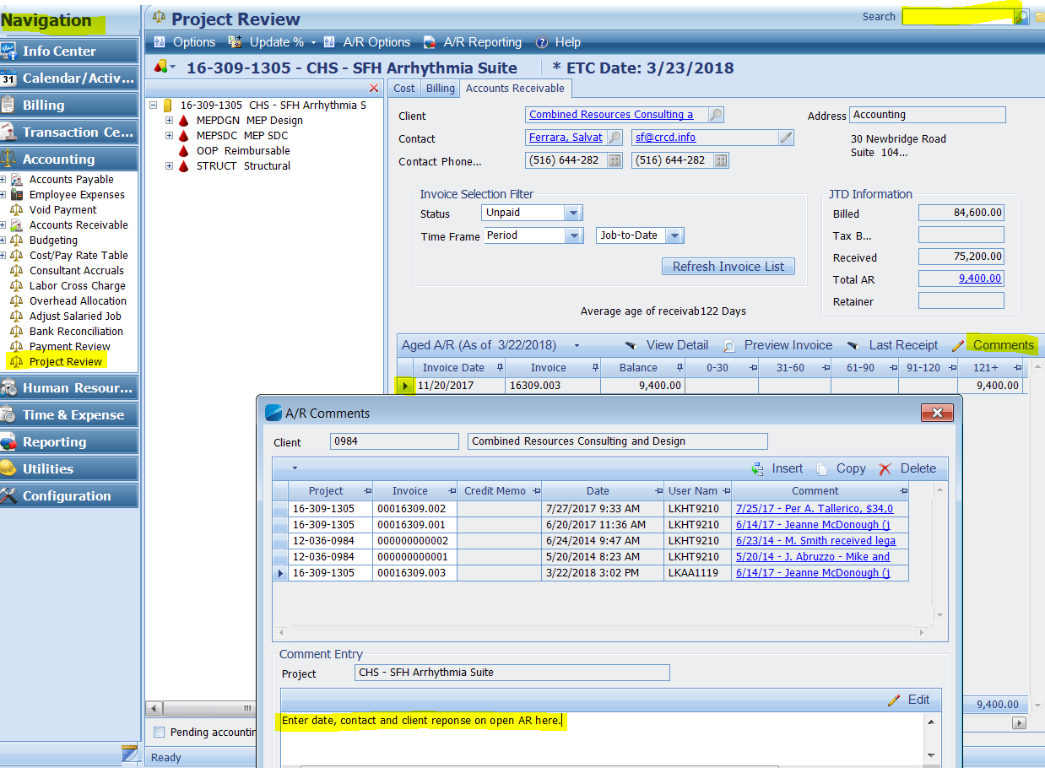

Enter the following AR information into this field in Vision

1. The date the comment was entered
2. Name of the person entering the comment
3. Cause of AR delay
4. Last date of client contact
5. Individual you contacted at client
6. Expected date payment will be received
7. Proposed PM Action Plan

**Steps to enter AR Comments:**

Step 1: Log into Vision

Step 2: On the Left Side Navigation Bar click “Accounting”

Step 3: In the dropdown menu, click “Project Review”

Step 4: In the search field in the upper right hand corner, click the magnifying glass

Step 5: Search by “Project Number” and enter your project number in the “Search Text” field

Step 6: Click the blue “Search” button

Step 7: Select “Accounts Receivable” tab within the lower ribbon

Step 8: Unpaid invoices will be displayed

Step 9: Place cursor on the invoice number for which you would like to add comments

Step 10: Select “Comments”

Step 11: Enter comments in the “Comments” field workspace

Step 12: If your comments have not changed since the prior biweekly review, then you should still enter your name and date, and indicate “No changes. See above comment.”