The LiRo Standard ***LS 8.1- Invoices WIP and AR*** presents the WIP & AR tracking process that the Business Unit Financial Managers are to follow. Instructions to download the standard are:

1. Navigate to the Li Ro Intranet <https://wssrvr2.liro.com/lirogroup/lcms/SitePages/LCMS.aspx>
2. Click the LCMS tab

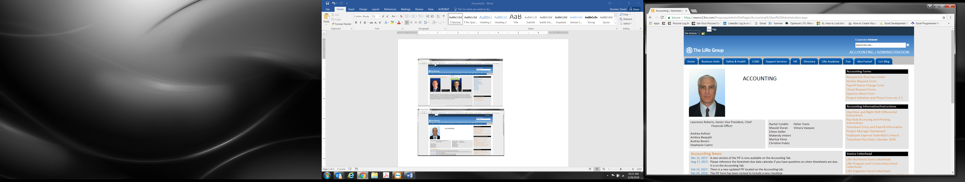

1. In the “Corporate Standards” section, click the link named “8.0 Accounting”

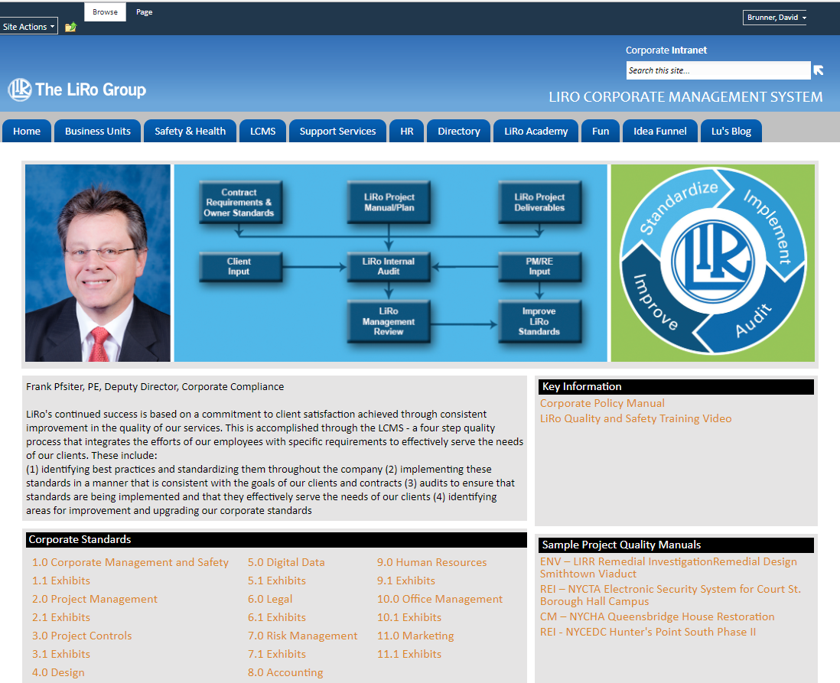

1. The following window will appear. Click LS 8.1 Invoices WIP and AR Rev 2.0 to view the standard and download the standard

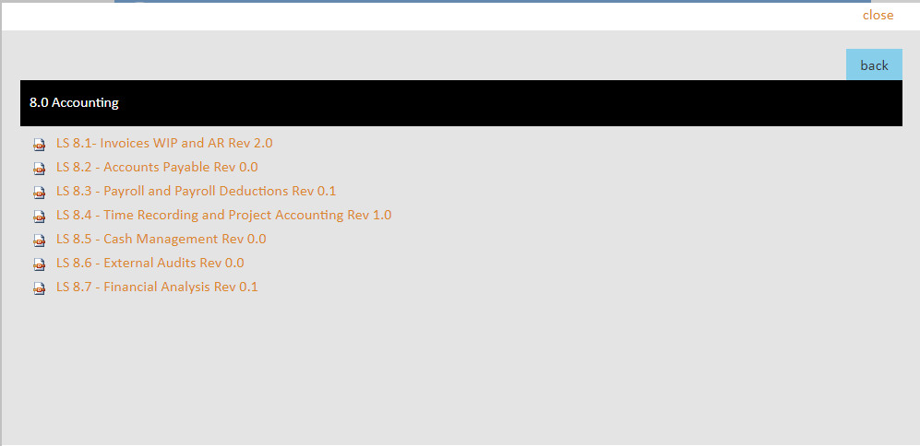

1. Sections 7.1 – 7.8 explain the process and responsibilities
2. Exhibits 8.6 - 8.7 contain the instructions for entering comments into Vision