PyCitySchools Analysis

Upon review of both school and student data, please find analysis below:

# District Summary



Among the 15 schools, the PyCitySchools district providing education to 39,170 post-secondary students. Reading scores are higher than Math scores, and 65.2% of our high schoolers are passing both subjects.

# School Summary

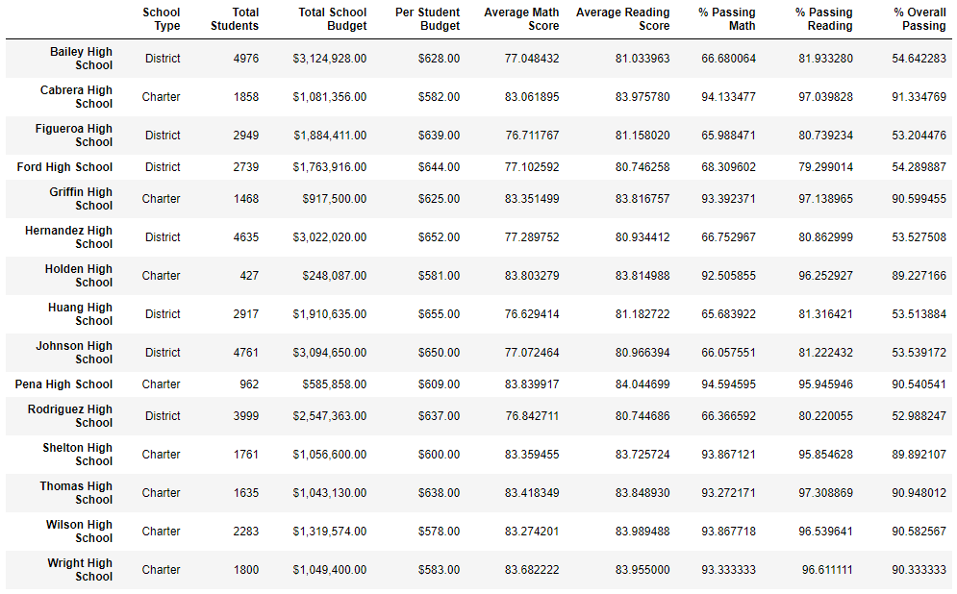

Here you can see how each school compares in regards to its school type, number of students, total budget, per-student spending, subject scores, and passing rates. Across the board, PyCitySchools’ students are performing better at Reading than Math. More trends can be parsed through this summary, which you can see below.

Highest-Performing Schools (by % Overall Passing)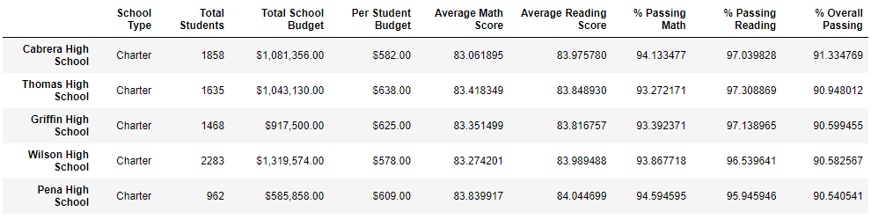

Here you can see that Cabrera High School is the highest-performing school in the PyCitySchools district, with 91.3% of its students passing both Math and Reading. All of the top 5 schools are Charter schools, and there’s a wide range of per-student spending among them.

# Bottom Performing Schools (By % Overall Passing)

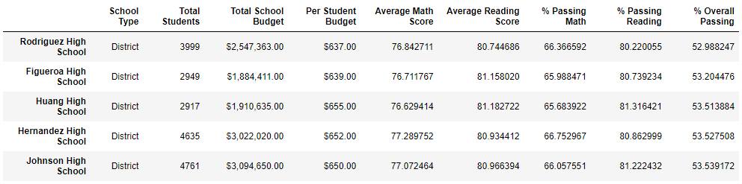

Rodriguez High School is the lowest-performing school in the district, with only 53.0% of its students passing both Math and Reading. All of the bottom 5 schools are district schools, and all are on the larger end of per-student spending.

# Math Scores by Grade

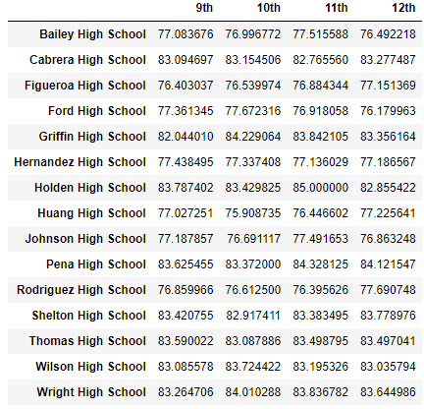

Here you can see that among each school, that math scores do not vary much by grade. Rather the larger variance can be found between schools.

# Reading Scores by Grade

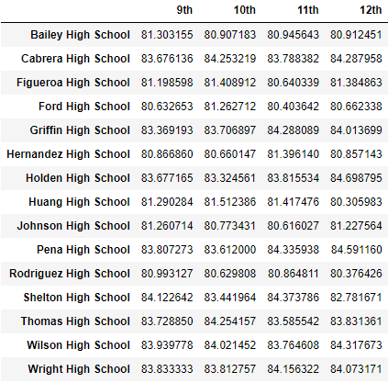

Similar to math scores, there is not much variance between grades when it comes to reading scores at each school. The variance is found more between schools.

Reading Score are almost always larger the Math Scores for each school and grade level.

# Scores by School Spending

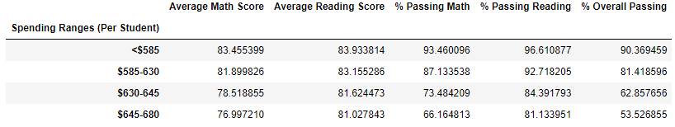

We see the opposite effect of what is expected here, with the less money spent on a student, the better they perform. Schools spending less than $585 per student have overall passing rates of 90.4%, which schools that spend over $645 per student have an overall passing rate of 53.5%. It is unclear as to whether as to how much of an indicator this is on student performance since per-student spending tends to line up with school size (generally smaller school sizes have smaller per-student spending).

# Scores by School Size

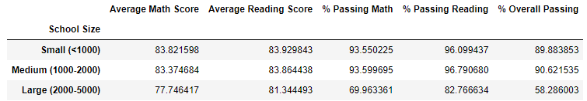

There is not a large difference in performance between small and medium school size (89.9% and 90.6% overall passing percentage, respectively), but a stark difference between the two of them and large schools which drop precipitously to 58.3% overall passing rate.

# Scores by School Type

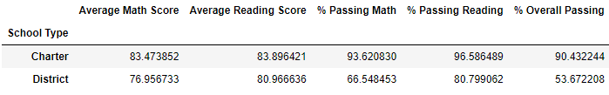

We find a distinct difference between Charter Schools with 90.4% of their students passing both subjects, and District Schools with only 53.7% of their students passing both subjects.

# Conclusions

-A determining factor of student success (i.e. larger average scores and larger passing rates) is school size. Small and Medium size schools performed much better than Large size schools. Small and Medium sized-schools have very similar overall passing rates - 89.9% and 90.6%, respectively. Large schools have an overall passing rate of 58.3%.

Another determining factor of success is school type. District schools have an overall passing rate of 53.7%, and Charter schools have an overall passing rate of 90.4%.

It is unclear as to whether school size or school type is the larger determining factor of student success since Charter schools comprise all of the small and medium schools and all of the District schools are Large-sized. More data would have to be collected to further understand.

Students perform better in Reading than Math across the board, regardless of school, school type, school size, or school spending. This is also true across grade levels, with average reading scores being higher than average math scores for each grade.