|  |  |  |
| --- | --- | --- |
| Categories | NaiveBayes | Support Vector Machine |
| Business | 56.7 |  |
| Entertainment | 67.6 |  |
| LifeStyle | 70.9 |  |
| Sports | 77.2 |  |
| Technology | 69.5 |  |

ACCURACY - NEWSPAPER

DNA India

The Times Of India

|  |  |  |
| --- | --- | --- |
| Categories | NaiveBayes | Support Vector Machine |
| Business | 75.6 |  |
| Entertainment | 93.7 |  |
| LifeStyle | 72.9 |  |
| Sports | 75 |  |
| Technology | 80.9 |  |

ACCURACY - MOVIE REVIEW TRAINING TESTING

Naive bayes: 90.39

SVM : 87.7

OBJECTIVE PERCENTAGE

Naive bayes

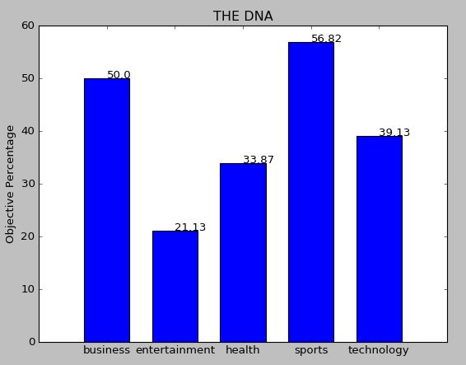

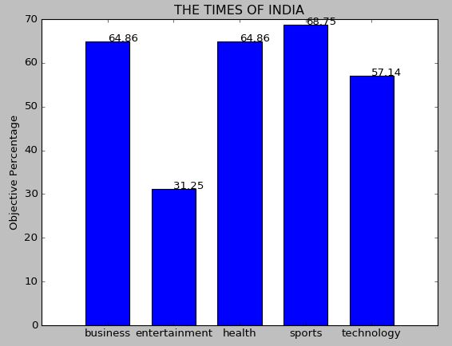

SVM: