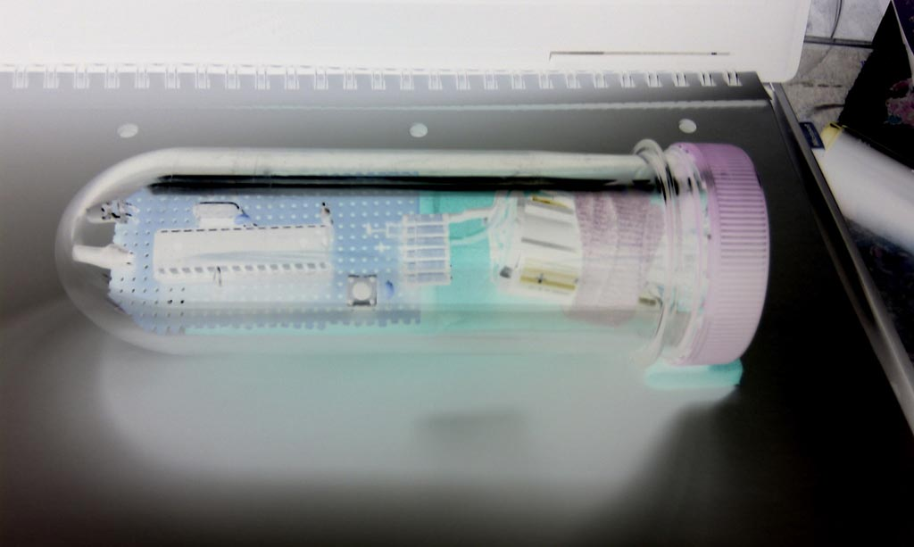

NightCachuino - Startup
The idea started, when I read a quite detailed book about geocaching [] at the beginning of the summer vacation 2010. The author mentioned a circuitry for night-caches, that should answer (i.e. blink) if being "hit" by the beam of a pocket lamp at night. Unfortunately there was no way to find out, how this circuitry exactly workes - nor where to buy it, or how to build one...
At this point I decided to make one myself, in a "student-project-compatible" way. I started with some ideas in the direction of a discrete built differentiating transistor circuit - and it grew too complicated soon. Then I tried a realization with opamps - and it grew too complicated soon. Then I remembered the Arduino board from the last years project - a microprocessor application as the most simple solution?
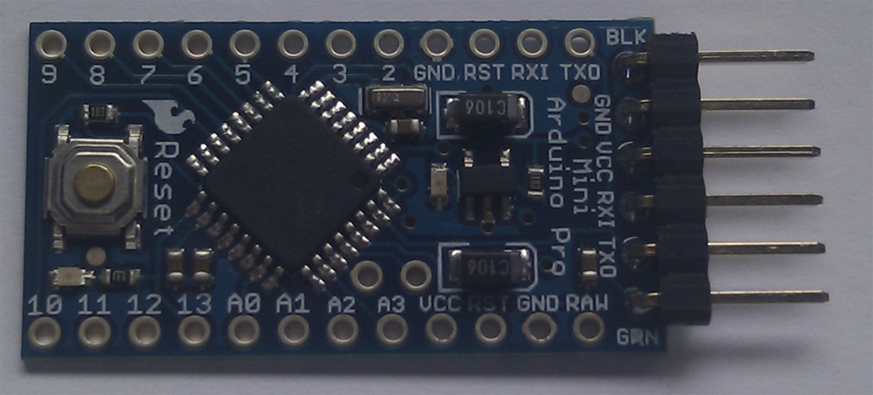
Google led me to a guy in Cologne, who made a demonstration of a very simple, battery powered, Arduino based, nightingale []. And he additionally reduced the hardware to the absolute minimum! That’ll be the way!!
First I bought a suitable Arduino board (Arduino Pro Mini) which would fit into my water-resistant housing (XXL petling) easily.

First Experiments
The most important problem to solve was about battery power consumption. The whole circuitry should be powered by batteries for a very long time (or by solar cells with an accumulator...). Therefore the current consumption had to be brought to the absolute minimum, i.e. significantly under 1mA.
The nightingale-example [Error: Reference source not found] worked like that:
- Enable the integrated watchdog circuitry
- Send the processor into sleep mode
- Do the code, when the processor was woken up again by the watchdog
- Go to sleep (power-save-mode) again - and so on...
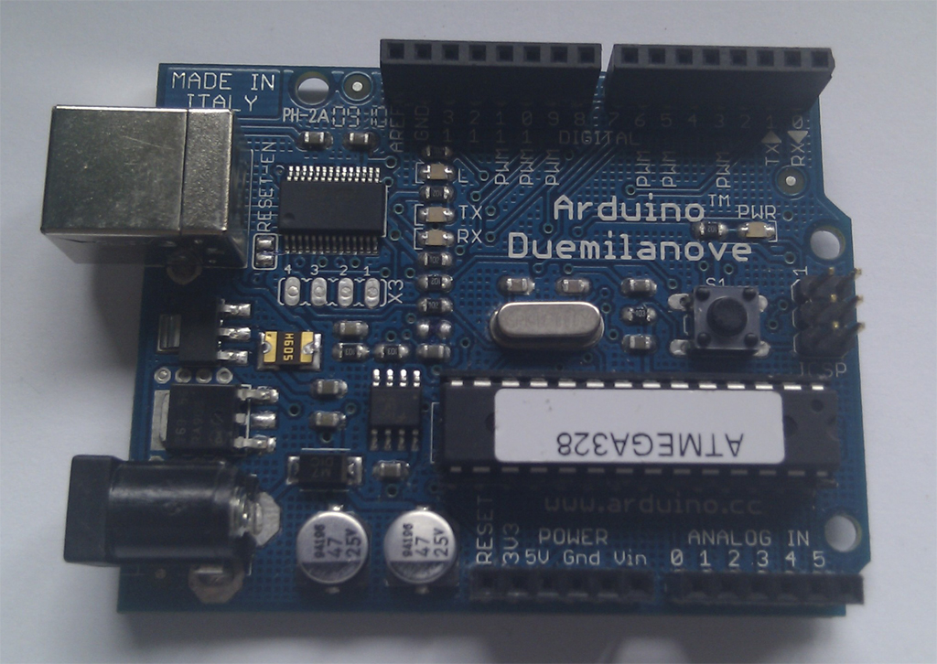
When starting my experiments, I was afraid the CPU might never wake up again, after I had sent it to sleep. So I decided to do my experiments with the standard Arduino Duemilanove board - where I could change the CPU-chip easily (just in case). The change back to the Mini Pro board could be done later, when everything was under control…
The Duemilanove board has the advantage of being powered and easily reprogrammed from the PC's USB port with the Arduino IDE (Integrated Development Environment).
As a first step, I copied the nightingale code [Error: Reference source not found] to the board, added a LDR photocell and a LED including the necessary resistors. The code worked fine, but I didn’t really understand every line; so I started experimenting a little. After some tries, the board stopped to work – as I had been afraid of all the time.
I bought a new processor, but I couldn’t make it run on my board ;-(. After endless hours, I realized it was NOT the processor that had be gone into endless sleep, but the board itself was broken (however…).
I ordered a new one at “my local Arduino dealer” immediately. But because I couldn’t wait, in parallel I started to build my own prototype-board, to be able to go on with my experiments.

Building my own Arduino prototype board
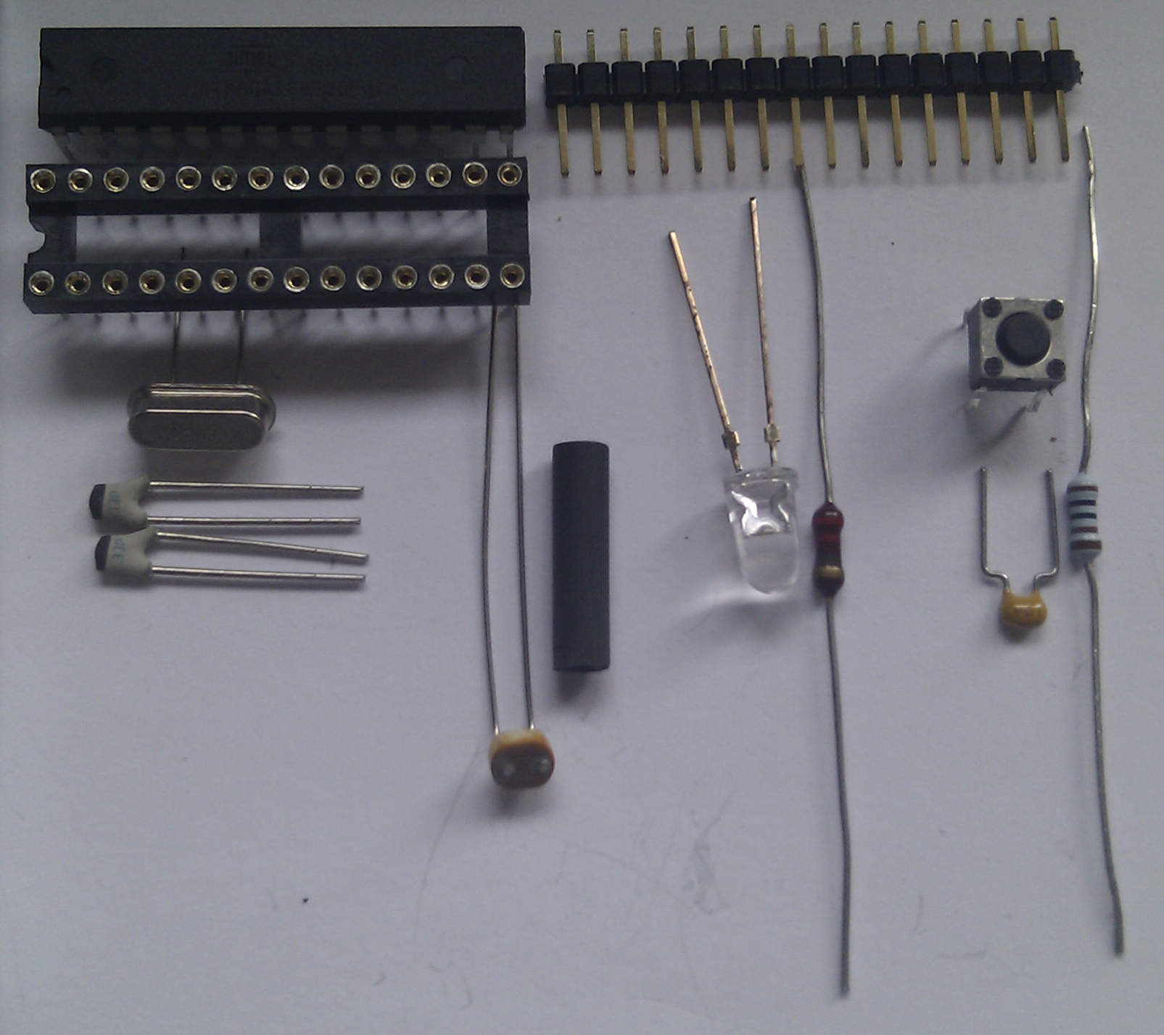
What my prototype board needed was the minimal configuration for the processor to run, plus a communication interface that would fit with my Arduino Pro Mini USB-breakout-board.
The whole soldering took about half an hour and my prototype-board ran!!!
The only thing a little more challenging was the programming of the bootloader to the new processor. To do this, you need an Atmel Incircuit Programmer (ISP), which I had from a “pre-Arduino” project, and a PCB board, where to plug in the processor (in my case, the broken Arduino Duemilanove board still worked for that). Then I had to fiddle around with some USB-driver configurations but in the end I managed to program the bootloader simply with the Arduino IDE.
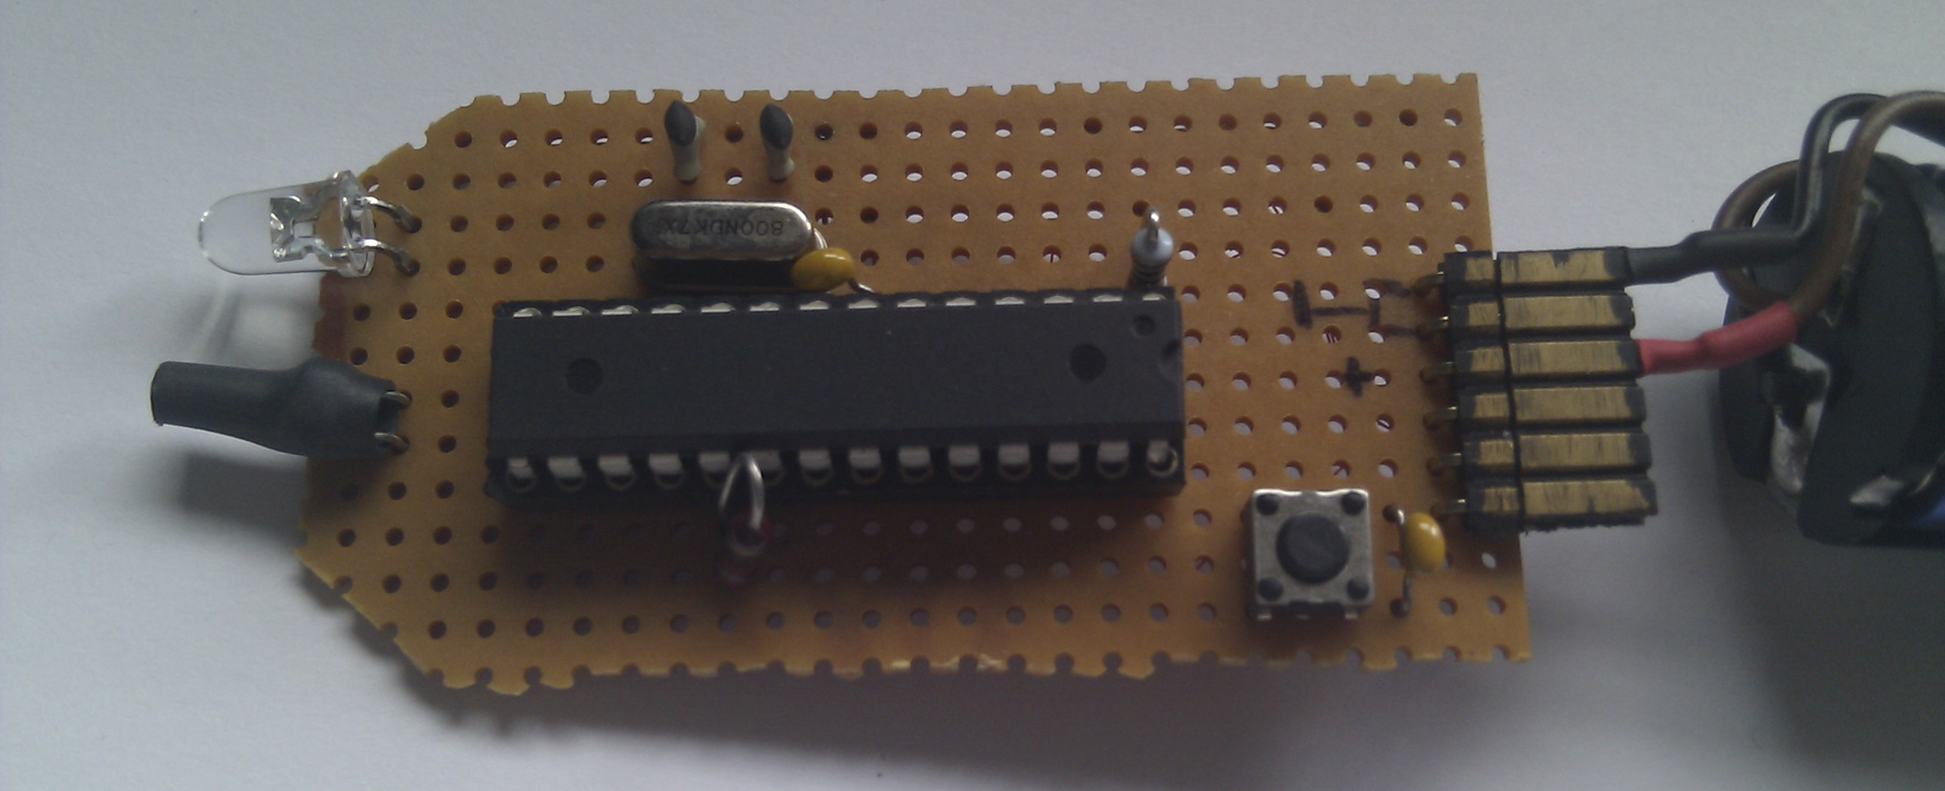
(→ schematic)

Code walk-through
Now I started to reconstruct the solution of the nightingale [Error: Reference source not found] experiment. While doing some cleaning up of the original code, I tried to understand what was going on there.

Enable the integrated watchdog circuitry
void setup(){
…
wdt_mysetup(WDTO_120MS); // [WDTO_15MS..WDTO_8S]
…
}
void wdt_mysetup(byte wdt_time) {
byte prescaler;
// ------------ fiddle up prescaler bits
wdt_time %= 10; // [0..9] allowed
prescaler = wdt_time & 7; // take lower 3 bits from argument
if (wdt_time > 7) prescaler|= (1<<WDP3); // if wdt_time = 8 or 9: set WDP3-Bit
// ------------ setup watchdog registers
cli(); wdt_reset(); // a) no interruption please!!!
MCUSR &= ~(1<<WDRF); // b) reset "Watchdog System Reset Flag"
// (no override from there...)
WDTCSR |= (1<<WDCE) | (1<<WDE); // c) ---------- start of timed sequence
// (-> doc8271.pdf|p.52)
WDTCSR = prescaler | (1<<WDIE); // d) set prescaler AND "WDT Interrupt Mode"
// (NO "Reset Mode"!)
// ---------- end of the timed sequence
sei();
}
The idea was to use the built-in watchdog timer of the processor to wake the device up – say every 120msec. The rest of the time, the processor should stay in powerdown mode.
The watchdog should be put into interrupt-mode, i.e. when the watchdog times out, it does NOT perform a complete reset of the whole device, but an interrupt service routine is called instead. Unfortunately the watchdog-library “<wdt.h>” does not support this mode of operation.
What we need for this reason is a custom-made setup method to initialize the watchdog-timer (wdt) as we want it! The time-interval is specified as a parameter to this method, and you can use the predefined constants from “<wdt.h”> for that purpose (for example: “WDTO_120MS”).
The timing is derived from a special watchdog oscillator, divided by a prescaler value. The bits of the prescaler value are unfortunately not in one line, so some fiddling around is necessary to set up the bits correctly (reason: bits 0 to 2 are in every Atmel processor, bit 3 was added later…).

Now lets set the watchdog to interrupt-mode! This has to be done in distinct steps [][]:
- Because there are some timing-relevant steps following, there should be no interruption. Therefore the watchdog is triggered prophylactically and interrupts are disabled temporarily.
- Reset the general “Watchdog System Reset Flag”. (When set, it could overwrite our intended watchdog-mode – and we do not want that, do we?)
- The actual programming sequence is initiated by setting the WDCE and the WDE bits in the Watchdog Timer Control Register (WDTCSR) no matter what mode you intend to have afterwards! I.e.: setting the WDE-bit does NOT mean to set the watchdog into reset-mode here, this pattern only initiates the programming cycle and the programming has to be done within 4 CPU-cycles from now on!
- In this step, the prescaler value AND the WDT Interrupt Mode Flag are written simultaneously. Note: they are not “ORed” into the existing register value, therefore the WDT Reset Mode Flag is set to zero automatically.
Believe me; it took me some time to get that clear…

Send the processor into power-down-mode
Before sending the processor to bed, one has to reduce power consumption to the very minimum:

pinMode(PIN_LED,INPUT); // a) set all used port to intput to save power
pinMode(PIN_LDR, INPUT); // b) ... just to be shure ...
digitalWrite(PIN_LDR, LOW); // c) switch off internal pullup
ADCSRA &= ~(1<<ADEN); // d) switch Analog to Digital Converter OFF

set_sleep_mode(SLEEP_MODE_PWR_DOWN); // e)
sleep_enable();
sleep_bod_disable(); // f) disable BrownOutDetection during sleep...
sei();

sleep_cpu(); // System sleeps here

Comment:
- Switch the LED driver pin to input(!) That way it becomes high impedance, and no current is leaking from that pin.
- Do the same to the LDR pin (OK it should already be an input – may be paranoia…)
- In an earlier part of the code, I switched on the internal pull-up resistor for that pin. Now it has to be switched off again, otherwise it would remain active during processor sleep.
- The “Analog to Digital Converter” (ADC) needs a lot of current during operation…
- Here I changed the sleep mode from the original nightingale example to “Power-Down-Mode” to save the most energy possible (in fact it’s a trade-off: “Power-Down-Mode” needs some cycles longer to wake up again, “Power-Save-Mode” needs higher current while in sleep mode).
- BrownOutDetection (BOD: voltage supervision) also needs some current, when active while in sleep mode. In the newer versions of the AVR GCC Libraries, there is a macro for this in “<sleep.h>”. Unfortunately, the Arduino IDE uses an older version of the libraries – so I simply copied the macro into my code (I hope this is legal?!).
The macro has to be called directly between the “sleep_enable()” and the “sei();sleep_cpu()” call to meet the timing requirements for the BOD disable sequence.

Do the code, when the processor is woken up again by the watchdog
When the watchdog timer fires (after 120ms in this case), the corresponding interrupt service routine is called:
ISR(WDT_vect) {
//wdt_expired=1; // meeningless, just to do something...
}
In this special case, it is not necessary to do anything in that interrupt service routine, because after doing nothing in the ISR, the code starts executing the main program loop() again, just behind the “sleep_cpu()” instruction.

The GeoCaching-Code
All the mentioned until now is only about saving energy to have the whole thing working with batteries. There was nearly nothing about the original intent of the whole project!
The good news is, the effective geocaching code is so trivial, it’s really not worth a whole chapter here!
When the processor wakes up, it switches on the pull-up resistor of the LDR photocell and makes an analog measurement of the light intensity. Then it compares the light intensity to the intensity value it measured during the last cycle and determines the deviation of it. If the deviation is high and positive (abrupt increase of light), the processor believes to see a pocket lamp and starts blinking. Beside that, the light intensity is tested against a threshold value to determine whether it’s night or day. The whole thing should only work at night, to avoid reaction by waving leaves of a tree or so…
...
Light = analogRead(0); // reading photoresistor
LightDeviation = LastLight - Light;
AbruptIncrease = LightDeviation > 30;
ReallyDark = LastLight > 990;
if(AbruptIncrease && ReallyDark)
{
BlinkLed(20, 200, 20); // ...(OnTime, OffTime, Cycles)
}
...
(→ source code)

Current Consumption
To estimate the current consumption of the circuit, we must distinguish (at least) three different states of operation:

- Processor in sleeping mode (inactive)
- Processor “heating up” the oscillator(s)
- Processor active at work!
- (LED blinking. Is ignored for this calculation, only occurs when the cache is found…)

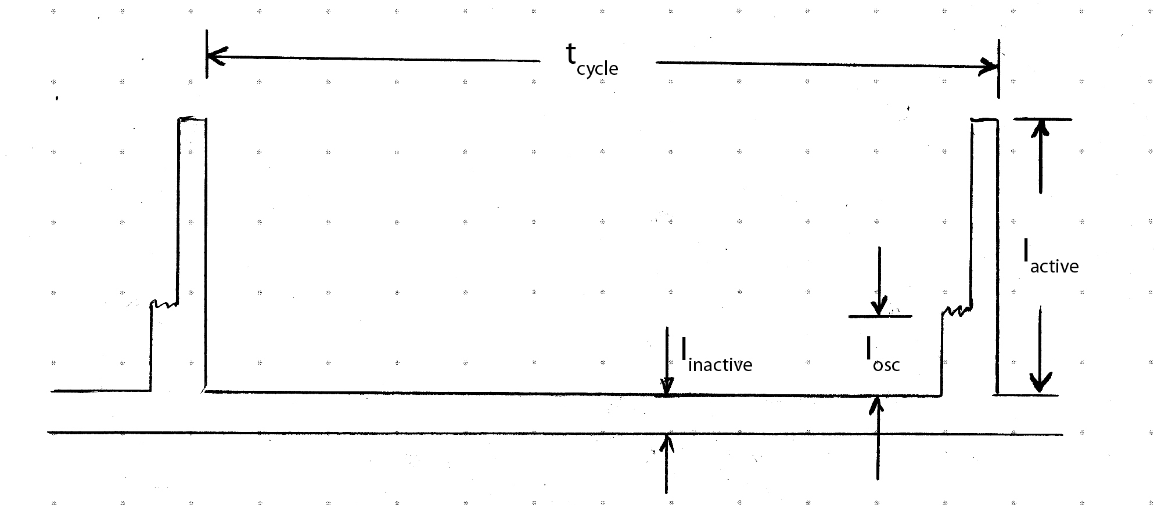

The following values are practically measured with oscilloscope and voltmeter, and not theoretically derived from datasheet values. If you find errors in my measurements or calculations – feel free to contact me!

t_{osc} | = | 1.11msec
t_{active} | = | 0.5msec
t_{cycle} | = | 120msec
I_{inactive} | = | 27.4uA | (measured with 1k serial resistor in power supply cable)
I_{osc} | = | 3.3mA | (this and the next one with 100Ohm serial resistor)
I_{active} | = | 10mA | (normal operation without LED blinking)

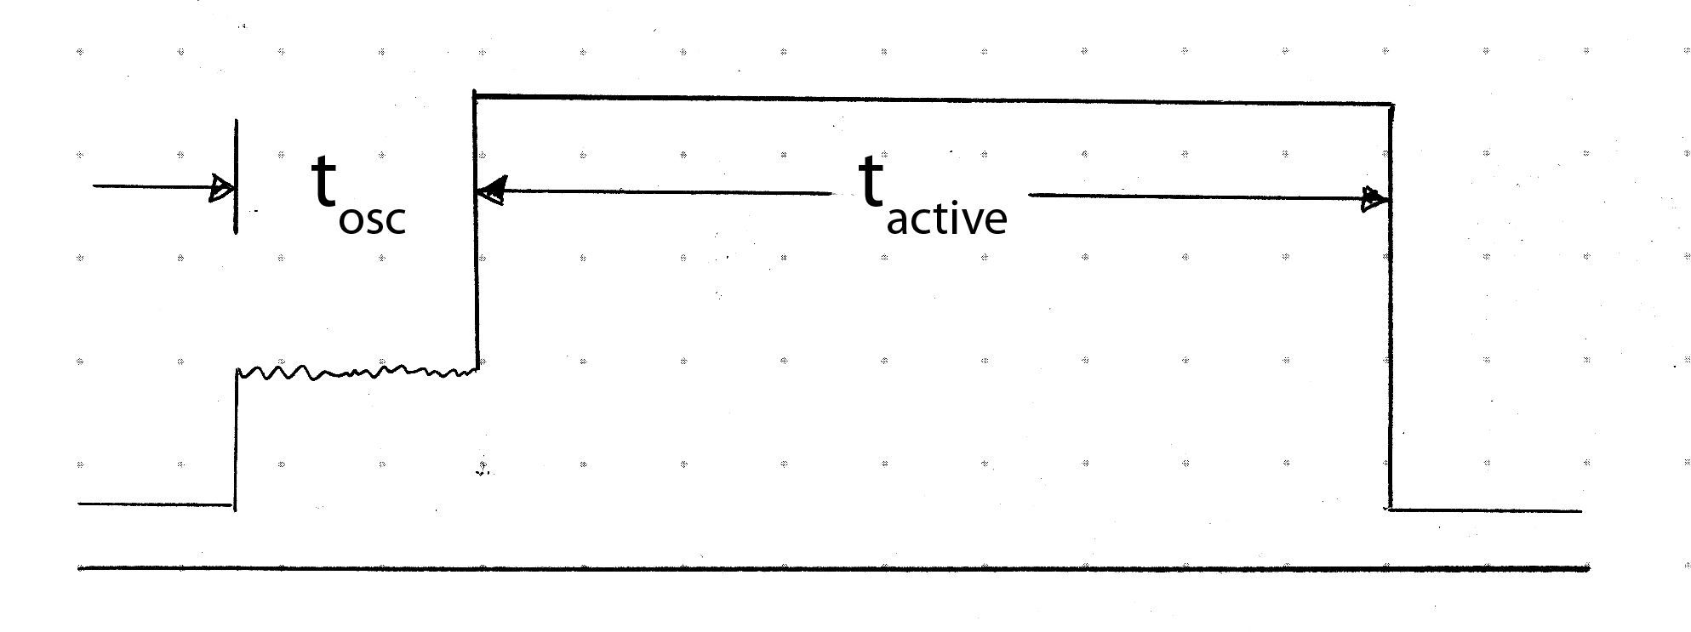

The average current consumption is calculated like this:

E_{active} | = | 10mA * 500usec | = | 5.00 uAsec
E_{osc} | = | 3.3mA * 1.11msec | = | 3.66 uAsec
E_{inactive} | = | 27.4uA * 120msec | = | 3.29 uAsec

I_{average} | = | E_{all} / t_{cycle} | = | (5 + 3.66 + 3.29) / 0.120 = 99.6 uA
t_{bat} | = | E_{bat} / I_{average} | = | 300mAh / 0.0996mA = 3010h = 126d = 4 month

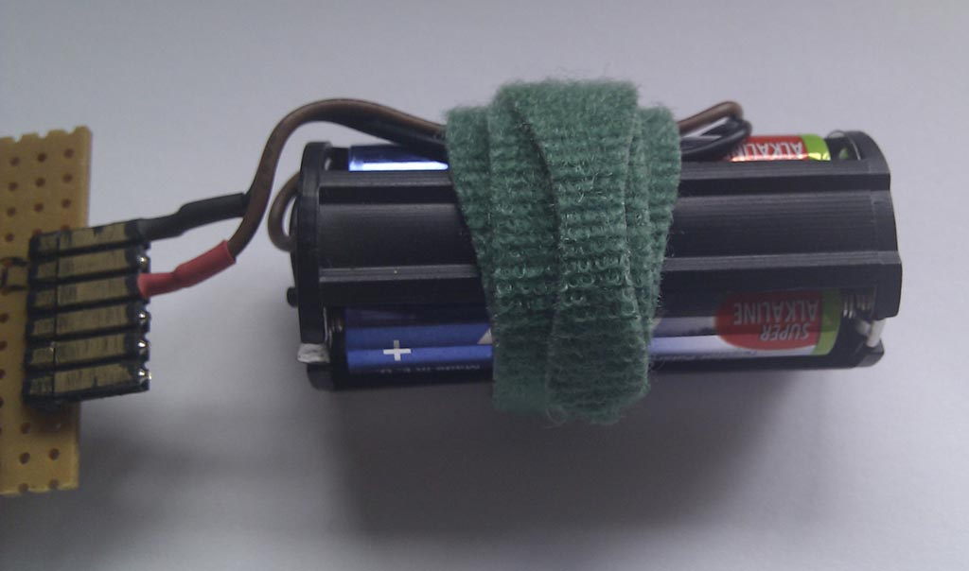
I believed this to be sufficient for the first try and used an obsolete battery pack from a broken headlamp as a “field” power supply (3 AAA cells => 4.5V).

Conclusion and perspective
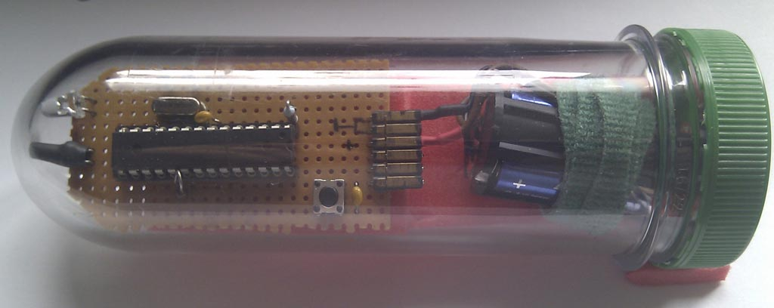
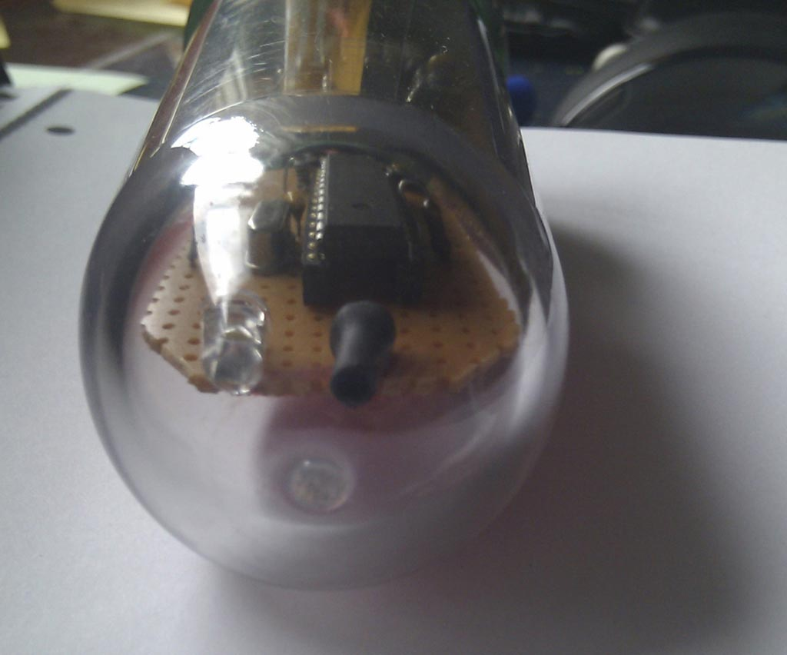
I packed it all together in my waterproof housing (XXL-petling) and “cached” it near the graveyard of the neighbour village. Then I gave the coordinates of the graveyard’s door to a friend and asked him to find my nightcache using his pocket lamp (at midnight).
He found it…

It took me a little time to find out about the special considerations of energy saving with that Arduino compatible board. But after that, it proved to work AND to be the simplest hardware solution by far! Programming the application code worked like a charm with the Arduino IDE and libraries.

Comparing my prototype hardware to the professional Arduino boards:
- It is cheaper (not too much, the Arduino boards are not THAT expensive)
- You need a preprogrammed Arduino chip, or program the bootloader to the chip by yourself.
- It does not have any power supply regulator circuitry, and therefore it needs less supply current than any other solution!
(If you are not used to solder on “grid style PCBs”, you can also use a Borduino Kit from Adafruit and simply leave out the power regulator stuff – the form-factor of the board is excellent!)

After having finished this first “NightCachuino” project, I googled a bit to get the links right for this documentation and what did I find (by accident)? Somebody already had done it!!! ☹
But it was too late! I already finished my stuff! These guys couldn’t put me off the fun of finding it out myself!
I had a look at their source code and they did one thing I hadn’t thought of yet: they had their device answer with the Morse code of the next coordinate! Very nice idea! I deleted the link to their page and will find out again by myself – maybe next weekend…

[?] Thomas Sadewasser: "Geocaching Abenteuer: Verstecken und Finden mit GPS"
[?] Martin Nawrath: sleep-watchdog-battery-experiment
Atmel Application Note AVR132: „Using the Enhanced Watchdog Timer“
doc8271_ATmega168_328_Manual.pdf, page 52 and 56

