**Manage Your To-Do Lists Using Python and Django**

**Demo**

**Project Overview**

**Prerequisites**

**Step 1: Set Up Your Virtual Environment and Django**

**Create a Virtual Environment and a Project Directory**

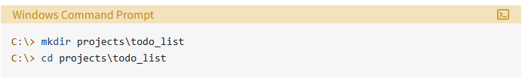

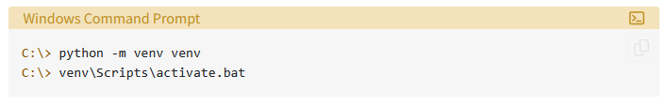

**Install and Test Django**

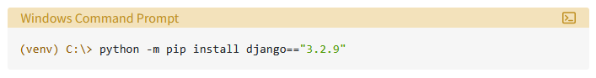

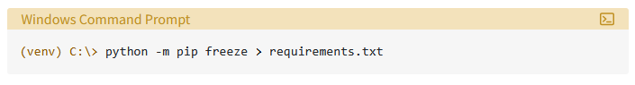

**Step 2: Create Your Django To-Do App**

<https://realpython.com/django-todo-lists/>

### Scaffold the Parent Project

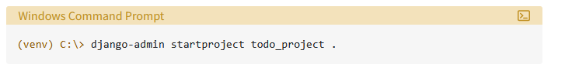

### Get Started on Your Django To-Do List App

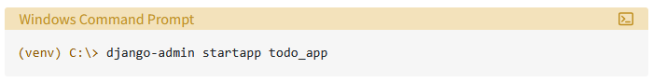

### Configure Your Project

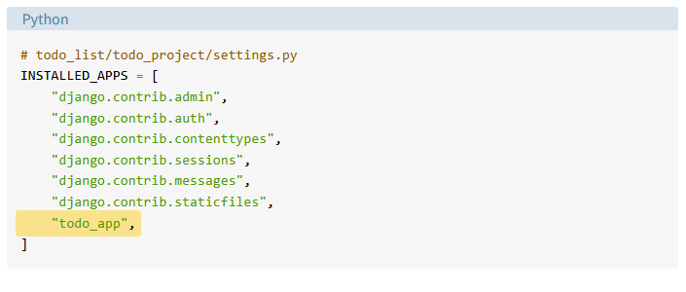

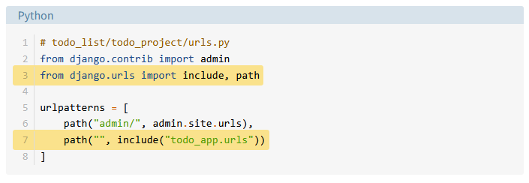

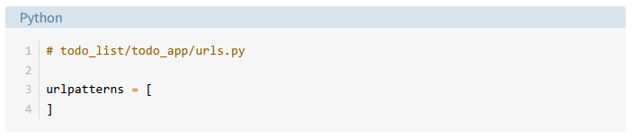

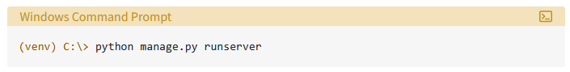

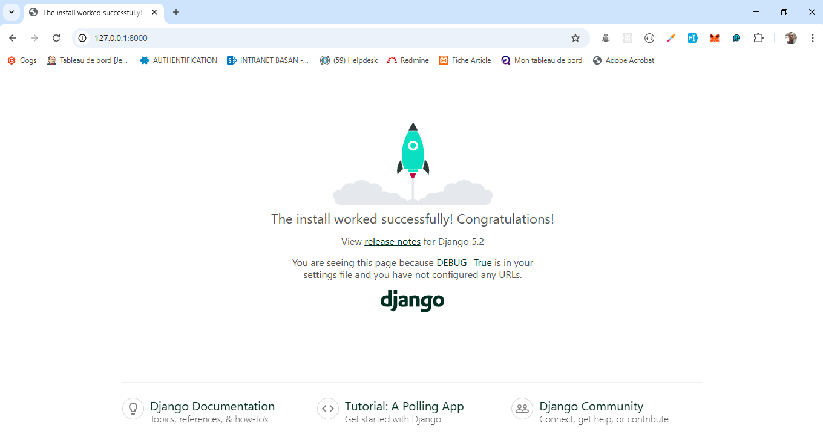

## Step 3: Design Your To-Do Data

<https://realpython.com/django-todo-lists/>