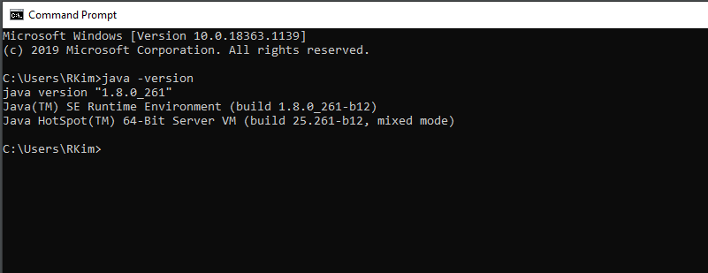

Per your request in Slack, I just downloaded SOAPUI versus Java SDK.

