‘Edible Native Flowers to Washington State’ Style Guide
Project Name: Edible Flowers Website Project
Audience: People interested in foraging, people who like flowers or nature, people living in Washington, and people visiting Washington.
Purpose: To inform the public about the native flowers around them that are edible.
Personality: The website is nature-y and feels like you walked into a forest with the brown, greens, and a pop of purple.
Comparable Sites: Washington Native Plant Society (link: https://www.wnps.org/native-plant-directory), Wild Foods and Medicines (link: https://wildfoodsandmedicines.com/category/blog/), Edible Wild Food (link: https://www.ediblewildfood.com/), Wild Edible Plants of the Pacific Northwest (https://sharedsurvivalknowledge.wordpress.com/2011/07/01/wild-edible-plants-of-the-pacific-northwest/), and Northern Bushcraft (https://www.northernbushcraft.com/plants/).
Features/Content: The website has a home page, a page for the flowers to be listed, a page for each flower, a page for the flower recipes to be listed, a page for each flower recipes category, a page where you can fill out a form to add a recipe, a page that lists some tips and safety, and a page with additional sources to go to. The flower pages have a picture of the flower, the scientific name, other names, a description of the flower, the distribution, and habitat of the flower. The recipe pages have a description of what parts of the plant are edible and below that are the recipes for that flower listed.
Color Palette:
Hex Code | Color Chip
#446600 Green | 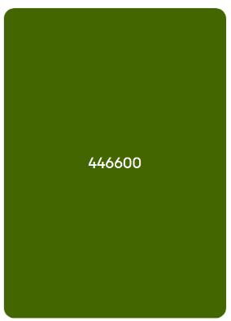
#669900 Light Green | 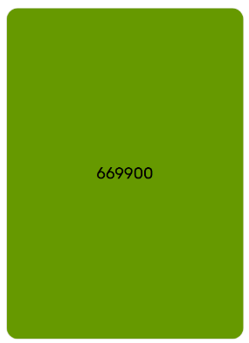
#887755 Brown | 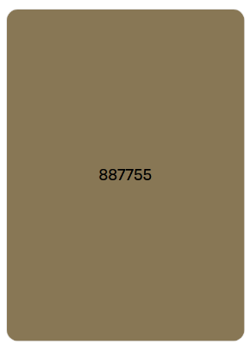
#DDDDDD Light Gray | 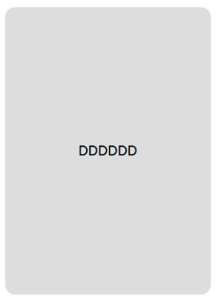
#BB7799 Mauve | 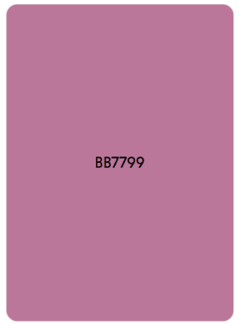
#8B4669 Wine | 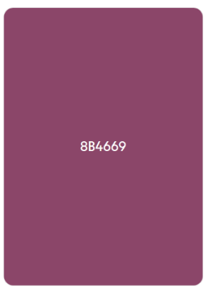
#AA5580 Mulberry | 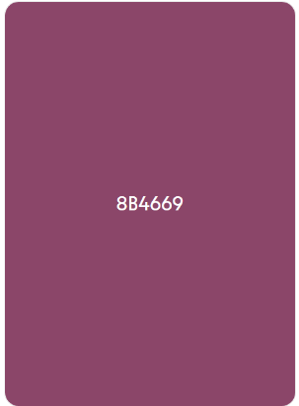

Styling Descriptions:
Overall Page:
Format-
The body has a background color of green. The font is light gray in color. The font-family is Georgia, “Times New Roman”, Times, serif.
Header:
Format-
The header has a background color of brown. The header has a 1px solid transparent border.
Navigation:
Format-
The navigation bar is wine in color. The navigation bar has a 1px solid transparent border.
The unordered list items in the navigation bar have a margin and padding of 0. The list style in the unorder list items is none.
The links in the navigation bar have top and bottom padding of 0.5rem and left and right padding of 1rem. The links have top and bottom margin of 0rem and left and right margin of 0.5rem. The text decoration is none and the color is light gray.
The active class for the links has a background color of mulberry. The border is 2px dotted and light gray. The border radius is 100px.
Layout-
The unordered list items in the navigation bar have a flex display and the content is justified to center. The links, the links when hover over, and the active class are all displayed as block.
Interactive-
The links in the navigation bar are mauve when they’re visited.
The links in the navigation bar when they are hovered over have a 2px dotted light gray border. The color is light gray. The border radius is 100px.
Main:
Format-
The main, flower pages, recipe pages, tips, additional resources, and recipe form classes have a background color of light green. The padding and margin are 0.5rem all around. The border radius is 0.5rem. The line height is 1.5.
The main h2, the edible flowers, recipes, flower pages h2, recipe pages h2, tips h2, additional resources h2, and recipe form h2 classes all have text-align to center.
The flower pages and tips class lists have no list style type.
The recipe pages class’s h3 has a normal font weight and a underlined text decoration.
The additional resources links are light gray in color.
The yarrow, hawthorn, violet, rose, salal, fireweed, yarrow recipes, hawthorn recipes, violet recipes, rose recipes, salal recipes, and fireweed recipes classes all have a background color of light green. The text is aligned to center. The border radius is 0.5rem. The top and bottom padding is 5px and the left and right padding is 15px. There is a width of 300px and a height of 350px. The left margin is 50px and the bottom margin is 10px.
The yarrow, hawthorn, violet, rose, salal, fireweed, yarrow recipes, hawthorn recipes, violet recipes, rose recipes, salal recipes, and fireweed recipe classes’ links are light gray in color and have no text decoration.
The yarrow and yarrow recipes classes images have a width of 300px and a height of 170px.
The hawthorn class image has a width of 300px and a height of 225px.
The violet and violet recipes classes images have a width of 300px and a height of 200px.
The rose class image has a width of 300px and a height of 225px.
The salal class image has a width of 300px and a height of 200px.
The fireweed and fireweed recipes classes images have a width of 300px and a height of 250px.
The hawthorn recipes, rose recipes, and salal recipes classes images have a width of 300px and a height of 250px.
The yarrow info class image has a width of 500px and a height of 281px.
The hawthorn info and rose info classes images have a width of 500px and a height of 375px.
The violet info and salal info classes images have a width of 500px and a height of 333px.
The fireweed info image has a width of 400px and a height of 533px.
The recipe form input and text area have a font family of Georgia, ‘Times New Roman’, Times, serif.
The recipe form button has a background color of wine. The font is light gray in color. The button has a 1px solid transparent border.
Layout-
The yarrow, hawthorn, violet, rose, salal, fireweed, yarrow recipes, hawthorn recipes, violet recipes, rose recipes, salal recipes, and fireweed recipes classes are all floated to the left.
The yarrow, hawthorn, violet, rose, salal, fireweed, yarrow recipes, hawthorn recipes, violet recipes, rose recipes, salal recipes, and fireweed recipes classes images have a display of flex.
Footer:
Format-
The footer has a background color of brown. The text is aligned to the center and there is 0.5rem of padding all around.

Page Layout Sketchs:
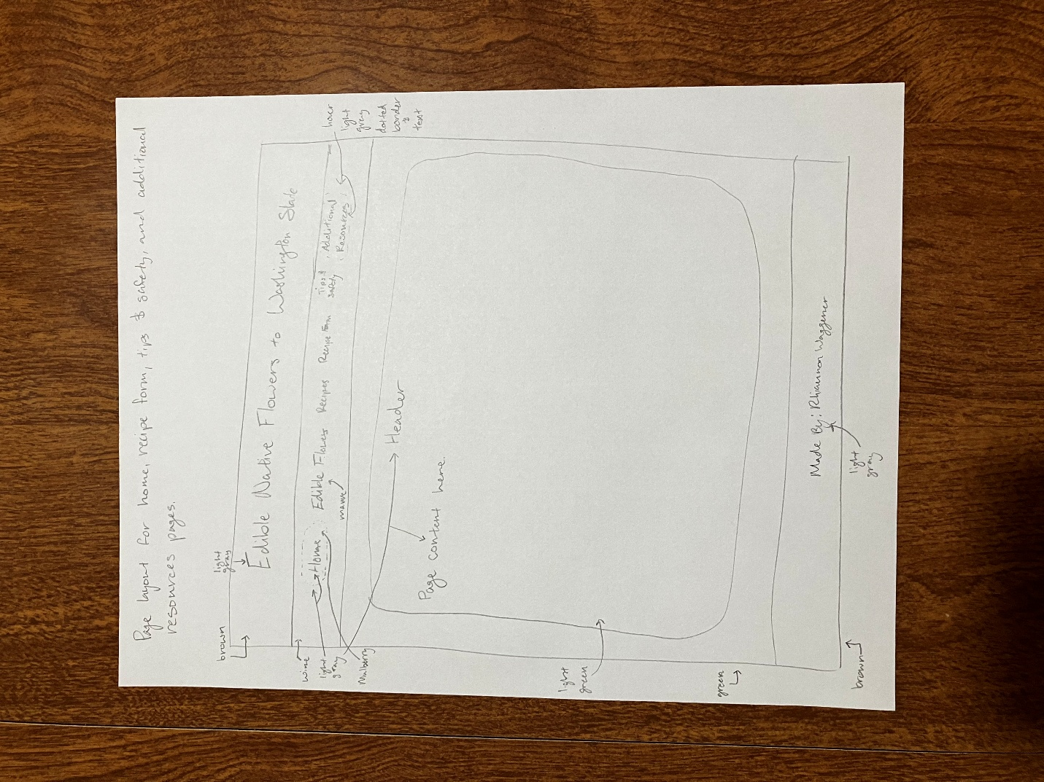
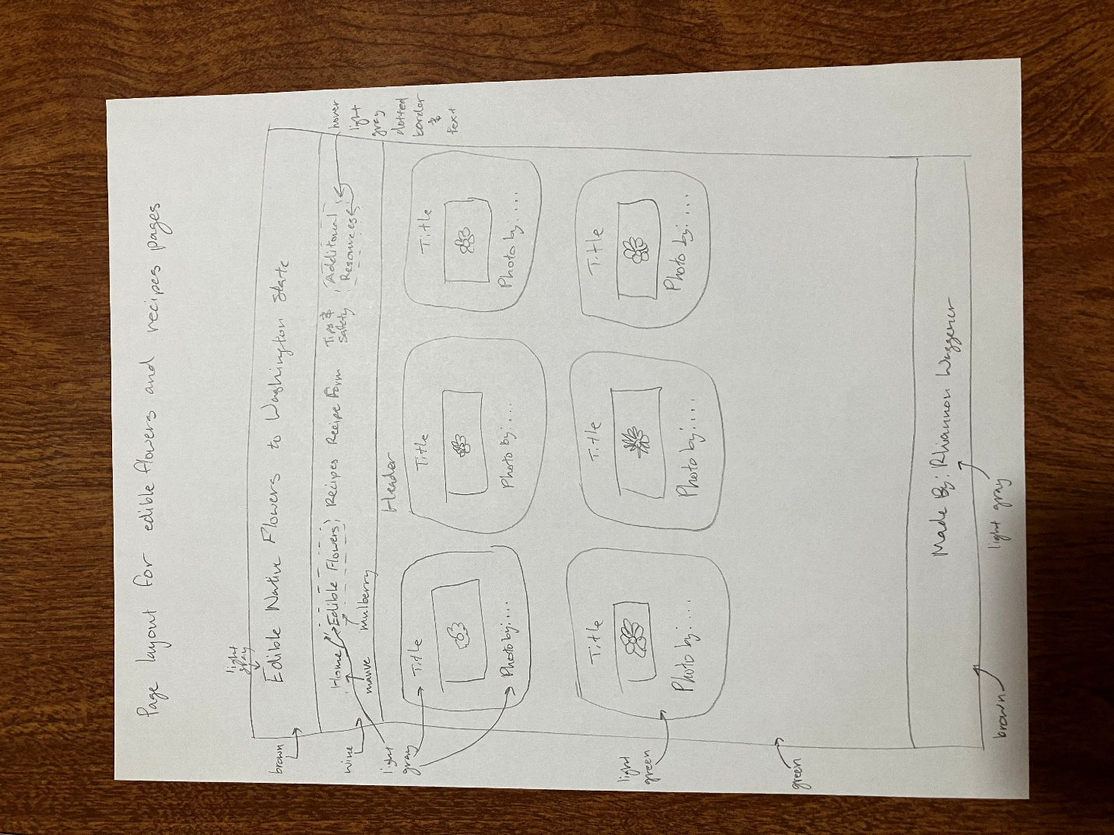
Graphic/Image Licensing:
Subject | Image | Licensing Information
Yarrow | 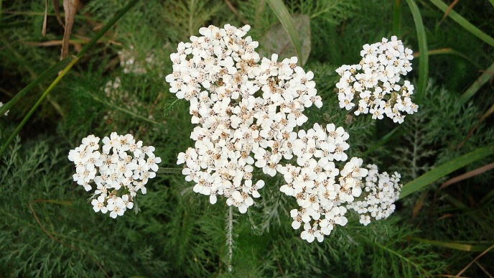 | Link: https://commons.wikimedia.org/wiki/File:The_stems_and_leaves_of_yarrow,_Achillea_millefolium,_have_been_used_medicinally_both_traditionally_and_modernly._(5d4b187a-1dd8-b71c-0725-32ae2927e3e5).jpg  Photo by: National Park Service  License: Public Domain
Hawthorn | 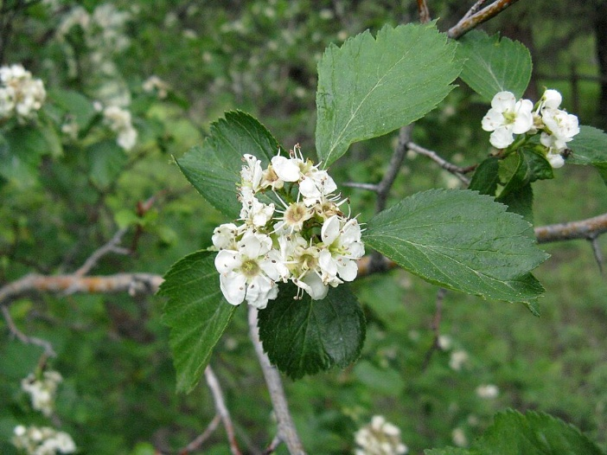 | Link: https://commons.wikimedia.org/wiki/File:Crataegus_douglasii_flowers.jpg  Photo by: Nadia Talent  License: Public Domain
Violet | 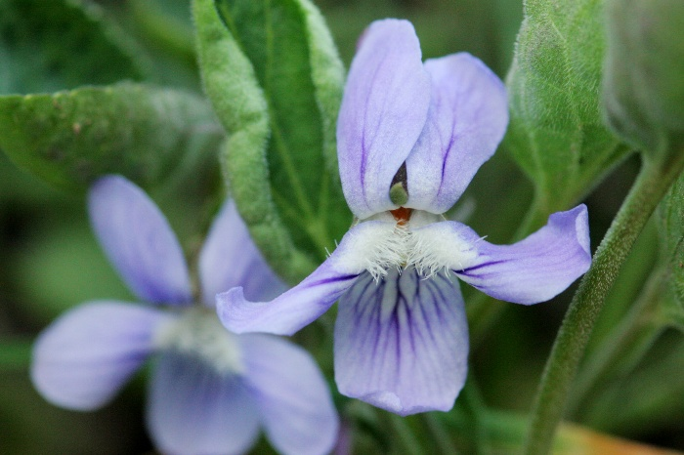 | Link: https://commons.wikimedia.org/wiki/File:Viola_adunca_-_Flickr_-_aspidoscelis_(1).jpg  Photo by: Cecelia Alexander  License: Creative Commons CC0 1.0 Universal Public Domain Dedication
Rose | 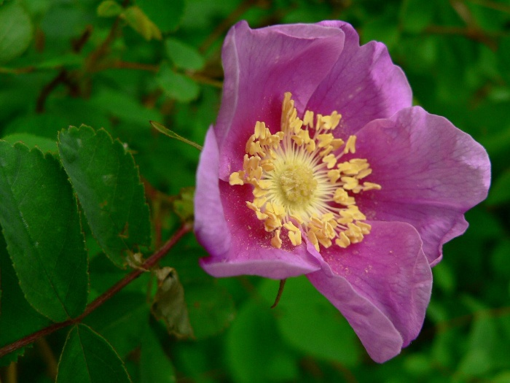 | Link: https://commons.wikimedia.org/wiki/File:Rosa_nutkana_07513.JPG  Photo by: Walter Siegmund  License: Creative Commons 3.0/2.5
Salal | 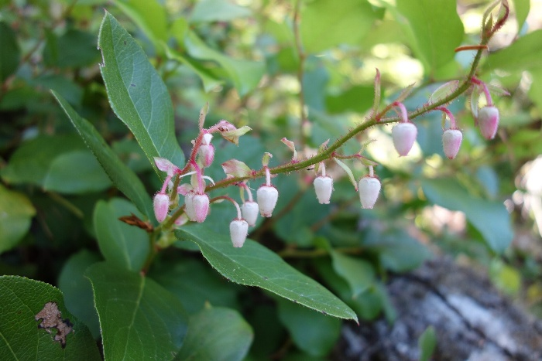 | Link: https://commons.wikimedia.org/wiki/File:Salal_(Gaultheria_shallon)_is_a_common_low-elevation_shrub._(6ee7b07d-9efc-428e-83ab-c38db87663cf).JPG  Photo by: National Park Service  License: Public Domain
Fireweed | 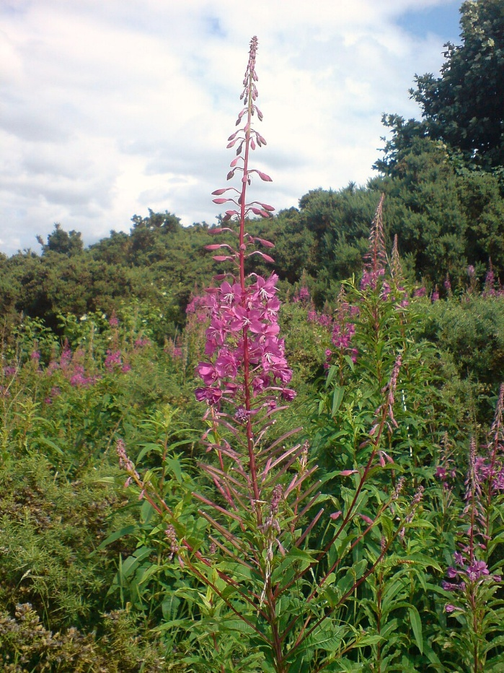 | Link: https://commons.wikimedia.org/wiki/File:Rosebay_Willowherb_Scotland.jpg  Photo by: Callum1234  License: Public Domain
Hawthorn Berries | 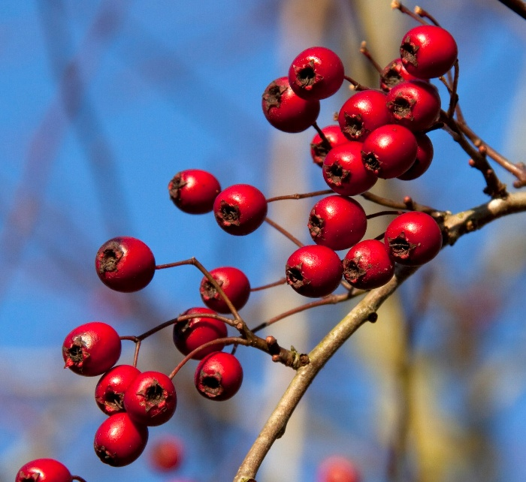 | Link: https://commons.wikimedia.org/wiki/File:Hawthorn_berries_(5204238641).jpg  Photo by: Magnus Manske  License: Creative Commons Attribution 2.0
Rosehips | 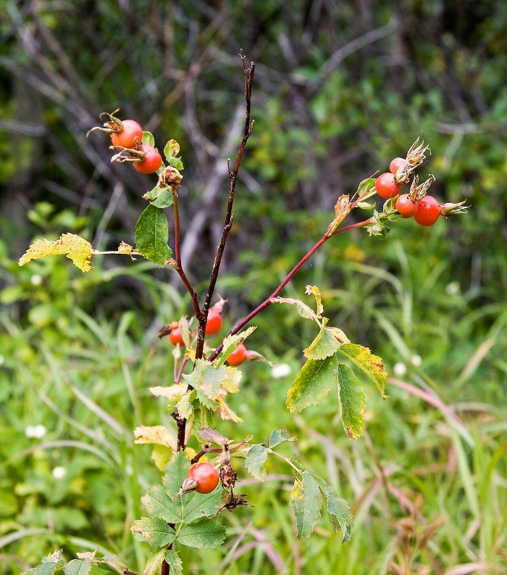 | Link: https://commons.wikimedia.org/wiki/File:Glacier_flora8.jpg  Photo by: Acroterion  License: Creative Commons Attribution-Share Alike 4.0
Salal Berries | 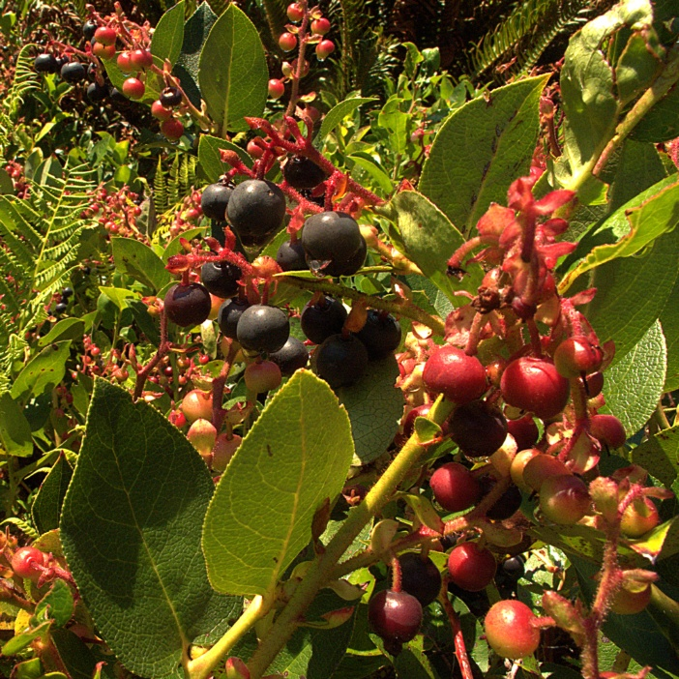 | Link: https://commons.wikimedia.org/wiki/File:H20120812-5316--Gaultheria_shallon--RPBG_(9564406099).jpg  Photo by: John Rusk  License: Creative Commons Attribution 2.0

