Color Report
What are "warm" and "cool" colors? What different feelings do they evoke?
Warm colors are red, yellow, and orange. These colors often make people think of fire, heat, light, sun, and warmth. Many people associate warm colors with feelings like fear, danger, anger, love, passion, energy, and happiness. Warm colors are often used to grab the audience’s attention. This is caused by the fact that warm colors have long wavelengths which causes the colors to pop. Warm colors have been shown to not only grab people’s attention but cause people to be in a better mood, increase their heart rate, and stimulate appetite. (1,3)
Cool colors are blue, green, and purple. These colors make people think of water, ice, grass, and the sky. These colors are often associated with feelings such as calmness, serenity, trust, balance, and sadness. Cool colors are often used to create depth and distance. This is caused by the fact that cool colors have short wavelengths that cause the colors to recede. Cool colors are soothing and are known to cause lowered blood pressure, reduced anxiety, and reduced depression. (1,3)
How does a color's effect change depending on the other colors nearby?
This effect is called simultaneous contrast which means that two complementary colors that are too similar to each other can clash. This happens because of how our brain interprets colors. For example, if a gray circle is on a darker gray background the circle looks lighter but if the same gray circle is on a lighter gray background the circle looks darker. This can happen with all complementary colors. So, to fix an issue were two complementary colors together clash you can either add a neutral color between them to break the colors up or make one of the colors lighter or darker to make the colors less similar and create harmony between the colors. (2)
What are some examples of the cultural differences related to color and meaning?
Different cultures can have many different meanings tied to certain colors. The first color we’re going to discuss is red. Western cultures associate red with excitement, danger, love, passion, Valentine’s Day, and Christmas (along with the color green). Australian Aboriginals associate red with land and Earth. Celtics associate red with death and the afterlife. China associates red with good luck, summoning, and celebration. The Cherokees associate red with success, triumph, and the East (where the sun rises). The Hewbrew associate red with sacrifice and sin. India associates red with purity. South Africa associates red with mourning. Eastern cultures associate red with happiness, prosperity, and is often worn by brides. The next color we’re going to discuss is orange. Western cultures associate orange with Halloween (along with the color black), autumn, and creativity. Ireland associate’s orange with religion specifically protestants. The Netherlands associates orange with the House of Orange. The next color we’re going to discuss is yellow. Western cultures associate yellow with hope, coward, hazards, weakness, and taxis. The Apache associate yellow with the East (where the sun rises). The Cherokee associates yellow with trouble and strife. China associates yellow with royalty and nourishing. Egypt associates yellow with mourning. India associates yellow with merchants. Japan associates yellow with courage. Eastern cultures associate yellow with sacredness, proof against evil, a color for the dead, and imperial. The next color we’re going to discuss is green. Western cultures associate green with Spring, new birth, money, St. Patrick’s Day, and Christmas (along with red). China associates green with exorcism and green hats imply that a man has cheated on his wife. In India green is associated with Islam. In Ireland green is associated with patriotism and Catholicism. In Islam green is associated with perfect faith. In Japan green is associated with life. Eastern cultures associate green with eternity, health, family, prosperity, and peace. The next color we’re going to discuss is blue. Western cultures associate blue with depression, sadness, corporate, and there is the bridal tradition of wearing something blue. The Cherokees associate blue with defeat and trouble. In China blue is associate with immortality. In Iran blue is associated with heaven, spirituality, and mourning. Eastern cultures associate blue with wealth and self-cultivation. The last color we’re going to discuss is purple. Western cultures associate purple with royalty. In Thailand purple is associated with mourning and widows. Eastern cultures associate purple with wealth. (4)
References
- https://www.colorpsychology.org/warm-cool-colors/
- https://ipoxstudios.com/complementary-colors-the-biggest-myth-of-all-time-video/
- https://www.paperpapers.com/news/warm-and-cool-colors/?srsltid=AfmBOoqgIYrWJQQ_EZr3KFxlmBAtJLCuO61KeqRWYiQ3aarxHdX_QV7e
- https://www.thoughtco.com/visual-color-symbolism-chart-by-culture-4062177

Images
Image #1
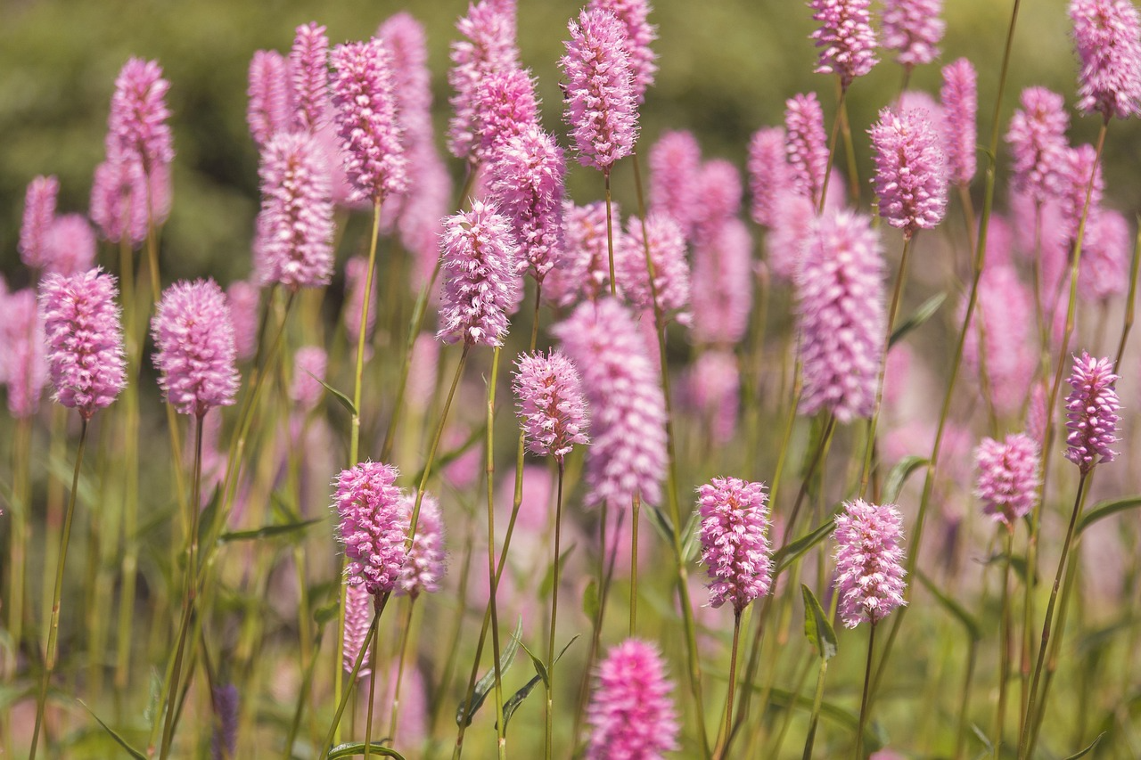
Name: Pink Flowers in a Field
Mood/Personality: This image feels calm and serene while also fun and bubbly because of the pink flowers.
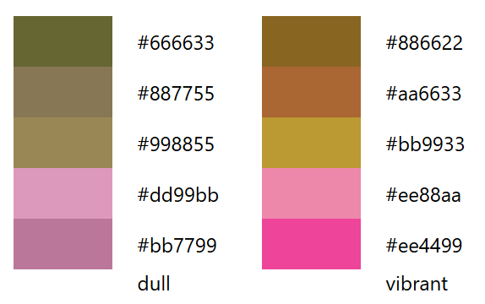
Color Palette:

Image #2
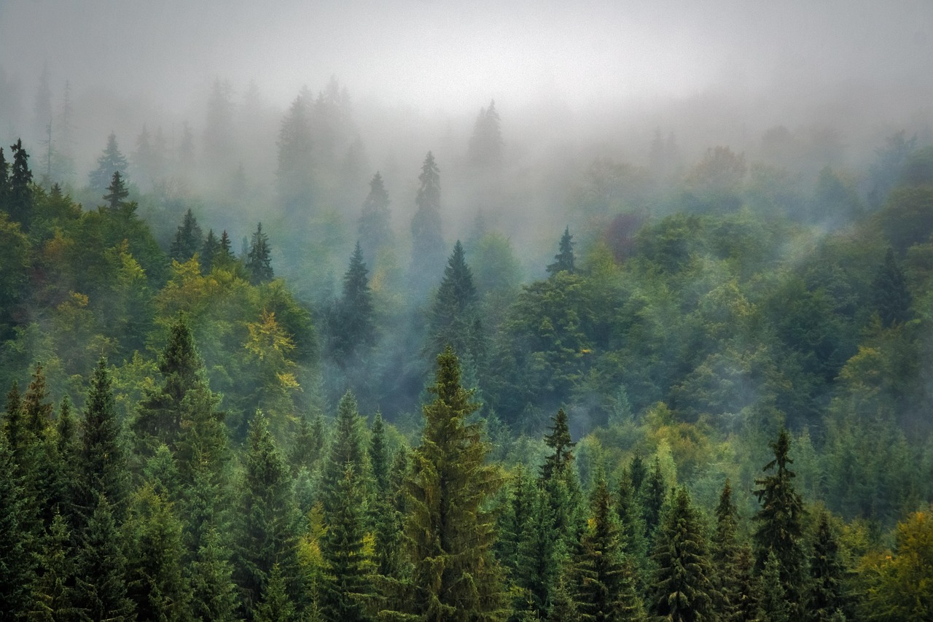
Name: Foggy Forest
Mood/Personality: This image feels serene and quiet. This image also feels mysterious, which is probably due to the fog.

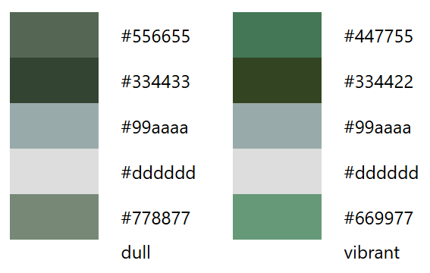
Color Palette:

Image #3
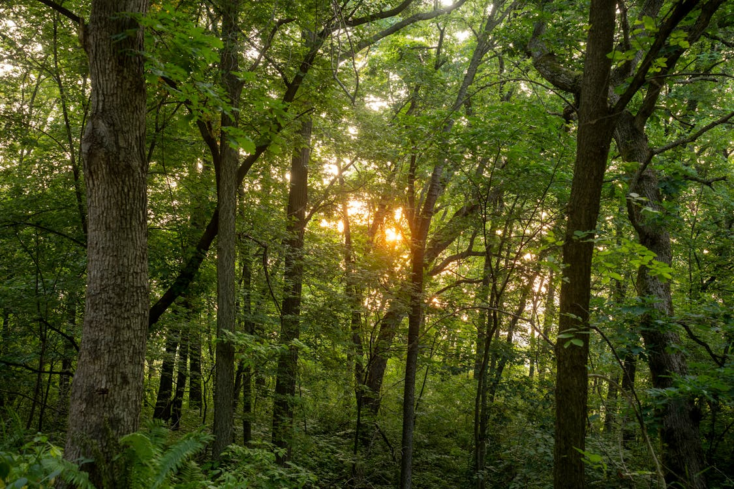
Name: Sun Shining Through a Forest
Mood/Personality: This image feels both calm and serene and also warm because of the bright yellow orange of the sun.

Color Palette:
