Personal Website Design
Development Guide
Site Directory Structure –
Folders:
images – contains the all the images needed for the site
css/styles – contains the styles for the site
edible flower – contains all of the individual edible flower pages
recipes – contains all of the individual recipes for the edible flowers
Files:
index.html
edible-flowers.html
recipes.html
recipe-form.html
tips.html
additional-resources.html
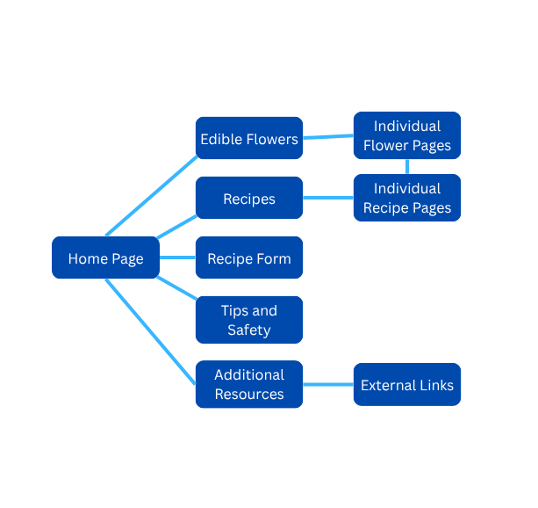
Main Navigation –
The home, edible flowers, recipes, recipe form, tips and safety, and additional resources pages will all have a navigation bar at the top of the page which will link to each other. The edible flowers page will link to each individual flowers page which gives information on the flower. The individual flower pages will have links to the individual recipe pages that coincide with the flower. The recipes page will link to each individual recipe page. The additional resources page is linking to external websites.
HTML Template –
<!DOCTYPE html>
<html lang=”en”>
<head>
<meta charset=”UTF-8”>
<title>Edible Flowers WA</title>
</head>
<body>
<header>
<h1>Edible Native Flowers to Washington State</h1>
</header>
<nav>
<ul>
<li><a href=”edible-flowers.html”> Edible Flowers</a></li>
<li><a href=”recipe.html”> Recipes</a></li>
<li><a href=”recipe-form.html”> Recipe Form</a></li>
<li><a href=”tips.html”> Tips and Safety</a></li>
<li><a href=”additional-resources.html”> Additional Resources</a></li>
</ul>
</nav>
<section>
<! Put information here for each page>
</section>
</body>
Wire Frame:
Interactivity List:
I plan to make a page for people to fill out a form with their own recipes so they can be added to the recipes page.
Design Guide
Layout or Storyboard –
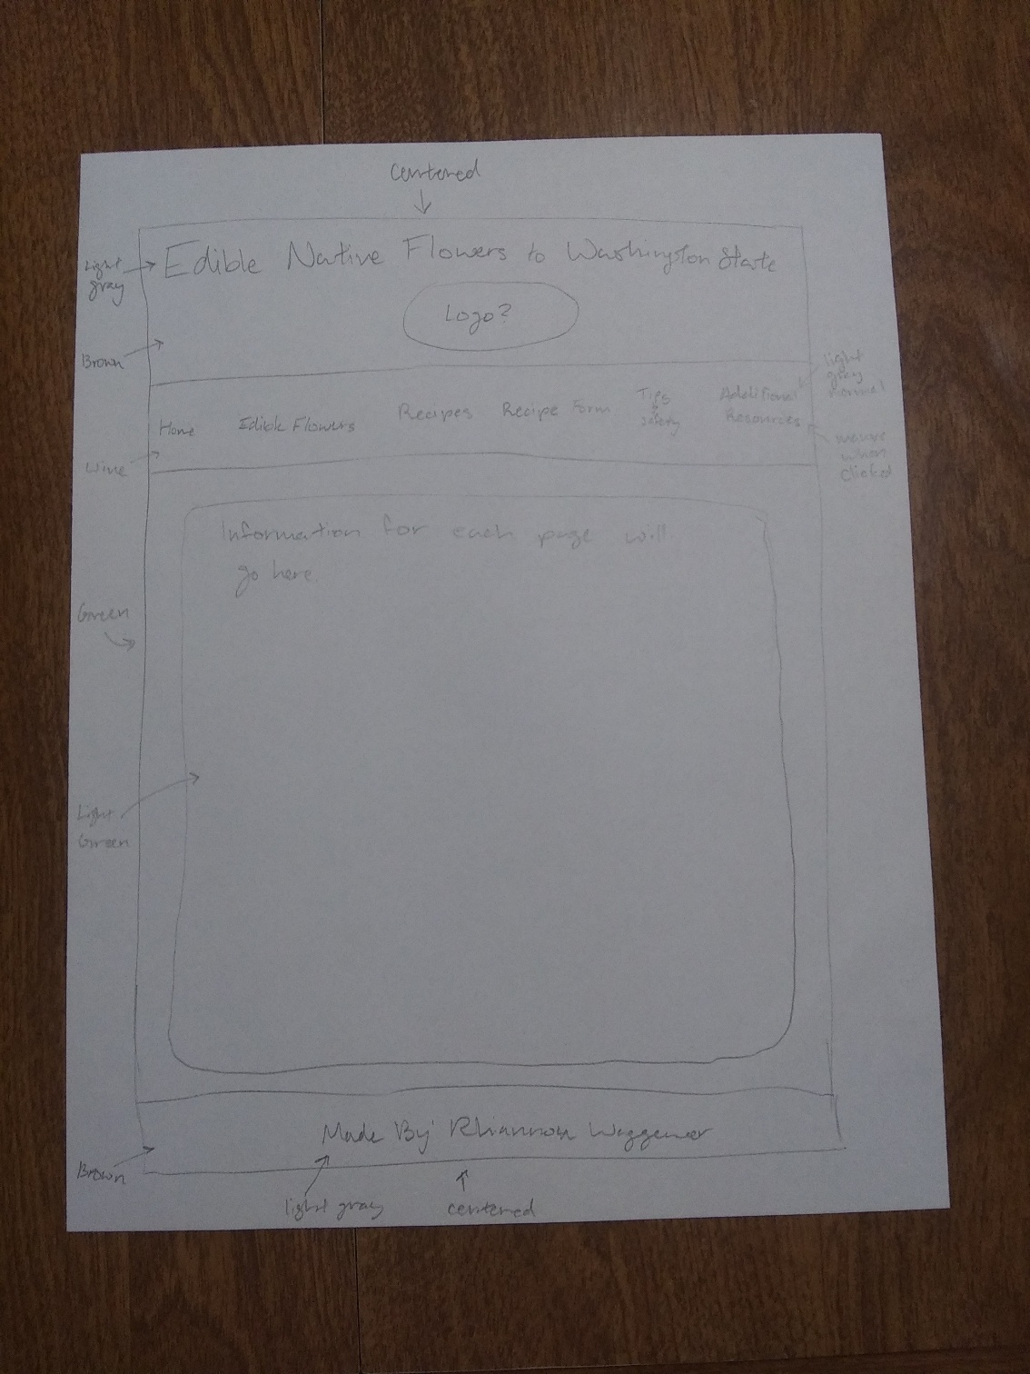
Color Palette –
Hex Code | Color Chip
#446600 Green | 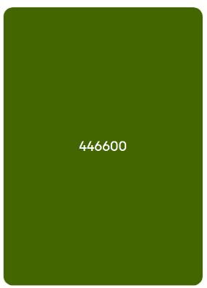
#669900 Light Green | 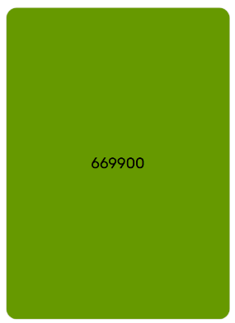
#887755 Brown | 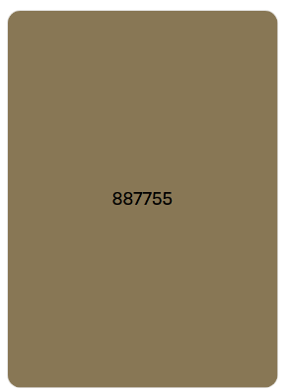
#DDDDDD Light Gray | 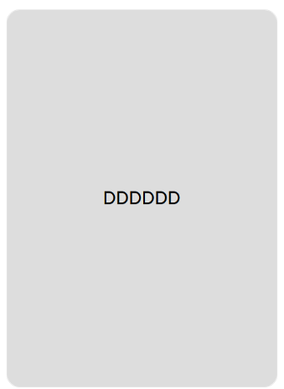
#BB7799 Mauve | 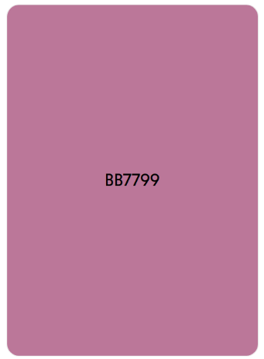
#8B4669 Wine | 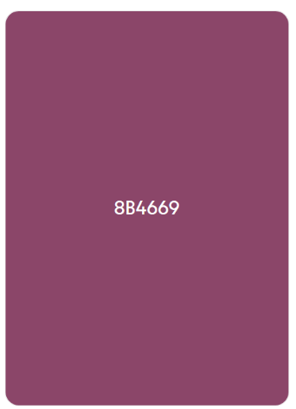

Style Guide –
- Font family
- Font size
- Background color
- Color
- Border
- Border radius
Media Assets –
I’m planning to add all of the photos below into the edible flowers page which will have a link that’ll lead to information on each flower. For the ‘creative commons’ photos, I have the website where the original photo is located bookmarked and I’ll add the link to the photos underneath them along with the photographer’s name.
Subject | Image | Original Location | Licensing
Yarrow | 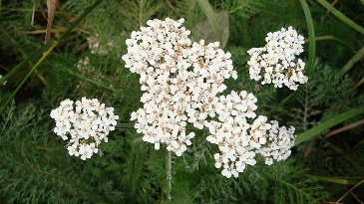 | Found on Wikimedia Commons.  Photo originally from National Park Service. | Public Domain.
Hawthorn | 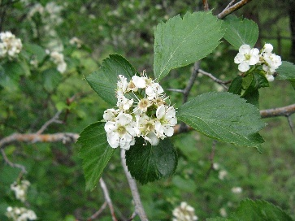 | Found on Wikimedia Commons. Photo originally from Nadiatalent. | Public Domain.
Oregon Grape | 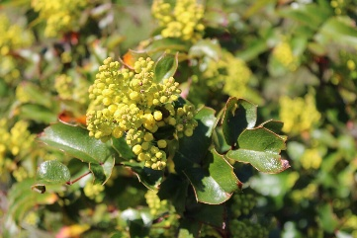 | Found on Wikimedia Commons. Photo originally from Chris Light. | Creative Commons 4.0.
Violet | 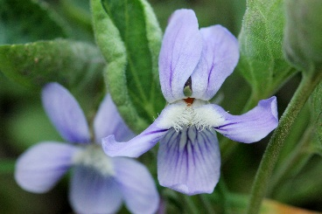 | Found on Wikimedia Commons. Photo originally from Flickr by Cecelia Alexander. | Creative Commons CC0 1.0 Universal Public Domain Dedication.
Rose | 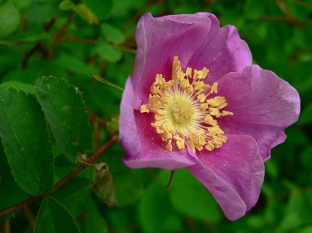 | Found on Wikimedia Commons. Photo originally from Walter Siegmund. | Creative Commons 3.0/2.5.
Salal | 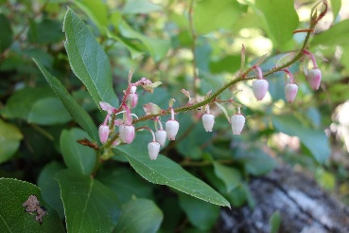 | Found on Wikimedia Commons. Photo originally from National Park Service. | Public Domain.
Salmonberry | 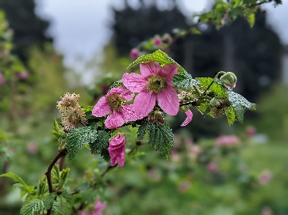 | Found on Wikimedia Commons. Photo originally from Marco Downs. | Creative Commons CC0 1.0 Universal Public Domain Dedication.
Thimbleberry | 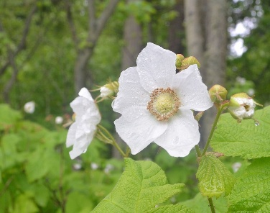 | Found on Wikimedia Commons. Photo originally from Bureau of Land Management Oregon and Washington by Jennifer McNew. | Public Domain.
Agoseris | 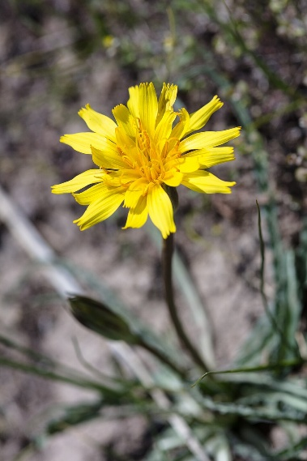 | Found on Wikimedia Commons. Photo originally from Yellowstone National Park by Jacob W. Frank. | Public Domain.
Arrowleaf balsamroot | 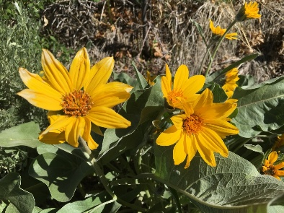 | Found on Wikimedia Commons. Photo originally from National Park Service. | Public Domain.
Beargrass | 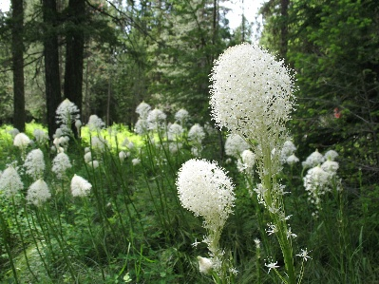 | Found on Wikimedia Commons. Photo originally from Glacier National Park by David Restivo. | Public Domain.
Bistort | 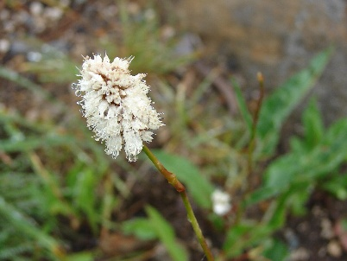 | Found on Wikimedia Commons. Photo originally from Mount Rainer National Park by Steve Redman. | Public Domain.
Camas | 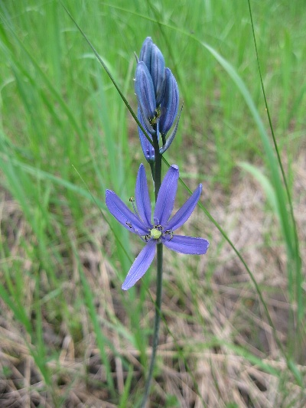 | Found on Wikimedia Commons. Photo originally from Forest Service Northern Region. | Public Domain.
Clover | 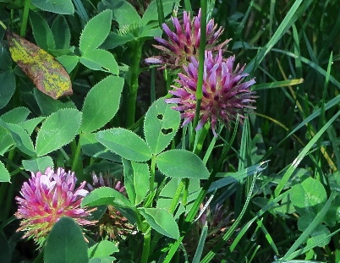 | Found on Wikimedia Commons. Photo originally from Flickr by John Rusk. | Creative Commons 2.0.
Coltsfoot | 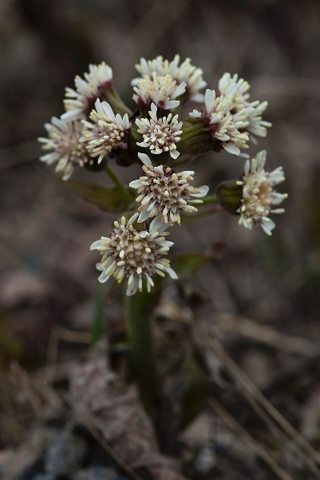 | Found on Wikimedia Commons. Photo originally from National Park Service by Jacob W. Frank. | Public Domain.
Yellow Pond Lily | 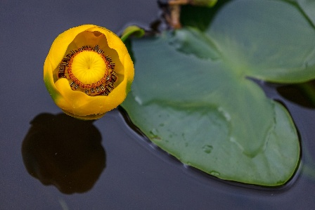 | Found on Wikimedia Commons. Photo originally from Flickr by YellowstoneNPS. | Public Domain.
False Solomon’s Seal | 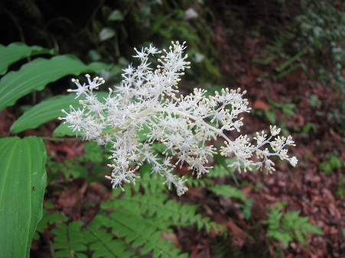 | Found on Wikimedia Commons. Photo originally from National Park Service by Tom Harrington. | Public Domain.
Goldenrod | 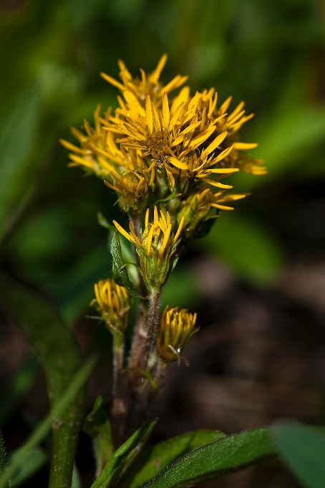 | Found on Wikimedia Commons. Photo originally from National Park Service by Jacob W. Frank. | Public Domain.
Mariposa Lily | 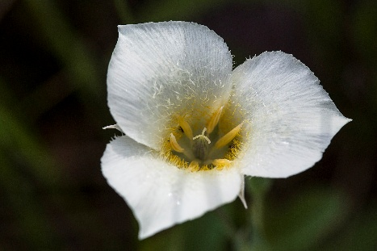 | Found on Wikimedia Commons. Photo originally from National Park Service by Jacob W. Frank. | Public Domain.
Marsh-marigold | 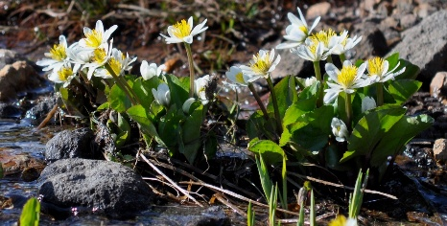 | Found on Wikimedia Commons. Photo originally from Mount Rainer National Park. | Public Domain.
Pearly everlasting | 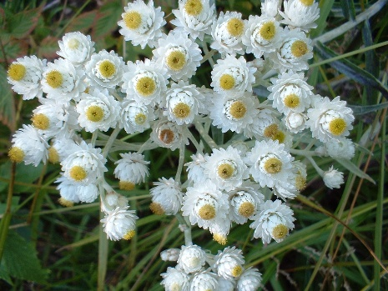 | Found on Wikimedia Commons. Photo originally from Pendragon39. | Public Domain.
Pineappleweed | 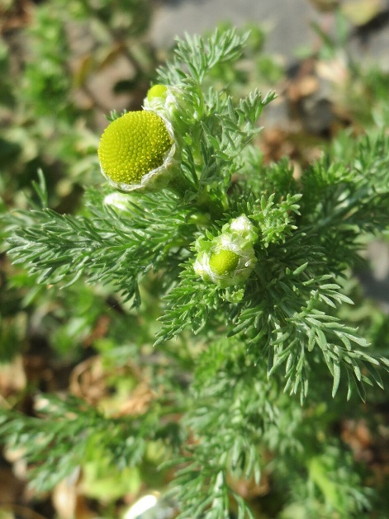 | Found on Wikimedia Commons. Photo originally from AnRo0002. | Creative Commons CC0 1.0 Universal Public Domain Dedication.
Roseroot | 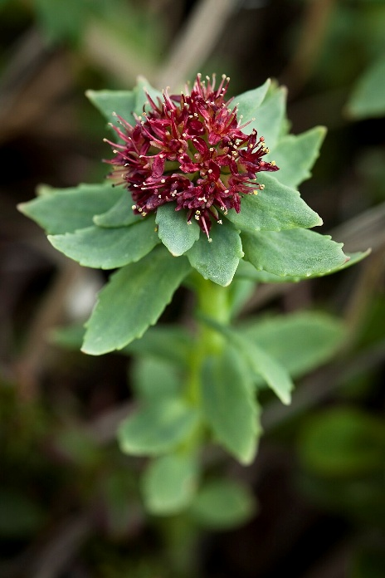 | Found on Wikimedia Commons. Photo originally from National Park Service by Jacob W. Frank. | Public Domain.
Sunflower | 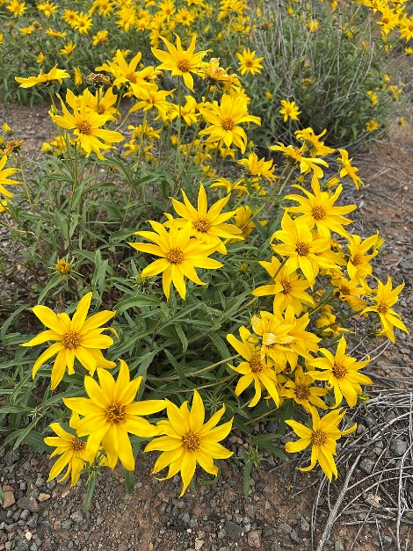 | Found on Wikimedia Commons. Photo originally from National Park Service. | Public Domain.
Marsh Woundwart | 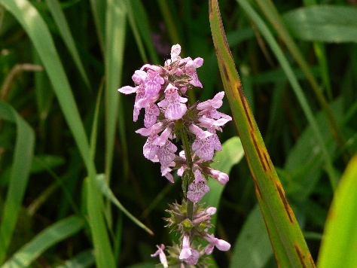 | Found in Wikimedia Commons. Photo originally from Banan214. | Public Domain.
Tiger Lily | 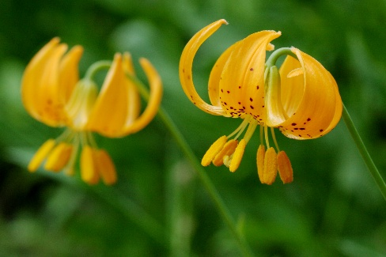 | Found in Wikimedia Commons. Photo originally from Flickr by Cecelia Alexander. | Creative Commons CC0 1.0 Universal Public Domain Dedication.
Wild mint | 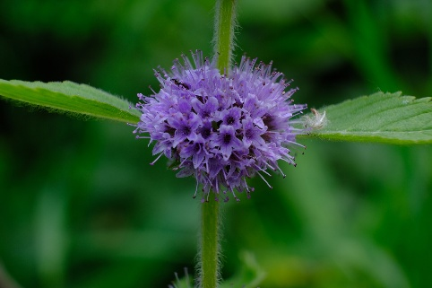 | Found in Wikimedia Commons. Photo originally from Jdshide by Jasper Shide. | Creative Commons CC0 1.0 Universal Public Domain Dedication.
Snow Lily | 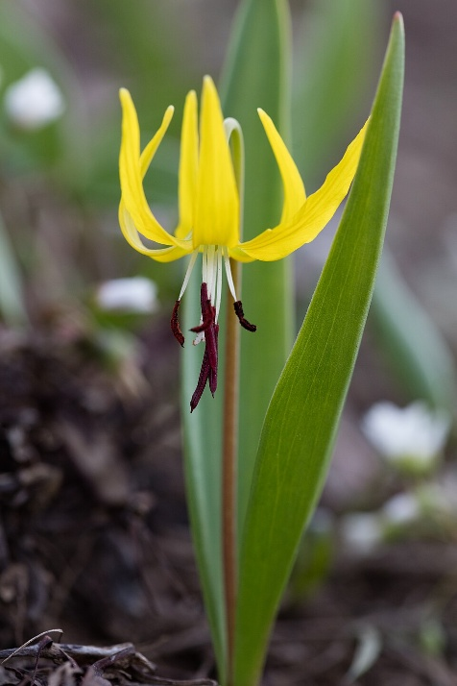 | Found in Wikimedia Commons. Photo originally from National Park Service by Jacob W. Frank. | Public Domain.

