# Assignment 1 – Group 14

### Task 1

The plot shows power consumption and water temperature as a function of time. One can clearly see a jump in power consumption as the temperature falls under a given minimum threshold of T=70C.

t_act should be right after the natural activation time so t_act=765 minutes in order to get a slight increase in temperature before turning off the heater and wait for a later time to increase the water temperature up to 74C and demand full load. S_act = 0

### Task 2

1. Power capacity = 2kW
2. Service duration = 815 – 760 min = 55 minutes.

Immediate response with no ramp-up or ramp-down time

1. Energy capacity = 2kW * 115 min = 2kW * 1.92h = 3.8kWh

### Task 3

### Task 4

Here is the plot that shows the activated flexibility over time with a clear rebound effect at t≈1000. The direction changes drastically from positive to negative. The rebound effect seems to last longer than the main load demand, this may be due to the small load that is activated to bypass the automatic temperature controller.

### Task 5

To shift the load to an earlier time t_act can be chosen strategically before the original initiation time of 760 minutes, so t_act=600 and S_act=1 should give a clear earlier load demand

Here the direction of flexibility is inverted

### Task 6

t_act = 500

t_act = 760

t_act =800

### Task 7

It seems that the earlier flexibility is activated, the greater the flexibility potential. As in t=500 offers more flexibility because of the higher water temperature resulting in a longer turn_off period for the heater. This means that the load can be delayed for a significant duration, giving a larger shift in power consumption.

While t=760,800, the already low water temperature provide less flexibility and the load cannot be shifted as much.

### Task 8

### Task 9

* Eq.2 => 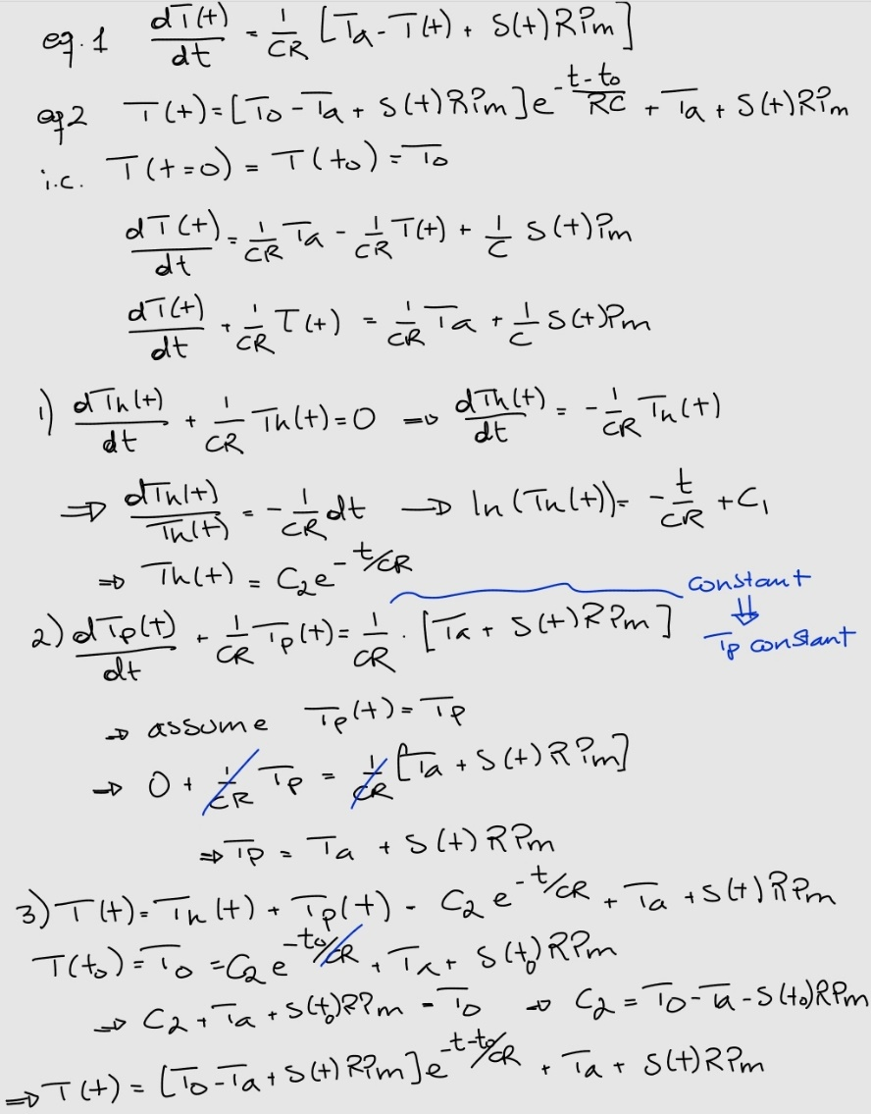
* A whiteboard with math equations

  Description automatically generated
* To calculate energy E = P [W] * t [h]. Here we have time in minutes so it is divided by 60 to transform it to hours.

### Task 10

The exercise model simplifies several aspects compared to the more detailed model in the article. It doesn't account for rebound effects, which are the increased power demands that occur after flexibility activation when the system compensates for earlier load reductions. Additionally, the exercise model simplifies temperature dynamics, using fixed parameters, whereas the article's model considers deviations due to external factors. Finally, while the exercise model uses basic ON/OFF control, the detailed model employs smart activation strategies, optimizing the flexibility potential for grid services like frequency reserves. These simplifications make the exercise model less applicable to real-world scenarios.

### 

### Code

